Geraint Jones (1908119)
1908119@student.uwtsd.ac.uk

Network operating systems and services 2 (NOSS)

Name of the author – Geraint Jones
Course – Network Operating Systems and Services (NOSS)
The faculty name – School of applied computing
The date of submission – 25/04/2022

Declaration

The work of this report is completed under the supervision of Dr Kaliyamurthy. I declare that this report is the product of my own work and is not being submitted for any other degree etc.

Acknowledgement

I would like to thank my family for giving me the additional time to undertake a degree, my employer for sponsoring the degree and the many lecturers for giving their time and knowledge to arm with the necessary to complete the tasks at hand.

Abstract

This report outlines the work completed in exploring NTFS, Group Policy as well as features of Windows Server which add FTP and Routing capabilities. It then moves on to discuss best practice with network security and password policies, as well as considerations given to failover clustering. These steps are annotated and where appropriate the technology expanded upon, as well as offering conclusion and evaluation of said tasks as well as evidencing the studies via the appendices.

Contents page
Declaration 1
Acknowledgement 1
Abstract 1
Contents page 2
Main chapters 3
1. Network Policy and Security Practices 3
1.1 NTFS 3
1.2 Group Policy 7
2. Routing and Packet Filtering 10
2.1 Topology 10
2.2 FTP 13
2.3 Packet filtering 15
2.3.1 Rule construction 15
2.3.2 Rule testing 16
3. Password principles 17
4. Failover clustering 18
4.1 File cluster 18
4.2 Quorum 19
4.3 Availability 20
4.3.1 High vs Continuous 20
5. Network security policy 21
5.1 Template 22
6. Conclusion and Evaluation 22
6.1 Future work 23
References 24
Supporting material 27

Main chapters

1. Network Policy and Security Practices

NTFS

New Technology Files System (NTFS) is a Windows file system that provides technologies to support encryption, permissions, and increased reliability of locally held files and folders[1].

Permissions

An administrator can change the permissions on these objects, by adding and removing rights for users or groups as shown in figure 1.
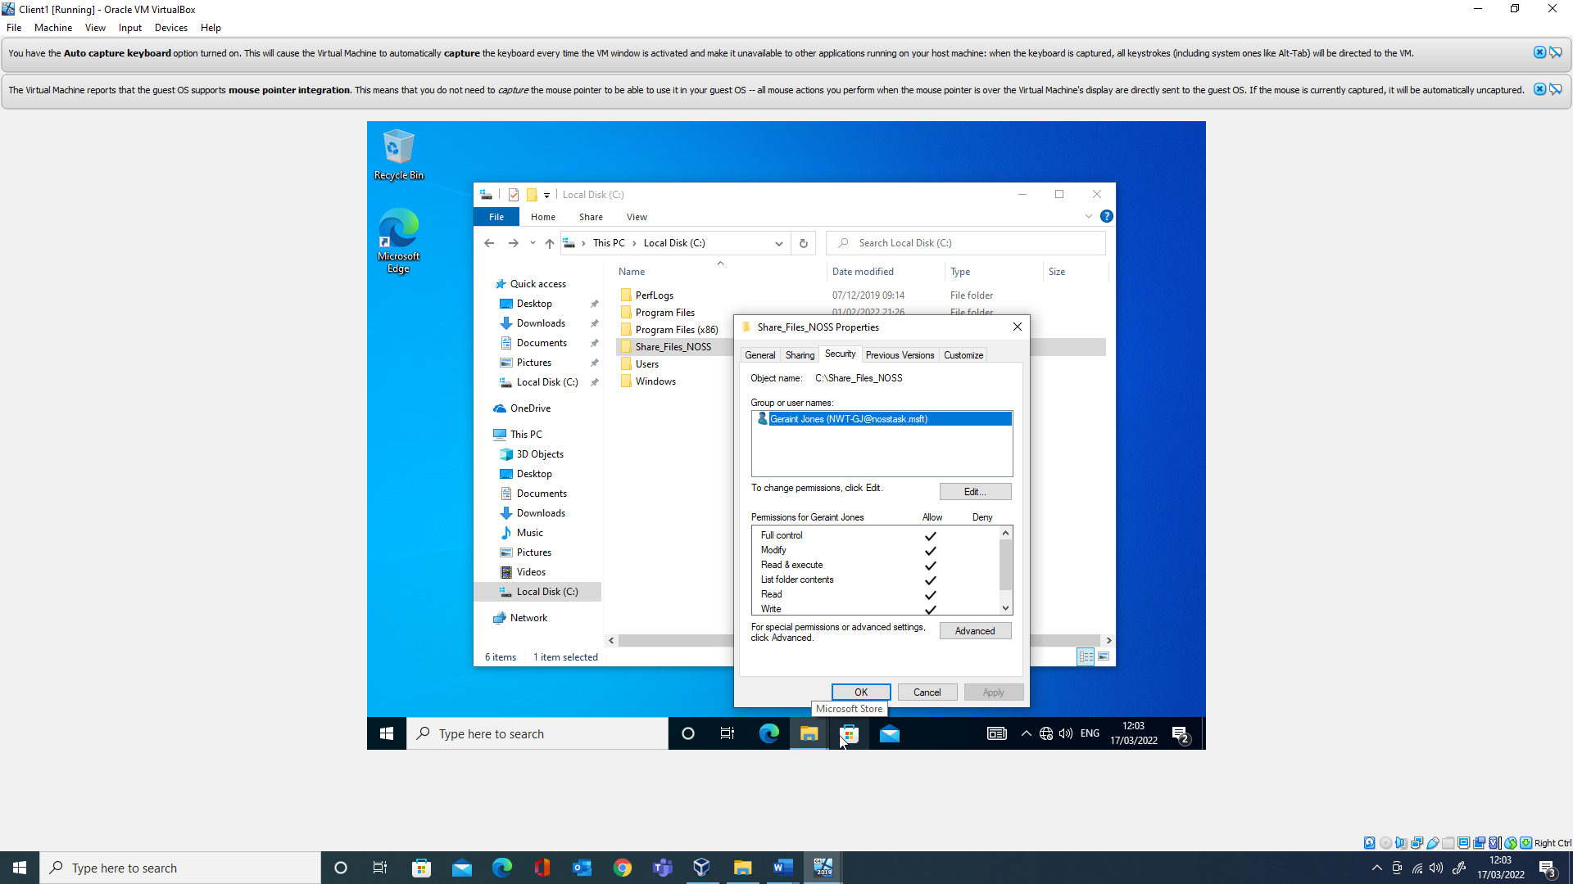
Figure 1
A breakdown of NTFS permissions can be seen in figure 2, such as “Read” and what actions that grants, for example the ability to “List Folder/Read Data” whereas “Write” permissions does not. Be aware it is possible to craft “Special Permissions” via the Advanced button in figure 1, where the individual attributes can be amended for a built-in security level. For example, “Read Permissions”, which would allow an individual to see the NTFS permissions, could be removed from a user or group giving “List folder contents” only.

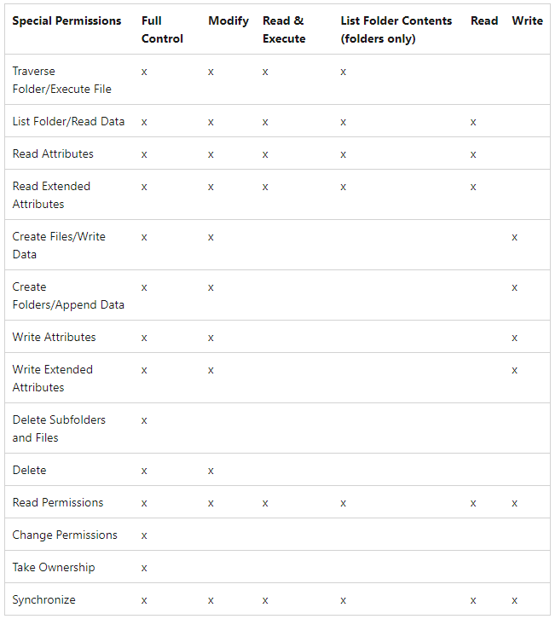
Figure 2[2]

Inheritance

All objects when created, will inherit a default set of permissions from their place of birth. This can be seen in figure 2 while removing said permissions for the exercise.

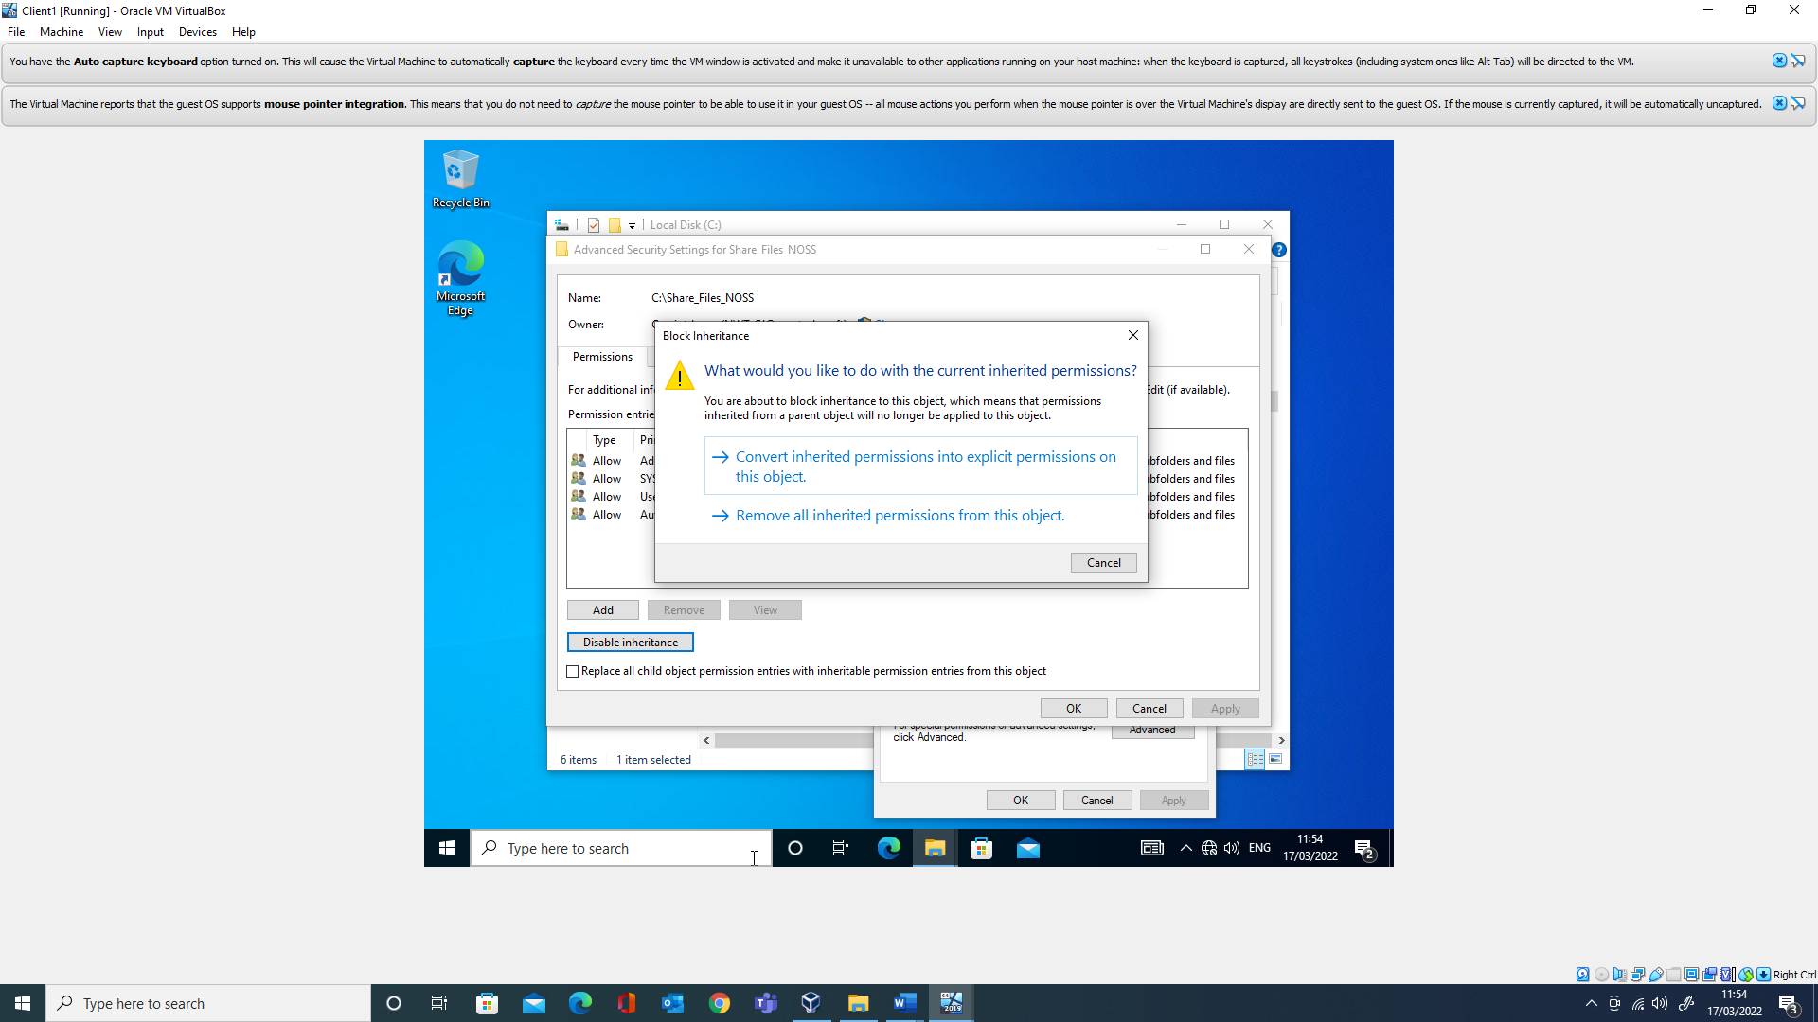
Figure 2

Denied

It is important to understand that by the design of permissions users can be stopped from carrying out a task as seen in Figure 3.

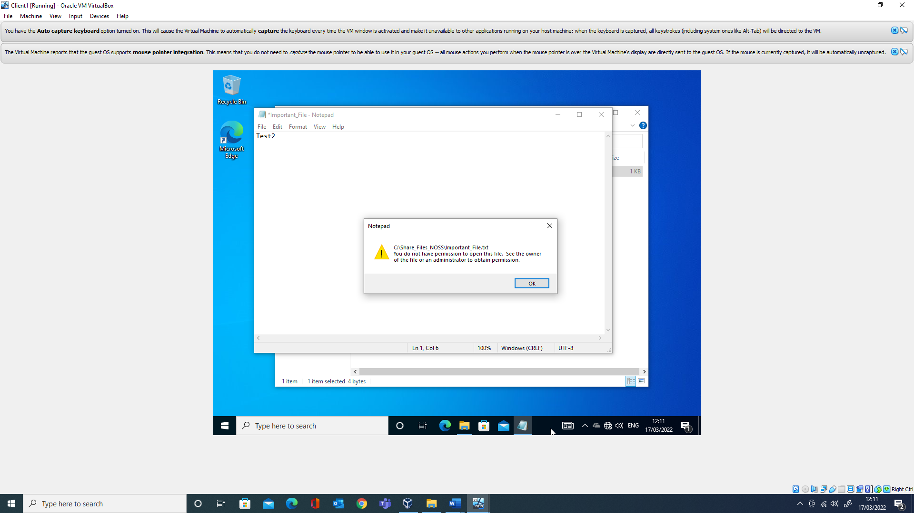
Figure 3
Although this is expected, the error message in other examples maybe unclear.

Ownership

If an administrator becomes denied from incorrectly set permissions, they can take ownership of a directory or file, to return the permissions on the object to a functional level, therefore re-establishing access[3].

Sharing

As well as local permissions, objects on the file system can be affected by share permissions. These are exposed when an administrator wants to share local resources to network connected devices. These can be seen in Figure 4.
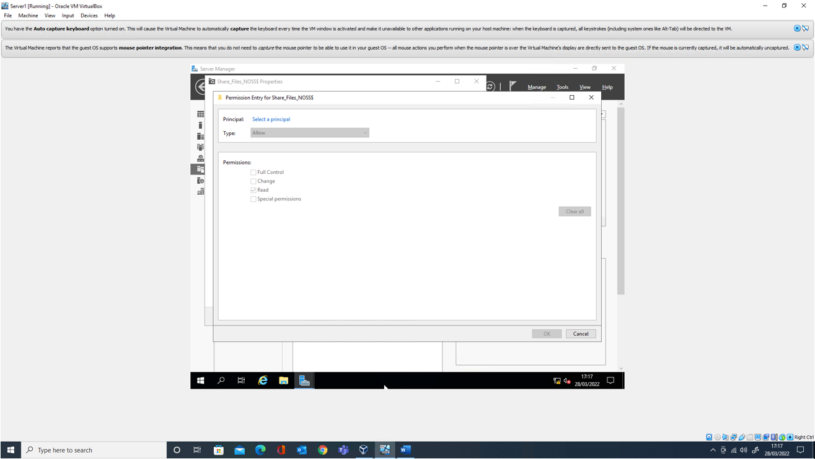
Figure 4

Effective permissions

Complications can arise from miss matching permissions set between a share and the local file system. It is important to note that a matrix of rules dictate the effective permission[4].

Mapped drive

When a file server, server 1, has a correctly configured firewall, NTFS and File share permissions, a drive can be mapped from a client computer, client 1, to the resources as seen in Figure 5.
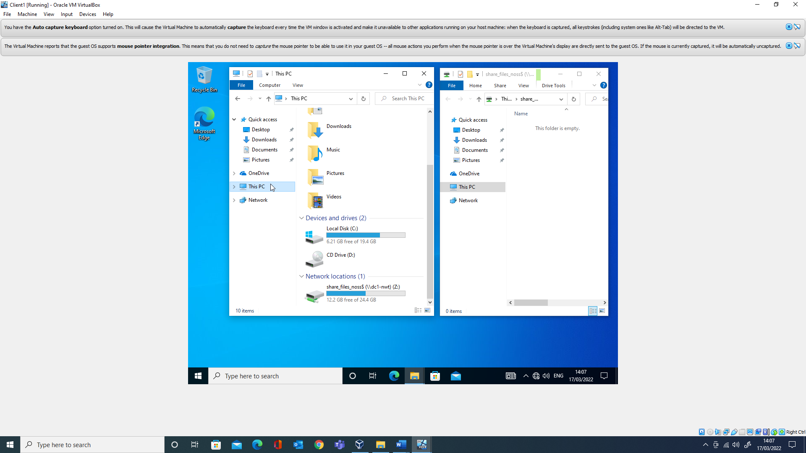
Figure 5

Group Policy

Group policy is a technology within active directory, for the central configuration and application of settings to operating systems (OSs) and applications running within the domain. These settings, group policy objects (GPO’s) are attached to Organisational Units (OUs). The active directory objects within the OUs, users and computers, have the settings applied from the GPOs to them, usually in an enforced manner[5].

Group Policy Management

Group policies are managed via the Group Policy Management console, figure 6.
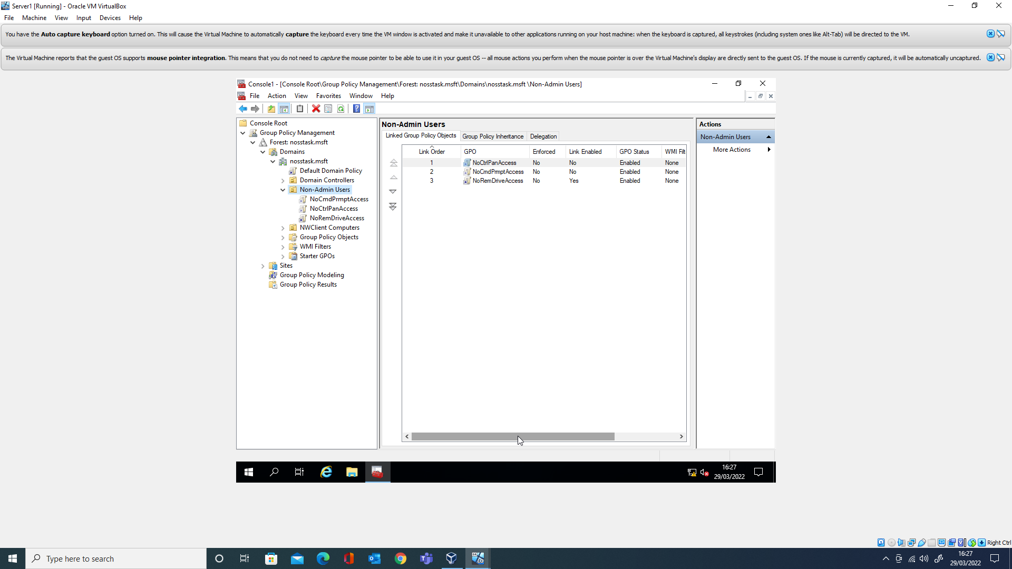
Figure 6

GPRESULT /r

To confirm if a group policy is functioning on a client computer, the command “GPRESULT /r” can be run. After some time, an output is generated listing the outcome of any group policies applied. This can be seen in figure 7.
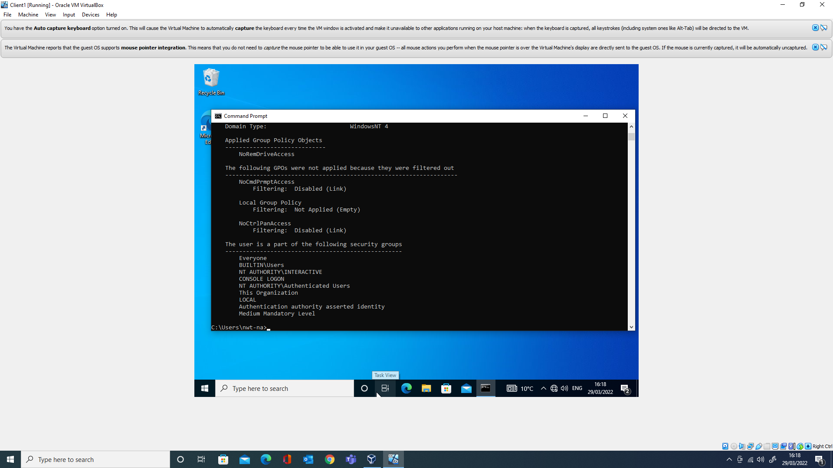
Figure 7

Registry

The windows registry was created to replace settings held in .ini and .bat files of earlier windows OSs. It is a hierarchical database used to store settings used to configure the OS and applications[6]. GPO’s often target the registry for their desired outcome. This can be seen in figure 8 where the registry key “Deny_All” is created by the GPO to enable the block on removable storage.
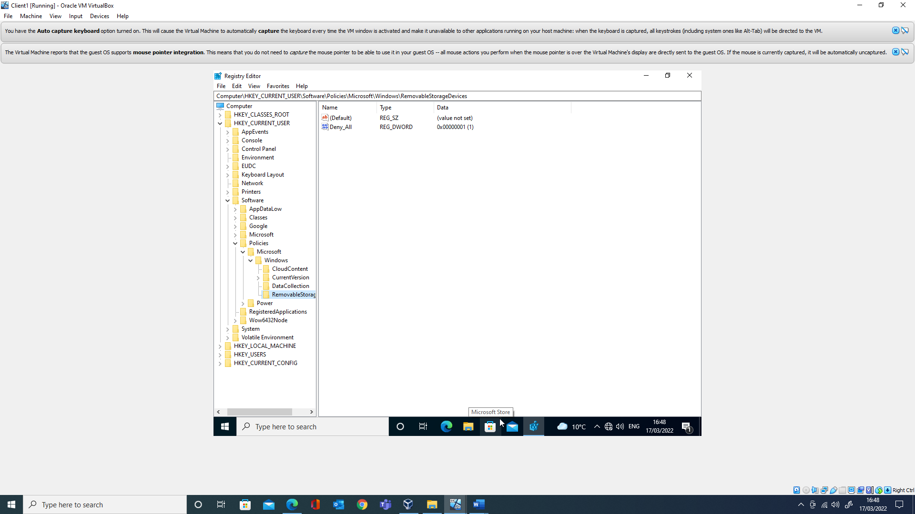
Figure 8
The registry is also secured via NTFS, which is used as part of the enforcement mechanism of group policy seen in figure 9 where the user can only read the registry key, therefore being unable to change it to allow use of removable media.
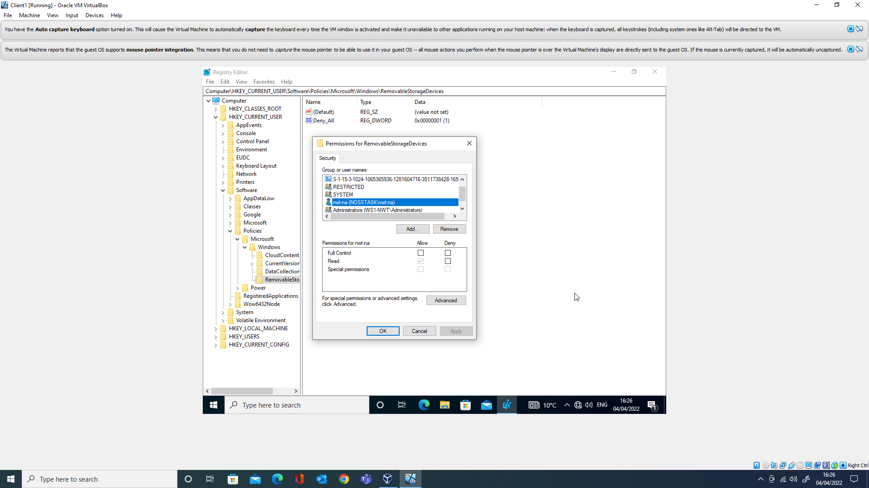
Figure 9

Computer VS User

Like the registry is split, Computer (HKEY_LOCAL_MACHINE) and User (HKEY_USERS), Group Policy mirrors this configuration, shown in figure 10. Depending on where the configuration is set, the change will play out in the corresponding portion of the registry.
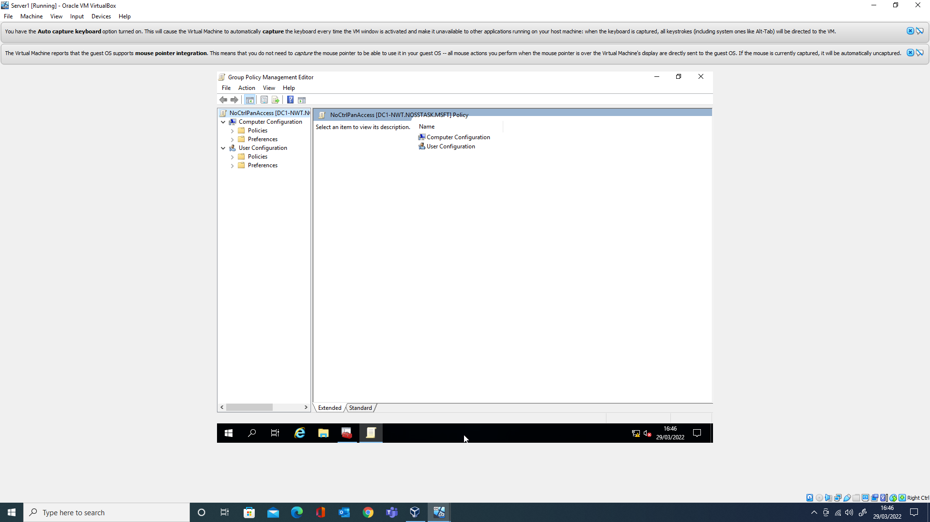
Figure 10

Application

Figure 11 demonstrates the application of group policy in the lab. Other examples can be seen in supporting material, such as the restriction of application installs which required changing the guest machine to bridged networking to allow internet usage to download a suitable installer.
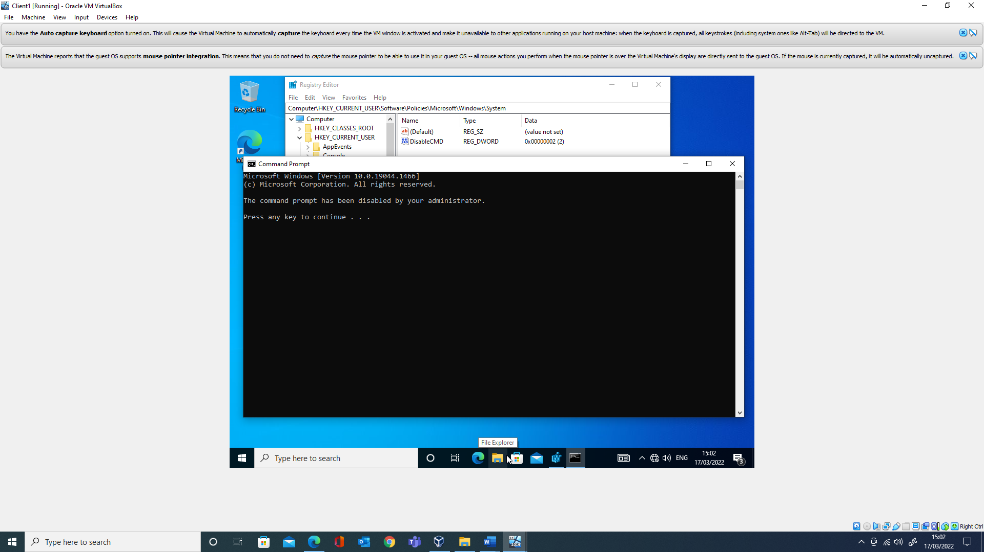
Figure 11

2. Routing and Packet Filtering

2.1 Topology

The network topology of the lab is shown in figure 12.
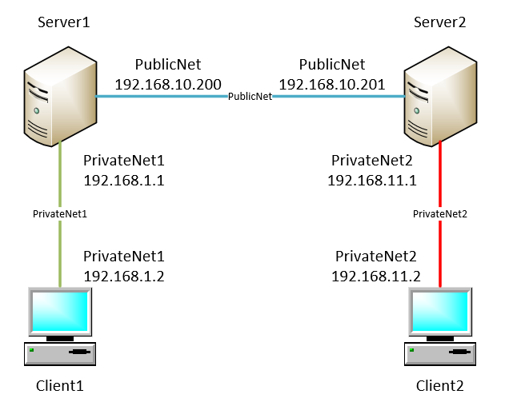
Figure 12
It is broken down into three separate networks, “PrivateNet1”, “PrivateNet2” and “PublicNet".
Communication within a network is achieved by using Address Resolution Protocol (ARP). ARP works between layer 2 and layer 3, with the purpose of translating between the 32-bit IPv4 address and 48-bit MAC address. To this end, if an endpoint wishes to communicate to another endpoint, it will first check its ARP table, to see if it holds an entry, and if not sends a broadcast message to all endpoints on the LAN asking if they are the owner of the destination IP address of interest. Once that endpoint receives the request, it will answer. Both devices will update their ARP table during this process, and communication will proceed. An ARP table can be seen in figure 13.[7]
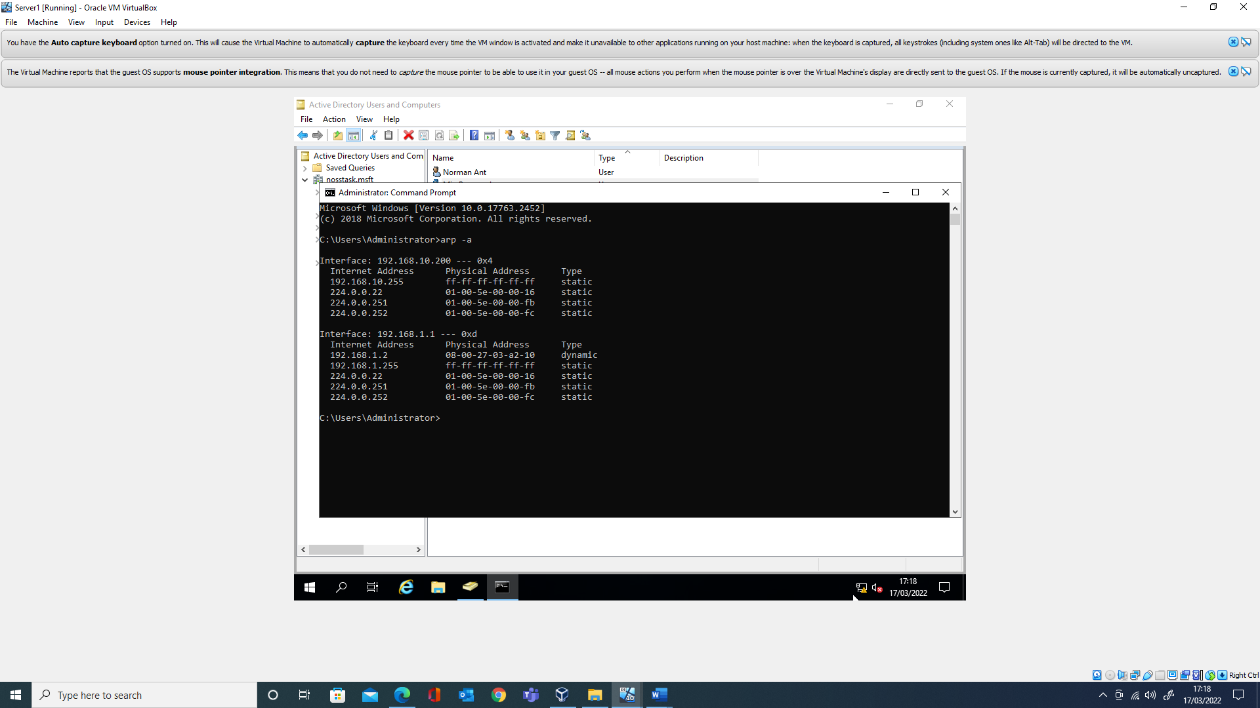
Figure 13

Routing

If communication is desired between the separate networks, routers will have to be introduced, to move packets between them[8]. During the ARP process, the destination IP address is checked against the sources IP address information. If it is deemed outside of the local area network (LAN) then ARP will use the endpoints route table to determine the MAC address of the default gateway from its IP address[9]. The default gateway holding the role of router on a LAN. A route table can be seen figure 14.
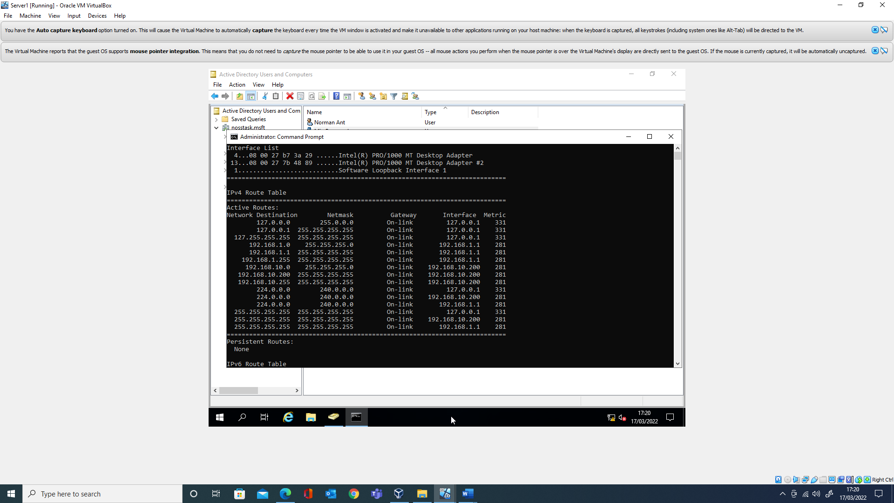
Figure 14
If a default gateway’s IP is not set, then the ARP process will fail, therefore a device will be unable to communicate outside of the LAN as shown in figure 15.
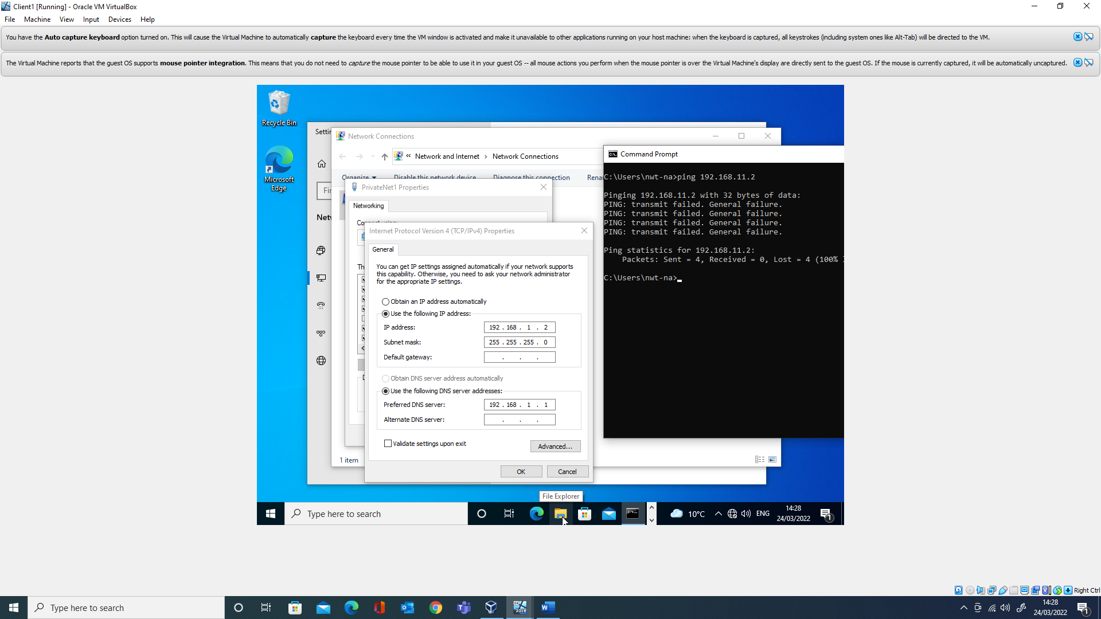
Figure 15

Routers

To be able to complete all the exercises required, the various LAN’s need to be able to communicate between them. To enable this, as discussed above a router is required between each network. Windows Server can be configured to act as a router. Both Server 1 and Server 2 in Figure 12, are configured on each of their Network Interface Cards to perform this function, by adding the role “Remote Access” with the specific configuration of “LAN Routing” with the RIPv2 protocol[10].

Connectivity

Once the above configuration is in place, the Windows firewall appropriately configured (ICMP blocked by default[11]) connectivity between the networks can be seen in figure 16 which shows Client 2 contacting Client 1 through ping.
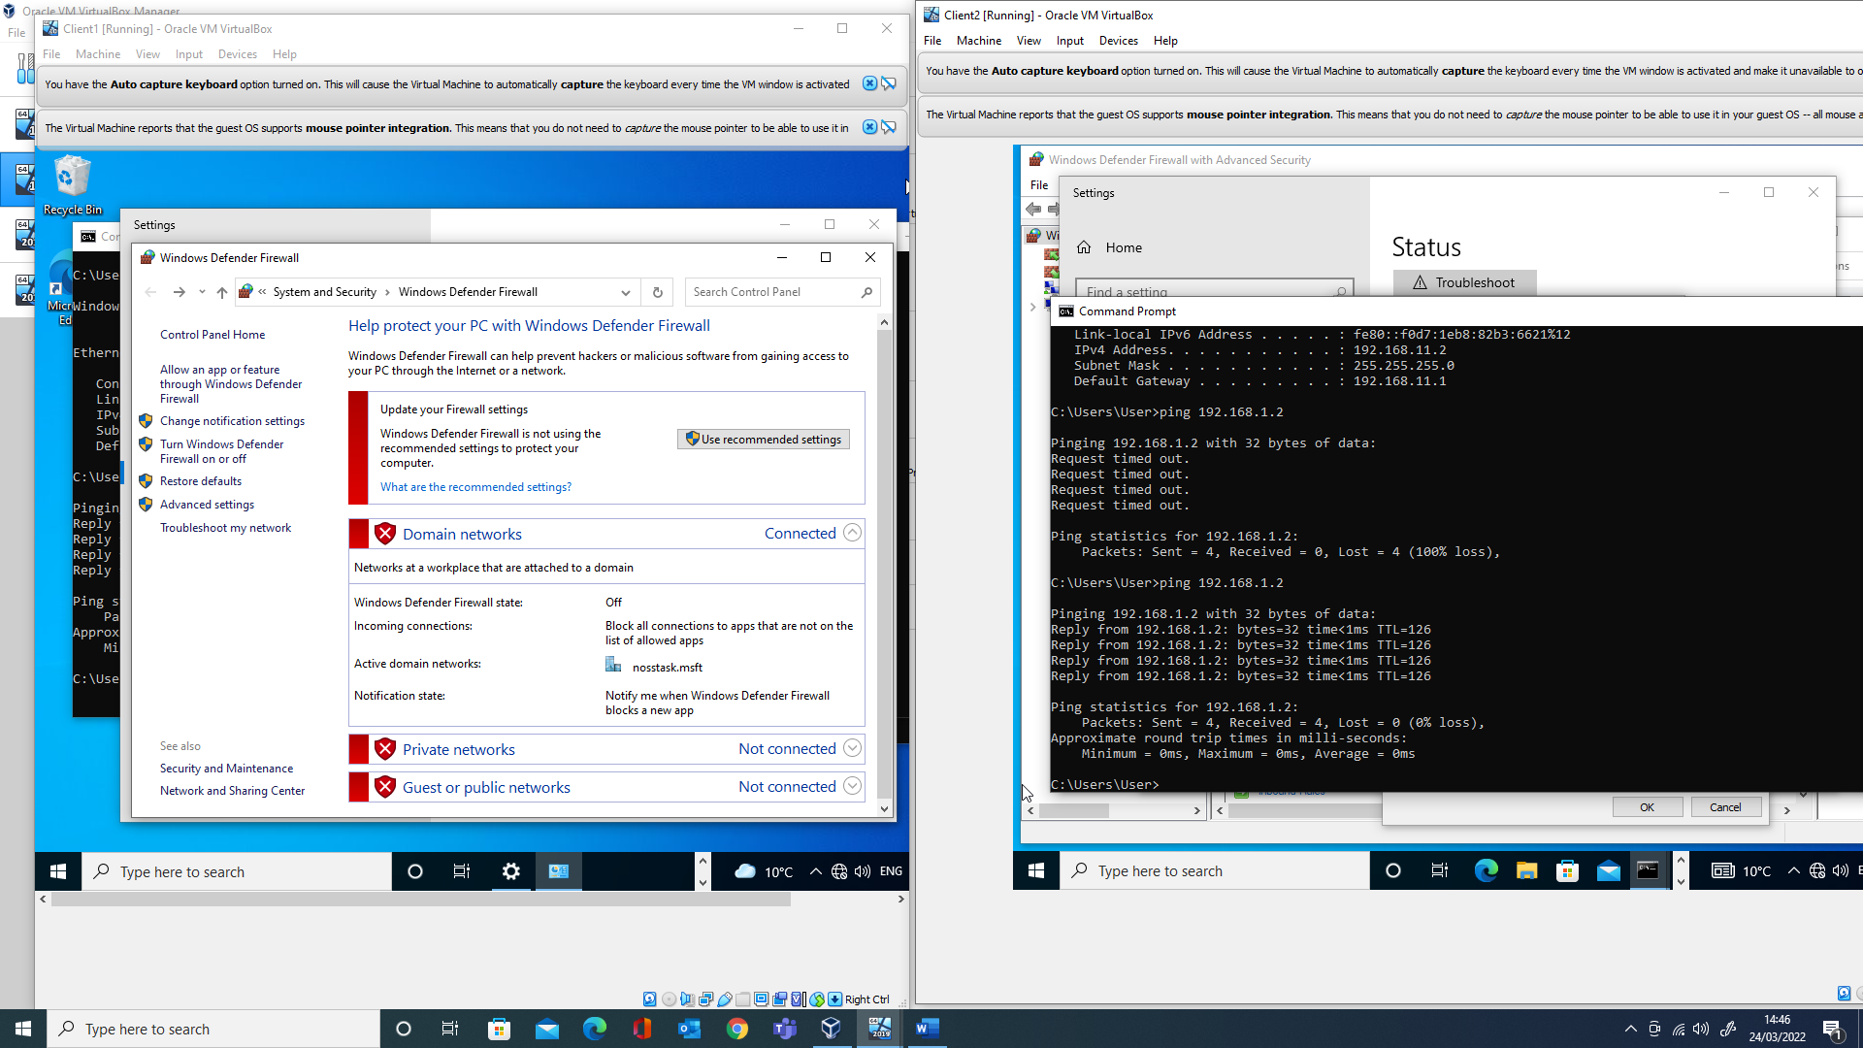
Figure 16

2.2 FTP

The task required setting up an FTP site on Server 2 and demonstrating sending a file from Client 2 on the private network to the site. Due to an error in the NTFS permissions, the “550 Access is denied.” error was shown in figure 17.
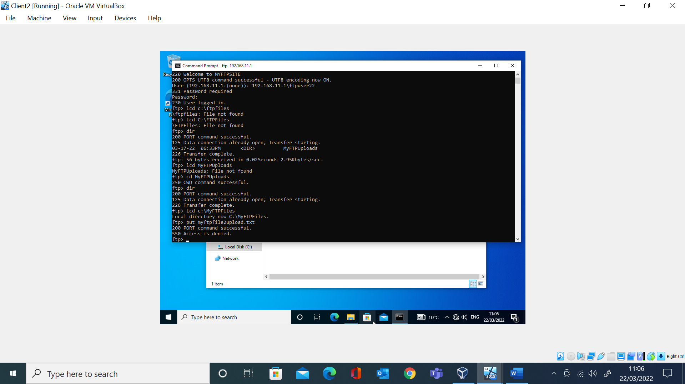
Figure 17
This was corrected by granting “ftpuser22” write permission over the directory “MYFTPUploads”, figure 18.
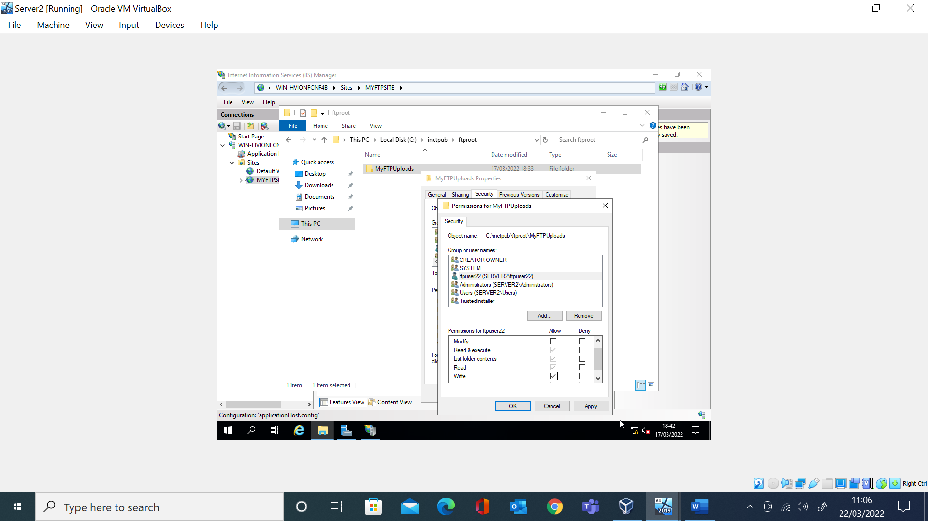
Figure 18
Once amended, the file transfer was a success as seen in figure 19.
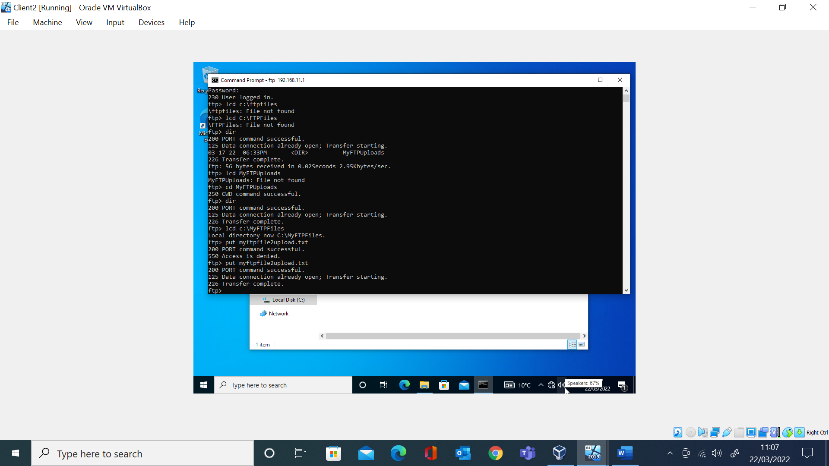
Figure 19

Packet filtering

Packet filtering in Routing and Remote Access (RRAS) allows an administrator the ability to craft rules on how to treat traffic as it passes through the router[12]. RRAS has the options of filtering on each network card based on Outbound, received by this network and Inbound, forwarded or processed by this network.
All rules set on either, outbound or inbound, are either set to receive by all for the criteria, or dropped by all except for the criteria, which is limiting.
Individual rules can be bound to source, destination, and port data.

Rule construction

Due to the limitation outline above, it was decided to set the rule to drop all except for the criteria, to save having to enter all the IP Addresses from the range. The issue being that you sacrifice usability if wanting to allow other services in the future. It was decided to build the rule on the outbound connection on “PrivateNet1”, figure 11, as if client computers on that subnet required consumption of other services in the future, exceptions could be added, which should be less of an administrative overhead than if setting to the inbound. Finally, the rule was restricted to source, destination IP Addresses and FTP port. This can be seen in figure 20.
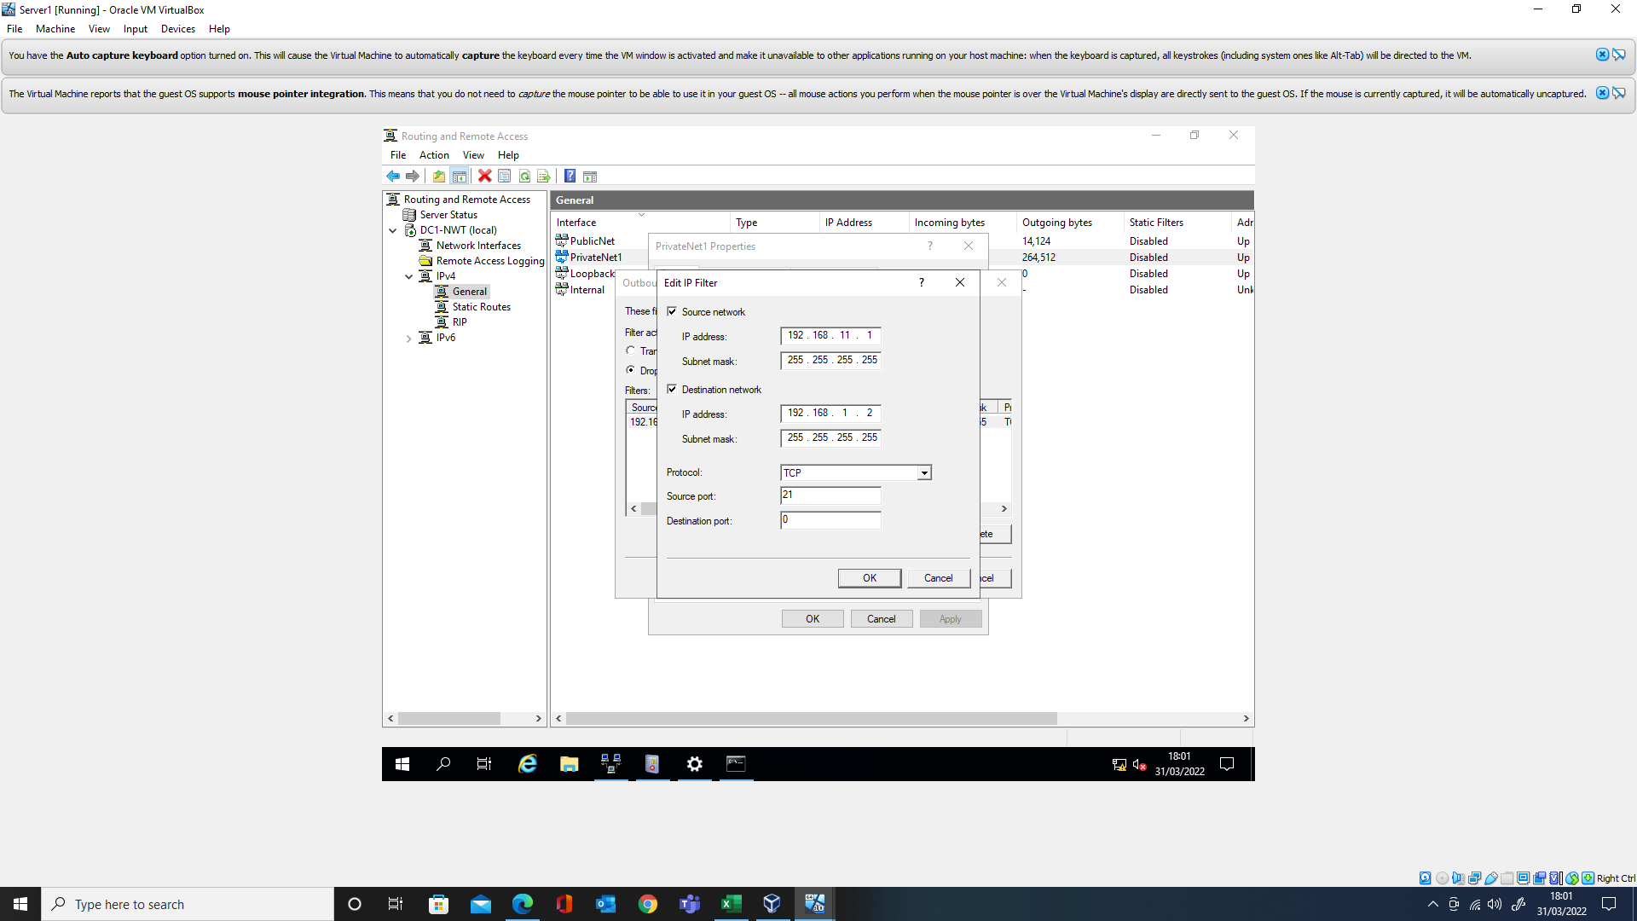
Figure 20

Rule testing

To test the rule, Client 2, was moved to “PrivateNet1”, and given the IP address 192.168.1.3.
Ping from both clients, to 192.168.11.1 was ran with the -t continuous switch. The rule was then adjusted on “PrivateNet1” in various ways as seen in figure 21.
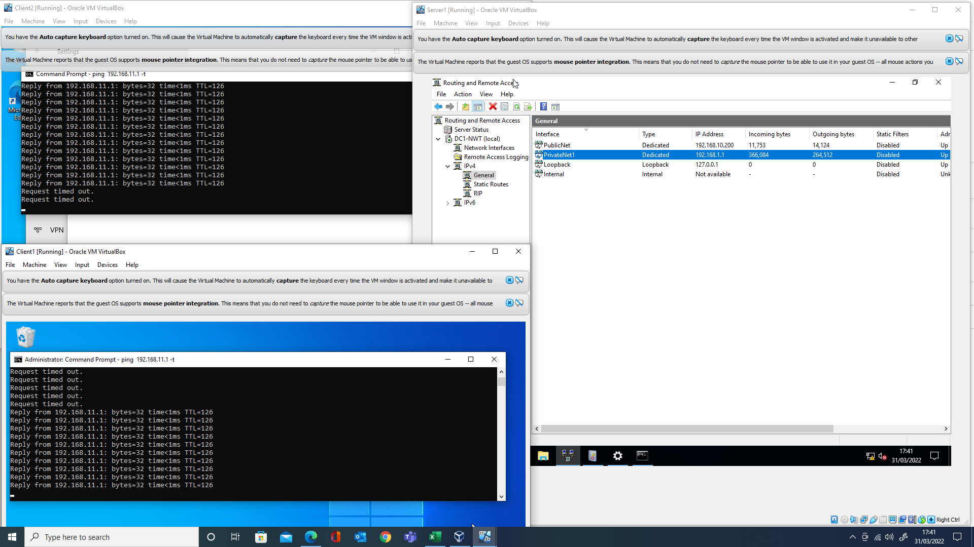
Figure 21
Initially there was confusion over inbound and outbound which resulted in complete loss of ping for both clients.
Once this was addressed, the destination address was changed between .2 and .3 to ensure ping would drop and activate between the end points.
Finally, port was added, and testing to the FTP site concluded as seen in figure 22.
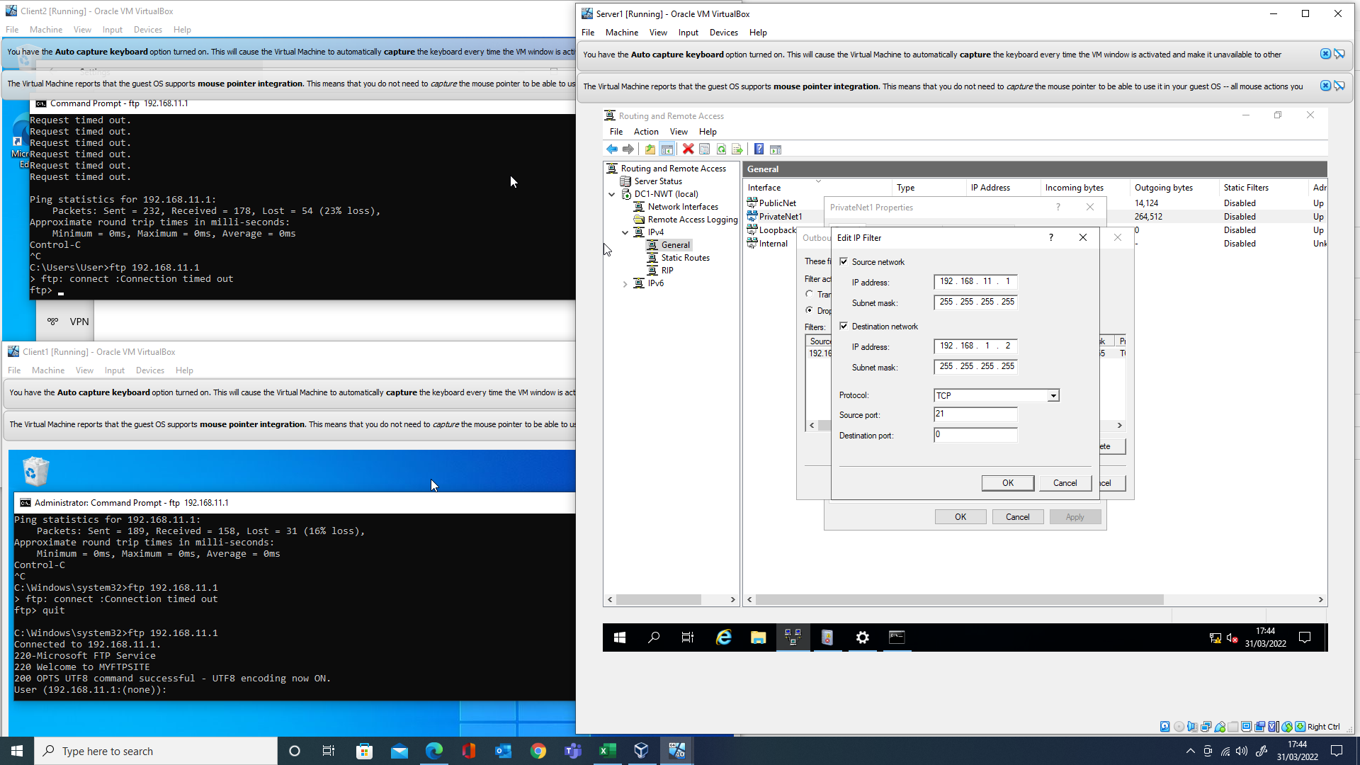
Figure 22

3. Password principles

Sound password principles in a modern network environment can be covered by the National Cyber Security Centres guidelines[13]. At a high level they can be stated as
- Only use passwords where necessary, replacing where possible with alternatives such as single sign on
- Leverage technology to improve security such as location conditions[14] or password blacklists
- Ensure the principles of Confidentiality, Integrity and Availability (CIA)[15] are applied to password management
- Support all staff in the organisation with better password training, including but not limited to best practice around use of password management, generation, and use (anti fishing campaigns)
- Ensure password policy is aligned to the previous points, by supporting staff with password fatigue
Further detail can be seen in figure 23
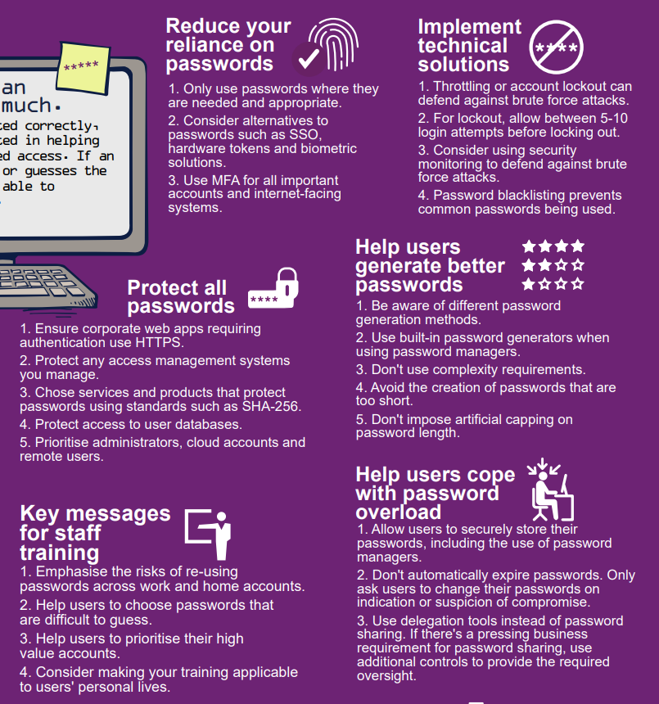
Figure 23

4. Failover clustering

A failover cluster, is two or more independent computers (nodes), working together to ensure their shared resources has increased scalability and up time, especially important in 24/7 or global operations. This shared resource could be virtual machines, user files or databases amongst other technology such as DNS[16].

File cluster

At a high level, a failover file clusters requires the following –
- The same version of Windows Server
- The same compatible hardware
- The same active directory domain
- Administrative accounts for the domain, to create cluster account and administer the nodes
- Network infrastructure to support shared storage
- Share storage (to host the shared resource, as well as files to enable the clusters operation)
- Shared private network (for communication between the nodes, heartbeat[17])
- Unique private IP for each node
- Shared IP address, DNS A Host record for the cluster (clients access this address, with the cluster managing distribution to the unique private IP’s)[18]
Figure 24 below shows the above logically
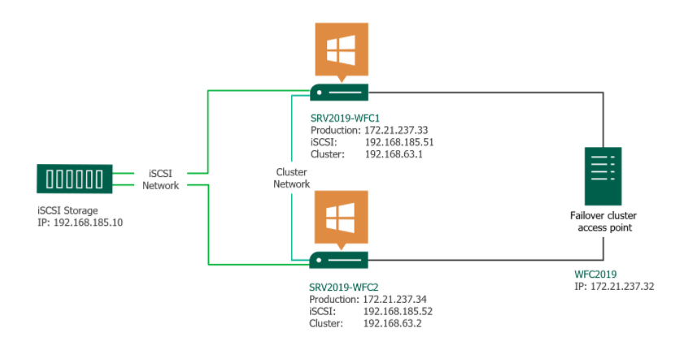
Figure 24 [19]
Clients wishing to access files on the “iSCSI Storage” would browse to the cluster name “WFC2019”. Depending on how the cluster is configured, traffic would route to either “SRV2019-WFC1” or “SRV2019-WFC2”. If for example during routine maintenance, one server was rebooted to install security patches, the clients would seamlessly gain access to the resource through the other node.

Quorum

Consider figure 24, and the scenario where the connection labelled “Cluster Network” becomes cut, ceasing communication between the two nodes. Which one would serve file access requests to the business? This is called “split brain”, and planning is required to avoid it, as if both attempt to control the clusters resources it can cause data loss via corruption[20].
To avoid this, the concept of quorum is created, where in the above scenario nodes will be forced offline, to ensure one owner or no owners. Each node has one vote towards quorum, with the number of votes deciding the outcome based on the quorum configuration selected. An environment can be setup with witness disks or file shares (including cloud[21]) when there are even number of nodes[22] to ensure there is always consensus in the vote.
In the case of figure 24, if one node was to go offline, the chance of the cluster continuing to work is 50%. It would benefit from the addition of a witness as shown in figure 25.

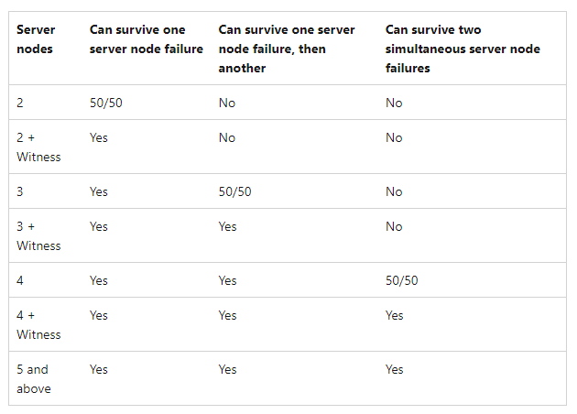
Figure 25[23]

Availability

A business will have to decide for each service, likely through a risk assessment process[24], how much availability they will require, with higher availability linked to increases in costs, figure 26.
Following on from the example above, the witness disk would require hosting somewhere, which would come at the cost of its hardware, additional to the configuration time/cost. Therefore, the decision might be made that the risk to the “Cluster Network” is low enough to accept. A calculation could be carried out to express this in terms of a percentage for the year, or the amount of 9’s in the uptime, for example 99.999% or “five nines”.[25].
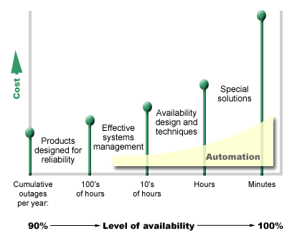
Figure 26[26]

High vs Continuous

High availability is the process of building systems to avoid unplanned outages (removing single points of failure) or minimising the disruption of those which are planned (software/operating system updates).
Continuous availability takes this further, by ensuring for both unplanned and planned outages that they are invisible to the user of the service, not just minimised. This also involves considering a system at the time of upgrade, so in an example of one with a database how would the data in a database remain accessible and amendable, as usual, if the database system was upgraded, or the hardware it lives on was to be replaced.[27]

5. Network security policy

The purpose of a Network Security Policy (NSP), is to lay down the rules of use of a network, be that by customer, employees or third parties, to adhere to thus ensuring CIA. In combination with other policies, it will cover the entire life cycle of assets, figure 27, to this end.

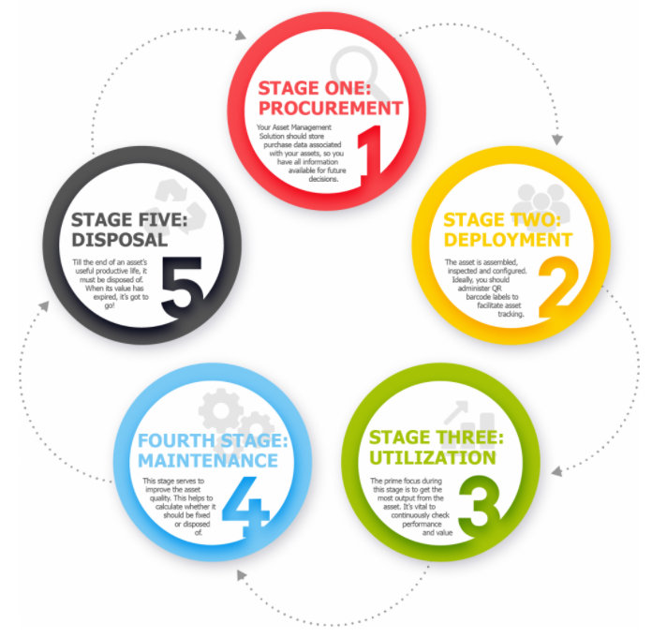
Figure 27
Researching publicly available NSP’s[28][29][30], shows that there is a discrepancy in what is specifically included, although at large they are similar. Figure 28 showing a more robust example appendix from NHS Leeds West Clinical Commissioning Group’s NSP. Example differences would be the admission of the physical environment that houses network equipment appearing in some policies and not others, or the mention of training by the business.
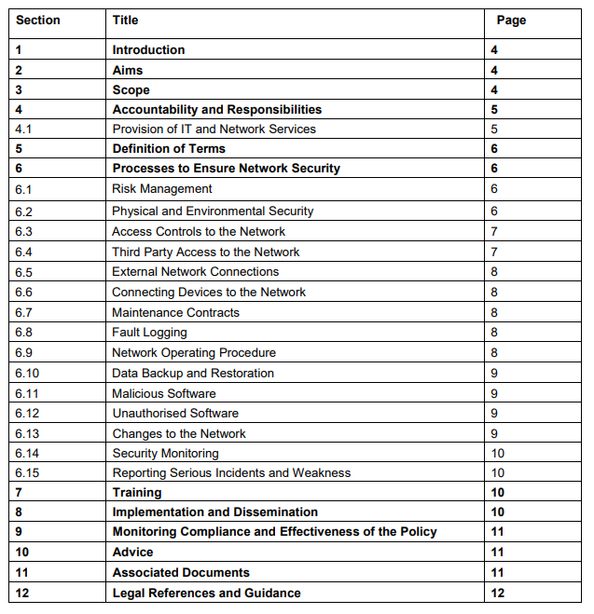
Figure 28[28]

Template

The advice of the author would be to create a template based on what was publicly available, please refer to supporting material titled “Subject: Network Policy Draft”[29] working to adjust further based on the maturity of your business.
For example, high availability practices maybe mandatory, linked into procurement policies, security practices to reach certain certification levels spelt out[31], consideration of segregated, distributed sites over a business’s Wide Area Network[32] or public networks requiring VPN (including work from home), to Cloud vendors being in scope[33].

6. Conclusion and Evaluation

The multi layered configuration of Windows / Domain security, adds complexity to what may be viewed as simple outcomes, with competing configuration at the permissions level, which could be in direct conflict with other measures such as firewall security, server security (in the example of FTP security) or group policies which could be applying unknown artifacts. It is important to plan and document (to be made readily available) all configurations for the best outcome. This starts with sound policies and procedures, ratified by business owners, who champion them. When introducing more complex configurations, like failover clustering, or Cloud environments, this is never truer.

6.1 Future work

If time can be afforded, continue working on building a cluster within Oracle Virtual box. The Failover Cluster feature was not available in my installation, something I would need to tackle further to progress.
Apply Group Policy Preference setting in the lab environment, to better understand the technology, and how it differs to GPO, for example by not being enforced[34].

References

[1] “NTFS overview | Microsoft Docs.” https://docs.microsoft.com/en-us/windows-server/storage/file-server/ntfs-overview (accessed Mar. 28, 2022).
[2] “File and Folder Permissions | Microsoft Docs.” https://docs.microsoft.com/en-us/previous-versions/windows/it-pro/windows-server-2008-R2-and-2008/cc732880(v=ws.10) (accessed Mar. 29, 2022).
[3] “Take Ownership of a File or Folder | Microsoft Docs.” https://docs.microsoft.com/en-us/previous-versions/windows/it-pro/windows-server-2008-r2-and-2008/cc753659(v=ws.11) (accessed Mar. 29, 2022).
[4] “Understanding File and Folder Permissions in Windows | Dell UK.” https://www.dell.com/support/kbdoc/en-uk/000137238/understanding-file-and-folder-permissions-in-windows (accessed Mar. 28, 2022).
[5] “Group Policy | Microsoft Docs.” https://docs.microsoft.com/en-us/previous-versions/windows/it-pro/windows-server-2008-R2-and-2008/cc726027(v=ws.10)?redirectedfrom=MSDN (accessed Mar. 29, 2022).
[6] “Windows registry for advanced users - Windows Server | Microsoft Docs.” https://docs.microsoft.com/en-us/troubleshoot/windows-server/performance/windows-registry-advanced-users (accessed Mar. 29, 2022).
[7] “What is Address Resolution Protocol (ARP)? Definition from SearchNetworking.” https://www.techtarget.com/searchnetworking/definition/Address-Resolution-Protocol-ARP (accessed Mar. 30, 2022).
[8] “How Does a Router Work? - Cisco.” https://www.cisco.com/c/en_uk/solutions/small-business/resource-center/networking/how-does-a-router-work.html#~how-routers-route-data (accessed Mar. 30, 2022).
[9] “Understanding routing tables | TechRepublic.” https://www.techrepublic.com/article/understanding-routing-tables/ (accessed Mar. 30, 2022).
[10] “Routing Protocol - Win32 apps | Microsoft Docs.” https://docs.microsoft.com/en-us/windows/win32/rras/routing-protocol (accessed Mar. 30, 2022).
[11] “Configure the Windows firewall to allow pings.” https://kb.iu.edu/d/aopy (accessed Mar. 30, 2022).
[12] “Add a packet filter | Microsoft Docs.” https://docs.microsoft.com/en-us/previous-versions/windows/it-pro/windows-server-2003/cc738952(v=ws.10) (accessed Mar. 30, 2022).
[13] “Password policy: updating your approach - NCSC.GOV.UK.” https://www.ncsc.gov.uk/collection/passwords/updating-your-approach (accessed Apr. 01, 2022).
[14] “Location condition in Azure Active Directory Conditional Access | Microsoft Docs.” https://docs.microsoft.com/en-us/azure/active-directory/conditional-access/location-condition (accessed Apr. 01, 2022).
[15] “What is the CIA Triad? Definition, Explanation and Examples.” https://whatis.techtarget.com/definition/Confidentiality-integrity-and-availability-CIA (accessed Apr. 01, 2022).
[16] “Failover Clustering | Microsoft Docs.” https://docs.microsoft.com/en-us/windows-server/failover-clustering/failover-clustering-overview (accessed Apr. 04, 2022).
[17] “Failover Clustering Networking Basics and Fundamentals.” https://techcommunity.microsoft.com/t5/itops-talk-blog/failover-clustering-networking-basics-and-fundamentals/ba-p/1472460 (accessed Apr. 01, 2022).
[18] “Failover Clustering | Microsoft Docs.” https://docs.microsoft.com/en-us/windows-server/failover-clustering/failover-clustering-overview (accessed Apr. 01, 2022).
[19] “How to create a Failover Cluster in Windows Server 2019.” https://www.veeam.com/blog/windows-server-2019-failover-cluster.html (accessed Apr. 01, 2022).
[20] “Understand cluster and pool quorum on Azure Stack HCI and Windows Server clusters - Azure Stack HCI | Microsoft Docs.” https://docs.microsoft.com/en-us/azure-stack/hci/concepts/quorum (accessed Apr. 04, 2022).
[21] “Deploy a cloud witness for a Failover Cluster | Microsoft Docs.” https://docs.microsoft.com/en-us/windows-server/failover-clustering/deploy-cloud-witness (accessed Apr. 01, 2022).
[22] “Understanding Quorum Configurations in a Failover Cluster | Microsoft Docs.” https://docs.microsoft.com/en-us/previous-versions/windows/it-pro/windows-server-2008-R2-and-2008/cc731739(v=ws.11)?redirectedfrom=MSDN (accessed Apr. 01, 2022).
[23] “Understand cluster and pool quorum on Azure Stack HCI and Windows Server clusters - Azure Stack HCI | Microsoft Docs.” https://docs.microsoft.com/en-us/azure-stack/hci/concepts/quorum (accessed Apr. 01, 2022).
[24] “NIST Risk Management Framework | CSRC.” https://csrc.nist.gov/projects/risk-management/about-rmf (accessed Apr. 25, 2022).
[25] “Five Nines Availability - 99.999% Uptime | SUSE Defines.” https://www.suse.com/suse-defines/definition/five-nines-availability-99-999-uptime/ (accessed Apr. 11, 2022).
[26] “Deciding what level of availability you need - IBM Documentation.” https://www.ibm.com/docs/en/i/7.1?topic=roadmap-deciding-what-level-availability-you-need (accessed Apr. 11, 2022).
[27] “Achieving ‘five nines’ in the cloud for justice and public safety | AWS Public Sector Blog.” https://aws.amazon.com/blogs/publicsector/achieving-five-nines-cloud-justice-public-safety/ (accessed Apr. 11, 2022).
[28] “Network Security Policy,” 2014.
[29] “Network Policy v.1.” https://villanova.policytech.com/dotNet/documents/?docid=1279&public=true (accessed Apr. 01, 2022).
[30] “Network Security Policy - Template - Digital Social Care.” https://www.digitalsocialcare.co.uk/resource/network-security-policy-template/ (accessed Apr. 01, 2022).
[31] “About Cyber Essentials - NCSC.GOV.UK.” https://www.ncsc.gov.uk/cyberessentials/overview (accessed Apr. 01, 2022).
[32] “A guide to Wide Area Networks (WAN) - BT Business.” https://business.bt.com/help/guides/wide-area-network/ (accessed Apr. 01, 2022).
[33] “VPN Gateway – virtual networks | Microsoft Azure.” https://azure.microsoft.com/en-gb/services/vpn-gateway/#overview (accessed Apr. 01, 2022).
[34] “Group Policy Preferences | Microsoft Docs.” https://docs.microsoft.com/en-us/previous-versions/windows/it-pro/windows-server-2012-r2-and-2012/dn581922(v=ws.11) (accessed Apr. 25, 2022).

Supporting material

“
Subject: Network Policy Draft
1. Purpose
This policy is intended to protect the integrity of the network, by mitigating risks and losses associated with security threats, thus ensuring a secure, reliable, performant service. It sets out to achieve this by preventing unauthorized access to business or personal data. In addition, The Business has a legal responsibility to secure its computers and networks from misuse.

2. Policy Statement

2.1 Addressing and Domain Services
2.1.1. Individuals/departments may not create nor support an Internet domain, hosted from The Business’s network without prior approval of the IT service.
2.1.2. The IT service will provision and manage The Business’s IP address space and all other related RFC 1918 private addresses in use.
2.1.3. The IT service is solely responsible for managing all domain names related to The Business.

2.2 Network Connections
2.2.1. The Business, staff or customers may not connect, nor contract with an outside vendor to connect, any device or system to The Business networks without the prior review and approval of The IT service. Departments that wish to provide Internet or other network access to individuals or networks not directly affiliated with The Business must get prior approval from The IT service.
2.2.2. Users are permitted to attach devices to the network if they are for use with normal business or customer operations, do not interfere with other devices on the network and follow all other business policies.
2.2.3. Unauthorized access to business networking equipment (firewalls, routers, switches, etc.) is not permitted. This includes any port scanning or attempts to ssh, snmp or otherwise gain access to business equipment.
2.2.4. Unauthorized access to business data closets is strictly prohibited.
2.2.5. The IT service will provide a general method for network authentication to business systems.

2.3 Wireless
2.3.1. The Business is the owner of all the unlicensed radio frequencies on campus, which includes the 2.4 GHz and 5 GHz spectrum. The IT service is responsible for managing these radio frequencies for the benefit of The Business community.
2.3.2. The IT service is solely responsible for providing wireless networking services on campus. No other department may deploy wireless routers, bridges, and/or DHCP (Dynamic Host Configuration Protocol) services on campus.
2.3.3. The IT Service is responsible for maintaining a secure network and will deploy adequate security procedures to support wireless networking on campus.
2.3.4. The Business will maintain a campus wireless network based only on IEEE 802.11 standards. The IT Service will collaborate with departments where devices used for specific applications may require specific solutions.
2.3.5. IEEE 802.1x is the currently supported authentication standard. Additional security protocols may be applied as needed.

2.4 External Traffic, Services and Requests
2.4.1. The IT Service will take action to prevent spoofing of internal network addresses from the Internet. The IT Service will also take action to protect external Internet sites from source address forgery from the business network.
2.4.2. The business's external Internet firewall policy is to deny all external Internet traffic to the business's network unless explicitly permitted. To facilitate this, departments and other administrative departments must register with The IT Service systems that require access from the Internet. Users that would like to request access through the business firewall must open a help desk ticket and fill out a firewall access request form.
2.4.3. Access and service restrictions may be enforced by IP address, port number or application behaviour. Proxy services may be used in conjunction with the firewall to restrict usage to authenticated individuals.
2.4.4. The IT Service reserves the right to decrypt all SSL traffic which transits the network.

2.5 Network Security
2.5.1. The IT Service will investigate any unauthorized access of business computer systems. The IT Service will work with administrative departments and law enforcement when appropriate.
2.5.2. Systems on the network must have adequate security installed and maintained. All systems connecting to the business network must be configured and maintained in such a manner as to prohibit unauthorized access or misuse.
2.5.3. If security problems are observed, it is the responsibility of all business network users to report problems to the appropriate system administrators or The IT Service for investigation.
2.5.4. Network usage judged appropriate by the business is permitted. Some activities deemed inappropriate include, but are not limited to:
- Attaching unauthorized network devices, including wireless router, gateway or DHCP server; or
- A computer set up to act like such a device.
- Engaging in network packet sniffing or snooping.
- Operating network servers of any sort in violation of The IT Service guidelines (illegal file-sharing server).
- Setting up a system to appear like another authorized system on the network (Trojan).
- Other unauthorized use prohibited by the business acceptable use or other The IT Service policies.

2.6 Enforcement
2.6.1. Any device found to be in violation of this policy or found to be causing problems that may impair or disable the network in any way is subject to immediate disconnection from the business's network. The IT Service may subsequently require specific security improvements where potential security problems are identified before the device is reconnected.
2.6.2. Attempting to circumvent security or administrative access controls for information resources is a violation of this policy. Assisting someone else or requesting someone else to circumvent security or administrative access controls is a violation of this policy.
2.6.3. The business considers any violation of acceptable use principles or guidelines to be a serious offense, and reserves the right to test and monitor security, and reserves the right to copy and examine any files or information resident on university computer systems allegedly related to unacceptable use.
2.6.4. Anyone found in violation of this policy will be subject to the disciplinary actions stipulated in the applicable Employee Acceptable Use Policy.

2.7 Monitoring and Auditing
2.7.1. The IT Service will maintain traffic logs for all network devices and servers for security auditing purposes.
2.7.2. The IT Service reserves the right to monitor, access, retrieve, read and/or disclose data communications when there is reasonable cause to suspect a business policy violation, criminal activity, monitoring required by law enforcement or at management request. Reasonable cause may be provided by a complaint of a policy violation or crime or as incidentally noticed while carrying out the normal duties of The IT Service staff.
2.7.3. The IT Service may perform a non-intrusive security audit of any computer system attached to the business's network at any time, to determine what risks that system may pose to overall information security. Any audit consisting of a penetration test would be performed with advance notice to the system administrator or his/her superior.

3. Scope
This policy applies to all business staff, contractors, guest account holders, and any other agents who may connect to the business network computing resources. This policy also applies to all devices which are used by those individuals for network access, whether personally owned, business issued or otherwise obtained. These devices include but are not limited to workstations, laptops, tablets, smartphones, servers, consoles, controllers, and any other computing device which can communicate on the business IP-based network.

4. Procedures
The IT Service staff can provide recommendations and support for this policy through specific considerations and technologies.[29]
“

“



