Student name: sadaf hassan
Student id: 2247725
Module name: introduction to Physiology
Case study report

Table of Contents
Page 1: .......................Student details and table overview
Page 2: ....................... Introduction to Physiology; Key risk factors including Physical Inactivity and Unhealthy Diet
Page 3: ..............................Family history, Age, Ethnicity, and Gestational Diabetes
Page 4: ................. Polycystic Ovary Syndrome (PCOS), Smoking, and Regulation of Blood Sugar Levels
Page 5: ................. Role of the Pancreas; Functions of the Liver and Muscles; Other Hormones involved in Glucose Regulation
Page 6: ................ Negative Feedback and Homeostasis; Disruptions in Diabetes
Page 7: ................ How Oxygen and Glucose Are Used to Produce Energy via Cell Metabolism; Step 1: Glycolysis (in the Cytoplasm); Step 2: Link Reaction and Krebs Cycle (in the Mitochondria)
Page 8: ..................... Step 3: Electron Transport Chain (ETC) and Oxidative Phosphorylation; Total Energy Yield; Importance of Health and Diabetes
Page 9: ..................................Recording and Tracking Blood Sugar in Type 2 Diabetes (for individuals with Type 2 diabetes)
Page 10: ........................ Weight Management; Smoking Cessation; Reducing Alcohol Intake; Stress Management and Sleep

Diabetic type 2
Diabetes Mellitus is a chronic metabolic condition that results in high blood sugar (hyperglycaemia) due to defective insulin production and action, which can occur at any age. The pancreas is a major endocrine organ involved in insulin synthesis, but many other organs (e.g. the endothelium of blood vessels) play critical roles in glucose homeostasis. Left unchecked, this imbalance can become long-term health issues like heart disease, kidney failure, nerve damage and impaired vision (NHS, 2022). Multiple risks are involved in the genesis and progression of diabetes.
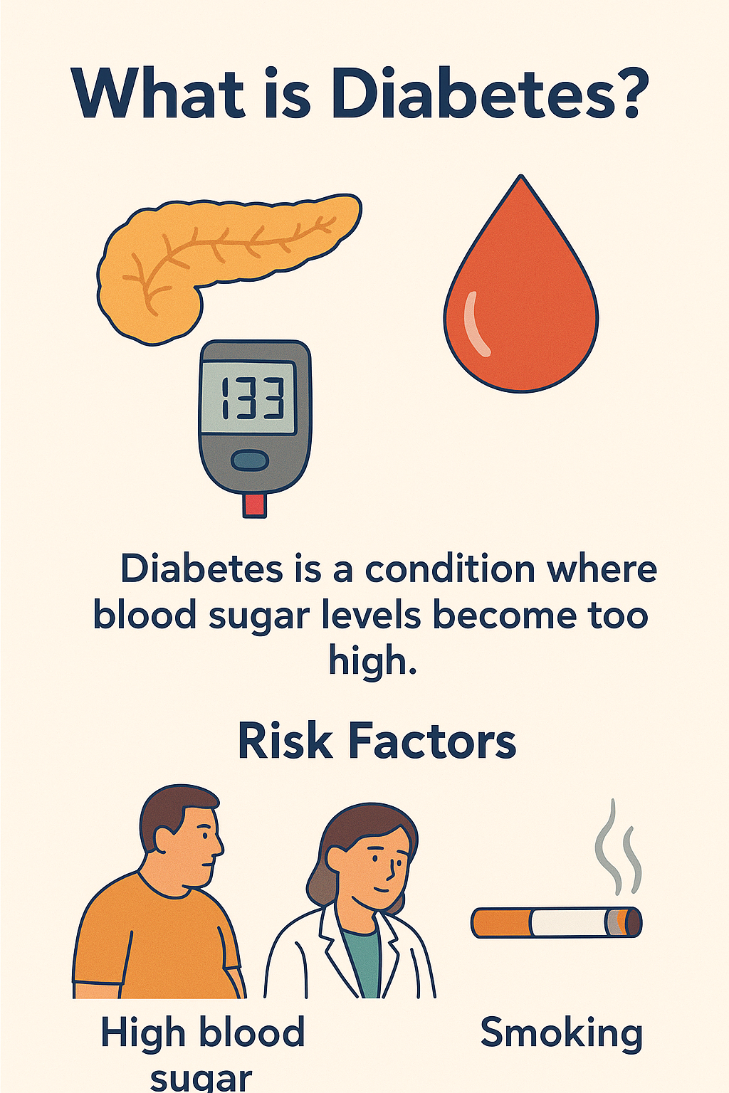
(Patient.info, 2025) (citation)(health education poster,N.D)
Key Risk Factors
- Obesity: Excess fat—especially in the abdominal area—is one of the most significant risks for type 2 diabetes.
- Physical Inactivity- Adequate physical exercise enhances insulin sensitivity, but prolonged lack of such activity has been reported to lead to insulin resistance.

Unhealthy Diet
- Family History: You are more likely to get diabetes if your father, mother, or brother has it.
- Age: The older you get, the more likely you are to have diabetes, particularly when you are over 40.
- Origin: Generally, diabetes is more common in those of South Asian, African-Caribbean and other black minority ethnic groups compared to non-white populations. Such a higher prevalence may be related to dietary habits, such as excessive ingestion of sweet foods.
- High Blood Pressure (Hypertension): When you have high blood pressure, your heart must work harder. That increases your risk of diabetes a great deal.
- High Blood Fat Levels: Especially low “good” HDL cholesterol, which is critical for reducing the risk of diabetes.
- Gestational Diabetes: If you develop diabetes during pregnancy, you have an increased risk for developing Type 2 in the future, Dr Peters (year) said - There may be a possible association between neurotic disorders and chromosomal aberrations with PCOS, which are two factors that can increase the risk of having IR and diabetes, too.
- Smoking: Insulin resistance goes higher, and the risk of developing cardiovascular disease becomes greater.
(citation) (World Health Organization, 2023)

Purpose of the Report
This report explains Type 2 diabetes by exploring its development, risk factors and health impact. It focuses on the biological etiologic of the disorder and discusses both lifestyle and genetic contributors. The report focuses on the significance of blood glucose control, and reviews evidence-based methods such as diet, exercise, weight management and medication. Although there are few formal studies of self-care in Type 2 diabetes, management has profound effects on health and social function.

Regulation of Blood Glucose Concentrations
Glucose is the body's main source of energy for cells, tissues, and organs. Blood glucose is kept under control in as close to optimal a state as possible, and in non-diabetics that means that their post-meal blood sugar should peak at about 8.5 to 9 mmol/l (153-162 mg/dl) within two hours of eating in order that organs are not damaged. Numbers, other than to be inside a healthy continuum, are less important, but the body uses homeostasis including the liver and pancreas and hormones to keep blood sugars stable until demands for energy increase.

The pancreas's function
It’s the alpha and beta cells in the small hormone-producing areas of the pancreas, known as islets of Langerhans, which keep blood sugar levels within a narrow range: — Beta cells: these produce insulin to lower blood sugar. We eat a meal, our blood sugar level goes up, and the pancreas produces insulin that it dumps into our blood to keep the sugar from rising too high. Glucose can now enter fat and muscle cells for fuel without contributing to a surge in the blood sugar level following a meal. Excess glucose is stored in the liver or muscles (as glycogen) long before after meal blood sugars reach abnormally high levels. (citation) (Hall & Hall, 2020; Marieb & Hoehn, 2019).

Alpha cells produce glucagon
If people are dying of starvation and there’s no more sugar in their blood glucagon sends a signal to the liver to break down glycogen (stored carbohydrate) and release glucose into the bloodstream (glycogenolysis), or to make new glucose from non-carbohydrate substrates such as amino acids (gluconeogenesis) if blood glucose is abnormally low after fasting.
Glucagon is normally released only during the night whenever blood glucose falls below a critical level, and if necessary to restore glucose balance. That is what you would call insulin and glucagon. Their collaboration is part of the symphony that maintains steady levels of blood sugar in our bodies (citation) (Atkinson, Eisenbarth & Michels, 2021; Hall & Hall, 2020).

The liver is a glucose storehouse
Once you eat food, insulin tells it to store the sugar as glycogen. Glucagon, however, provokes the liver to release glucose back into the blood when it’s hungry. And your muscles have their own muscle-specific cache of glycogen, to be burned as fuel during periods of activity—it maximizes glucose availability to those greedy organs like the brain and just generally guarantees that energy balance is tended to.
In addition to insulin and glucagon, other hormones have significant effects on glucose regulation under conditions of stress or prolonged fasting: (Hall & Hall, 2020; Nelson & Cox, 2017).
• Adrenaline (Epinephrine): The adrenal glands step up its production in a crisis; it very rapidly increases sugar levels in the blood by promoting breakdown of glycogen and suppressing insulin release.
It's all very simple:
• Cortisol: Under stress or when diseased, it stimulates gluconeogenesis to keep vital organs supplied with fuel.
• Growth hormone: It reduces muscle cells’ reliance on sugar and leaves more glucose for the brain.
• Incretins: This gut hormones secreted after a meal stimulate insulin production and especially slow digestion, causing sugars to rise more gradually.
Feedback loops are extremely efficient at controlling your blood sugar. So, after you eat: Blood sugar goes up - Pancreas feels it - Insulin is made – Glucose gets dragged into cell/cached/storage/hiding - Back to normal.
- When you’re fasting or physically active: Your blood sugar drops — your pancreas detects this and releases glucagon. The liver responds by releasing glucose to stabilize the blood sugar. This steady control delivers a sustained stream of energy and prevents overdrive at either end. The disruption: In Type 1 diabetes, the immune system attacks beta cells; in Type 2 diabetes, people become insulin-resistant and fail to produce enough insulin. This causes not enough or no insulin to be produced and too much sugar remaining in the blood. Atkinson, Eisenbarth & Michels, 2021; Diabetes UK, 2024). This doesn’t have adequate spillover control, but a program with lifestyle modification can keep blood sugar in balance to someday prevent complications.(Public Health England, 2020; Colberg et al., 2016).

- Cellular Metabolism: The Oxidative Production of Energy Oxygen and Glucose The human body, while a wonder of biological engineering, never rests in burning biological fuel to keep its engine humming. Muscle contracts, nerves tell muscles what to do and, in this effort, there is a cohesiveness of tissues over many weeks. This whole energy-generating process is what your body’s cells do in cellular respiration. It takes in oxygen from the air as it breathes and consumes sugars such as glucose as a source of food with which to make adenosine triphosphate (ATP), the basic unit of energy for all living things. (Nelson & Cox, 2017; Sherwood, 2016; Hall & Hall, 2020).
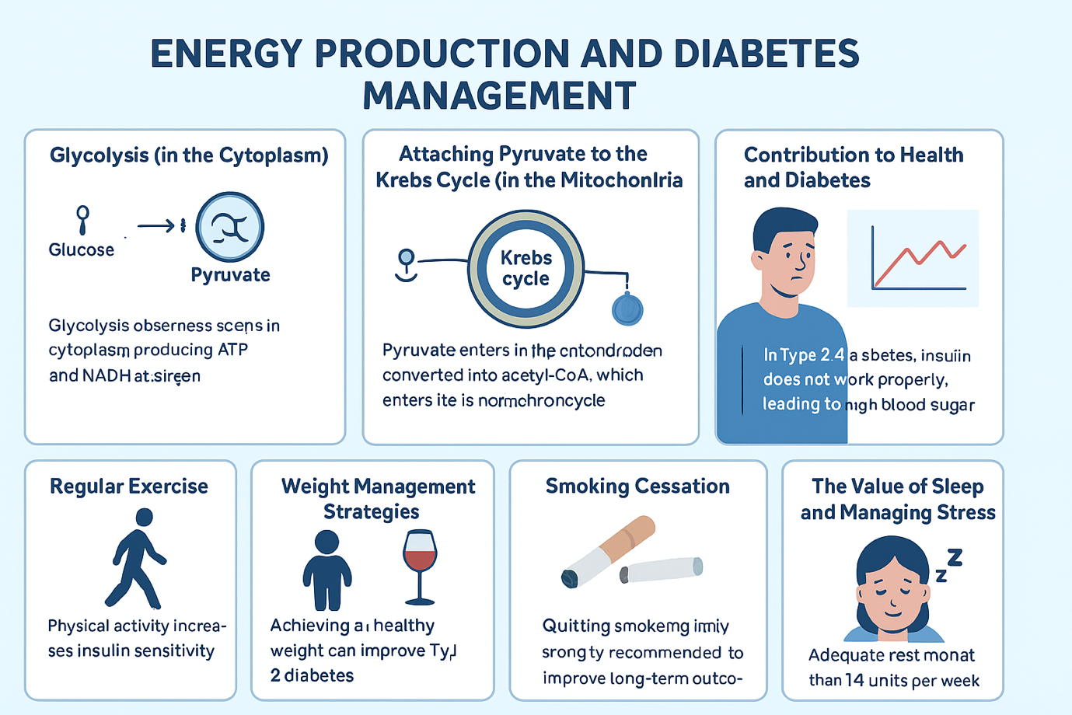
(NHS England, 2023)

1st step: Glycolysis (in Cytoplasm)
Once inside cells, six-carbon sugars like glucose get transformed in a process called glycolysis. In this way they are broken down to two pyruvate molecules, generating a small amount of ATP and ferrying NADH containing high-energy electrons into the cell transmitting oxygen cellular-y. If glycolysis is carried out anaerobically, however, some substrates primed for more catabolic reactions down the line are left over. (Sherwood, 2016; Nelson & Cox, 2017).

Step 2: Attaching Pyruvate to the Krebs Cycle (in the Mitochondria)
In the presence of oxygen, pyruvate goes into the mitochondria (the cell's power plant) for maximum energy conversion. In this little organelle, there is a conversion of pyruvate to acetyl CoA, which is necessary to begin the Krebs cycle (citric acid cycle.) This elaborate process not only produces ATP but also releases carbon dioxide, which we expel. Crucially, the energy produced by The Krebs cycle is in the form of many NADH and FADH₂ molecules that are important for subsequent steps of cellular respiration.
3) Electron Transport Chain (ETC)
and Oxidative Phosphorylation After being produced, NADH and FADH2 donate their high energy electrons to the electron transport chain, which is a series of proteins located on the inner mitochondrial membrane. As electrons move through this chain, they give up energy that is captured to pump protons (H⁺ ions) across several proteins through the mitochondrial membrane against their concentration gradient, creating an electrochemical gradient like how a battery works. At the end of this chain, Oxygen (O 2) is the final electron acceptor, combining with electrons and protons to generate water. Because oxygen plays such a key role in energy production, it is critically important; without oxygen the whole process comes to a screeching halt and ATP drops off drastically.

Total Energy Yield
In the presence of oxygen, a mole of glucose can generate about 36 to 38 moles of ATP. This is in sharp contrast to anaerobic respiration, which yields only 2 ATP from each glucose molecule under low-oxygen conditions and lactic acid buildup. This comparison demonstrates both incredible human physiology and how important oxygen is for efficient energy.

Contribution of health and diabetes
The intricate relationship of glucose and oxygen in the energy metabolism reflects their importance for life. Management of diabetes, especially regarding glucose control, specialists frequently relate "Prevention of Diabesity" to tactics adopted for preventing start of the disease. Dysfunction in blood sugar regulation could create situations in which there is not enough glucose and other needed nutrients to supply cells, even when these nutrients are available in the bloodstream causing weakness and fatigue; the most severe cases, metabolic demands deteriorate to a point where proteins and fats break down for energy resulting in production of harmful ketones leading to ketoacidosis—emphasizing the importance of well-rounded nutritional interventions. (Hall & Hall, 2020; Atkinson, Eisenbarth & Michels, 2021; NHS, 2022).

Blood Sugar Monitoring and Type 2 Diabetes patients
Monitoring blood sugar is more than just a matter of obligation – it turns into an empowering self-care routine. Minute-to-minute changes which can be affected by diet, exercise, stress levels or illness require careful observation to enable patients to: Identify patterns over time Grasp effective management techniques Avoid dangerous highs ( hyperglycaemia ) or lows ( hypoglycaemia ) early and ward off emergencies Help your healthcare provider adjust treatment to get better control of complications such as kidney damage, blindness, and stroke Maintain motivation with clear progress from blood glucose data Besides, regular monitoring is the key to managing health in the long term (with annual HbA1cs that can prevent complications such as heart disease or kidney damage). (NHS, 2023; Diabetes UK, 2024; Colberg et al., 2016).
Recommended Lifestyle Changes

Regular exercise
Exercise can be useful in managing Type 2 Diabetes. The World Health Organization (2020) recommends at least 150 minutes a week of moderate exercise like brisk walking or swimming, along with resistance training to improve muscle capacity for taking in glucose. (WHO,2020),

Weight Management Strategies
The purpose of this is to help people with Type 2 diabetes attain their weight and health goals. The UK's Direct trial showed that supervised dietary programs achieved meaningful weight loss with remission seen in what the majority was likely (Lean et al., 2018). Even small weight reductions (5–10%) can improve blood sugar levels as well as other risk factors for heart disease and stroke such as blood pressure and cholesterol measures (Public Health England, 2020)., with remission observed in the majority of participants

Smoking Cessation
Benefits Smoking elevates risks such as heart disease and nerve damage — both conditions common in people with diabetes, so quitting is highly advised to enhance longer-term health prospects.”

Alcohol Consumption Guidelines
Alcohol intake should be reduced to decrease the likelihood of hypoglycaemia with insulin or other drugs and because of its caloric value. UK guidelines currently recommend that people drink no more than 14 units each over the course of several days in any given week.

The value of sleep and managing stress
Prolonged stress can be harmful to your blood sugar level, because of the hormones (cortisol/adrenaline) it influences. The combination of mindfulness practices with relaxation techniques and sufficient sleep can improve metabolic control (Hall & Hall, 2020).
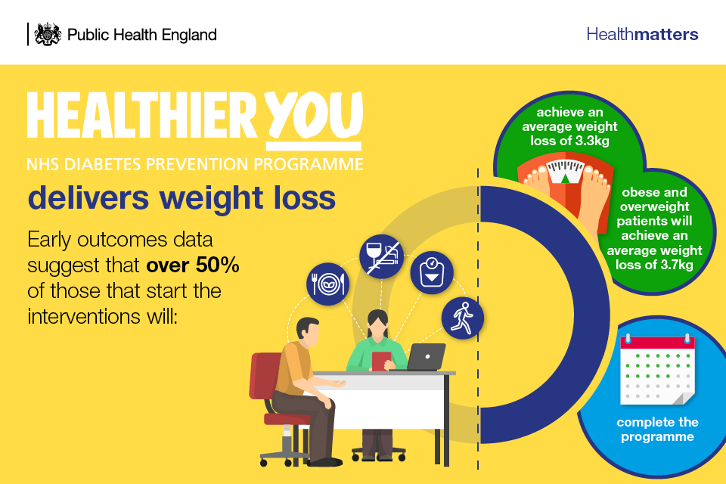
( Public Health England, 2016 )
Healthier You: NHS Diabetes Prevention Programme infographic showing results and lifestyle components in England. (Public Health england, no date)

Conclusions
Its aim has been to emphasize the role of insulin with glucose and oxygen inside common diabetes protocols. Continual and consistent tracking of blood sugar levels enables people living with Type 2 diabetes to detect patterns in their body’s natural rhythms and to help reduce extremes, thus improving the care experience with healthcare professionals—increasing access to much needed support. Indeed, and there is abundant evidence to the effect that adopting healthier lifestyle choices – such as healthy diets suited to each individual along with exercise in addition followed by weight loss interventions should this be necessary- as well as not smoking and good management of stress can effectively regulate blood sugar levels so that complications are averted. Finally I will refer a mini case-study that we discussed in respect to Mr Khan whose education, reinforced by supportive monitoring, allowed him to dramatically cut his blood sugar (HbA1c) and weight with significant improvement in quality of life – this clearly underlines that good management can deliver huge quality-of-life benefits if accurate information is available to trigger needed change. Isasis the role of insulin with glucose and oxygen in Its aim has been to emphasise the role of insulin in relation to glucose and oxygen within. Individuals, along with exercise, followed by weight loss interventions, should this be necessary, as well as not smoking and good management of stress well as not smoking and good management of stress.

References
Atkinson, M.A., Eisenbarth, G.S. & Michels, A.W. (2021) ‘Type 1 diabetes’, The Lancet, 398(10291), pp. 31–44.
Department of Health and Social Care (2021) Data saves lives: reshaping health and social care with data. London: DHSC.
Diabetes UK (2024) Diabetes facts and stats. Available at: https://www.diabetes.org.uk (Accessed: 2 October 2025).
Marieb, E.N. & Hoehn, K. (2019) Human Anatomy & Physiology. 11th ed. Harlow: Pearson.
Diabetes UK (2024) Blood sugar levels. Available at: https://www.diabetes.org.uk (Accessed: 2 October 2025).
Hall, J.E. & Hall, M.E. (2020) Guyton and Hall Textbook of Medical Physiology. 14th ed. Philadelphia: Elsevier.
Nelson, D.L. & Cox, M.M. (2017) Lehninger Principles of Biochemistry. 7th ed. New York: W.H. Freeman.
NHS (2022) Diabetes – complications. Available at: https://www.nhs.uk/conditions/diabetes/ (Accessed: 2 October 2025).
Sherwood, L. (2016) Human Physiology: From Cells to Systems. 9th ed. Boston: Cengage Learning.
Colberg, S.R. et al. (2016) ‘Physical activity/exercise and diabetes: a position statement of the American Diabetes Association’, Diabetes Care, 39(11), pp. 2065–2079.
Public Health England (2020) Health matters: preventing type 2 diabetes. London: PHE.
Figure 1 – Patient.info (2025) What is Diabetes? Infographic. Available at: https://patient.info/health/media/infographics/diabetes (Accessed: 15 October 2025).
Figure 2 – NHS England, Diabetes UK, University of Cambridge & Public Health England (2023) Diabetes and Metabolism: Understanding Glycolysis, the Krebs Cycle, and Lifestyle Management. Available at: https://www.nhs.uk/conditions/type-2-diabetes/ (Accessed: 15 October 2025).
Figure 3 – Public Health England (2018) Health-related outcomes in the NHS Diabetes Prevention Programme. Infographic. Available at: https://www.gov.uk/government/publications/health-matters-preventing-type-2-diabetes/health-matters-preventing-type-2-diabetes (Accessed: 15 October 2025).

