Cover page

Mia cutler

E-Portfolio

Contents page:

- Cover page
- Contents page
- Task one- essay summary
- Task two- infographic
- Task three- essay plan
- Library search
- Summary of sources
- Reference list

Task one
The bear necessities of stress (discussing the body’s response to stress)
Mark wetherell looked at the body’s response to short- and long-term stress, wetherell gives examples on how stress can come about in your mind and body. With his example of walking in the woods and a bear coming out of nowhere he states that a person would feel a jolt, sweating and heart rate increase. This shows that we interpret stress within the brain and and sets motion in the nervous and endocrine system.
When people recognise stressor, they expound into the brain which then send a signal to the adrenal glands, the adrenal glands sit above kidneys to respond with stress. Stress triggers two different pathways the first being sympathetic adrenal medullary system which is adrenaline which is an immediate response through the nervous system and the second pathway is slower because it includes hormones through the bloodstream. The two different pathways are perfect systems to help us deal with stress as it helps our body feel the stress and we enter a fight or flight reaction.
The studies that they made included standing in front of an audience and speaking or physical challenges such as putting their hand in ice cold water Mark wetherell (2022.)
In their sleep labs they measured people's cortisol levels hourly, and it showed that cortisol declined throughout the day (Elder et al., 2016) this experiment showed that stress is a daily challenge. Another experiment shows that parents with a child of autism have lower levels of anxiety and depression when writing goals within life (Lovell et al., 2015.)

Task two
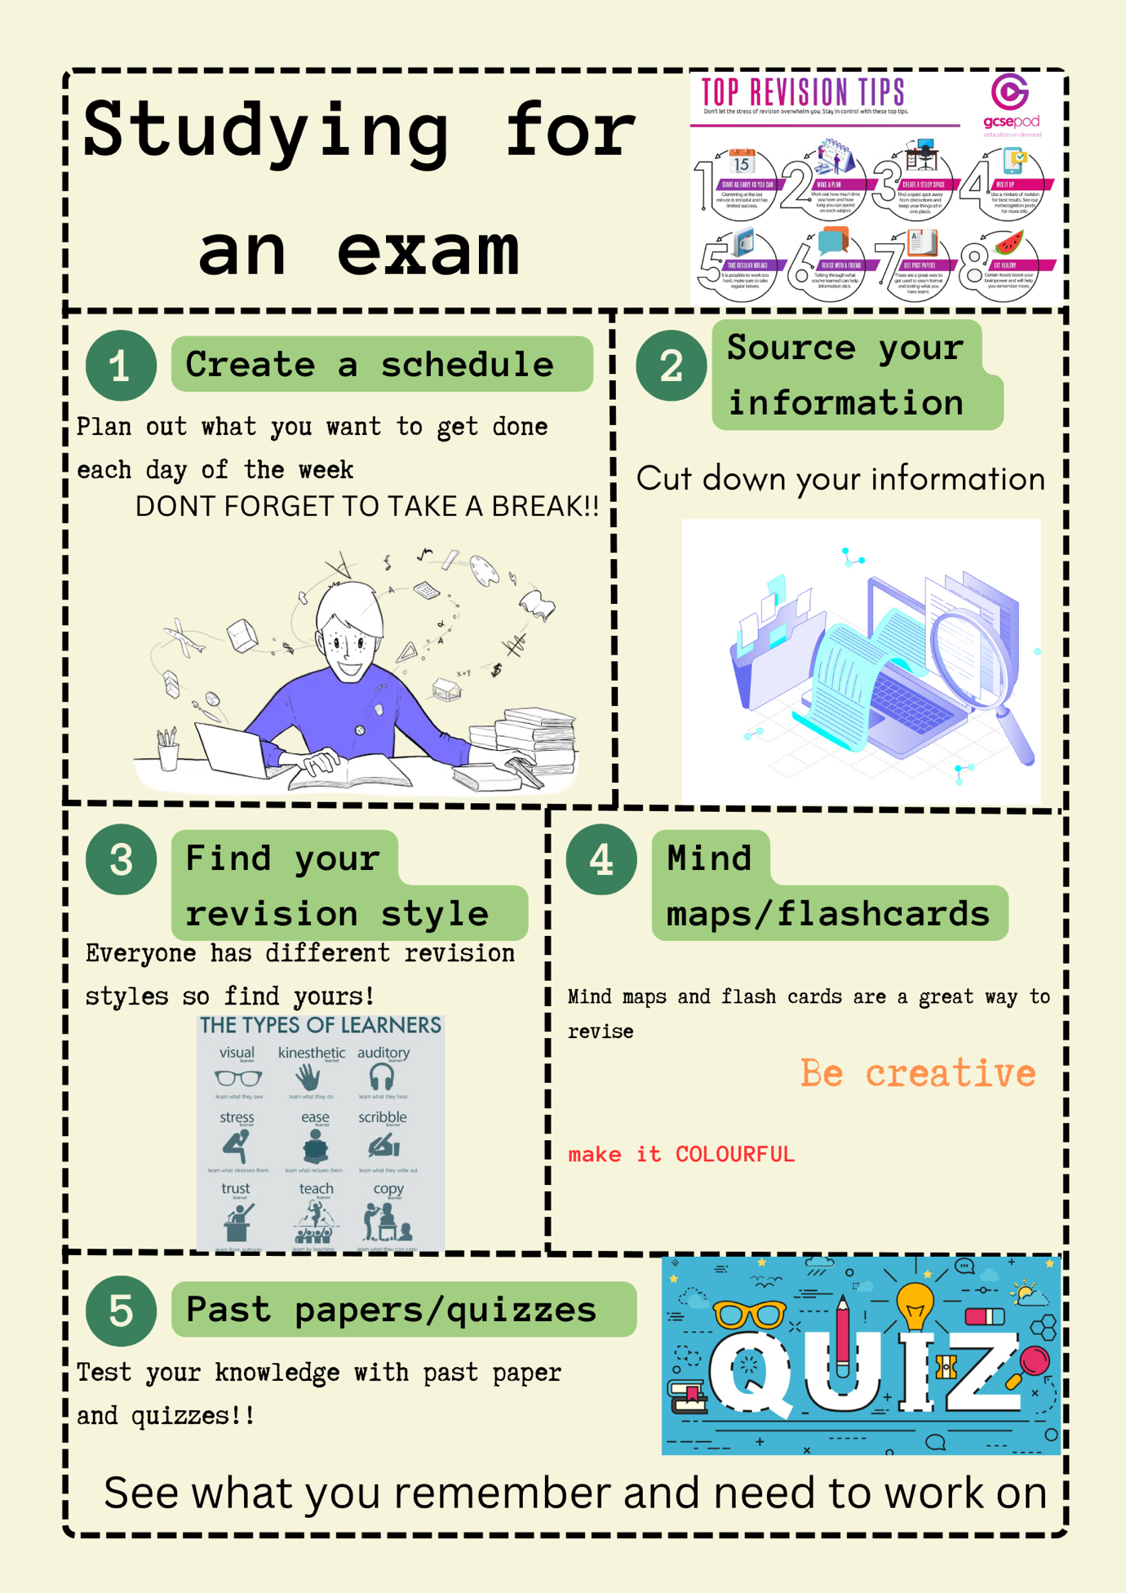
Infographic:

Task three
Essay plan:
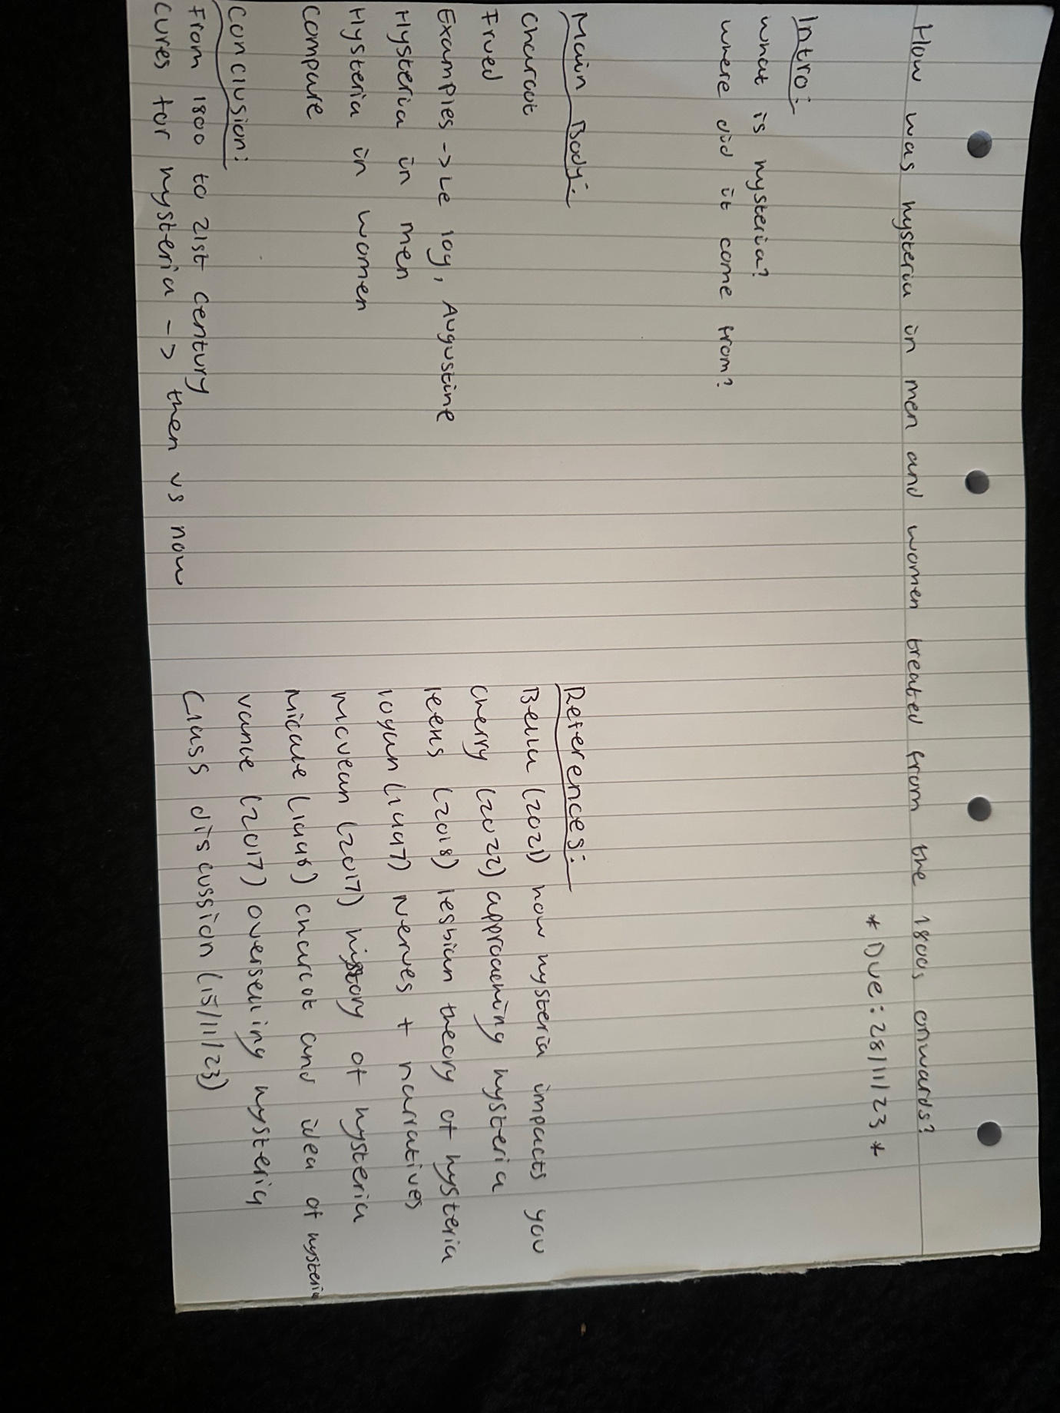

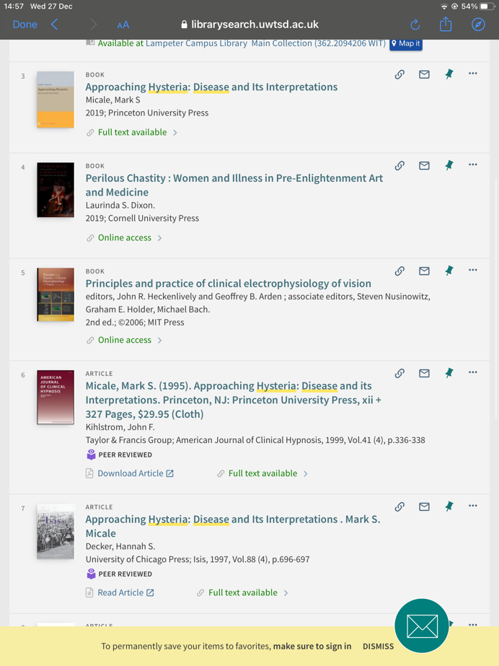
Library search:
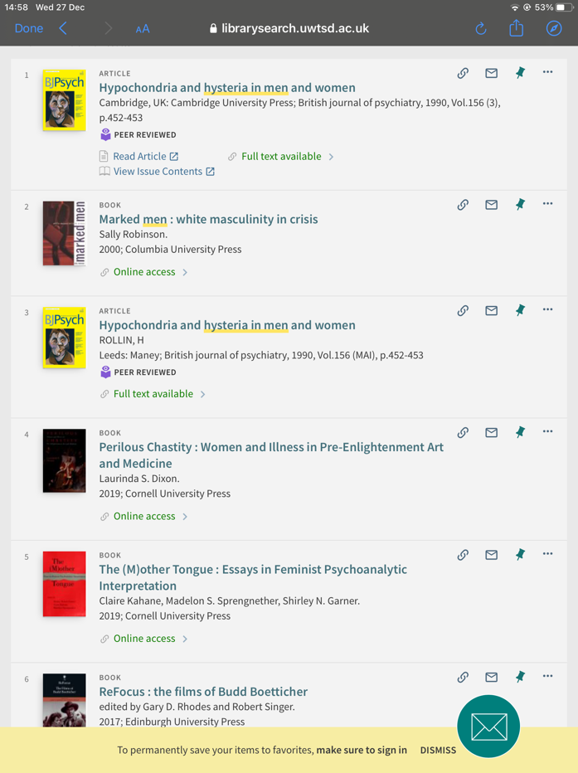

Summary of sources:

For my sources I searched up hysteria as a whole as many articles and books have information about women and men as well as treatments and causes. My second search is just on men as articles have more information about women other than men because it was not seen in men as often. I picked from the list given by looking at a brief summary, from the first screenshot I picked book 3 and 6 as it has all relevant information. From screenshot two I looked at number 1 and 2 however no book had relevant information I didn’t already have, instead of picking these I looked more into ‘causes of hysteria’ and ‘symptoms of hysteria.’ All sources are peer reviewed and relatable as they are on the library and has been reviewed by the web they are also popular and most popular.

Reference list:

Christine., (2019) the value of quizzes- part 2: building quiz funnels for lead generation
https://viralsolutions.net/value-of-quizzes-part-2-building-quiz-funnels/

Coresignal., (2022) Data Sourcing: an Integral Part of Today's Business
https://coresignal.com/blog/data-sourcing/

Finders and founders., the types of learners
https://microsites.bournemouth.ac.uk/student-blog/files/2022/04/Revision1.jpg

Gcsepod., top revision tips
https://www.gcsepod.com/wp-content/uploads/2019/09/Top-Revision-Tips.jpg

Mark wetherell., (2022) The bear necessities of stress https://www.bps.org.uk/psychologist/bear-necessities-stress

Shovel., how to study for an exam
https://shovelapp.io/how-to-get-good-grades/studying-for-exams/

