INTRODUCTION TO LEADERSHIP AND MANAGEMENT

Student Name: Umair Ahmed
Student Number: 2428436
Module Code: LCBB4015

Word Count: 1500
Contents
- Introduction 2
2. Definition and Importance of Leadership: 2
3.How Leadership style should change as organization grow: 3
4.Different Leadership styles for Organization Growth: 3
Path Goal Theory: 4
Servant Leadership Theory: 4
Situational theory: 4
Emotional Intelligence and Leadership: 4
Adaptive Leadership: 4
5.Essential Leadership skills as Organization Expands: 5
6.Conclusion and Recommendation: 5
Recommendation 5

- Introduction:
Every organisation needs leadership because it is frequently the foundation of its operations and the primary force behind change. Early on, leaders frequently have a command-and-control mentality, making choices, overseeing activities, and keeping a careful eye on results. But when businesses grow, this centralised approach can no longer be maintained. CEOs are no longer able to participate in every decision, and excessively directive leadership can hinder employee engagement, agility, and creativity. Leaders must change as organisations become more varied and complex, taking on roles that foster the professional and personal development of their staff. (Eva et al., 2019). This essay examines the necessity of coaching and supportive leadership techniques to replace authoritative models, drawing on Jamie Dimon's observations and well-known leadership theories, such as situational, transformational, and servant models. It will explain leadership and its significance, assess how styles should evolve as a company grows, pinpoint the key leadership competencies for growing businesses, and offer suggestions for modern business executives.

Definition and Importance of Leadership:
One of the most intricate and multifaceted phenomena is leadership. Leadership is the ability to persuade, inspire, and direct people or groups towards accomplishing organisational objectives (Northouse, 2021). According to Stogdill, leadership is "an influencing process aimed at goal achievement," with a particular emphasis on persuading a certain set of individuals to achieve a specified goal. Leadership plays a different role at every stage of change. These days, the most prominent issues facing businesses and organisations are those related to leadership and its function. Therefore, the "Leaders" are those who provide guidance, win people over, and then inspire them to achieve the goals. (Conger, 1992, pg 18)
In this competitive period where organisations are dealing with shifting trends, the role of leadership is extremely important (Bass, 1990). The majority of organisations today need strategic leadership that can foresee the changes that will be required and create an environment that is highly conducive to employees understanding and successfully implementing those changes (Burke & Cooper, 2004)
There are multiple reasons, why leadership is important in the workplace:
- Achieving Goals: Leadership is very important for achieving goals. A great leader has ability to motivate his team to achieve common goals.
- Providing Task support: A great leader has ability to manage the team members by assisting them in executing their actions.
- Creating Positive Work Environment: A great Leader can create a positive and productive work environment. This can only be achieved by encouraging team members, by communicating with them, can by building a trust.
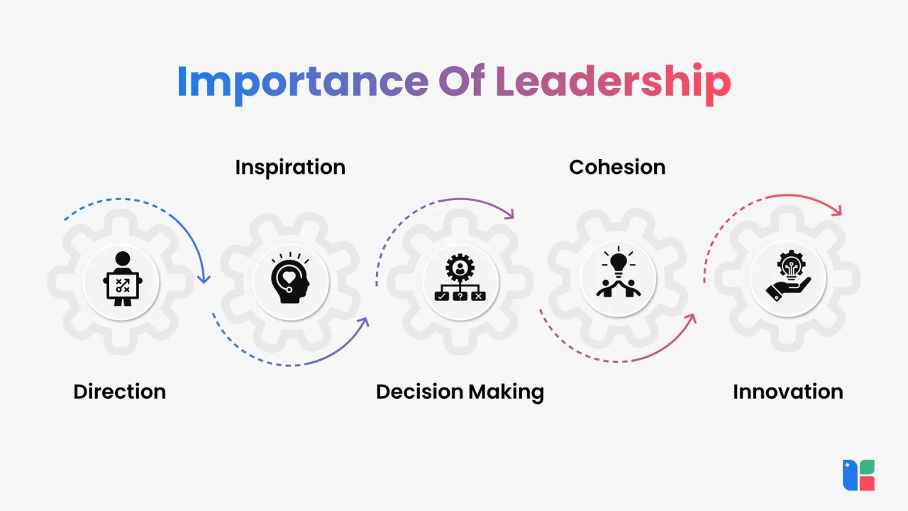

Figure 1: Importance of Leadership (Jaro Education, 2025)

- Provides Feedback: Another quality of great leader is that they provide timely feedback to their workers. It helps them to achieve their goals.
- Introducing Change: A great leader always bring a change in the work environment according to the need of time. They always inspire the workers about the need and benefits of change.
- Motivation: Leaders play an important role in motivating team members if they are finding it hard to achieve their goals.
- Creates a Strong Vision and Direction for the Future: A great leader is aware of the value of having a clear vision and knows how to develop one that will steer their company in the right direction.
- Building The Team Spirit: It is the great quality of leader to bring all the team members or workers at same platform. A great leader should build collaboration among their workers to achieve a same goal.

How Leadership style should change as organization grow:
Leadership must change from a directive, hands-on style to one that is empowering, strategic, and adaptable as businesses grow in size, breadth, and complexity. Because small organisations require quick decisions, clear communication, and careful supervision but as businesses grow, this strategy loses its effectiveness, necessitating a change to transformational, situational, and servant leadership philosophies in order variety of problems, and changing conditions.

4. Different Leadership styles for Organization Growth:
Team dynamics are influenced by different leadership philosophies. Every leadership style, including transformational and adaptive leadership, has distinctive traits that affect how teams function. Transformational leadership, for example, encourages and empowers staff members to go beyond their comfort zones. This approach creates an atmosphere that is conducive to creativity.
Transactional leaders, on the other hand, emphasise rewards and tasks that are structured. They set clear guidelines and offer rewards for reaching objectives. This approach works well in settings that require tight adherence to regulations, but it may inhibit creativity, particularly when led by transformative and adaptive leaders.
Making decisions without consulting team members is a sign of autocratic leadership. While adaptive leadership can result in speedy decision-making, transformational leaders frequently experience low morale as a result. Performance may suffer as a result of teams feeling underappreciated. Jeff Bezos, the creator of Amazon, is a prime example of an adaptive leader. Bezos's emphasis on long-term planning, his passion with customers, and his readiness to try new things and adjust to shifting market conditions were hallmarks of his leadership, which helped Amazon grow into one of the most valuable businesses in the world.

Path Goal Theory:
According to the Path-Goal Theory (House, 1971), effective leaders modify their style—which can be directive, supporting, participative, or achievement-oriented—to fit the demands of their team and the circumstances.

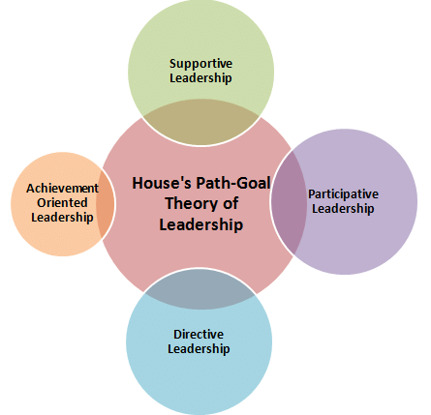
Figure 2: Path-Goal Theory of Leadership (Manu Melwin, 2019)
This adaptability becomes essential in crisis situations such as the COVID-19 epidemic and the 2008 Great Financial Crisis. For example, during COVID-19, Dimon shaped the employee experience through supportive leadership. The power of flexibility and the strength and weakness of Path-Goal Theory were both demonstrated by Dimon's leadership during COVID.

Servant Leadership Theory:
Leaders should take on the role of servants or coaches as their organisations grow, helping rather than leading. (Greenleaf, 1970) contends that leaders ought to put their followers' and stakeholders' needs first, encouraging camaraderie and teamwork. Long-term sustainability and increased organisational loyalty have been associated with servant leadership. Nadella changed Microsoft's culture by emphasising employee growth and empathy, which boosted creativity and financial results.

Situational theory:
According to this theory, managers should modify their approach according to the work complexity and level of maturity of their staff. One of the earliest contingency theories of leadership was created by Fred Fiedler. His approach supports the idea that there is no one ideal set of leadership behaviours or attributes and emphasises the significance of context in good leadership. Leaders must switch from directing to coaching, helping, and delegating in scaling organisations. For instance, Google's management gives talented teams freedom while offering direction as required.

Emotional Intelligence and Leadership:
The ability of a leader to control their own emotions as well as comprehend and affect those of others is known as emotional intelligence (EI), and it has grown in significance in the field of leadership. High EI leaders are better able to manage stress, make wise choices, and forge enduring bonds with others. The former CEO of PepsiCo, Indra Nooyi, is well known for her leadership skills and emotional intelligence. During her tenure, PepsiCo prospered thanks to her strategic vision and ability to interact with stakeholders, consumers, and workers.

Essential Leadership skills as Organization Expands:
Essential leadership skills are essential as organisation expand. Following are the leadership skills, leaders must develop:
- Communication: Communication is one of the most important leadership skill as organisation expands. Ability to remain vigilant and active during conversation, paying attention ability to communicate goals, issues, outcomes, giving feedback, guarantees good communication.
- Leadership abilities are essential for motivating people. An effective leader does not tell employees what to do but empower them, what they are hired for and also direct the group of people towards common goals. Good leaders cultivate the environment of trust, responsibility and creativity and guide their team members.
- Strategic Thinking: Managers must possess strategic thinking, which helps them to foresee trends, spot opportunities, and create long-term plans that support the goals and objectives of the company.
- Decision-Making: abilities Decision making ability is necessary when organisation faces any ambiguity and uncertainty. A good leader should have ability to make decision as organisation grows promptly.
- Problem Solving: completes the list of necessary talents. Problem solving skill gives leader the ability to recognise problems, evaluate them and to address in better way. This ability is necessary for organisational advancement.
In the face of changing possibilities and challenges, these abilities enable managers to motivate teams, handle complexity, and propel organisational success.

Conclusion and Recommendation:
To conclude, good leadership is very essential for any organisation’s growth. Authoritative, command-and-control approach can work well in smaller companies. But as business grows, transformational, situational and servant leaderships models are required. Satya Nadella and Jamie Dimon’s leadership styles clearly indicate the influence of flexible leadership styles for any organisation’s progress.
Recommendation: Businesses should spend money on a variety of leadership development courses and abilities. These are the current needs, but they are not priorities for the success of any organisation. No organisation can succeed with outdated leadership techniques. A culture of feedback is necessary, and leaders at all levels should be empowered. A business will inevitably prosper if a solid relationship between the boss and employees is established. The business will advance with the aid of all these tactics. By putting these tactics into practice, leaders may successfully transition from being athletes to coaches and conductors, guiding their teams to scalability, innovation, and long-term success.
.

References:
- Benmira, S. and Agboola, M., 2021. Evolution of leadership theory. BMJ leader, pp.leader-2020.
- Celestin, M. and Vanitha, N., 2020. From Boss to Coach: The Shift Towards Servant Leadership in Modern Organizations. In Global Web Conference on Multidisciplinary Research and Development (GWCMRD-2020) (pp. 119-126).
- Chapman, A.E., 2020. Analysis of Jamie Dimon: Impact of Leadership and Culture at JP Morgan Chase & Co.
- Deng, C., Gulseren, D., Isola, C., Grocutt, K. and Turner, N., 2023. Transformational leadership effectiveness: an evidence-based primer. Human Resource Development International, 26(5), pp.627-641.
- Google (2021). ‘Transform your leadership style for business growth & success ‘ Available at: https://www.abundance.global/leadership-style-for-business-growth-success/ (Accessed :16 July 2025)
- Google (2025). ‘What is leadership? Definition, Meaning & Importance’ . Available at: https://www.jaroeducation.com/blog/what-is-leadership/ (Accessed : 18 July 2025)
- Khan, U., Ajaz, F., Khan, A., Khan, S. and Fatima, S., 2016. The role of leadership on organizational change. International Journal of Management Sciences and Business Research, 5(11).
- Khan, A., 2023. Essential skills every business manager should master, Global Journal of Econometrics and Finance, 1(01), pp.1-12.
- Northouse, P.G., 2025. Leadership: Theory and practice. Sage publications.
- Organizatinal Behaviour II KTU MBA Syllabus - Scientific Figure on ResearchGate. Available from: https://www.researchgate.net/figure/Houses-Path-Goal-Theory-of-Leadership-Supportive-Leadership-In-supportive-leadership_fig10_333261623 [accessed 18 Jul 2025]
- Linkedin (2024). ‘Leadership styles & theories: Exploring the evolution’. Available at: http://linkedin.com/pulse/leadership-styles-theories-exploring-evolution-illumeo-489jf/ (Accessed : 16 July 2025)
- Owotemu, A.E., Bernardi, R. and Nwosu, C., 2024. Impact of Leadership Approaches on Organisational Management & Economic Growth. Open Access Library Journal, 11(12), pp.1-20.
- Siena Heights University (2022). ’10 reasons leadership is important in the workplace’. Available at: https://www.sienaheights.edu/10-reasons-leadership-is-important-in-the-workplace/ (Accessed : 16 July 2025)
- The University of Queensland ( 2025) . ‘Leadership in the 21st century’. Available at: https://www.cliffsnotes.com/study-notes/27570854 (Accessed : 16 July 2025)

