Report on Practical using Virtual box

- Introduction
The aim of this practical was to create a 4 virtual machine simulated network using virtual box. This virtual simulated network has 2 servers and 2 clients with 3 network switches. We was then to demonstrate how to create a DNS, DHCP and an active directory. I was working with John Hughes in my class for the practical.

2:The creation of 4 Virtual machines (2 windows 8 servers and 2 windows 7 clients)
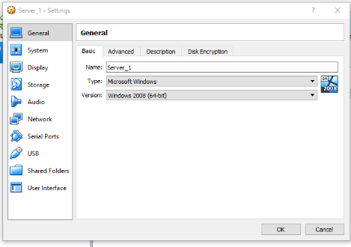
2.1: Stages of Virtual machines creation

This is the beginning of how a windows 8 server is built in virtual box. Not showing Server2 as it is the same process and no changes. Clients are also the same except for the name of the machines as the clients are “Client1 and Client2”.

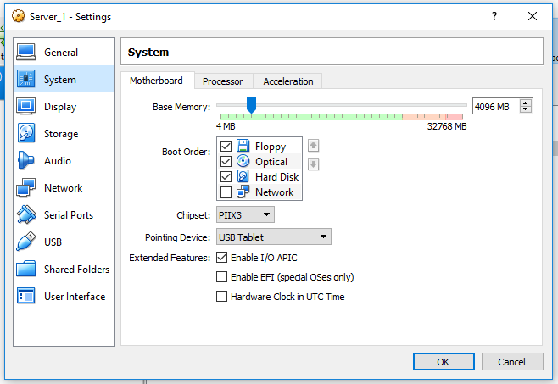

This is where RAM (Random Access Memory) is allocated to the server and how much was given to make the server work. Will not show server 2 as it is the same as server 1 in terms of setting up the servers. The clients also have the same amount of RAM so I won’t show the screenshots for that process.

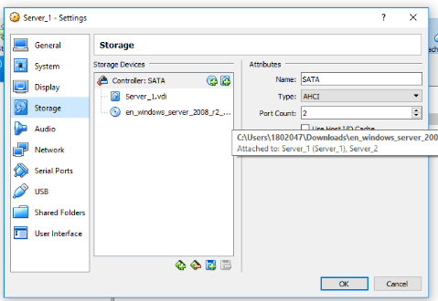
This where the image for windows 8 is installed to make the machine run. I won’t show the screenshots for the clients as the only 2 things that change are the network adapters and the image used to make the machine run. Since server 2 is the same there is no need to show the process for that either.

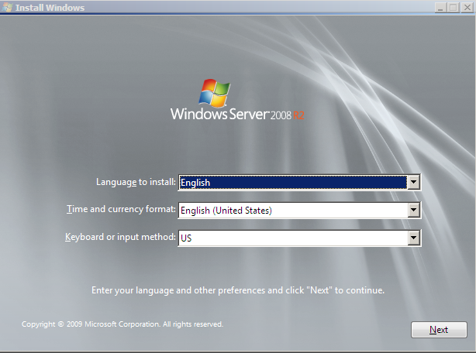
2.2: Installation of my 2 Windows 8 Servers

This is the beginning of setting up a windows 8 server. There is no need to show server 2 as it is the same process.

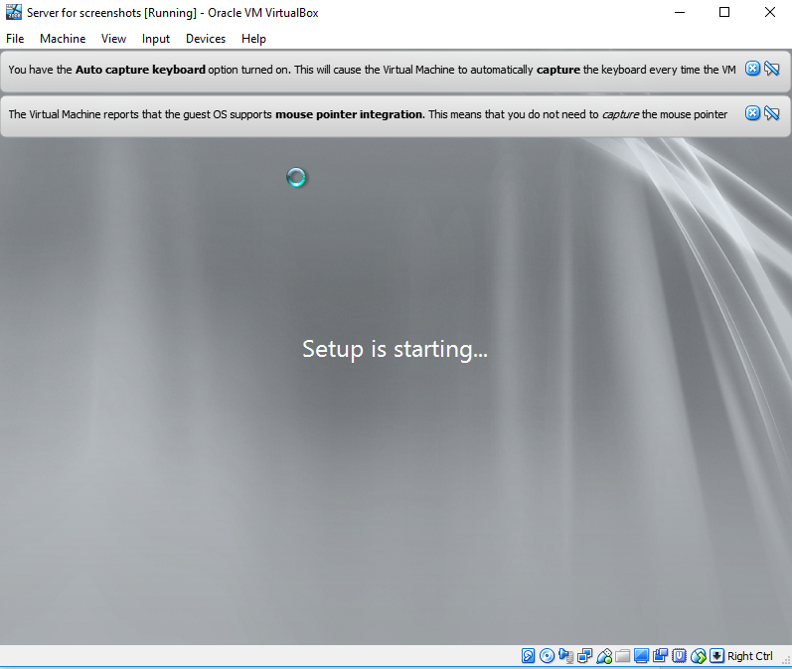
This is the server starting up after a bunch of clicking on stuff. There is no need to show server 2 as it is the same process.

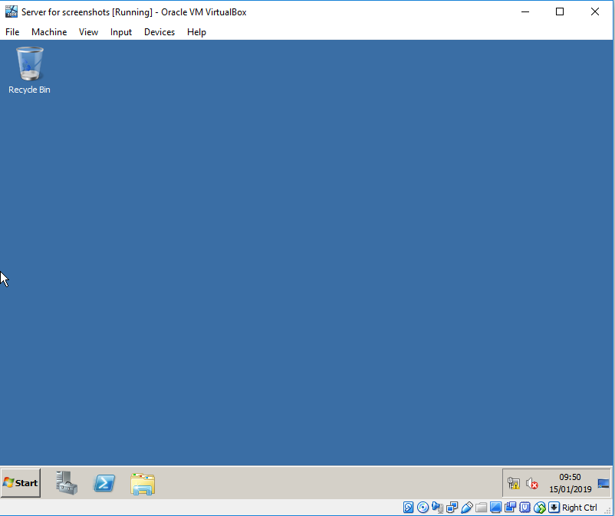
This is a screenshot of the windows 8 server running after the process of installation. There is no need to show server 2 as it is the same process.

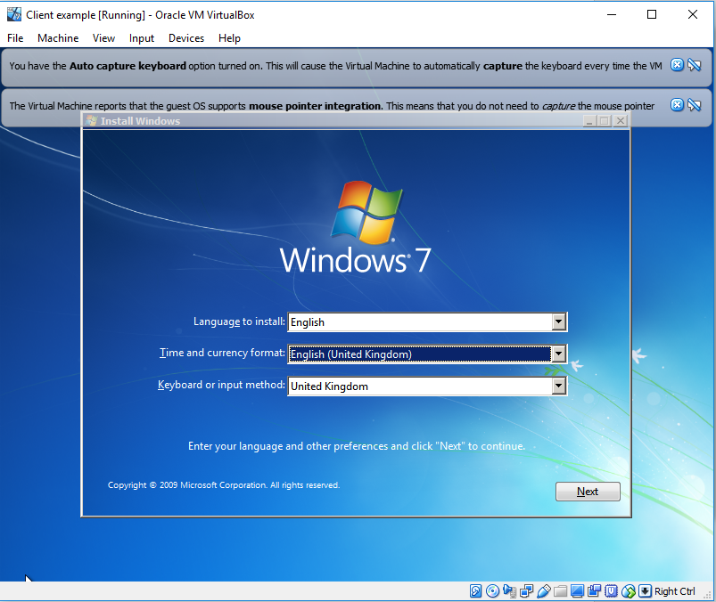
2.3: Installation of my 2 Windows 7 Clients
This is the set up for the windows 7 clients since they are the same there is no need to show the set up for both clients.

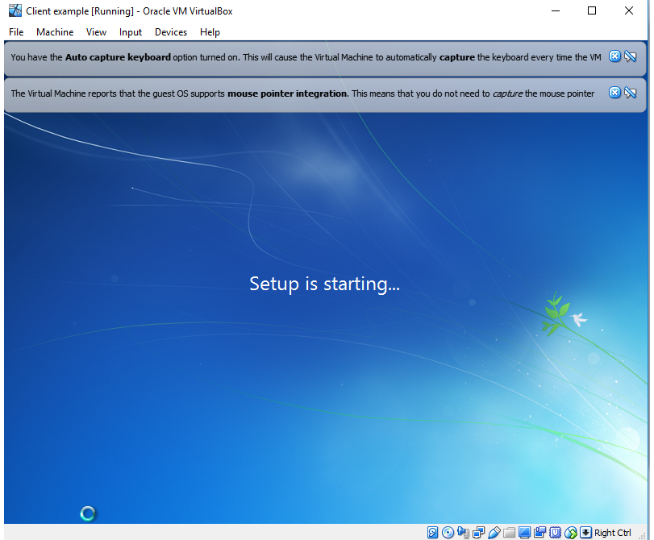
This is the setup for the windows 7 clients as it is the same for client 2 there is no need to show the process twice.

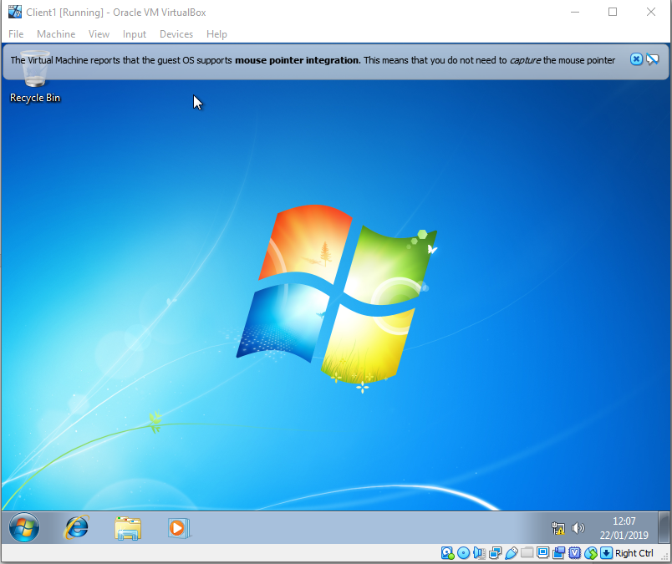
This is the finished setup for windows 7 client1 as the process is the same for client 2 there is no need to show the process.

3: Network Design used for Virtual Machines
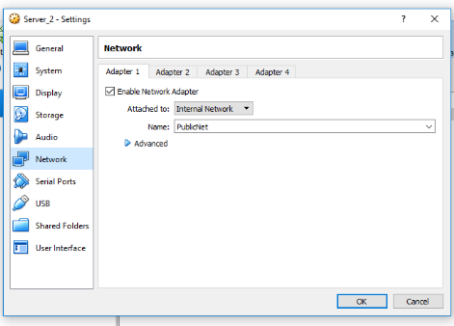
3.1: Creation of Virtual Switches (3 Virtual Switches, PublicNet, PrivateNet1, and PrivateNet2)
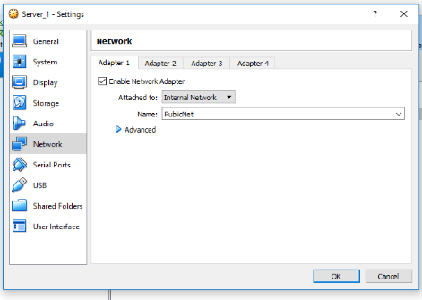

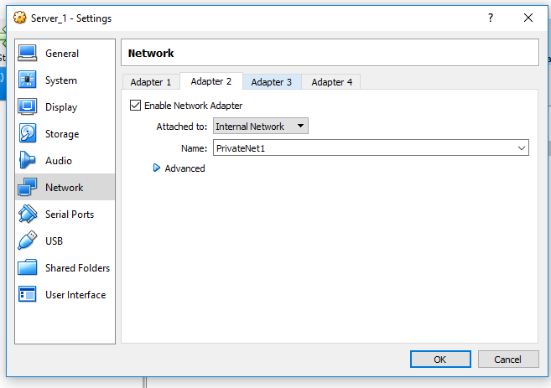
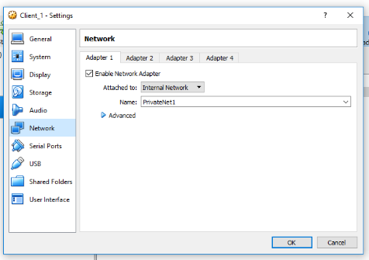

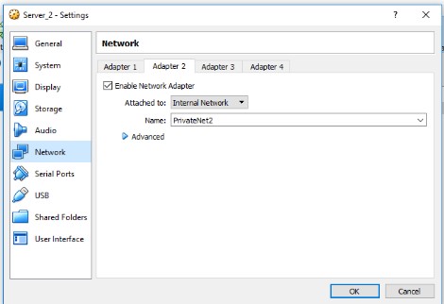
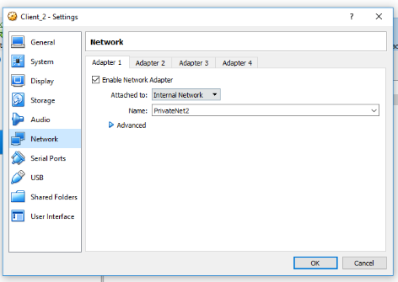

The screenshots above are to show that all of the switches aren’t the same except for Server 1 and Server 2 on PublicNet, Server 1 and Client_1 on PrivateNet1, and Server 2 and Client 2 on PrivateNet2.

3.2: My Network Addresses (3 Networks 192.168.1, 192.168.100, 192.168.101)

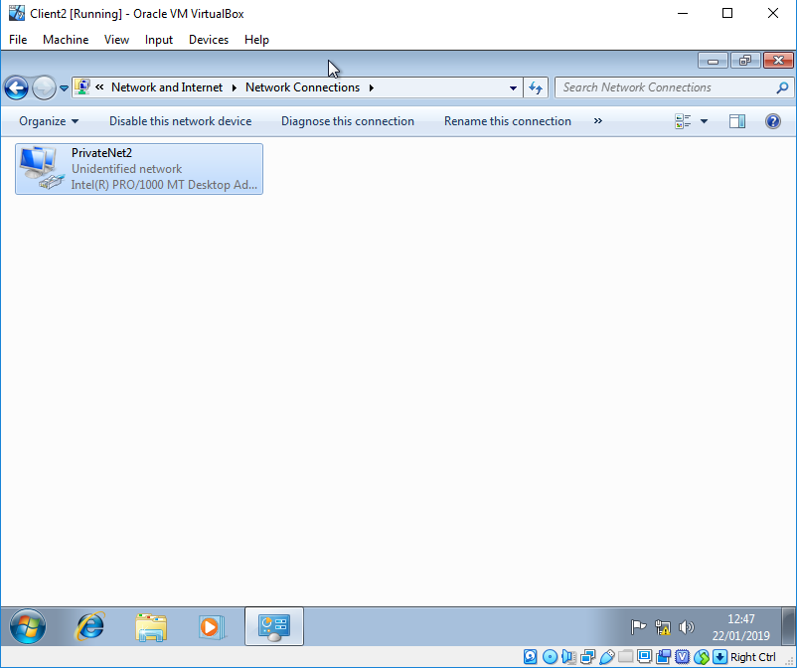
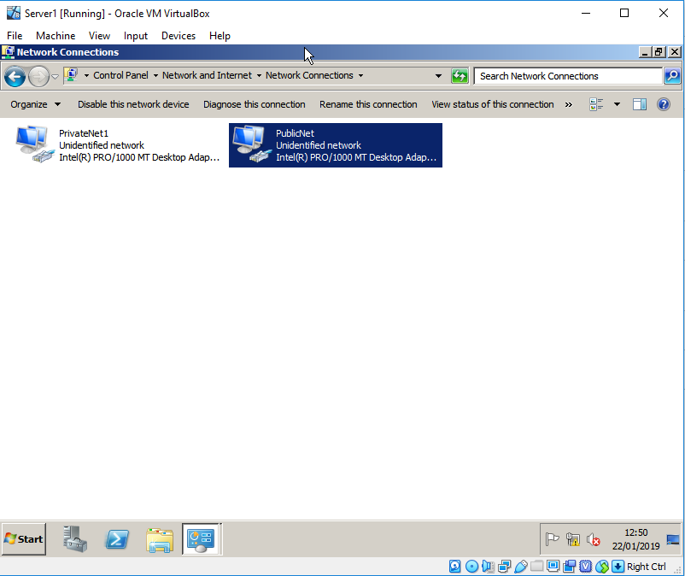
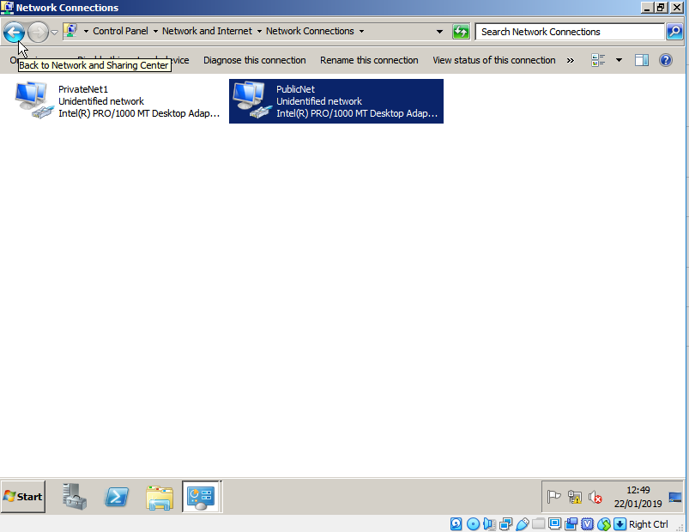
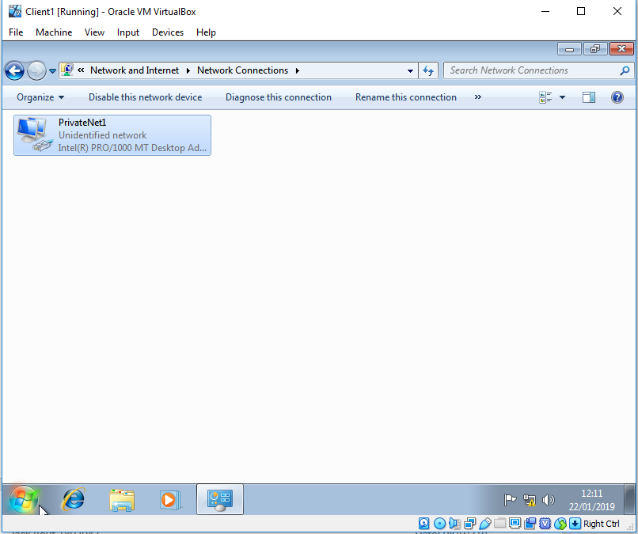

This is the network addresses for both of the servers and the clients. I will not show the IP addresses as they can be found in “testing and settings of DHCP” as it showing IP addresses in the command prompt.

4:The creation of 2 primary domains (Lightside.com and Darkside.com)
- Use of dcpromo (Creation of a new forest and put a name, summary)

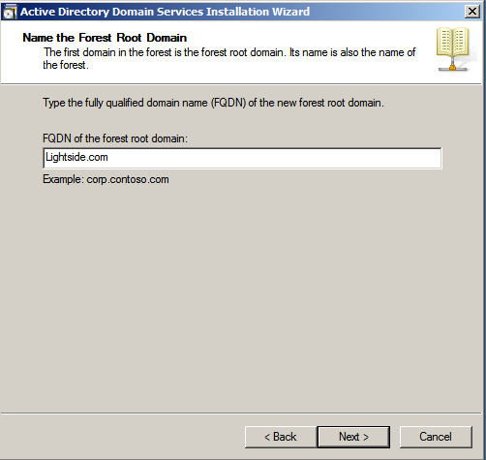

This is the process of setting up my DNS (Domain Name Service) in this case lightside.com and to sum it up this DNS is going to stop clients from having access to all of the stuff that admins have. This will limit the use that clients have and allow admins to have all permissions. I would show this for server 2 but it is the same process.

Creation of objects (Users and computers)

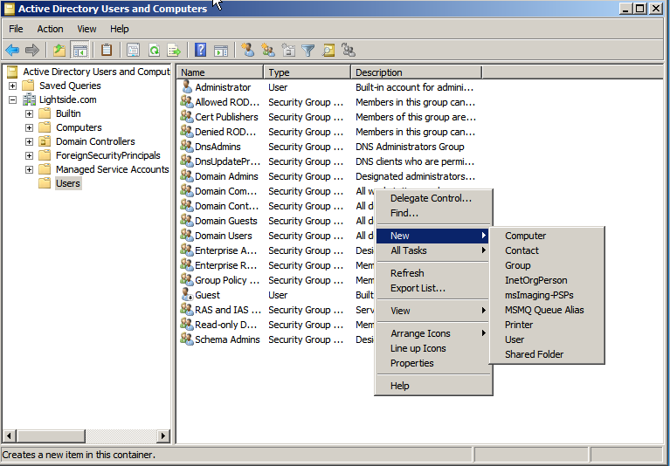

This is a screenshot of adding a new object whether it’s a client or a computer for example.

Permission to access (Domain users vs Domain Admins)
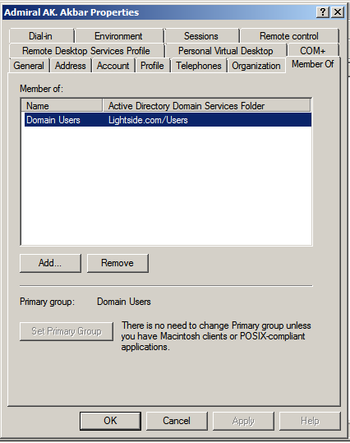
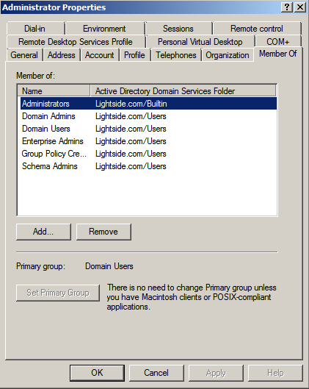

These 2 screenshots above show an admin and a user. As show the administrator has access to everything as he needs the access in order to keep everything running. The client/user doesn’t have any permissions at all as if that was the case anyone could have privileges to do as they please.

5: DHCP
Install

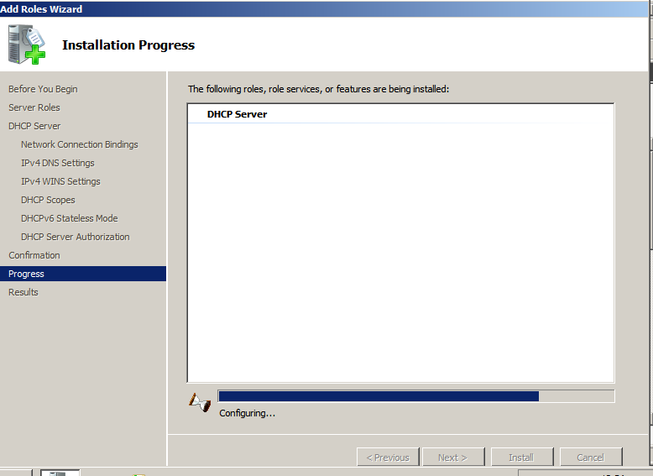

This is the beginning of me creating a DHCP (Dynamic Host Configuration Protocol). Since this is the same setup for server 2 there is no need to show that.

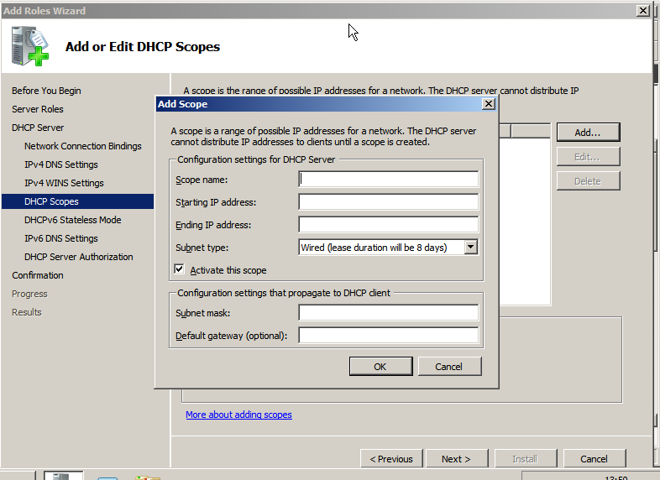
Scope creation

This screenshot is creating a scope with in my DHCP and a scope can reserve IPs for a later occasion and automatically give out IP addresses for clients.

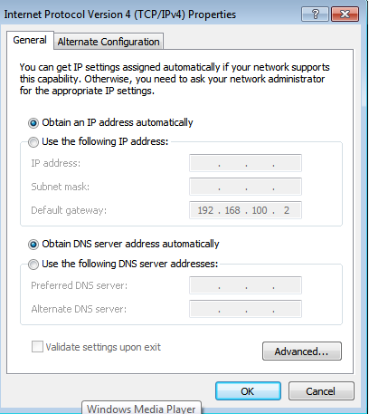
Testing and settings of DHCP
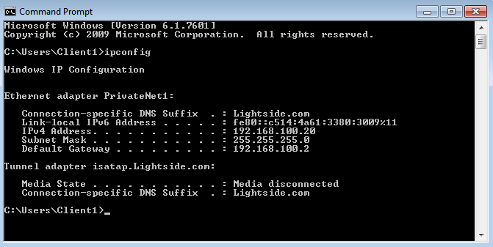

The screenshots above show that the DHCP is working because of the IP address are automatically being obtained and what it has done is given an IP address that was created in a scope from 192.168.100.20 to 192.168.100.20. I was trying to make it so it gave me 100.2 but I created my scope badly and as shown above the DHCP is working. I will not show this for server 2 as it is the same process.

