Change and Stability Management

Name of Student: SOLANKI GULNAZ YASINBHAI
Student ID- 2232646

Table of Contents
Introduction and background to the organisation and the reason for change 3
Key change management models – planned and emergent change 4
How the models can be utilised when considering incremental (small scale) or a large scale change programme 10
Consider how you would identify and deal with resistance factors to the change 12
How to know when the change programme has been completed and how you might assess its effectiveness 13
Conclusion 13
References 14

Introduction and background to the organisation and the reason for change
Asda is a UK based supermarket that was founded in the year 1949. The company stores diversified number of products to meet the needs and wants of its customers such as toys, clothing, health and beauty as well as home-ware (Emerald, 2014). The company has also invested in insurance and financial services and this has expanded its market base, hence, generating incremental sales and revenues. As well, it has invested well in market research to identify unmet needs, communicate to its suppliers about the same and get to introduce new products across its stores and this has improved its customer attraction and retention rate. The company was acquired by Wal-Mart for 6.7B pounds in its quest to grow its market presence and customers. The company has invested well in marketing and management and this has enabled it to generate good sales and grow its brand value.
Due to the fact that business firms have to make changes to their operations every now and then (Vora, 2013). Asda has invested well in strategic audits to analyse its performances in different areas. This has made the company to introduce a number of changes. For example, it has come up with a plan to refill its stores to ensure that customers easily access the products that they need in the right quality and quantity. With this regard, employees have been directed to refill ambient foods between 7pm and 12 am with frozen goods being refill between 7am and 1pm. This is new restocking strategy is aimed to ensure that its stores does match demand and supply. As well, the company is making changes to its employee management technique. It is working to ensure that employee demand matches supply in order to minimise unnecessary costs. Hence, it has conducted an employee forecast and identified the need to lay off 211 night shift managers across its stores. The management believes that existing supervisors have the capabilities to execute the roles that such managers are performing and thus, there is need to cut on the labour costs.
There are a number of reason that drive change in every organisation. These reasons need to be logical and well justified so that the changes to add value to the company financially and non-financially. With this regard, one of the reason why Asda is making changes to its restocking strategy has already been mentioned. Working to ensure that demand is met is important for the growth of the company’s market competitiveness and performance in satisfying customers’ expectations. Thus, Asda is able to attract and retain them in large numbers. The company is working to ensure that it minimises unnecessary expenditure so that it maximizes on its financial returns. By having a balanced workforce, the company will be able to incur necessary expenses and this will be vital in fostering high maximization of profits.

Key change management models – planned and emergent change
Implementing chances by firms is a very sensitive activity and thus, it has to be executed following the right procedures and mechanisms (Santos et al., 2023). If this is not done, the change may not be implemented on time or in other cases, the expected goals of the change may not be achieved. Therefore, there is need for management to ensure that the relevant models and strategies are followed for change to be implemented successfully. Thus, below is a discussion of the different change management models that Asda’s management may utilise to implement its respective changes in the retail sector:
Kurt Lewin Change model
Unfreeze: it is important for business firms to accept the fact that a change needs to be made in the workplace (Vora, 2013). This is the phase whereby management sees the value of the change(s) to be made and sets up a plan to implement. For instance, this is the phase whereby the management of Asda understood the need to implement a new re-stocking strategy. The company had realised that some clients were complaining of not getting the foods that they needed in its stores. This is a threat to the company’s market competitiveness and the attraction of customers. As well, after doing the employee audit and forecasting, the company realise that it had excess workers whose roles could be executed by other existing workers. At this point, the company had to plan on how to lay off the unwanted workers.
Figure 1: Lewin Change Model
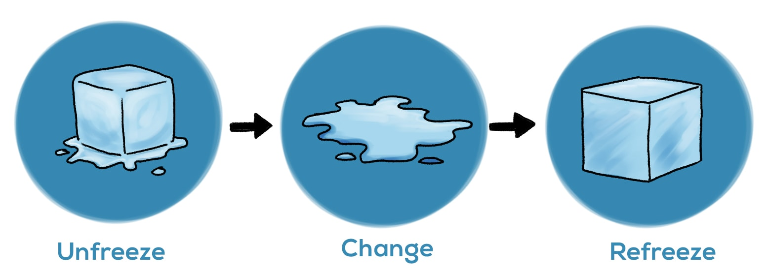

Change: it is important for business firms to ensure that they have implemented the necessary change once they have made the decision to do so (Sparks, 2015). According to Lewin, this is the phase whereby the companies implement their outlined change. Thus, Asda management need to implement the outlined new re-stocking strategy across its stores. As well, this is the phase the company implement the new employee management strategy. It sends out layoff notice to the night shift managers and follows the employment procedures to the latter.
Freeze: in this phase, the company needs to build on the change that is made. With regard to Asda, the management will make it part of its culture to refill ambient foods during night time and the frozen goods during daytime. This means that customers will be accessing the foods on time and this will fully meet their respective needs and wants. There is need for the company to ensure that its employ audit is done continuously. This does not mean that the company will be firing employees every now and then because in the process of the aforementioned exercise, it may identify departments that are under staffed and implement the relevant recruitment procedures. As a result of this, the company will ensure that it has the right quality and quantity of employees to improve its operational efficiency and effectiveness, hence, it will easily achieve its targeted goals and objectives.
ADKAR stages of change model
ADKAR is another change management model that firms may implement. It is important in ensuring that the relevant changes are made so that the anticipated goals and objectives are met on time. The steps that are followed with regard to this model are discussed below;
Awareness: it is important for business firms to ensure that they have created awareness when they are about to implement any form of change (Santos et al., 2023). In this case, the management of Asda has to ensure that employees are made aware of the change and they are convinced of the reasons for its implementation. This means that the employees will be ready for change they will be convinced of the need to change the restocking strategy. As well, there is need to explain to the managers being laid off for the reason for doing so and other employees as well need to understand this so that they do not develop job insecurity issues.
Desire: before implementing the change, there is need for employees to desire it. This means that they need to be convinced about and agree to implement it by playing their roles competitively. Thus, once the employees of Asda have seen the need to change the restocking strategy, they will desire it. This, they will be competitively involved in its implementation to the latter. With regard to laying off of night shift managers, the existing employees have to be satisfied that actually such workers are surplus of requirements and the process needs to be done within the law.
Knowledge: before a transition is done, there is need to ensure that employees have the skills and knowledge to implement a given change (Kirby, 2017). They need to be actively involved in the change process for targeted goals to be attained. In this case, Asda management needs to ensure that employees are trained on the new restocking strategy. As well before the supervisors take up the roles of night shift managers, they need to be trained to have the required competencies to execute assigned roles in a more competent and productive manner.
Figure 2: ADKAR
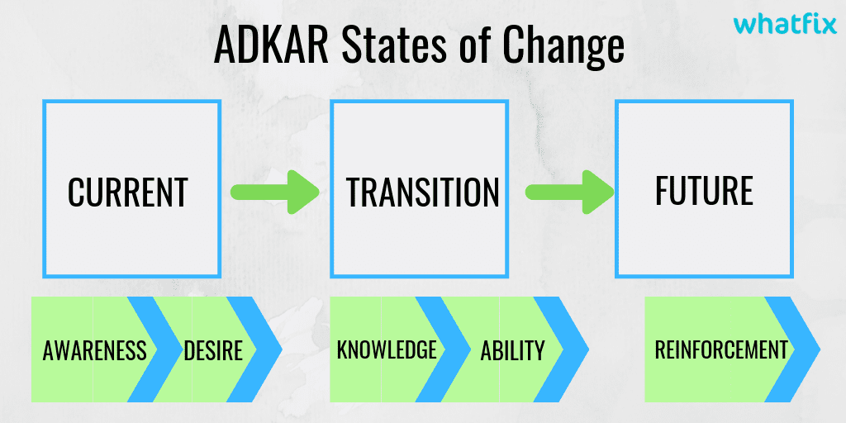
Ability: this is whereby the management needs to ensure that employees have the confidence to implement the outlined change. This is done via the use of rewards and other motivation strategies. Through this, the changes to be made at Asda will be implemented successfully.
Reinforcement: there is need to ensure that the change is reinforced by countering any arising challenge or conflict. This is vital in ensuring that the outlined change delivers goals targeted or even surpasses them.
Kotter’s 8 step change
Sense of urgency: it is important for business firms to ensure that an urgency to implement a change is created (Crestani, 2016). In this case, the employees of Asda needs to understand the urgency that is needed to implement the new restocking strategy. This is achieved by enabling them understand the direct impacts of this change to the company.
Guiding coalition: there is need to create a coalition whereby employees and managers will easily work together. This is achieved by engaging them in the change process and giving them full details on why the change has to happen within Asda.
Change vision: this means that a vision needs to be created as to what the change aims to achieve in the long run (Agyemang and Ryan, 2013). Employees of Asda have to be made to understand that the change will aid the success of the company in balancing demand and supply to improve the satisfaction of customers.
Communication: it has to be very effective and clear for employees to understand all aspects of the change. Asda management needs to ensure that across its stores, all employees are fully aware of the new change to be implemented in order to ensure that customers easily accesses the products that they need on time.
Counter obstacles: there is need to understand that challenges are likely to be faced along the way. To counter them, there is need to put in place an effective plan to offer all the required solutions. In this case, the management of Asda will succeed in attaining the change goals because the new restocking strategy will be implemented successfully.
Figure 3: Kotter’s 8 change process

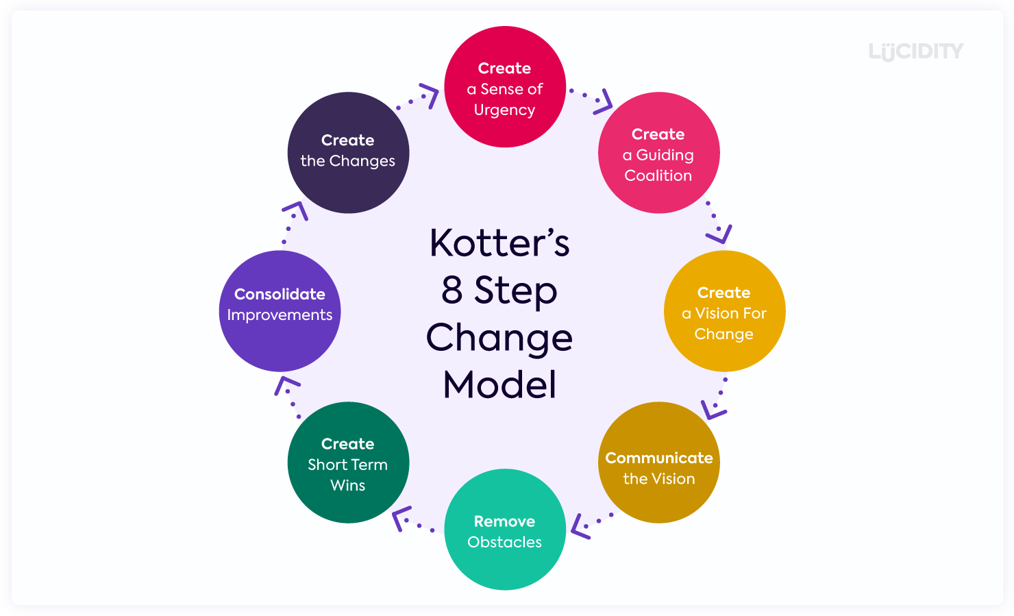

Short-term wins: there is need to ensure that the relevant short term wins are put in place so that the change implementation team are fully geared to attain the targeted goals (Crestani, 2016). In this case, the management of Asda needs to monitor the impacts of the restocking strategy by setting short term goals and analysing whether they have been met or not. This motivates employees to be more focused on the change implementation process.
Make improvements: this is important in ensuring that the necessary improvements are made as changes are being implemented. Asda needs to analyse the areas of improvement to meet the targeted restocking goals. There is need to as well introduce new strategies that will give customers the shopping experience that they need to stay loyal to the company.
Anchoring change: business need to anchor on changes made especially when they are delivering targeted goals. In this case, the management of Asda will have to keep on working to fully meet the needs of customers. This will ensure that the company is aligned towards its growth by improving its customer service and shopping experience every now and then. This will significantly improve its market performance and competitiveness.

How the models can be utilised when considering incremental (small scale) or a large scale change programme
It is important to ensure that the above models are utilised when implementing different change programmes. There are 2 types of such programmes, small and large scale. With regard to the latter, there is need for the management of Asda to ensure that the change model implemented is not lengthy (Emerald, 2014). This is because the outlined change has to be implemented immediately because the implementation period id small. Thus, there is no need to follow a lengthy process and in this case, the best model to implement is Lewin model, which one has 3 phases, refreeze, change and then freeze. With this regard, the small change programme will be implemented on time and the targeted goals will be attained. However, when it comes to a large scale change programme, it is significant to use either ADKAR or Kotter’s 8 change model. This is due to the fact that there is good or ample time to implement this particular model. Therefore, there is need to ensure that no stone is left unturned when implementing the change. These models give the management enough time to develop the team that will be in charge of the change implementation process in Asda. A vision will created and employees will be fully informed about the change for them to easily agree to implement (Flanding et al., 2018). Risks or obstacles that are likely to be faced will be timely identified and relevant structures will be put in place to counter them. This will be vital in ensuring that the change is implemented effectively and on time. Through effective training, the employees or change management team will be fully aware of how to implement the change by executing the roles and responsibilities in an outstanding and successful manner. Hence, the anticipated change goals will be easily attained and the change will be anchored. It will be capitalised on, further, to keep improving the competitiveness and productivity of the company.
Driver factors for change
Improving operational process: there is need to improve the effectiveness and efficiency of organisational process in order to attain the targets firms are after (Flanding and Grabman, 2022). With regard Asda, the need to achieve this does drive the company to make different changes. For instance, the company introduces a digitalisation strategy whereby it incorporates the use of technology across all its operations. This ensures that the level of effectiveness and efficiency is improved to attain its targets on time.
Organisational culture; it is important for business firms to ensure that they are run under the right beliefs and values. In this case, the culture of a company may influence changes every now and then. For example, Asda has implemented the customer oriented culture whereby it’s only focused on the satisfaction of its customers. As a result of this, the company is motivated to adjust its restocking strategy so that customers can easily access the products that they needs across its stores on time and in the right quality and quantity.
Customer needs: the needs of customers keep on changing every now and then (Kirby, 2017). Thus, there is need for business firms to be very open about changing its strategies every now and then. Since the company offers beauty products, it is important to note that customer demands change and thus, there is need to always stock those products that will fully match their needs and expectations.
Supply and demand: business firms need to ensure that supply and demand is well balanced. With this regard, changes has to be made in Asda depending on such changes. It is important to note within the retail sectors, seasons determine what to stock. Thus, Asda needs to be very flexible when it comes to its inventory. It needs to change from one product to the next depending on the demand trends so that it maximizes on available market opportunities at all times.
Power: management have the power to make different changes with regard to what is best for the company (Santos et al., 2023). This is why management decided to lay off the night shift managers. It felt that they were surplus of requirement after the audit that was done in Asda. Thus, it had to utilise its power to minimise the unnecessary labour expenditure that it was exposed to.
Competition: there is need for firms to ensure that competition is countered because Asda operates in a very competitive market. The market is flooded with many firms, hence, Asda needs to make relevant improvements every now and then. As such, there is need for the company to work on improving its competitiveness in the market to easily attract and retain as many customers as possible. This is vital in improving its market base and ensuring that bit generate incremental sales and revenues in the retail market.

Consider how you would identify and deal with resistance factors to the change
In business firms, there are different reasons why there is resistance to change (Schirmer and Geithner, 2018). Within Asda, there are instances when resistance to change is high and this delays the company’s operations. For example, when the employees are not involved in the change process, they resist to it because they are not convinced of its need. They feel that they are being undermined by their leaders and feel deserted. This makes them to be affected mentally and in the process, they do not easily embraced change. Due to lack of information, the employees fear the unknown and thus, they do not support the change to be made (Sparks, 2015). To solve this, management needs to implement one of the change management modes that have been covered above. They need to introduce the change before implementing it and justify it to all employees. Once employees’ support has been won, the resistance to any given change is countered, hence, it’s effectively implemented. The employees form a good collaboration with management to ensure that the change is implemented from the 1st phase to the last one. This is important in ensuring that the company utilises its resource to fully implement the change and achieve the goals that it’s after.

How to know when the change programme has been completed and how you might assess its effectiveness
When implementing change, there is always a well outlined plan that has to be followed to the latter. The management has a plan that has to be effectively executed step by step so that the anticipated goals are attained on time. With this regard, the management gets to ensure that challenges are identified in the process and countered so that change implementation is successful. To understand when the change has been completed, the last phase of the plan is executed. Once the last step is over, the management is convinced of the success of the change implementation process (Vora, 2013). As well, the management may access the effectiveness of a change process by checking whether the anticipated goals were attained on time or not. If Asda realizes that the change goals are attained as expected, then the process is said to be successful and effective and vice versa. Once a given problem has been solved or performance has been improved, it means that the change process is complete and successful.

Conclusion
Changes have to be made in business firms every now and then because internal and external environment keeps on changing. Thus, there is need to ensure that the right steps are undertaken in implementing the changes. As discussed above, if Asda fails to introduce a change on time, the anticipated goal is not likely to be achieved. Thus, there is need for the management to select and implement an appropriate change strategy or model from the 3 discussed above, Lewin, Kotter’s 8 model as well as ADKAR. This is vital in ensuring that the company gets it change management right and engages in different activities that lead to attainment of both its long term and short term goals. All along, any change management risk has to be identified and countered to foster organisational success.

References
Agyemang, G. and Ryan, B. (2013), "Accountability and Performance Management Systems within Private and Public Sector Organisational Change Processes", Managing Reality: Accountability and the Miasma of Private and Public Domains (Advances in Public Interest Accounting, Vol. 16), Emerald Group Publishing Limited, Bingley, pp. 1-38
Crestani, I. (2016), "Change Communication: Emerging Perspectives for Organisations and Practitioners", The Management Game of Communication (Advances in Public Relations and Communication Management, Vol. 1), Emerald Group Publishing Limited, Bingley, pp. 225-244.
Emerald (2014), "Asda, Morrisons and Tesco offer employees an alternative route to a degree: Earn-as-you-learn proves popular as cost of higher education rises", Human Resource Management International Digest, Vol. 22 No. 3, pp. 21-23
Flanding, J.P., Grabman, G.M. and Cox, S.Q. (2018), "Playbook to Digital-era Change Leadership", The Technology Takers, Emerald Publishing Limited, Bingley, pp. 61-160
Flanding, J.P. and Grabman, G.M. (2022), "A Practice of Purpose-driven Change Management", Purpose-driven Innovation: Lessons from Managing Change in the United Nations, Emerald Publishing Limited, Bingley, pp. 21-44
Kirby, A. (2017), "Retail Insights ‐ Wal‐Mart’s takeover of Asda", International Journal of Retail & Distribution Management, Vol. 28 No. 3, pp. 1-22
Santos, E., Queiroz, M., Borini, F.M., Carvalho, D. and Dutra, J.S. (2023), "The journey of business transformation: unfreeze, change and refreeze – a multiple case study", Journal of Organizational Change Management, Vol. 36 No. 1, pp. 47-63
Schirmer, F. and Geithner, S. (2018), "Power relations in organizational change: an activity- theoretic perspective", Journal of Accounting & Organizational Change, Vol. 14 No. 1, pp. 9-32
Sparks, L. (2015), "Settling for second best? Reflections after the tenth anniversary of Wal‐Mart's entry to the United Kingdom", International Journal of Retail & Distribution Management, Vol. 39 No. 2, pp. 114-129
Vora, M. (2013), "Business excellence through sustainable change management", The TQM Journal, Vol. 25 No. 6, pp. 625-640

