
Student Name: Krunal Ashokbhai Sorathiya
Student ID: 2430614
Module Name: International Business Concepts
Module Code: LCMB7034
Lecturer’s Name: Jean Wang
Topic: Nestlé’s International Expansion Strategy and Operations in an Emerging Market (India)
Submission Deadline: 21/07/2025
Word Count:

Table of Contents
1. Introduction 3
Justification for the company being an MNC 3
Key benefits of international operations 4
Nature of the global operations of the company 6
Identification of market entry modes 8
3. Impact of OLI factors on international market entry mode 10
Cross-Cultural Differences Between Switzerland (Home Country) and India (Emerging Market) 14
Impact of Cultural Differences on Nestlé’s Market Entry Strategy in India 16
Influence of Cultural Factors on Nestlé’s Long-Term Success and Operational Performance 17
5. Critical Discussion and Recommendations 18
6. Conclusion 22
Reference List 23
Appendices 29
Appendix 1: Nestle marketing Strategy 29
Appendix 2: Business Model Canvas of Nestle 30

1. Introduction
This report will explore the international operations of Nestlé with a specific focus on its expansion into India, which may be considered as one of the most dynamic emerging economies in the world. It illustrates the global value chain of the company by ensuring high research and development (R&D), sourcing, production, marketing as well as financing, which is useful in its internationalisation strategy. The analysis will highlight the entry modes which are by Nestlé across global markets as well as identify the dominant approaches in influencing its presence in India. OLI (Ownership, Location, Internalisation) framework, will be used in the report which will be useful to assess the factors influencing market entry decisions of the company. It will discuss in-depth examination of the cultural differences between Switzerland and India as well as their implications for strategic suc\cess. The report also made key adjustments to Standard Operating Procedures of Nestlé to enhance effectiveness in India.

Justification for the Nestle being an MNC
The scale, organization as well as globalisation of its activities will be useful in categorising Nestle in an effective manner as a Multinational Corporation (MNC) along with Transnational Corporation (TNC). Nestle may be treated as one of the largest FMCG in the world and engages in operations in more than 180 countries (nestle, 2025). It consists of the emerging economies such as India, China, Brazil, Indonesia, Mexico as well as South Africa which are the major developed markets in Europe and North America. This wide global presence is evidence of the geographical decentralisation as well as cross-border coordination of MNCs along with TNCs. Nestle global value chain is integrated in various countries such as the corporation operates in over 350 factories in different countries, purchases of raw materials which consist of dairy, cocoa, along with grains in various agricultural markets, and conducts (R&D) by using a network of specialised global and regional R&D centres in Switzerland, the USA, China, Singapore, and many other countries (nestle, 2025).
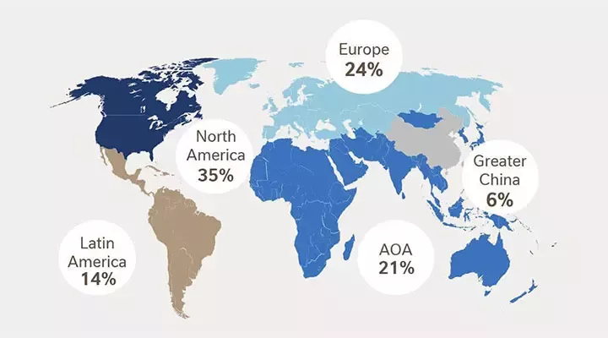
Figure 1: Nestle in different countries
(Source: nestle, 2025)
Moreover, Nestle mainly has decentralised operation, however, the c company has globally coordinated organisational structure which provides local subsidiaries the mandate to localise products, packaging, along with marketing techniques to maintain quality, sustainability along with brand portfolio management (Alon et al., 2020). This efficiency on the global level, more specifically sensitivity on the local level is unsuitable and arraigned with transnational strategy outlined by Bartlett and Ghoshal.

Key benefits of international operations

Global Revenue Growth and Market Diversification
The benefits of international operations by Nestle mainly consist of expansion into various geographical marketplaces. This will be useful for the company to reduce reliance on a single economy as well as experience a long-term growth in income. Market existence in over 180 countries is useful for Nestle to access different purchasing power, demographic as well as consumption of food in different ways (nestle, 2025). The emerging markets such as India, Brazil, Indonesia as well as China, maintain the growth of the company in terms of a balanced global portfolio.

Economies of Scale and Operational Efficiency
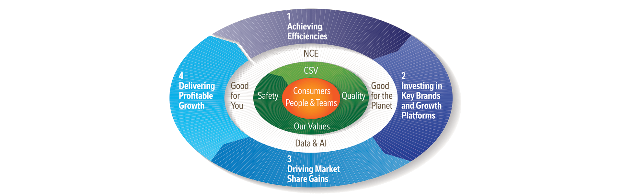
Figure 3: Nestlé Virtuous Circle for operational efficiency
(Source: nestle, 2025)
Nestle also maintains high economies of scale to enhance the efficiency of production network, sourcing as well as distribution network associates of the world by using Nestlé Virtuous Circle (nestle, 2025). The company has more than 350 manufacturing plants throughout the world, and this was useful for the company to optimize volume levels of production, unit costs, along with global procurement benefits in sourcing raw materials which consist of dairy, coffee, cocoa as well as packaging materials.

Innovation and Knowledge Transfer
The global business activities are beneficial for Nestle to reach a variety of consumer insights, cultures related to food and research systems, which is useful in driving product innovation. The company has a global network of R&D, more specifically, it is able to develop new formulations, local recipes as well as move successful products across markets.

Strengthened Brand Equity and Competitive Positioning
Its international operations can promote the capacity of Nestle to develop robust international brands which consist of Nescafé, KitKat, Maggi as well as Nestle Pure Life (Tze et al., 2022). The unity of globalisation of the brand along with adaptation to the local environment is useful in promoting credibility and awareness along with retention of customers. The existence of the company markets is useful for helping Nestle compete in an effective manner with both the regional as well as the international competitors.

Nature of the global operations of the Nestle

Research and Development (R&D)
Nestle has an effectively established network of R&D throughout the world, which may be treated as highly integrated, more specifically it makes the company one of the most research-oriented companies in the industry (Takahashi, 2021). It has regional research centres in many countries such as China, Singapore, the USA, Brazil as well as France to its central R&D headquarters in Switzerland. This is the world network which is useful for Nestle to pool together highly developed scientific knowledge with local consumer understandings, more specifically it is useful in creating innovations in nutrition, health, packaging, and safety related to food as well as sustainability. The R&D teams also have collaborations with universities, agricultural institutes as well as suppliers across the world which provide new technologies as well as innovative designing low-cost products.

Sourcing and Supply Chain
Nestle mainly has a vast global sourcing system with thousands of suppliers in a variety of agricultural markets. Milk, cocoa, coffee, grains, fruits as well as packaging inputs are raw materials which are purchased in a direct manner from farmers as well as certified sustainable suppliers (Islam, 2022). The Responsible Sourcing Programme is useful for the firm to maintain traceability, environmentally friendly and helpful to support the livelihood of the farmer particularly in emerging economies. Sourcing in various continents is useful for Nestle to optimize costs, reduce the supply related risks, and remain flexible in the market.

Production and Manufacturing
The Nestle production network mainly has more than 350 manufacturing plants which are widely spread in more than 80 countries (nestle, 2025). This robust international presence will be helpful for the company to localise their production, reduce transportation expenses, fulfil the local regulatory requirements and meet the local demand in an effective manner. Most of the factories provide a specific focus on specific product lines such as beverages, dairy, infant nutrition, confectionery, as well as pet care. Plants in the emerging markets provide regional units that are able to capture nations in the region by using economies of scale.

Marketing, Sales, and Distribution
Nestle sales business may be organised in decentralised country level which may be considered as subsidiaries that tailor product portfolio, pricing as well as promotional strategies to local culture along with consumer tastes (Orji, Oyenuga and Ahungwa, 2020). The large market penetration is also ensured in the global market by a multichannel distribution system, which consists of supermarkets, e-commerce, traditional retail as well as food-service partners.
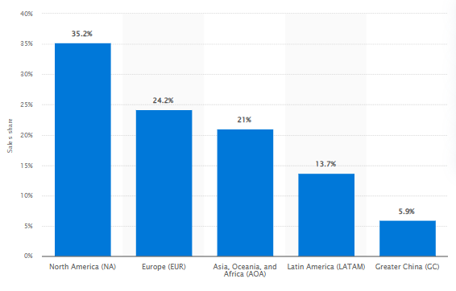
Figure 2: Global sales share of Nestle
(Source: Ozbun, 2025)

Financing and Global Coordination
The financial management of Nestle is properly coordinated which is useful in ensuring that global capital allocation, management of risk as well as investment planning may be conducted by using its Swiss headquarters. The firm also has done a high investment in business by utilising retained earnings, international debt markets as well as FDI, which lead to good liquidity and consistent international growth.

Identification of market entry modes
The number of modes of international market entry which was adopted by Nestle for its global expansion are based on different regulatory conditions, market environments as well as strategic goals in different countries. A significant one is a foreign direct investment (FDI) which may be influenced wholly owned subsidiaries, more specifically, Nestle usually executed in big and stable markets as the USA, the UK Germany, Australia, Brazil, India, as well as China., Nestle was able to incorporate this entry mode to ensure manufacturing, marketing, and distribution (Kuzey et al., 2021).
Acquisitions may be treated as another major mode of entry that Nestle which cis utilized by the company may access existing brands, distribution channels as well as market experience on a fast track (Islam, 2022). The famous ones are the acquisition of Gerber in the US, Rowntree in the UK as well as other regional brands in Latin America, Asia, along with Africa. Nestle also ventures into markets by using joint ventures as well as strategic alliances in an effective manner in markets. As an example, the joint ventures of Nestle with Coca-Cola (Beverage Partners Worldwide) as well as General Mills (Cereal Partners Worldwide) were useful in the sharing of expertise as well as an expansion of its product reach.
In the emerging market, Nestle has employed the greenfield investment which was useful in establishing completely new manufacturing plants to attain long term growth as well as satisfy local demand (Driffield et al., 2024). Among all these modes, Nestle mostly uses FDI by utilising wholly owned subsidiaries as well as strategic takeovers, more specifically these modes provide the highest control as well as allowance, ability to build resources on a long-term basis.

3. Impact of OLI factors on international market entry mode
Ownership Advantages and Their Influence on Entry Mode
The ownership driven benefits of Nestle mainly consist of its world-wide portfolio of brands, technical development as well as technologies, financial resources along with which are good management skills and may be considered as important determinants of its entry mode in the emerging economies such as in India. Nestle is considered as market leader in nutrition, health and wellness, more specifically, the company has a lot of intangible resources at its disposal such as trademarks (ex: Nescafé, Maggi, KitKat), patented production related technologies as well as advanced quality management systems (Takahashi, 2021). These ownership benefits will be useful for the company more inclined to venture into foreign markets in wholly owned subsidiaries or high-control forms which is useful to maintain the intellectual property leakage risks or disparity in the quality standards in the foreign markets which are reduced. Nestle was finding it profitable to spend in a proper manner in India as well as take direct control over its production decisions (Rahman and Hasan, 2024) Moreover, the brand has high brand equity as well as its ability to localise global products to the taste of the locals which includes Maggi noodles as well as spice profiles). Moreover, the capability of Nestle is to fund huge financial capital in capital commitment in the long run which was useful for the company to ensure the establishment of manufacturing facilities in Moga, Nanjangud, Bicholim and in Gujarat.
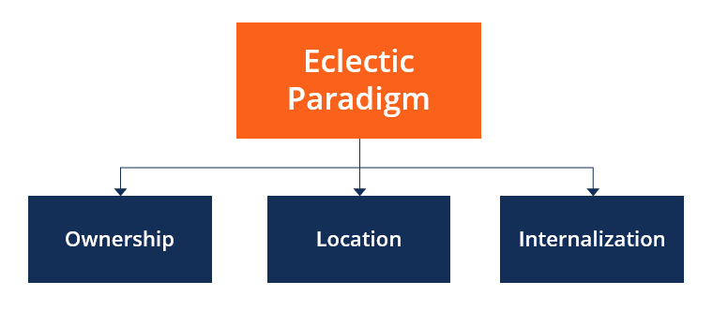
Figure 4: OLI framework
(Source: Corporate Finance Institute, 2023)
These ownership resources always indicate the effectiveness of supply chain systems, which needs to be integrated as well as closely observed to maintain the global quality standard by the incorporation of franchising and low-control entry modes in India. The company was able to capitalise on the higher R&D centres along with proprietary testing frameworks which were able to enhance the inclination and that would prefer FDI-based entry mode. On a broader note, the previous experiences of entering other emerging markets as well as contributed to the further development of confidence that Nestle will be able to deal with complex regulatory as well as cultural conditions, more specifically the application of high-commitment entry modes in India (Varma and Perkins, 2020). Due to this reason, OLI ownership pillar has a potent push to Nestle towards high-control as well as investment-oriented entry mode in emerging markets which is useful to ensure that its core competencies are transferred in an effective manner across the borders.
Location Advantages and Their Impact on Nestlé’s Entry Mode in India
The location specific factors of India mainly include size of markets, demographic trends, regulatory environment, supply of labour, agricultural resources as well as the growing middle-class expenditure are the determiners of the entry mode Nestle has adopted. India may be considered a vast country with a high rate of urbanisation, due to this response packaged foods, ready-to-eat products, beverages as well as nutritional products have a big demand in India , more specifically, in India Nestle also has a long-term market due to the favourable environment in the country (Kamble, Tamboli and Khan, 2024). The size as well as potential of the Indian market was the motivating factor which was useful for Nestle to open up large scale manufacturing processes with fully owned subsidiaries as opposed to exporting or licensing. In addition to that, the rich agricultural foundation in India is useful in providing availability of major raw materials such as milk, wheat, coffee, spices and fruits. This is useful in promoting the argument of local production, which was useful in reducing costs of transportation as well as assisting in the growth of integrated value chains.
The fact that labour is readily available along with the cost of operation is lower which was useful in enhancing the viability of local production, making Nestle have high motivations to invest directly instead of relying on external partners. However, location benefits need to be considered in addition to regulatory complexities. Nestle also spent money on food safety regulation, shifted policies on FDI, as well as bureaucracy in India, which was useful for companies to invest in compliance, legal experience, as well as specific operation units (Butt, 2024). The long history of Nestle was beneficial to navigate these complexities better, however the risk of location-specific regulations is strong and supports the importance of the high-control modes of entry that guarantee internal controls. The Maggi noodles crisis of 2015 indicated the way regulatory uncertainty may lead to a loss of brand loyalty which enhances the management of reputational risk (Jain, 2021). Furthermore, the cultural diversity of India always demands a high level of local marketing adjustment, more specifically this needs to be best achieved through subsidiaries as opposed to expatriates.
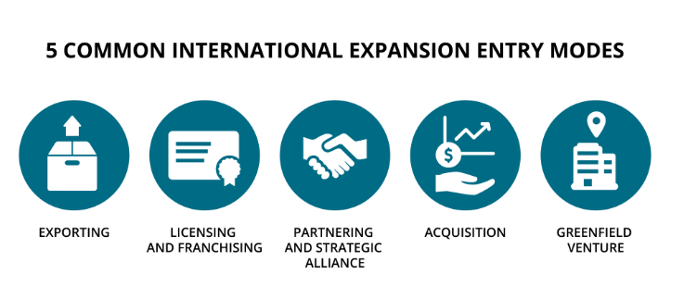
Figure 5: Market entry modes
(Source: Manuel, 2022)
Internalisation Advantages and Their Influence on Market Entry Strategy
Internalisation has many multiple Nestle stands to accrue by using internalisation and retaining some of its functions which consist of production, distribution, innovation, and as well as quality control at local levels., In the case of Nestle, internalisation of operations in India will be able to reduce the risks of potential opportunism, inconsistency in quality, leakage of intellectual property as well as supply chain interference (Avi-Yonah and Kir, 2024). Based on the competitive advantage of Nestle, it has been observed that the company largely relies on the safety of the products, their nutritional value as well as brand name by using wholly owned subsidiaries as well as vertically coordinated supply chains. The vibrant as well as unstable regulatory dimension of India also promotes internalisation which may be useful Nestle to secure direct leadership on compliance alone react in a swift manner (Varma and Perkins, 2020). As an example, internalisation was profitable for Nestle to use its international R&D, legal counsellors, along with quality assurance networks to demonstrate the safety of products as well as rebuild trust, more specifically, in the case of Maggi noodles ban. It has been observed that internalisation is useful for the company to reduce transaction costs which are linked to contract negotiation, quality control along with other external relationships.

Cross-Cultural Differences Between Switzerland (Home Country) and India (Emerging Market)
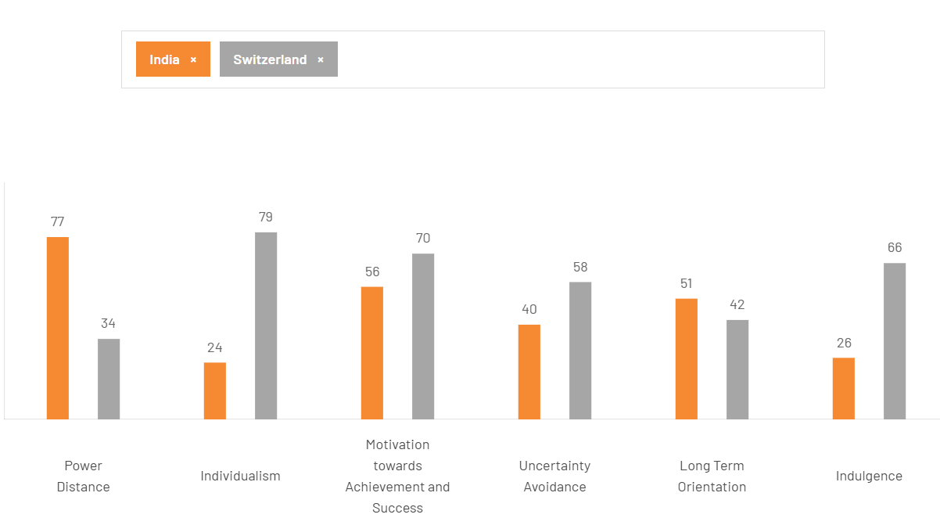
Figure 6: Hofstede Cultural Insights
(Source: The Culture Factor, 2025)
Within the scope of the international strategy, cultural differences between Switzerland, the home country of Nestle, and India, one of the most important emerging markets, have been observed to be particularly high. Based on the cultural understanding of Hofstede, India has a high score in Power Distance (77) relative to Switzerland (34), this signifies that the Indian society is more tolerant to hierarchical frameworks as well as authority differences and top-down decision making (Tze et al., 2022). On a converse note, it has been observed that Swiss culture believes in flat organisations, collective responsibility as well as involvement during decision-making. This is where the gap strikes on leadership practices, communication styles and organisation management of Nestle where a more directive and respect-of-authority leadership in India is necessary when compared to the collaboration and decentralised leadership approach derived in Switzerland. On a broader note, the other significant disparity comes in Individualism as Switzerland comes out with a very high score of 79 indicating high emphasis on independence, personal initiative as well as self-reliance (theculturefactor.com, 2025). On the other hand, India with a comparatively low score of 24 which brings out a collectivist culture that puts emphasis on community, family influence and relationship-building. In the case of Nestle, these variable influences consumer behaviour, advertising strategies and negotiation styles in a proper manner as the Indian consumers are more favourable to family related messages and local social values than in Switzerland.
Moreover, variations are also observed in Motivation towards Achievement and Success where Switzerland has the score of 70 and India of 56 as it shows that both cultures value success, but Switzerland is more performance driven. This may impact the cognitions of productivity, timekeeping as well as efficiency among the workforce in Nestle and there is a need to change the expectations and performance assessment of the internal workforce (Jan, Alshare and Lane, 2024). In Uncertainty Avoidance, Switzerland has a higher score of 58 than India with a score of 40 which signifies that the Swiss culture embraces structured settings, set rules and predictable operation, whereas India is more at ease with uncertainty and relaxed decision-making. Nestle encounters cultural issues in trying to apply homogeneous quality-control or compliance in India properly.
More specifically, the fact that India scores moderately in Long-Term Orientation (51) in comparison with Switzerland (42) indicates that the Indians are slightly more pragmatic and future-oriented in their orientation. This has been observed to be encouraging adaptive thinking as well as the relationship-building with a long-term perspective. On the other hand, Swiss culture balances between tradition and cautiousness in future planning. However, there is a great difference between the two in the Indulgence with the Swiss scoring a high 66 in contrast to India scoring low (26) meaning that Swiss consumers have more likely to indulge themselves in seeking pleasures and more likely to spend on other pleasures that are not necessities while Indian consumers tend to hold back and therefore spend money on necessities (Escandon-Barbosa, Ramirez and Salas-Paramo, 2022). This may have an impact on the product positioning, pricing and category expansion of Nestle. All these cultural peculiarities define the expectations of consumers, workplace behaviour, marketing approaches as well as decision-making of Nestle at work in the Indian market in a proper manner.

Impact of Cultural Differences on Nestlé’s Market Entry Strategy in India
The cultural differences between Switzerland and India had a great impact on the market entry strategy adopted by Nestle. This has impacted on the way the firm decides on the localisation approach, organisational structure along with the positioning of the brand. The Power Distance in India provided Nestle with a high control entry mode in the form of wholly owned subsidiaries. This in turn allowed the leadership to operate with authority and a strong sense of leadership hierarchy and control (Joullié et al., 2021). This has been observed to be more consistent with what the Indians expect of a top-down approach to governance. Such collectivist society made Nestle not focus on the global standardisation but rather on intensive localisation in products, communication and interaction with stakeholders. On an additional note, this resulted in localising Maggi noodles to local Indian spices, specific advertising towards family bonding along with close relationship with the local distributors and communities. The low Uncertainty Avoidance of India also allowed being flexible with flavours, package size and regional strategies and therefore a significant on-ground presence is necessary. On a further note, the perception of consumer value also varied between India and Switzerland, which is low in Indulgence score (Ahmed, Khaled and Zaid, 2024). Hence, Nestle offered affordable, essential, and mini packs instead of premium segments that prevail in Switzerland. These cultural differences also influenced Nestle to have a consolidation with the local agricultural societies for a proper relational orientation of the Indian society.
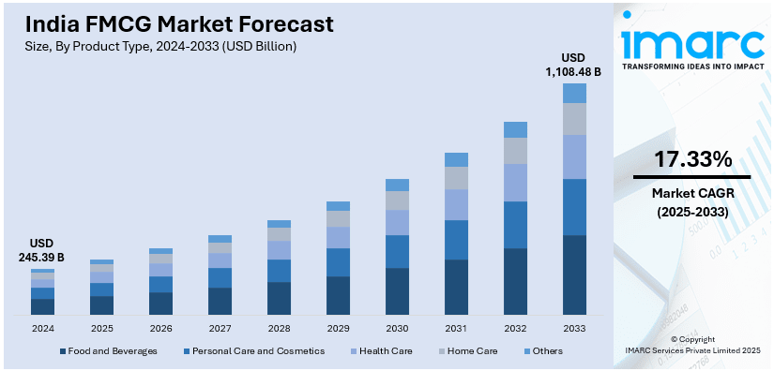
Figure 7: Indian FMCG market growth data
(Source: I Marc Group, 2025)

Influence of Cultural Factors on Nestlé’s Long-Term Success and Operational Performance
Nestle is highly influenced by the cultural aspects of its long-term success and performance in India along with the effects on consumer loyalty, workforce efficiency and stakeholder relations. The Power Distance in India is high as the employees prefer hierarchies and authoritative leadership (Zhai, 2022). Due to this reason, Nestle would have to seek to incorporate well-structured management systems and good management bodies to maintain stability in its operations. Collectivist culture in the country supports the community-based activities of Nestle like farmer training, nutrition awareness programme and CSR partnerships to build trust and brand equity. Collectivism reduces the consumer level, which also makes family-oriented products as well as communications more effective. This strengthens the constant interest in brands such as Maggi, Nescafé and Cerelac. The lower Uncertainty Avoidance in India encourages flexibility and Nestle may try new flavours, packages as well as marketing approaches without having to go through a cultural upheaval (Kamble, Tamboli and Khan, 2024). However, it has to be stated that this flexibility needs to be supported by strong internal quality controls to prevent informal practices that could influence safety and compliance. Cultural restraint as seen in the low Indulgence score of India keeps fertilising Nestle to focus on affordability, value-for-money products along with small packs innovations to continue penetrating the mass market.

5. Critical Discussion and Recommendations
1. SOP Adjustment 1: Localised Product Development and Quality-Control Processes
One of the significant changes Nestle should implement in its Standard Operating Procedures concerns the way of product development, testing as well as adjusting it to specifics of the culturally diverse and price-conscious Indian consumer market. On a broader note, it may be stated that the OLI framework underlines that even though Nestle has got good ownership advantages including global R&D capability, proprietary food technologies as well as brand recognition (Lasserre and Monteiro, 2022). Along with that, its internal operations need to incorporate India local taste profiles, dietary norms, along with the affordability needs to reap the maximum location benefits. The Indian cuisine is consistently based on the regional spices, the vegetarian dietary regulations, and the long-established sensory tastes, therefore, the product development SOPs need to incorporate obligatory local sensory panels, region-related recipe testing, as well as an organisation of localisation phase before commercial introduction. This is very crucial after following previous experiences like the Maggi controversy whereby lack co-ordination between local testing procedures and regulatory requirements exposed the effect of lack of localisation of quality-control mechanisms (Česalová, 2024). For an effective counter, Nestle should be able to integrate an updated SOP that would require India-specific R&D checkpoints, which entails the repetitive consumer-testing of products across several states, more stringent checks of compliance with the Food Safety and Standards Authority of India (FSSAI) and SOP-limited risk-assessment procedures that are sensitive to Indian food safety. On an additional note, the cultural analysis reveals that trust, familiarity with ingredients and safety are valued by Indian households particularly the mothers (Singh, 2024). Hence, SOPs of packaging communication, nutritional transparency and sourcing of ingredients has to be modified that includes mandatory processes of verification of claims, culturally appealing labelling, and affordable price without suffering a quality loss. The internalisation advantage of Nestle has been enhanced with the help of this adjustment since localisation is not outsourced to third party suppliers but is an internal capability. Finally, the localisation in SOPs enables Nestle to reduce cultural friction, enhance consumer acceptability, and have long-term market resilience.
2. SOP Adjustment 2: Strengthening Ethical Supply-Chain Management and Stakeholder Collaboration
The second necessary SOP change is related to the supply-chain activities of Nestle that should incorporate cultural as well as institutionally informed supply-chain activities of procurement, distribution and regulatory involvement into the multifaceted agricultural, retail, and logistics ecosystem in India. On a specific note, the socio-cultural structure of India highlights invaluable importance on the connection with the community, trust-building with the local vendors, and long-term collaboration with farmers; therefore, transactional procurement approaches, which have a Western imprint, can be conflicting. Nestle needs to reform its SOPs, instead, to institutionalise relationship-based supply-chain involvement, such as verified partner development, farmer training, and transparent contract processes and procedures in line with the local expectations (Basak, 2024). On a broader note, the OLI school of thought shows that though Nestle has advantages in terms of internalising quality control and technological transfer in its global supply chain, a successful internalisation in India means the incorporation of local standards of cooperation, respect, and informal communication patterns into formal processes. SOPs must organise its communication channels which should take into account the high context communication culture of India in which a message is communicated with the help of relationships and not through instructions. Moreover, since the regulatory landscape in India is mixed in terms of states, SOPs should incorporate the guidelines that should be used to perform the multi-level check of compliance, local legal audit, and continuous control over the changing food-safety regulations (Gupta et al., 2024). In addition to that, the ethical sourcing should be incorporated into SOPs with clear indicators of sustainability that are Indian-specific, including water-use optimisation, protection of livelihood of farmers, and traceability of crops in the region. This is critical in the state where cultural discourses highly reward the corporations that make local communities feel elevated and take part in the development of the nation in an observable way. From an operational point of view, SOP must also incorporate obligatory risk-reduction measures of infrastructural hurdles such as transporting dairy products through temperature-controlled means. This also includes mapping rural demand of the route, and structure distribution back-ups in case of disruption due to monsoons (Rahman and Hasan, 2024). Nestle enhances its location advantage by adjusting its supply-chain SOPs to capture the culture of trust, fairness, relational business practices, along with regional diversity. This has been important in the Indian context, and as such, its internalisation strategy is implemented smoothly within the disintegrated logistics context of India. This change will also favour the long-term reputation of Nestle because culturally insensitive supply-chain actions can be easily met with the blast of Indian media in the Indian media-saturated environment.
3. SOP Adjustment 3: Workforce Management, Cross-Cultural Training, and Decentralised Decision-Making
The third significant SOP change Nestle will have to take into account will be its human-resource practices, workplace communication standards, as well as leadership styles in the culturally unique organisational setting in India. The workplace culture in India has been observed to be hierarchical, relationship-based, and indirect than Switzerland, the mother country of Nestle. On a specific note, it has been observed that the SOPs standardising decision-making procedures, expectations of communication, or leadership behaviour in Western standards may foster organisational productivity and misunderstanding. As a solution to this, Nestle needs to come up with SOPs that incorporate cultural competency as a prerequisite in its operations such as well-structured cross-cultural training sessions to expatriates and local senior managers. These modules also need to include Indian expectations at the workplace, the type of negotiation, team dynamics, along with the culturally relevant feedback systems (Coates et al., 2025). Moreover, decentralisation of decision making by the regional managers should be mandatory as the Indian states are too diverse in their cuisine, religion, language and consumer behaviour. This decentralisation is in line with the OLI framework because it will be useful for Nestle to maximise the location advantages in India by unique managerial control with the help of reduced response to local market indications and operational flexibility. In addition to this, the SOPs concerning HR should formalise the inclusive hiring policies that focus on the development of local talents, diversity consciousness, and the involvement of the community. This plays an important part in India where customers tend to favour companies who may be seen as large contributors to the local job market and skill development (Ezeafulukwe et al., 2024). The performance-management SOPs must be modified according to the cultural inclination of the Indians. This should be collectivistic whereas the measures of performance done by teams are frequently more motivational than individual measures. More specifically, Nestle has to provide the SOP guidelines to control internal communication by using culturally appealing mediums: town halls, staff engagement practices (regional), and informal relations meetings which contribute to building trust. Finally, the conflict-resolution processes should be adjusted to meet the Indian negotiation style based on harmony and not conflict resolution (Wilhelm, 2025). These cultures along with institutional considerations incorporated into the HR and leadership SOPs will be useful for Nestle to make sure that the internal functioning of the company is supported by societal values of India and, thus, promote the level of staff satisfaction, their productivity, retention, and organisational integrity. Altogether, long-term success of Nestle in India has been observed to be largely dependent on its capacity to apply cultural insights to products, operations and stakeholder engagement practices. This not only minimises the cultural friction but also improves the internalisation advantage of Nestle as the workforce will work in a culturally optimised setting.

6. Conclusion
It may be concluded that the market entry and the long-term operation of Nestle in India proves that cultural alignment, localisation, as well as strategic adaptation are the key factors of the long-term success of operating in emerging markets. The varied consumerist behaviour of India, the high sensitivities of Indian society to food-safety along with the collectivist culture of the Indian business environment provides strategies for multinational companies to adjust their globalised practices. The above analysis of OLI demonstrated that even though Nestle owns several advantages i.e. good R&D, global brand equity, and technological capabilities is only realised when the advantages are in a localised manner. Equally, the cultural-distance test highlighted the necessity of products, communication style, leadership as well as supply-chain interaction localisation. On a further note, the suggested SOP modifications, such as local product development and quality management, culturally oriented supply-chain as well as ethical sourcing are all aimed at ensuring that Nestle would be able to minimise its operational risks. This may be helpful to create more trust with its consumers and become more responsive to regional diversity. From the use of such practices that are informed culturally, Nestle will be able to enhance its internalisation advantage in the process of attaining the massive growth potential in India. Finally, the success of Nestle in the Indian market in the long term will not be determined by the global models, but the local cultural intelligence installed in all levels within its operations, strategic along with management flows.

Reference List
Ahmed, A.M.M., Khaled, A.S. and Zaid, J.A., (2024). Impact of Consumers' Brand Loyalty Towards Nestlé Products in NCR, India. Journal homepage: https://gjrpublication. com/gjrbm,4(06). https://www.researchgate.net/profile/Gjr-Publication-3/publication/385525001_Impact_of_Consumers'_Brand_Loyalty_Towards_Nestle_Products_in_NCR_India/links/6729187277b63d1220da6b79/Impact-of-Consumers-Brand-Loyalty-Towards-Nestle-Products-in-NCR-India.pdf
Alon, I., Jaffe, E., Prange, C. and Vianelli, D., (2020). Global marketing: strategy, practice, and cases. Routledge. https://moodle2.units.it/pluginfile.php/243130/mod_resource/content/0/3_Segmentation_Targeting_Positioning.pdf
Avi-Yonah, R. and Kir, A., (2024). The Meaning of «Is»: Reflections on Nestle. Intertax, 52(4). https://papers.ssrn.com/sol3/Delivery.cfm?abstractid=4669271
Basak, J., (2024). Issues of rural artisans: a study and implementation of E-Commerce platform to mitigate the challenges http://20.198.91.3:8080/jspui/bitstream/123456789/8342/1/PhD%20Thesis%20%28Information%20Technology%29%20Jayanta%20Basak.pdf
Butt, U.I., (2024). Nestlé’s role in global food security, climate change and consumer health. International Journal of Social Sciences and English Literature, 8, pp.7-15. https://www.researchgate.net/profile/Umar-Butt-9/publication/384110099_Nestle's_Role_in_Global_Food_Security_Climate_Change_and_Consumer_Health/links/67040676b753fa724d647056/Nestles-Role-in-Global-Food-Security-Climate-Change-and-Consumer-Health.pdf
Česalová, A., (2024). Indian Influence in Uganda: The Case Study of Rolex: The Socio-Political and Cultural Inclusion Through the Lenses of Food. https://www.diva-portal.org/smash/get/diva2:1885565/FULLTEXT01.pdf
Coates, J.M., Santhanalakshmi, K., Dinesh, N., Gandhimathi, S., Chandel, P.S. and Selvakumar, P., (2025). Assessment and Evaluation in Transnational Staff Development. In Training and Development in Transnational Higher Education (pp. 387-406). IGI Global Scientific Publishing. https://www.researchgate.net/profile/Pankaj-Chandel/publication/391071318_Assessment_and_Evaluation_in_Transnational_Staff_Development/links/68105697bd3f1930dd675482/Assessment-and-Evaluation-in-Transnational-Staff-Development.pdf
corporatefinanceinstitute.com. (2023). Corporate Finance Institute. Available at: https://corporatefinanceinstitute.com/resources/management/eclectic-paradigm/ (Accessed: 2 December 2025).
Driffield, N., Harrington, L., Surdu, I. and Yuan, X., (2024). Maximising the (unequal) benefits of foreign direct investment: Addressing the two-speed problem. Contemporary Social Science, 19(4), pp.469-494. https://www.tandfonline.com/doi/pdf/10.1080/21582041.2024.2433670
Escandon-Barbosa, D., Ramirez, A. and Salas-Paramo, J., (2022). The effect of cultural orientations on country innovation performance: Hofstede cultural dimensions revisited?. Sustainability, 14(10), p.5851. https://www.mdpi.com/2071-1050/14/10/5851
Ezeafulukwe, C., Onyekwelu, S.C., Onyekwelu, N.P., Ike, C.U., Bello, B.G. and Asuzu, F.O., (2024). Best practices in human resources for inclusive employment: An in-depth review. International Journal of Science and Research Archive, 11(1), pp.1286-1293. https://www.researchgate.net/profile/Njideka-Onyekwelu-2/publication/378125970_Best_practices_in_human_resources_for_inclusive_employment_An_in-depth_review/links/65c7e28f34bbff5ba7fb831a/Best-practices-in-human-resources-for-inclusive-employment-An-in-depth-review.pdf
Gupta, D.K., Tiwari, A., Yadav, Y., Soni, P. and Joshi, M., (2024). Ensuring safety and efficacy in combination products: regulatory challenges and best practices. Frontiers in Medical Technology, 6, p.1377443. https://www.frontiersin.org/journals/medical-technology/articles/10.3389/fmedt.2024.1377443/pdf
imarcgroup.com (2025) India FMCG Market Size, Share | Industry Analysis 2033. Available at: https://www.imarcgroup.com/india-fmcg-market (Accessed: 2 December 2025).
Islam, M.S., (2022). Lead time for Nestle’s LC documentation arrival from global markets. https://dspace.bracu.ac.bd:8443/xmlui/bitstream/handle/10361/16890/18104173_BBA.pdf?sequence=1&isAllowed=y
Jain, P., (2021). Crisis Communication-The rise of New Brand Language in India. Psychology and Education. https://www.academia.edu/download/67499099/1998_Article_Text_3761_1_10_20210211.pdf
Jan, J., Alshare, K.A. and Lane, P.L., (2024). Hofstede’s cultural dimensions in technology acceptance models: a meta-analysis. Universal Access in the Information Society, 23(2), pp.717-741. https://link.springer.com/content/pdf/10.1007/s10209-022-00930-7.pdf
Joullié, J.E., Gould, A.M., Spillane, R. and Luc, S., (2021). The language of power and authority in leadership. The Leadership Quarterly, 32(4), p.101491. https://www.sciencedirect.com/science/article/am/pii/S1048984320301181
Kamble, S., Tamboli, S. and Khan, W., (2024). A Comparative Analysis on Marketing Strategies Adopted by Britanni a and Nestle with Respect to the State Maharashtra. FUTURE PROOFING BUSINESS, p.275. https://www.researchgate.net/profile/Sheetal-Bura2/publication/385514220_Embracing_Talent_Innovation_and_Disruptive_Technologies_FUTURE_PROOFING_BUSINESS/links/67287cb8ecbbde716b578128/Embracing-Talent-Innovation-and-Disruptive-Technologies-FUTURE-PROOFING-BUSINESS.pdf#page=285
Kamble, S., Tamboli, S. and Khan, W., (2024). A Comparative Analysis on Marketing Strategies Adopted by Britanni a and Nestle with Respect to the State Maharashtra. FUTURE PROOFING BUSINESS, p.275. https://www.researchgate.net/profile/Sheetal-Bura2/publication/385514220_Embracing_Talent_Innovation_and_Disruptive_Technologies_FUTURE_PROOFING_BUSINESS/links/67287cb8ecbbde716b578128/Embracing-Talent-Innovation-and-Disruptive-Technologies-FUTURE-PROOFING-BUSINESS.pdf#page=285
Kuzey, C., Dinc, M.S., Khan, F.U. and Raj, V., (2021). Foreign Direct Investment Decision-Making Motives for Multinational Enterprises: A Study of Eight Firms in an Emerging Economy. Journal of Management, Economics, and Industrial Organization, 5(1), pp.39-64. https://www.academia.edu/download/94642928/Foreign_Direct_Investment_Decision-Making_Motives_0.pdf
Lasserre, P. and Monteiro, F., (2022). Global strategic management. Bloomsbury Publishing. https://gsom.spbu.ru/files/upload/master_program/materials/international_business_strategy/lasserre_globalisation_indices.pdf
Manuel, L. (2022) 6.1 International Entry Modes, Global Marketing In a Digital World. Fanshawe College Pressbooks. Available at: https://ecampusontario.pressbooks.pub/globalmarketing/chapter/6-1-international-entry-modes/ (Accessed: 2 December 2025).
Nestle, (2025). Available at: https://www.nestle.com/investors/overview (Accessed: 2 December 2025).
Nestle, (2025). Available at: https://www.nestle.com/investors/overview/strategy (Accessed: 2 December 2025).
Orji, M.G., Oyenuga, M. and Ahungwa, A., (2020). Effects of Sales Promotion on Consummer Buying Behavior of Food Seasoning Among Nigerian House Holds: A Case Study of Nestle Maggi Naijapot’Budapest International Research and Critics Institute-Journal (BIRCI-Journal) Volume 3,(1). Budapest International Research and Critics Institute-Journal (BIRCI-Journal), 3(1), pp.134-149. https://www.academia.edu/download/62223981/BIRCU_PUBLISHED_JOURNAL20200228-105699-8pwlcz.pdf
Ozbun, T. (2025) Nestlé sales distribution by region 2024, Statista. Available at: https://www.statista.com/statistics/268894/food-sales-of-the-nestle-group-by-region/?srsltid=AfmBOooLugCD8Sxx0c72WkF7qa-CLVSoFvQsI8Jz3jH6bdXrO1SjR_t2 (Accessed: 2 December 2025).
Rahman, K.S. and Hasan, M.D., (2024). Balancing Ethics and Profitability: Strategies for Nestle to Overcome Ethical Scandals and Enhance Reputation. https://www.theseus.fi/bitstream/handle/10024/859440/Rahman_Hasan.pdf
Rahman, K.S. and Hasan, M.D., (2024). Balancing Ethics and Profitability: Strategies for Nestle to Overcome Ethical Scandals and Enhance Reputation. https://www.theseus.fi/bitstream/handle/10024/859440/Rahman_Hasan.pdf
Singh, S., (2024). Factors influencing perceptions of processed baby foods and feeding practices among Indian mothers: a qualitative investigation. BMC Public Health, 24(1), p.2734. https://link.springer.com/content/pdf/10.1186/s12889-024-19631-2.pdf
Takahashi, H., (2021). Everything Originated from Milk: Case Study of Nestlé. World Scientific. https://www.worldscientific.com/doi/pdf/10.1142/9789811235917_0001
theculturefactor.com (2025) The Culture Factor Group. Available at: https://www.theculturefactor.com/country-comparison-tool?countries=india%2Cswitzerland (Accessed: 2 December 2025).
Tze, X.C., Zhe, X.C., Sin, C.C. and Shieh, H.C., (2022). A Study on Marketing Strategy of Nestle in Asia. Advances in Global Economics and Business Journal, 3(1), pp.1-14. http://mail.agebj.org/index.php/agebj/article/download/46/24
Tze, X.C., Zhe, X.C., Sin, C.C. and Shieh, H.C., (2022). A Study on Marketing Strategy of Nestle in Asia. Advances in Global Economics and Business Journal, 3(1), pp.1-14. http://mail.agebj.org/index.php/agebj/article/download/46/24
Varma, T.M. and Perkins, S.C., (2020). Nestle India in a Soup: Mapping Emotions to the Use of Coping Strategies. Journal of Marketing Development & Competitiveness, 14(4). http://www.na-businesspress.com/JMDC/JMDC14-4/8_Varma_PerkinsFinal.pdf
Wilhelm, L., (2025). Formulating development: How Nestlé shaped the aid industry (p. 288). Manchester University Press. https://library.oapen.org/bitstream/handle/20.500.12657/106483/1/9781526181008.pdf
Zhai, J., (2022). The impact of the COVID-19 pandemic on Nestlé enterprise and its response. https://digital.car.chula.ac.th/cgi/viewcontent.cgi?article=9099&context=chulaetd

Appendices

Appendix 1: Nestle marketing Strategy
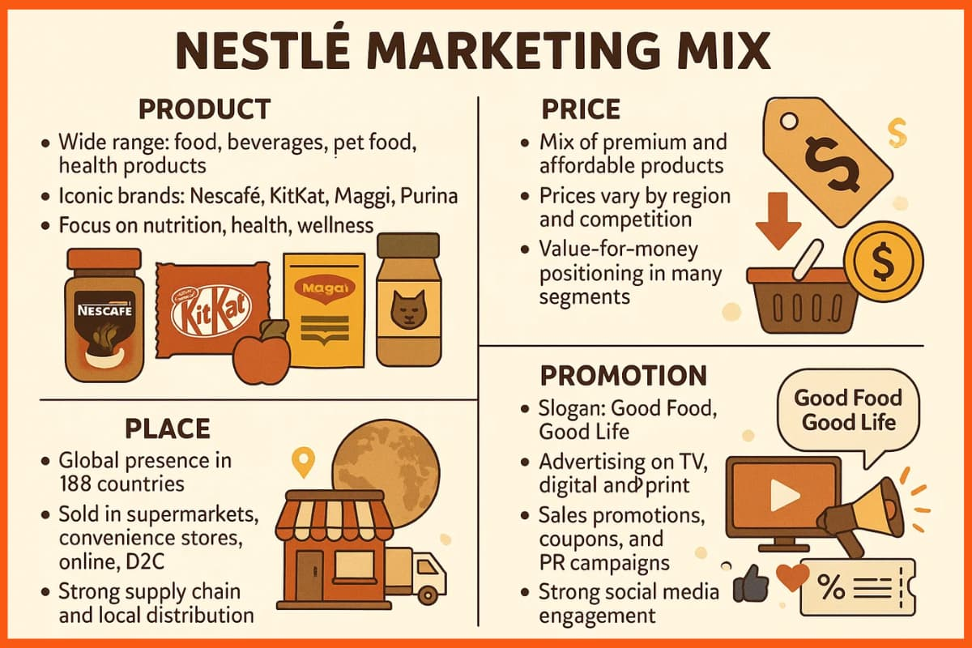

Appendix 2: Business Model Canvas of Nestle


