Oliver Altissimo

2305263

Game Design And History (ACCA4033)

Life Is Strange

“Life is strange: Chrysalis” [1] game develop by “Dontnod Entertainment [2]”, the same development team that made the emotionally charged story “Remember Me” [3], published by “Square Enix” [1] on 30 January 2015.
“Life is Strange” [1] plays on the two words “Life” and “strange” the dialogue and the thrust of the game are woven around these words. Therefore, we must ask the question how are these two words intrinsically linked? The Oxford dictionary defines “life” as a state of ceaseless change and functional activity peculiar to organized matter. “Strange” is defined as foreign, alien, not one’s own, queer, peculiar, eccentric, surprising, unaccountable, unexpected [4]. In defining these words “life” and “strange” we must ask our self how the dichotomy of these words can blend together.
The philosopher J.P. Satre (1905-1980) in his work Being and Nothingness- seems to predict the title “Life is Strange” [1]. He advocates a view of life as being absurd or erroneous. It was as if he felt that people were defining their own reality [5]. In other words, having to make choices which is a characteristic of this computer game.
So both these definitions start to give us a clue of how this game might have evolved. By analysing the “Life is strange: Chrysalis” in detail, this might give us an insight into the construction/philosophy of the game and its potential commercial prospects.
To create an intriguing story as the book (Game design: Theory and practice) says the key concept for an interesting gameplay is non-linearity and the aim of the non-linearity is to give the player the control over the progression of the story. This in contrast to single player games have a similar path to each other because they are linear, even in well-known titles like “the Final Fantasy saga (1988-2014)”, “Dishonored (2012)”, “the Bioshock series (2007-2013)” [6], are based on linear storytelling [6]. The implication of Linear Storytelling is that it follows a line, the progress of the story is from A to B and to progress to B you must complete A.
Non-linearity gives the player a sense of control of the game. In the combinations with non-linearity and storytelling, it harvests an enhanced gaming experience for the player, giving them choices to explore the story. With the non-linearity and the storytelling, the game spontaneously creates a branching story. The core of a branching story is, it allows the player to choose a path to travel down and whatever route the player chooses the ending of the story will differ [7]. Good examples of non-linearity storytelling can be seen in well-known titles like “Telltale Storeys: The Walking Dead Series”, and “Quantic Dream: Heavy Rain”.
For every Important choice that the player make in “Life is Strange” [1] the game will indicate that the story branches in a different direction it will show this through a butterfly symbol appearing on top left of the screen.
This concept of non-linearity and storytelling is at the core of the game.
As the book “Rouse and Ogden Steve. (2005) Game design: Theory and practice” says “the goal of game storytelling is to create a story in which players feel they can play a significant role that may affect the outcome. Non-linearity is an essential tool for accomplishing that goal. To add non-linearity to the storytelling experience is through a branching story” [7].
Mixed within the non-linearity there is a rewind function so the player can reverse their choice. This functionality means the player does not have to quick save or got to the main menu, and load the save file, but they can rewind back in time (within that level) and choose a different action. This was inspired by the game “Remember Me” [3]. allowing players to rethink their choices. Both non-linearity and the rewind factor gives the game a replay value as they both encourage the gamer to replay and discover the different branches of the story.
“Life is strange” was proclaimed the most visually attractive games released in 2015, and. the concept artist Edouard Caplain is behind all this.
He was the main influence in creating the aesthetics of the game and during his work he had a broad range on innovation and creativity. “I love it. And you do not always have such a broad range to play with in every production, so it was sweet to have that freedom on Life is Strange.” [8]
Before joining “Dontnod Entertainment” he worked on other projects like “Alien: Isolation” and “WarDevil: Unleash the Beast Within” [8]. “Life is Strange” [1] is his first work where he started from the beginning right through to the finish in putting his ideas and experience from other games into practice. [8]

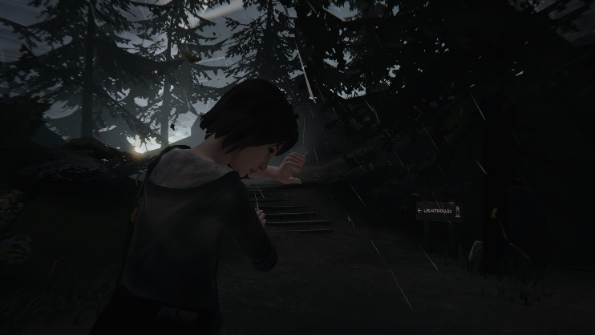

Edouard Caplain used the colour palette in an intriguing way. Within the colour palette in the game are two dominant tones: warm and cool. The warm shades are orange, red and yellow representing autumnal feel, and the cold shades blue and black represent loneliness and sadness. For example, when the character Maxine is with people, Caplin uses the warmer tones when she is on her own within a cutscene with the tornado, it changes to blue and black tones [9].
Artists have used this technique to evoke feelings within their works through the ages and in film and television today the use of colour is used to portray a sense of feeling dependant on the colours used: - Cartoons such as Simpson [10] or films like The Birds: directed by Alfred Hitchcock [11]. Edouard Caplain was tasked additionally to create the town “Arcadia Bay” as close to realism and keeping with his art style.
The town was based in the state of Oregon (USA) [8] around the city of Astoria, but it turns out it was too big. He wanted “a typical” quaint town which he found in a small seaside town named “Garibaldi" [8].
Most of the story in chapter 1 is based around the academy of “Blackwell Academy”. The school was built in 1910 on top of a hill above the town. His initial research was to depict a style of architecture and material of that era, with the surrounding neighbourhood/nature of that period too. [8]
During the process of his study, Edouard Caplain realized that the making of “Blackwell Academy” was one of his favourite pieces to work on. [8]

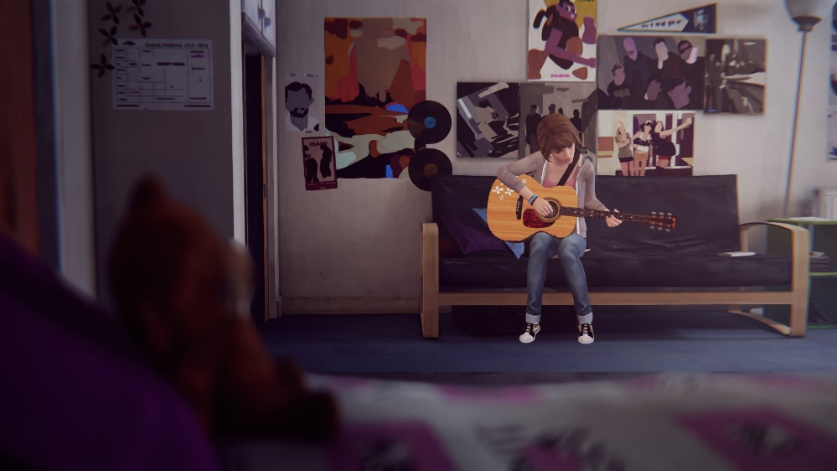
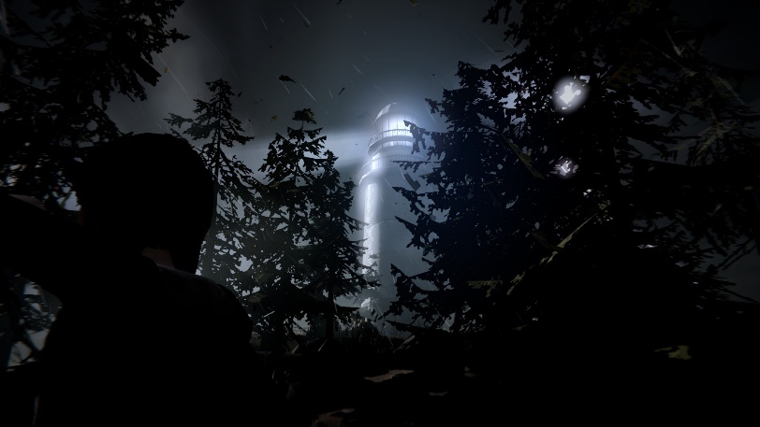
The art aspect of the game is one of the main cores, the sound design is another standing by the side of it, playing a key role in setting the atmosphere for the game.
The music in the game manages to immerse the player even deeper into the story. A team of; composer Jonathan Morali, audio lead Sébastian Gaillard, audio artist Frédéric Devanlay, sound designers Louis Martin and Yannick Tassin worked together on an indie-folk genre for the bulk of the game using mainly an acoustic guitar. [12]
Most companies usually manage to produce their own types of music for their games, but since the team developing this game did not have a large budget, they licensed a band for their music. The band named “Syd Matters” whereby they chose two tracks of music "To All of You" and “Obstacles” [13] coming from their album “Someday We Will Foresee Obstacles”.
Choosing this path was a good idea for a cost and time point of view. Maxine is played by the voice of Hannah Telle [13] putting Maxine into a realistic life situation, the team had to not only concentrate on the visual art, but also to mimic a realistic sound environment.
In trying to portray a realistic sound environment the sound design team used diegetic audio to mimic the surrounding sounds of nature and the school [13].
The sounds Maxien hears, such as the school bell or the wind cutting through the trees, the player will hear it so providing a better immersion into the game. [14] When Max is in the corridor at the beginning of the game, you can hear very clearly the surrounding sound. But when she puts on the headphones there is a fading transition from the surrounding sound to the music playing. This is good example of diegetic audio.
“Life is Strange” it’s a graphic novel, involving the player to make choices and work through their consequences. Under this story line is the writer Jean-Luc Cano, who has been developing the story from the beginning. Jean-Luc Cano was tasked to draft the story and the different outcomes of the game, keeping in mind the rewind mechanics [15]. The narrative in the game leads you into a dark story of choices with intriguing characters. To do this, Jean-Luc Cano has elevated the dramatic and exciting moments with challenging storytelling, and character development all linked to collaborating with the team of artist and sound designers to produce the game. In the first chapter as the player is getting to know the main character, they also discover a new acquired power, in turn this will decide which destiny to follow along the story. At the beginning of the story, as a player we get introduced to a female character walking in a middle of a woods.
Moving towards the cliffs looking for shelter, she finds a lighthouse. The storm develops into a tornado and blows down the light house collapsing onto her. Suddenly, she wakes during her photography class and realized it was all a dream. After class, she goes to the bathroom to freshen up here she sees a butterfly flying around in the corner. Maxine follows the butterfly and takes a photo of it. Unexpectedly, a boy enters the bathroom followed by a young blue hair girl, threatening and black mailing the boy about drugs. The young boy pulls out a gun and accidentally shoots the blue hair girl. Maxine attempts to stop the boy, she raises her right hand and suddenly she’s back in the classroom where she had woken up from the unusual dream. At this point in time, Maxine realizes that by raising her arm she can go back in time. (This is the new power she has acquired).
Showing from the beginning the character development and dramatic and exciting moments that Jean-Luc Cano was aiming for.
When the game was released, one of the raising critics for the game was that games was made for girls since it had a female protagonist. But the developer has contradicted this statement saying that male and female can enjoy the story and the game [16, 17]. The official age rating for the game “Life is Strange” [1] is meant to be 16+ [1] years old or young adult. but the game is being played by younger audience as the comments for the games are from teenagers around 13 to 15 [18], because how they can relate to the characters and the life struggles as Maxine (main character) how is very shy and an introvert.
“Dontnod Entertainment” have realise that if player learns at the same time as the character how to use their new abilities, the player will be more attracted to the game and manage to find the right flow for their audience.
As the player will be traveling in a very steady calming flow throughout the story the games will allow the player to sprint, but the sprint is not too abrupt and doesn’t add to the flow, allowing the player to enjoy the story. Throughout the game the player will have to look or find, the information given to them through cutscenes, the player cannot skip them and miss any information.
The game throws at the player sets of choices and results with consequences. The main challenge for the player is which choice to take, decisions between the good one and a bad one.
In the first chapter there are twelve achievements and for getting these achievements the player must take eleven “Optional photo” during the story (the last one achievement is just for finishing the chapter).
For completing these achievements the player must take photos of an object, marks or incisions, people, and animals etc. If the player wants to complete the game a 100%, they must go back to that check point and search for the perfect photos.
Since the developing team and budget were small, they decided to concentrate on the story and the art style of the game. An example of lack of detail is the lip sync. This isn’t one of the best as the player can see sometimes the character mouth moves without any coordination. In an interview with Red Bull, they said that they use an automatic lip-sync for the characters. [15]
During the journey in “Life is Strange” the game suggests using a controller, but it can be played whit keyboard as well. Through the experience of playing the game the preferred method would be using a controller, since using a keyboard is quite confusing. “Life is strange” [1] is a very well-made game for a small developing team. The game really outshines itself in the art style and the storytelling. The art style takes the player through a very relaxing and calming story. Other important characteristic of the game is the rewind mechanics allowing the player to travel back in time and choose a different outcome hence non-linearity. Unfortunately for this small team certain aspects of the game are not completed and badly done like the lip-sync, or the controls for keyboard.
The community did not really receive the game very well, and heavily criticised it, for its dialog. The game didn’t have an impact on the gaming market due to the above-mentioned aspects, but the team knew they had a good revolutionary story-based choice and consequence game with unique cinematography.

Bibliography

[1] | Author, “Life is strange,” [Online]. Available: https://www.square-enix-games.com/en_EU/games/life-is-strange. [Accessed 1 11 2023].
[2] | “DontNod,” DON'T NOD. [Online]. [Accessed 31 10 2023].
[3] | “Remember Me,” dontnod entertainment, [Online]. Available: https://dont-nod.com/en/games/remember-me/. [Accessed 12 10 2023].
[4] | H. W. Fowler, F. G. Fowler and E. McIntosh, “The concise oxford dictionary,” in The concise oxford dictionary, Oxford, Clarendon Press, 1931, p. 658;1202.
[5] | W. O. O’Brien, “The Meaning of Life: Early Continental and Analytic Perspectives,” Internet encyclopedia of philosophy, [Online]. Available: https://iep.utm.edu/mean-ear/. [Accessed 15 10 2023].
[6] | M. Shepard, “Interactive Storytelling - Narrative Techniques and Methods in Video Games,” scalar, 12 05 2014. [Online]. Available: https://scalar.usc.edu/works/interactive-storytelling-narrative-techniques-and-methods-in-video-games/linear-and-non-linear. [Accessed 2023 10 23].
[7] | R. Rouse and S. Ogden, “Game design: Theory and practice,” in Game design: Theory and practice, Plano, TX, Wordware, 2005, p. 119;223.
[8] | N. V. and R. , “Edouard Caplain on the Art Behind Life Is Strange,” Vox Groovy, 09 02 2016. [Online]. Available: https://www.voxgroovy.is/archives/12106. [Accessed 2023 10 12].
[9] | E. Caplain, “The Artist behind Life is Strange,” 80Live, 03 03 2016. [Online]. Available: https://80.lv/articles/life-is-strange-concept-artist-talks-about-art/. [Accessed 12 10 2023].
[10] | C. Herbert, “Matt Groening explains why the Simpsons are yellow,” JEO, 08 11 2022. [Online]. [Accessed 2023 10 27].
[11] | Author, “The Birds,” IMDb, [Online]. Available: https://www.imdb.com/title/tt0056869/. [Accessed 29 10 2023].
[12] | J. Metreau, “'Life is Strange': How the Frenchman Jonathan Morali created a folk soundtrack to link,” 20minutes, 25 01 2016. [Online]. Available: https://www.20minutes.fr/culture/1771631-20160123-life-is-strange-comment-francais-jonathan-morali-cree-bande-originale-folk-lier. [Accessed 22 10 2023].
[13] | A. Jones, “Life is strange game audio review,” The Sound Architect, 16 04 2016. [Online]. Available: https://www.thesoundarchitect.co.uk/life-is-strange-game-audio-review/. [Accessed 2023 10 22].
[14] | B. Maestro, “What is the difference between diegetic sound and non diegetic sound?,” BBC Maestro, 12 01 2023. [Online]. Available: https://www.bbcmaestro.com/blog/diegetic-vs-non-diegetic-sound. [Accessed 24 10 2023].
[15] | D. McFerran, “Be kind, rewind: The making of Life Is Strange,” Redbull, 28 08 2025. [Online]. Available: https://www.redbull.com/gb-en/life-is-strange-interview. [Accessed 21 10 2023].
[16] | D. Bonthuys, “Main Character's Gender Irrelevant to Creating a Good Story, Life is Strange Dev Say,” GameSpot, 01 02 2015. [Online]. Available: https://www.gamespot.com/articles/main-character-s-gender-irrelevant-to-creating-a-g/1100-6425024/. [Accessed 29 10 2023].
[17] | M. Hoimes, Interviewee, Life is Strange - Michel Koch and Jean-Luc Cano Interview. [Interview]. 28 04 2016.
[18] | M. Lafferty, “Parents' Guide to Life is strange,” Parents' Guide to Life Is Strange, 2015. [Online]. Available: https://www.commonsensemedia.org/game-reviews/life-is-strange. [Accessed 18 10 2023].
[19] | V. v. Gogh, Artist, Wheatfield with Crows. [Art]. Vincent van Gogh Foundation, 1890.
[20] | S. Schiesel, “Murderer's young prey; a father's torment,” The New York Times, 27 02 2010. [Online]. Available: https://www.nytimes.com/2010/02/27/arts/television/27heavy.html. [Accessed 25 10 2023].
[21] | A. v. d. Meer, “Structures of choice in narratives in gamification and games,” Medium, 09 09 2019. [Online]. Available: https://uxdesign.cc/structures-of-choice-in-narratives-in-gamification-and-games-16da920a0b9a. [Accessed 1 11 2023].

