  Component One:  What are the key skills required when working in the housekeeping team? 750 words (+/- 10%)  Contribution to Overall Module Assessment: 25% | Student No: | 2207143
 | Module Title: | Operating Hotel Facilities
 | Module Code: | BMIH4006
 | Lecturer: | Hotel Placement
Introduction
The hotel industry depends a lot on people who are good at doing different things, like being organised, talking to others and getting along with people. This report is about looking at the important skills I need to work in housekeeping in a hotel. Therefore, this report will focus on thinking about myself and what I am good at in the housekeeping field. Here, I will talk briefly about how important certain skills are for people who work in hospitality and why they matter. The importance of people who clean and maintain hotel rooms will be talked about in this article from my own experience.
Discussion

A person in charge of keeping guest rooms tidy and orderly in preparation for incoming guests is known as a room attendant. These skilled individuals undertake the cleaning of lavatories, replacing bedding, replenishing bathroom supplies, vacuuming carpets and wiping off the dust from furniture (Raghubalan and Raghubalan, 2016). A professional in the field of housekeeping is responsible for managing cleaning and maintenance tasks in different sections of a hotel, such as guest rooms, corridors and communal areas. Their primary objective is to guarantee that the guests enjoy clean, organised and welcoming accommodations. Performing cleaning and upkeep duties for guest rooms, communal spaces and laundry facilities. Therefore, to guarantee the cleanliness and organisation of a room or space, housekeeping experts must pay attention to even the minutest of particulars. This position entails a considerable amount of physical exertion, encompassing activities such as prolonged standing, stooping, hoisting and moving about. Effective time management is essential for housekeeping professionals to stay on track and complete their tasks efficiently. The proficiency of housekeeping personnel in communicating with guests and fellow staff is crucial in ensuring a pleasant and satisfying stay for the guests (Leiter and Bakker, 2010). Moreover, to thoroughly clean and upkeep a hotel room or public space, housekeeping personnel must possess the skill of adhering to intricate directions (Casado, 2012).
Throughout my employment as a housekeeping personnel at Marriott, I have acquired a plethora of valuable experiences and skills. Therefore, it has become apparent to me that meticulousness and efficient time allocation constitute highly esteemed proficiencies in this given field. As a housekeeping staff member, my responsibilities require me to exhibit proficiency in the areas of efficiency, attention to detail and organisational skills, which I perceive as some of my strong points. One of the key strengths I possess in this role is my ability to exhibit a high level of attention to detail. I derive a sense of satisfaction from meticulously maintaining an immaculate and impeccably organised living space that adheres to the most exacting of standards (Mullins and Dossor, 2013). I consistently engage in the practice of diligently reviewing and scrutinising my assignments to guarantee the utmost accuracy and precision in all facets of my work. I possess proficient time management abilities. I possess the knowledge and skills necessary to prioritise my tasks and work with proficiency, thereby accomplishing the given tasks within the designated time frame (Cottrell, 2019). The acquisition of this skill set is indispensable in a professional milieu where demands are high and time constraints are prevalent. Notwithstanding, indication suggests that there exist certain domains that require improvement to achieve success within the realm of housekeeping. One aspect that necessitates improvement is my proficiency in communicating effectively. However, at times, I encounter difficulty in effectively communicating with fellow staff members, particularly in circumstances where a language barrier exists. This undertaking aims to enhance my communication skills, to optimise my ability to collaborate harmoniously with every member of the team. One additional competency which I must cultivate is my capacity for multitasking which is a commonplace occurrence in modern society. Whereby individuals must contend with the simultaneous execution of multiple tasks and occasionally, the task of managing multiple responsibilities can present a formidable challenge (Quick, 2020). Furthermore, it is arguable that developing competencies in multitasking would enhance productivity and enable the completion of tasks within shorter timelines. Overall, employment within the housekeeping department can be regarded as a significant occasion for educational advancement. Numerous skills crucial to this particular field have been acquired by me, namely precise focus and efficient time allocation. Although there are still certain aspects that require improvement, I possess a firm belief that through persistent endeavour, I can evolve into a proficient and esteemed member of the collective.

Conclusion
The essay has explained the important skills needed to work well on Marriott's housekeeping team. Hotel industry needs people with basic abilities like speaking well, managing time and being smart and they need to have specific skills that are very important. The above essay has discussed my experience while working in the hotel industry as a housekeeping staff. Using what I learned in my study helped me deal with hard things during my employment. Further, the above reflective essay has explained why the housekeeping team is important in the hotel sector.

Word Count | 822

Component Two:
Contribution to Overall Module Assessment: 25%
In this scenario – You have just been promoted to the team leader for a floor within the hotel. A guest complains that on their arrival, their room had not been properly cleaned. Create an action plan and answer the following questions.

Problem | Why did it happen? | What are you going to do? | How will you prevent this from happening in the future? | What measures would you introduce to improve team effectiveness?
A guest is upset that when they got to their room, it was not cleaned well. | The room might not have been cleaned well because the staff didn't talk to each other properly. | First, I would apologise to the guest and assure them that we will take immediate action to ensure that room was not properly cleaned. I would write down the problem and try to find out why it has happened. | Regarding the matter, to make sure nothing bad happens again, I will make a bigger list of things to clean that cover everything in the room. I will personally check regularly to make sure that things are being cleaned properly (Fallon & Rutherford, 2010). | I will set clear goals and expectations for each team member to make the team work better (Ferdinand and Kitchin, 2017).
A guest is upset that when they got to their room, it was not cleaned well. | There are many reasons why the room might not have been cleaned well like maybe there are not enough cleaning things available. | I will tell the people who clean the rooms about the problem right away and ask them to clean the room again until the guest is happy. Next, I will see why there might be a problem with the cleaning supplies by looking at how much we have and where they are stored. | I will check each room carefully to make sure it is clean and meets the hotel's hygiene rules before guests can stay there. I will check to make sure that there are always cleaning supplies available for the housekeeping staff to use (Johnston et al., 2012). | I will have team meetings often to talk about any problems and try to work better as a team. I will also check if we need more cleaning supplies to do our job (Jones, 2010).
A guest is upset that when they got to their room, it was not cleaned well. | There might not have been enough workers which caused them to clean quickly and as a result, some places might have been missed. | First, I will say sorry to the people who clean the rooms and the people at the front desk because the room was not ready. I express remorse for the disturbance encountered and guarantee the prompt correction of the issue (Rogers, 2008). | I will make sure that the people who clean the rooms talk more with the people at the front desk. This way, I can make sure that all the rooms are really clean when we give them to our guests. | I plan to ramp up the number of housekeeping personnel to ensure that every room is impeccably cleaned and done on time (Tesone, 2010).
A guest is upset that when they got to their room, it was not cleaned well. | Various factors might have contributed to the inadequate cleaning of the room. Possibly, the reason for this could be the inadequate training of those who have recently taken up the responsibility. | My foremost duty as the team's head is to promptly and courteously address any concerns expressed by the guest. I will check the room myself to see if anything needs more cleaning and make sure it is taken care of right away. | I will give newly joined housekeeping staff regular training on how to clean hotel rooms well. I will also teach them how to spot places that need extra cleaning. | I will keep teaching and helping all the new employees until they get better at their job. I will make sure everyone knows what they need to do and give them feedback when they do a good job (Sharma et al., 2019).
A guest is upset that when they got to their room, it was not cleaned well. | There might be different reasons why the guest's room was not cleaned properly when they first came, like not having enough time to clean it. | I will check right away if the housekeeping workers had too much work to do or did not use their time wisely. | I would make a stricter list for the cleaning staff to follow and make sure they are doing their job well (Wood, 2013). | I will check how well my staff is doing and what they need to work on and I will also look at how they use their time at work, regularly. I will give credit and prises to team members who do an outstanding job (Vallen & Vallen 2012).

Component Three:
Contribution to Overall Module Assessment: 50%
Your task is to create and prepare a presentation following the detailed scenario provided below.

As the floor housekeeping manager and given the recent guest complaints you need to put together a basic training presentation for your colleagues within the housekeeping team to get the best out of them, ensure that brand standard is being achieved and that Health and Safety procedures are also being followed.

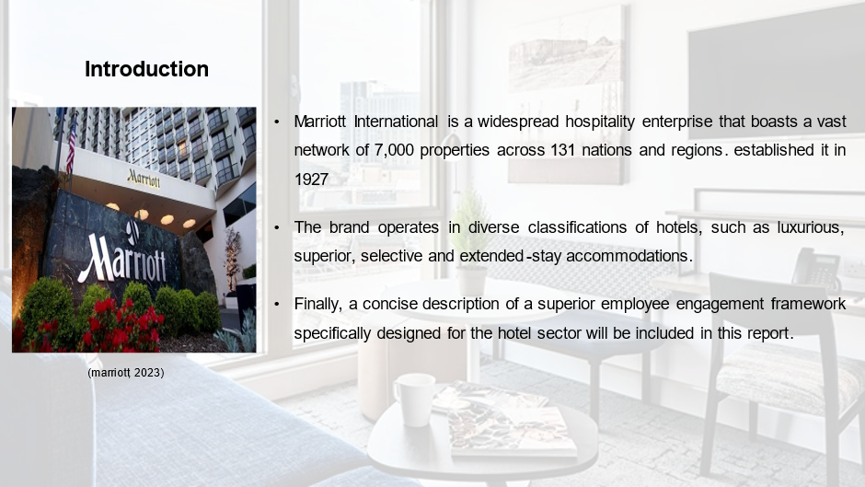
Training Notes: Introduction
Marriott International is a widespread hospitality enterprise that boasts a vast network of 7,000 properties across 131 nations and regions. established it in 1927. After being founded by J Willard Marriott, the hotel chain has grown to become a major player in the global hospitality industry (marriott, 2023). The brand operates in diverse classifications of hotels, such as luxurious, superior, selective and extended-stay accommodations. As the manager in charge of housekeeping at Marriott Hotel, I plan to address recent visitor complaints by implementing essential training strategies for my colleagues in the housekeeping department. I believe that by implementing these strategies, individuals will gain a clearer comprehension of their job duties and obligations, ultimately enabling them to showcase their exceptional abilities. I must ensure that both brand guidelines are being met and safety measures are being implemented. Finally, a concise description of a superior employee engagement framework specifically designed for the hotel sector will be included in this report.
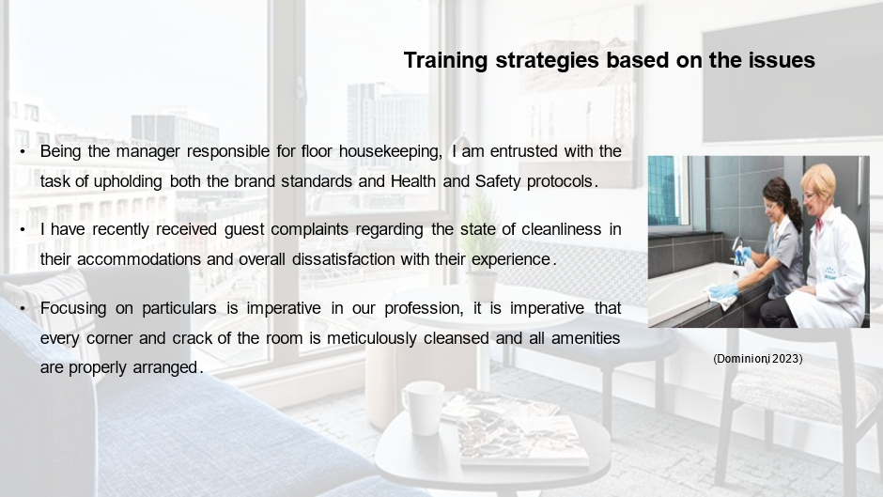
Training Notes: Training strategies based on the issues
Being the manager responsible for floor housekeeping, I am entrusted with the task of upholding both the brand standards and Health and Safety protocols. I need to ensure that our guests enjoy a hygienic and comfortable stay while they are staying in our hotel. I have recently received guest complaints regarding the state of cleanliness in their accommodations and overall dissatisfaction with their experience. Therefore, to optimise the performance of our team, all members must possess a thorough understanding of the prevailing brand requirements, topmost standards and Health and Safety protocols (Dominioni, 2023).
Attention to Detail
Focusing on particulars is imperative in our profession, it is imperative that every corner and crack of the room is meticulously cleansed and all amenities are properly arranged. Therefore, it is imperative to meticulously inspect and scrutinise every facet of the space to ascertain that no detail has been overlooked.

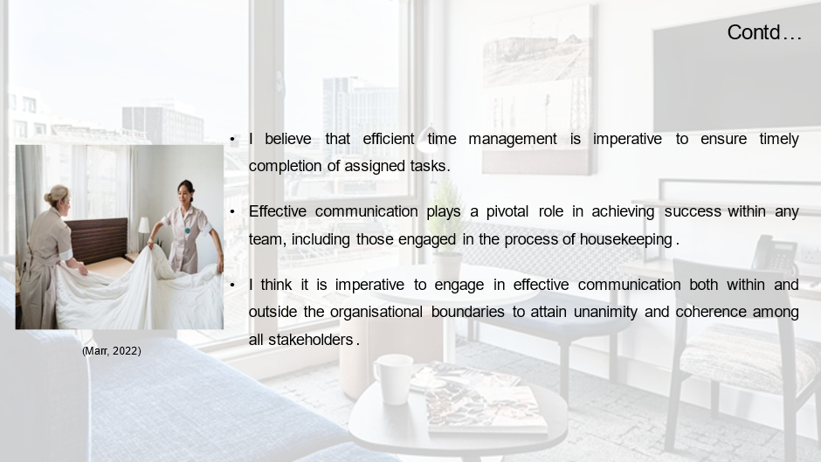
Training Notes: Time Management
I believe that efficient time management is imperative to ensure timely completion of assigned tasks. Therefore, it is imperative to properly allocate one's time and prioritise obligations to ensure the timely completion of tasks while maintaining quality standards.
Communication
Effective communication plays a pivotal role in achieving success within any team, including those engaged in the process of housekeeping. I think it is imperative to engage in effective communication both within and outside the organisational boundaries to attain unanimity and coherence among all stakeholders (Marr, 2022). Therefore, it is imperative to maintain communication regarding any revisions or modifications in the timetable and collaborate to ensure the successful completion of tasks.
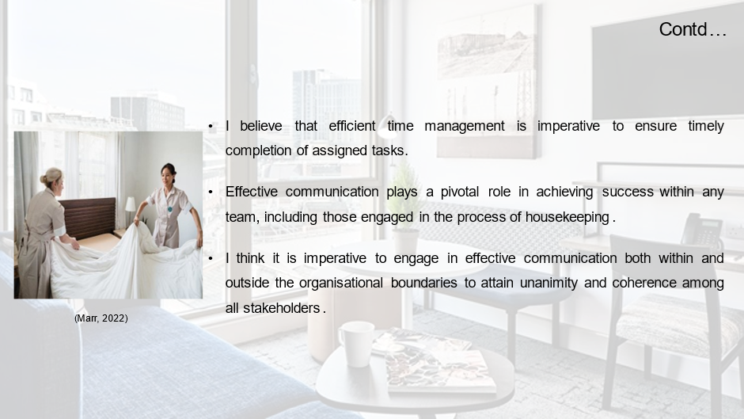
Training Notes: Daily checklists
I believe that it is imperative to furnish the housekeeping staff with daily checklists that outline the requisite tasks for preserving the hotel's brand standards and adherence to health and safety protocols. I will motivate my staff to mark the checkboxes after accomplishing every undertaking and be permitted to keep the checklist readily accessible over the day. Establishing periodic reviews of the checklists in collaboration with them to evaluate their advancements can have a positive impact on the operations of our hospitality establishment.
Peer mentoring
One strategy which will be implemented is the allocation of experienced staff members to novice employees to furnish them with proper guidance and support (Ark, 2022). This will promote a cohesive sense of community among my team members and enhance their collaborative efforts.

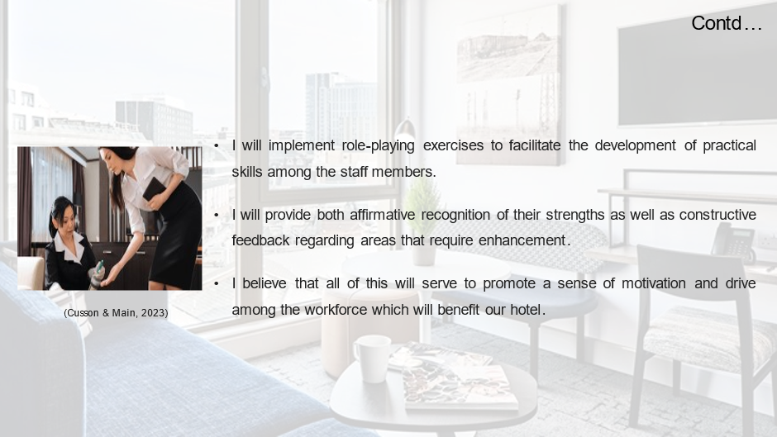
Training Notes: Role-playing exercises
I will implement role-playing exercises to facilitate the development of practical skills among the staff members. Thereby enabling them to adeptly navigate a wide range of complex and challenging situations that may emerge in the course of their professional duties. I contend that the implementation of this particular strategy would prove to be exceedingly advantageous in the resolution of issues about complex guests or the assurance of comprehensive safety protocols.
Feedback sessions
Another strategy is to promote continuous improvement among my staff members, I will schedule frequent feedback sessions (Schmidt, 2021). I will provide both affirmative recognition of their strengths as well as constructive feedback regarding areas that require enhancement. The aforementioned approach is likely to motivate individuals to share their input and suggestions for enhancement.
Incentives
The current strategy entails the implementation of an incentive strategy for all employees, contingent upon sustained adherence to the hotel's brand standards and strict conformance to health and safety protocols (Cusson & Main, 2023). The incentivisation of employees can be achieved through various means, including acknowledgment during corporate gatherings, financial incentives such as bonuses, or advancement opportunities. I believe that all of this will serve to promote a sense of motivation and drive among the workforce which will benefit our hotel.

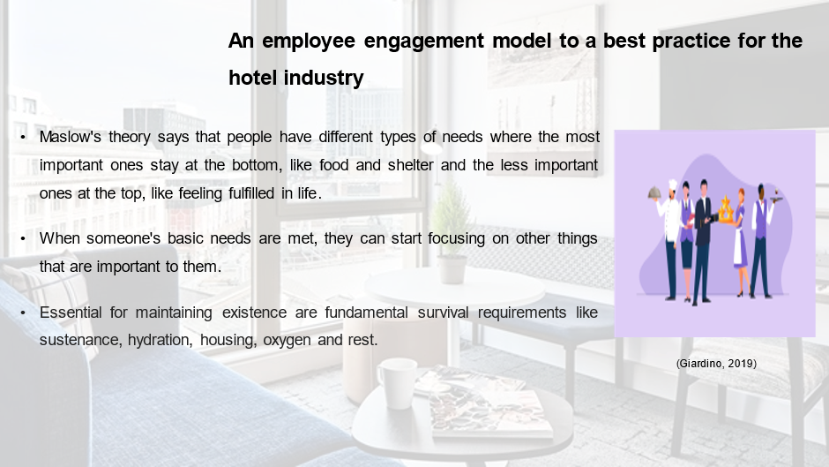
Training Notes: An employee engagement model to a best practice for the hotel industry
Maslow's theory says that people have different types of needs where the most important ones stay at the bottom, like food and shelter and the less important ones at the top, like feeling fulfilled in life (Bridger, 2018). When someone's basic needs are met, they can start focusing on other things that are important to them (Giardino, 2019).
Physiological needs
Essential for maintaining existence are fundamental survival requirements like sustenance, hydration, housing, oxygen and rest (Ferrazzi, 2023).
Safety needs
After fulfilling basic physiological requirements, the subsequent essential needs to satisfy are related to protection and stability.

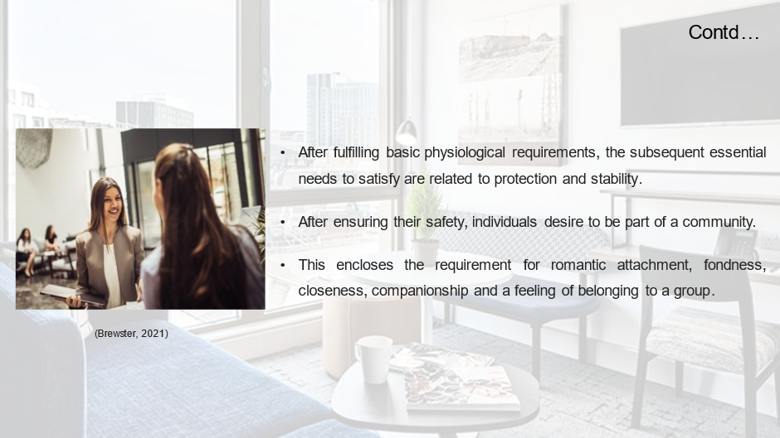
Training Notes: Safety needs
After fulfilling basic physiological requirements, the subsequent essential needs to satisfy are related to protection and stability.
Love and belonging need
After ensuring their safety, individuals desire to be part of a community. This encloses the requirement for romantic attachment, fondness, closeness, companionship and a feeling of belonging to a group.
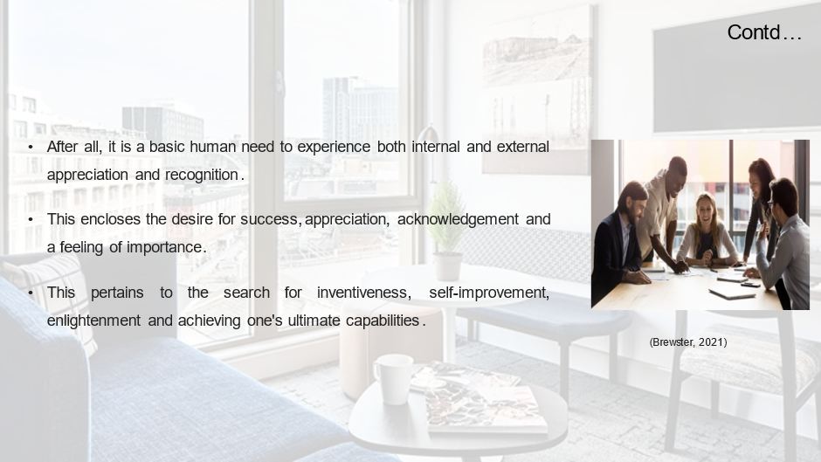
Training Notes: Esteem needs
After all, it is a basic human need to experience both internal and external appreciation and recognition. This encloses the desire for success, appreciation, acknowledgment and a feeling of importance (Brewster, 2021).
Self-actualisation needs
At the most elevated stage, human beings aspire to realise their utmost potential and attain a sense of direction and significance in their existence. This pertains to the search for inventiveness, self-improvement, enlightenment, and achieving one's ultimate capabilities.

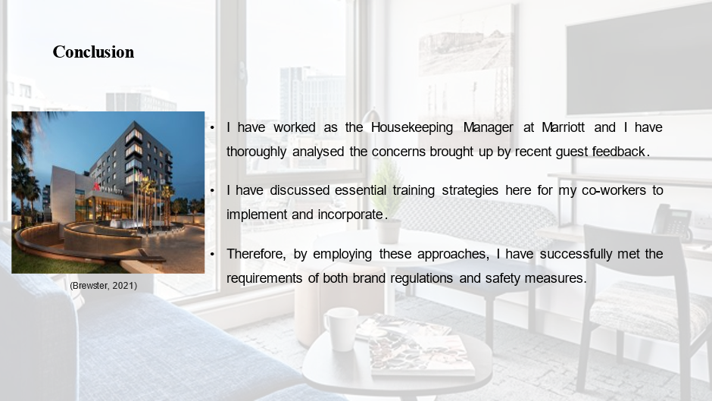
Training Notes: Conclusion
I have worked as the Housekeeping Manager at Marriott and I have thoroughly analysed the concerns brought up by recent guest feedback. I have discussed essential training strategies here for my co-workers to implement and incorporate. I believe that, by putting these strategies into action, my staff can gain a thorough comprehension of their job responsibilities and duties, which ultimately leads to improved work output and execution. Therefore, by employing these approaches, I have successfully met the requirements of both brand regulations and safety measures. Lastly, for prioritising customer satisfaction, here I have discussed the Maslow Model which can improve the overall guest experience at hotels.

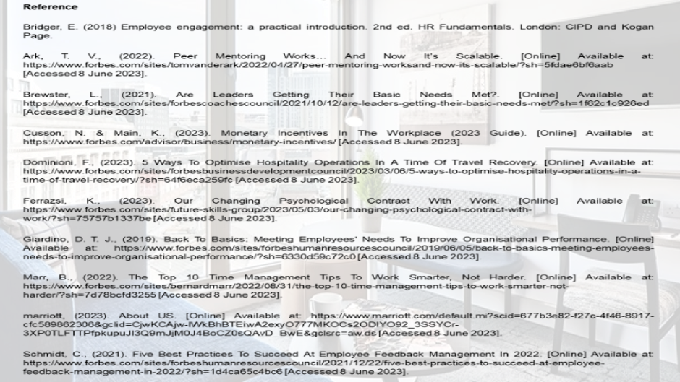
Training Notes: Reference
Bridger, E. (2018) Employee engagement: a practical introduction. 2nd ed. HR Fundamentals. London: CIPD and Kogan Page.
Ark, T. V., (2022). Peer Mentoring Works… And Now It’s Scalable. [Online] Available at: https://www.forbes.com/sites/tomvanderark/2022/04/27/peer-mentoring-worksand-now-its-scalable/?sh=5fdae6bf6aab [Accessed 8 June 2023].
Brewster, L., (2021). Are Leaders Getting Their Basic Needs Met?. [Online] Available at: https://www.forbes.com/sites/forbescoachescouncil/2021/10/12/are-leaders-getting-their-basic-needs-met/?sh=1f62c1c926ed [Accessed 8 June 2023].
Cusson, N. & Main, K., (2023). Monetary Incentives In The Workplace (2023 Guide). [Online] Available at: https://www.forbes.com/advisor/business/monetary-incentives/ [Accessed 8 June 2023].
Dominioni, F., (2023). 5 Ways To Optimise Hospitality Operations In A Time Of Travel Recovery. [Online] Available at: https://www.forbes.com/sites/forbesbusinessdevelopmentcouncil/2023/03/06/5-ways-to-optimise-hospitality-operations-in-a-time-of-travel-recovery/?sh=64f6eca259fc [Accessed 8 June 2023].
Ferrazsi, K., (2023). Our Changing Psychological Contract With Work. [Online] Available at: https://www.forbes.com/sites/future-skills-group/2023/05/03/our-changing-psychological-contract-with-work/?sh=75757b1337be [Accessed 8 June 2023].
Giardino, D. T. J., (2019). Back To Basics: Meeting Employees' Needs To Improve Organisational Performance. [Online] Available at: https://www.forbes.com/sites/forbeshumanresourcescouncil/2019/06/05/back-to-basics-meeting-employees-needs-to-improve-organisational-performance/?sh=6330d59c72c0 [Accessed 8 June 2023].
Marr, B., (2022). The Top 10 Time Management Tips To Work Smarter, Not Harder. [Online] Available at: https://www.forbes.com/sites/bernardmarr/2022/08/31/the-top-10-time-management-tips-to-work-smarter-not-harder/?sh=7d78bcfd3255 [Accessed 8 June 2023].
marriott, (2023). About US. [Online] Available at: https://www.marriott.com/default.mi?scid=677b3e82-f27c-4f46-8917-cfc589862306&gclid=CjwKCAjw-IWkBhBTEiwA2exyO777MKOCs2ODIYO92_3SSYCr-3XP0TLFTTPfpkupuJI3Q9mJjM0J4BoCZ0sQAvD_BwE&gclsrc=aw.ds [Accessed 8 June 2023].
Schmidt, C., (2021). Five Best Practices To Succeed At Employee Feedback Management In 2022. [Online] Available at: https://www.forbes.com/sites/forbeshumanresourcescouncil/2021/12/22/five-best-practices-to-succeed-at-employee-feedback-management-in-2022/?sh=1d4ca65c4bc6 [Accessed 8 June 2023].

References
Ark, T. V., (2022). Peer Mentoring Works… And Now It’s Scalable. [Online] Available at: https://www.forbes.com/sites/tomvanderark/2022/04/27/peer-mentoring-worksand-now-its-scalable/?sh=5fdae6bf6aab [Accessed 8 June 2023].
Brewster, L., (2021). Are Leaders Getting Their Basic Needs Met?. [Online] Available at: https://www.forbes.com/sites/forbescoachescouncil/2021/10/12/are-leaders-getting-their-basic-needs-met/?sh=1f62c1c926ed [Accessed 8 June 2023].
Bridger, E. (2018) Employee engagement: a practical introduction. 2nd ed. HR Fundamentals. London: CIPD and Kogan Page.
Casado, M. (2012) Housekeeping Management. London: Wiley.
Cottrell, S. (2019) The Study Skills Handbook. 5th ed. London: Red Globe Press.
Cusson, N. & Main, K., (2023). Monetary Incentives In The Workplace (2023 Guide). [Online] Available at: https://www.forbes.com/advisor/business/monetary-incentives/ [Accessed 8 June 2023].
Dominioni, F., (2023). 5 Ways To Optimise Hospitality Operations In A Time Of Travel Recovery. [Online] Available at: https://www.forbes.com/sites/forbesbusinessdevelopmentcouncil/2023/03/06/5-ways-to-optimise-hospitality-operations-in-a-time-of-travel-recovery/?sh=64f6eca259fc [Accessed 8 June 2023].
Fallon, M. & Rutherford, D. (2010) Hotel Management and Operations. London: Pearson.
Ferdinand, N. and Kitchin, P. (2017) Events Management - An International Approach. 2nd ed. London: SAGE Publications Ltd.
Ferrazsi, K., (2023). Our Changing Psychological Contract With Work. [Online] Available at: https://www.forbes.com/sites/future-skills-group/2023/05/03/our-changing-psychological-contract-with-work/?sh=75757b1337be [Accessed 8 June 2023].
Giardino, D. T. J., (2019). Back To Basics: Meeting Employees' Needs To Improve Organisational Performance. [Online] Available at: https://www.forbes.com/sites/forbeshumanresourcescouncil/2019/06/05/back-to-basics-meeting-employees-needs-to-improve-organisational-performance/?sh=6330d59c72c0 [Accessed 8 June 2023].
Johnston, R., Clark, G. & Shulver, M. (2012) Service Operations Management. London: Pearson.
Jones, T. (2010) Professional Management of Housekeeping Operations. London: Wiley.
Leiter, M. P. and Bakker, A. B. (2010) Work Engagement: A Handbook of Essential Theory and Research. Hove [England]: Psychology Press.
Marr, B., (2022). The Top 10 Time Management Tips To Work Smarter, Not Harder. [Online] Available at: https://www.forbes.com/sites/bernardmarr/2022/08/31/the-top-10-time-management-tips-to-work-smarter-not-harder/?sh=7d78bcfd3255 [Accessed 8 June 2023].
marriott, (2023). About US. [Online] Available at: https://www.marriott.com/default.mi?scid=677b3e82-f27c-4f46-8917-cfc589862306&gclid=CjwKCAjw-IWkBhBTEiwA2exyO777MKOCs2ODIYO92_3SSYCr-3XP0TLFTTPfpkupuJI3Q9mJjM0J4BoCZ0sQAvD_BwE&gclsrc=aw.ds [Accessed 8 June 2023].
Mullins, L. and Dossor, P. (2013) Hospitality Management and Organisational Behaviour. 5th ed. Harlow: Pearson.
Quick, L. (2020) Managing Events. Real Challenges, Real Outcomes. London: SAGE Publications Ltd.
Raghubalan, G. and Raghubalan, S. (2016) Hotel Housekeeping - Operations And Management. 3rd ed. India: Oxford University Press.
Rogers, T. (2008) Conferences and conventions a global industry (2nd ed., Events management series). Oxford ; Boston: Butterworth-Heinemann.
Schmidt, C., (2021). Five Best Practices To Succeed At Employee Feedback Management In 2022. [Online] Available at: https://www.forbes.com/sites/forbeshumanresourcescouncil/2021/12/22/five-best-practices-to-succeed-at-employee-feedback-management-in-2022/?sh=1d4ca65c4bc6 [Accessed 8 June 2023].
Sharma, N., Chaudhary, N. and Singh, V. (2019) Management Techniques For Employee Engagement In Contemporary Organisations. Hershey, Pennsylvania: IGI Global.
Tesone, D. (2010) Principles Of Management For The Hospitality Industry. 1st ed. London: Routledge.
Vallen, G. & Vallen, J. (2012) Managing Hotel Operations. London: Pearson.
Wood, R. (2013) Key Concepts in Hospitality Management. London: Sage.

