Mind Map Link: https://mm.tt/map/3953564289?t=dnC77ZKgj5
Module:

Software Solutions for Business


Student Name: Lizandro Roberto Mata hugo

student Id: 2533010

group: 1

Module Code: ACCA 4026

Lecturer: amitave banik

University of Wales Trinity Saint David

London Campus



Table of Contents
Introduction 1
Task 1. e-Commerce Website builders or software solutions 2
1.1 WooCommerce 2
1.2 Wix 3
Task 2. Mind-map of contemporary software applications 5
a. Mind mapping and explain the benefits of using mind mapping in business operations 5
b. Create a mind map of contemporary software applications 7
Task 3. Office Applications 8
a. Four office software solutions for business operations 8
MS Word 8
MS PowerPoint 10
MS Excel 11
MS Access 11
b. Practical demonstration of Two Office Features 13
Mail Merge 13
If Statement 13
Task 4. Communication and Collaboration applications 13
a. One contemporary Communication and one Online Collaboration applications/tools 13
MS Outlook 13
MS Teams 13
b. One feature of a freely available Communication (1) and one feature of a Collaboration (1) application 13
MS Outlook 13
Ms Teams 13
Conclusion 14
References Error! Bookmark not defined.

Introduction
In this assignment about Software Solutions for Business as far I am concern, we will learn and understand a lot about how the software works, what it is for and why it is important. As far I have investigated software solutions was created to centralized data and deliver real time insights. This will help to the teams to work smarter and to have a faster respond as will be needed from the business. Also, business can reduce considerable the cos of operations applying software solutions. Also, we can be more competitive in the market. Furthermore, we can see that software solution for business is any programme or platform that helps to automatize tasks, it improves operations, it will manage data and will support decision that we have to make it. From the moment we implement this we will save an huge amount of time with the automatization, it will manage customers sales, it helps tracking finances and countability of the businesses, it is very useful organising personal and team projects, it will Analiza all the date to get a better decision at the moment we have to decide, we will have this help deciding. It will also improve our communication. Adding to this, it has a lot of benefits and is easy to understand, it is a great help to save time, get better accuracy, it also increases the productivity and as a result our business can grow and provide better insights. We can say that is an indispensable tool that help companies to work smarter, we can get results faster and the work will be more effective.

Task 1. e-Commerce Website builders or software solutions

WooCommerce

By the book Building E-Commerce Solutions with WooCommerce we can see that we share the fact that when we have little knowledge about website builders, we consider that online stores are difficult or complex, however, it is not. This website provides a strong e-commerce solution to set up your online store in a short time, we can see that installing this website is an easy task and once it is installed, we can add the products, the payment methods and the shipping solutions for your business. We will customise the business as it is needed by adding themes to change how it looks and the appearance [1]. Supporting this fact, we can see in the book MASTEING WooCommerce that they agree that this website is one of the most popular, it is the second most popular after Shopify. When we decided to use a website builder this are important facts we must take into consideration mostly if we have limited knowledge [2].


Figure 1: WooCommerce animated image [3]
Electronic commerce is the process of selling and buying goods and services using online platforms such as websites and apps on the internet. Transactions are electronic, including payments, transfers and digital payment. There are few types of e-commerce like; -Business to Customers (B2C) which is the most common where business sell services or products direct to customers. Example Amazon and Tokopedia. -Business to Business (B2B), this is for purchases between 2 companies. Example, Alibaba and Indotrading. -Customer to Customer (C2C), this allows individual to sell to other customers, example eBay and OLX. -Customer to Business (C2B), in here individuals sell products to business such as digital contexts or freelance services. Examples, Upwork and Shutterstock. –(B2G) Business to Government as the name says it involve transactions between business and the government for example, Government procurement service. -(G2B) Government to Business, in here the government provides service through digital platform to a business for example business regulation services [4].
Having In consideration all the facts we have research, WooCommerce give a lot of benefits when we create a business and depending on the type of business there are plenty of options to carry on.

Wix

Wix is very popular website builder tool around the world, with more than 200 million users. It is because this website builder it is very easy to understand, also it is attracted for business because it is cheap. If we compare with other websites builders, Wix is being design for a person with almost having not knowledge. It is very easy to edit with plenty of templates which make the job easy for small business [5].

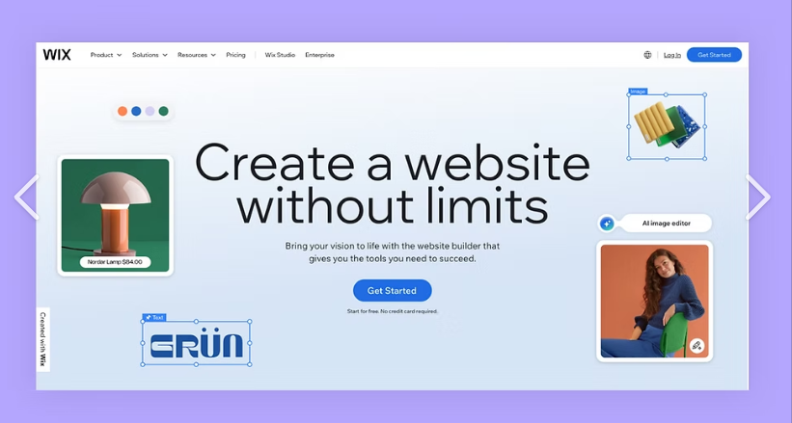
Figure number 2: Main page of Wix website [6].
Also, in the following article we can explore more about Wix in which they are talking about IA site generator. They say that it is very beneficial because it will assist you to get the best of it and reaching your needed in the area you are into. With the IA it will be easier and faster to build your own website because of the large number of tools you will have it [7]. On the other site we will talk about the impact in students in the 21st century, now a day technology it is very indispensable to be able to competent at the moment to get a good position in the workplace. During the school time or university, we have the opportunity to apply all this and be able to get that knowledge for our future carrier [8]. By review in the Forbes website about the pros and cons of Wix, we can see it is not perfect but for beginner and small business is a good choice. In the good side we can see that it has more than 200 app integration available, also it is built in SEO and it is very easy to drag and drop interfaces, On the other side we can see it has limited storage plans, one your template is live you can not make any change and also visitor analytic are not available on free or combo plans [9]. Researching more about mind mapping we can see that it also agrees about the benefits of it; There I hight percentage of people who using mind map has increase the motivation in learning, there is also more lack of learning independently, it helps to use both sides of the brain and with it students increase their communication skills [10].

Task 2. Mind-map of contemporary software applications

Mind mapping and explain the benefits of using mind mapping in business operations.

Mind mapping is a very helpful tool that help us, for example at the moment of doing a presentation, it helps us to remember more information while we have written in the mind map only key words and helps to improve our memory and retain more information about the topic or presentation selected to be exposed.it is a perfect tool to plan with clarity to make the right decision at the moment to choose for a presentation and save time capturing ideas or making structure more understandable reducing the amount of text or paper and saving the time planning and executing. This visual format also helps to everyone to remember information than reading a large number of documents, like we normally do in a classic way. It also can be made or share in a group to be made and by the contribution of every single person of a group, once any of the integrant of the group apport with information on it, it will be updated to everyone in the group. By BMC Journal in the research article who made an investigation of the impact of mind mapping and the speech on creativity in nursing student, by them we can see that Nurses need techniques more creative for complex health and care challenges owing to the complicate vocabulary. It helps to develop serious tasks making it a lot more easy to understand [11]. In another search made by me in the journal article made by Wiley Online Library we can agree that mind maps is a potential help for students as a pre-writing activity and improve writing skills, the use of this tool helps in the experimental writing experience [12]. By another research by Macrothink Institute after an investigation with elementary teachers’ views on mind mapping using interviews to 24 teachers from elementary school, between two and twenty-one were already instructed about maid mapping techniques. The result shows that mind mapping is very effective, much more enjoyable and the visual tool improve the learning, the creativity and memory, teaches use it to prioritize knowledge, at the moment of supporting lessons and also when we evaluate the understanding of it, this is the most prefer from students because it enhance engagement and expressions, some of the challenges include drawing and it help to organize ideas. In conclusion mind mapping is considered one of the most important and useful tools for students, especially for the youngest [13]. By other article we can see that mind map is considered a radiant thinking, we can process or connect from a central point and is like a natural function of our human mind. This graphic technic is a very powerful tool that we can apply to improve our learning in our everyday workday and study and also the clear thinking at the moment of understand the text in the mind map, it also can be use as self-learning method to make easy to understand all the difficult concepts that we can see difficult to understand for the users, students or anyone who wants to structure a presentation with easy understanding [14].

Create a mind map of contemporary software applications

Mind Map Link: https://mm.tt/map/3953564289?t=dnC77ZKgj5

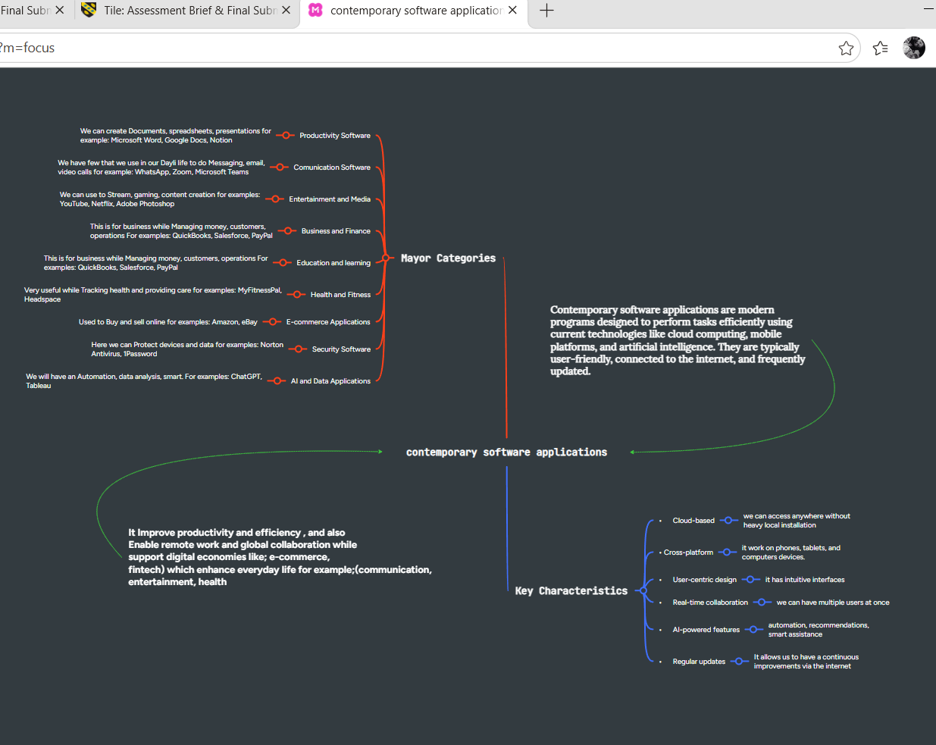

Task 3. Office Applications

Four office software solutions for business operations

MS Word
As far as I acknowledge, in my short use the software applications, Microsoft Office pack is the most used around the world. By Springer Nature in their book, we can see that by the middle 1980s were more than 300 versions of word but after a Decade it came as a Microsoft Word and become a standard writing tool. With this a new era of writing, Thinking, communication and design on its own way has started [15].

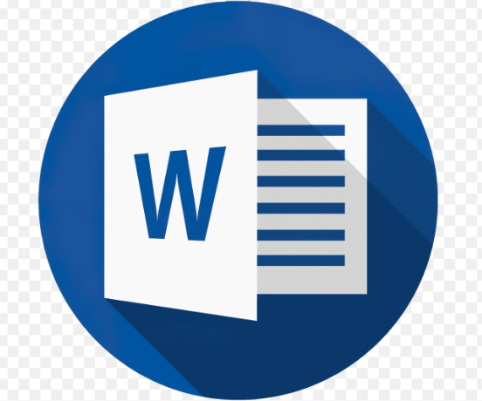
Microsoft Word Image [16]
We can see in the following book that, at the beginning of Microsoft work processing was not fully formed application, in the 1950s and 1960s we were using computers basically for numerical calculations like as a calculator and was used very little as a writing tool. After the introduction of time-sharing system in the early 1960s, people got more access to the computers which allows to edit text and interact. Some systems allow us to edit text in the specific ubication, it could be done because of line editors, it was good because we could edit without starting a new document and not having to start from cero. Even thought we had all this advances at that moment, the fists text editors found it very difficult to use it. This was because mostly owing to the lack of experience and often the commands were cryptic. In the 1980s and 1990s word started to be accessible to a private users and businesses, after that Microsoft word was emerging gradually to be the main standard domain. In 1983 Microsoft word was released and was innovating itself as an innovating hardware as an operating system. Also, it integrates a large number of features such as spell checking, also grammar assistance, we could access to templates and also, they introduce advanced formatting tools [17]. Personally, I can say that MS word is an indispensable tool for every one, it can be for small kids at school, in the college or university. Our learning system is design to have it in all the task that we have to do it. Furthermore, at work it is everywhere, as a teacher to prepare classes and all the task, in the business to do reports, etc. we have it everywhere globally. It helps a lot in terms of saving space for example before it we have to do all by paper and at the end we end up with a huge amount of documents, we have shelf full of old documents from past years and if we need any specific without a proper register will take ages to find. Another good point is that when we type the have the spelling correction, So, that mean we do not have to do the extra effort that before this we did it. If they have to write an important letter, we had to have a dictionary next to us to see the correct spelling or the write word to choose for a specific text. The only bad reflection about It is that at some point we got a bit comfortable with it, and we are always waiting for the programme to solve our writing mistakes.

MS PowerPoint

In my own experience I can say that PowerPoint it is completely new for me and the experience I have working with it is very basic. Of course I have seeing it, it is impossible to do not know about it in the 21st century where everywhere you can see people use for their tasks. I have started with a very little knowledge about PowerPoint but during this module I have got a lot more knowledge and I can say that I can use it and explore try to find more about it. For me it is the first contact, and I have found indispensable and I am sure that after I learn this and get the appropriate skills my jobs options will open widely to go for a new challenge.

PowerPoint image [18].
By research gate in the book notes about inventing PowerPoint, we can see that PowerPoint was the first presentation software design for Macintosh and windows, also we see that it was the first big investment that apple have ever made, after that Microsoft buy it being the first significant purchase that ever made. It was based in Silicon Valley, USA. And in there they have a graphic business where it will get developed. Now a days after more than twenty years power point is installed around the word in more than one billion computers [19].
In other text we can also see that it was not easy at the beginning because the people who create PowerPoint was in danger for two times and the two times they did the impossible to win. Now we can see that primary schools ask to the children to pass a PowerPoint exam because they believe that it will be crucial for their future realization in the next steps in all education levels and in the futures careers. Someone by the name Steven Pinker says that the scientist now a day cannot work without PowerPoint. In the church, is use a lot to deliver sermons, journalist and newspaper are using this, everywhere we can see around is PowerPoint used. We see that only few people fought for it at the beginning, with a strong determination they keep alive it until was a succeed. We also can see that it took three years to complete one product and almost no one believed in that product [20]. As a conclusion we can say that is very important to believe in what we want even the other does not.

MS Excel

By my point of view taking in consideration that I have seeing it a few times because my line of work is not based on spending time working in front of the computer I can say that when I started to learn about Ms Excel was like, I was discovering a new world, I did not know all that we can make with this application.

I have to say that I still in the beginner place, but I am trying my best to learn more about it. After a few readings in different web pages, we can get that Ms Excel is a very powerful spreadsheet programme created by Microsoft it is use for a multiple’s purposes like, to organize data can be any way, alphabetic or different order. Also, it will analyse your data and with all this together we will be able to see it more efficiently. Moreover, we have in this platform several number of formulas and functions that allow us to do our job easier and more efficient, also in this application we can create graphs, bar chart, etc. to visualize in a different way. There is also a tool call pivot tablet which help to summarize, reorganize and filter large databases for an exhaustive analysis. In general, it is used in business and finance, also making projects, and for a personal use. This useful tool is bought by large companies for the employees use in the business and for the school to be used by the student. On the other side it can be use for a personal use but it has a value expressed in your currency, it is not free. It was created in 1985, originally for Apple computers, Excel is an extremely powerful tool used in most companies. From basic additions to more complex operation, Excel sheets can be the backbone of many projects. This is used mainly in companies for tasks such as accounting or finance [21].
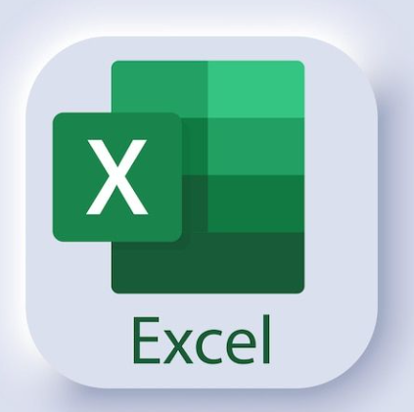
Image of Ms Excel [22].
It’s after 1987 that Excel has been released for Windows. Becoming later, in 1990, a part of the pack office (including Word and Power Point). It’s, however, in 1992, that a more popular and accessible version has been released, adding the very useful features such as ‘AutoFill’, widely used as it is a great time saver. Over the next years, Excel has been improved to be faster and to allow a more utilisation for users. Making it a main tool for may companies around the world. As it became sightly harder to use for beginners, Microsoft added digital assistance on the software in the late 90’s. Those frequent updates and improvements made Excel being a core part of the pack office, but it also erased the potential competitors. Indeed, in the early 80’s, some similar software was in use for Macintosh and Microsoft, Lotus 1-2-3 being the main one, it allowed the users to do graphics, charts and basics operations. But available only for Macintosh, when Excel was compatible with both systems. Excel became rapidly more powerful and took the lead.
In my utilisation, I started using Excel as a student, at the beginning using basics calculations skills; I am now using it more confidently and learning how to use more features of it [23].

MS Access

Starting with a completely cero knowledge about Ms Access and just review it a bit during the module I can say that I still need a lot to learn and understand about it. What we saw during this module was very limited almost nothing, so I did not have the opportunity to explore more in detail. So, having this into consideration this analyse will be made by research on the website. The first think we can Obser is that Ms Access is part of the Microsoft packet but if we need only this, we can buy separated. Another feature is that it is designed toto help to create and to manage databases for users with a little knowledge. It is different to excel because access was made to deal with several amount of data while excel is most likely for calculations and spreadsheets. With Ms Access we can create database, to have forms for data entry, we can generate report very fast, it is very easy to integrate with other applications, on the other side we can see that this application is only available for PC.
Ms Access, on the opposite of the previous software, is not part of the pack office. It is, however, part of the Office suite: building, focused more on companies, including Word, Excel, Outlook and Access. It has a very different utilisation and is mainly targeted for the companies. Indeed, it is a very useful tool for the daily origination in a company. Originally launched in 1992, it then had many updates added into it, making it a more powerful software [24].


Ms Access image [25].
The main targeted users for Access are the companies. Allowing them to have a clear view of their database and generating reports when needed. Designed for business, an Access table can feature some specific data such as an address, name, phone number, all appearing on a sheet and letting appearing what needed for the company. For some safety and security reasons, the sheet can be easily protected by a password or even encrypted. Relationship can be done between different date and spread sheet to create more complete reports. The software is also compatible with Excel. Access is also very good to avoid mistake, the data entry trend to be sensitive and doesn’t allow the user to go further if any mistake is done.
In my opinion, I found it very hard to use at first, as it quite differs from the other software for the Pack office. It requires to be very precise and doesn’t allow mistakes; a lot of patience is involved to start a new task on it. However, once the core information has been entered and as well as the different sections needed, it becomes a perfectly clear vision of the company and the coming tasks [26]. As a conclusion of this we can say that Ms Access is a very powerful tool, which is very beneficial and is indispensable when we deal with large amount of data.

Practical demonstration of Two Office Features

Mail Merge
Open Ms Word and go to the section Mailing and in the click start mail merge as it show in the screenshot.

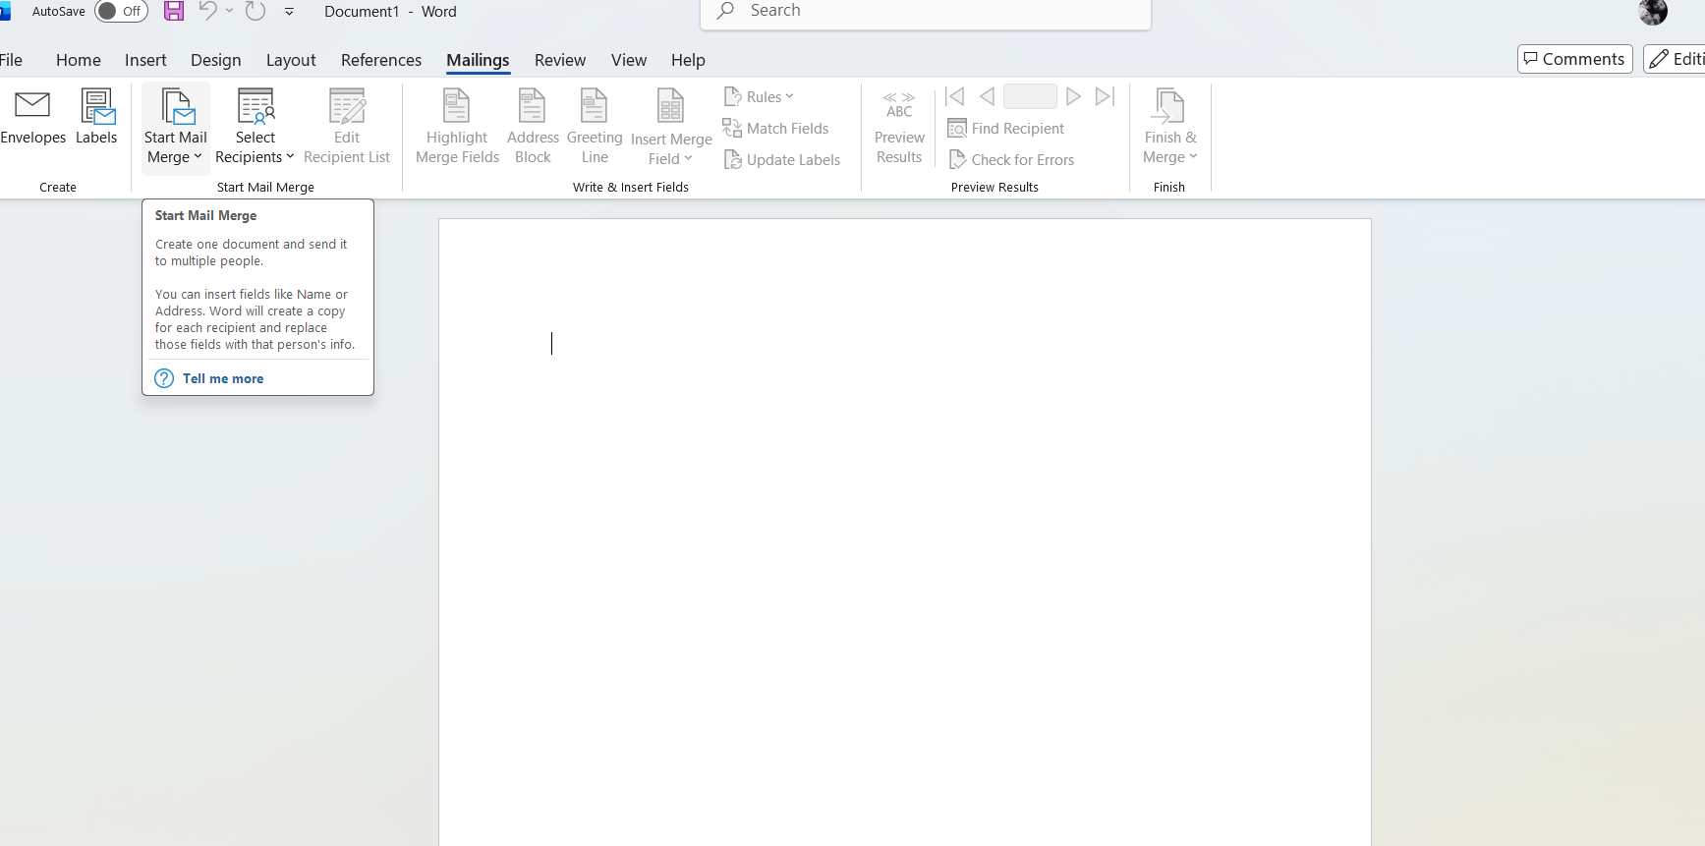

If Statement
First, you go to Ms Excel and open a new blank page
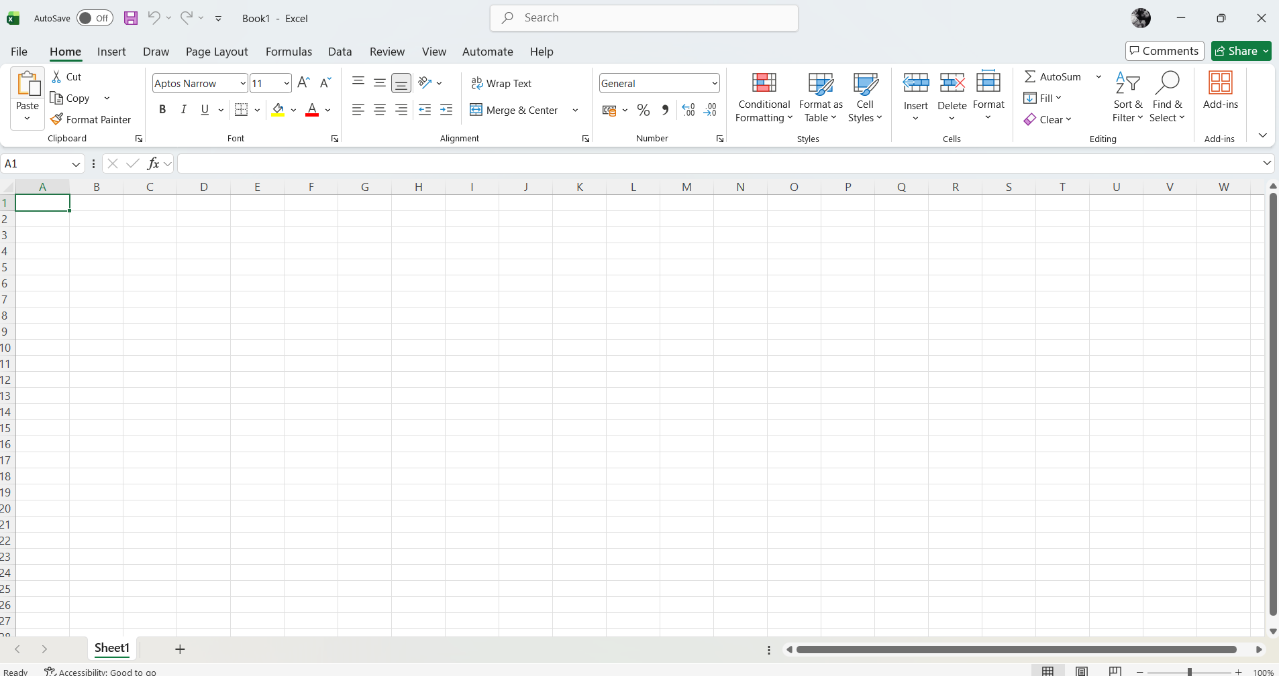
Second, we must go to the section formula and in the top let side of the screen we have insert function, in there we have few options and we have to select If.

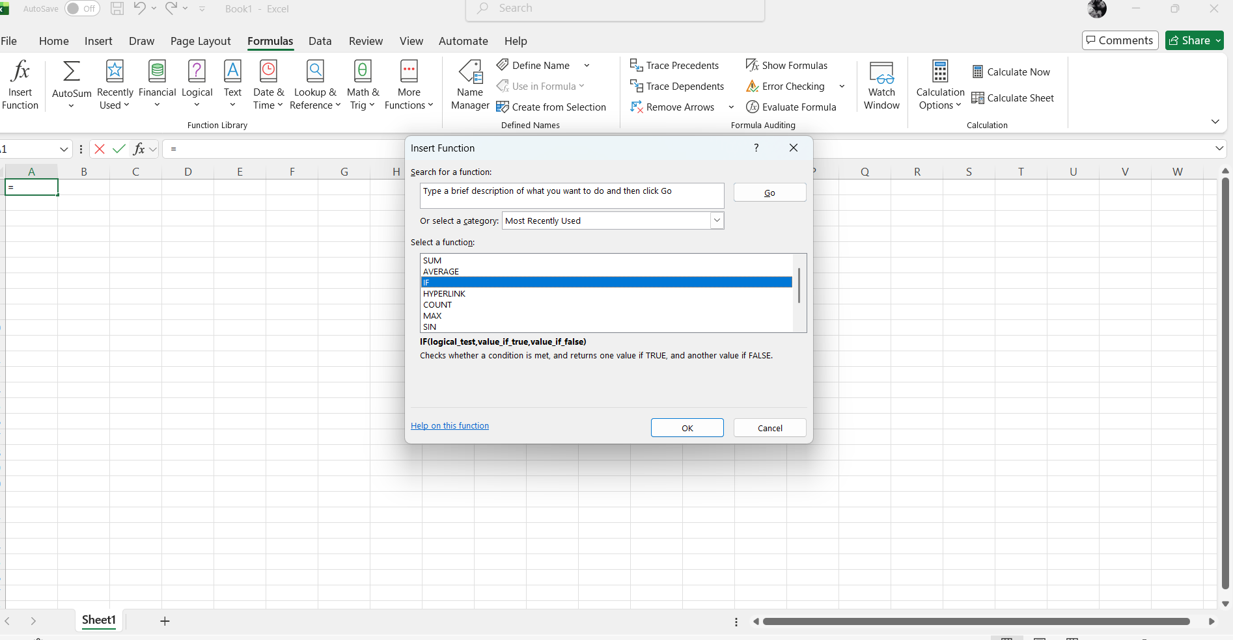

Task 4. Communication and Collaboration applications

One contemporary Communication and one Online Collaboration applications/tools

MS Outlook

This is a very common tool, and it is indispensable for almost everyone in the planet. It is a personal information manager made by Microsoft and the common use is to send personal Email to clients. It allows to send emails, receive emails and organize it for example by separated folders. In there we have tools like calendar management where we can keep track of futures appointments or special dates. Also, we will find task scheduling, this is away that we can manage our time at the moment to plan anything on our days [27]. We have contact organization where we have a list of our contact making easy now to send an email. Also, there is a tool very useful for everyone which is note taking, in here we can write and save any important information. It also, protect us from spams and we can have encryption as well like two factor authentication and one of the good options is to be able to recover emails. Here we can see also that they say that outlook is an electronic messaging that for many of us keep us in contact with friends, working colleges, students colleagues, clients from business [28]

.

MS Teams
As the name say it is a collaboration app that bring together chat, also video meeting, we can storage file and is an app to integrate all inside of one place. It is mostly used by business, in the schools and also organisations.
We can see by the following book that during the covid time it was an indispensable tool to keep students engaged, it was found for teaches as a tool to give live classes; to interact each other’s by chat, they could also record the classes and to have discussions about it. This tool help student to be connected and ask questions on real time. On the other side for a few teaches was a bit problematic because of the lack of training and they were not prepared to use it and it was fatal because students were not getting connect to the classes because of the technical issues and it make students lose the motivation to join the meetings. As far we can see that both must be train because the lack of it does not help to anyone. It is the best example we can get about an experience using Ms Teams [29].

One feature of a freely available Communication (1) and one feature of a Collaboration (1) application

MS Outlook
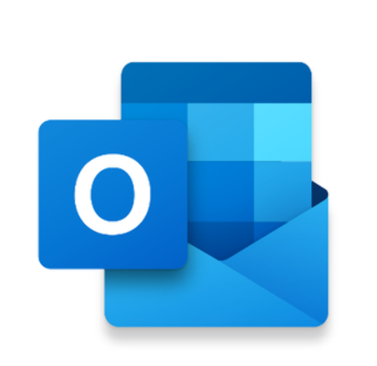
Image of Ms Outlook [30].

Ms Teams


We have here a Ms Teams Image [31].

Conclusion

As a personal conclusion I can say that I have learn but not that much I expect that I would do it, I know that it is important to have a self-learning, but for some of us in more difficult to do without a proper guidance. On the other side I can say that my knowledge about Microsoft Office is stronger that when I started. And also I found a new vocation to study.

References

[1] | R. Ravensbergen, Building E-Commerce Solutions with WooCommerce, Packt Publishing Limited, 2025.
[2] | P. Rauland, Mastering WooCommerce, 2024.
[3] | A. P. Safira, “multilingual press,” 2022. [Online].
[4] | saputo, “developing moder e-commerce,” in woocommerce for digital products, Indonesia, CV TOPAZART, 2024.
[5] | Carlos, “name,com,” 04 08 2023. [Online]. Available: https://www.name.com/blog/benefits-of-wix.
[6] | static.com, “wix,” [Online]. Available: static.wixstatic.com.
[7] | S. Rais and S. Lokhande, “Developing a library website using the Wix AI site generator,” Librery hi Tech News, 2026.
[8] | B. A. Dharma and Alin Septiana, “The Use of WIX as a Learning Media to Support Self-regulated Learning and Learning Activity,” Atlantis Press, 2023.
[9] | Forbes, “Wix Review: Features, Pros & Cons,” 08 07 2025. [Online]. Available: https://www.forbes.com/advisor/business/software/wix-review/.
[10] | M. Syukur, “Mind Mapping Technique In Vocabulary Teaching And Learning Context: A Systematic Literature Review,” ideas, 2025.
[11] | R. Rezapour-Nasrabad, “Investigating the impact of mind mapping and speech on creativity in nursing students,” BCM Nursing, 2025.
[12] | H. N. H. C. C. C. Y. L. T.-W. C. Charles Y. C. Yeh, “The Effect of Mind Map as a Prewriting Activity in Third Grade Elementary Students' Descriptive Narrative Creative Writing With a Writing E-Portfolio,” Wiley Online Library, 2025.
[13] | Ö. Keleş, “Elementary Teachers‟ Views on Mind Mapping,” International Journal of Education, 2012.
[14] | A. Wickramasinghe and N. Widanapathirana, “Effectiveness of mind maps as a learning tool for medical students,” South-East Asian Journal of Medical Education, 2007.
[15] | O. Kruse and Christian Rapp , Digital writing tecnologies in higher education, 2023.
[16] | logos-world, “logos-world,” Microsoft Word Logo, symbol, meaning, history, PNG,, 2020. [Online]. Available: logos-world.net.
[17] | T. A. Heilmann, Digital Writing Technologies in Higher Education, springer, 2023.
[18] | icons8, “Powerpoint 2025 icons Icons, Logos, Symbols,” 14 November 2025. [Online]. Available: icons8.com.
[19] | R. Gaskins, “Notes about Inventing PowerPoint,” in Sweating Bullets, 2012.
[20] | R. Gaskins, “Sweating Bullets,” in Notes about Inventing PowerPoint, San Francisco, Vinland Books, 2012.
[21] | Britania, “britannica,” 23 march 2026. [Online]. Available: https://www.britannica.com/technology/Microsoft-Excel.
[22] | pinterest, Microsoft excel logo, Printerest, 2024.
[23] | C. Ginsberg, “A Brief History of Microsoft Excel,” 15 July 2025. [Online]. Available: https://blog.nobledesktop.com/history-of-microsoft-excel.
[24] | F. Davidson, “Access Database Tutorial,” 09 April 2024. [Online]. Available: https://accessdatabasetutorial.com/2010/12/29/heres-a-brief-history-of-microsoft-access/.
[25] | Vecteezy, Microsoft Access logo, vecteezy.com, 2024.
[26] | T. K. Academy, “Microsoft Access: Functions and Features,” 06 March 2026. [Online]. Available: https://www.theknowledgeacademy.com/blog/microsoft-access-functions/.
[27] | J. Lambert, microsoft outlook 2026, icrosoft press, 2016.
[28] | l. joan, microsoft outlok step by step, 2016.
[29] | K. C. BARBEE, “Engage Me! A Qualitative Case Study of Student Engagement Using Microsoft Teams in Middle School,” 2022.
[30] | clipartmax, “clipartmx,” 04 Octubre 2018. [Online]. Available: clipartmax.co.
[31] | petri, “petri,” 16 May 2025. [Online]. Available: petri.com.

