

Network Security
(ACCA7019)

End of Semester Assignment

By
David Ntino (2225674)

MAY, 2023

Table of Contents
Table of Figures 3
List of Acronyms 5
Introduction 6
1. security threats facing modern network infrastructures 7
a. What is Network Security? 7
b. Types of security threats and Attacks 7
c. Tools to Mitigate the Effects of Malware 8
d. Principles of Securing a Network 9
1e. Mitigating the effects of common network attacks 11
1f. Cisco Network Foundation Protection (NFP) framework 11
1g. Mitigating the effects of Viruses, Worms, and Trojan horses 12
1h. Endpoint Vulnerabilities and Protection Methods 12
2. Securing Cisco Routers 13
3a. Implementing AAA ON Cisco router 14
3a. Securing a network with AAA 14
4. Mitigating threats to Cisco routers and networks using ACLs 14
5. Implementing Secure Network Design, Management, and Reporting 15
a. Implementation of a comprehensive security policy 15
5b. Techniques and Tools for Network Security Testing 15
6. Mitigating Common Layer 2 Attacks 16
a. The Layer 2 vulnerabilities and mitigation is summarised below. 16
8. Implementing the Cisco IPS Feature Set 17
a. Intrusion Prevention Systems 17
8b. Signatures 18
9. Implementing a Site-to-site VPN 18
a. Purpose of VPNs 18
9b. IPsec VPNs 18
9c. Configuration file in packet tracer 19
9d. Types of Encryptions 19
9g. Public Key Infrastructure 21
10. Implementing a Remote VPN 22
11. Cisco ASA 22
a. How does ASA operate? 22
SECTION 2 23
1. A2Z Technologies Limited 23
2. Blueprint design of a secure network Implementation 24
3. Proposal for iDEAL IT Solution Limited 25
4. Proposed Cost Analysis 27
5. Project Plan Timeline 30
5a. Hardware and Software cost 31
5b. Logical Configuration Setup 31
5c. Defensive Mechanism 32
6. Attacks Affecting Organisation Network 36
7. Recommended Network Security Testing 36
8. Invoice of Secured Network Implementation 37
9. Conclusion 38
10. Reference 39

Table of Figures

Figure 1. 1 CIA Triad [5] 7

Figure 2. 1NFP Plan diagram [7] 8

Figure 3. 1 Encryption/Decryption 16

Figure 4. 1 Digital Signature 17

Figure 5. 1 Public Key Infrastructure Illustration 19

Figure 6. 1 Public Key Infrastructure 19

Figure 7. 1 Physical Blueprint design of a secured Network 21
Figure 7. 2 Logical Blue Print Design for the proposed secured network Infrastructure 22

Figure 8. 1 A DMZ Architectural setup 23

Figure 9. 1 Cost Analysis for Secured Network Implementation 25

Figure 10. 1 Links to IT Network Vendors [33] 26

Figure 11. 1IPsec Remote Access framework [32] 29

Figure 12. 1configure the IPsec Remote Access feature [32] 29

Figure 13. 1 AWS Network Firewall deployed in Multi-AZ [31] 30

Figure 14. 1 L2TP Packet Encapsulation [29] 31

Figure 15. 1 Remote Access to a Web server 31

Figure 16. 1 Web server to Remote user 32

Figure 17. 1 SSL VPN Tunnel 32

Figure 18. 1 Invoice 34

List of Acronyms

- AAA - Authentication, Authorization, and Accounting
- SSH - Secure Shell
- ACLc - Access Control Lists
- DHCP - Dynamic Host Configuration Protocol
- VPN - Virtual Private Network
- IKE - Internet Key Exchange
- NFP - Network Flow Processor
- NAS - Network-attached storage
- LAN - Local Area Network
- ASP - Adaptive Security Appliance
- OSI - Open systems intercommunication
- IDS - Intrusion Detection System
- IPS - Intrusion Prevention System
- IPS - Internet Protocol Security
- PPP - Point-to-Point Protocol

Introduction

Network Security protects networks and data from breaches, intrusions, and other cyber threats. This term describes hardware and software solutions as well as processes or rules and configurations relating to network use, accessibility, and overall threat protection [1].

Cyberattacks are not stopping any time soon, and in fact, are getting more sophisticated. 59% of respondents say cyberattacks are growing increasingly sophisticated. 75% of companies have experienced an increase in email-based threats. 72% of companies expect to be harmed in 2023 by a collaboration-tool-based attack [1].

With increasing reports of attacks on networks, it is important that every organisation adopt the best and most recent network security defense architecture to avoid losing their valuable data and resources to cyber attackers.
This work addresses the best approach to setting up a secured network security infrastructure.

SECTION ONE

1. security threats facing modern network infrastructures

a. What is Network Security?

This can be described as the application of security tools, security policies, and tactics to prevent, monitor and respond to unauthorised network breaches or intrusions, while also protecting digital assets, including network traffic. Network security can be either software or hardware technologies designed for protecting an organization or system from any form of cyber-attack or breach [3].

b. Types of security threats and Attacks

- Malware Attack
Malware is malicious software or viruses that have the tendency to harm a network or system. Malware includes viruses like worms, spyware, ransomware, adware, and trojans.

- Phishing Attack
Phishing attacks are one of the most widespread types of cyberattacks. It is a type of social engineering attack wherein an attacker pertains to being a trusted contact and sends fake emails to victims.

- Password Attack
This is a form of attack that occurs when an attacker attempts to crack a user or system password by using various programs and password-cracking tools like Aircrack, Cain, Abel, John the Ripper, Hashcat, etc. Some of the different password attacks are brute force attacks, dictionary attacks, and keylogger attacks.

- Man-in-the-Middle Attack (MITM)
MITM) is also known as an eavesdropping attack. An attacker tries to hijack the session between a client and a host. By doing so, hackers can steal or manipulate data.

- SQL Injection Attack
A Structured Query Language (SQL) injection attack occurs on a database-driven website when an attacker manipulates a standard SQL query. It is done by injecting malicious code into a vulnerable website search box, thereby making the server reveal crucial information.

- Denial-of-Service Attack: In this attack, attackers take over a system or network, thereby preventing authorised users from accessing the network. The target systems, servers, or networks flood them with traffic to exhaust their resources and bandwidth.

- Insider Threat: This threat is common in small businesses, mostly when a staff holds access to multiple accounts with data. The threat actor can be motivated by greed or personal issues.

- Crypto-jacking
Crypto-jacking occurs place when attackers access someone else’s computer for mining cryptocurrency. The attackers gain unauthorised access to someone else's computer for mining cryptocurrency [4].

c. Tools to Mitigate the effects of malware
Access control allows you to increase your network security by limiting user access and resources to only the parts of the network that directly apply to individual users’ responsibilities [2].

- Anti-malware software
- Malware is harmful software like viruses, trojans, worms, keyloggers, spyware, etc, and is designed to spread through computer systems and infect networks. Anti-malware tools are network security software designed to identify dangerous programs and prevent them from spreading or affecting a system [2].

- Application Security: Application security helps establish security parameters for any applications that may be relevant to your network security [2].

- Data loss prevention (DLP): DLP technologies and policies can help protect staff and other users from misusing and possibly compromising sensitive data [2].

- Email Security: Email security helps identify dangerous emails and can also be used to block attacks and prevent the sharing of vital data via email [2].

- Endpoint Security: Personal devices can become targets when users rely on them to access business networks. Endpoint security adds a layer of defense between remote devices and business networks [2].

- Firewalls: Firewalls are used to manage network traffic, allowing authorized traffic through while blocking access to non-authorized traffic.

- Intrusion prevention systems (also called intrusion detection) helps to scan and analyze network traffic/packets so that different types of attacks can be identified and responded to quickly.

- Network segmentation: Various kinds of network traffic exits, each associated with different security risks. Network segmentation allows a network to grant the right access to the right traffic while restricting traffic from suspicious sources [2].

- Virtual private network (VPN)
VPN security tools are used to authenticate communication between secure networks and an endpoint device. Remote-access VPNs generally use IPsec or Secure Sockets Layer (SSL) for authentication, creating an encrypted line to block other parties from eavesdropping [2].

Deploy a zero-trust security framework
This approach helps secure access from users, end-user devices, APIs, IoT, microservices, containers, and more. It protects your workforce, workloads, and workplace since you must first verify their trustworthiness before granting access [3].

Educate users on threat sources
Train users on whom and what to trust and teach them not to fall for phishing or other schemes. Have them install two-factor authentication as a first line of defense [3].

d. Principles of Securing a network
The world has evolved into an internet era, where organisations are now depending on the internet and network for carrying out their services. The need to satisfy the demands of both e-commerce and customer contact requires connectivity between internal corporate networks and the outside world. For privacy and data integrity, there exist some principles that guide network security.

This principle can be summarised as the CIA Triad, Confidentiality, Integrity, and Availability.
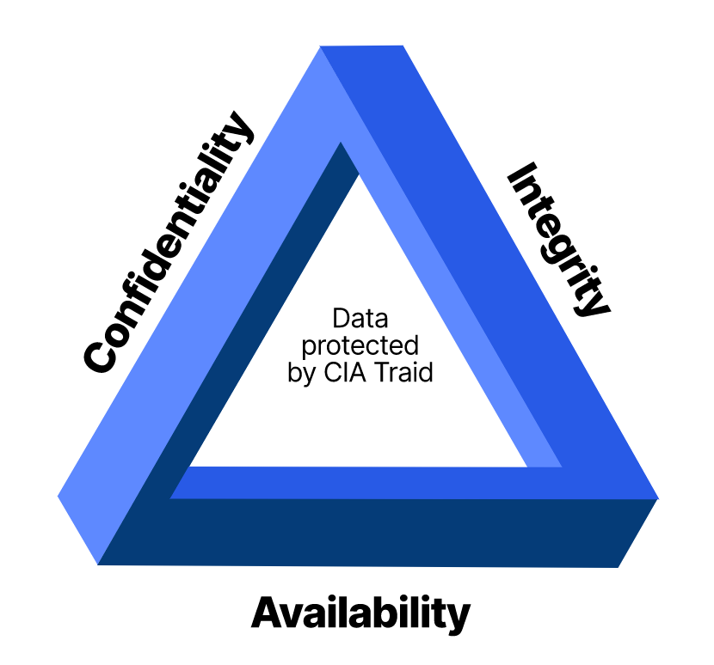

Figure 1. 1 CIA Triad [5]

1. Confidentiality: Network security is designed to prevent unauthorised disclosure of information of users or customers. The purpose of the confidentiality principle is to keep personal information private and to ensure that it is visible and accessible only to users or corporations who own it or need it to perform their organizational functions [5].

Example: Use network security mechanisms (for example, firewalls and access control lists [ACL]) to prevent unauthorized access to network resources [6].

2. Integrity: Network security also involves data integrity, meaning protection against authorised modification of network data or configuration settings in transit [5]. A data integrity solution might perform origin authentication to verify that traffic is originating from the source that should be sending it [6].

Examples [6]
Modifying the appearance of a corporate website
Intercepting and altering an e-commerce transaction
Modifying financial records that are stored electronically

Availability: This principle covers the accessibility of network software or data. It ensures that the technology infrastructure and resources are available to organizations or users when they are needed.

1e. Mitigating the effects of common network attacks

Effects of common network attack methodologies can be mitigated in Small and Medium-sized (SMBs) businesses by following the steps [8]:

- Owners of SMBs should enforce the use of strong passwords by their staff to prevent brute-force attacks.
- Access to sensitive data and systems should be limited and restricted to staff, according to their job specification.
- Staff or employees must be educated about network security and how to protect their data. 4. Company Privacy policies must also be introduced to all staff.
- Staff personal computers must be installed with VPNs.
- All sensitive data and configuration settings must be backed-up in safe cloud storage, in case of a security attack.

1f. Cisco Network Foundation Protection (NFP) framework

Network Foundation Protection (NFP) is a framework designed by Cisco with different logical functions to perform different security techniques on network routers and switches devices. It provides a logical security strategy for infrastructure protection forming the foundation for continuous service delivery [7].

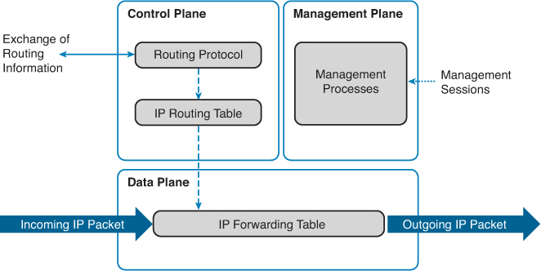

Figure 2. 1NFP Plan diagram [7]

The NFP has three dynamic function sections [7]:
- The Management Plane: Provides the ability to manage network elements.
- The Control Plane: Provides the ability to route data correctly.
- The Data Plane: Provides the ability to forward data from one point to another endpoint.
The Cisco NFP framework provides the tools and techniques to secure each of these planes [7].

1g. Mitigating the effects of Viruses, Worms, and Trojan horses

SMBs can mitigate the effects of Viruses, Worms, and Trojan Horses by adhering to the following points [8].

- Software used by SMBs must be updated frequently.
- Firewalls on the operating system must be updated regularly.
- Firewalls must be set up to prevent unauthorised access to their network.
- Antivirus software should be installed and updated regularly to prevent virus infection.
- Staff personal devices like flash drives or Hard drives must not be used on the systems.
- SMBs must ensure to back up their data as often as possible. An auto backup set can be set up for this purpose.[8]

1h. Endpoint Vulnerabilities and Protection Methods
Endpoint is a point of access to an enterprise network and creates points of entry that can be exploited by cyber attackers. Endpoint devices are end-users personal devices (BYOD) like laptops, desktops, mobile devices, etc, [9].

Some of the endpoint vulnerabilities are:
- Outdated software: Outdated Operating systems and applications can contain vulnerabilities or loopholes for an attack.
- Weak login credentials: Weak passwords is a vulnerability, and can easily be cracked.
- Phishing attacks like social engineering attacks where users are tricked into giving out confidential details to impersonators.
- Malware such as viruses, worms, trojan horses, etc are possible endpoint vulnerabilities.

The following are possible protection methods to adopt against these vulnerabilities [10]:

- Implementation of advanced antimalware and antivirus protection to protect, detect, and correct malware across multiple endpoint devices and operating systems.
- Proactive web security to ensure safe browsing on the web.
- Data classification and data loss prevention to prevent data loss and exfiltration.
- Integrated firewall to block hostile network attacks.
- Insider threat protection to safeguard against unintentional and malicious actions
- Endpoint, email, and disk encryption to prevent data exfiltration.
- Multi-factor authentication can give an extra layer of security by prompting users to enter additional credentials aside from just a password.

2. Securing Cisco Routers

Packet tracer configuration files have been uploaded Moodle.

3a. Implementing AAA ON Cisco router

3a. Securing a network with AAA

AAA stands for Authentication, Authorisation, and Accounting. It is a network security framework that regulates access to computer resources, policies, and audit usage. AAA has network management and cyber security features for screening users and keeping track of their activity as long as they're connected to the network [11].

- Authentication function in AAA checks users' identity It compares a user's username and password with its stored database credentials [11].

- Authorisation in AAA functions differently from Authentication. Authentication dictates what parts of the network infrastructure device, a user can access. The areas and sets of permissions granted to a user are stored in a database along with the user’s identity [11].

- Accounting: Accounting maintains track of user activity while they're logged in to a network. This is achieved by leveraging the data collected during the user’s access [11].

There are two types of AAA: Network Access and Device Administration.

AAA has several types of protocols that help to secure a network, they are:
- Remote Authentication Dial-In User Service Plus (TACACS+)
- Diameter
- Terminal Access Controller Access-Control System [11].

In summary, AAA functions as an identity and access management tool for ensuring the security of a network [11].

4. Mitigating threats to Cisco routers and networks using ACLs
Packet tracer file in Moodle

5. Implementing Secure Network Design, Management, and Reporting

a. Implementation of a comprehensive security policy
A security policy is a written document that contains plans on how the company will protect its infrastructure and information technology assets. An organisation's security policy may include acceptable use policies that will educate its employees about the best way to protect both the physical and digital assets organisation [13].

The following steps can be taken in implementing a comprehensive security policy [13]
- Statement of the purpose: describe why the policy is necessary and why it must be implemented.
- A statement that defines whom the policy applies: This statement will define whom and what the policy is applicable.
- Authority and Access Control policy to specify who has access to which resources must be documented.
- Data Classification: There must be a statement that divides data into categories of sensitivity.
- Statement of the responsibilities and duties of employees and who will be responsible for overseeing and enforcing policy;
- security awareness training: This is to instruct employees on security best practices -- this includes education on potential security threats, such as phishing, and computer security best practices for using company devices.
- Policy Update: After implementation, there should be provision for possible policy updates, as the organisation advances [13].

5b. Techniques and Tools for Network Security Testing
Network Security testing is conducted to check whether a network is secured or vulnerable to attacks from the internet or even from the internal network.

Network security testing tools are automated and logical tools that scan the network for security vulnerabilities [14].

The following are techniques and tools used for performing network security testing.
- Network Scanning: The Network scanner is a tool used to scan, monitor the network, identify the hosts connected to the network, and identify the services running on the network like FTP, HTTP, POP3, and SMTP.
Tools include Nkito, Wireshark, PRTG Network Monitor, Snort, Syxsense, etc [14].

- Vulnerability Scanning: This is a network security process that detects and analyse breaches in computer systems and reports the information to administrators. AppScan, Acunetix, AppSpider, Astra, Burp Suite, OpenVas, Intruder, etc [14].

- Ethical Hacking: This is the practice of testing a computer network or web application to check for security weaknesses before a malicious hacker does.
Tools include Invicti, Fortify Webinspect, Cain & Abel, Nessus, Nkito, etc [14].

- Penetration Testing: Pen. testing as often called is a test to evaluate computer security by simulating an active attack on a computer system or network.
Tools include Kali Linux, Nmap, Metasploit, John the Ripper, etc [14].

- Intrusion detection and prevention systems (IDS/IPS): These tools monitor network traffic and alert administrators to potential attacks or policy violations. Tools like Snort and Suricata [14].

- Social engineering testing: This is testing of the effectiveness of security awareness training and policies by attempting to trick employees into giving out sensitive information or performing unauthorized actions. This could include phishing simulations and phone-based social engineering tests [14].

6. Mitigating Common Layer 2 Attacks
Layer 2 is a Data link layer of the OSI model that is responsible for the transmission of data frames between network devices over the physical layer. Some of the threats affecting Layer 2 are always targeted at disabling the network or compromising network users with the aim of extorting sensitive data from users. These attacks exploit normal protocol processing such as a switch's ability to learn MAC addresses, end-station MAC address resolution via Address Resolution Protocol (ARP-RFC 826), etc [15].

a. The Layer 2 vulnerabilities and mitigation is summarised below.

- MAC address flooding: This is a vulnerability that occurs when a network switch is flooded with unknown MAC addresses, by an attacker, who attempts to overflow the Layer 2 forwarding table (a Layer 2 forwarding table is built based on the MAC addresses), which causes packets to flood to all ports in a virtual LAN, enabling the hacker to eavesdrop or sniff network connections over a switched network, while disrupting normal network performance.

To mitigate this vulnerability, a Secure Port Security must be implemented. Port security is a dynamic feature that can be used to limit and identify the MAC addresses of the stations that allow access to the same physical port. When a port is configured as a secure port and the maximum number of secure MAC addresses is reached, a MAC address of a station attempting to access the port that is different from any of the identified secure MAC addresses triggers a security violation [15].

- DHCP server spoofing and MitM attacks
This is an attack that occurs when an attacker generates false IP addresses in order to exhaust the address space of the legitimate DHCP server. The attacker uses a false DHCP server to launch a MitM attack, with the aim to reroute normal traffic flow between two endpoints. The rerouted traffic now flows through the attacker's end station, allowing the attacker to capture or observe traffic between the two unsuspecting targeted endpoints.

To mitigate this attack, a DHCP snooping feature must be enabled on all Layer 2 ports of the network, this will identify trusted ports, which can send DHCP requests and acknowledgments, and untrusted ports [15].

- ARP spoofing
Address Resolution Protocol is often used by an end station to bind a MAC address to an IP address. This enables two stations to communicate on a LAN segment
If an attacker sends an ARP packet with a spoofed (false) source address, this can cause the default gateway to store it in its ARP table, without performing any authentication. This can make the network vulnerable to attacks.

The Mitigation techniques include using a dynamic ARP inspection, this will ensure that the access switch relays only on "valid" ARP requests and responses [15].

Other Vulnerabilities are
IP Host Spoofing, Spanning Tree Protocol, VLAN hooping, and CAM Table over attacks.

8. Implementing the Cisco IPS Feature Set

a. Intrusion Prevention Systems
An Intrusion Prevention and Detection System (IPDS) is a term in network security that represents a combination of hardware and software security systems that protects computer networks from cyber attackers, unauthorised access, and malicious activity [16].

IPDS has an intrusion prevention and detection system for monitoring, analysing, and generating event logs of network traffic in real time. If it detects abnormal traffic patterns, it can alert the system administrators to take immediate action in stopping the intrusion or attack [16].

8b. Signatures
A signature is a pattern of data that is related to a specific type of malicious traffic. It is a security-based detection pattern that detects a byte sequence in network traffic or known malicious instructions by comparing the behaviour of each traffic with a database of already discovered and recorded malicious traffic. If the traffic matches a signature in the database, it automatically blocks the traffic and alerts the network security team of the intrusion [17].

9. Implementing a Site-to-site VPN

a. Purpose of VPNs
VPNs are a technology system that boasts internet and network security and enables safe remote access for users who need access to a large network enterprise and its resources. VPNs encapsulate and encrypt every traffic through a tunnel to a remote server, which sends the traffic out to the internet. This traffic can only be accessed by an authorised user [18].

There are two types of VPNs, The Remote Access and Site-to-site VPNS
The function of these VPNs is to prevent an unauthorised third party from inspecting traffic flow between specific users and the resources they access online [18].

9b. IPsec VPNs

IPsec is a network protocol suite that offers a standardised method to provide encryption, authentication, and other security functions between endpoints. These endpoints can be routers or firewalls providing security services for the hosts behind the router firewall [19].
IPsec is designed to ensure the privacy of IP network communications; this is why is often used to establish a VPN connection [20].
IPsec VPN uses a combination of authentication and encryption protocols to perform specific tasks. The two most important protocols are Security Authentication Header (AH) which checks for packet authenticity via MD5/SHAxxx and Encapsulating Security Payload (ESP) which ensures data integrity and any other encryption [20].

It operates in two modes: Transport and Tunnel mode.
The transport mode is intended for host-to-host exchanges while the tunnel mode is for use in gateway-to-gateway [19]

9c. Configuration file in packet tracer

9d. Types of Encryptions
Encryption is the scrambling of data to make it readable and meaningful to only authorised parties.
Two types of encryption exist, symmetric and Asymmetric encryption.
In Symmetric encryption, the same key used for encryption is used for decryption. This technique ensures that the integrity of data is maintained, and only an authorised user with the encryption can access the data. whereas in Asymmetric encryption, different keys are used for data encryption and decryption. This technique is very unique from asymmetric encryption because a user with an encryption key can’t access the data, only a user with decryption can access the data.
Protocols that use asymmetrical algorithms are IKE, SSL, SSH, and PGP [22].
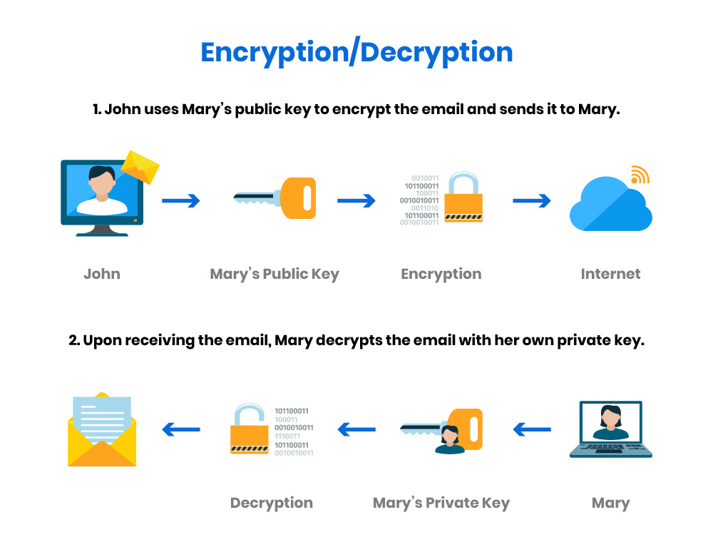

Figure 3. 1 Encryption/Decryption

Hashing uses a mathematical algorithm to generate a value from a text or list of numbers. A hash function converts a given numeric or alphanumeric key to a small practical integer value.
The output data known as the hash is unique to the input data. If any part of the original data is altered, the resulting hash data will be different from the original.
Types of Hash functions are Division, Mid Square, Folding, and Multiplication methods [23].

A digital signature is an electronic, encrypted stamp of authentication that evaluates the integrity of digital documents. A mathematical algorithm is used to create a digital signature by using the sender's private key to sign a message. The recipient uses the sender's public key to verify the digital signature, confirming that the message has not been modified since it was signed and that it came from the sender who claimed to have sent the message [21].
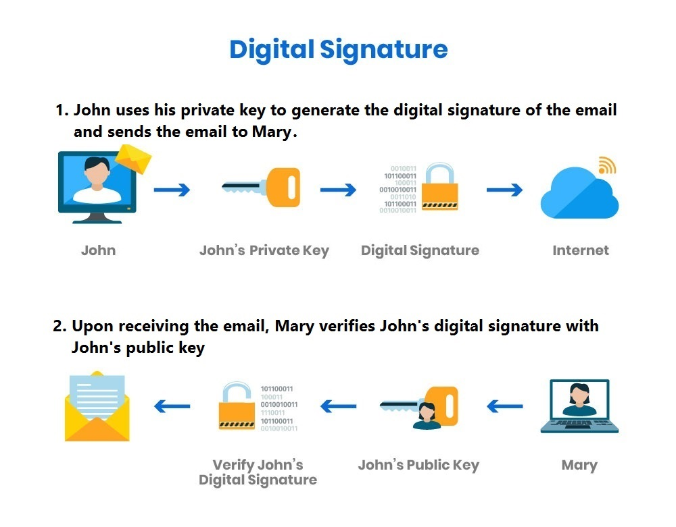

Figure 4. 1 Digital Signature

With a combination of these techniques, a sender can encrypt a message with a secret key and also generate a digital signature using their private key to authenticate the message and finally generate a hash key of the original message or document, which can be to verify the integrity of the document or message.

9e. Cryptographic Hash
A cryptographic hash can also be called a cryptographic hash function CHF. CHF is a security technique for authenticating the integrity of the validity of data.
It translates data of various lengths into a fixed-size numerical string, called the hash. A CHF protects data integrity and authentication by ensuring that no similar messages or data with the same hash value exist. If it does, it means the data has been altered or modified [24].

9f. Encryption Algorithm
An encryption algorithm is very useful when data needs to be encrypted for the purpose of maintaining confidentiality before it is sent out. An encryption algorithm converts a plaintext into an encrypted text called ciphertext. The ciphertext is sent to the receiver with an encryption key to convert back the ciphertext to its original readable format, as plaintext [25].

Example: When a sender sends sensitive data to a recipient, it uses the recipient's public key to encrypt the data. Recipients can use their private keys to decrypt the data. This ensures that only recipients with access to the private key can read the original message and that unauthorized parties intercepting the message see only incomprehensible ciphertext.

9g. Public Key Infrastructure
Public Key Infrastructure is a technology that authenticates users' digital certificates to ensure it corresponds to the identity of the user. One or more trusted parties digitally sign documents certifying that a particular cryptographic key belongs to a particular user or device. PKI operates on a model called the hierarchical trust model. In this model, a trusted third party called a Certificate Authority (CA), issues digital certificates that verify the identity of entities within the system.
This scenario explains further it better.
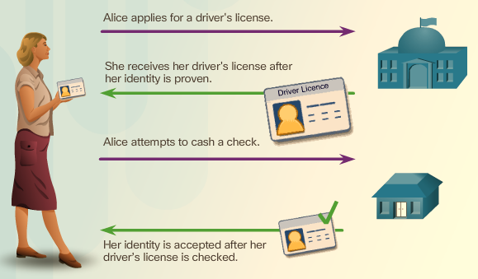

Figure 5. 1 Public Key Infrastructure illustration
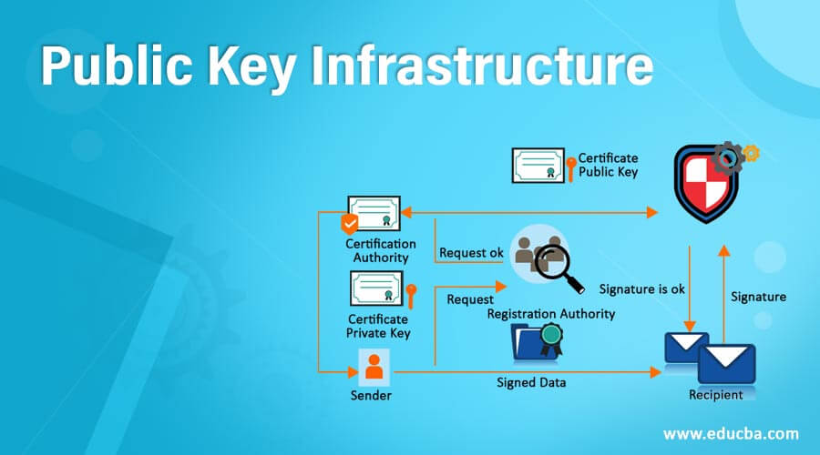

Figure 6. 1 Public Key Infrastructure

10. Implementing a Remote VPN

Packet Tracer File.

11. Cisco ASA

a. How does ASA operate?
ASA operates as an advanced stateful firewall because of its advanced security features such as application layer inspection, intrusion prevention, and VPN (virtual private network) connectivity [26].

The application-layer inspection helps to identify and block threats like viruses or malware that may be hidden in application traffic. The intrusion prevention feature functions as a detector and preventive mechanism against attacks that attempt to exploit vulnerabilities in network protocols or applications. With VPN connectivity, the ASA securely connects remote users or branch offices to the enterprise network.

ASA has an AAA feature. when you explicitly configure AAA SSH authentication, this configuration only applies to usernames with passwords, and you can use any AAA server type (aaa authentication ssh console radius_1 [26])

Other advanced features are IPsec SSL VPN, and clientless SSL VPN support, and many more features.

SECTION 2

1. A2Z Technologies Limited
A2Z Technologies Ltd is a company that specialises in the design and manufacture of high-tech electronic equipment, which is then sold to retailing companies in the UK and around the world.

2. Blueprint design of a secure network Implementation

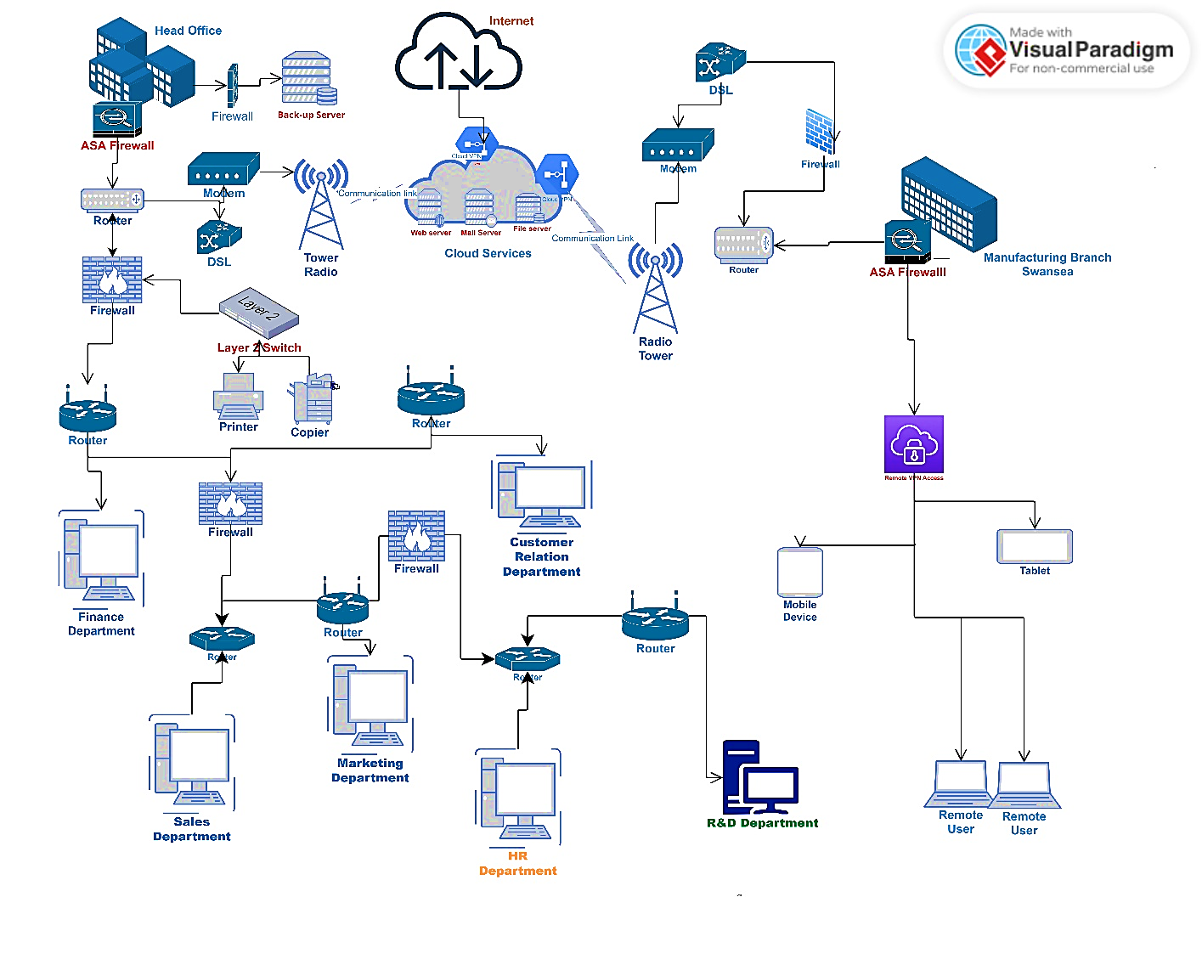
Figure 7. 1 Physical Blueprint design of a secured Network

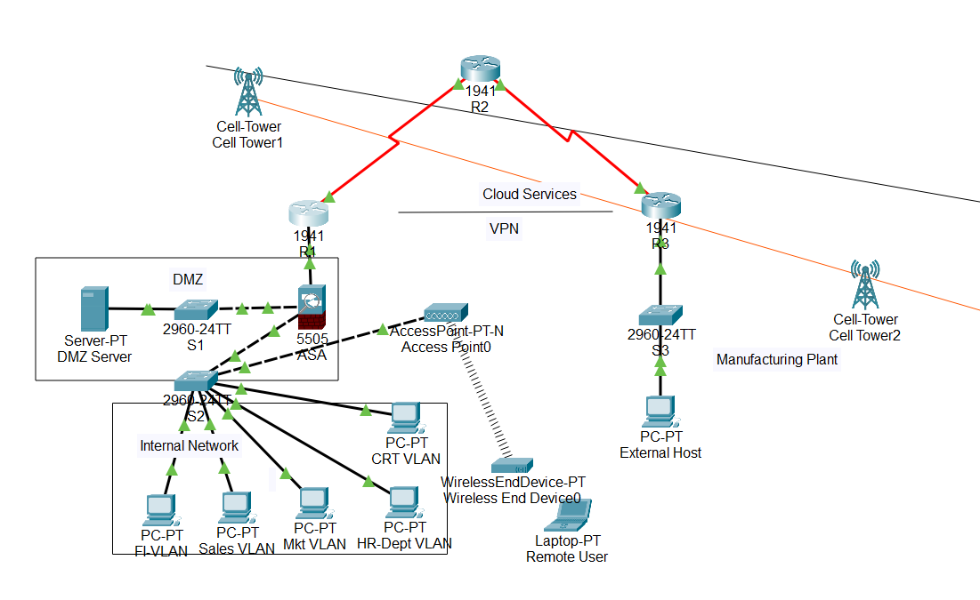
Figure 7. 2 Logical Blue Print Design for the proposed secured network infrastructure

3. Proposal for iDEAL IT Solution Limited

About us: We are a leading and reliable IT service Solution organization. We serve as an asset to any company. We bring in productivity, connect resources, and are crucial to development.

Mission
A commitment to providing customized IT solutions, which drives growth and profit in the long run.

Vision
To be the leading IT solution provider, in all aspects of IT services, including network infrastructure and security implementation, and Cloud services security.

Client: A2Z Technologies Limited
About Client: A2Z Technologies Limited is a company that specialises in the design and manufacture of high-tech electronic equipment, which is then sold to retailing companies in the UK and around the world. The company has its
head office in Swansea with a manufacturing plant based in Cardiff.

Proposed Choices and Security Measures
The Problem: A2Z Technologies have been relying on cloud services, but has no secure network infrastructure

Scope
The purpose of this proposal is to design and implement a secure network infrastructure for A2Z technologies.

The proposal will cover the following Implementation:
1. Installation of VPNs
2. Implementation of Remote Access Gateway
3. Firewalls and Access Controls
4. Intrusion Detection Systems/Intrusion Prevention Systems (IDS/IPS).
5. Malware Management
6. Secure Configurations
7. Install a backup server

I will be adopting the DMZ network architectural model for the security of the network.
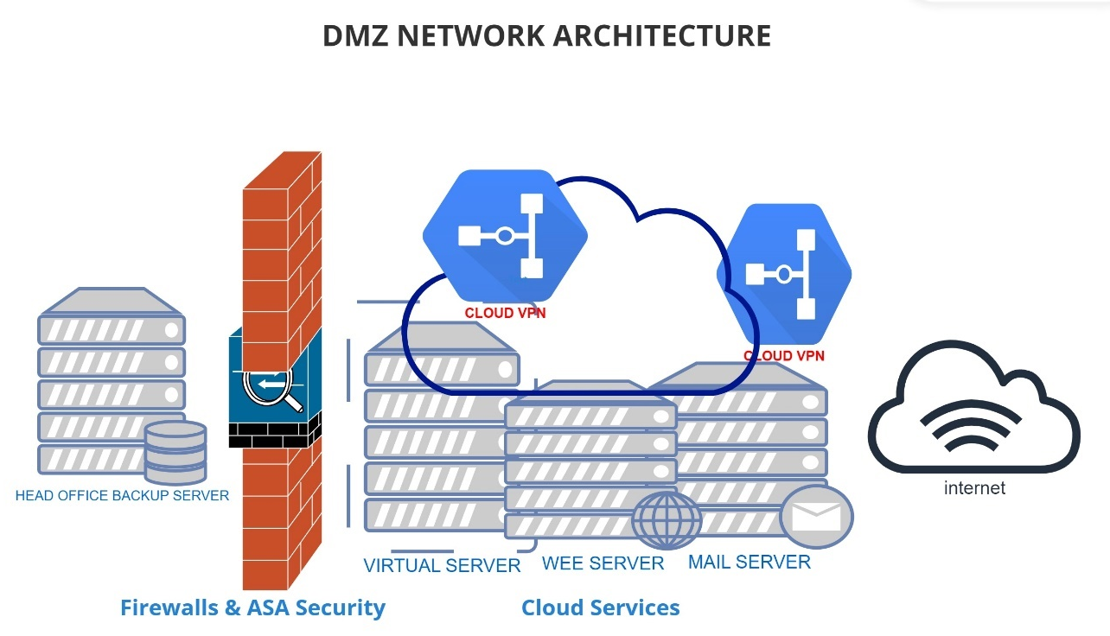

Figure 8. 1 A DMZ Architectural setup

A DMZ network architecture protects sensitive organizational systems and resources and offers users from the public internet access to certain secure services while maintaining a buffer between those users and the private internal network.

Protection against Internet Protocol (IP) spoofing: A DMZ can stall potential IP spoofers, while another service on the network verifies the IP address's legitimacy by testing whether it is reachable.
Network reconnaissance prevention: The ability to prevent an attacker from being able to detect potential targets within the network. In any case of network compromise, the internal firewall still protects the private network, separating it from the DMZ.
Access control: A DMZ network provides access control to services outside an organization's network perimeters that are accessed from the internet. It increases the number of obstacles a user must bypass before access to the organisation's private network

4. Proposed Cost Analysis

According to [30] Cisco is ranked the best Network Infrastructure and security company, with many years of experience in service. They have the best IT support service and guarantee policies. The majority of the equipment and tools in this proposal are from the Cisco company.
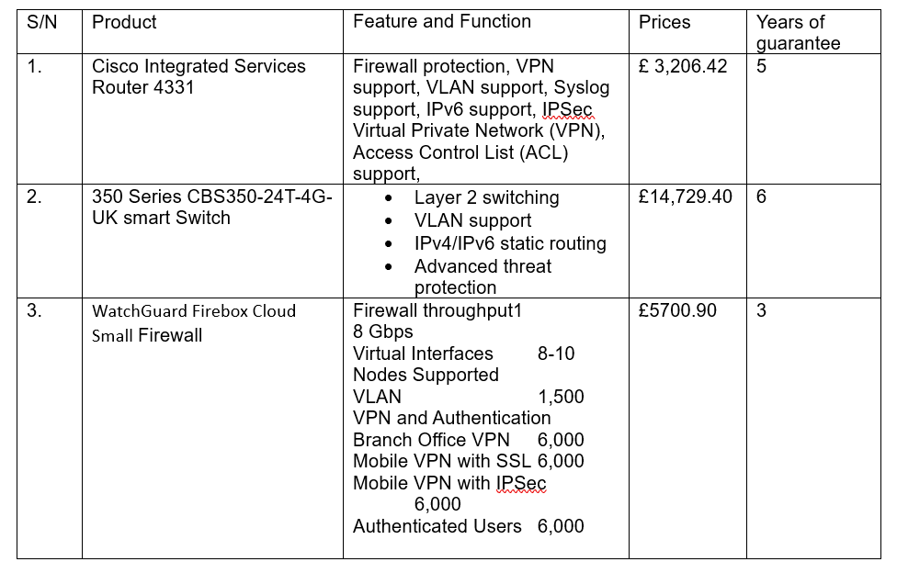
Below is the breakdown of the proposed cost analysis for implementing the solution.

Figure 9. 1 Cost Analysis for Secured Network Implementation
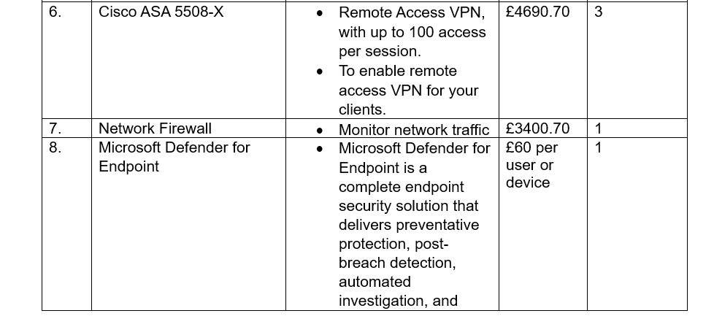
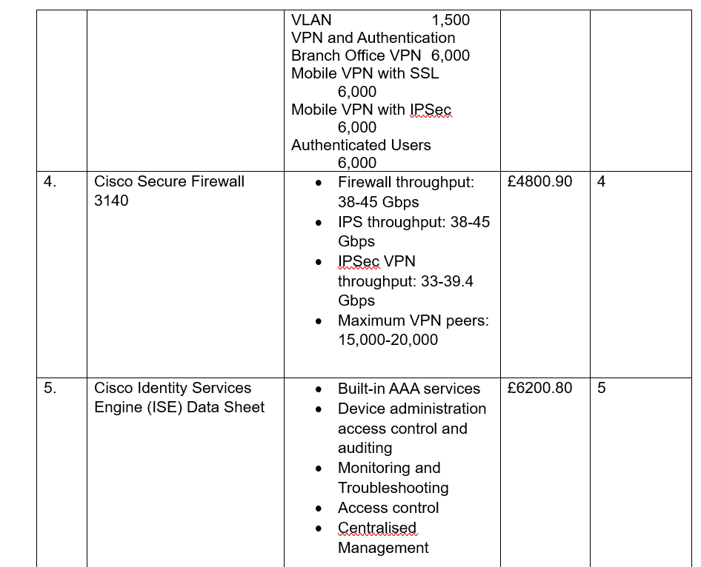

Due to the short timeline of this proposal, I wasn’t able to source prices from other vendors, but this is a link to other network infrastructure vendors, for your consideration.
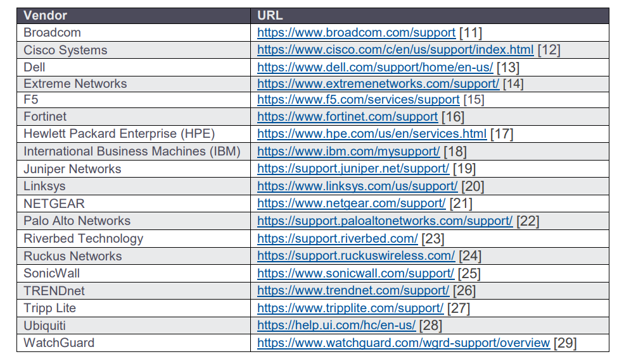

Figure 10. 1 Links to IT Network Vendors [33]

5. Project Plan Timeline
Below is a three-month project plan and timeline for the implementation of a secured network infrastructure:

Month 1: Planning and Preparation

Week 1: Establish Project Scope and Goals
- Identify the goal, objectives, scope of the project, and required deliverables.
- Prepare a project plan.

Week 2: Hardware and Software Specification
- Research and identify appropriate hardware and software for the project.
- Develop a budget for the project

Week 3: Configuration Planning
- Develop a network configuration plan
- Develop a security plan

Week 4: Defensive Mechanisms
Plan for security monitoring and incident response

Month 2: Implementation

Week 1-2: Acquisition and Installation of Hardware and Software
- Purchase and install hardware and software as needed
- Configure hardware and software according to the network configuration plan

Week 3: Configuration Implementation
- Implement a network configuration plan
- Configure firewalls, routers, switches, and other network devices

Week 4: Testing and Troubleshooting
- Analyze network connectivity and performance
- Troubleshoot any issues that arise during testing

Month 3: Final Testing and Deployment

Week 1-2: Security Monitoring and Incident Response Setup
- Configure security monitoring systems
- Develop incident response procedures

Week 3: Final Testing and Optimization
- Conduct final testing and optimization of the network
- Fine-tune network configurations as necessary

Week 4: Deployment and Training
- Deploy the network infrastructure
- Provide training to users and IT staff on the new network and security measures.

The proposal already contains types of hardware and software, that will be deployed. As for software, this plan includes the installation and configuration of operating systems, security software, and monitoring tools.

5a. Hardware and Software cost
Cost: This refers to the cost of physical devices required for the implementation and security of the network infrastructure. Examples are Intelligent Routers, smart Switches, and Firewalls.

Software Costs: this refers to the cost of installation software, software for management of the hardware Security software like firewalls, Antivirus, VPNs, etc

Maintenance cost: The maintenance cost covers the ongoing associated with maintaining and supporting the security and maintenance of the network. Examples are software updates, hardware repairs or replacements, and technical support.

5b. Logical Configuration Setup

IPsec Remote Access
The IPsec Remote Access feature introduces server support for the Cisco VPN Client (Release 4.x and 5.x) software clients and the Cisco VPN hardware clients. This feature allows remote users to establish VPN tunnels to securely access the corporate network resources [32].

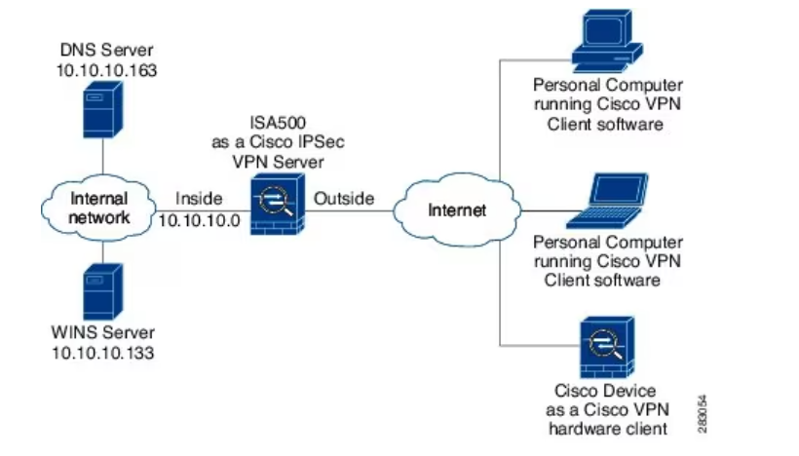

Figure 11. 1IPsec Remote Access framework [32]

Configuring IPsec Remote Access
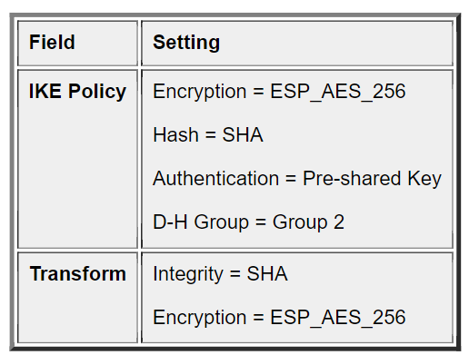

Figure 12. 1configure the IPsec Remote Access feature [32]

5c. Defensive Mechanism
For this proposal, I will be Implementing a DMZ network architecture, as explained in point 3. Above.
An additional security measure will be to conduct penetration testing and other any relevant security measures, depending on the company can afford.

- VPN and Firewall configuration

The workload subnet has the default route to the firewall endpoint in the corresponding AZ. The firewall subnet has a default route via IGW. IGW has an ingress route table associated with it

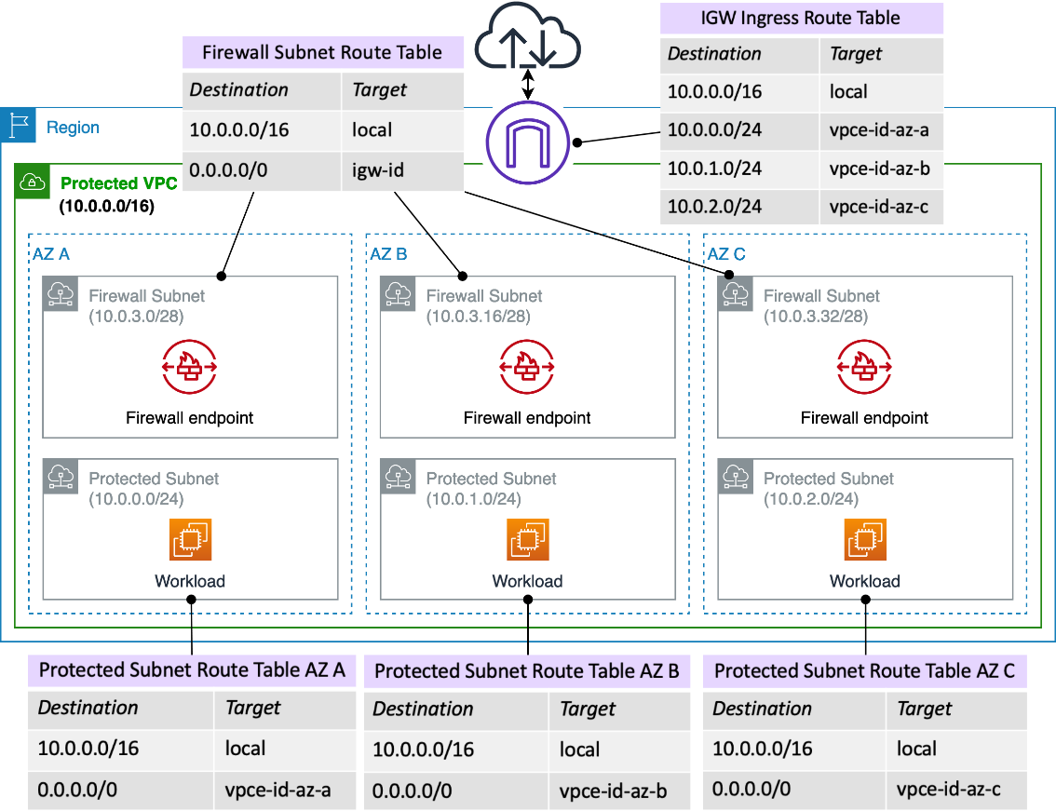

Figure 13. 1 AWS Network Firewall deployed in Multi-AZ [31]

- L2TP Packet Encapsulation
As an expansion to PPP, L2TP allows PPP packets to be transmitted through tunnels over the public network.

If only PPP is deployed on the network, dial-up calls initiated by PPP terminals can only reach the edge node NAS of the dial-up network. The NAS is the termination point of PPP sessions. When L2TP is deployed, PPP packets can be transparently transmitted over the public network and reach the LNS in the enterprise headquarters [29].

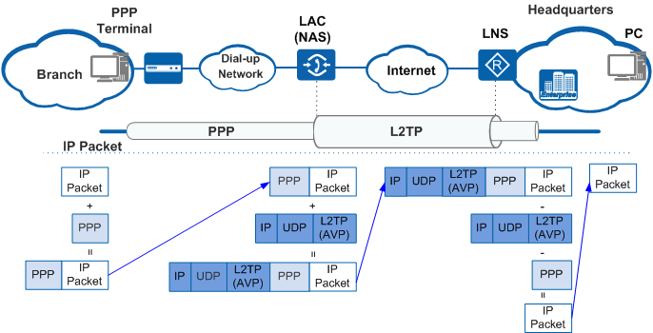

Figure 14. 1 L2TP Packet Encapsulation [29]

- Packet Encapsulation in Web Proxy

Figure 8.1 shows the packet encapsulation procedure when a remote user accesses web resources on the enterprise network. Such access comprises two sessions: One is the HTTPS session and the other is the HTTP session. In the HTTPS session, the source port is 6293, which is a random port, and the destination port is 443. In the HTTP session, the source port is 10091, which is also a random port, and the destination port is 80.
This describes the service interaction procedure of the web proxy function and the mechanism of packet encapsulation in a web proxy.

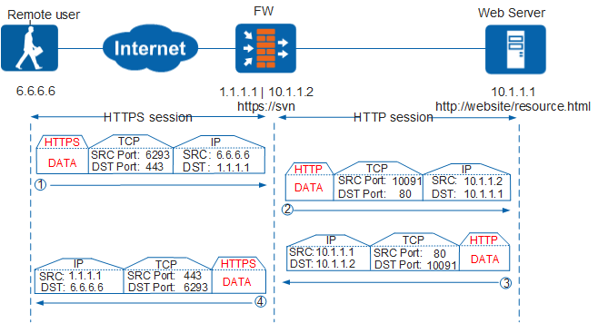

Figure 15. 1 Remote Access to a Web server
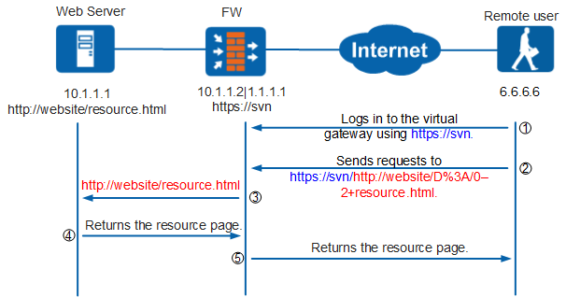

Figure 16. 1 Web server to Remote user

Figure 16.1 Indicates the procedure for a remote user to access the web server on the enterprise network using the web proxy function.

- SSL VPN Tunnel

SSL VPN is used to enable users to securely and efficiently access an enterprise's intranet resources from outside the enterprise.

SSL VPN is an SSL-based VPN remote access technology. SSL VPN allows users from any Internet-enabled location to launch a web browser to establish a remote access VPN connection.
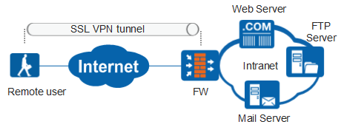

Figure 17. 1 SSL VPN Tunnel

6. Attacks Affecting organisation Network
No matter how well-secured a network is, cyber attackers will always attempt to penetrate the corporate network perimeter and gain access to internal systems.

1. Endpoint attacks— This refers to gaining unauthorized access to user devices, servers, or other endpoints, typically by infecting them with malware.

2. Malware attacks: Infecting IT resources with malware, allowing attackers to gain unauthorized access to systems, steal data, and do d. These also include ransomware attacks.

3. Vulnerabilities, exploits, and attacks: exploiting vulnerabilities in software used in the organization, to gain unauthorized access, compromise, or sabotage systems.
4. Advanced persistent threats: these are complex multilayered threats, which include network attacks but also other attack types.

7. Recommended Network Security Testing
To test the security of the network infrastructure, some security tests must be conducted, to check for any backdoor that can be used by attackers to breach the network.

- Black box penetration testing: This scenario is regarded as the most authentic, it demonstrates how an attacker with no inside knowledge of the network would target and breach through the network infrastructure. However, this test is expensive [28].

- Internal/External Infrastructure Penetration Testing
This is an assessment of on-premise and cloud network infrastructure, including firewalls, system hosts, and devices such as routers and switches [28].

- Grey box penetration testing
Grey box testing is useful to help understand the level of access a privileged user could gain and the potential damage they could cause. This particular testing is often recommended to customers as it is the best balance between efficiency and authenticity. [28]

Either of these tests must be conducted periodically, to sustain the security of the network.

8. Invoice of Secured Network Implementation

Invoice for the professional/consultancy service

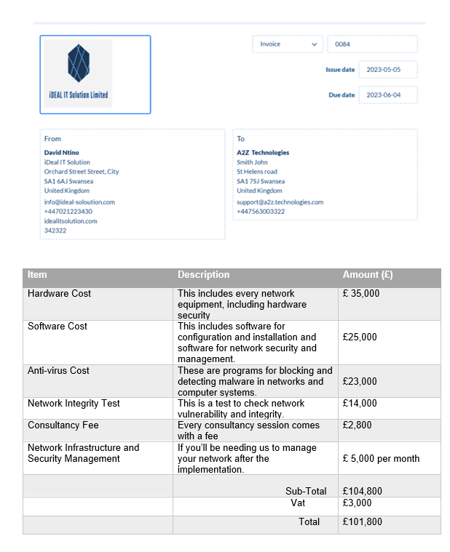
Figure 18. 1 Invoice

9. Conclusion

In conclusion, network security is a very aspect of every organisation with a network infrastructure. Just like our personal property requires us to keep them safe, the network also needs maximum security. Organisations must embrace the new system network of security.

The above proposal, if well implemented, can prevent network attacks, and any form of cyber breaches.

10. Reference

[1] mimecast, “The State of Email Security,” Mimecast. https://shorturl.at/OSZ67 (accessed May 05, 2023).
[2] “14 Network Security Tools and Techniques to Know,” Gigamon Blog, Jun. 13, 2019. https://blog.gigamon.com/2019/06/13/what-is-network-security-14-tools-and-techniques-to-know/#references (accessed Apr. 29, 2023).

[3] Cisco, “How to Protect Your Business Against Malware Attacks,” Cisco, 2022. https://www.cisco.com/c/en/us/products/security/malware-protection-best-practices-detection-prevention.html#~best-practices
[4] S. M, “10 Types of Cyber Attacks You Should Be Aware in [2021],” Simplilearn.com, Nov. 11, 2022. https://www.simplilearn.com/tutorials/cyber-security-tutorial/types-of-cyber-attacks

[5] J. Bedrick, “What is Information Security | Policy, Principles & Threats | Imperva,” Learning Center, Mar. 26, 2023. https://www.imperva.com/learn/data-security/information-security-infosec/#:~:text=of%20Digital%20Transformation.-

[6] M. W. and K. Wallace, “Chapter 1: Understanding Network Security Principles,” Network World, Apr. 23, 2009. https://www.networkworld.com/article/2268110/chapter-1--understanding-network-security-principles.html

[7] “Cisco Network Foundation Protection Framework > CCNA Security Portable Command Guide: Network Foundation Protection | Cisco Press,” www.ciscopress.com. https://www.ciscopress.com/articles/article.asp?p=1924983&seqNum=2 (accessed Apr. 30, 2023).

[8] Santander, “How to avoid computer viruses,” www.santander.com, Sep. 27, 2022. https://www.santander.com/en/stories/how-to-avoid-computer-viruses

[9] F. Point, “What is Endpoint Security?,” Forcepoint, Aug. 09, 2018. https://www.forcepoint.com/cyber-edu/endpoint-security

[10] Trillix, “What Is Endpoint Security? How It Works & Its Importance | Trellix,” www.trellix.com, 2022. https://www.trellix.com/en-us/security-awareness/endpoint/what-is-endpoint-security.html#endpoint-security (accessed Apr. 30, 2023)
[11] F. Labs, “What Is AAA Security?,” Fortinet, 2022. https://www.fortinet.com/resources/cyberglossary/aaa-security#:~:text=AAA%20verifies%20the%20identity%20of (accessed May 01, 2023).

[12] S. Richardson, “Threats to and Attacks on Routers - SCND,” Cisco Certified Expert, Jun. 03, 2020. https://www.ccexpert.us/scnd/threats-to-and-attacks-on-routers.html

[13] B. Lutkevich, “What is a Security Policy? - Definition from SearchSecurity,” SearchSecurity, Sep. 2021. https://www.techtarget.com/searchsecurity/definition/security-policy
[14] J. Varghese, “10 Best Network Security Testing tools in 2022,” www.getastra.com, Dec. 16, 2021. https://www.getastra.com/blog/security-audit/network-security-testing-tools/

[15] J. Bartlomiejczyk and M. Phipps, “Preventing Layer 2 security threats,” SearchNetworking, Sep. 2004. https://www.techtarget.com/searchnetworking/tip/Preventing-Layer-2-security-threats
[16] T. Target, “What is network intrusion protection system (NIPS)? | Definition from TechTarget,” WhatIs.com, 2023. https://www.techtarget.com/whatis/definition/network-intrusion-protection-system-NIPS#:~:text=A%20NIPS%20continually%20monitors%20an (accessed May 01, 2023).
[17] “Signature | Malwarebytes Glossary,” Malwarebytes. https://www.malwarebytes.com/glossary/signature

[18] E. Tittle, “How to set up a VPNs for enterprise use,” SearchNetworking, 2022. https://www.techtarget.com/searchnetworking/tip/How-to-set-up-a-VPN-for-enterprise-use

[19] J. Pike, Cisco Network Security. 2002, pg 216.
[20] “IPsec VPN Explained | How IPsec works | IPsec vs SSL,” www.goodaccess.com, 2022. http://goodaccess.com/blog/ipsec-vpn (accessed May 03, 2023).

[21] IBM, “Digital signature overview,” www.ibm.com, Mar. 14, 2019. https://www.ibm.com/docs/en/b2badv-communication/1.0.0?topic=overview-digital-signature

[22] ICO, “What types of encryption are there?,” Ico.org.uk, Apr. 24, 2019. https://ico.org.uk/for-organisations/guide-to-data-protection/guide-to-the-general-data-protection-regulation-gdpr/encryption/what-types-of-encryption-are-there/

[23] “Hash Functions and list/types of Hash functions,” GeeksforGeeks, Dec. 19, 2021. https://www.geeksforgeeks.org/hash-functions-and-list-types-of-hash-functions/

[24] “What is a Cryptographic Hash Function (CHF)? | Security Encyclopedia,” www.hypr.com. https://www.hypr.com/security-encyclopedia/cryptographic-hash-function#:~:text=A%20cryptographic%20hash%20function%20(CHF)%20is%20an%20equation%20used%20to

[25] simplilearn, “The Most Effective Data Encryption Techniques,” Simplilearn.com, Mar. 26, 2020. https://www.simplilearn.com/data-encryption-methods-article

[26] “CLI Book 1: Cisco ASA Series General Operations CLI Configuration Guide, 9.6 - Introduction to the Cisco ASA [Cisco ASA 5500-X Series Firewalls],” Cisco, Jun. 04, 2021. https://www.cisco.com/c/en/us/td/docs/security/asa/asa96/configuration/general/asa-96-general-config/intro-intro.html#ID-2172-0000035e (accessed May 03, 2023).

[27] B. Lutkevich, “What is a DMZ in Networking?,” SearchSecurity, 2021. https://www.techtarget.com/searchsecurity/definition/DMZ

[28] Cynet, “Network Attacks and Network Security Threats,” Cynet. https://www.cynet.com/network-attacks/network-attacks-and-network-security-threats/

[29] “L2TP Implementation - AR500, AR510, AR531, AR550, and AR2500 V200R008 CLI-based Configuration Guide - VPN - Huawei,” support.huawei.com. https://support.huawei.com/enterprise/en/doc/EDOC1000154777/8488d366/l2tp-implementation

[30] “ShieldSquare Captcha,” www.globaldata.com. https://www.globaldata.com/resourcecenter/

[31] “Deployment models for AWS Network Firewall,” Amazon Web Services, Nov. 17, 2020. https://aws.amazon.com/blogs/networking-and-content-delivery/deployment-models-for-aws-network-firewall/

[32] “Configuring IPsec Remote Access,” www.cisco.com. https://www.cisco.com/assets/sol/sb/isa500_emulator/help/guide/ah1498304.html (accessed May 05, 2023).

[33] L. Hansen, “Network infrastructure security,” Network Security, vol. 1997, no. 6, pp. –12, Jun. 1997, doi: https://doi.org/10.1016/s1353-4858(97)89529-3.

