DIGITAL SKILLS
AND
RESEARCH METHODS
Module Lecturer: Renuga Jayakumar
Module Code: BMSK4003
Student Name: Shemshat Nazarova
Student ID: 1706500

Table of Contents
Introduction 3
Research-informed Literature 4
Knowledge and understanding of subject: 5
Analysis 6
Practical application and deployment: 8
Skills for professional practice: 9
Conclusion 11
Reference List 12

Introduction
This report has described the effectiveness and evaluation of the modern technologies in the workplace. It has also evaluated the social media as a marketing tool. The effective communication that is required for professional development is also summarized under this section. The communication and gathering in the workplace is also analyzed in this section. Mainly, this report an evidence based research about the pre-defined topics. The first part of the report is consists with different dimension of the knowledge of the subject. This report also consists of an analysis part. A practical application and deployment of the modern technologies is also summarized under this section. The penultimate part of the report consists of the required skill for professional practice.

Research-informed Literature
- Source 1: Journal / Article
Technology allows employees and business to be much more efficient and productive from its most primary level. You can track time of employees, schedule appointments and sales calls, also can perform many complex tasks which took hours with the help of technology it will be in just some minutes, which makes life very easier.
In case of business accuracy is most desirable property. By the use of technology unbelievable accuracy is achieved. With the help of technology it is possible to generate the hole financial statements and information in a few moments with perfect accuracy. Modern Technology also gives the best security to the business.
Internet gives you more than you want. With the help of internet technology you can expand or promote your business too. With the help of Internet technology communication with customers becomes very easy, you can inform any employee or client instantly by making call or leaving a message or email, which helps in business significantly. (Zawadzki, and Żywicki, 2016)
- Source 2: Journal / Article
In current era one of the most vital point of business marketing strategies is social media because now it’s not only limited in amusement communication tool. It’s a new and fresh marketing strategy for vast performance perspective in medium and small sized enterprises. Now consider any company we judge and compare each with another by number of followers and likes in Twitter or Facebook, content’s richness, interaction and communication with the customers and definitely the language which is used (Öztamur and Karakadılar, 2014). For this some companies who are using formal language during the process of communication with customers and whose contents are less attractive is are very much less successful. In research we found that qualitative method of research methodologies is mostly used to observe how they communicate with customers to engage themselves with that company. This is how social media is used as one of the strategic tool for marketing in social network.
- Source 3: Journal / Article
One of the best practices of information gathering is Strategic communication. Strategic communication is well planned to motivate and educate the employees, help to building trust with one another and to giving them information about current market offerings. With the support of physical and social environment and employees involvement strategic communication takes place. Requesting the employees send them a chance to make suggestion, ask questions and collect the knowledge of current scenario (Kent et al. 2016). It can be done by simply creating corporate blogs, with setup of suggestion boxes, by fixing meetings to individual employee or by arranging meetings with a small group of employees. In professional firm one can easily get the opportunity to administer and develop the annual survey of employees. In this process it is very important that other employees can understand how one can act on individual suggestions and gathered information in surveys.

Knowledge and understanding of subject:
Knowledge is same for everyone. Which is different that is the source from which these all will come from different source. In case of marketing there are mainly 3 ways are mainly taken which everyone should understand. Those are:
- Social media as a tool of marketing: In case of Brexit, first of all a clear knowledge is required because now a day’s social media is very much effective to promote anything. Those may be product or may be any service. In case of promotion which is the base section of marketing can be easily achieved by this (Van Deursen and van Dijk, 2009). Before doing anything the proper knowledge and how to use it as a powerful weapon that should be in grip.
- Information gathering and communication: At the time In case of Brexit the online promotion or any other way of doing marketing or marketing strategy, first of all on which the promotion is doing or other relevant information regarding that product or service should be gathered effectively which will help to make a better marketing strategy. Beside this at the time of doing promotion in the social media or over the internet, everything should be very much clear and full filled so that the people can take all the necessary information regarding that promotion.
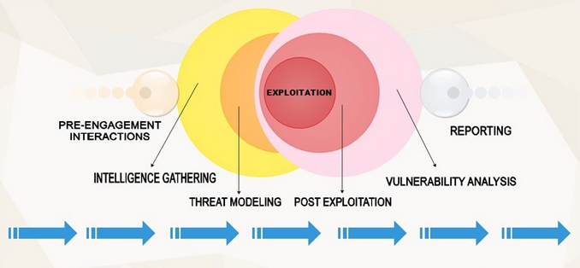
Figure 1: Information gathering process
(Source: Öztamur and Karakadılar, 2014)
- Own professional research evidence: Beside all this some special research work also need to be done by the individual because only by this way one can easily identify the key factors which is unique or which should be added with the existing system or in the marketing strategy.
If we consider a practical scenario of Brexit, than we should look forward to a startup company of software where they are going to setup from zero. These 3 factors are highly needed because without proper marketing strategy they will not be able to make a single step for the future desires. The main difference of a buildup company and a startup company is the buildup company has already been done this things and the startup company are yet to start these all things.

Analysis
Use of up graded technologies within the workplace has developed a level of technical savvy. The technology is applicable to any types of organization, i.e. from the learning institution to the space center. For implement of technology both the hardware and the software have to connect with the system, Brexit. Appling the modern technology, the business organization can face a number of advantages. Such as business would be more effective, employee productivity and monitoring power would be continuous (Zawadzki and Żywicki, 2016). It will be helpful to go with the computational accuracy. Use of technology would make the life easier. The competitive power in the organization will grow up and become helpful for marketplace sustainability. Technology will successfully develop the workplace communication. Apart from this, involvement of technology improves the information flow, it started to flow both in upward and downward direction also with horizontal and outward flow of system of Brexit. Technology inclusion supports the innovation service. The decision-making procedure get upgraded. For technology inclusion the tablets, proper management system, workplace cloud base apps and collaboration tool should be included. Apart from theses it would be better to use IOT theme and smarter office. There is no doubt to say that, digital technology inclusion is one of the types of technology inclusion. One of such tool is social media, inclusion of which, information gathering concepts becomes more organized, related to Brexit. For improving the communication in the workplace, the technology like texting, email, vision conferencing, Blogs, instant messaging technology would be helpful. In the next an employee knowledge and perspective about the use of modern technology is summarized under.
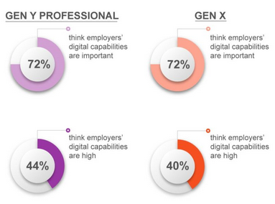
Figure 2: Employee perspective for improving communication in the workplace
(Source: Gui and Argentin, 2011)
The next picture has described the use of technology in some of the multinational organizational which includes the organization like coca cola, apple, Nike, Starbucks and rest others. These types of organization are termed as design centric organization. Graph shows the design centric index.
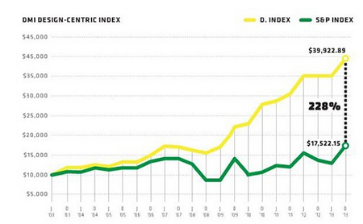
Figure 3: Design centric index of some MNC’s
(Source: Dychtwald et al. 2006)

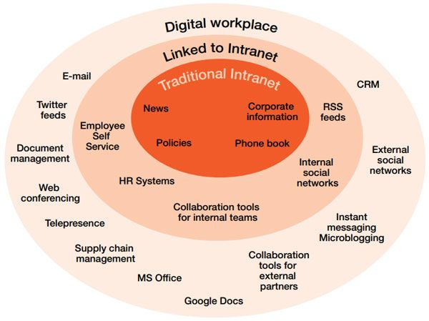
Figure 4: Procedure to link up with digital technologies
(Source: Czarnecki, 2009)

Practical application and deployment:
If we consider the above key points which is the main of doing a proper marketing then only knowledge and understanding won’t give all the things until those are not deploying in the business to get the probable outcome.
If we consider the first point then after understanding the knowledge of Brexit, it will not going to be worked unless those will not affect the social platforms. After understanding the main reason then the main pressure comes and that is how to use those on the social media because only the special things will work on social sites by which the people will be attracted (Van Deursen et al, 2014).
If we talk about Brexit and the second point then after gathering the relevant information a straight forward study is needed to be analysis from the very first which is highly effective to get the desired result. Information will indicate so many thing like the market demand, product review, product facts, feedback from the customers which is very much needed to get a better environment
In the last section individual study and research will get the best way to give the best because without research work nothing can be done effectively. In the research work will determine that what should be the best way to achieve the desired position and thus will be possible by a thorough research work.
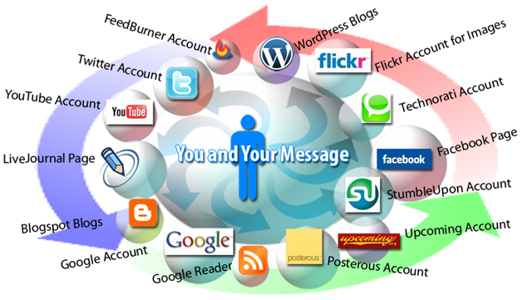
Figure 5: Requirement of social media for marketing
(Source: Van Deursen et al, 2014)
In modern era if we talk about the Jio Company as an instance then we can observe the above points with an effective way. They started analysis the present telecom system and make a thorough research in the market, collect the demands from the public and make a proper strategy they started the business in the market. Their marketing was exceptionally superb in the social media. Facebook, twitter and many other websites promote their plans, facilities that were the main reasons behind their success. By this real life case study it clearly states that the above points are needed to be considered effectively.

Skills for professional practice:
The above key factors will work when those will be considered effectively and with skillfully. Skillful nature is highly desired to achieve that much success. Other than this a company will face so many problems of Brexit. So before anything the member hiring should be very much crucial and the hiring process should be very different because only by tough rounds will create the buzz in the aspirants and by only this way the cream of the students will come out with positive nature. Skillful professional practice can be achieved in the following segments:
- Proper test: By the proper and effective exam can be a key to select those people who will be fully fit and skilled with their potential which will be very much needed for the organization because these persons will bring the success for the company (Van Deursen and van Dijk, 2014).
- Talk it out: At the time of interview if the selectors judge the aspirants with proper discussion then they will understand clearly that who will be the key factors of Brexit for their organization and will be best for doing their job. Beside this some real life examples can judge those aspirants because in those cases their views can clearly indicate their state of mind and thus will prove about their potentiality.
- Take challenge: in the workplace there are different types of problems of Brexit will come and according to that those should be taken as challenges because to solve those problems with effective way is the main motive to get the desired thoughts (Prensky, 2001). At the time of selection the selectors should think about those candidates who are eagerly waiting to take the problems or any other issues as challenges.
- Excited always: The skillful persons are always excited to take anything because they are very much confident to face the problems as they have the right skill, they know that how to cope up with those issues and make those into the positive outcomes. So those excited candidates will be the key of the company to get the right success which they want to grab.

Conclusion
Reviewing this whole report it can be concluded that, from these report one can gain in detail knowledge about the published literature on the topic, use of modern technologies in the workplace, importance of social media as a marketing tool. The next part of the report has analyzed the importance of social media as a marketing tool. Some evidence of Brexit, of a startup company and developed company is compared and contrasted with specific example. The last section has analyzed the required professional practice for conducting better communication in workplace.

Reference List
Battro, A.M., 2004. Digital skills, globalization, and education. Globalization: Culture and education in the new millennium, pp.78-96.
Czarnecki, K., 2009. How digital storytelling builds 21st century skills. Library Technology Reports, 45(7), p.15.
Dychtwald, K., Erickson, T.J. and Morison, R., 2006. Workforce crisis: How to beat the coming shortage of skills and talent. Harvard Business Press.
Gui, M. and Argentin, G., 2011. Digital skills of internet natives: Different forms of digital literacy in a random sample of northern Italian high school students. New media & society, 13(6), pp.963-980.
Kent, K., Goetzel, R.Z., Roemer, E.C., Prasad, A. and Freundlich, N., 2016. Promoting healthy workplaces by building cultures of health and applying strategic communications. Journal of occupational and environmental medicine, 58(2), pp.114-122.
Öztamur, D. and Karakadılar, İ.S., 2014. Exploring the role of social media for SMEs: as a new marketing strategy tool for the firm performance perspective. Procedia-Social and behavioral sciences, 150, pp.511-520.
Prensky, M., 2001. Digital natives, digital immigrants part 1. On the horizon, 9(5), pp.1-6.
Van Deursen, A.J. and van Dijk, J.A., 2009. Improving digital skills for the use of online public information and services. Government Information Quarterly, 26(2), pp.333-340.
Van Deursen, A.J. and van Dijk, J.A., 2014. Digital skills: Unlocking the information society. Springer.
Van Deursen, A.J.A.M., Helsper, E.J. and Eynon, R., 2014. Measuring digital skills. From Digital Skills to Tangible Outcomes project report. London: University of Twente.
Van Dijk, J.A.G.M., 2012. The evolution of the digital divide: The digital divide turns to inequality of skills and usage. Digital enlightenment yearbook 2012, pp.57-78.
Zawadzki, P. and Żywicki, K., 2016. Smart product design and production control for effective mass customization in the Industry 4.0 concept. Management and Production Engineering Review, 7(3), pp.105-112.

