Professional Development Plan
HLTA status (Partneriath/ERW), NVQ Level 3 Child, Care, Learning and Development, BTEC Level 3 Supporting Teaching and Learning, Paediatric First aid. Safeguarding. Basic Health and Safety, Introduction to ALN in Wales, Fire Marshall Training, Fire Safety Awareness, Curriculum for Wales.

To give effective written and verbal feedback to pupils, to raise maths levels of targeted pupils to within their Progression Step, being a successful student at UWTSD and improving Welsh.

Objective | Actions | Resources | Target Date | Success criteria
To further improve teaching and learning experiences by giving effective verbal and written feedback, in line with updated school policies. | Be aware of the updated school policy of always having a green pen to hand; being aware of when and where to use marking symbols; processes for pupils to respond to marking.  Be more confident with using written and verbal feedback to support learner progress.  Confer with class teacher for lesson objectives to direct pupils within marking. | Undertake in-house training, focusing on the approaches that will be employed.  Observe good practice taking place in other classes (Trust Trios). | Feb 2024 | Be able to participate in book looks, work scrutiny, and listening to learners, to evaluate efficacy of practice.  Be confident marking pupils’ work and providing them with efficient next steps to progress their learning.
To continue to improve maths and numeracy standards by raising maths level for targeted pupils IA, MD, MG, AT to work within Progression Step 3 | Work to raise standards in Maths and mathematical reasoning by improving pupils' confidence with maths.  Speak to Numeracy Lead regarding Numicon intervention to aid with place value.  Use the unit overviews to track progress/ value added and track Standardised age scores when maths tests undertaken. Liaise with ALNCo regarding Dyscalculia training to support learners.  Work with class teacher to discuss progress of pupils and next steps. | Data available from class teacher and topic assessment to set starting point and next steps, to plan targeted activities for in class intervention.  If necessary, use assembly time for additional intervention.  Use Numicon intervention to bridge place value gaps.  Use unit overviews to tailor intervention. | End of unit tests  Feb 2024 | Learner successfully using Numicon to complete tasks, progressing to rely on additional resources less. Observing learner being involved in lessons with growing confidence.  Learner making progress on their end of unit assessments.
To achieve degree in Early Years, Education and Care, Practitioner Status | Attend and actively participate in lectures.  Complete assignments to a high standard and upload them on-time | Lecture handouts, and lecture presentations saved on Teams  UWTSD library  Reading lists, and lecturers. | July 2025 | Graduating with a BA Honours qualification, allowing me to enrol on the PGCE course
To improve Welsh oracy and written skills | Speak with Welsh Co-ordinator to enrol on Welsh training course, use incidental Welsh regularly whenever possible, | In class Welsh resources, use Duolingo app to improve basic Welsh already possessed. | July 2024 | Increased confidence when speaking Welsh to class, improved fluency especially with pronunciation and being able to write comments accurately.

Briefing Paper – Effective Reflection
What is reflection and reflective practice?  Reflective practice began in fields of expertise that dealt with real life, practical situations, like health, social care, and education, where the professional would consider the interactions and situations they had dealt with. Then taking the positives from the experience forward to use again but also learning from negatives. Learning from those circumstances in order to improve organizational effectiveness (University of Cambridge, no date).  As a student, Cottrell (2019) believes self-reflection is thoughtful consideration of how your work, mental and physical state, impacts your study and by reflecting you take ownership of your own performance and therefore promoting self-efficacy.  Individual reflection is beneficial on a personal and professional note but when working for an organisation or setting where collaborative working is the norm it is paramount to participate in group reflections occasionally or share best practice and learn from your colleagues or external agencies.  Pacey (2016) says becoming successful at reflective practice is not a quick fix and should be looked upon as embarking on a journey.  Bolton (2014) suggests a reflective diary where you can record feelings and emotions and information on the successes and failures not just the specific experience. Considering the situation, what was the impact on the child, of the successful practice and conversely what was less beneficial and looking to change the outcome for next time. | Why is reflective practice important to EY practice?  To be a conscious practitioner reflecting is highly beneficial. By considering the consistency of their practice and looking to improve. As with being a critical thinker when researching, critically exploring what has been successful or not in their own practice and being prepared to alter how they work for the better, therefore being proactive and showing drive and ambition (Birth to 5 Matters, no date).  Here in Wales childcare settings are governed by the CSSIW who expect the setting to scrutinize four themes, and before an inspection create a Self-Assessment of Service Statement. In creating the document, the setting will deliberate on the themes of well-being, care and development, the environment, and leadership and management. By following these four themes, during group reflection and individual, their reflection can follow a structure to examine the positive and negatives situations that are highlighted and then take the successes forward while learning from any unsuccessful activities to improve.  By sharing experiences within your setting and learning from colleagues and external experts you will be able to sustain the positives and alter the negatives not just to improve practice for the early years practitioner but the children they are working with. Although the reflections will come from the practitioner’s perspective the considerations are for the child’s experience to be improved and not losing sight of that will encourage the individual's success and that of the setting whose focus is on the child in their care. There is no end to reflection, it is a continuous cycle.
The theory of reflective practice:
John Dewey was an American educator who was passionate about the reform of education. He believed we should learn by doing, with discussions, interaction, and integration between academic fields. He believed that once you began an experience that highlighted difficulties then you started reflecting on the problem, conceptualising seeking potential solutions. Donald Schon was an American philosopher, he also believed in the concept of reflective practice. Schon (2016) discussed the two variations of reflection, when the opportunity to reflect in action arises and you can alter your delivery instantly as opposed to reflecting after the event, allowing you to reconsider or confirm actions that worked thus helping practitioners to articulate their knowledge (Slesser et al, 2018). Reflecting in action is especially beneficial in workable situations like an education or childcare setting as you are not always able to plan for all eventualities. By learning from Schon’s reactive reflections the practitioners’ bank of solution strategies will evolve to assist them in becoming even better practitioners.
The theory of reflective practice is the reasoning behind changing or adapting your practice whereas the reflective model is the tool to follow to change.

Gibbs’ model 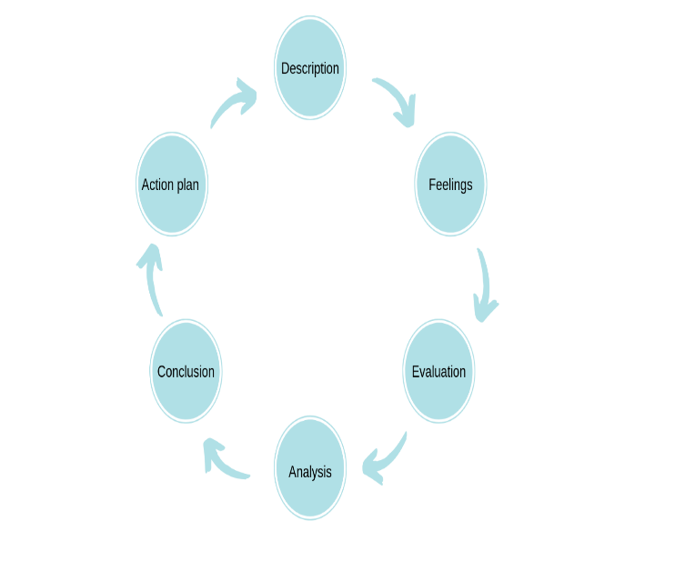 | Driscoll’s model  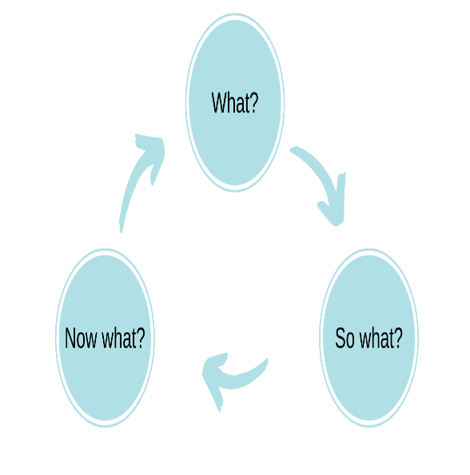
Analysis of models – compare/contrast/pros/cons:
Gibbs (1988) is an in-depth plan that gives the practitioner the framework to follow to learn from an experience, as an individual session or for on-going learning/behaviour activities. This model leads you through six strategies and questions within those headings, describing the original situation, then addressing the feelings that arise, through exploring and analysing, then forming a plan from the conclusion. The Gibbs method is beneficial as it has the potential to deliver a more informed plan once the process has been completed. The plan is suited to a learning log or diary entry; however, the Open University (2014) believed this method may be superficial reflection as it doesn’t consider the need for critical analysis and is not objective enough.
Driscoll (1994) created the second example when he further developed the original questions asked by Terry Borton in 1970. It is one of the more basic strategies with three questions to ask yourself: what do you want to learn? What did you know in the situation and what could help you make sense of it? And what will you do next time?
The strength of this model is its simplicity, it can be easily used in action as well as after the fact. But there is a chance that the basic questions will not get to the root of any problems that could be addressed as they are skimmed over.
There is no one strategy that is better than another as the scenarios they are used for varying greatly also, so the early years practitioner would benefit from knowing the difference so they can choose the right model for the situation they would like to reflect on.

Conclusion
This information has highlighted the fact that you reflect more than you realise and have been doing so, to some degree, for a while. When reflecting different people and professions will prefer different models and theories, and what is efficient to one setting will need work at another. For reflection to have an impact on your practice it is imperative to evaluate both positive and negative experiences to have a balanced comprehension of your working environment. An understanding of a couple of models would expand your understanding and allow you to address situations as they arise, if necessary, with in action reflection or delve further into the causes and results. While remembering the good practice that has also been used

What is Professional Practice and Why is it Important?
To answer what professional practice is we first need to understand what is professional. Perez (2019) believes a professional has gained specific expertise through their personal growth, while possessing the qualities necessary, and follows the appropriate principles and moral code for their area. A professional has received targeted training and is prepared to follow the standard of practice while providing a service that is outside their personal concerns. The energy and innovation of a professional establishment nurtures the evolution of professionals as individuals and as team members.
The National Childcare Strategy of 1998 (DfEE 1998) instigated improvements to the professional role of the early years' practitioner incorporating strategies and standards for the setting as a whole and introducing outcomes set for the child (DfES 2003; DCSF 2008; Early Education 2012; DfE 2017a), which have been incorporated into fabric of the inspection process across the board. Brock (2012) believed the opinions and expertise of the early years' practitioner had been missing from the discussions surrounding the early years area. With that in mind research began using practitioners to classify professionalism in their field. It was decided there were seven connecting areas comprising of knowledge, qualifications and continuing development, unique credentials, self-determination, values, ethics, and rewards. The study centered on the experiences of twelve practitioners from varying roles and levels of qualifications working within the early years setting, from birth to five years, returning six years later to reflect. Over the six years their working environment has evolved continuously but their opinions on professionalism were unchanging.
When working within the early years setting the practitioner must be mindful and have critical awareness of their environment and their practice, recognise their own role and responsibility and be able to reflect upon it. It will be important to be able to communicate effectively with all ages and agencies as working collaboratively is essential and being able to connect with the children is essential.
To work in the early years or even any educational setting, being a professional is just one part of your role. It should not be just working with children, this should be a vocation, where the dedication of the practitioner is seen and is starting to be recognised (DfE 2021). To work in the care and education setting it is imperative the practitioner holds themselves accountable, by having strong values and core beliefs that align with the ethos of the setting and environment they are immersed in.
Gasper (2009) suggests ideas to connect the different professional ideas, methods and targets in early childhood care and education. Looking at what is important when working within a setting that is joined by other agencies for the benefit of individuals and the setting, sharing good practice and exploring how to avoid the complications and negatives. Gasper believes that the best professionals know and understand the theories and practicalities of a child’s development while being enthusiastic, respectful, and compassionate.
Values are the things that matter to you, they impact the way you work and how you live your life, both consciously and subconsciously. They are used to help make choices in life and for you to be content. Personal values can change a grow throughout your life as things that are important to you also change but by adhering to the values you have can assist with the balance of work/life. When considering the early years practitioner, it is vitally important that their values are compatible with that of the setting. It takes a certain kind of person to work in the care/education setting and having aligned values is beneficial.
Early years practitioners show dedication and care towards the children and families they deal with. Constantly considering the needs of the child, their rights, health and well-being, individuality, and common beliefs. Pacey (2016) highlights the need for a good understanding of the developmental needs of the child for the practitioner tasked with improving the development. Powell (2010) discusses in her article in the British journal of educational Studies, the need for nurture and enthusiasm, along with a genuine liking for children. Being able to communicate well with a range of people and ages or academic achievements, working within a team at your setting but being able to converse with outside agencies and parents. Working collaboratively is important when the child’s needs are covered by multiple agencies and sharing information. Communication is more than talking, the professional practitioner will have the skills to communicate in a range of ways, by careful observations and accurate records.
The professional practitioner in Wales will be confident in their own abilities and be able support colleagues in protecting children from and recognising and supporting those suffering from abuse, neglect and harm and the dangers that surround them by having a comprehensive awareness of safeguarding in the early years. The safeguarding policy covers a range of situations including bullying, online safety, child protection and preventing radicalisation. Showing confidence provides reassurance to the people in need of support and the public, and by promoting well-being and staying safe for children and young people, it is paramount to work in partnership with other agencies, parents, and carers to be able to protect them. The practitioners have access to the Wales safeguarding Procedures App that has all the information at hand to support and advise the practitioner, including specific regional boards and resources.
Partnership and multi-agency working is important to the early years practitioner because it can help to provide improved outcomes for children and families. As highlighted by the Welsh government (2016) these benefits can include identifying and responding to the needs of the children and their families earlier so the need does not escalate to a more serious issue. Collaborative working can introduce a more holistic approach for families, utilising the different approaches and resources available. By avoiding agency conflicts the quality and stability of services and reduces duplications and gaps. It also empowers the children and families by valuing their contributions and giving them the information to make choices.
Observation and planning are a continuous process that allows practitioners to monitor each child's progress and plan appropriate activities and experiences, thus evaluating the curriculum's effectiveness. It informs professional practice and ensures practitioners are meeting the needs of the child in the early years setting in Wales. This is achieved, according to Birth to Five Matters (2021), by starting with the child and building relationships based on observation and targeting the specific interests, strengths and areas that need to be developed. By receiving relevant training in child development to understand how children learn and grow, and what they need to thrive. Including the child and their families and other professionals in the assessment and planning stages and respecting the input. Ensuring the environment is stimulating and supports learning across the seven areas of learning in the Foundation Phase curriculum. These include communication and language, personal, social, and emotional development, physical development, literacy, mathematics, understanding the world and expressive arts and design. Also evaluating the impact of the provision and practice on the children’s outcomes and adjusting as necessary for improvements.

The principles of the UNCRC are the fundamental values that guide the implementation of the Convention and the realisation of children’s rights. They inform the professional practice and why this is important in the early years setting in Wales by ensuring all children are treated with dignity and respect, regardless of their race, religion, abilities, or any other status (Article:2). They help professionals to make decisions that are in the best interest of the child, considering their views, needs and preferences (Article: 3). These principles are important in the early years setting in Wales because they recognise that children are active agents of their own learning and development, and that they have unique perspectives and experiences that should be valued and respected.
In conclusion, there is no one thing that is needed to be a professional practitioner, there are many facets, and they are interlaced with each other. The role of a practitioner often crosses between educator, carer, cheerleader, supporter, champion, nursemaid, and counsellor not necessarily in that order. Using the skills, they have gained through experience, training, teamwork, and networking, knowing who to ask and when if support is needed. If the early years practitioner has succeeded at their role they have allowed, facilitated and encouraged the individually specific academic growth, health, and well-being of the future.

Reference list
Birth to 5 matters. (2021) Professional reflective practice. Available at: https://birthto5matters.org.uk/wp-content/uploads/2021/03/PDF-20-Professional-Reflective-Practice-1-1.pdf (Accessed: 22nd October 2023).
Bolton, G. (2014) Reflective Practice: Writing and Professional Development, fourth edition. London: Sage
Brock, A. (2012) Building a model of early years professionalism from practitioners’ perspectives. Journal of Early Childhood Research 11(1) 27–44 Building a model of early years professionalism from practitioners’ perspectives (sagepub.com) (Accessed 20th October 2023)
Cottrell, S. (2019). The Study Skills Handbook. 5th edn. London: Macmillan International Higher Education/Red Globe Press.
Department for Education (2021), National Professional Qualification (NPQ): Early Years Leadership Framework. Available at https://assets.publishing.service.gov.uk/government/uploads/system/uploads/attachment_data/file/1182417/National-Professional-Qualification-for-Early-Years-Leadership.pdf (Accessed 28th October 2023)
Early years foundation stage (EYFS) statutory framework - GOV.UK (www.gov.uk)
https://help-for-early-years-providers.education.gov.uk/get-help-to-improve-your-practice/working-in-partnership-with-parents-and-carers
https://hwb.gov.wales/api/storage/3e89a21c-60fb-416c-99dd-6e1af3982409/a-curriculum-for-funded-non-maintained-nursery-settings2.pdf.
Lindon, J. and Trodd, L. (2016) Reflective Practice and Early Years Professionalism. 3rd edn. London: Hodder Education
Pacey (2016) Developing Self Reflective Practice. Available at: https://www.pacey.org.uk/Pacey/media/Website-files/PACEY%20member%20practice%20guides%20(PDFs)/PG04-self-reflective-practice.pdf (Accessed: 22nd October 2023).
Powell, S. (2010) Hide and Seek: Values in early childhood education and care. British Journal of Educational Studies. Vol. 58, No. 2. Available at: HIDE AND SEEK: VALUES IN EARLY CHILDHOOD EDUCATION AND CARE (uwtsd.ac.uk)
Slesser, S., Morago, P., Bruce, L. and Macmillan, M. (2018) Reflective Practice, Available at https://content.iriss.org.uk/reflectivepractice/index.html (Accessed 27th October 2023)
University of Cambridge Libraries (No Date). Models of Reflection. Available at: Models of reflection - Reflective Practice Toolkit - LibGuides at University of Cambridge Subject Libraries (Accessed 25th October 2023)
University of Edinburgh (2020) Reflection Toolkit, Gibbs’ Reflective Cycle. Available at https://www.ed.ac.uk/reflection/reflectors-toolkit/reflecting-on-experience/gibbs-reflective-cycle (Accessed 22nd October 2023)
University of Hull (2023). Reflective writing: Reflective frameworks. Available at https://libguides.hull.ac.uk/reflectivewriting (Accessed 22nd October 2023)
Welsh Government (2021) Keeping Learners safe. Available at https://www.gov.wales/sites/default/files/publications/2021-12/keeping-learners-safe.pdf (Accessed 17th October 2023)
Welsh Government (2016) Theme 5: Developing Community Partnerships and Multi-agency Working, Resources 1 and 2. Available at https://www.gov.wales/sites/default/files/publications/2018-12/theme-5-developing-community-partnerships-and-multi-agency-working-resources-1-2.pdf (Accessed 28th October 2023)
Welsh Government (2022). Children's Rights in Wales. Available at https://www.gov.wales/childrens-rights-in-wales Accessed (29th October 2023)

