Website Development Report
Student ID:2328493
BSc (Computing)
Web Design & Development
Date:18/03/2026
Contents
- Introduction
- Requirement
- Implementation
- Validation
- Conclusion
- References

introduction
This report highlights the design, development of Greggs, a popular UK bakery chain. The website was generated using HTML and CSS to showcase products company information, contact details.
The report outlines the requirements implementation and validation of the website. It evaluates the website in terms of usability accessibility and search engine optimisation (SEO). Additionally, a comparison between you existing websites is included to analyse design quality user experience.
The website was designed to focus on users experience and to ensure that the customers can easily find menus as well as offers and contact details.

Requirement
The purpose of this website is to provide essential information about Greggs including its products history and service. The website is designed for customers who are interested in bakery products and want to learn more about the company. The website includes a homepage product page as contact page to ensure users can easily navigate and find information.
The site covers various bakery products such as sandwiches, pastries drinks and it also provides company information contact forms and store locations visual cotent is uused extensively to enhance engamgent with product images banner and promotional graphics,
target Audience
The primary audience includes:
- Regular customers: People who visit Greggs interested in finding out about current deals and special offers.
- New customers: Individuals searching for nearby stores or product information.
- General audience: Anyone interested in Greggs’ offers or looking to contact the company.
The website is easy to use for people of all ages. It is very simple to navigate work well on phones and is it is design so everyone can use it without any difficulty.

3. Implementation
Overview:
The website contains of several pages, including Home, Menu, Contact, Offers, About, and Store Locator. The layout is clean and professional, using Greggs’ brand colours (blue and yellow) consistently. Navigation is consistent across pages, with a header menu for easy access.

3.1 Home Page
Screenshot: [Insert screenshot]
Design Decisions:
- Featured banner for promotions.
- Quick navigation links to Menu, Offers, and Store Locator.
- Footer with social media links and contact info.
Purpose:
Introduces visitors to Greggs, highlights current promotions, and allows quick access to other pages.

3.2 Menu Page
Screenshot: [Insert screenshot]
Design Decisions:
- Categorized product list (Bakery, Sandwiches, Drinks).
- High-quality images for each product to enhance user engagement.
- Prices clearly displayed.
Purpose:
Allows visitors to browse items before visiting a store, improving convenience and customer satisfaction.

3.3 Contact Page
Screenshot: [Insert screenshot]
Design Decisions:
- Simple contact form with required fields.
- Store locator map embedded using Google Maps.
- Footer repeated for easy access.
Purpose:
Provides customers with a way to reach Greggs for inquiries, complaint

Implementation
Figure 1: Home Page
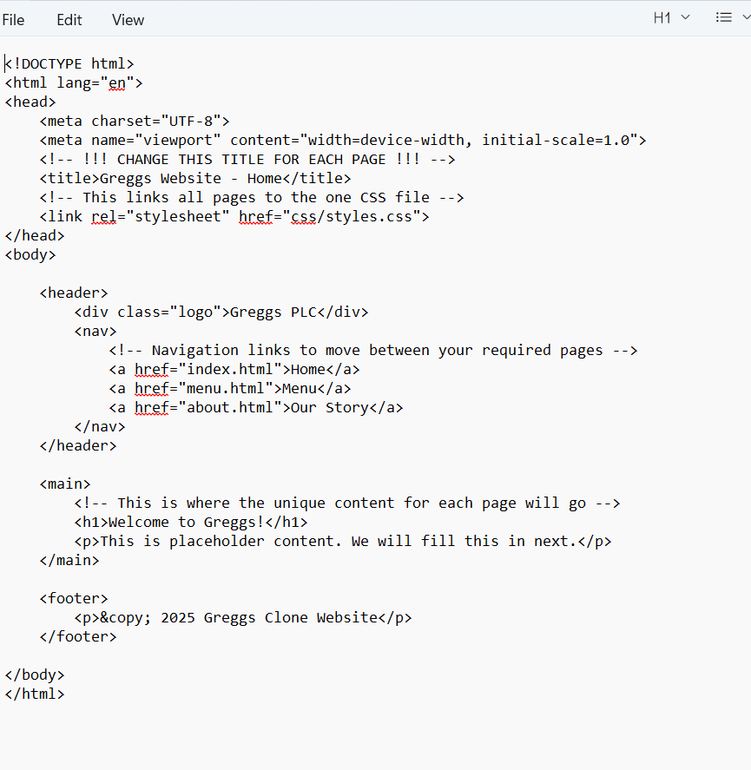
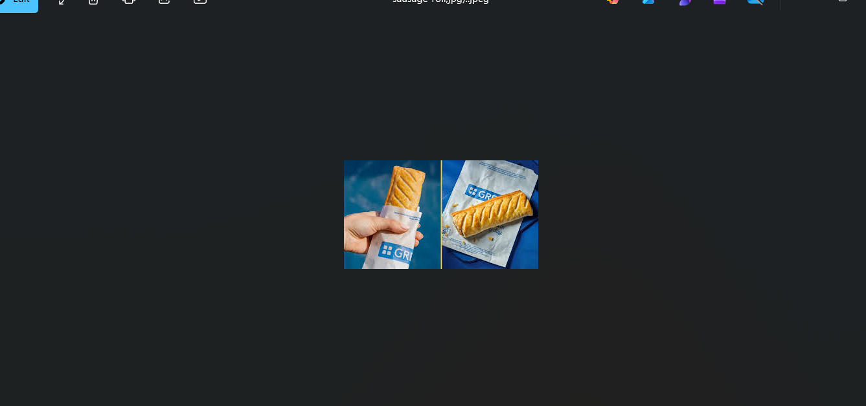
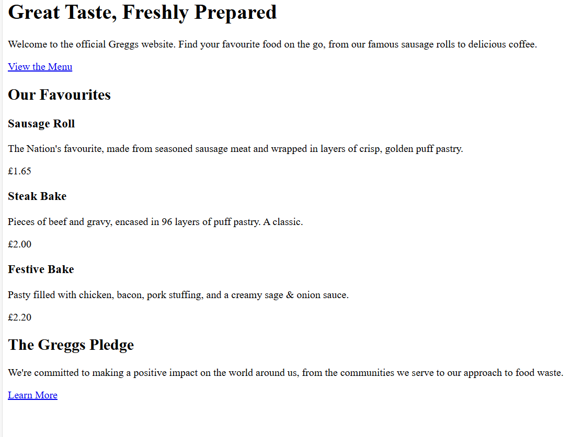
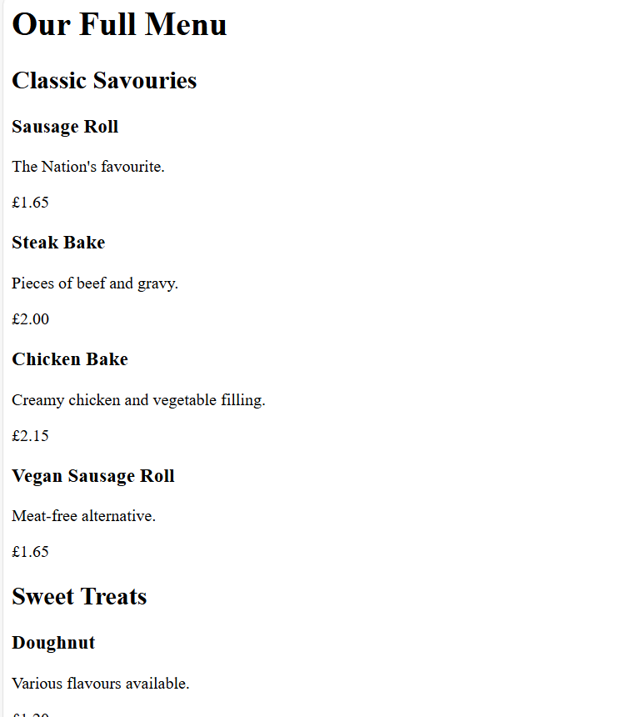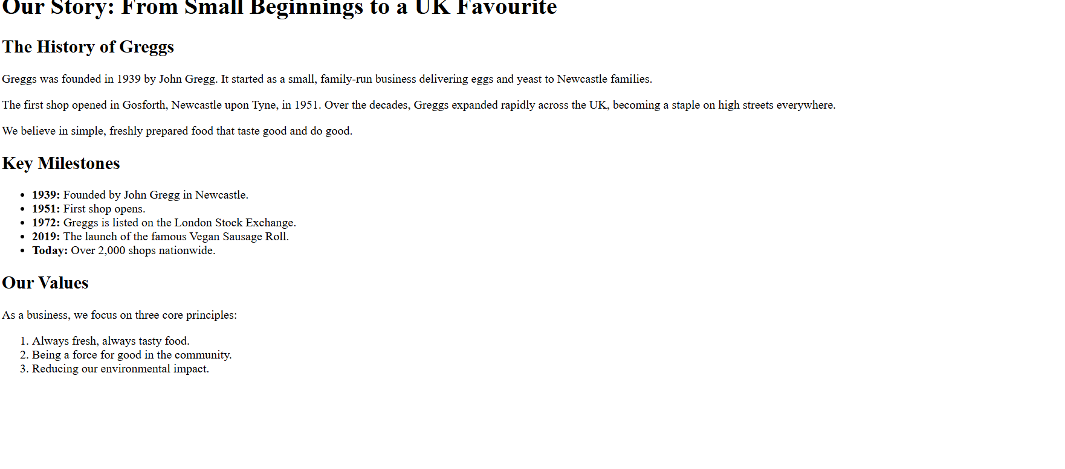

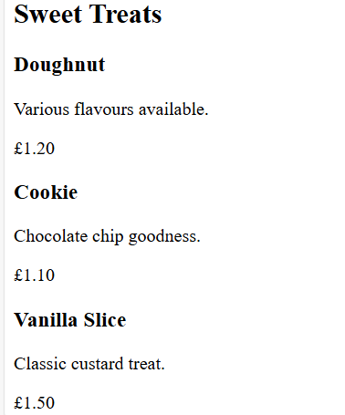

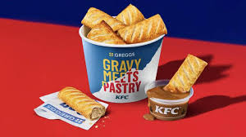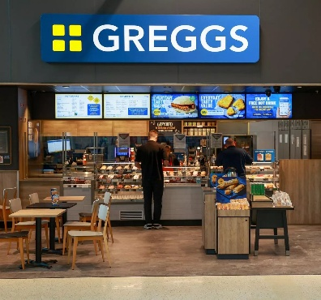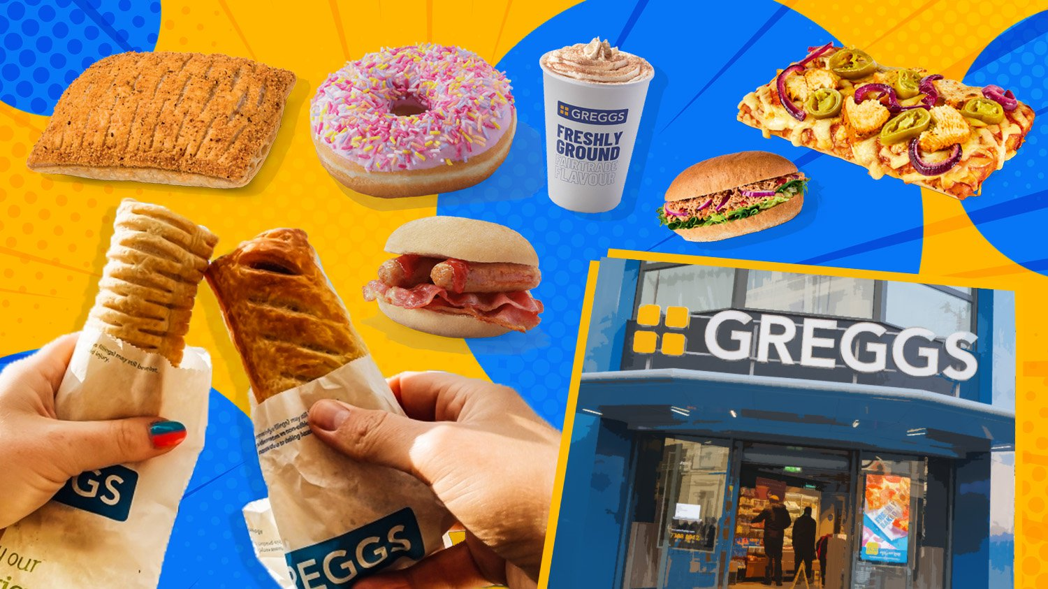
Referances
Greggs (2025). Greggs. [online] @GreggsOfficial. Available at: https://www.greggs.com/.
‌
Retail Week. (n.d.). Greggs: latest news, analysis and trading updates. [online] Available at: https://www.retail-week.com/companies/greggs.
‌
Contributors to Wikimedia projects (2004). Wikimedia Commons. [online] Wikimedia.org. Available at: https://commons.wikimedia.org/.
‌

