Student Name: Karen Davies

Student No: 1807580

Programme of Study: BA Photography In The Arts

Module: ADAD4010

Tutor’s Name: Ryan L. Moule & Rob Jones

Word Count: 1,593

In an ever changing landscape of concrete jungle cities, towns, villages, highways, flight paths, ocean crossings, pollution, noise, technology, war, growth of the human population and longer life expectancies. Mental health issues, disease, illnesses, loneliness, isolation along with the diminishing natural world of jungles, green belted countrysides, glaciers the ozone layer, disease, extinction of animal species, sea-life, human interaction not only with one another but with nature itself.
Is it any wonder why we desperately seek peace, harmony, interaction, spectacular colour, movement, search for ones emotions not only spirituality, emotionally and physically but yearn that sense of feeling freedom along with space, not only personal space but a wider spectrum of space and tranquility that the natural world can offer.(Definition of the natural world https://www.merriam-webster.com/dictionary/the%20natural%20world).
As a curator of mixed and multi media (mixed media-Art Term see mixed media vs. Multi media https://www.tate.org.uk/art/art-terms/m/mixed-media). I would like to take you on a journey through exploring movement, vision, sound, reflection of light, colour and space. Through a magical and very powerful glimpse into the natural phenomena of our beautiful skies from five pieces of art, installation, film, sculpture and photography in my exhibition at Mission Gallery Swansea.

The first piece for my exhibition is of film shown on a wide screen projector the full length of the first left side of the gallery. To view the film you will be able to sit in comfy reclining seats with headphones provide to enjoy the synthesised digital sound tracks that complement the movement of the visual Sky phenomena with an over voice of a narrator for your choice of either listening or reading a well documented explanation of each individual phenomena, curated by www.Beautiesofearth.com

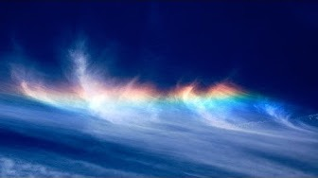
(https://www.youtube.com/watch?v=YjJf_pkDVAg) Please click the link to view the 4 parts of the short films, using the form of words picture and sound explore the “The Most Amazing Natural Phenomena on Earth - Sky Phenomena.

Fig 1

Fig 1a
Part 1” showing time of a 9 minute glimpse of the Fire Whirl, Polar Stratospheric Clouds, Belt of Venus, Halo, Light Pillars, Sky Punch, Blue Hour also known as the golden hour, the perfect lighting for photographers and Fire Rainbow all beautifully illustrated and explained.
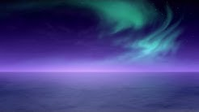

Fig 1b

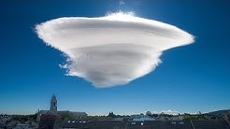
Part 2, showing time of 5 minutes exploring the forms of Ball Lightning, Rainbow, Sun Pillar, Polar Night and the Midnight Sun.

Fig 1c

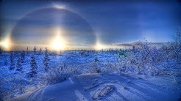
Part 3, showing time of 8 Minutes presents Aurora, Monochrome Rainbow, Spaceship Lenticular Cloud, also known as a Lens Cloud, Sun Break and Volcanic Lightning.

Fig 1d
Last but not least Part 4, showing time of 6 minutes concluding with the Mammals Clouds, Twilight also known as the “blue hour” popular among photographers and painters, Parhelia (Sun dog) and Terminator (Solar).
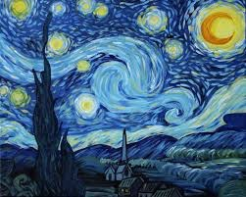
The second piece for the exhibition is the oil on canvas of the Starry Night one of Vincent Van Gogh legacy of many famous paintings from the museum of Modern Art. New York.
“This morning I saw the countryside from my window a long time before sunrise with nothing but the morning star, which looked very big”. (quoted from chapter six The Stars, page 77 from the book Starry Night Van Gogh At The Asylum by Martin Bailey, White Lion Publishing).

Fig 2
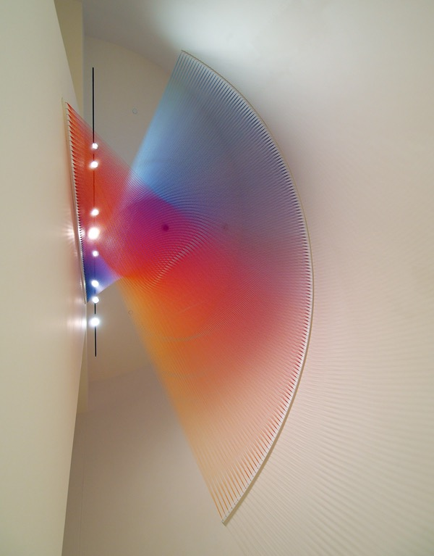
The painting completed in June 1889, with the use of of two vital colours of ultramarine mostly covering the sky and the cobalt blue highlighting the moon. Specialists have determined that the white has darkened overtime and the painting would have been more vibrant and striking, and are often not appreciated. Through Van Gogh’s creative vision and memory he created the Starry Night during the day in his studio. A year earlier Van Gogh had written to his friend Bernard stating how he had regretted not working more from memory explaining that imagination is a capacity that must be developed to enable the creativeness of a more exalting and consoling nature at just a glance of reality that allows the viewer to perceive. The endlessly debated meaning of the Starry Night remains elusive as so often in great works of art. The key lying in the view of Van Gogh that the night sky evokes the eternal, the infinite and life after death. On completing the Starry Night Van Gogh had ambivalent feelings about what was to become one of the most celebrated masterpieces. (Page 83 of chapter six The Stars from Starry Night Van Gogh At The Asylum by Martin Bailey, White Lion Publishing). (The painting, https://en.wikipedia.org/wiki/The_Starry_Night).
For my third piece I have installed a Dazzling Ceiling Installation of a Rainbow by artist Gabriel Dawe’s called Plexus 27. Sara Barnes states “Thousands of rainbow-hued threads create an exquisite form that spans from the ceiling and onto the wall. Texas-based Dawe arranged and pulled the individual strings taut, giving the illusion that they’re simply a projection of light. It’s much more complex than that, though. Threads crisscross over one another, and Plexus 27 appears to change its shape depending on your vantage point. Sometimes, it looks like a three-dimensional funnel, while other times as flat bands of colour radiating from the wall.” By Sara Barnes on March 5, 2015. (https://mymodernmet.com/gabriel-dawe-plexus-27/).

Fig 3
My 4th installation chosen is of three-dimensional clouds which appear in layered glass, illustrated in a column of four different formations of cloud forming.

Fig 4

Buenos Aires-based artist, Leandro Erlich’s a self-proclaimed “architect of the uncertain,” Relic plays with an audience’s visual senses. Through his single cloud collection giving us the audience a surreal taste of what a captured cloud in glass would look like.
Leandro using an artistic method of layering, through numerous panes of glass, embellished individually with acrylics creates an illusionary sculptural pieces called “Captured Cloud”. My modern net States that "Time and time again, the artist forces viewers to rethink the way they see things. Like a true

magician, he leaves one to question the impossibility of something. What appears to be a three-dimensional anomaly seems to be true based on sensory observation, but, ultimately, is just an illusion”. (https://mymodernmet.com/leandro-erlich-single-cloud-collection/)
For my 5th piece for the exhibition I have chosen three photographic images from past to the present day, showing not only the progression from heliography “an image captured which used Bitumen of Judea coated onto a piece of glass or metal; the Bitumen then hardened in proportion to the amount of light that hit it.” (The First Photo https://petapixel.com). Through to digital technology, “Digital Photography uses cameras containing arrays of electronic photodetectors to capture images focused by a lens, as opposed to an exposure on photographic film.” ( Digital Photography https://en.m.wikipedia.org).

The first image is called “Great Nebula of Orion” by George Willis Ritchey an American optician, telescope maker and astronomer. (George Willis Ritchey https://en.m.wikipiedia.com).

THE GREAT NEBULA OF ORION: This is a digital print of a photographic plate from the Ritchey 60-inch telescope at Mount Wilson Observatory, made in 1908. (http://nautil.us/issue/32/space/these-astronomical-glass-plates-made-history)

Fig 5

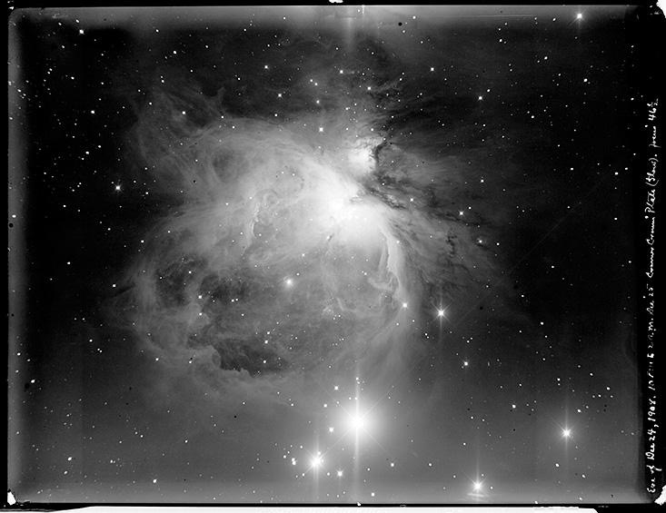
1908 atop Mount Wilson George Willis Ritchey was capturing the most spectacular view of the “Great Nebula of Orion” anyone had ever seen. The huge 60-inch reflective curved mirror collected the Nebular light, as the incoming photons slowly exposed the emulsion onto a photographic glass plate. “Later, an assistant would develop the negative and label it “Ri-0”—the inaugural scientific image from Ritchey’s state-of-the-art scope.” (http://nautil.us/issue/32/space/these-astronomical-glass-plates-made-history).

The next Image is of the “Milky-way” by Michael Shainblum an a professional aerial photographer and filmmaker based in San Francisco, California.
“With Shainblum’s unique creativity and the ability to capture scenes in a distinct style as well as a flair for coming up with new ideas. Has resulted in

being commissioned by large clients including Nike, Samsung, Facebook, LG, Apple and Google. You will also be able to find Michael's work published widely by media outlets such as National Geographic, Wired Magazine and The Weather Channel.”

Fig 5a

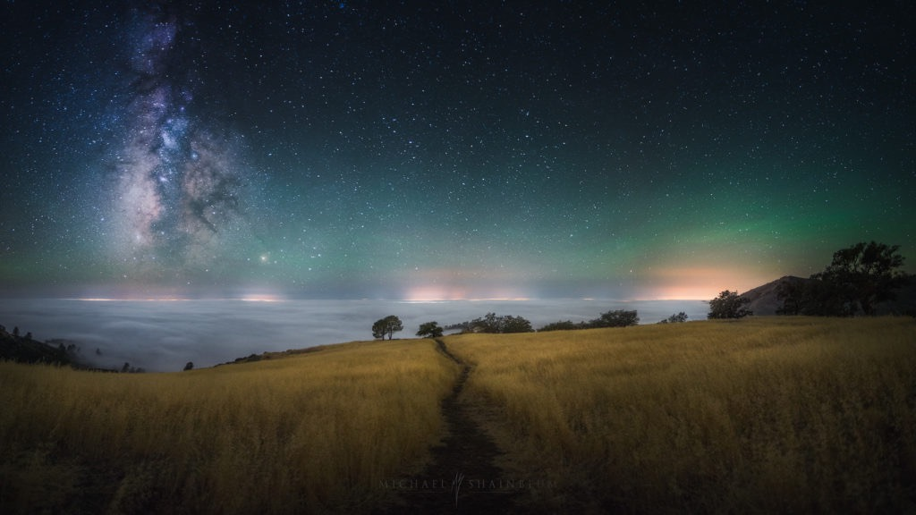
The Milky Way over Santa Ynez. California night sky photography. Shainblum explains that a heavy layer of fog covered everything except the 6K elevation mountain peak I was standing on. The view of the Milky Way was even darker than what I have seen in Death Valley or in Arizona. The Milky Way over Santa Ynez. California night sky photography. He goes on to say it was another incredible night shooting Milky Way Photography over Santa Ynez. The green glow you are seeing in the sky is called ‘airglow’. (http://www.shainblumphoto.com/project/california-milky-way-night-sky/).
To conclude the exhibition Ive installed the last image called “Moon over Half Dome” by Ansel Adams.
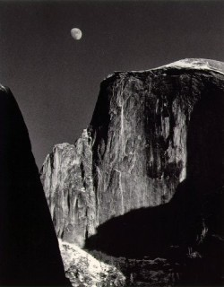

Fig 5b
Adams is probably one of the most well known nature and landscape photographers. “The long career of Ansel Adams (1902-1984) represents a prolific and rich contribution to American photography including many hundreds of images that continue to profoundly influence the conception and practice of the art of photography.” (https://ccp.arizona.edu/study-research/educators/ansel-adams). His black and white photographs of Yosemite Valley CA are well spread in galleries, on posters and in books. (http://www.anseladams.com/).

Below is an Ariel floor plan of the mission gallery and the plan of where the media and film will be exhibited.

Bibliography

- Definition of the natural world https://www.merriam-webster.com/dictionary/the%20natural%20world
- mixed media-Art Term see mixed media vs. Multi media https://www.tate.org.uk/art/art-terms/m/mixed-media
- www.Beautiesofearth.com (https://www.youtube.com/watch?v=YjJf_pkDVAg
- chapter six The Stars, page 77 from the book Starry Night Van Gogh At The Asylum by Martin Bailey, White Lion Publishing.
- Page 83 of chapter six The Stars from Starry Night Van Gogh At The Asylum by Martin Bailey, White Lion Publishing). (The painting, https://en.wikipedia.org/wiki/The_Starry_Night
- Rainbow (Plexus 27) Sara Barnes. https://mymodernmet.com/gabriel-dawe-plexus-27/
- Captured Cloud https://mymodernmet.com/leandro-erlich-single-cloud-collection/
- The First Photo https://petapixel.com
- Digital Photography https://en.m.wikipedia.org
- “Great Nebula of Orion” George Willis Ritchey https://en.m.wikipiedia.com and http://nautil.us/issue/32/space/these-astronomical-glass-plates-made-history)
- Milky-way http://www.shainblumphoto.com/project/california-milky-way-night-sky/
- Moon over Half Dome by Ansel Adams https://ccp.arizona.edu/study-research/educators/ansel-adams and (http://www.anseladams.com/
- Figure abbreviated as Fig.
- Fig 1, Fig 1a, Fig1b, Fig1c, Fig1d a 4 part film curated by Beauties of Earth 23 September, 2017.
- Fig 2, Oil on Canvas Starry Night Revised 29 April 2019.
- Fig 3, Installation Rainbow (Plexus 27) 5 March, 2015.
- Fig 4, 3D Sculpture Captured Cloud 13 March, 2013.
- Fig 5, Great Nebula of Orion 21 January 2016.
- Fig 5a, Milky-way 25 February, 2016.
- Fig 5b, Moon over Half Dome, Half Dome, Yosemite Valley, ca. 1956.

