EFFECTIVE TEAM WORKING AND COMMUNICATION (BMSW 4002_LON)
by Tsvetelina Viktoria Tsvetanova
Student ID: 1907859
Assignment 1

Effective Team Working and Communication
Christopher Mafuva
University of Wales Trinity Saint Davis
London
6/1/2020

Table of Contents

- Introduction 3
- Types of Communication 4
- Three models of communication 7
- Conclusion 9
- References 11
- Appendix 13

The purpose of this report is to examine and analyze team work and communication, why they are important and how they can become even more effective in the workplace. Both teamwork and communication are needed in every profession and organization in order to complete tasks effectively and on time by avoiding conflicts and misunderstandings. Moreover, this report will examine the definitions of both terms and will also present and analyze personal experiences of communication in the workplace. In addition, three theories of communication will be presented and explained and also the way in which they can all be applied in the workplace.
First of all, if we need to define teamwork we could say that it is the unifying power that holds a team together in order to complete the desired tasks (The Happy Manager, n.d.). There are many reasons why team work is important in the workplace. The most important one is the idea that a team functions better than an individual when it comes to problem solving due to individual skills being strengthened when more people come together to achieve a goal (The Happy Manager, n.d.). Other reasons why teamwork is important are related to motivation of the members being increased, fewer hierarchical differences among the members and also many times customers being more pleased by the work of a team than the work of a single person (The Happy Manager, n.d.). It is also important to note that when more people work in a team, they come up with more ideas and therefore businesses and organizations are able to achieve innovation much easier (Middleton, 2019).
In addition, a very important aspect of a team that functions properly in the workplace is communication. In general, communication is both the verbal and nonverbal exchange of thoughts and information, and it is crucial for the workplace in order to get the job done and increase productivity (Faizal, 2019). The necessary result of communication is that all people involved should reach a point of mutual understanding of the point being made (Griffiths & Dunham, 2015). Communication in the workplace is one of the most important factors that affect success. Good communication not only decreases conflicts and misunderstanding among coworkers and customers, it also promotes productivity in employees and makes them feel more engaged with their work and therefore more focused on finishing their tasks (Bosworth, n.d.). Effective communication also helps in the growth of productive and more efficient teams as mentioned previously. It also helps facilitate healthier employee- manager relationship but also relationships between employees too (Bosworth, n.d.).
Given my current experience as a hospitality employee at Marriott hotels, communication is extremely essential when working with guests, managers and colleagues. Both verbal and nonverbal communication are needed due to the constant contact I need to make with the guests of the hotel in order to provide excellent services. In this case, good communication results in a more pleasant experience personally but also helps with receiving more positive feedback from the guests which in turn could lead to promotions and more training, thus increasing the salary. It is also very important to note that communication with my colleagues is essential to cooperate and always find ways to please guests even when the hotel is full and there is limited space, in order to accommodate everyone on time. The types of communication and the different theories will be discussed further in the next part of the report.

Types of communication
Generally speaking, communication can be separated into two types. Verbal and nonverbal. Also, verbal communication can have two different types, oral and written communication (Communication theory, n.d.). Verbal communication uses the spoken words either when talking to someone face to face or when talking through another device (Communication, 2016). Throughout my career, communication was always important in order to share thought and ideas. In my current career however, it is even more important since good communication is a prerequisite for this type of work. To start with, good communication skills are required in order to receive instructions from my supervisors in order to complete the necessary task on time without delay. Another example could be when my supervisor asks me to talk to the guests and let them know that their table will be ready in a few minutes. In this case, politeness and kindness are necessary in order to explain to the guests what the situation is. Sometimes guests have to be patient and wait for longer periods of time for a place to be open for them. Being communicative and informative in general, helps keep the guests waiting patiently without irritating them and making them feel uncomfortable and unwelcome. Also, being clear and having a nice tone of voice is necessary when wanting to be polite and informative (Business Jargons, n.d.). My goal is to always communicate with the guests and making them feel pleasant while being at my service. This way, misunderstandings are avoided and the entire working experience is very enjoyable. Verbal communication is always needed and it has become a part of my professional life and who I am as a person. Good verbal communication on the other hand helps me grow and develop in the workplace to have a good relationship with everyone.
Negative experiences from previous jobs with no communication did not allow creativity and productivity to exist in the workplace. The managers were not able to communicate because they did not want to listen to the employees. The only goals that were to be achieved were targets that were put without providing any oral or written instructions. Many colleagues did not speak any English at all, so verbal communication was not possible. There was also no oral or written feedback so employees did not know if they were on the right track. This is an example of very poor communication in the workplace.
Nonverbal communication is a bit different than verbal. Nonverbal communication utilizes various cues like gestures, posture and eye contact made with others (HelpGuide.org, n.d.). Sometimes, when verbal communication is not possible, nonverbal can play a very crucial role in understanding others, receiving instructions and providing services. Through body language and facial expressions it is most of the time evident if someone is feeling nervous or anxious. In this case, guests might feel uneasy as well. So, my gestures and my body language in general must provide others with a sense of confidence and certainty. In the example of serving guests, most of the time, if they need to place an order or ask for the receipt, I need to make efficient eye contact all the time in order to make sure that no one is left waiting. I also need to watch out for gestures made by guests with their hands for example, which mean that they are in need of my services. Another example is when my supervisors are far away but need me to complete a task so they use their body language and gestures to let me know what needs to be done. Nonverbal communication is a bit more challenging and can create more misunderstandings but having good nonverbal skills and responding fast to other people’s needs has helped me do well in my current job.
After discussing the different types of communication, we should also refer to the three different theories that have been developed and analyze them. The three theories are the Shannon-Weaver model of communication, Berlo’s model of communication and Schramm’s model of communication. First of all, the Shannon-Weaver model is generally used by most countries in the world since it is the most popular (Managementstudyguide.com, n.d.). According to this theory, the message (thought) starts from the sender, which is called the information source. Then, the transmitter, either the mouth that transmits the signal or a machine, reach the receiver who decodes the signal and then reaches its destination, which is for example the receivers brain. In a typical workplace scenario, this model is commonly found when communicating with others. It can be utilized orally, for example or through a computer or the phone. In this theory, the message being transmitted might be contaminated by noise. The noise are external factors that might affect the integrity of the signal reaching the receiver. If for example a meeting is being arranged and there is an error with the phone, the recipient might not hear the time of the meeting. The message has reached him (there is a meeting) but the noise (in this case error with the call) has changed the message, so the employee will probably miss the meeting (Businesstopia, 2018).
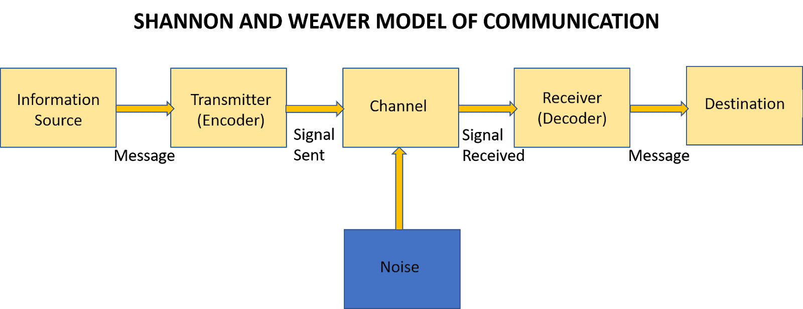
Berlo’s model of communication works in a similar way but includes extra factors that might affect communication. The model is called the SMCR (Source Message Channel Receiver). Simply put, the source sends the message to the receiver through a channel. A channel might be hearing for example or seeing. One factor that might affect the overall communication could be the content of the message. If for example, a manager asks an employee to write a report but does not give very specific instructions then the employee will not be able to complete the task correctly because the message was not clear enough.
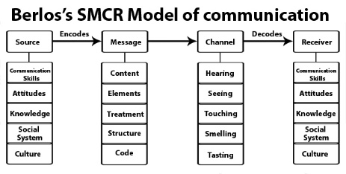
In addition, Schramm’s model of communication is more or less similar to the other two models if we consider that all three models include a sender a message and a receiver. In this model however, it is not just the sender and the receiver that are important. According to Schramm, in order to have successful communication both the sender and the receiver must be able to code and decode the message respectively. This is the most important aspect of Schramm’s model, the fact that the message should be delivered and understood properly in order for the communication to be effective (Managementstudyguide.com, n.d.). In the workplace, this model of communication could work like the other two models but this time we put an emphasis on the coding and decoding of the message. If for example, a manager gives instructions to an employee, the manager should code the message very carefully in order for the employee to understand it and then in turn the employee must decode the message carefully in order to do as instructed, avoiding mistakes and misunderstandings. If we use this model for the workplace, the emphasis is always placed on the message and that it is delivered properly.
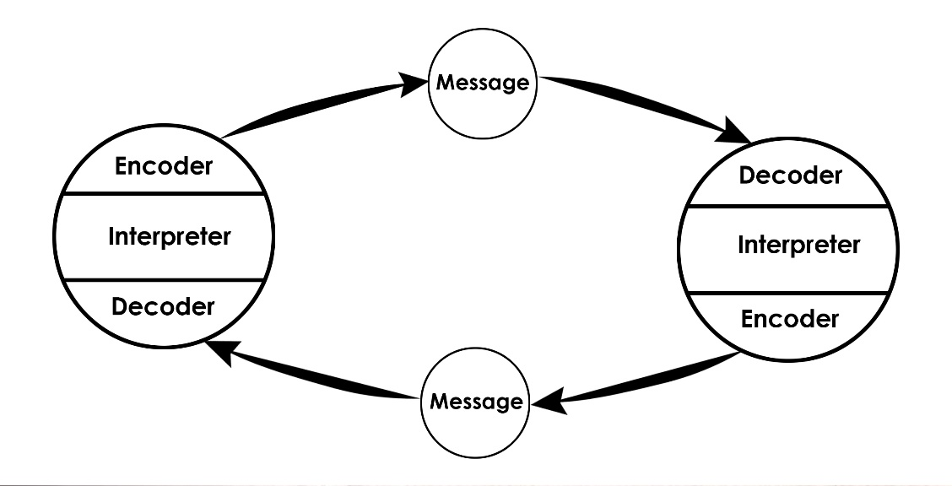
In this report, we started the introduction by examining the definition of team work and why it is important for the workplace. We then continued with communication and its definition and why communication is a must have on the workplace. Finally, some personal details were given on my current profession and how communication has been helping me do well both with my colleagues and managers but most importantly with guests. Furthermore, the different types of communication were defined and were then divided into two different categories, verbal and nonverbal. Then, personal examples were used in order to demonstrate how both types of communication are used in my job both in a positive and a negative way. Finally, the three models of communication were presented and explained and also provided examples of how they can be used in the workplace. The Shannon –Weaver model which is the most commonly used of all models in communication, Berlo’s model of communication and Schramm’s model of communication. All models of communication use more or less the same idea. They all include a sender a message and a receiver. The differences are in the content though. In the Shannon-Weaver model the noise that is involved plays an important role in the decoding of the message. In Berlo’s model there are various factors that might affect the message being delivered, for example if one heard the message correctly. Finally, in Schramm’s model, the most important thing is for the message to be understood in order for communication to be effective.

References
Bosworth, P. (n.d.). The Power of Good Communication in the Workplace | Leadership Choice. [online] Leadership Choice. Available at: https://leadershipchoice.com/power-good-communication-workplace/ [Accessed 6 Jan. 2020].
Businesstopia. (2018). Shannon and Weaver Model Of Communication - Businesstopia. [online] Available at: https://www.businesstopia.net/communication/shannon-and-weaver-model-communication [Accessed 5 Jan. 2020].
Communication, 3. (2016). 3 Main Types of Communication | A-State Online. [online] A-State Online. Available at: https://degree.astate.edu/articles/undergraduate-studies/3-main-types-of-communication.aspx [Accessed 5 Jan. 2020].
Faizal, F. (n.d.). What Is Workplace Communication & Why Does It Matter? | Feedough. [online] Feedough. Available at: https://www.feedough.com/what-is-workplace-communication-why-does-it-matter/ [Accessed 6 Jan. 2020].
Griffiths, B.A & Dunham, E.B (2015) ‘Communication’, in Maund, A., Schriek, M. and Tinkler, P. (2017). Certificate in Higher Education: Skills for the Workplace Student Yearbook. Sage, p.23.
HelpGuide.org. (n.d.). Nonverbal Communication. [online] Available at: https://www.helpguide.org/articles/relationships-communication/nonverbal-communication.htm [Accessed 5 Jan. 2020].
Managementstudyguide.com. (n.d.). Shannon and Weaver Model of Communication. [online] Available at: https://www.managementstudyguide.com/shannon-and-weaver-model-of-communication.htm [Accessed 5 Jan. 2020].
Middleton, T. (2019). The importance of teamwork (as proven by science) - Work Life by Atlassian. [online] Work Life by Atlassian. Available at: https://www.atlassian.com/blog/teamwork/the-importance-of-teamwork [Accessed 6 Jan. 2020].
Communication Theory. (n.d.). Types of Communication. [online] Available at: https://www.communicationtheory.org/types-of-communication/ [Accessed 5 Jan. 2020].
Business Jargons. (n.d.). What is Verbal Communication? definition and meaning - Business Jargons. [online] Available at: https://businessjargons.com/verbal-communication.html [Accessed 5 Jan. 2020].
The Happy Manager. (n.d.). Why is teamwork important? | 8 good reasons why teamwork is so important!. [online] Available at: https://the-happy-manager.com/articles/why-is-teamwork-important/ [Accessed 4 Jan. 2020].

Appendix


