Entrepreneurship

Student : Alexandru Sasco 2026429
Lecturer : Vasilios Tavlaridis
Course : LCBB5001_BIRM
Date : 02/04/2023

Table of Contents
1.Introduction 3
2.Entrepreneurship 3
3.UK/EU small businesses 3
4.Entrepreneurs and small business owners 5
5.Entrepreneurial motives/skills 6
6.Conclusion 7
References 8

- Introduction
The entreprenership is a term that’s used and adopted by humanity in last 300 years.
The further study will examine the main definitions and carachteristics of entrepreunership. Will be researched the SME’s corporations in the UK/EU in quantitative method. Will be defined the terms of entrepreneurs and small business owners and showed the difference between them. To understand the force of entrepreuners move will be reasearched the motive and skills required for starting and running a business. To emphasize the studies will going to be privided relevant data in graphs and examples.
- Enterpreneurship
Enterprenership is a feature of the human being to control and deploy existing under hand resourses ’’to create an inovative business for the achievement of financial growth in an uncertain environment’’ (Dollinger, 2008) It is a process of finding the new combination of resources for the purpose to make profit based on generating the market value. Entrepreuners are determined to set the cost of production by the mandatory prices for the necessery resources away from alternative uses (Sobel, 2018). Casimir (2018) concluded that entreprenership is making a contribution for creation and rising of employment.
There are five types of entrepreneurship:
- Private or independent refers to activities in private firms where an individual uses all his human and natural resources to establish new ideas (IvyPanda, 2023)
- Social enterpreneurship is the field where entrepreneurs tend to do activities towards creating social value. Their action often comes with no profit intentions but in interest of the environment (Abu-Saifan, 2012)
- Corporate Entrepreneurship is the process for developing new ideas, products and services within a large company (Morris, 2010)
- Academic Entrepreneurship is appropriate in the scientific field and institutions.
- Public Sector Entrepreneurship is the support for the self-employed entrepreneurs by the local authorities for developing the networking in the country (Hayter, 2018)

- UK/EU small business
Small business are defined by the certain number of employess, sales turnover, profitability in its existence on the market (Storey, 2016, p.8) Any idea of the business that generates the profit or just brings an impact to the environment and is run by and individual or more can be a small business. Many developed countries tend to have their own characteristics of small business. The EU’s understanding is similar to the UK’s. According to GOV.uk (2023) a company is considered small if there are working 50 employees or less, the turnover of £10.2 million or less, or a balance sheet of maximum £5.1 million. Micro-entites on the other side are companies with 10 employess or less, a turn-over of £632,000 or less with a balance sheet of less then £316,000. Micro-businesses are creating huge possabilities to start an idea in a competent way. The UK registered 5.5 million of private sector businesses in 2022 and the amount of micro-businesses consist 95.5%.(Young, 2023) Even if is a decline of 6.6% compared with 2020 SME’s still constitute 99.9% of UK’s business population. Businesses without employers were registered 74%. In 2022 were registered 5.47 small businesses with an employment rate of 12.9 million(48%) and turnover estimated
at £1.4 trillion(34%) (GOV.uk, 2022)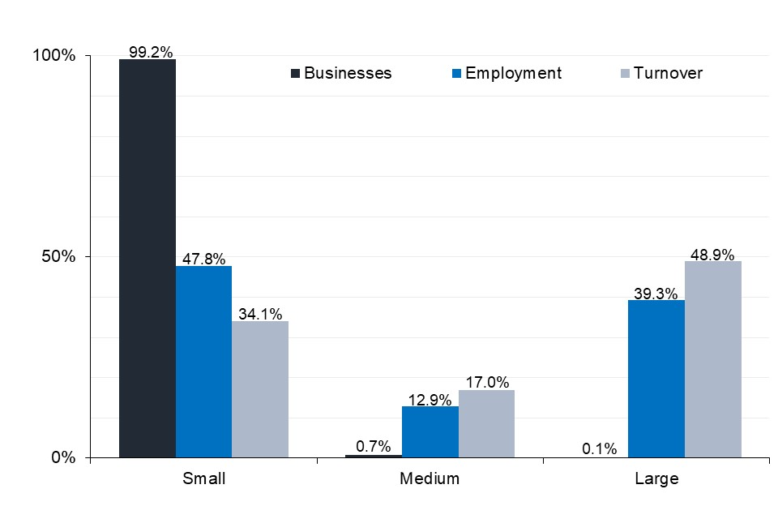

Figure 1. Contribution of SME’s to total population, employment and turnover for 2022(source GOV.UK)

The private sector are having three legal forms in composion, sole proprietorships(56%), ordinary partnerships(6%), and companies(37%). 2.9 million sole proprietorships, 932,000 companies and 257,000 ordinary partnerships did not employ anyone.
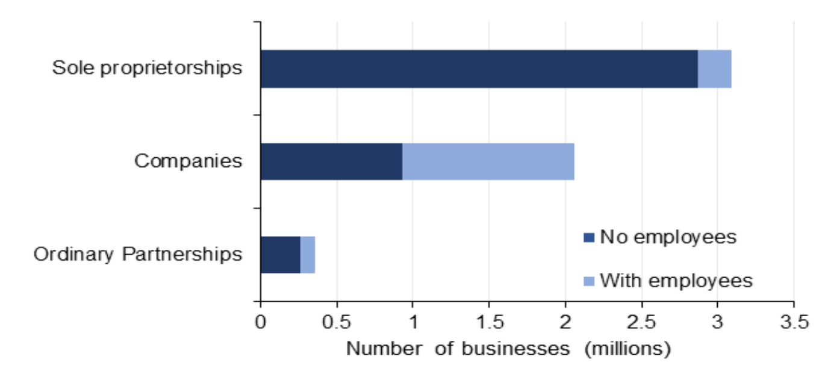
Figure 2. Number of business with and without employers in the UK. (GOV.UK 2022)

BROADSWORD EVENT HOUSE LIMITED is a appropriate example of small corporation. The company deliver live, virtual and hybrid events for clients around the world. It is running since 2006, has a turnover of 3.4 million and 10 employees with 4 resignations (Pomanda, 2023).

- Entrepreneurs and small business owners
Entrepreneurs are individuals who are bringing business from an idea knowing the resources and planning, and foreseeing major threats and rewards of the future venture (Seth, 2022) They are usually coming with an innovative idea, product or service with more effective model then the present one and are willing to give the last finance or even give up a career for the stake of the idea. By the fact that idea is innovative, entrepreneurs are the only ones who knows what place, materials, and capital must make the venture to the idea’s success. There must be employed certain people for the position required or trained if they got no experience (Casimir, 2018). Successful entrepreneurs are driving force of the modern economy.
A small business owner is providing the demand reflected in their local or any other field, industry, or company (Sanfilippo, 2023). They often are using just personal knowledge from their experience avoiding any possibility for a problem and ignoring a different approach in an extreme situation. Small business owners’ approach is based on already existing scheme and theorems, that without innovation, can create a comfort of the position.
In the relation with the company entrepreneurs and business owners have a difference. While small business owners prefer to take rarely decisions based on their visualised path, entrepreneurs are gambling with the risk to achieve the result. They see their company as assets, that can be continuously shaped and developed for the market or even sold to a certain point, but small business owners tend to stay familiar with their business that possibly blocks their entrepreneurial ambition (SPIROPOULOS, 2014)
An example of successful entrepreneur is Philip Green. He is a current CEO of the Arcadia Group that include brands as TOPSHOP, Topman, Evans, Wallis, Burton. At 15 he stopped the school and found a job at a shoe importer, that gave him a look Across the Globe. At 21 he has settled a business having £20,000 loan by importing and selling jeans. Later Philip bought up bankrupt stock from ten designer brands and organized retail premises for selling. Over the years he highly developed by buying clothing and having a retail chain stores that brough him $5.8 billion Net Worth (Tucker, 2022)

- Entrepreneurial motives/skills
One of the empowering tool for entrepreneur is motivation (Yamini, et al., 2022) The individual must posses the passion that from a positive emotion suddenly creates unforeseen opportunities (Cardon, et al., 2009). The personality of an entrepreneur has to feel the need of achievement and autonomy, generalized self-efficacy, high locus of control, innovativeness, opportunism and stress tolerance (Frese and Gielnik, 2014) In the condition of interacting with people an entrepreneur must have leadership and team building skills. Being innovative often in venture brings risk that requires a bold decision, and the individual must be prepared for the possible negative outcome.
The figure 3 shows the prevalence of reasons between 1000 entrepreneurs with opened business. The most frequent reason is the needed/wanted extra income (42%) followed by desire of life independency (29% and 25%) and the third essential personal interest in the area (19%). All the other reasons were regarding to situational factors of life.
The entrepreneurial skills are the personal and interpersonal abilities of people expressed in their behaviour. People are possessing these skills whether inherited or developed by gaining knowledge and personal experience. Beside the starting an business, it requires skills to be run in an competent way. An entrepreneur should develop and understand the managerial skills and business knowledge that are reflected in his behaviour on performing crucial tasks and activities related to general management, operations, finance, purchasing, human resources, marketing, administration, external relations (Nieuwenhuizen, 2008 p.1)
Entrepreneurs who’ve been opening the business during the extreme conditions of the environment, posses stronger character and higher developing expectations. These extreme conditions might be a generator for personal worth.

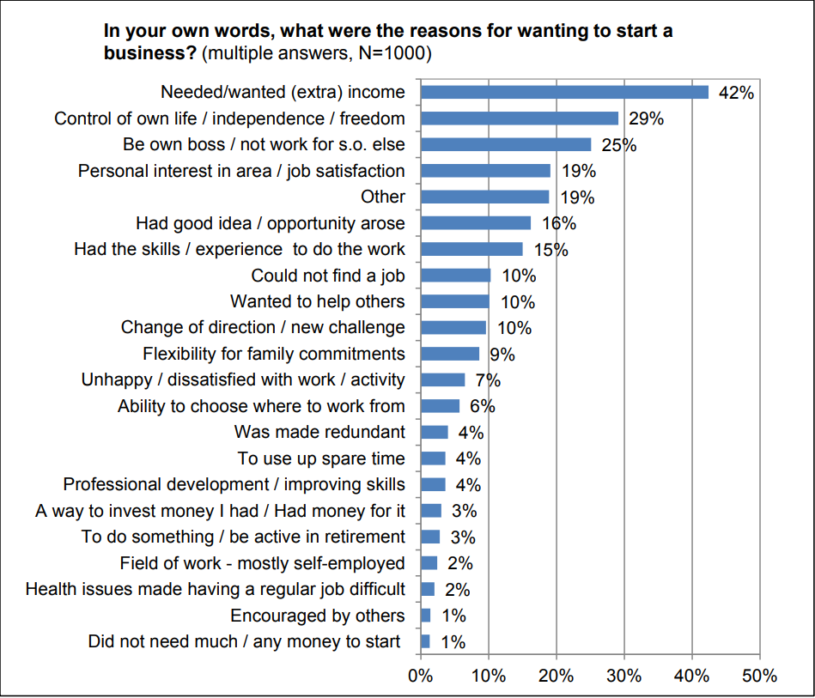
Figure 3. Prevalence of reasons (Source GOV.UK)
- Conclusion
The report examined the main characteristics of entrepreneurship and it’s ability to develop humans in any sector or field of performance. Was brought the main features of UK/EU small businesses and The most changed was a decline of 6.6% of small UK businesses in 2022 compared to 2020. UK are providing huge chances for worth ideas to come in reality.
The entrepreneurs are individuals who bring innovation in new model for the real demand. There is a certain need of risk taking and stress tolerance to be able to surpass the possible obstacle. Entrepreneurs are seeking for new invention while small business owners are likely to not expand. Small business owners are more vulnerable to be stuck in the comfort zone from the lack of challenges and untraditional ways for growing the business. Entrepreneurs must have clear understanding and vision to implement the idea in reality. They need to be motivated and creative with significant ignorance to the empty opinions and situations. For moving force an entrepreneur has to know what motivates his entrepreneurship. As well skills of management and business knowledge is a huge advantage.

References
Abu-Saifan, S., 2012. Social entrepreneurship: definition and boundaries. Technology innovation management review, 2(2).
Business population estimates for the UK and Regions 2022: Statistical release (HTML) (2022) GOV.UK. Available at: https://www.gov.uk/government/statistics/business-population-estimates-2022/business-population-estimates-for-the-uk-and-regions-2022-statistical-release-html (Accessed: April 2, 2023).
Cardon, M.S. et al. (2009) ‘THE NATURE AND EXPERIENCE OF ENTREPRENEURIAL PASSION’, The Academy of Management review., 34(3), pp. 511–532. Available at: https://doi.org/10.5465/amr.2009.40633190.

Casimir C. Barczyk, P. (2018) ‘The Practice of Human Resource Management by Very Small Business Entrepreneurs’, Problemy Zarządzania, 16(1(73) Facets of Entrepreneurship), pp. 11–24. Available at: https://doi.org/10.7172/1644-9584.73.1.

Dollinger, M.J., 2008. Entrepreneurship. Marsh Publications.

Hayter, C.S., Link, A.N. and Scott, J.T., 2018. Public-sector entrepreneurship. Oxford review of economic policy, 34(4), pp.676-694.
Here's what I just found on pomanda.com - broadsword-event-house-limited (2023) Pomanda. Available at: https://pomanda.com/company/05893488/broadsword-event-house-limited#:~:text=Broadsword%20Event%20House%20Limited%20Overview&text=Broadsword%20Event%20House%20Limited%20is%20a%20established%2C%20small%20sized%20company,healthy%20growth%20in%20recent%20years. (Accessed: April 2, 2023).

IvyPanda. (2023) 'Independent Entrepreneurship, Intrapreneurship, and Social Entrepreneurship'. 13 February. (Accessed: 31 March 2023).
Morris, M.H., Kuratko, D.F. and Covin, J.G., 2010. Corporate entrepreneurship & innovation. Cengage Learning.
Nieuwenhuizen, C. ed., 2008. Entrepreneurial skills. Juta and Company Ltd.
Sanfilippo, M. (2023) Entrepreneur or small business owner: Which are you?, Business News Daily. Available at: https://www.businessnewsdaily.com/8327-business-owner-versus-entrepreneur.html (Accessed: April 2, 2023).
Sobel, R.S. (2018) Entrepreneurship, Econlib. Available at: https://www.econlib.org/library/Enc/Entrepreneurship.html#:~:text=Entrepreneurship%20is%20the%20process%20of,the%20entrepreneur%20makes%20a%20profit. (Accessed: March 30, 2023).
SPIROPOULOS, R., 2014. Small Business Owners Vs Entrepreneurs: Which One Are You? Black Enterprise (Online), .
Storey, D.J., 2016. Understanding the small business sector. Routledge. (p.8)
Tucker, J. (2022) 10 of the UK's Greatest Entrepreneurs, Headspace. Available at: https://www.headspacegroup.co.uk/10-of-the-uks-greatest-entrepreneurs/ (Accessed: April 2, 2023).

Understanding Motivations for Entrepreneurship(HTML) (2015) GOV.UK. Available at: https://assets.publishing.service.gov.uk/government/uploads/system/uploads/attachment_data/file/408432/bis-15-132-understanding-motivations-for-entrepreneurship.pdf
Yamini, R., Soloveva, D. and Peng, X., 2022. What inspires social entrepreneurship? The role of prosocial motivation, intrinsic motivation, and gender in forming social entrepreneurial intention. Entrepreneurship Research Journal, 12(2), pp.71-105.
Young, H. (2023) Small business statistics UK 2023, Startups.co.uk. Available at: https://startups.co.uk/analysis/small-business-statistics/#:~:text=In%20total%2C%20the%20most%20up,have%20more%20than%20250%20employees). (Accessed: April 2, 2023).

