Digital Skills and Research Methods
BMSW4003
DSR Assessment 2 Individual Report
Student name: Evette Sophia White
Student number: 2027886

Contents
Introduction 3
Background 3
Aims and objectives 5
Methodology 5
Results 6
Discussion 8
Conclusion 10
References 11
Appendices 12
Appendix I: Questionnaire 12
Appendix II: Results 18

Introduction
Virtual Learning Environment (VLE) – Moodle is a web-based system of software system and an online where the staff and the students can interact, access the materials for their courses while submitting their course assignments. VLE-Moodle is made up of tools and various activities which aim to facilitate learning. Under the VLE, the students can learn, revise, do assignments and carry out other tasks in relation to learning (JISC, 2009). This report aims at reviewing on how the students view VLE and a review of the impact of Moodle on the learning of students in the University of Wales Trinity Saint David London Campus. This shall go a great way in providing a framework to improve on the experience of VLE towards improving on the learning experience.

Background
In the context of the Covid-19 pandemic, VLE has provided a great platform where students in distance learning, blended learning, part-time learning, virtual learning and other forms of learning can access learning materials anywhere and anytime whenever they need to. In the time where most people are being encouraged to adopt virtual learning, VLE-Moodle have become a very important resource which is made up of various resources such as learning materials, assignments briefs and guidance, lecture materials and other materials which facilitate learning. With the Moodle, students have been able to continue with their learning right from their homes and achieve their career dreams (JISC Digital Media, 2015).
In University of Wales Trinity Saint David London Campus, Moodle is used as its major form of VLE. The Moodle provide support for learners in various BA, MA and even under doctorate levels of learning. The Moodle is based on each course which is broken down into modules as it is based on the modules. The Moodle provide the students with a platform to access the calendar, email, and the various modules under their courses, the library and other resources. Under each of the modules, the students can access the learning materials such as readings, lecture materials for every week and other resources for learning. From the Moodle, the students are always supported in the online support (Davies and Harris, 2016).
Past researches and publications shows that many students have positive experiences with the VLE despite some few cases of negative experiences with the VLE-Moodle. A research by Barker and Gossman on the learning impact of a virtual learning environment: students’ views which involved 242 participants who were all second year students at SFC (Sixth Form College) found out that VLE is an important learning environment which provide students with an opportunity learn in an informal manner and to learn independently in their own pace, time and place in a manner which is suitable to learners while offering the students with flexibility in their courses as well as their busy lives (Barker and Gossman, 2013).
The positive experience of students on the VLE has also been supported by a study which was carried out by Scardamalia & Bereiter in the year 1966 in USA on Computer Supported Intentional Learning Environment (CSILE) Studies. According to the study, VLE is a very effective tool especially in some aspects of learning such as reading, vocabulary, analytical and other skills as the study found that the students who made use of VLE performed well under reading, vocabulary, analytical skills, independent thought and multiples perspectives as compared to the students who didn’t use the VLE software. The study came up with the conclusion that VLE provide support to the students to learn independently while encouraging reflection and independent thinking among students (Scardamalia and Bereiter, 1996).
An evaluation on the VLEs by the UK government under the strategy paper which made up of educational setting which was made up of 41 providers all colleges, primary and secondary schools found out that the VLE bring about great experiences to the students as it enhances learning as it provide enforcement to the actual learning and also provide the students with an opportunity to catch up with the various learning aspects which they missed. The research found out various aspects of positive experiences of VLE. However, the study further found out that the VLE is not well known among some learning institutions (Ofsted, 2009).
Despite many students having good learning experiences on VLE, there are also negative experiences which have been found in relation to the usage of VLE in the learning institutions. Some of the negative aspects which have been associated with the use of VLE include the impact of server issues as it requires internet, lack of social interaction and emotional contact as in the case of traditional classroom (Crook, 2004). A review by JISC in 2007 among higher education learners concluded that VLE encourages passive learning rather than active learning. The VLE also sometimes lead to lack of motivation as students are less engaged or involved as compared to traditional face to face learning (Conole et al., 2006).

Aims and objectives
The major aim of this research is to review on the impact of Virtual Learning Environment (VLE) – Moodle on students’ learning experience at the University of Wales Trinity Saint David London Campus. Some of the aims of this study include:
- To analyse the negative and positive views of the student’s on the experience of using Moodle
- To understand how frequently the students in University of Wales Trinity Saint David London Campus use Moodle
- To quantify the experiences of learning by students on Moodle in University of Wales Trinity Saint David London Campus

Methodology
This is a primary research which made use of a questionnaire (Appendix I) which targeted students from University of Wales Trinity Saint David London Campus. The questionnaire was filled by 15 students who were randomly selected from any course in University of Wales Trinity Saint David London Campus. The survey was carried out through survey monkey where the randomly selected students received a link to the survey through their emails and had up to three days to complete the survey. The questionnaire was made up of various questions including multiple choice questions, yes or no question, closed end questions, open ended questions and other questions. The survey was strictly confined under the geographical area of University of Wales Trinity Saint David London Campus. All the participants received the links to the survey the same day and all had three days to fill the questionnaire. The results were recorded in an excel table to make is easy to analyse the results. The participants were not required to give their names and measures were put in place to ensure that the data were kept private and secure.
The questions in the survey first sought to understand if the participants had used Moodle and for what purpose. After that, the next question sought to analyse the extent of the importance of the Moodle to students. The next question sought to understand the experience of student’s on Moodle and the general positive impact of the Moodle on the learning experience of the students and the last question sought to understand the impact of the Moodle in the motivation of the University of Wales Trinity Saint David London Campus students.

Results
Results for question 1
 | Yes | No
Have you ever used Moodle before? | 14 | 1
Results for question
 | To access the library | To access class lectures | To submit assignments | To access my email
If Yes, What is the major reason that you use Moodle for? | 3 | 6 | 4 | 2
Results for question 3
To what extent do you agree or disagree with the following statements on the usage of Moodle
Answer options | Strongly agree | Agree | Neutral | Disagree | Strongly disagree
The Moodle allow me to learn independently | 10 | 3 | 1 | 1
The Moodle allow learn in a flexible manner | 13 | 1 | 1
The Moodle allow me to be engaged and involved with other students | 5 | 3 | 4 | 2 | 1
The Moodle provide a way to positively interact with the tutors | 6 | 3 | 1 | 4 | 1
Results for question 4
 | 5 | 4 | 3 | 2 | 1
How would you rate VLE-Moodle in relation to improving the learning experience of students? | 7 | 4 | 3 | 1
Results for question 5
 | Yes | No
Do you think the VLE-Moodle increases your motivation as a student to learn? | 8 | 7

Discussion
During the three days, 15 questionnaires were filled by the participants who were 8 males and 7 female students and all the questionnaires were submitted in the right time. The first question sought to understand if the students have used VLE before and the results were that 14 (94%) had used the Moodle and only 1(6%) had not used the Moodle as shown in the chart below:

This means that majority of the students in University of Wales Trinity Saint David London Campus are using the Moodle for their studies. The second question aimed at understanding the purposes of using Moodle where it was found that the students use the Moodle for varying reasons with the major one being to access the class lectures (6) while some other uses include to access the library, students email and to submit assignments .

The third question was a multiple choice question where the participants were to show how they agree or disagree with the various statements in relation to the Moodle. From the results shown in the table above, the students agree that the Moodle bring about various benefits towards the learning experience such as allowing them to learn independently where 10 students strongly agree and 3 agree out of the 15 that the Moodle allow them to learn independently while one was neutral and one disagreed to that the Moodle allow them to learn independently. Most of the participants also believe that the Moodle allow them to study in a flexible manner. A whooping 13 participants agreed that the Moodle allow them to study in a flexible manner, while 1 agreed and one was neutral. However, there is mixed experience among the students in terms of the aspect of the Moodle promoting involvement and engagement of the students and the teachers which is in line with the findings by Deci and Ryan in 2002 who found out that in some cases, VLE does not support positive interaction among the teachers and the students and between the students themselves.
The fifth question was on motivation where it was found out that the students have mixed feelings when it comes to the impact of VLE-Moodle on motivation. In this case, 8 participants felt that Moodle motivate them to learn while 7 felt that Moodle does not motivate them to learn.
The fourth question enquired on the general experience of the students on Moodle where it was found out that most students agree that Moodle bring about a positive experience when it comes to learning. Therefore, Moodle enhances the learning experience of students under the various environments.

Conclusion
It can be concluded that VLE-Moodle plays a very important role in enhancing the learning experience among students. The research on the influence of VLE on the learning experience of students in University of Wales Trinity Saint David London Campus revealed that many students use Moodle for their learning today for various reasons such as assessing the lectures, assignments, email and others. The VLE-Moodle brings about various benefits to learning such as making learning effective, encouraging independent learning, allowing students to learn in a flexible manner. The Moodle have also been found to enhance motivation for students to learn. However, there are few negative experiences when it comes to the use of VLE by the students such as lack of social interaction, lack of involvement and engagement among other negative aspects. The findings from this research is in line with the findings from the literature review.

References
- Barker, J., Gossman, P. (2013) ‘The learning impact of a virtual learning environment: students’ views ‘ Tean Journal 5 (2) July [Online].Available at: http://bit.ly/AtMwtr [Accessed 23rd July 2021]
- Conole, G., de Laat, M., Dillon, T. and Darby, J. (2006) LXP: Student Experiences of Technologies – Final report of the LXP project. Available online at: http://www.jisc.ac.uk/media/documents/programmes/elearningpedagogy/l xp_project_final_report_nov_06.pdf (accessed 4 March 2013).
- Crook, C. K. (2000) Motivation and the ecology of collaborative learning Rethinking collaborative learning, London, Free Association, 161-178.
- Davies C. and Harris L. (2016) Engaging professional learners using the Virtual Learning Environment (VLE): a case study from social care. Wales Journal of Learning and Teaching in Higher Education , Volume 1, Number 1, 60-65 pp ISSN 2396-7285
- Deci, E. L., & Ryan, R. M. (2000) The ‘what’ and ‘why’ of goal pursuits: Human needs and the self-determination of behaviour. Psychological Inquiry, 11, 227–268.
- JISC (2009) Effective Practice in a Digital Age (Bristol, HEFCE)
- JISC Digital Media (2015) ‘Use of VLEs with Digital Media. JISC Digital Media Guides’. [Online] Available at: http://www.jiscdigitalmedia.ac.uk/guide/introduction-to-the-use-of-vles-with-digital-media [Accessed 21st July 2021).
- Ofsted (2009) Harnessing technology – transforming learning and children’s services (1296-2005DOC-EN), DfES 2005 [Online] Available at: www.dcsf.gov.uk/publications/e-strategy [Accessed 23rd July 2021).
- Scardamalia, M. & Bereiter, C. (1996) Scardamalia & Bereiter’s Computer Supported Intentional Learning Environment (CSILE) Studies (USA, CSILE Learning Gains)

Appendices

Appendix I: Questionnaire
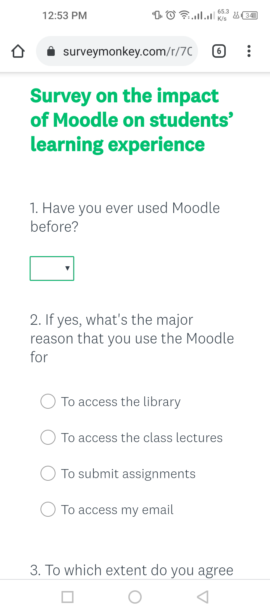

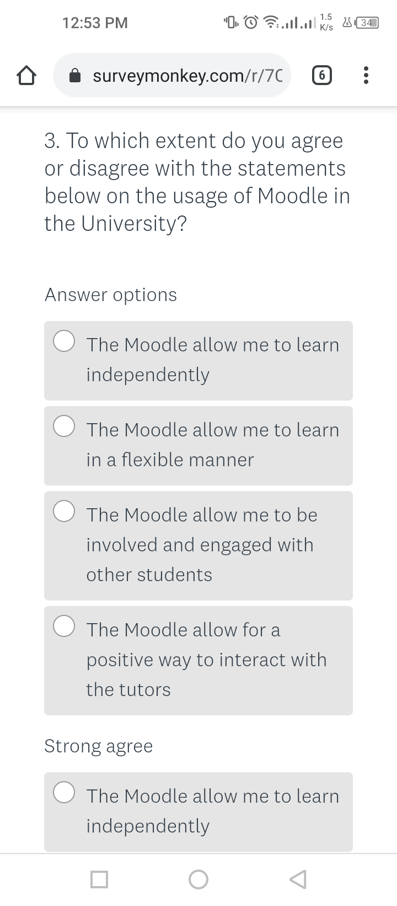
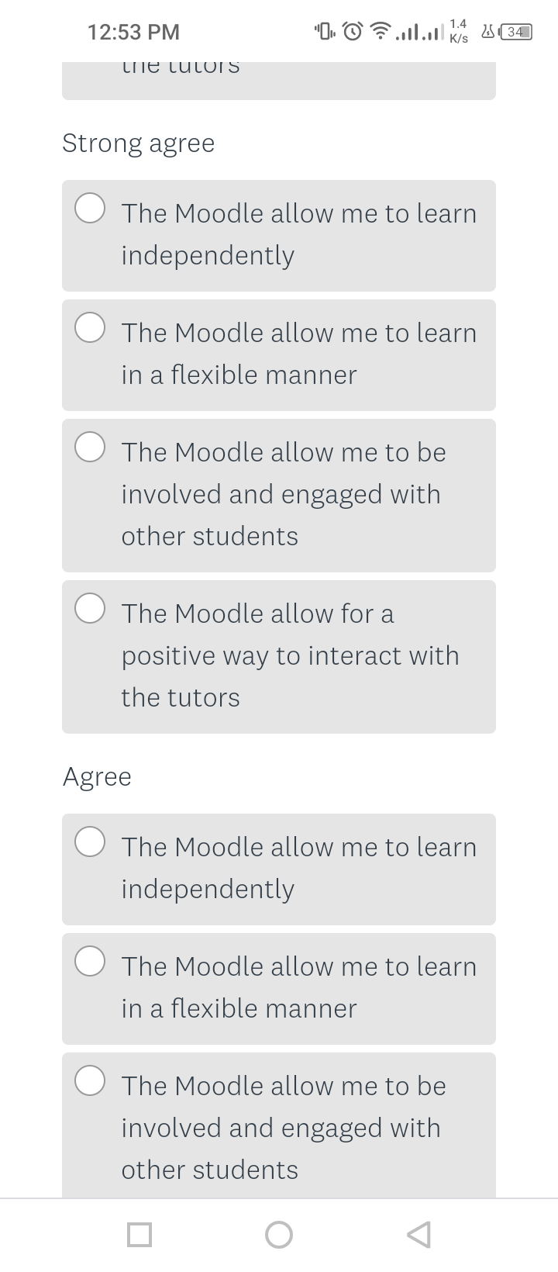
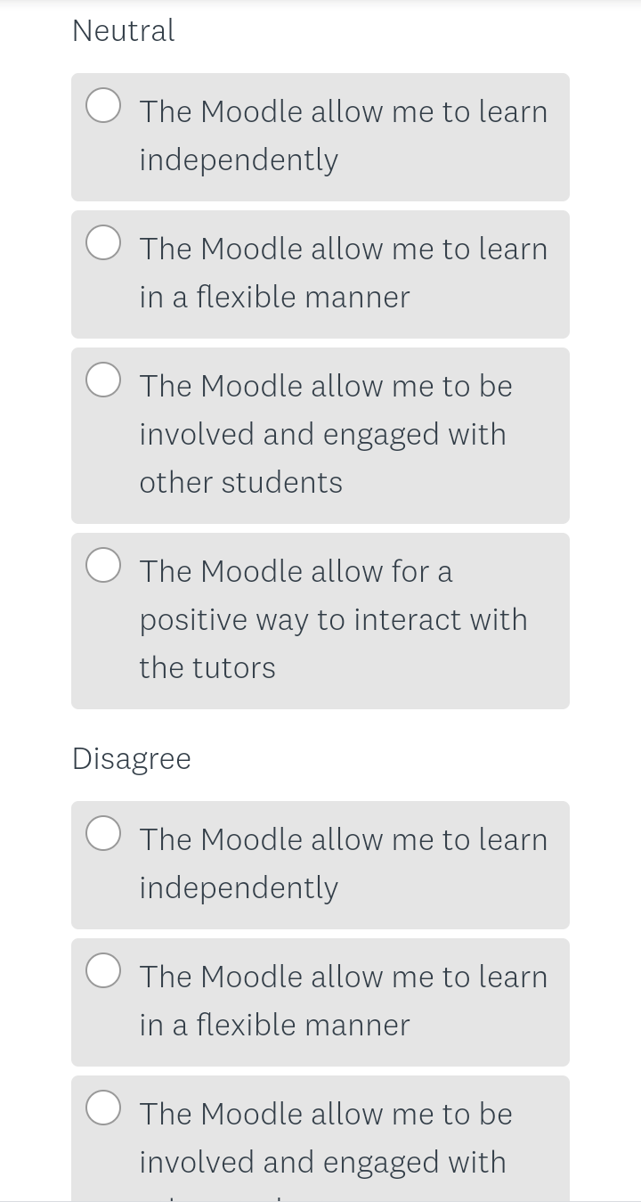
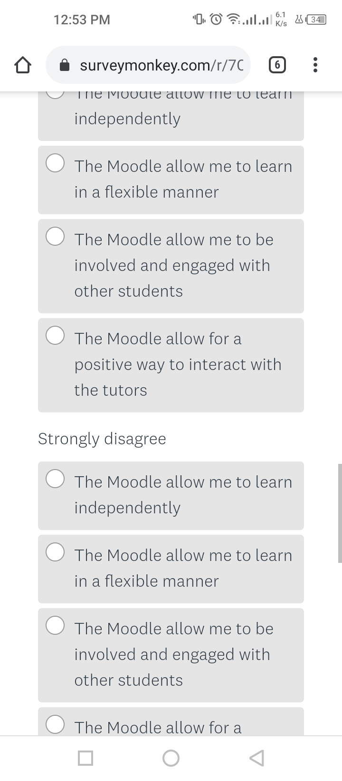
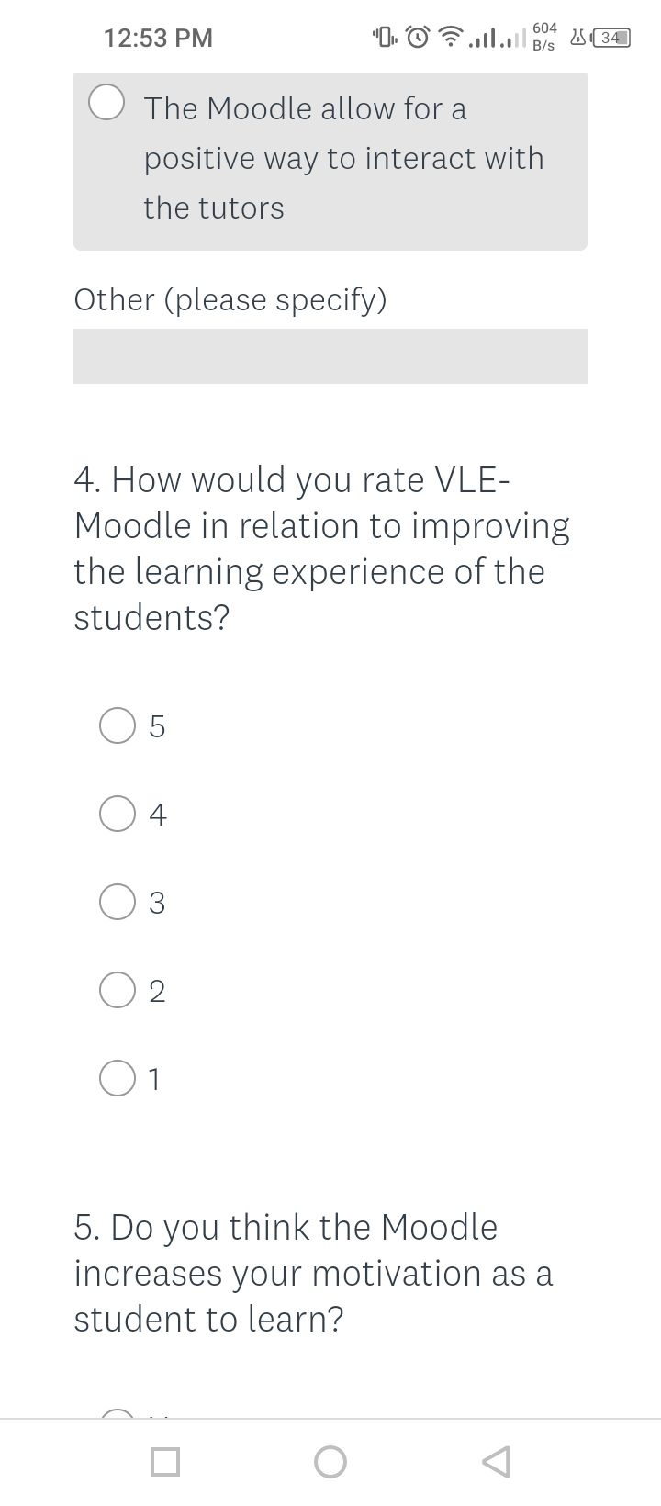
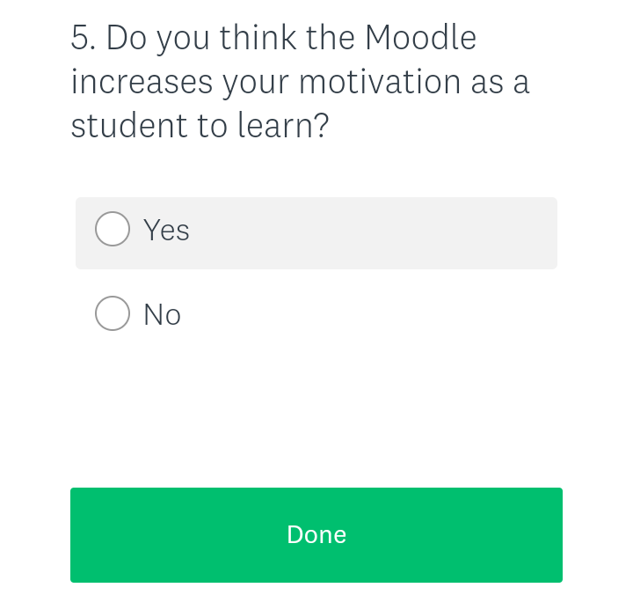

Appendix II: Results
Results for question 1
 | Yes | No
Have you ever used Moodle before? | 14 | 1
Results for question
 | To access the library | To access class lectures | To submit assignments | To access my email
If Yes, What is the major reason that you use Moodle for? | 3 | 6 | 4 | 2
Results for question 3
To what extent do you agree or disagree with the following statements on the usage of Moodle
Answer options | Strongly agree | Agree | Neutral | Disagree | Strongly disagree
The Moodle allow me to learn independently | 10 | 3 | 1 | 1
The Moodle allow learn in a flexible manner | 13 | 1 | 1
The Moodle allow me to be engaged and involved with other students | 5 | 3 | 4 | 2 | 1
The Moodle provide a way to positively interact with the tutors | 6 | 3 | 1 | 4 | 1
Results for question 4
 | 5 | 4 | 3 | 2 | 1
How would you rate VLE-Moodle in relation to improving the learning experience of students? | 7 | 4 | 3 | 1
Results for question 5
 | Yes | No
Do you think the VLE-Moodle increases your motivation as a student to learn? | 8 | 7

