
evidence of learning
(Learning in the Digital EraBMPS4009/C)


Chloe clark/2207404

Table of Contents
The first steps into preparing for higher education 2
MIND MAP ON HIGHER EDUCATION 3

PRESENTATION 4
reflection

Preparing for Higher Education

There are many different paths that can lead you into higher education. The first steps into preparing for higher education are making sure that you submit your applications to universities of your choice, you can do this using UCAS. This allows you do apply for five different choices. This is whether you’re a first-time learner, or an older student who is making a return to learning. It is important when going into higher education that you learn how to manage your time effectively. According to (Bhardwa, 2020) giving yourself an unrealistic expectation of how much you can get done in a day is only going to set you up for failure. It can be very difficult to maintain any high level of productivity for long periods of time, you will end up burning yourself out. To ensure you learn how to manage your time effectively while at university it is important that you prioritise the important things such as your work and mental health, it is important that you have a good work life balance. According to (Morris, 2022) technology has become central to enhancing a student’s experience, it helps support student progression and improves the quality of teaching and the methods in which we learn. With everything being online it enables students to learn more efficiently, and it enables them to use multiple devices and utilize their online resources. When transitioning into higher education it can be difficult for many people it Is important that they are aware there are many forms of support for things such as money, mental health these can be found on your university website and on boards throughout the university.

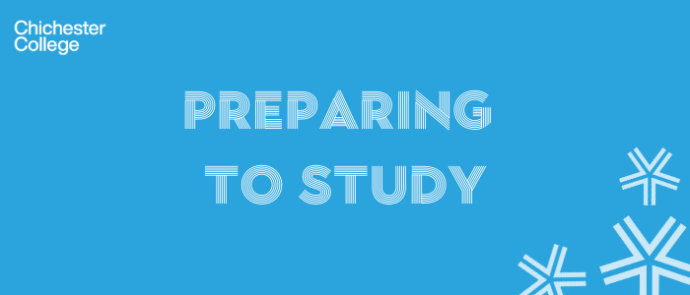

Becoming a digital learner
These are largely the attributes that will assist in becoming a learner in the digital era due to the fact, overall, it has become easier for the use of electronics to help with studies. The fact that students can always be in contact with lecturers and tutors increases students ability to concentrate on the work and not have to worry about contacting
Improved mental health
Better standard of work
Less stress
Digital planners
Time management
More readily available information
Great overall result and grade
Higher standard of understanding
Refining of ideas
Easier use of electronics
Mobile learning
Useful e-resources
Google/Web browsers
Internet
Office 365 skills
Laptops
According to (Pearson, ND) digital learners are on the go and more diverse than ever before. They are actively using different types of technology to learn on all sorts of devices.
Becoming a Digital Learner
https://youtu.be/GSmOiTlxCK0 video link

Reflection
In reflection to this assignment, I applied for university back in May choosing to do a degree in law and criminology. I found university very hard to get used to, I moved away from home and into a shared house with strangers I didn’t know. I was unsure whether I wanted to go back into education as going to university was never something that appealed to me whilst in school and leaving a job in which I had stable income, this took a large amount of getting used to seeing as I have been in employment since I was 15. Getting to grips with using different kinds of technology and programmes I hadn’t used before was though, I found trying to make a video for this assignment very challenging. Online learning resources has been very handy for my assignments as I have all the information I need at the tips of my fingers. This was the hardest assignment in which I had to complete due to the technological nature of it, as when I was still in full time education it was largely still handwritten work and there wasn’t much need for computer skills such as the ones I am developing now. I struggled with the whole process of moving due to never having experienced something of this scale before however I have acclimatised well and intend on attempting to carry on improving my learning. The whole purpose of me returning to education is to prove to myself that I can do it whether people believe in me or not I want a good education so I can set a good example for my younger siblings so hopefully they’ll have a similar drive to do as well as I have. The ultimate goal however is to gain enough experience from this course so I can get a job in social care as I was affected a lot by this in my childhood so I would like to help as many underprivileged children who did not grow up with a great background and prove to them that you can defy the odds and make something of yourself even when the world tries to stop that from occurring.

Bibliography
How to manage your time as a university student, Seeta Bhardwa March 25th, 2020
https://www.timeshighereducation.com/student/advice/how-manage-your-time-university-student 19th October 2022

https://www.solutionpath.co.uk/insights/digital-transformation-in-higher-education/
professor Neil Morris 2022
21st October 2022

https://ccgonline.chichester.ac.uk/course/view.php?id=2265
Chichester college 2022
22nd October 2022

https://www.pearson.com/us/higher-education/customers/institutional-leaders/digital-learner.html
22nd October 2022

Adobe Spark 2022

