

Programme: BA (Hons) Leadership and Management Skills for the Workplace
Student: Marie Jandova

Student Number: 2020984
Module: Knowledge and Information Management Skills for the Workplace
Module code: BMSW 5106
Module Lecturer: Md Kalam
Assignment Title: Knowledge and Information Management of Amazon.com

Task 1 - Knowledge and Information Management of Amazon.com
Table of Contents
Knowledge and Information Management of Amazon.com 2
Introduction 2
Background of Amazon 3
Organisational Structure of Amazon 3
How Amazon Manages its knowledge 5
AWS 5
KM in Amazon Conclusion 6
What is Knowledge Management 6
Tacit knowledge 7
Explicit knowledge 8
Knowledge management circle 8
Knowledge Needs Analysis 9
Knowledge management models 11
SECI model 11
Investigation of knowledge for Amazon Knowledge Management 13
Evaluation 13
Pros: 13
Cons: 13
Recommendations 14
References 14

Introduction
Knowledge management is one of the most important parts of a business or even individual life. Being daily surrounded by so much new information and carrying old information and being able to use them at the right time and place, can get quite challenging. Especially for the largest E-commerce organisation in the world – Amazon.com. This Report explains what is knowledge, and how is knowledge used and managed by Management models such as K – Needs and the SACI model. It also explains the Amazon strategy and their AWS Cloud computing system expecting to prove the importance of Knowledge Information Management of Amazon.com

Background of Amazon
Amazon started as an online book market founded by Jeff Bezos in 1994. Amazon was successful and people started to get used to the internet and Amazon began selling other products like technology, clothing, food, beauty products and became the largest online market where customers can buy anything and everything at basically any time, delivered to their home. Amazon is a very customer-focused organisation, so Amazon's focus was on customer needs and wishes more than Amazon's profit. The organisation, therefore, experienced huge customer trust and convenience. Another huge success of the Amazon organisation is Amazon Web Services. It all started in 2002 when AWB got their own apartment and began the use and share of their cloud, Amazon allows third parties to use their website to create extra income. Nowadays customers can enjoy Amazon music, Amazon video, Alexa, and Echo. Etc.
Jeff Bezos is today the richest man in the world and Amazon.com is the biggest and fastest growing organisation.

Organisational Structure of Amazon
Companies use Organisational Structures to organise job roles and responsibilities.
Amazon uses the Hierarchical Corporate structure, which has many layers of management mainly because of Amazon’s size. Amazon is the largest company in the world with almost 1 billion employees worldwide. Now, to build and manage such a large company, there needs to be structure, system, and plan. Amazon has many managers leading smaller groups of subordinates.
Amazon focuses on customers so they go the way the customer is the most satisfied, Amazon pushes literally everything in the favour of a customer “Customer obsession”.
Amazon splits their division into Northern America and International (Amazon is global and has teams all over the world)
AMAZON.COM CEO – Jeff Bezos uses the two-pizza rule, which means the teams created should not be more than 5-8 which is enough for two pizzas. He limits the size of groups to small. And creates more groups for a project. That way each group can focus on it is task and experiment more. All teams are completely independent of other teams that way each team can focus better on their main task without getting distracted. Projects are not getting crossed until it is needed. Bezos rather challenge his employees than bring new people to the business. People in developing and innovation positions have all the requirements to test new systems and practices. Jeff Bezos says “communication is terrible” referring to it as the most time-consuming action.
Amazon.com is different from for example Apple – another Tech. company. The previous CEO of Apple – Steve Jobs also separated people into smaller teams but his strategy was to collaborate between different groups and divisions and communicate weekly about all projects and works being done.
AWS CEO – Andy Jassy – Responsible for Amazon Web Services since 2021 (cloud computing started offering it is IT services in 2006, Today AWS creates around 70% of Amazon's operating profit (visualcapitalist.com)).

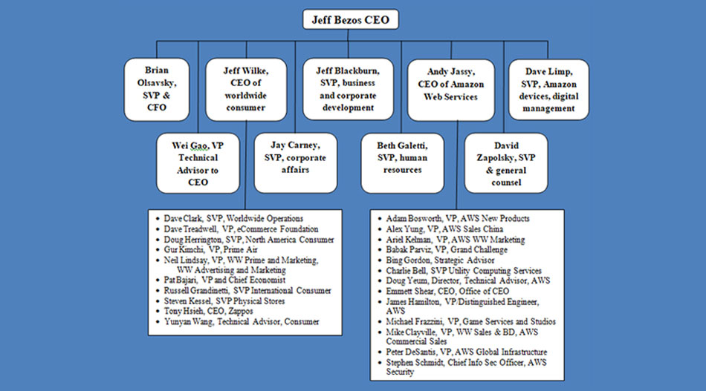

How Amazon Manages its knowledge
Amazon is collecting data globally and monitoring any changes in human behaviour (Covid-19 pandemic and people panicking), price changes ( putting lower prices on goods in countries with lower income), politics (war in Ukraine), customer needs ( First day back to school in September), customer wishes and priorities (more medication for colder months when flu is all over).
Little over 30% of sales of Amazon are made based on recommendations ( the little feature when customer buying staff through Amazon, that shows what other products people have bought together with the product the customer already wants). Or advertisements are also based on the data collected about the customer. ( for example, talking about having a baby with my partner often, generating pregnancy accessories, and baby accessories advertisements from Amazon all the time).
Machines can compare data better than humans, they can identify behaviour patterns based on the customer shopping list ( collecting data about what products/food has been bought before buying actual baby accessories proves that machines can predict pregnancy depending on the shopping list time before). Amazon can even tell when the customer is on a holiday, based on the customer's location and which telecom customer using ( Amazon is in many different markets and uses the same data collected at any time for all the platforms he is expanding in now ( For example, Amazon collects data about customers based on their shopping from a holiday in 2015 and will try to recommend a sunscreen which is cosmetic, will recommend cent toys if Amazon noticed that customer has a kid and will recommend maybe even some travel heck accessories). Amazon uses their AWS to do all this work which is extremely fast and efficient. People are predictable, 30% of Amazon’s turnover comes from the recommendation of a product to the customer

AWS
Amazon Web Services is an online service. AWB can be used to build and run any type of application without any commitment, a pay-as-you-go system. AWS is the biggest and fastest Cloud service ( Cloud = somebody else’s computer people rent to use virtually). Organisations like Netflix, BMW, Disney, GE, Tinder, and CIA uses the AWB cloud system.
AWS takes over 50% of a could market with Microsoft and Google being their only competition for now. When more than 50% of people use AWB as their Cloud for their business, this gives Amazon the opportunity to collect more data about others that non of its competitors have. Amazon can stop other businesses when they become thread to Amazon based on data about their sales collected ( Amazon is known for buying smaller companies under pressure, when amazon wanted to buy Dieapers.com in 2021 and they refused to sell it, Amazon offered discounted diapers in their website and despite loosing millions on it Amazon got most of the customers change the supplier, Diapers.com had no choice but to sell the company to Amazon). Amazon also supports third parties, and sellers, through their Amazon website and has that way control over their data and sales.
Anyway, AWS is growing rapidly, not only huge and small companies are using this Cloud but also the government. Moving this huge amount of data from all over the world can be financially and time-consuming. Amazon, therefore, introduces smaller devices called Snowball which is resistant even in a war zone, to collect a large amount of data in the organisations and transport the data in the Cloud. To be able to store and move this amount of data AWS needs to operate with a huge amount of electricity (having their own power plans).

KM in Amazon Conclusion
- Information systems are essential for Amazon
- Amazon is monitoring any changes globally though AWS
- People are predictable, 30% of Amazon’s turnover comes from the recommendation of a product to the customer
- Amazon analyses what customers will need when and where and deliver those good often from chine weeks in advance
- Amazon analysing each person’s behaviour to know if they are a good customer or a bad customer (based on their returns or reviews)
- Amazon requires only half employees compare to the traditional retailer, thanks to their robotic advantage
- For data collecting, storing and analysing is responsible AWS.

What is Knowledge Management
Knowledge management is the way an organisation COLLECT, MANAGES/organises, SHARES AND ANALYSE it is Knowledge. Correct knowledge management ensures that the right information is delivered in the right place or to the right person in the right time ( for example; calling the firefighter when there is a fire and not a doctor is correct knowledge management).
Every organisation needs, uses, collects and generates knowledge, knowledge is the value of the company, the more knowledge company has, the bigger value the company has. Knowledge is usually the biggest strategic company Asset and the company is built on it.
Every organisation store knowledge, it can be the form of an employee, files, emails, or materials. Knowledge creates the organisation and as known; knowledge is always not available to everyone. Information is not available to everyone because not everyone knows where to look for it or is not accessible to everyone or even because the person holding the information is not sharing it.
The key to success is to find valuable information for the organisation and found a way how to store it and share it with others. By monitoring and storing data the company can be one step ahead, knowing from previous data collections what is the best step to make. A simple example of this would be The Café store Knowledge is not always easy to separate into not valuable and valuable and is also impossible to fully store and document and keep it is value. People also have different learning methods and stored information will be understood In different ways (for example, if a specialist will write a specialised book, the information has been stored but, the person reading it will not become a specialist himself, because of the level of understanding is different, level of experience is different, and the information delivery – book reading cannot be compared to actual actions of a specialist in real life).
There are two different types of knowledge – Tacit and Explicit knowledge

Tacit knowledge
The Experiences, Culture, Values, Intuition and Beliefs of each individual and it is unique. Tacit knowledge usually has bigger value as it’s the personal experience of a person and can not be stored (for example the Lecture at university is passing on his personal Tacit knowledge that he gained through life, is the way he explains it, the note of his voice, the body language, the way he can answer relevant questions). This knowledge can be harder accessible because when the person leaves, his Tacit knowledge leaves with him and is not accessible as it is a personal view on things.
Tacit knowledge in Amazon – Amazon in its CEO and Management positions employs experts all over the world to deliver the best on the market, people working for amazon studied, for example, Harvard University, or studied technological engineering. Amazon also has great leaders and motivational preachers, those people know how to speak to other people, and how to lead and innovate. All of them came with experiences and creative minds. Amazon became a kind of monopoly when became global. Using strategy to get customer only to shop through their website and stay loyal. Amazon is employing teams of people all over the world, people that have different cultures, different schools etc. and letting them experiment with projects. Amazon uses the knowledge of people in India in terms of computing, the knowledge of people in the Czech Republic in terms of power plans, the knowledge of American people to lead, knowledge of the best psychologist from France to predict people's choices in shopping, uses Chinese market and factories for Amazons products and so on. To be able to do this is a huge advantage to their competitors.

Explicit knowledge
The Policies, Procedures, Documents and Artifacts. Explicit knowledge is storable and easily transferable, anyone can access it (for example, the Lecture at the University recommends the students' books to read). This knowledge can be then easily accessible, and even if the Lecture leaves, the information is stored.
Explicit knowledge of Amazon - Because Amazon is dominating many platforms such as home accessories, cosmetics, pet accessories, fitness supplements, movies, tools, cloud etc. Amazon is creating its own rules and pricing. Also, Amazon knows very well how data collection works and how to beneficially manage data. Today this job does software developed for customer data collection. Each customer has their own profile with amazon and Amazon is customised for each customer based on previous data collection and evaluation about each customer. Those data are being collected from customers through their electronic devices. Amazon is monitoring each click, conversation, location of a customer, conversations, anything, and everything that can help them predict what the customer might want and need. Those data are collected through AWS and stored for purpose of future use.

Knowledge management circle
- Collect TACIT knowledge and transfer it to EXPLICIT knowledge
- Collect EXPLICIT, pass EXPLICIT, collect feedback = TACIT knowledge (Kalam, 2022)

- 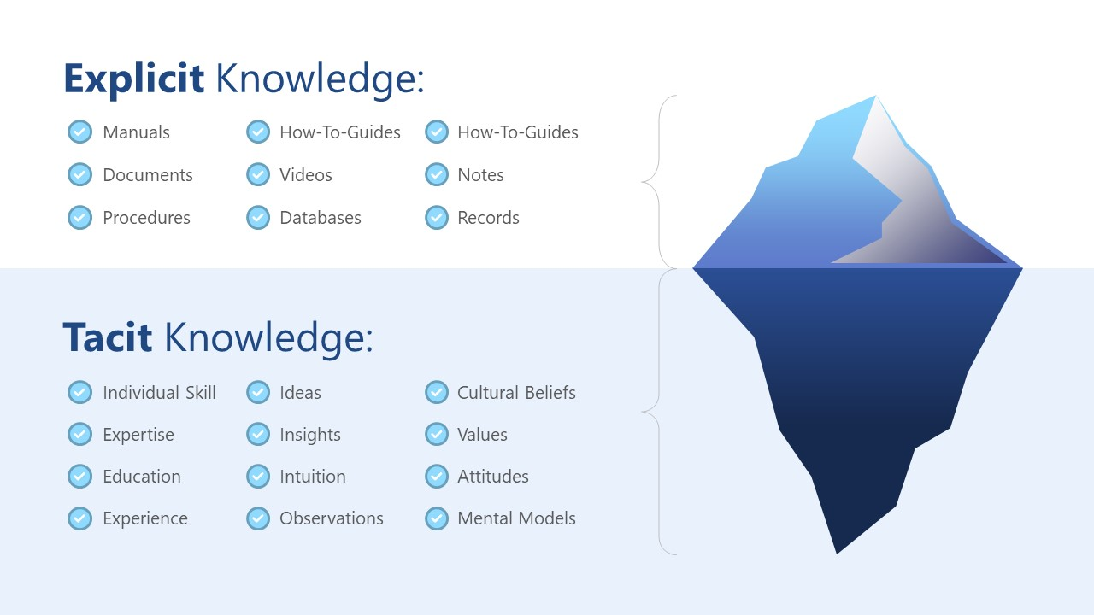

(Slidemodel.com)

Knowledge Needs Analysis
K - Needs
Analysis to identify the problems, causes of the problems and solutions to the problems. Those analyses are through the gaps between:
- “MUST KNOW”
- “KNOWS”
- “CAN DO”
- “MUST DO”.
What organisation knows and can do now, and what organisation must know and must do in the future to achieve their aim. After K – Needs analyses can be very clear about what prevents the company from doing what it desired.
Probably all or almost all organisations uses K – Needs model, Apple is pushing through new innovations (new phone model every year, iPod, iPad, MacBook, Air Pods, also a cloud computing and more)
Jeff Bezos must have used this or a similar technique when converting Amazon.com from an online book store to an everything store. Amazon growing really fast and does not really stop. Amazon is developing and overcoming obstacles and kind of set the course for other companies as amazon is the fastest growing of all.
There are few clear examples of how Amazon used Must do and Must know especially during and after the Covid-19 pandemic. Millions of Customers needed products to their door step and Amazon manage to do so despite huge collapse of other companies.
For example:
Amazon knew about pandemic but needed to know what people will need in order for them to get it in stock in time. Amazon did the analyses to find out that masks will be high inquiry in the market in two weeks’ time. As pandemic progressed, it began harder, almost impossible to ship from China to USA. The Ships that left China did not have there to unload in USA. And shipping containers could not be returned to China for another transport – Lack of containers. When Amazon saw the inability for their product to be shipped, Amazon began to make its own Amazon containers in China, that way, the container shortage didn’t not affect them. But when Amazon had their own containers, they still could not be shipped because they would now get unloaded in the USA on time, therefore Amazon began to use Air ways and its own Jets to insure deliveries on time.
K – Needs model simply helps with better and faster decision making and can significantly improve the business process. Amazon clearly said that they want to be the only E-commerce that people going to shop from and they managed to deliver food, masks, medicine etc. in crisis, due to their clear goal sets and findings on what needs to be done to overcome the gabs and threads that were and are in the way.
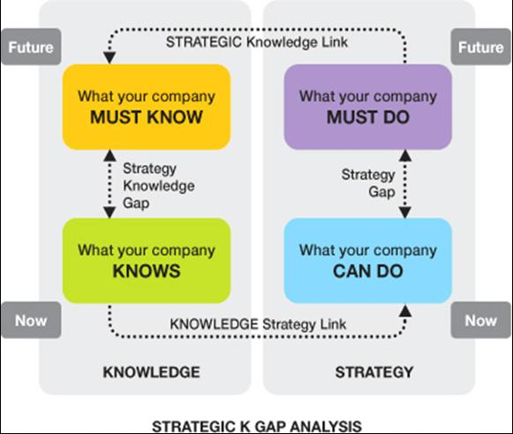

Knowledge management models
- SECI model
- Von Krogh and Roos Model.
- Nonaka and Takeuchi.
- Choo Sense-Making KM model.
- WIIGS KM Model.
- Boisot I-Space.
- MAYER and ZACK KM cycle model.
- Complex Adaptive System Models.

SECI model
SECI model is focusing on making personal knowledge available to others. SECI model is continuous knowledge creation (learning more via reading or working for example) and communication. SECI model has four modes.
- Socialization – which is Tacit knowledge shared with another Tacit knowledge through face-to-face communication and social interaction between two or more people. (for example Brainstorming – group discussion to produce ideas or solve a problem)
- Externalisation – is focusing on how to transfer Tacit knowledge to Explicit knowledge. In this process, Tacit knowledge gains visible form and becomes Explicit knowledge which can be easily saved and passed on. This can happen when the Tacit knowledge is written down, recorded or drawn.
- Combination – transferring a group of Explicit knowledge to another new group of Explicit knowledge. This can be done by reviewing a report.
- Internalisation – is changing Explicit knowledge to Tacit knowledge when people are for example learning from written information by doing it and experiencing new Tacit knowledge that can be passed on.

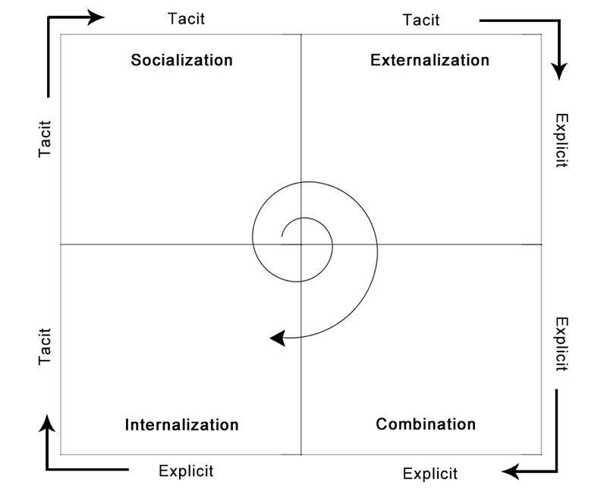
When using SECI model people are spinning their knowledge from outside of the organisation and sharing their knowledge with the goal to have more knowledge inside of the organisation. That being said, Amazon is employing highly educated and experienced people in their development and manager positions. Those people sharing and document their knowledge inside of the organisation. Specialists are put in teams together to work on a project, they can exchange their opinions and experiences because they all have the same goal – success. Their knowledge is being documented, Amazon is big on monitoring people and keeping records of everything. For example, Amazon has cameras and sensors on workers in warehouses. Amazon is monitoring their hand movements, their speed, their body temperature, even the time the workers spend in the toilet or how many boxes can they get ready, how many errors they might do, or what are most workplace accidents (this being done internally but it can be done externally from different companies or peoples previous work experiences). After collecting all those data, data is saved, compared with others, and evaluated. Based on those data Amazon makes company policies, statistics, and facts. Reviewing those statistics is the Combination. Amazon can take the results, the Explicit knowledge they have and teach people new tactics, work techniques, and health and safety standards.
SECI model was designed by Japanese organisations, they rely much more on Tacit knowledge than most west countries, but Amazon always seems to let CEOs experiment and use their experiences. Of course not always we can use the SECI model when for example having clearly stater information or policies, if there is not a way how to maybe skip some steps in the rotation. But overall Amazon is using and improving its operations with the experiences and capture of information’s they have and successfully collect further.

Investigation of knowledge for Amazon Knowledge Management
The main reason Amazon is so successful is because of their full commitment to its customers. Amazon always looks at what are the customers’ needs and what customers appreciates the most. Most data and feedback is collected right from customers. Customers have customed account which is convenient for then in terms of offers and Amazon have in return data of what they are like, what they like and what they are the most likely to buy.
Amazon is using Hierarchical structure inside of the organisation to lead people and separate them in small team to achieve less confusion between projects. Amazon has visions and missions and constantly working on improving its way of operating. (fastest delivery – trying new delivery drones, side way robots, carry robots in warehouses, their own power plans etc.) Amazon is not afraid of experimenting or even loosing few billions on profit as long as they achieve larger growth.

Evaluation
Knowledge management has many positive effects not only in organisations but also in the personal life of each individual. This report proved how important KM is and what value KM had for any organisation.

Pros:
- Quicker problem solving
- Improves communication
- Sharing external knowledge
- Sharing specialist knowledge
- Better collaboration
- Faster innovation
- Keeping up with the latest information

Cons:
- It can be hard to motivate people to share their knowledge.
- Hard to find a fay how to efficiently record and keep knowledge.
- New analyses every day

Recommendations
Amazon definitely knows how to collect data and use it for their own good but Amazon is a grooving giant. Sharing some of the collected data and knowledge maybe just with their third-party sellers could potentially help both sides with sales, most third-party sealers are managing delivery themself, this would make it easier for Amazon and Amazon would still get profit from the sales.
Also, Amazon had a few problems with security and since they hold 50% of market data, security is the most important because they are not only responsible for their data but also for customers' data, bank details etc. Amazon is investing millions in new Amazon Robotics and growing their already gigantic company, maybe if they tried to invest more in security and try to resolve some issues about data breaches that have been addressed would have a positive impact on the organisation.

References
Amazon.com Inc. (2017). 2017 Annual Report, Retrieved 17 December 2018 [accessed 25.4.2022]. available online at: https://ir.aboutamazon.com/static-files/917130c5-e6bf-4790-a7bc-cc43ac7fb30a
Amazon.com Inc. (2017) Cloud computing with AWS [accessed 9.9.2022]. available at: https://aws.amazon.com/what-is-aws/

Amazon.com Inc. (2017). The 6 Pillars of the AWS Well-Architected Framework [ accessed 9.9.2022]. available online at: https://aws.amazon.com/blogs/apn/the-6-pillars-of-the-aws-well-architected-framework/
Amazon.com Inc., (n.d), Our culture, Retrieved 15 December 2018. [accessed on 1.5.2022]. available at: https://www.aboutamazon.com/working-at-amazon/our-culture
Amazon.con Ins. (2022) Importing and exporting between the UK-EU customs border. [accessed 6.5.2022] available at: https://sellercentral.amazon.co.uk/gp/help/external/RPQMXMSB2MBQCJD
Budovski, J., (2022). Amazon Poter’s five forces analysis. [accessed 6.5.2022] available at: https://research-methodology.net/amazon-porters-five-forces-analysis-2/

Bhatt, G., (2002). Strategies for individual and organizational knowledge. Journal of Knowledge Management, 6(1), 31-39 [accessed 9.9.2022] available online at: https://www.researchgate.net/publication/242023663_Strategies_for_individual_and_organizational_knowledge_Journal_of_Knowledge_Management_61_31-39
Coppola, D., (2021), Amazon – statistics and facts. [accessed on 4.5.2022] available at: https://www.statista.com/topics/846/amazon/#topicHeader__wrapper
Farooq, U., (2022), Pestle Analysis of Amazon. [accessed 6.5.2022] available at: https://www.marketingtutor.net/pestle-analysis-of-amazon/

Greene, J., (2021). Amazon's employee surveillance fuels unionisation efforts: 'It's not prison, it's work'. [Accessed 3.5.2022] available at: https://www.washingtonpost.com/technology/2021/12/02/amazon-workplace-monitoring-unions/
Greenspan, R., (2019). Amazon.com Inc. Five Forces Analysis and Recommendations [accessed 5.5.2022] available online at: http://panmore.com/amazon-com-inc-five-forces-analysis-recommendations-porters-model

Howard, B., (2016). Knowledge Audit [accessed 9.9.2022] Available online at: https://slideplayer.com/slide/9750341/

Prabhakaran, J., (2021). What is Tacit Knowledge: Importance, Benefits and Examples. [Accessed 9.9.2022] Available online at: https://document360.com/blog/tacit-knowledge/

Dudovskiy, J., (2021). Apple Organizational Structure: a brief overview. [Accessed 9.9.2022] Available online at: https://research-methodology.net/apple-organizational-structure-a-hierarchical-structure-that-may-change-in-near-future/

Dudovskiy, J., Amazon Organizational Structure: a brief overview. [Accessed 9.9.2022] Available online at: https://research-methodology.net/amazon-organizational-structure-2-2/

TASK 2 – KNOWLEDGE MANAGEMENT FRAMEWORK AMAZON (PAGE16)


DISCUSSION
The biggest organisation the more knowledge they need to manage and it gets challenging. Machines can manage, knowledge better than humans, Amazon is using AWS to collect and manage data globally and internally. Amazon is considered as one of the biggest technological companies.

INTRODUCTION
Knowledge Management systems were introduced to help easily manage, capture, create knowledge and insure its use in the right time.
Amazon is the biggest global
e-commerce organisation.
(amazon.com), (statictica.com), (simplylearn.com), (research-methodology.net)
(amazon.com), (statictica.com), (simplylearn.com), (research-methodology.net)
AWS – the largest Cloud platform primary driven for Amazon
REFERECENCES

Amazon.com Inc. (2017). 2017 Annual Report, Retrieved 17 December 2018 [accessed 25.4.2022]. available at: https://ir.aboutamazon.com/static-files/917130c5-e6bf-4790-a7bc-cc43ac7fb30a
Amazon.con Ins. (2022) Importing and exporting between the UK-EU customs border. [accessed 6.5.2022] available at: https://sellercentral.amazon.co.uk/gp/help/external/RPQMXMSB2MBQCJD
Coppola, D., (2021), Amazon – statistics and facts. [accessed on 4.5.2022] available at: https://www.statista.com/topics/846/amazon/#topicHeader__wrapper
Farooq, U., (2022), Pestle Analysis of Amazon. [accessed 6.5.2022] available at: https://www.marketingtutor.net/pestle-analysis-of-amazon/
Greene, J., (2021). Amazon's employee surveillance fuels unionisation efforts: 'It's not prison, it's work'. [accessed 3.5.2022] available at: https://www.washingtonpost.com/technology/2021/12/02/amazon-workplace-monitoring-unions/
AIMS

- To improve Amazon operation
- To improve Customer service
- To innovate faster
- To get more Experience
- Collect TACIT knowledge and transfer it to EXPLICIT knowledge

RECOMMENDATIONS

- Sharing some data to support better third-party sellers
- Improving security as Amazon was reported for data breach or selling data several times. This will help to build better trust.
Amazon reported revenue almost 480 billion U.S. dollars in 2021. Amazon is consuming half of online market and keep growing rapidly.
PURPOSE

Knowledge Management is to collect and share ideas, studies, experiences, perspectives, analyses, data in order to make them available in the right place at the right time.

Amazon is large organisation with almost a million of employees. The knowledge and data that amazon collect and analyses as a beneficial for the organisation are stored for future use. This improves Decision making, time in which are projects done, communication, overall employee knowledge, fastest innovating.

UWTSD – MARIE JANDOVA – POSTER

KNOWLEDGE MANAGEMENT FRAMEWORK –
AMAZON.COM

