How do picture books tackle the themes of sadness & depression?

Student name: Blaine Henderson
Student number: 2003595
Programme of Study: BA Illustration
Module: Research in Context (ADAD5003(
Word count: 2667
Tutor: Chris Harrendence

“It starts as sadness then I feel myself shutting down, becoming less capable of coping. Eventually, I feel numb and empty” (mind, 2019). According to mind (2019), depression is a state of mind where a person can feel gloomy for a lengthy period of time and can affect their everyday life. Although the person may be in low spirits, it can escalate to the point where they feel suicidal. Currently, several picture books targeted at different and/or all age groups have been discussing these themes in distinctive styles of narration and illustration with educational or other purposes, all the while underlining the seriousness of sadness and depression. In the following essay, this topic will be investigated and substantiate along with research sources such as picture books and other forms of research. Furthermore, an analysis into the techniques that artists and illustrators incorporate to convey their message in their picture books will be conducted and the methods through which different artists tackle the same theme will also be considered. These methods will include Semiotics, Colour Theory and Visual storytelling for example and the use of these techniques in the following picture books; Sad Book, A Shelter for Sadness, and I had a Black Dog. All these artists and authors address the topics of Sadness and Depression through their work, in a variety of techniques both through pictures and text.

The first book that will be analysed is called the Sad Book, written by Michael Rosen, and illustrated by Quentin Blake. Looking at the synopsis of the book, it explains about the loss of the author’s son Eddie and how the author:

Writes about his sadness, how it affects him and some of the things he does to try to cope with it. This is a very personal story that speaks to everyone; whether or not you have known what it’s like to feel really, deeply sad, its truth will surely touch you.
(Rosen, 2005, p. back cover)

The author intended to express his experience of dealing with sadness and depression from a personal experience and how he has managed it. However, on inspecting the narration from the synopsis, there is a bluntness to the style of writing where it reads “What makes Michael Rosen most sad is thinking about his son Eddie, who died.” (Rosen, 2005). The way that the sentence ends bluntly reflects the style of narration and mood in the book as evidenced in page one (see Fig. 1).

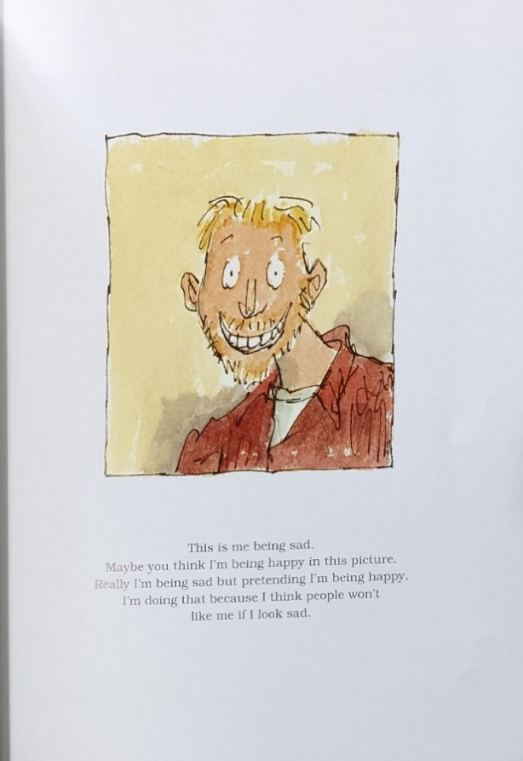
Fig. 1: Sad Book Page 1

In relation to this page, the author and illustrator have created a contradiction with the text and images as the image depicts the author smiling in bright, warm colours, but the text reads that the author is being sad and although he looks happy, he is masking his sad emotions so that people would not avoid him (Rosen, 2005, p.1) (see Fig.1). As stated by Martin Salisbury and Morag Styles (2012), “Maria Nikolajeva and Carole Scott use the term ‘counterpoint’ when words and pictures tell different stories and provide ‘alternative information or contradict each other in some way’ resulting in several possible readings.” The author and illustrator have created this counterpoint in order to represent how someone could appear to be happy on the surface, but may not share that feeling on the inside. In addition to this, when reading “I’m doing that because I think people won’t like me if I look sad” (Rosen, 2005, p.1), this could highlight the conflict that sad and depressed people face between the desire to speak up about their feelings and the worries of people’s judgement or rejection.

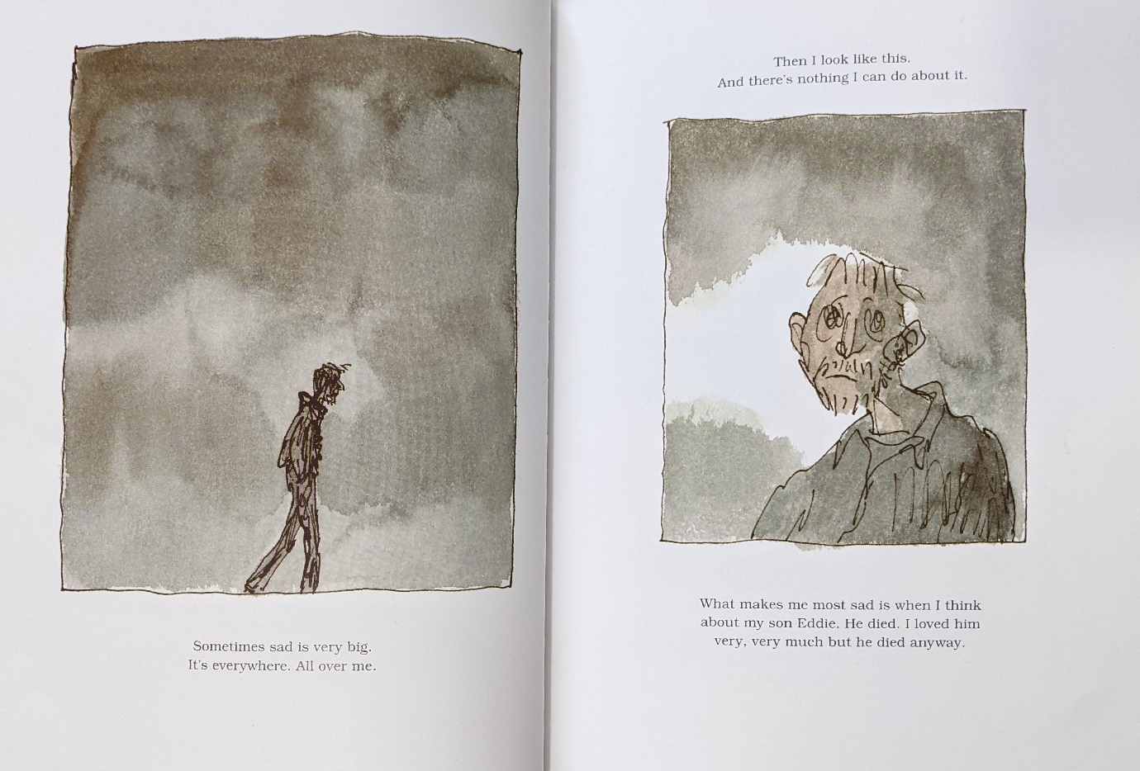
Fig. 2: Sad Book Page 2 and 3
Following on from this point, Rosen continues to narrate about his depression and the cause being the loss of his son. However, the illustrations now reflect the narration as they display the author looking sad and being surrounded in washes of murky greys. In relation to colour theory, colours can be used as a form of representing emotions, as stated by Stecker (2021) “Color plays more of an influential role in our lives than we realize. It can affect our minds, bodies, and overall mood”. Although the colour blue is more associated with sadness than grey, perhaps the illustrator has chosen grey or an absence of colour to capture an emptier feeling such as depression. Furthermore, the medium that Blake was most likely watercolour judging from the texture of the background. Doonan proclaims that:
Every mark, every modification of texture, the manner in which the pen or brush originally met the surface of the paper – delicately or boldly, incisively or sensuously – is telling.
(Doonan, 1993, p.12)
When taking this statement into account, the use of the watercolour texture adds that sense of oppressive and gloom into the atmosphere of the picture.
Another detail to make about the pictures is the use of composition. The picture on the left features a man walking with his head facing downwards through a murky grey fog. According to HelpGuide (2022), “Body language is the use of physical behaviour, expressions, and mannerisms to communicate nonverbally, often done instinctively rather than consciously.” Considering this information, the illustrator has drawn the man with a sulky posture as a way of visually communicating his negative feelings without needing to describe it through text.

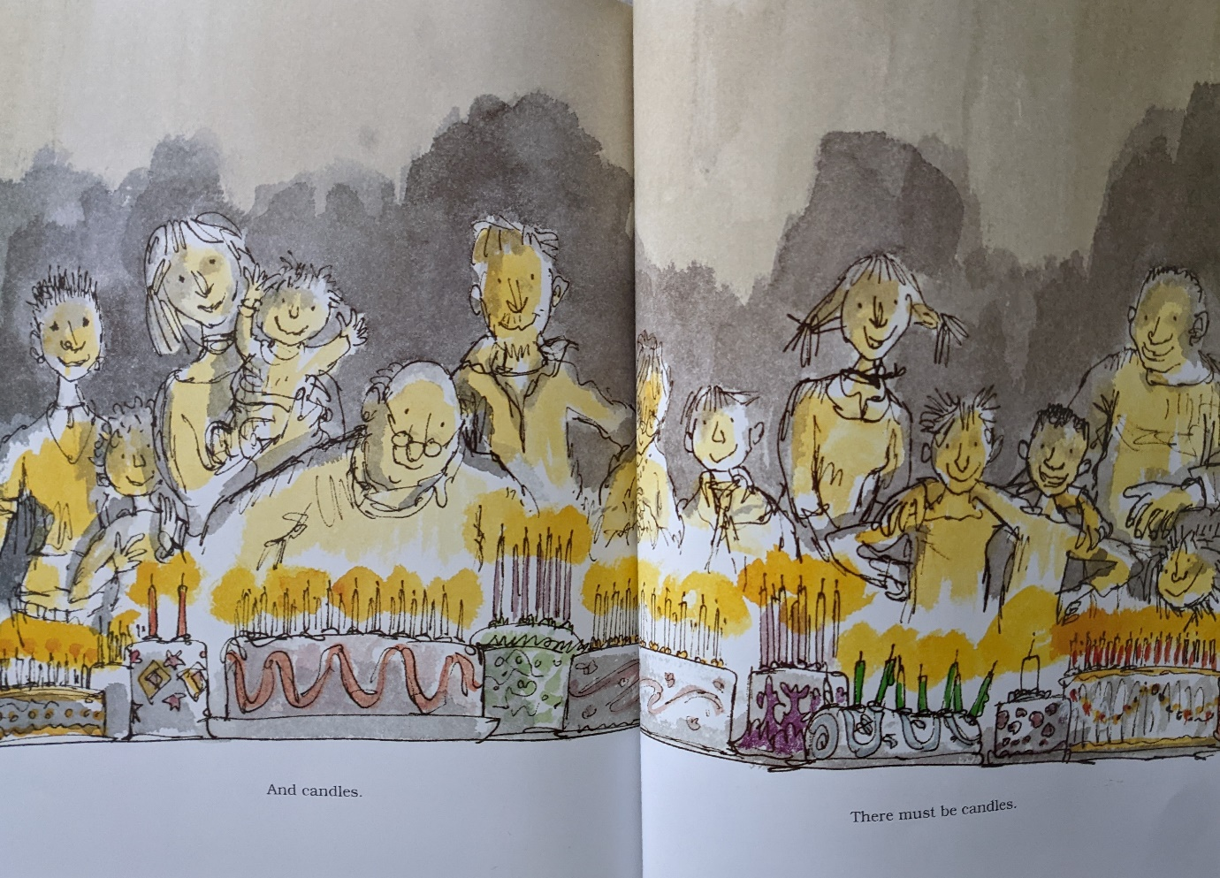
Fig. 3: Sad Book Page 26 and 27
Even though most of the pages in Sad Book depicts the author’s negative outlook on his life after the loss of his son, the author also shares the memories that he looks back on in order to deal with his sadness. An example of this is when Rosen talks about how he enjoys celebrating birthday parties in general and how “there must be candles” for birthday cakes (Rosen, 2005, p. 27) (see Fig. 3). The author could be intending to show that each individual has their own way of coping with their negative emotions.

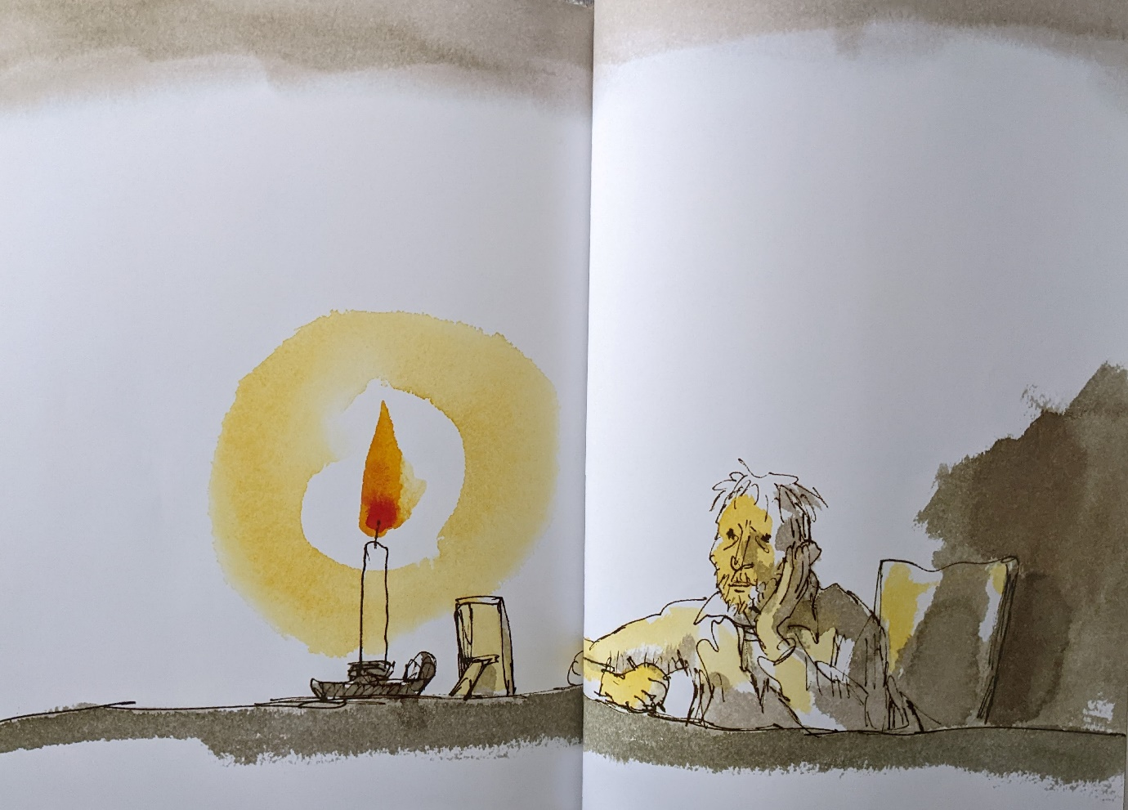
Fig. 4: Sad Book Page 28 and 29
In addition to the last statement about candles, the last two pages features a textless picture of Rosen staring at a photo frame with a candle burning behind it (see Fig. 4). Taking the symbolism and knowledge of the birthday candles from the previous paragraph, and his late son as well as the picture frame into consideration, the author and illustrator could be hinting that the illustration represents the author celebrating his son’s birthday. Moreover, the illustrator utilises a double page spread for the illustration in order to add prominence to the scene.

This second book by Anne Booth and David Litchfield called A Shelter for Sadness depicts a boy creating a shelter for his Sadness to live in. This book communicates the theme of sadness and depression in relation to mental health, and implores the importance of having a safe space to take one’s time to exercise their sadness however they like to. In addition, the author “Anne Booth was inspired to write this book by the words of Etty Hillesum, a Jewish woman and victim of the Holocaust” (Booth, 2021). Particularly, Booth was inspired by what Hillesum wrote:
Give your sorrow all the space and shelter in yourself that is its due, for if everyone bears grief honestly and courageously, the sorrow that now fills the world will abate. But if you do instead reserve most of the space inside you for hatred and thoughts of revenge – from which new sorrows will be born for others – then sorrow will never cease in this world. And if you have given sorrow the space it demands, then you may truly say: life is beautiful and so rich.
(Esther ‘Etty’ Hillesum, 1914-1943)

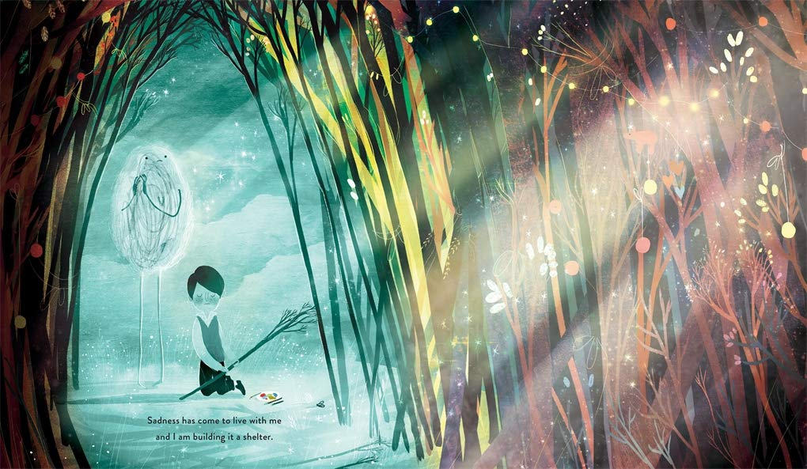
Fig. 5: A Shelter for Sadness Page 1 and 2
The book starts off with a double page spread illustration featuring a boy who is building a shelter for his sadness to live in (Booth, 2021). One noticeable element of the picture is the use of a contrasting colour palette between the colourful shelter and the blue space outside the shelter that the boy and Sadness are in (see Fig. 6). With reference to colour psychology, “blue colors like purple and green are known for evoking feelings of calm, sadness, or indifference.” (Stecker,2019). As the overall narrative of the book focuses on the theme of sadness in relation to mental health, the illustrator David Litchfield might have used the colour blue to represent the emotion sadness taking over the boy’s emotions. Furthermore, the multi-coloured shelter is the safe space for him to place Sadness in so that it wouldn’t interfere with the rest of his mental health.
When comparing the use of colour in A Shelter for Sadness and Sad Book, each of them uses a different colour to represent the theme of sadness as one uses blue while the other uses grey. As previously mentioned, Quentin Blake might have used grey in his illustrations for Sad Book to represent sadness in a heavier and slightly menacing way to capture the author’s anguish from the loss of his son. Whereas David Litchfield used the colour blue to represent sadness in a lighter and friendlier tone as it complements the calming atmosphere that is created in the book.
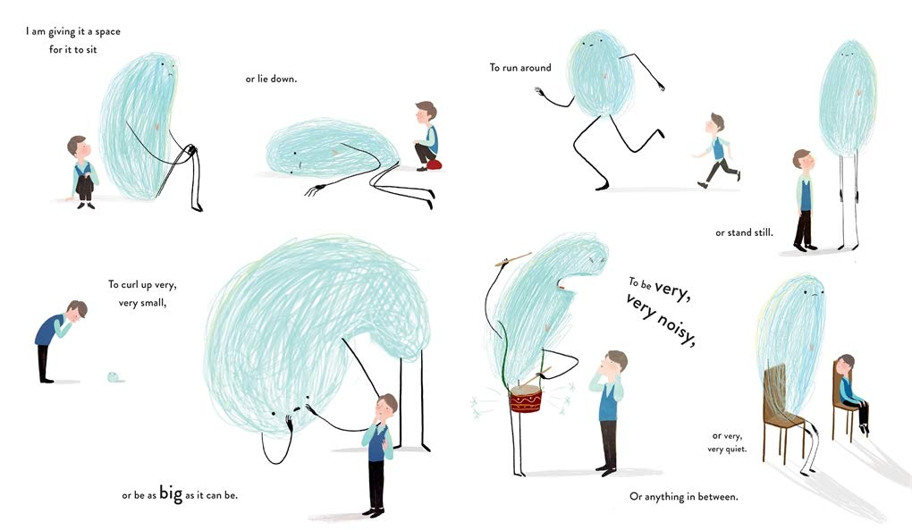
Fig. 6: A Shelter for Sadness Page 5 and 6
After the boy invited Sadness into the shelter, the boy then allows Sadness to do anything within the space it has been provided. This has been visualised with numerous illustrations of the two figures performing numerous activities with text accompanying each one to describe the pictures individually (see Fig. 6). The text altogether reads:
I am giving it a space for it to sit or lie down. To curl up very, very small or be as big as it can be. To run around or stand still. To be very, very noisy, or very, very quiet. Or anything in between.
(Booth, 2021)
The combination of text and image shows that Sadness has freedom to express itself however it wants to in the space of the shelter that the boy has given it.
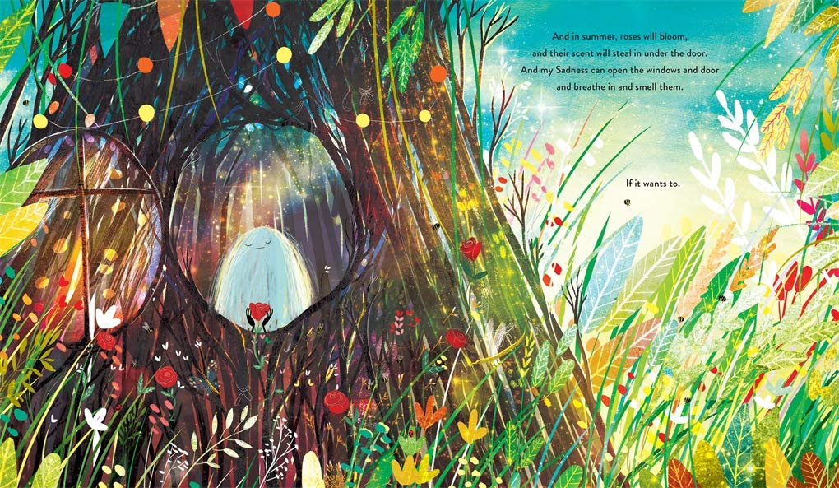
Fig. 7: A Shelter for Sadness Page 17 and 18
On further reading of the book, the landscape outside of the shelter begins to change from the blue, misty background that was seen in the first pages, to a more clear and colourful landscape with foliage as seen in Fig. 7. Moreover, the author has mentioned a time frame within the text as it reads “And in summer…” (Booth, 2021). The author has portrayed a healthier change in landscape to depict the improvement in the child’s mental wellbeing. Continuing to read the text, it talks about the flowers scent of the flowers when blooming and that Sadness could open the windows to smell the flowers if it desires to do so (Booth, 2021). Similarly with the text in Fig. 6, the style of sentence structure conveys a sense that the boy is giving Sadness the freedom to choose to do what it needs to instead of forcing it.
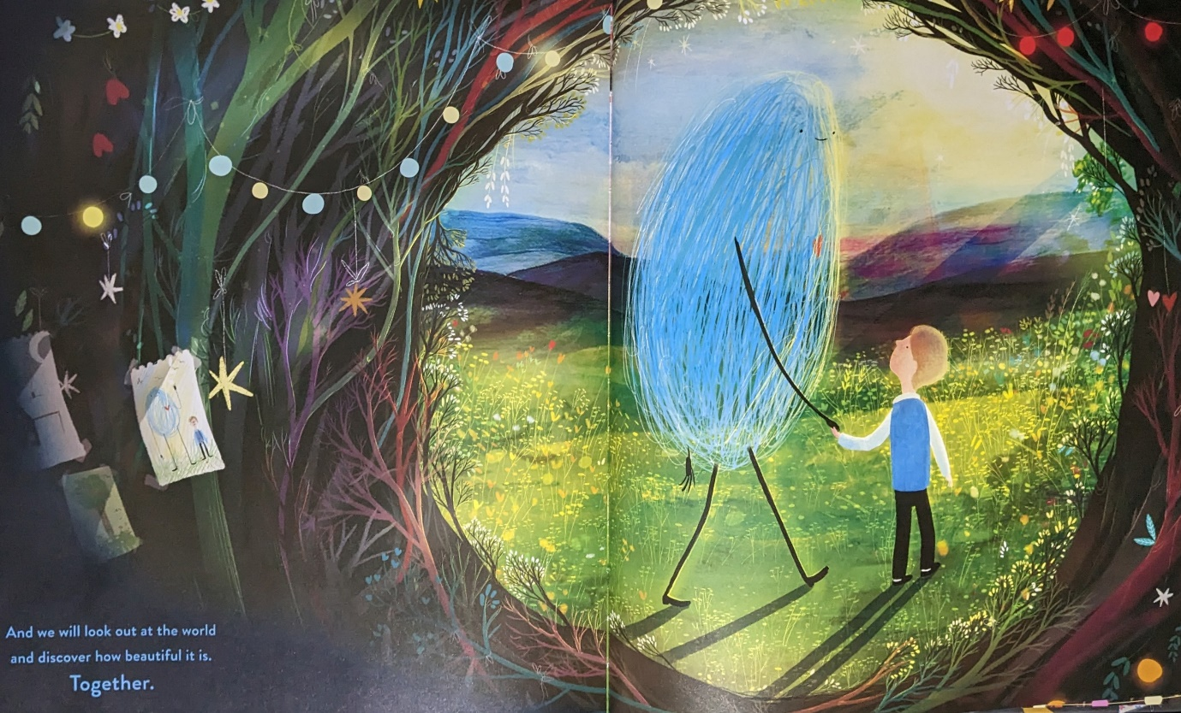
Fig. 8: A Shelter for Sadness Page 31 and 32
Moving on to the final pages of the book, the picture displays the boy and Sadness leaving the shelter hand in hand and walking through the outer world. Furthermore, the text written at the bottom corner of the left page reads “And we will look out at the world and discover how beautiful it is. Together.” (Booth, 2021). Coming back to the style of sentence structure, the way that the author has written the text for the final page is similar to the final part of Hillesum’s quote where she writes “And if you have given sorrow the space it demands, then you may truly say: life is beautiful and so rich.” (Esther ‘Etty’ Hillesum, 1914-1943). As the author stated that she was inspired by this quote, the (application of intertextuality could be reflecting the entirety of the book’s story and the experience that the boy went through with his sadness.

The final book titled I Had A Black Dog by author illustrator Matthew Johnstone provides information about depression through a narrative approach from “his own personal experience of depression” (Johnstone, 2007). This is achieved by creating a personification of depression as a black dog and utilising it throughout the story to explain the experience of having depression and giving advice on how to confront it. An additional point to add about the black dog is a reference to the term ‘Black Dog’ that Winston Churchill used to describe his own depression.

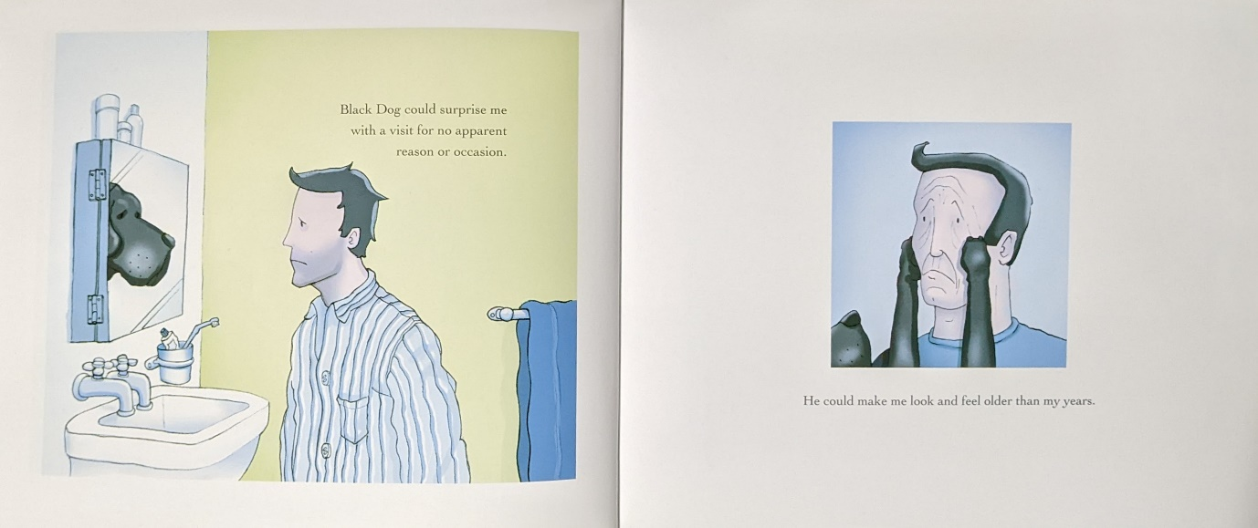
Fig. 9: I Had a Black Dog Page 3 and 4
An example of how Johnstone creates a blend of narrative and informative text is in page 3 where he writes, “Black Dog could surprise me with a visit for no apparent reason or occasion” (Johnstone, 2007). The purpose behind this is to present information about depression to the target audience in a format that helps them understand the points that the author is conveying.
Additionally, the playful use of composition for the illustrations captures a visual representation of the narrative text. This is seen in Fig. 9, when the black dog appears in the reflection of the man in page three, and in the picture of page four where it displays the perspective of the black dog who is pulling the man’s face downwards. In reference to John Berger (2008), “The idea that if we can physically see a location, then it would make sense that someone can see us too from that location.” Considering this theory and the quote “he could make me look and feel older than my years” (Johnstone, 2007), the use of composition and to show the black dog’s perspective and the man’s face portrays the physical and emotional effects of depression on the man.
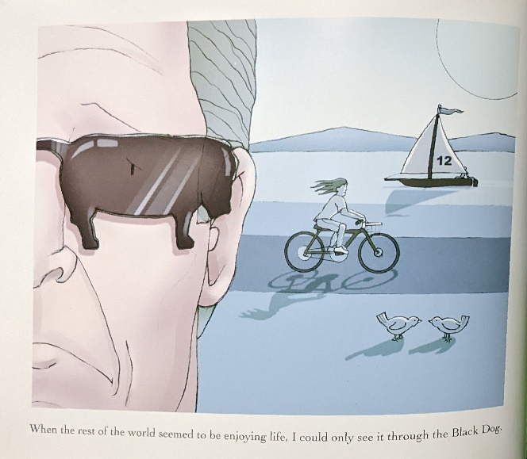
Fig. 10: I Had a Black Dog Page 5
This point can be further extended into page 5 as it depicts the man looking through sunglasses in the shape of the black dog and the background coloured in shades of blue (see Fig. 10). In the same case as with A Shelter for Sadness, blue can be used to represent sadness in colour theory. When combined with the symbolism of the black dog shaped sunglasses, the author visualises the negative outlook that he saw with depression.

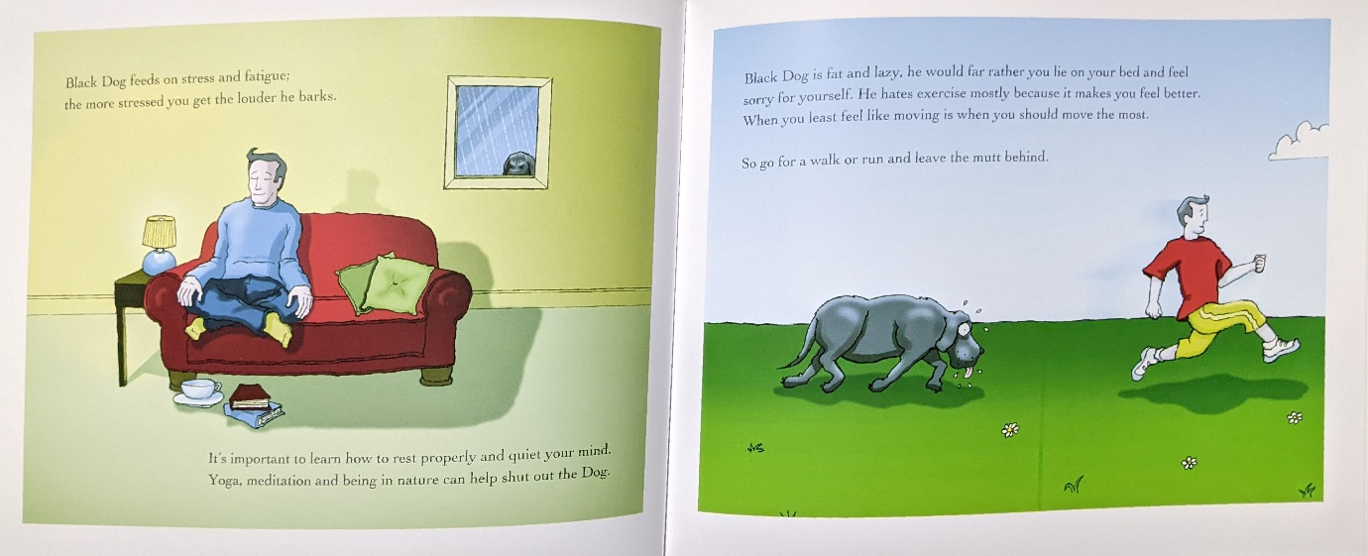
Fig. 11: I Had a Black Dog Page 31 and 32
Although initially a gloomy atmosphere is developed throughout half of the book. The narrative takes a turn as it employs comedic irony into the part where it talks about methods to deal with the black dog (see Fig. 11). In accordance to Kenitz (2022), “Situational irony is a statement or event that contrasts our expectations. Comic irony occurs when you add the element of humour”. The inclusion of irony shifts the mood to a lighter sense so that it would complement the message of the story without causing conflict.

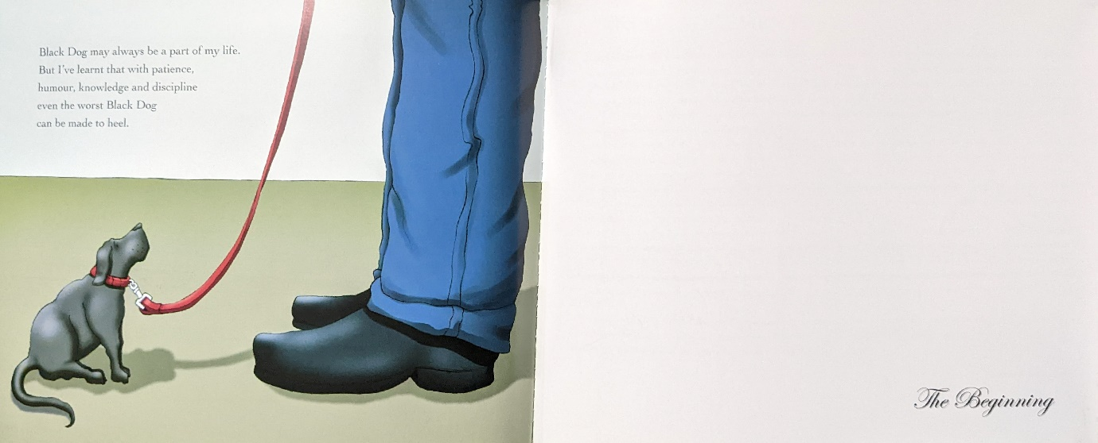
Fig. 12: I Had a Black Dog Page 39 and 40
Subsequentially explaining the different ways of tackling depression, the book finishes with an illustration a small version of the black dog on a leash (see Fig. 12). Furthermore, the text on page 39 mentions about the black dog is apart of life and by incorporating the techniques learnt in the book, the individual will be able to manage their own black dog (Johnstone, 2007). According to Strum and Boland (2022), “Depression typically lasts for several months, but it can also develop into a chronic condition that lasts for years in some cases.” The author is ending the story on a reminder that depression doesn’t go quickly, but is a long-term fight for an individual. This is further evidence on the final page as it says, “The Beginning” (Johnstone, 2007) instead of it being ‘The End’. By replacing the writing, it echoes the message that depression doesn’t have an end as it effects the individual on an everyday basis.

After conducting research with the picture books that tackle sadness and depression, it has been discovered that each one has their own individual style of conveying the theme of their story through visuals and narrative. Sad Book conveys the author’s experience with depression from his personal viewpoint, A Shelter for Sadness uses a personification of sadness and metaphors to discuss the importance of having a safe place to address your sadness, and I Had A Black Dog conveys information about depression through the use of the black dog metaphor and storytelling techniques. All three of these books share the same underlining theme of sadness and depression, however they each use similar concepts and skills to communicate this theme to their target audience in their preferred styles.

List of Illustrations
Figure. 1: Blake, Q. (2004) Sad Book Page 1 [Illustration]. Sad Book. (Accessed: 12th November 2022).
Figure. 2: Blake, Q. (2004) Sad Book Page 2 and 3 [Illustration]. Sad Book. (Accessed: 12th November 2022).
Figure. 3: Blake, Q (2004) Sad Book Page 26 and 27 [Illustration]. Sad Book. (Accessed: 12th November 2022).
Figure. 4: Blake, Q (2004) Sad Book Page 28 and 29 [Illustration]. Sad Book. (Accessed: 12th November 2022).
Figure. 5: Litchfield, D. (2021) A Shelter for Sadness Page 1 and 2 [Illustration]. Available at: https://www.amazon.co.uk/Shelter-Sadness-Anne-Booth/dp/1787417212 (Accessed: 24th November 2022).
Figure. 6: Litchfield, D. (2021) A Shelter for Sadness Page 17 and 18 [Illustration]. Available at: https://www.amazon.co.uk/Shelter-Sadness-Anne-Booth/dp/1787417212 (Accessed: 24th November 2022).
Figure. 7: Litchfield, D. (2021) A Shelter for Sadness Page 5 [Illustration]. Available at: https://www.amazon.co.uk/Shelter-Sadness-Anne-Booth/dp/1787417212 (Accessed: 24th November 2022).
Figure. 8: Litchfield, D. (2021) A Shelter for Sadness Page 31 and 32 [Illustration]. A Shelter for Sadness. (Accessed: 24th November 2022).
Figure. 9: Johnstone, M. (2007) I Had a Black Dog Page 3 and 4 [Illustration]. I had a Black Dog. (Accessed: 19th November 2022).
Figure. 10: Johnstone, M. (2007) I Had a Black Dog Page 5 and 6 [Illustration]. I had a Black Dog. (Accessed: 19th November 2022).
Figure. 11: Johnstone, M. (2007) I Had a Black Dog Page 31 and 32 [Illustration]. I had a Black Dog. (Accessed: 19th November 2022).
Figure. 12: Johnstone, M. (2007) I Had a Black Dog Page 39 and 40 [Illustration]. I had a Black Dog. (Accessed: 19th November 2022).

Bibliography
Allen, K. (2016) A naïve realist theory of colour. First Edition. Oxford University Press.
Bang, M. (2016) Picture this: How Pictures Work. Second Edition. Chronicle Books: San Francisco.
Berger, S. (2008) Ways of Seeing. First Edition. Penguin Books: London.
BetterHelp Editorial Team. (2022) “Black Dog:” Depression & How It Works. Available at: https://www.betterhelp.com/advice/depression/understanding-the-metaphorical-black-dog-depression-and-how-it-works/ (Accessed: 19th November 2022).
Booth, A. and Litchfield, D. (2021) A Shelter of Sadness. First Edition. Templar Books: London.
Burton, T. (2005) The Melancholy Death of Oyster Boy & Other Stories. First Edition. Faber and Faber: London.
Doonan, J. (1993). Looking at Pictures in Picture Books. United Kingdom: Thimble Press.
Fox, G. (unknown) Male Depression: Those Black Dog Days. Available at: https://www.theyakmag.com/male-depression-those-black-dog-days/#:~:text=Winston%20Churchill%20is%20credited%20with,who%20has%20suffered%20the%20blight. (Accessed: 20th November 2022).
HelpGuide. (2022) Nonverbal Communication and Body Language. Available at: https://www.helpguide.org/articles/relationships-communication/nonverbal-communication.htm#:~:text=Body%20language%20is%20the%20use,giving%20and%20receiving%20wordless%20signals. (Accessed: 9th December 2022).
Johnstone, M. (2007) I Had A Black Dog. First Edition. Robinson Publishing: London.
Jones, M.M. (2022) Principles of Visual Storytelling: Types & Impact. Available at: https://study.com/academy/lesson/principles-of-visual-storytelling-types-impact.html#:~:text=Visual%20storytelling%20relies%20on%20conveying,emotional%20connection%20with%20the%20audience. (Accessed: 17th November 2022).
Kenitz, D. (2022) Comic Irony: Explanation and Examples. Available at: https://www.skillshare.com/en/blog/comic-irony-explanation-and-examples/ (Accessed: 20th November 2022).
Mary Jo Nye. (1994). Language and Image in Nineteenth-Century Chemistry. In From Chemical Philosophy to Theoretical Chemistry (p. 73–). University of California Press. https://doi.org/10.1525/j.ctt1ppv0b.10
McVeigh, T. (2011) Celebrities back ‘black dog’ campaign to defeat depression. Available at: https://www.theguardian.com/society/2011/jul/24/mental-health-black-dog-sculpture-campaign (Accessed: 19th November 2022).
Mind. (2019) Depression. Available at: https://www.mind.org.uk/information-support/types-of-mental-health-problems/depression/about-depression/ (Accessed: 20th November 2022).
Mollica, P. (2013). Color Theory: An Essential Guide to Color-from Basic Principles to Practical Applications. United States: Walter Foster Publishing.
Parkes, D. (2022) A Brief History of Storytelling: How Long Has It Existed? Available at: https://danielaparkes.com/blog/brief-history-of-storytelling/#:~:text=History%20of%20Visual%20Storytelling%20%E2%80%93%20Over%2036%20000%20Years&text=The%20historical%20background%20of%20visual,reflect%20or%20pre%2Dempt%20events. (Accessed: 22nd November 2022).
Peirce, & Hoopes, J. (1991). Peirce on Signs Writings on Semiotic by Charles Sanders Peirce. University of North Carolina
Poetry Foundation. (2022) Horace. Available at: https://www.poetryfoundation.org/poets/horace (Accessed: 19th November 2022).
Rosen, M. and Blake, Q. (2004) Sad Book. First Edition. London: Walker Books.
Salisbury, M. and Styles, M. (2012) Children’s Picturebooks The art of visual storytelling. First Edition. Laurence King Publishing: London.
Scieszka, J. and Johnson, S. (1994) The Frog Prince Continued. Second Edition. Penguin Books: London.
Strum, J. and Boland, D. (2022) How Long Does Depression Last? Can Depression Be Cured? Available at: https://www.therecoveryvillage.com/mental-health/depression/how-long-does-depression-last/ (Accessed: 21th November 2022).
Scott, D. (2018) How to Analyze Art. Available at: https://drawpaintacademy.com/analyze-art/ (Accessed: 13th November 2022).
SCYAP. (2020) Basic Colour Theory-Printable. Available at: https://scyapinc.org/basic-color-theory-printable/ (Accessed: 15th November 2022).
Snicket, L. and Klassen, J. (2013) The Dark. First Edition. Orchard books: London.
Somekh, D. (2022) Your Non-Scientific Guide to Colour Semiotics. Available at: https://huddlecreative.com/blog/your-non-scientific-guide-to-colour-semiotics (Accessed: 15th November 2022).
Stecker, S. (2021) Color Psychology: The Effects of Color. Available at: https://www.mountainvistapsychology.com/color-psychology-the-effects-of-color/#:~:text=Colors%20close%20to%20the%20red,calm%2C%20sadness%2C%20or%20indifference. (Accessed: 21st November 2022).

