An Alternate Means of Manufacturing High Formability Dual Phase Steels
University of Wales Trinity Saint DAvid
Alex Harrison (2115879) B.Eng materials science
2024
This thesis is the result of the author’s original research. It has been composed by the author and has not been previously submitted for examination which has led to the award of a degree.’

Signed: Alex Harrison Date: 20/05/24

Abstract
Dual Phase steels are a category of HSLA (High strength low alloy) steels. Dual Phase steels see widespread use in modern automotive designs. Used primarily in the creation of automotive body panels Dual Phase steels offer a desirable combination of formability and strength.
Dual Phase steels have been in commercial production for over 50 years, and as such the underlying principles involved in the manufacture of more conventional Dual Phase steel grades are well established
Tata steel UK produces a series of Dual Phase steels, which are intended for consumption by the auto industry. Current production methodologies result in yield losses in excess of 5% of the total material.
Over the last five years a body of academic literature has established that an intermediate heat treatment cycle between hot rolling and cold rolling results in a product that offers greater material performance.
This study explores an alternative production method based on principles discussed within the paper “A route for production of elevated strength Cold rolled HSLA steels”. Based on these principles an alternate production route has been simulated. When compared to the current route this production route promises increased homogeneity, as well as improved formability. Applying the process discussed in this paper it is possible to reliably elevate the product from a DP800 grade to a DH800 grade without the need to alter the alloying chemistry.

Contents
Abstract 1
Introduction 2
Dual Phase steels: Theory and Literature 2
Current production route for DP800 8
Test regime 9
Project goals 9
Project timeline 10
Initial testing run 11
Industrial considerations 12
Opportunities for further development 13
Conclusions 14
References 14

Introduction
In the modern automotive industry Dual Phase steels (DP) are crucial in the construction of components that demand high strength and effective impact absorption properties. These steels provide a balance between the conventional high-strength low-alloy (HSLA) steels and hot stamping steels. DP steels offer greater strength and better cold formability compared to more conventional HSLA steels. When compared to more complex steels such as TRIP assisted (Transformation Induced Plasticity) and TWIP (Twinning Induced Plasticity) steels Dual Phase steels offer lower strength in the final product, though offers its capabilities at a more cost-effective price point. While hot stamping steels are exceptionally strong, they require more tooling capable of simultaneously manipulating the material mechanically as well as applying thermal treatment to the part in question. (C.Horvath, 2017)
Due to the relative cost of TWIP and TRIP assisted steels and the tooling requirements of Hot stamping steels, Dual Phase steels remain a viable choice for automotive manufacturers to this day. Initially, DP steel usage was centred around the grade DP590, but as the expectations and requirements placed on the automotive sector have increased, the use of grades DP780 and DP980 has expanded rapidly. This paper concerns itself with the manufacture of DP800, a grade manufactured between Port Talbot steelworks and Llanwern steelworks, both located in south Wales.
As of 2021 Tata steel UK provided up to 50% of flat steels consumed by the British automotive market. This represented 35% of the company’s total order book. Due to the prominent place automotive steels have within the Tata Steel UK optimising the production of these more valuable alloys offers a potentially large return on investment.

Dual Phase steels: Theory and Literature
Dual Phase steels, as the name implies, are steels constructed out of two main Phases: that being α ferrite and α’ martensite. By promoting the development of substantially harder martensitic grains within a substrate of softer ferrite, desirable qualities of both can be retained. The relative quantities of martensite and ferrite can vary within the grade, though it typically ranges from 10% to 50% martensite within the ferrite matrix. Greater amounts of martensite within the ferrite matrix are typically associated with higher grades of Dual Phase steels. DP800 typically has ~45% martensite within the microstructure.
In the years since its original inception Dual Phase steel have undergone a series of evolutions, and modern Dual Phase steels move away from the binary of ferrite/martensite, often including elements of retained austinite or bainite. Such steels include TBF (Trip assisted Bainite Ferrite) steels as well as Q&P (Quench and Partition) steels. (Mohrbacher, 2020) Despite this the more conventional Dual Phase steels still see production for the automotive industry. This is largely due to their relative ease of productions and lower price point in comparison to TBF and Q&P steels.

Mechanical Properties of Dual Phase steels
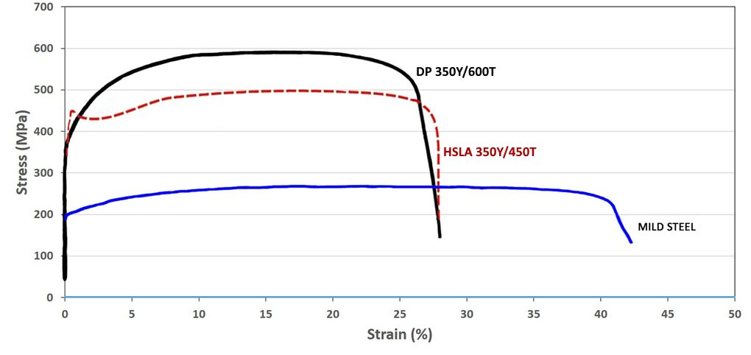
Figure 1 engineering stress strain curves for typical examples of a Dual Phase steel (black), HSLA steel (red), as well as a mild steel (blue) (World Auto Steel, 2024)
Dual Phase steels boast several advantages over more conventional grades of steels, the first being its high strength. Dual Phase steel varies in strength but typically offers an ultimate tensile strength of between 600MPa up to 1000MPa, when comparing this to a more common structural steel, such as ASTM 1010, or ASTM A36 grades, whose UTS ranges from 325-400MPa. The difference in ultimate tensile strength is clear when comparing low alloy steels. (Willian D. Callister, 2019)
This in and of itself does not differentiate it from other offerings of high-strength steels, including other high strength low alloy steels (HSLA steels). Where Dual Phase steel varies is in formability, itself a product of multiple separate qualities. Dual Phase steel’s formability is a product of its low yield point, its ability to yield continuously, and its uniform elongation.
Dual Phase steels offer a low yield point relative to their ultimate strength. Dual Phase steels typically see a yield point of between 300MPa and 350MPa. This means that the material more readily begins to deform but requires more force to break entirely. This provides the material with two beneficial qualities. The first is that it requires less force to bend into shape, requiring less intense tooling to achieve the desired outcome. The second is that its low yield point and high tensile strength combine to provide the material with a degree of toughness typically beyond the capabilities of a similarly alloyed steel. (Bhadeshia, 2017)
In addition, Dual Phase steels yield continuously, this means that the material transitions from elastic deformation to plastic deformation without rapid changes in the strain experienced. In a more conventional steel grade, the yield point is accompanied by a series of microstructural changes that begin to align the dislocations found within the microstructure to the axis of stress. This is referred to as discontinuous yielding. The result of discontinuous yielding is that pressing operations must be cautious of the yield point, otherwise they run the risk of applying an excessive level of force to the material once it has transitioned from elastic to plastic deformation. By smoothly transitioning from elastic to plastic deformation the material offers both greater moment to moment feedback to press operations as well as less dramatic material changes under applied force.
Dual Phase steels offer a high degree of uniform elongation over many of its competitors. This means that when the material is placed under force, it undergoes its deformation using material from the whole workpiece. The alterative to this is that the material undergoes ununiform deformation, or necking. Necking results in unwanted thinning of parts of the final part as well as increased residual stresses in these specific parts. This can eventually compromise the whole piece.
When considering the benefits of Dual Phase steels there are two further considerations for the material. The strain hardening co-efficient, or n-value, and the plastic strain ratio, or r-value. The strain hardening co-efficient represents the degree to which the material will harden as it is exposed to plastic deformation. This is a desirable quality to possess in steel intended for pressing applications. A high strain hardening co-efficient means that-once pressed the material is more able to hold its shape against unintended deformation. The plastic strain ratio, sometimes referred to as the Lankford coefficient, or r-value describes the ratio of the width strain to thickness strain. In more simple terms this describes how much the material will resist thinning across its thickness when being drawn. A low r-value means that the material will suffer from thinning when pressed, risking holes, weak points and tolerancing failures. A high r-value describes a material that will maintain is thickness when undergoing deep drawing operations. r-value is often a major consideration for canning operations as well as the automotive engineering, where stamping and pressing complex parts avoids the need for more complex engineering solutions.

Heat treatment.
To create the duplex structure of Dual Phase steels the steel must undergo a heat treatment cycle which allows for the development of both the carbon rich martensite Phase as well as the ferrite Phase which carbon is less soluble in. This can be achieved via two separate heat treatment methodologies: Inter-critical annealing and continuous annealing.
Inter-critical annealing:
The simplest method of heat treating for a Dual Phase structure involves heating the steel to between the upper critical temperature range of 750°C-912°C (depending on carbon content), where the steel transforms fully into the austenitic Phase, and the lower critical temperature of ~727°C where the steels transform into ferrite and possibly pearlite. At this stage the microstructure is characterized by a mixture of carbon rich austenitic grains surrounded by ferrite grains. This material is then quenched, ensuring the transformation of the austenitic regions into martensite. This method is the simplest, though it requires the time to soak the material until the structure is equalised at the desired ratio of ferrite/martensite. These time constraints make this method undesirable for mass production.
The second method involves heating the steel to above the upper critical temperature, holding the steel in the austenitic zone long enough to see some recrystallization. Once the desired amount of ferrite/austenite ratio is achieved the steel is rapidly cooled to below the lower critical temperature. This transforms the austenitic Phase that has been developed into martensite. Once the martensite has formed the steel is typically held at 300°C to 500°C to temper the martensite, restoring some degree of toughness to the material. This method is the more popular of the two for large scale production as it does not require soaking the material until equalised. It does, however, require a greater degree of control over the timing of the heat treatment. This makes it the more suitable process when processing using continuous annealing.
When considering continuous annealing heat treatment cycles, they are further differentiated by the subsequent processes they will be expected to undergo. The first variant is aimed at producing the material without galvanising the steel, this is conventionally performed on a Continuous Annealing Processing Line (CAPL). The second more popular variant is the heat treatment cycle that includes a section for hot dip galvanisation of the steel. This is the more popular choice in the automotive industry where galvanised steel offers superior corrosion resistance to bare steel
Since galvanisation must be performed at above the melting point of the zinc in the pot this forces a constraint in the heat treatment cycle. Galvanisation with strip temperatures near to, or below the freezing point of zinc run the risk of poor zinc adhesion as well as solidification in the tank. On the other hand, soaking the steel at a temperature of >420°C runs the risk of over-tempering the martensite deposits, or over-aging any precipitates.
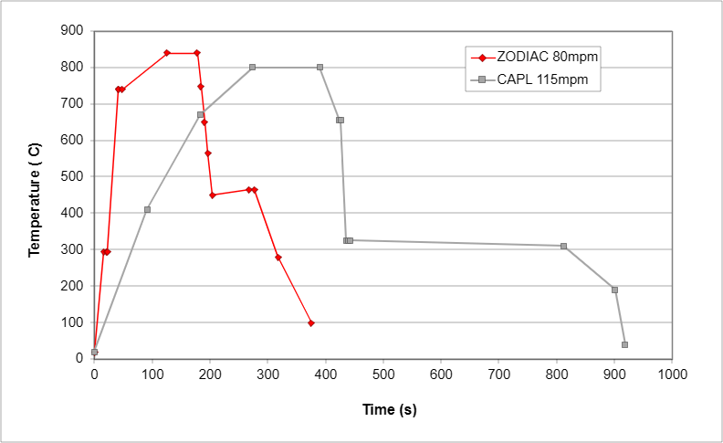
Figure 2: comparison of heat treatment cycles of CAPL DP800 vs. heat treatment cycle of galvanised DP800 on the ZODIAC line.

As seen in figure 1 the solution for the problems presented by galvanisation were mitigated by two main alterations to the process. The first was by increasing the heating and cooling rate of the material. This was done to compensate for the increased temperature during the latter stages.

The second was to ensure that the soaking period where over aging was performed at above 450°C, the temperature of the hot dip tank. After which the steel was rapidly quenched. The aim behind this change is to simultaneously heat treat the material while in the process of hot dip galvanisation. This process is much quicker than the soaking stage of the standard CAPL process as it is performed at higher temperatures, which I turn increase the rate of diffusion of carbon from the martensite.

Chemistry
Dual Phase steels are relatively complex to alloy, as carbon content must be carefully controlled to ensure optimal ratio of martensite to ferrite within the substrate. In addition, the selection of alloying additions chosen must be selected based on their ability to strengthen the material without sacrificing the materials ability to yield continuously. Typical Dual Phase steels contain relatively low alloying amounts, with 0.08-0.2C, 0.5-1.5Mn wt%
Dual Phase steels commonly include the use of microalloying additions such as titanium, vanadium, and most relevant to this paper, niobium. Each of these alloying additions is selected based on either its ability to form precipitates, or its ability to impede the growth of grains during recrystallisation.
Niobium sees use as an alloying addition in many HSLA steels, as relatively small additions can provide large increases in the material’s tensile strength. Niobium acts to strengthen steel through several different discrete mechanisms:
Niobium strengthens steels via grain refinement. Grain refinement is widely acknowledged to simultaneously enhance both the strength and toughness of steels. In conventional high-strength steels, such as those which use principally use Phases such as ferrite, pearlite, and bainite, grain refinement has a more significant influence on yield strength than on tensile strength. This in turn tends to reduce in the cold working potential of the material as diminishing its ability to elongate uniformly. However, in the case of Dual-Phase (DP) steels, the effect of grain refinement is notably different. Here, refining the microstructure improves the work hardening potential.
When discussing grain refinement the single most relevant principle is the Hall-Petch equation, which is described in Callister’s: Material science and engineering as:
$$σ_{y}=σ_{0}+k_{y}d^{-1/2}$$
Where d is the average grain diameter, σ_{y} represents the yield strength co-efficient of the material, and k_{y} represents the tensile strength coefficient. (Willian D. Callister, 2019)
In the case of DP steels the specific coefficients were determined by Ramazani et al. (Ramazan. A, 2012) to be 3.98 MPa·mm^(-1/2) for yield strength and 8.39 MPa·mm^(-1/2)for tensile strength in DP steels, consequently, the strengthening contribution due to ferrite grain size in the DP steel under consideration is estimated to be approximately 70 MPa for yield strength and 150 MPa for tensile strength.
When comparing this to conventional DP steel, which typically has a coarser grain structure and a similar volume fraction of martensite, the tensile strength increment attributed to grain refinement is expected to be substantial, potentially reaching up to 100 MPa. This significant increase underscores the role of grain refinement in enhancing the mechanical performance of Dual Phase steels, particularly in applications requiring a combination of high strength and good ductility.
In addition to this, the fine dispersion of martensite within the broader ferrite matrix significantly enhances the steel's mechanical properties. This microstructural arrangement acts to impede the development of voids and cleavage fractures, which are common failure modes in many steels. The presence of martensite, a harder Phase, within the softer ferrite matrix, provides a more uniform distribution of stress and strain during deformation. This distribution helps to prevent the initiation and propagation of cracks, thereby improving the material's toughness and resistance to fracture. As a result, the interaction between the dispersed martensite and the ferrite matrix contributes to a more robust and durable steel, capable of withstanding higher loads and more severe service conditions. (C.Mathew Enloe, 2021)
Furthermore, precipitation strengthening in the ferrite Phase in conjunction with grain refinement
results in more even strain distribution within the microstructure. This in turn improves the materials’ ability to yield continuously, reducing the risk of necking at higher strains. From this a greater degree of ductility can be expected from the strength provided.

Academic literature It is stated in the paper “Metallurgical Effects of niobium in Dual Phase Steel” (Mohrbacher, 2020) that:

“The nano-sized niobium carbides dispersed within ferrite Phase are expected to significantly
increase dislocation density in the very beginning of deformation leading to large instant
work-hardening. The dislocation loops formed around the precipitates reduce the effective
mean-free path length between particles with increasing Ashby-Orowan strengthening, i.e., work hardening as a consequence.“

or to paraphrase, niobium carbide precipitation increases the initial work hardening co-efficient of the material, though the paper goes on to add:

“With the progress of deformation, cross-slip on secondary slip planes can be activated in the vicinity of particles resulting in dynamic recovery”

Dynamic recovery is a concept described in the 1986 journal article “introduction to dislocations” (Derek Hull, 1968) describes a process by which dislocation that were previously immobile immediately snap and self-terminate with a dislocation of the opposite alignment. In effect this process undoes work hardening during work hardening.
As a result of this the material exhibits a surprisingly uniform work hardening co-efficient. This in turn provides the final part with an increase in its strength regardless of the strain the work part has experienced.

Current production route for DP800 at Tata Steel UK
To assess the value of an alternate production route, the current production route needs to be discussed. As of the time of writing this report the current production route for DP800 outlined below.

Material is first processed as any other steel grade within the steelworks, it begins as pig iron produced from a blast furnace. It is then processed via Basic Oxygen Steelmaking where it is aluminium killed. Additional processing may be necessary such as desulphurisation or degassing. Once the liquid steel is acceptable for further processing it is sent to secondary steelmaking to ensure that the liquid chemistry matches the grade below:

Element | C | Si | Mn | Cr | Ni | Ti
Aim %Wt | 0.12 | 0.2 | 1.72 | 0.5 | 0.02 | 0.03
Table 1: Major alloying elements of DP800 by % weight

Once the correct chemistry has been achieved the liquid steel is then cast into slab via continuous casting process. This is a typical production route for steels regardless of final application. Once cast the slab is then typically placed in a re-heat furnace to “soak” at 1220°C until hot rolled at 850°C and a reduction of 70%. After hot rolling the coil is cooled on the run out table until it is re-coiled at 650°C.

This is where the production route diverges from the theory, as the coil is routed to the cold mill via hot coil finishing to have 20m removed from either end by design in order to eliminate the complications caused by coil-end effect. This effect is an unintended product of current production methodologies and results in the coil ends having a very high tensile strength, making both rolling and welding difficult. This reworking of the coil before being sent for cold rolling represents a non-value-added activity for the final product.

After the product undergoes cold rolling it will typically be routed either through CAPL, if the product is wanted uncoated, or through ZODIAC, if the customer has order galvanised material.
The final temperature profile of these two production routes have been discussed earlier in this document.

Test regime

Project goals
The goal of the testing regime is to apply the principles discussed in “A route for production of elevated strength Cold rolled HSLA steel” to the production process at TATA steel. Material would undergo a simulation of the current processing route as well as the proposed processing route. Any material benefits would then be weighed against the current cost of operating the batch anneal furnace.
In this investigation the steel supplied was produced from Port Talbot site, South Wales. This material was intended to produce DP800. The steel in question has an alloy composition that can be described as within industry norms.
Element | C | Si | Mn | Cr | Ni | Ti
Aim %Wt | 0.12 | 0.2 | 1.72 | 0.5 | 0.02 | 0.03

After casting to slab on the continuous casting line the slabs spent ~5-7 hours “soaking” in the reheat furnace at a temperature of 1220°C. Once heated the material underwent hot rolling with finishing temperatures above 850°C. The final strip gauge post hot rolling was 3.6mm. at this point the material was sent for hot roll finishing.
Material was sampled from two points, at the front end of the coil and the middle. The front-end sample was collected from the hot roll finishing section offcuts. This sample served as the perfectly adequate example of material that, currently, exhibited the undesirable properties that necessitated the entire process of shape correction. In addition, a sample was cut from the centre of the same coil. This was to ensure that the material in its “ideal” state did not undergo any undesirable transformations.

Project timeline

When the project was first proposed in September 2023 the initial proposed timeline was as follows: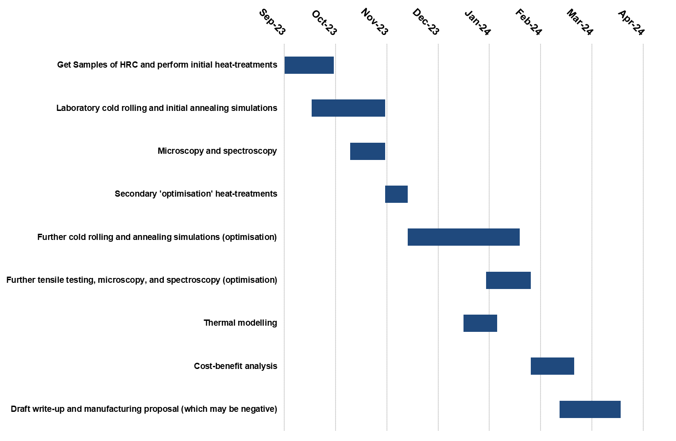
Figure 3: initially proposed testing schedule
This underwent several alterations as the project developed. The first alteration was the inclusion of a preliminary testing Phase, in which the material would be tested in the hot band condition. This preliminary test served to assess the viability of further testing, before more significant resources were required.

Initial testing run
The testing program was divided into two Phases. The first Phase was preliminary testing in which the hot band samples were annealed and then immediately tested for tensile strength. This initial test was to gauge whether the material would respond to the annealing cycle in the manner expected. Samples were divided into two groups, the control group, which was tested without any additional processing, as well as the test group which was annealed at 600°C for 2 hours then left to air cool. This process was expected to achieve two main objectives, first was to reduce the tensile strength of the material, and the second was to reduce cross width variability by allowing for the microstructure to normalise and diffusion to occur.

Results and analysis
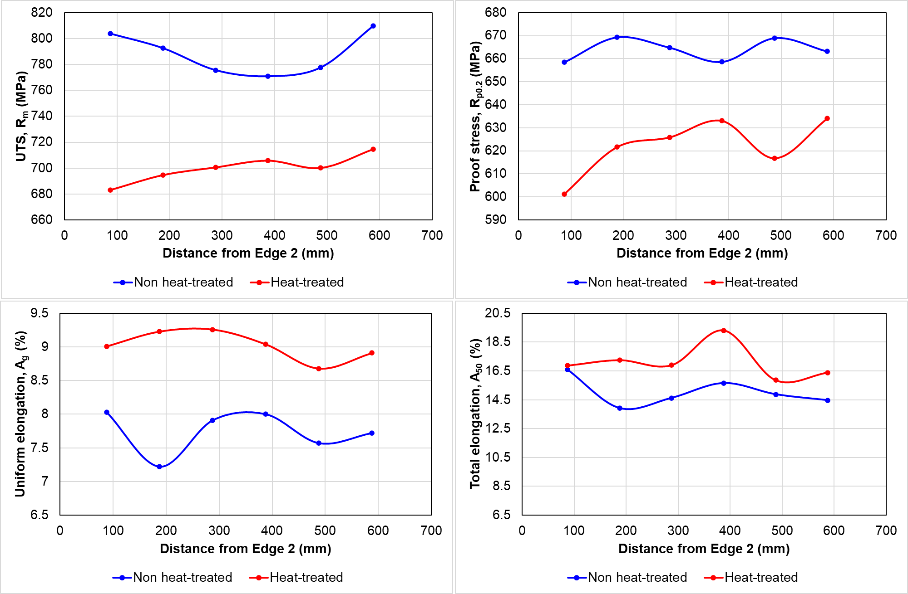
Figure 4a. (top left) Cross width comparison of Ultimate tensile strength between heat treated and non-heat treated hot band material
Figure 4b. (top right) Cross width comparison of proof stress between heat treated and non-heat treated hot band material
Figure 4c. (bottom left) Cross width comparison of uniform elongation between heat treated and non-heat treated hot band material
Figure 4d. (bottom right) Cross width comparison of total elongation between heat treated and non-heat treated hot band material
During the preliminary testing Phase, the material broadly responded as anticipated, demonstrating a reduction in ultimate tensile strength (UTS) by an average of ~100 MPa. This decrease in UTS aligns with the expected outcomes based on the current understanding of normalising thermal treatments. In addition, the yield strength was lowered and its elongation, both total and uniform, increased. Both of these changes are considered beneficial for the process of cold rolling.
Furthermore, the cross-width variation in the ultimate tensile strength was largely reduced, indicating that the process of normalisation had acted to reduce deviations observed in unannealed material.
With the material properties of the hot band material behaving as anticipated the decision was made to proceed with a full simulation of the production route.

Testing
Following the promising results of the preliminary testing scheme the decision was made to advance the project onto its main Phase. This would involve a simulation of the full production route from hot rolled coil to cold-rolled galvanized steel.
Samples would be collected from the same areas as the preliminary study. With one testing group being taken from discarded coil ends on the hot roll finishing line, and the other from the middle of the same coil.
The collected samples were once again divided into two sets: the test group and the control group. The samples were alternately allocated to each group across the width of the sample to minimize any metallurgical differences that might arise due to cross-width variation. This approach also facilitated the monitoring of variations across the width of the coil. Unlike the preliminary testing scheme these samples were cut into 360mm by 100mm plates. This change in sample size was to facilitate Continuous Annealing Simulation (CASim) operations later in the testing regime.
In order to simulate rolling conditions the material underwent gauge reduction of 60% on the cold mill pilot line located in Llanwern steelworks.
After cold rolling the simulation of the heat treatment process was performed using Continuous Annealing Simulation (CASim). This system aims to simulate the thermal profile of continuous annealing process. The system generates heat by passing a current through the sample, relying on the steels electrical resistance to generate heat. This is then monitored using a series of five thermocouples welded to the sample around the centre of one of the samples faces. The system uses the reading from the centre thermocouple to monitor the temperature. Controlled cooling is performed via a gas quench.
The simulators control unit can be used to either define new heat treatment cycles or be pre-loaded with existing thermal profiles. In this case the only relevant heat treatment profiles are limited to that of DP800 on CAPL, and DP800 on ZODIAC galvanising line.
Whilst testing the material using a CAPL heat treatment cycle was considered it was discounted for two main reasons. The first being the current climate the steelworks find itself in. There is a significant risk of Port Talbots CAPL being mothballed/demolished. This is due to the unit struggling to fill its order book at profitable levels. Market changes have seen Llanwern’s ZODIAC galvanised material largely supersede bare steel from CAPL.
The second, and more metallurgically focused reason was the concern over the CAPL’s heat treatment cycle itself. The heat treatment cycle of CAPL begins with a more extended heating zone. In “Metallurgical Effects of Niobium in Dual Phase Steel” it is suggested that the rapid heating rate of the galvanisation style process runs the risk of allowing the newly recrystalising austenitic grains too much time to develop, undermining efforts to refine the grain structure.
Once the samples had undergone all steps involved in simulating the thermomechanical treatment of DP800 steel they were analysed using two main methods: Tensile Testing and Optical microscopy.
Samples for tensile testing were cut into two “blanks”, one parallel to the rolling direction, and the other transverse to the rolling direction. Each “blank” was then milled using a CNC mill into a dog bone style specimen compliant with ISO 1: ASTM. This means that the gauge length is 50mm, and the sample neck is 12.5mm wide.
These samples underwent tensile testing using a Zwick Roell Z250 tensile testing machine.
Samples for optical microscopy were prepared by sectioning the material into two pieces: one parallel to the rolling direction and the other transverse to the rolling direction. These sections were then mounted using a hot mounting press, ensuring they were securely embedded in a resin to facilitate handling and subsequent processing. The mounted samples were mechanically polished to achieve a 1-micron finish. Following polishing, the samples were etched using a 2% Nital solution to reveal the microstructure.

Results
Mean:
Test? | Pos | Rp0.2 | Rm | Ag | A{lo 50mm} | n(4-6) | n(5-10) | n(10-Ag) | R5% | R10% | Man A | Rp/Rm
Cont. | Mid | 335.77 | 834.10 | 13.19 | 18.27 | 0.212 | 0.178 | 0.138 | 0.68 | 0.69 | 20.5% | 0.403
Test | Mid | 341.61 | 832.10 | 13.25 | 18.60 | 0.220 | 0.184 | 0.141 | 0.69 | 0.71 | 21.3% | 0.411
Cont. | Edge | 340.51 | 841.90 | 12.74 | 15.43 | 0.204 | 0.170 | 0.132 | 0.65 | 0.67 | 20.5% | 0.404
Test | Edge | 347.58 | 827.72 | 13.21 | 18.09 | 0.225 | 0.188 | 0.144 | 0.68 | 0.66 | 20.5% | 0.420

Table 2: Mean material characteristics of both the test group and the control group
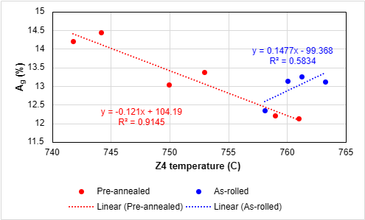
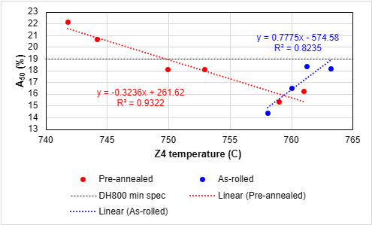
Figure 6: Comparison of uniform elongation versus temperature between pre-annealed (test) group and As-rolled (control) group.
Figure 5: Comparison of total elongation versus temperature between pre-annealed (test) group and As-rolled (control) group. This diagram also includes the minimum specification for high formability Dual Phase steels.

Results from this initial testing process concur with the assertions seen in “Metallurgical Effects of Niobium in Dual Phase Steel”. Both the test group and the control group exhibited a tensile strength of above 800MPa as seen on table 2. Both groups also retained a similarly low yielding point of ~340MPa. This means that the process of pre-annealing has had little impact on the final strength of the material.
Where the two groups deviate is in the properties most related to formability. As seen in graph 2 the total elongation of the material improves from a maximum of 18% up to a maximum of 22% elongation. This change allows the pre-annealed sample to comfortably achieve the grade of DH800 whereas the control group was never able to achieve the grade.

Discussion and conclusions

Industrial considerations
Broader shifts in the business structure of TATA Steel UK currently make concrete assessment of the method’s long term viability difficult. This is largely due to the intended closure of the Port Talbot site’s blast furnaces by the end of 2024. Alongside the blast furnaces there are likely to be a number of other facilities that will be either mothballed, dismantled, or replaced with newer facilities to complement the new arc furnaces that are planned to be in operation by 2028. As of the time of this report, May 2024, very little is certain.
The methods discussed in this paper may still represent a viable production route. This would require the steelworks to maintain the capability to batch anneal imported material. This, however, would require its own feasibility study in time as the composition and thermal processing of imported slab and hot roll coil becomes known.
In order to discuss the viability of the process, and to avoid falling into speculation and rumour, the discussions surrounding this process will be based on the company’s operations as of the start of 2024. From this frame of reference

Opportunities for further development
Due to the limitations of both time and materials available during the testing process there were a number of avenues that were not explored. The first expansion to the testing regime would be to increase the number of samples within the current scope of testing. New product simulations based on arc furnace technology taken priority over all other forms of research within the product development department. To further this study a more statistically significant number of datapoints would allow for greater confidence in the results
Another improvement would be to include the use of quantitative measurements of grain size and Phase distribution. Current assessment methodologies available to the lab are either qualitative or based around measuring via a optical microscopes graticule. These adjustments would allow a more quantitative characterisation of the steels’ microstructure.

The current study presents an opportunity to refine the process at several points during this new production route. The first refinement would surround the intermediate batch annealing cycle. The annealing parameters shown in this document were largely drawn from pre-existing literature. Subsequent testing of this production method should consider including a study of intermediate annealing time and temperature.

A further opportunity to refine the method comes from the reduced strength of the intermediate product. In the preliminary tests the annealed hot band exhibited lower strengths than the unannealed material. It is possible that this would allow for a greater gauge reduction during the cold rolling process.
However, testing this would require the consideration of the increased resiDual stresses this would impart on the final cold rolled product. These stresses would in turn require that the final annealing cycle be adjusted to accommodate the increased internal energy in the material.

Academic literature surrounding the distribution of niobium precipitates within a microstructure often relies on the use of transmission electron microscopy, as precipitates typically range in size from 6-13 nanometres, beyond the current capabilities of the facilities available to this study. Whilst the quality of niobium precipitation can be inferred from the mechanical results achieved, a direct means of assessing them would have allowed this study to corroborate its findings more closely with those of “Metallurgical effects of Niobium in Dual Phase steel”.

Conclusions
The material in its hot rolled state exhibits greater homogeneity in both its width as well as its length. In addition, the intermediate annealing cycle results in on average UTS of 100 MPa less than before. This works to mitigate the issues described in the current process regarding greater difficulty in rolling the material.
One cold rolled and annealed the material exhibits a greater degree of formability, with improvements seen in its r-value and n-value. The material, when processed comfortably achieves the grade of DH800

References
Bhadeshia, H. (2017). Steels: Microstructure and Properties Fourth edition. Butterworth-Heinemann.
C.Mathew Enloe, F. D. (2021). A Route for production of elevated Strength Cold Rolled HSLA Steel.
Derek Hull, D. J. (1968). Introduction to dislocations. American Journal of physics , 174-174.
Mohrbacher, H. (2020). Metallurgical Effect of Niobium in Dual Phase Steel. Metal: advanced multiphase steels, 10-27.
Willian D. Callister, D. G. (2019). Callister's Material Science and Engineering:Global edition. Singapore: Wiley.
World Auto Steel. (2024, May 20). AHSS Application guidelines: Dual Phase. Retrieved from AHSS Application guidelines: https://ahssinsights.org/metallurgy/steel-grades/ahss/dual-phase/#:~:text=The%20DP%20steel%20exhibits%20higher,HSLA%20with%20comparable%20yield%20strength.

Addendum 1. Raw data from preliminary testing
Specimen ID | Condition | Gauge | Width | E | Rp0.2 | ReH | ReL | Ae | Rm | Ag | A{lo 50mm} | n(4-6) | n(5-10) | R5% | A(corr) | At | Agt | Rb | Rp/Rm
1 | Annealed | 3.504 | 12.604 | 171.8 | 649.16 | 653.07 | 644.94 | 2.93 | 719.41 | 9.82 | 20.39 | 0.1329 | 0.1123 | 0.6744 | 20.39 | 20.66 | 10.22 | 503.2 | 0.902350537
3 | Annealed | 3.542 | 12.606 | 210.1 | 653.59 | 667.2 | 646.17 | 2.33 | 728.32 | 8.81 | 13.3 | 0.1272 | 0.1074 | 0.7683 | 16.01 | 13.53 | 9.14 | 523.9 | 0.897394003
5 | Annealed | 3.556 | 12.624 | 220.6 | 645.57 | 650.68 | 644.17 | 2.38 | 724.93 | 9.35 | 17.75 | 0.125 | 0.1065 | 0.7338 | 17.75 | 17.97 | 9.66 | 523.7 | 0.890527361
7 | Annealed | 3.583 | 12.615 | 229.8 | 644.41 | 651.34 | 640.88 | 2.5 | 724.7 | 9.51 | 17.37 | 0.1293 | 0.1094 | 0.7195 | 17.37 | 17.59 | 9.82 | 541.6 | 0.889209328
9 | Annealed | 3.582 | 12.618 | 212.6 | 652.53 | 669.58 | 648.44 | 2.45 | 731.85 | 9.36 | 17.78 | 0.1279 | 0.1082 | 0.7894 | 17.78 | 18.01 | 9.68 | 527.3 | 0.891617135
11 | Annealed | 3.583 | 12.612 | 219.1 | 650.76 | 660.15 | 649.09 | 2.33 | 733.89 | 9.01 | 17.09 | 0.124 | 0.1061 | 0.8744 | 17.09 | 17.32 | 9.34 | 544.1 | 0.886726894
13 | Annealed | 3.592 | 12.601 | 212.2 | 648.88 | 657.42 | 646.86 | 2.34 | 733.21 | 9.28 | 17.04 | 0.1251 | 0.1066 | 0.7885 | 17.04 | 17.28 | 9.61 | 546.7 | 0.884985202
15 | Annealed | 3.595 | 12.608 | 218.9 | 652.3 | 668.56 | 648.72 | 2.31 | 734.55 | 9.47 | 18.46 | 0.1285 | 0.1083 | 0.7391 | 18.46 | 18.7 | 9.8 | 539.7 | 0.888026683
17 | Annealed | 3.596 | 12.607 | 218.2 | 646.25 | 669.5 | 643.6 | 2.3 | 730.66 | 9.32 | 18.32 | 0.1314 | 0.1117 | 0.7243 | 18.32 | 18.55 | 9.64 | 540.2 | 0.884474311
19 | Annealed | 3.596 | 12.615 | 216.6 | 645.17 | 661.61 | 642.24 | 2.35 | 729.4 | 9.31 | 18.3 | 0.132 | 0.1121 | 0.7963 | 18.3 | 18.52 | 9.63 | 525.4 | 0.884521525
21 | Annealed | 3.597 | 12.629 | 221 | 648.07 | 658.36 | 645.8 | 2.44 | 732.95 | 9.26 | 17.43 | 0.128 | 0.109 | 0.854 | 17.43 | 17.65 | 9.58 | 526.1 | 0.884194011
23 | Annealed | 3.595 | 12.626 | 219.1 | 649.72 | 659.17 | 638.1 | 2.13 | 732.25 | 9.46 | 17.45 | 0.1299 | 0.1101 | 0.8155 | 17.45 | 17.68 | 9.78 | 525 | 0.887292591
25 | Annealed | 3.593 | 12.623 | 215.5 | 646.82 | 665.54 | 642.99 | 2.46 | 735.48 | 9.75 | 17.2 | 0.1479 | 0.122 | 0.3942 | 17.2 | 17.43 | 10.07 | 534.2 | 0.879452874
27 | Annealed | 3.598 | 12.624 | 218.5 | 650.88 | 658.5 | 645.26 | 0 | 738.84 | 9.43 | 17.18 | 0.1307 | 0.1109 |  | 17.18 | 17.42 | 9.75 | 546.8 | 0.880948514
29 | Annealed | 3.619 | 12.642 | 206.8 | 649.02 | 652.17 | 642.9 | 2.28 | 737.42 | 10.04 | 20.17 | 0.131 | 0.1113 |  | 20.17 | 20.41 | 10.38 | 532.1 | 0.88012259
31 | Annealed | 3.602 | 12.657 | 216.2 | 617.8 | 633.31 | 601.19 | 2.07 | 708.93 | 10.32 | 19.73 | 0.1437 | 0.1216 |  | 19.73 | 19.94 | 10.64 | 509.8 | 0.871454163
33 | Annealed | 3.586 | 12.634 | 205.4 | 623.23 | 639.06 | 621.68 | 2.41 | 714.48 | 9.97 | 18.36 | 0.1402 | 0.1178 |  | 18.36 | 18.6 | 10.29 | 518.6 | 0.872284739
35 | Annealed | 3.572 | 12.635 | 210 | 611.64 | 620.43 | 600.46 | 2.62 | 704.44 | 10.85 | 20.45 | 0.1543 | 0.1317 |  | 20.45 | 20.67 | 11.16 | 506 | 0.868264153
37 | Annealed | 3.561 | 12.634 | 197.9 | 632.21 | 636.69 | 614.91 | 2.36 | 713.44 | 10.55 | 23.21 | 0.1419 | 0.1218 |  | 23.21 | 23.44 | 10.88 | 514.7 | 0.886143194
2 | As rolled | 3.544 | 12.599 | 215.6 | 707.59 | 708.48 | 707.27 | 1.12 | 795.04 | 8.13 | 10.91 | 0.1038 | 0.094 | 0.698 | 14.02 | 11.22 | 8.48 | 713.4 | 0.890005534
4 | As rolled | 3.555 | 12.609 | 210.3 | 652.41 |  |  |  | 763.27 | 8.36 | 17.62 | 0.1052 | 0.0935 | 0.7137 | 17.62 | 17.86 | 8.71 | 549.3 | 0.854756508
6 | As rolled | 3.58 | 12.595 | 220.7 | 652.96 |  |  |  | 764.77 | 8.68 | 17.12 | 0.1109 | 0.0972 | 0.6004 | 17.12 | 17.36 | 9.02 | 540.2 | 0.853799181
8 | As rolled | 3.584 | 12.636 | 219.5 | 637.45 |  |  |  | 757.92 | 8.83 | 18.27 | 0.1106 | 0.097 | 0.7273 | 18.27 | 18.5 | 9.17 | 526.3 | 0.841051826
10 | As rolled | 3.59 | 12.621 | 193.7 | 641.48 |  |  |  | 757.89 | 8.53 | 17.66 | 0.1098 | 0.0974 | 0.719 | 17.66 | 17.93 | 8.89 | 559.8 | 0.846402512
12 | As rolled | 3.594 | 12.6 | 185.5 | 639.38 |  |  |  | 760.11 | 8.71 | 17.44 | 0.1088 | 0.0956 | 0.7501 | 17.44 | 17.71 | 9.09 | 551.5 | 0.841167726
14 | As rolled | 3.596 | 12.607 | 190.6 | 636.47 |  |  |  | 756.76 | 8.69 | 17.79 | 0.1111 | 0.0984 | 0.7311 | 17.79 | 18.06 | 9.06 | 564.7 | 0.841046038
16 | As rolled | 3.596 | 12.608 | 188.2 | 634.33 |  |  |  | 755.23 | 8.64 | 16.77 | 0.1105 | 0.0975 | 0.7759 | 16.77 | 17.04 | 9.01 | 545.5 | 0.839916317
18 | As rolled | 3.603 | 12.59 | 191.2 | 636.04 |  |  |  | 751.86 | 8.87 | 17.88 | 0.1133 | 0.1002 | 0.7774 | 17.88 | 18.13 | 9.24 | 543.1 | 0.845955364
20 | As rolled | 3.603 | 12.616 | 185.7 | 631.42 |  |  |  | 748.35 | 8.69 | 17.64 | 0.113 | 0.1005 | 0.7364 | 17.64 | 17.9 | 9.06 | 539.7 | 0.843749582
22 | As rolled | 3.395 | 12.62 | 203.9 | 665.5 |  |  |  | 791.7 | 8.77 | 16.79 | 0.1129 | 0.0995 | 0.661 | 16.79 | 17.04 | 9.13 | 573.5 | 0.840596185
24 | As rolled | 3.597 | 12.596 | 191.2 | 627.67 |  |  |  | 744.44 | 9.33 | 19.03 | 0.1172 | 0.103 |  | 19.03 | 19.29 | 9.69 | 533.9 | 0.84314384
26 | As rolled | 3.592 | 12.62 | 182.5 | 628.56 |  |  |  | 748.62 | 8.81 | 16.65 | 0.114 | 0.1009 |  | 16.65 | 16.92 | 9.19 | 542.7 | 0.83962491
28 | As rolled | 3.595 | 12.621 | 187.3 | 614.71 |  |  |  | 748.88 | 9.21 | 17.68 | 0.116 | 0.1023 |  | 17.68 | 17.93 | 9.57 | 534 | 0.82083912
30 | As rolled | 3.613 | 12.654 | 209 | 611.19 |  |  |  | 739.07 | 9.61 | 18.6 | 0.1224 | 0.1071 |  | 18.6 | 18.82 | 9.93 | 527.7 | 0.826971735
32 | As rolled | 3.607 | 12.621 | 190.7 | 631.25 | 631.64 | 627.97 | 0.86 | 741.49 | 9.65 | 19.56 | 0.124 | 0.1093 |  | 19.56 | 19.81 | 10.01 | 528.8 | 0.851326383
34 | As rolled | 3.587 | 12.607 | 197.5 | 632.77 | 636.47 | 631.61 | 1.25 | 747.75 | 9.9 | 18.84 | 0.1308 | 0.1141 |  | 18.84 | 19.08 | 10.25 | 537.6 | 0.846232029
36 | As rolled | 3.605 | 12.615 | 179 | 639.36 |  |  |  | 759.91 | 10.53 | 19.49 | 0.134 | 0.1182 |  | 19.49 | 19.78 | 10.91 | 580.9 | 0.841362793
38 | As rolled | 3.531 | 12.614 | 148.2 | 657.65 | 663.89 | 661.45 | 1.31 | 763.31 | 9.41 | 17.13 | 0.122 | 0.1072 |  | 17.13 | 17.46 | 9.9 | 532.3 | 0.861576555

Addendum 2. Raw data from main testing
Specimen ID | Pre-annealed | Position | Est. DFF | Est. Soak | Est. GJC | Gauge | Width | E | Rp0.2 | Rm | Ag | A{lo 50mm}
21S16/37-4 T | N | Mid | 763.23 | 835.73 | 444.44 | 1.650 | 12.564 | 197.5 | 328.65 | 832.43 | 13.12 | 18.17
21S16/37-4 B | N | Mid | 761.24 | 833.74 | 458.34 | 1.649 | 12.562 | 191.6 | 342.89 | 835.76 | 13.25 | 18.37
21S16/37-5 T | Y | Mid | 758.98 | 840.24 | 449.43 | 1.612 | 12.565 | 217.1 | 338.65 | 833.12 | 12.21 | 15.33
21S16/37-5 B | Y | Mid | 760.98 | 841.24 | 460.02 | 1.615 | 12.563 | 190.8 | 342.86 | 827.27 | 12.12 | 16.23
21S16/37-1 T | N | Edge | 760.04 | 840.34 | 420 | 1.653 | 12.56 | 198.8 | 333.55 | 836.99 | 13.14 | 16.48
21S16/37-1 B | N | Edge | 758.06 | 834.9 | 448.73 | 1.649 | 12.567 | 182.2 | 347.46 | 846.81 | 12.34 | 14.37
21S16/37-11 T | Y | Edge | 749.96 | 833.27 | 449.43 | 1.592 | 12.562 | 203.3 | 336.89 | 827.12 | 13.04 | 18.08
21S16/37-11 B | Y | Edge | 752.93 | 834.26 | 442.49 | 1.586 | 12.559 | 178.1 | 358.26 | 828.31 | 13.38 | 18.10
21S16/37-7 T | Y | Mid | 741.79 | 834.82 | 409.81 | 1.590 | 12.569 | 194.6 | 339.43 | 831.88 | 14.21 | 22.13
21S16/37-7 B | Y | Mid | 744.16 | 839.67 | 462.54 | 1.591 | 12.553 | 202.9 | 345.50 | 836.13 | 14.45 | 20.70

Specimen ID |  | n(4-6) | n(5-10) | R5% | R10% | A(corr) | At | Agt | Rb | n(5-15) | n(4-Ag) | n(8-Ag) | n(10-Ag) | Man A | Rp/Rm | Rp @ 0.57Rm
21S16/37-4 T |  | 0.2114 | 0.1779 | 0.704 | 0.7081 | 18.17 | 18.52 | 13.53 | 717.2 | 0.165 | 0.174 | 0.147 | 0.138 | 20.0% | 0.394807972 | 474.49
21S16/37-4 B |  | 0.2121 | 0.1781 | 0.6543 | 0.6775 | 18.37 | 18.75 | 13.67 | 763.4 | 0.165 | 0.173 | 0.146 | 0.138 | 21.0% | 0.410273284 | 476.38
21S16/37-5 T |  | 0.2146 | 0.1804 | 0.6975 | 0.7257 | 17.17 | 15.66 | 12.58 | 733.9 | 0.17 | 0.179 | 0.148 | 0.135 | 19.0% | 0.40648406 | 474.88
21S16/37-5 B |  | 0.2182 | 0.1829 | 0.7289 | 0.7382 | 17.18 | 16.59 | 12.54 | 728.1 | 0.172 | 0.182 | 0.15 | 0.137 | 20.0% | 0.41444752 | 471.54
21S16/37-1 T |  | 0.2067 | 0.1732 | 0.708 | 0.7058 | 20.32 | 16.83 | 13.55 | 732.9 | 0.16 | 0.169 | 0.142 | 0.134 | 21.0% | 0.398511332 | 477.08
21S16/37-1 B |  | 0.2004 | 0.1675 | 0.591 | 0.6269 | 16.26 | 14.81 | 12.78 | 829.7 | 0.157 | 0.166 | 0.139 | 0.13 | 20.0% | 0.410316364 | 482.68
21S16/37-11 T |  | 0.2241 | 0.1877 | 0.799 | 0.7436 | 18.08 | 18.42 | 13.43 | 718.6 | 0.174 | 0.183 | 0.154 | 0.143 | 20.0% | 0.407304865 | 471.46
21S16/37-11 B |  | 0.2268 | 0.1888 | 0.5615 | 0.5836 | 18.1 | 18.49 | 13.82 | 730.9 | 0.174 | 0.183 | 0.154 | 0.144 | 21.0% | 0.432519226 | 472.14
21S16/37-7 T |  | 0.2218 | 0.1864 | 0.6738 | 0.6871 | 22.13 | 22.48 | 14.62 | 706.1 | 0.17 | 0.179 | 0.152 | 0.144 | 24.0% | 0.4080276 | 474.17
21S16/37-7 B |  | 0.2242 | 0.1882 | 0.6782 | 0.6902 | 20.7 | 21.05 | 14.84 | 740.6 | 0.171 | 0.18 | 0.153 | 0.146 | 22.0% | 0.413213256 | 476.59

