Lauren Emily Price Student Number: 1807244

Generating Business data and analysis
ASSIGNMENT 2

CONTENTS

EXECUTIVE SUMMARY 2
INTRODUCTION 2
WHAT IS A SPREADSHEET 2
MICROSOFT EXCEL 2
STRUCTURE OF A SPREADSHEET 3
LOGIC MODEL 3
DATA MODEL 4
PRESENTATION MODEL 4
CATEGORIES OF DATA 5
DATA ANALYTICS 6
DATA VISUALISATION 6
STAGES OF MODELLING 7
BASIC AND ADVANCED FUNCTIONS OF EXCEL 8
ADVANTAGES AND DISADVANTAGES OF USING A SPREADSHEET 10
ADVANTAGES 10
DISADVANTAGES 10
CONCLUSION 11
REFERENCES 11

EXECUTIVE SUMMARY
This report will attempt to document my understanding of the essential concepts and principles of modelling and analysing data. The evaluation will include synthesis and theoretical material and its practical application using the four Excel files which include the Prosumer Survey, the Appliance Carbon Data List, the Weather List File and the Electrical Data File.

INTRODUCTION
This report will demonstrate my understanding of Microsoft Excel and how I am able to use basic and advanced functions to filter, sort and analyse the data from the four Excel files. I will attempt to show evidence of my role and reflect on theory and practical application including my understanding of the essential concepts and principles of modelling and analysing data. I will evaluate the strengths of using a spreadsheet for pre-processing the data, analysing the data and visualising the data.

WHAT IS A SPREADSHEET
A spreadsheet is a software application that is made up of rows and columns that enable a user to manage and sort data by using mathematical formulas to calculate and analyse the data contained within cells (Computer Hope; 2019).
A spreadsheet can also be referred to as a worksheet. (Techopedia Inc; 2019).
It is designed to enable unique operations to be carried out for a number of reasons including the sorting and analysis of data, data visualisation in the form of graphs and charts, the ability to create multiple worksheet and interlink data and the ability to use mathematical formulations and calculations for expediency purposes. (Ibid).

MICROSOFT EXCEL
Microsoft Excel is the world’s most widely-used spreadsheet programme. Excel is extremely popular due to its versatility in performing many unique functions and applications. (Walkenbach; 2008).
The four spreadsheets in question have been created using Microsoft Excel.
There are many benefits to using Excel to create spreadsheets. It is a useful tool to perform just about any numerical analysis possible, it can be used to create charts and graphs, it is possible to import data from a wide range of sources and it can be used to organise and arrange data in the form of lists. It is an extremely time efficient application which can also perform tasks using its macro capabilities. (Walkenbach; 2008).

STRUCTURE OF A SPREADSHEET
There are three main components to consider when designing and creating a spreadsheet, these are:
- The Logic Model
- The Data Model
- The Presentation Model

LOGIC MODEL
The basis of construction of the Logic Model comprises three main stages:
Conceptualisation; this is where you would redefine issues, consider modelling techniques and objectives and consider assumptions based on underlying techniques.
Verbalisation; this is where you would define modelling factors and write statements based on the relationship between the factors.
Formulisation; this is where you would submit symbols assigned to the model factors, add statements of any units used and statements of any conventions used.
Below is an example of a Logic Model.
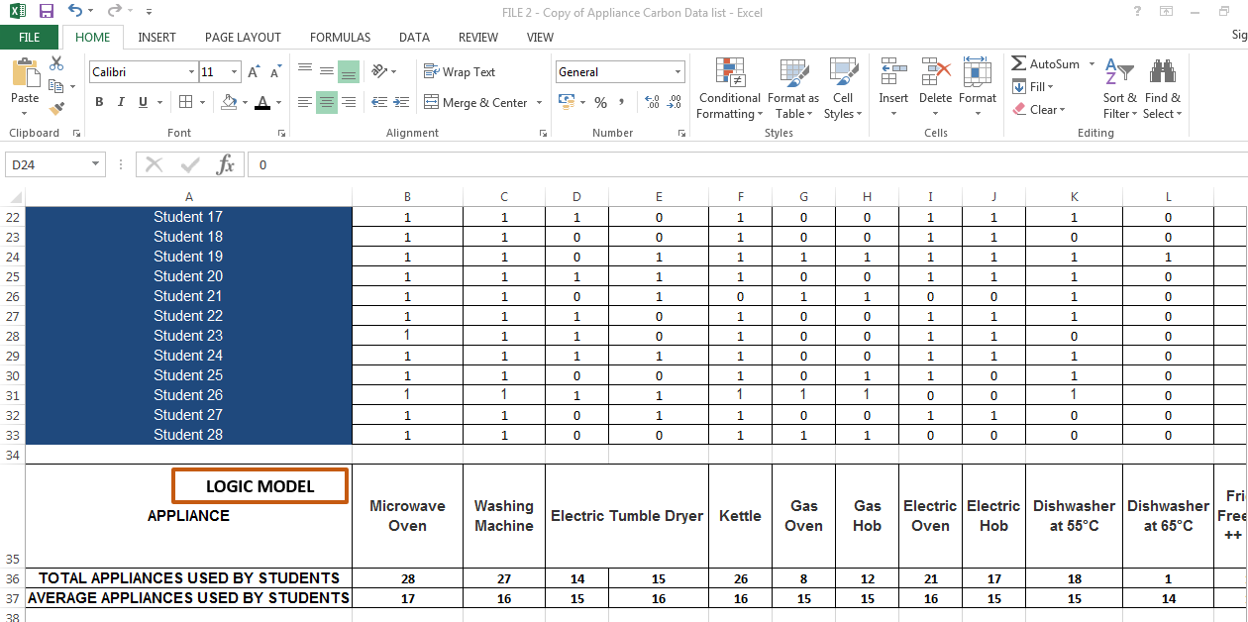

DATA MODEL
The Data Model allows you to create tables of data inside the Excel Workbook. The Data Model provides complete transparency of the data in the form of tables in a field list. (Microsoft; 2019).
This particular model is extremely important. It allows the user to gain a better understanding of the data and enables the data to be manipulated and analysed by using calculations and formulas.
Below is an example of a Data Model.
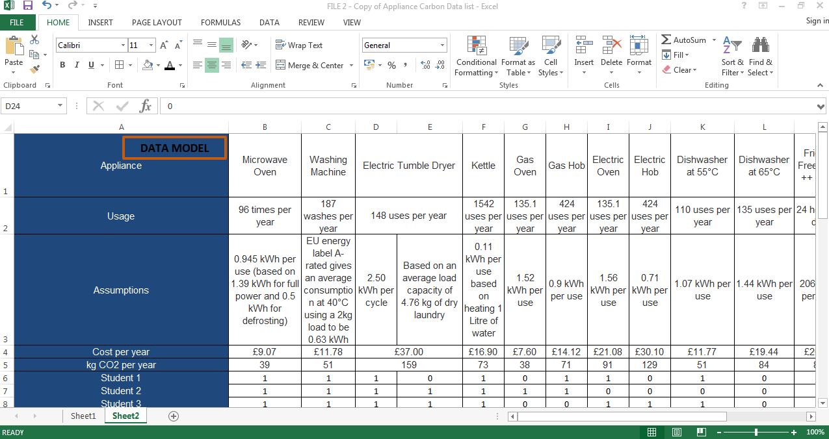

PRESENTATION MODEL
It can be difficult to interpret and analyse data in Excel. The Chart Tool is an extremely useful application. The Presentation Model is where you can use the Chart Tool in Excel to communicate your data in the form of a graph or chart. Using visual aids to communicate your information is much more appealing. It enables the data to be analysed clearly and more efficiently. (GCF Global Inc; 2019).
Below is an example of a Presentation Model.
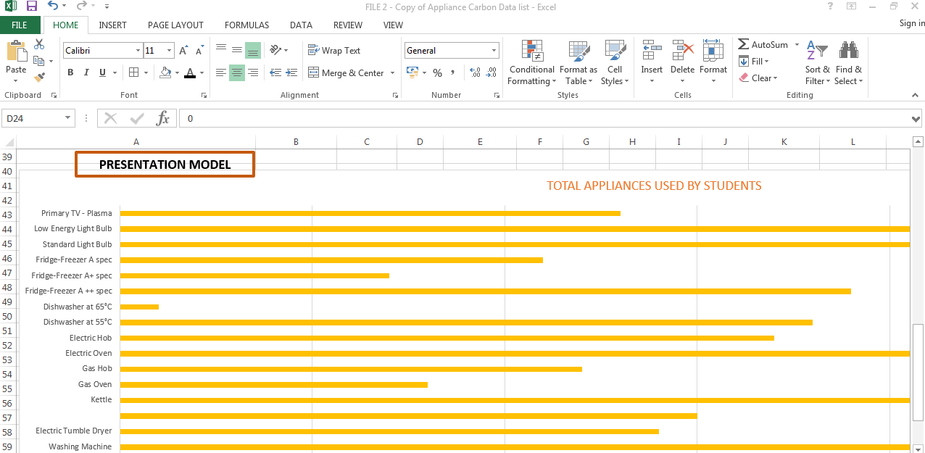

CATEGORIES OF DATA
There are four categories of data, these are known as:
- Categorical – Categorical Data is data that is sorted into categories according to specific characteristics.
- Ordinal – Ordinal Data can be ordered or ranked according to some relationships to another for example, order numbers.
- Ratio – Ratio Data is continuous and has a natural zero for example order quantity or order cost.
- Interval Data – Interval Data is similar to Ordinal Data, but the data has constant differences between observations for example, order date or arrival date.
(Evans, J; 2014)
Below is an example of Categorical Data, taken from the Prosumer Spreadsheet. It is possible to see that data is sorted into categories according to specific characteristics.

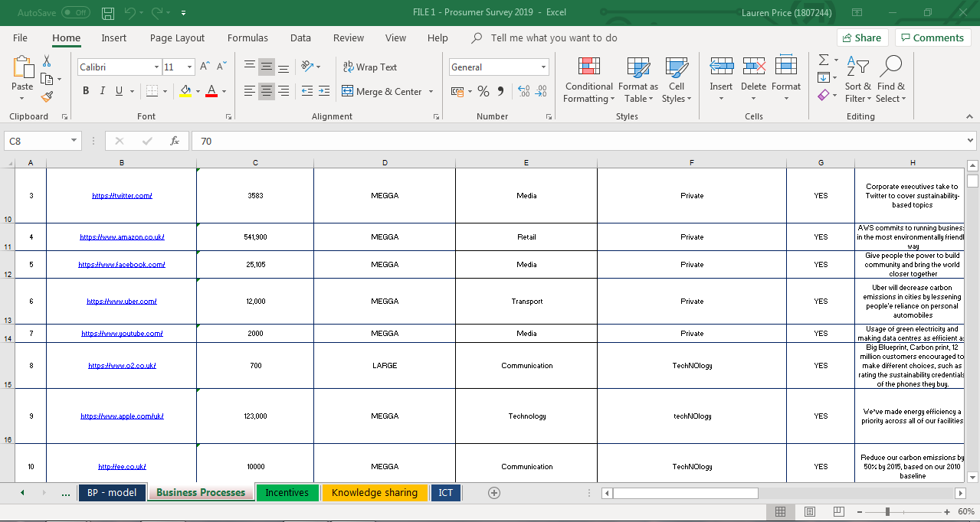

DATA ANALYTICS
Data Analytics is how data is examined and analysed in order to gain information and draw conclusions from the information contained within it by using specific applications and software. This particular method is commonly used in business. (Tech Target; 2019).
Data Analytics is extremely important and useful in business. It enables improved, more informed decisions to be made.
Data Analytics can greatly improve a business in terms of revenues and operational performance and efficiency. Analysing and examining current or historical data in this way means that the user can gain an improved insight into business operations and can potentially boost a business’s current and future potential. (Ibid).
In business, data is collected in many forms; for example, customer service and satisfaction questionnaires, financial data including stock prices or supplier charges.
Using Data Analytics, users can learn a great deal from data and see where the business requires areas of improvement. This can potentially redesign the strategy and objectives of the business and aid with decision making for the future. (Marr, B; 2015).

DATA VISUALISATION
Data Visualisation is the way in which data is displayed in a pictorial or graphical format so that it can be analysed in a more efficient manner, making it easier to interpret. Data Visualisation is often more user friendly and engages the audience due to its ability to present the data interactively, providing a clearer understanding of the data and eventually enabling improved decision making. (SAS; 2019).
Data provided in the form of a tables consisting of a large amount of numerically filled rows and columns could be much more difficult to understand compared to that of a visual aid such as a chart or graph. Using Data Visualisation, data can be manipulated and can be interactively changed to grasp a better understanding of the data.
Data Visualisation is important, especially in business. It is much easier for the human brain to process large amounts of complex information with the use of visual aids such as graphs and charts rather than pages of numbers in a spreadsheet. Data Visualisation is used for expediency, it is a quick way to convey complex data in a manner which is easy to interpret. (Ibid).
Below is an example of a Pivot Table, created from data contained within the Weather Data File. This particular table shows high and low temperatures for the month of January 2018. This is an example of how data visualisation can provide a much clearer understanding of the data, making it easier to interpret.
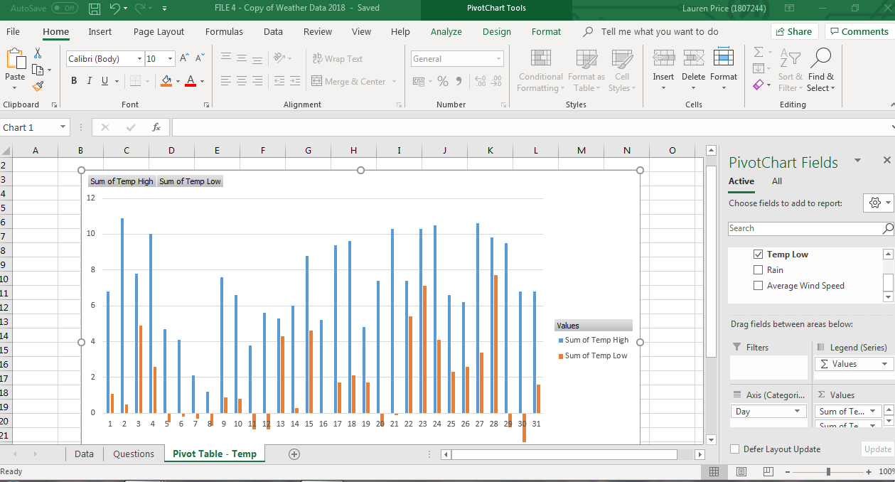

STAGES OF MODELLING
There are six distinctive stages of modelling to consider when looking at solving a problem with the analytics of a spreadsheet. These are described in further detail below: -
- Recognizing a Problem
It is important to first recognise a problem within the spreadsheet in order that the problem can be rectified.

- Defining the Problem
The next stage is to define the problem. The complexity of the problem can increase due to a number of factors, for example; there being more than one course of action, time limitations, the owner of the problem differing from the problem solver and the problem belong to more than one person.
- Structuring the Problem
It is important to structure the problem by way of stating the goals and objectives, analysing possible decisions and identifying and restrictions or constraints.
- Analyzing the Problem
Analytics play a major role during this stage. There is a certain degree of experimentation when it comes to the analysis of the solution process. It can be helpful to evaluate and analyse different scenarios and the risks associated with decision making and possible outcomes and alternatives, finding a solution that meets certain goals or objectives and determining the best possible solution for the problem.
- Interpreting Results and Making a Decision
Users must understand the possible limitations of spreadsheet models and note that models cannot show every detail of the problem. It is important that users note their underlying assumptions and incorporate their own judgement into decision making.
- Implementing the Solution
In business it is important that the results of the model are translated into something others will understand in a clear and concise manner. This stage may necessitate the need for providing adequate resources, motivating employees, modifying organisational policies, eliminating resistance to change and developing trust.
(Evans, J; 2014).

BASIC AND ADVANCED FUNCTIONS OF EXCEL
Microsoft Excel has many basic and advanced functions. It is an extremely useful application for interpreting and analysing data.
I have been required to analyse data contained with four spreadsheet files. A number of my workings have been described in further detail below.
By using the Sort function on the tool bar, it is possible to sort data in order of largest to smallest which makes analysing it a lot quicker.
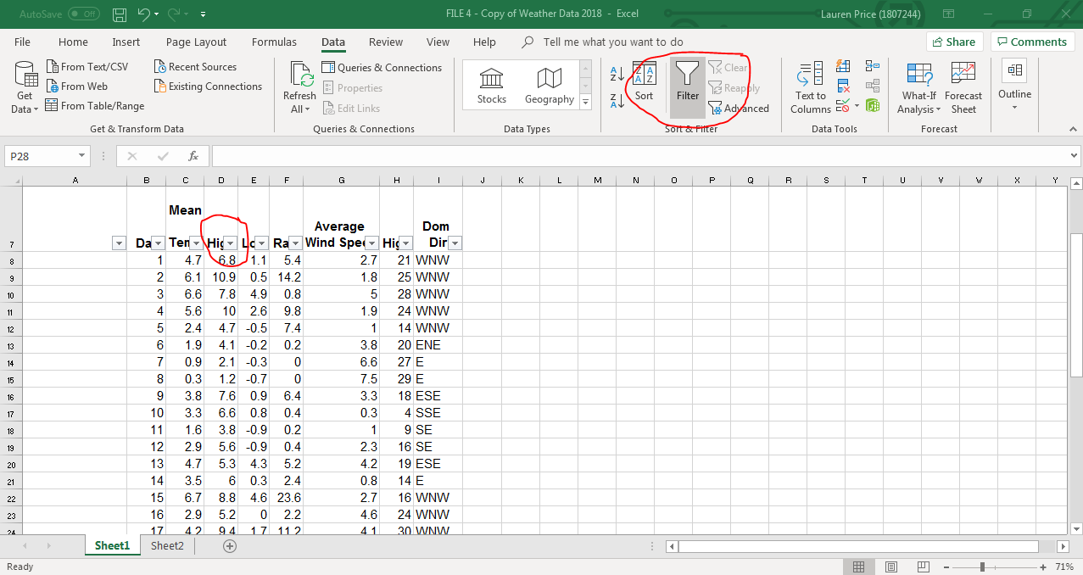
By using the Filter function, it is possible to not only sort data but filter it so that specific criteria can be analysed. In the example below, I wanted to ascertain the number of days of rain in January with more than 1.0mm.
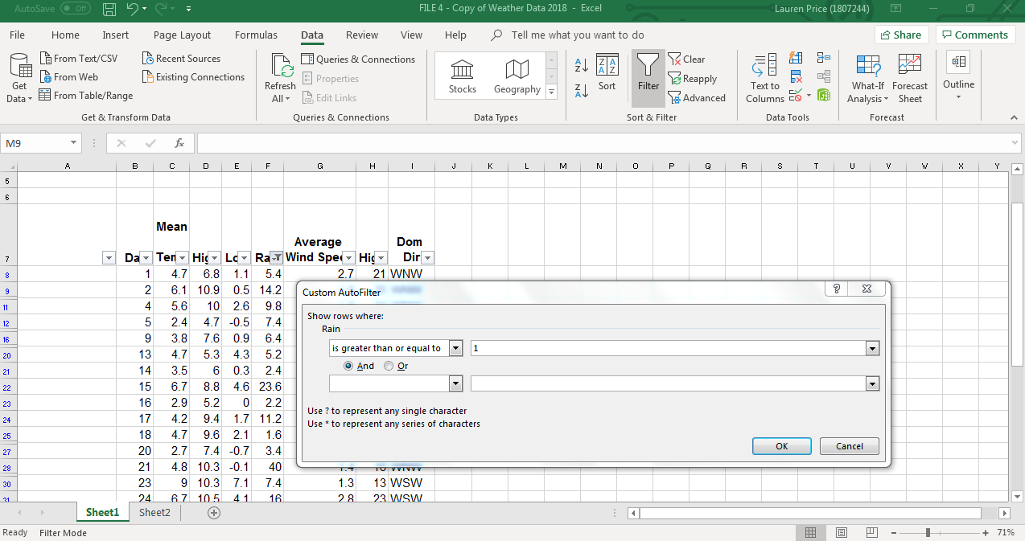

The IF function is an extremely useful tool. The IF function returns one value if the condition is TRUE, or another value if the condition is FALSE. (Tech On The Net; 2019).
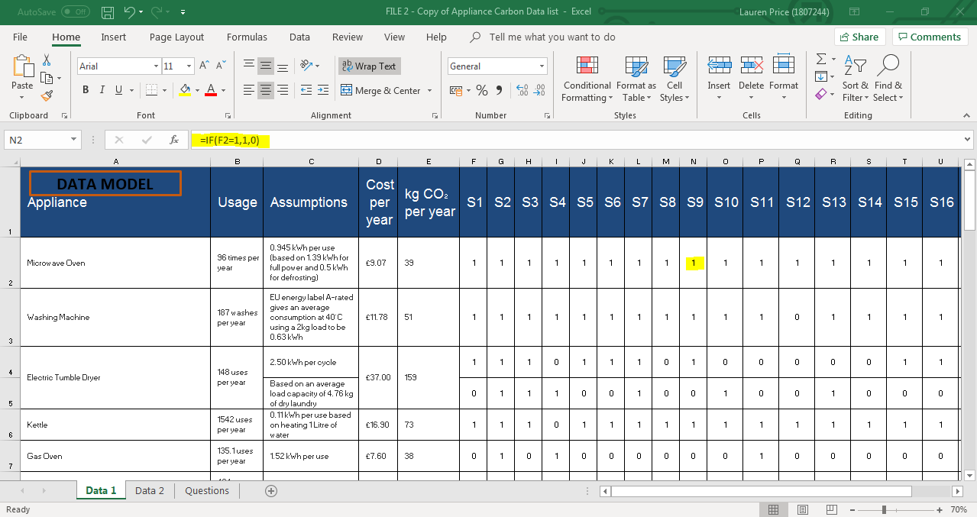

ADVANTAGES AND DISADVANTAGES OF USING A SPREADSHEET
It is highly important in business that any information or data relating to the business operation, is analysed, tracked or stored by using the appropriate method. Spreadsheets are highly popular with accountants and those who analyse and manage data. Spreadsheets have a number of advantages for this purpose but also have some limitations, which need to be considered. (Natter, E; 2019).

ADVANTAGES
One of the most simple uses of a spreadsheet is for organising data by using rows and columns. The program allows the user to create visual presentations in the form of charts and graphs; enabling pages of overwhelming data to be analysed and interpreted much quicker. (Natter, E; 2019). This Data Visualisation enables the user to grasp a clearer understanding of the data. The user would therefore be able to relay the information regarding the data and/or results to an audience who would be able to visually engage in analysing the data.
A spreadsheet enforces data integrity. It is possible to specify formats, so entries are consistent. It is also possible to use a macro for more complex matters. A macro can reject and correct errors automatically. (Techwalla; 2019).
Spreadsheets are able to calculate information via the use of simple or complex formulas. Once the formula has been set, complex calculations that would normally take up a lot of time can be calculated with the touch of a button. (Natter, E; 2019). This expediency is invaluable in business, it saves time meaning it potentially saves money.
It is possible for Excel spreadsheets to be shared, making collaborative work much easier. This makes working collaboratively on large projects in a business environment much more efficient because data can be shared between colleagues and can have more than one user without having the need for more than one spreadsheet to be created.

DISADVANTAGES
Calculations must be entered into a spreadsheet in the form of formulas. It can be difficult to learn the correct formula for each type of calculation that is required. If the formula is incorrect the system will not return the correct information. (Natter, E; 2019).
Spreadsheets have security issues. They are not as secure and are at risk from data corruption. This may be of a huge disadvantage in business due to the sensitive nature of information and data including financial records etc. which may be at risk from hackers. (Natter, E; 2019).

CONCLUSION
Attempting to analyse large data spreadsheet files, filled with rows and columns of information can be overwhelming. It has been extremely helpful to understand and be able to use a number of different formulas and functions to analyse and interpret the data and answer relevant questions designed by myself and attached to each spreadsheet file within a separate worksheet. I have found that the main benefit of using this type of application for spreadsheet creation is its simplicity. Using Microsoft Excel, data can easily be organised into rows and columns and can be interpreted and manipulated by the using basic or more complex formulas or functions. Microsoft Excel is a readily available and relatively inexpensive programme and the majority of people have at least a basic knowledge of using it. Although, it is important therefore that users grasp a clear understanding of the correct formulas and functions to use for the particular calculation they are wishing to carry out. This can be extremely difficult. Without the correct formula, mistakes and errors to the calculation will be present. It is important therefore that training is provided within a business environment for users who are creating spreadsheets for business purposes in order for data analytics to be carried out effectively and without error.

REFERENCES
Computer Hope. (2019). Spreadsheet. Available at: https://www.computerhope.com/jargon/s/spreadsheet.htm
Evans, J. (2014). Business Analytics.
GCF Global Inc. 2019. Excel 2010 – Working With Charts. Available at: https://edu.gcfglobal.org/en/excel2010/working-with-charts/1/
Marr, B. (2015). Big Data : Using SMART Big Data, Analytics and Metrics to Make Better Decisions and Improve Performance. Chichester : John Wiley & Sons
Microsoft. (2019). Create a Data Model in Excel. Available at: https://support.office.com/en-ie/article/create-a-data-model-in-excel-87e7a54c-87dc-488e-9410-5c75dbcb0f7b
Natter, E. (2019). The Advantages & Disadvantages of Spreadsheets. Available at https://smallbusiness.chron.com/advantages-disadvantages-spreadsheets-26551.html
SAS Institute Inc. (2019). Data Visualization – What it is and Why it Matters. Available at: https://www.sas.com/en_us/insights/big-data/data-visualization.html
Tech On The Net. (2019). MS Excel: How to use the IF Function (WS). Available at: https://www.techonthenet.com/excel/formulas/if.php
Tech Target. (2019). Data Analytics (DA). Available at: https://searchdatamanagement.techtarget.com/definition/data-analytics
Techopedia Inc. (2019). Spreadsheet. Available at: https://www.techopedia.com/definition/4426/spreadsheet
Techwalla. (2019). The Advantages of Using Spreadsheets. Available at: https://www.techwalla.com/articles/the-advantages-of-using-spreadsheets
Walkenbach, J. (2007). Excel 2007 Bible. Indianapolis, IN: Wiley.

