DOMNICA IACOBAN

1813025
Developing relationships and workplace achievement

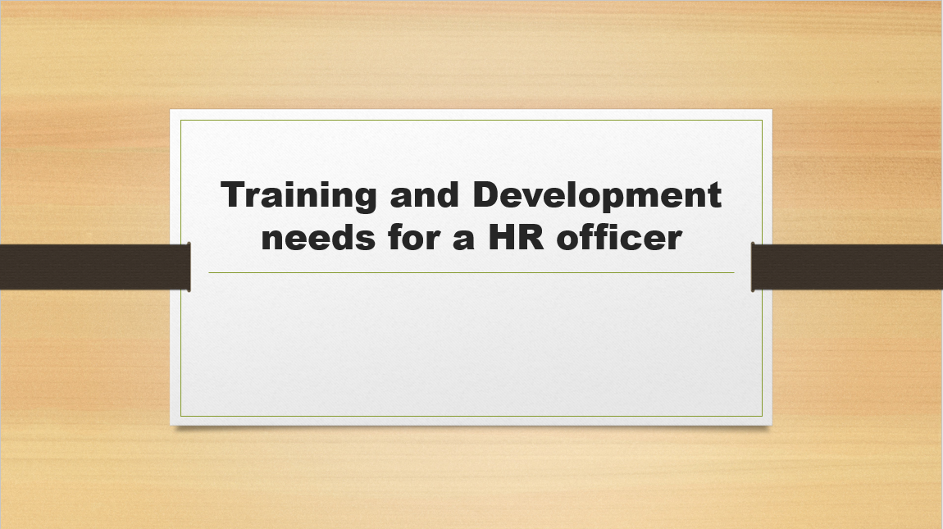
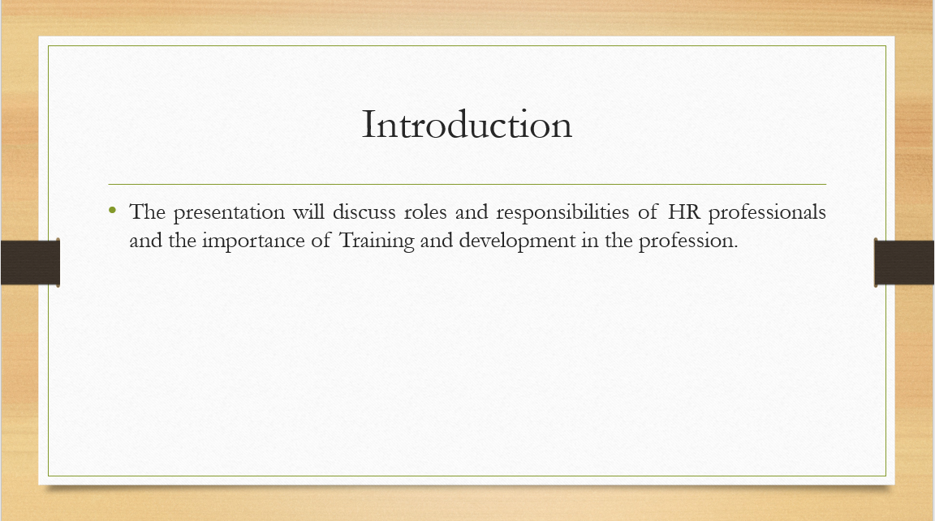Introduction
This presentation will talk about the different roles and responsibilities of an HR officer in the optometrist company named Hakim Group. Apart from describing the necessary skills, knowledge, and attitude of an HR officer, the presentation will also depict the result of Personal Skill Audit. The purpose of the audit is self-judgment so that skill gaps can be identified and necessary training can be identified for improving the skills. The necessity of Training and Development will also be described in this presentation. How a newly recruited HR officer can provide value to the Hakim Group is also a matter of discussion for this presentation.
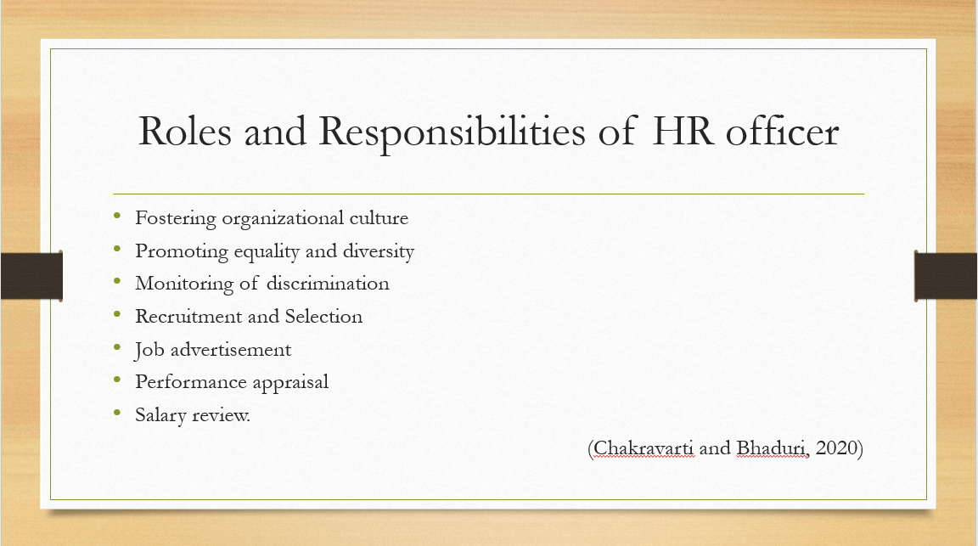
Roles and Responsibilities of HR officer
The basic roles and responsibilities of an HR officer are to foster the organizational culture. That can be done by promoting equality and diversity within the organization. Therefore, an HR officer needs to meticulously monitor the existence of discrimination and harassment in the organization. Apart from fostering a culture, the role of an HR officer is to conduct recruitment and selection. That is why the HR officer needs to circulate the vacancy in different online-offline channels. The HR officer also contacts the different third-party organization for sourcing potential candidates. Performance appraisal and salary reviews are also the responsibility of an HR officer (Chakravarti and Bhaduri, 2020)
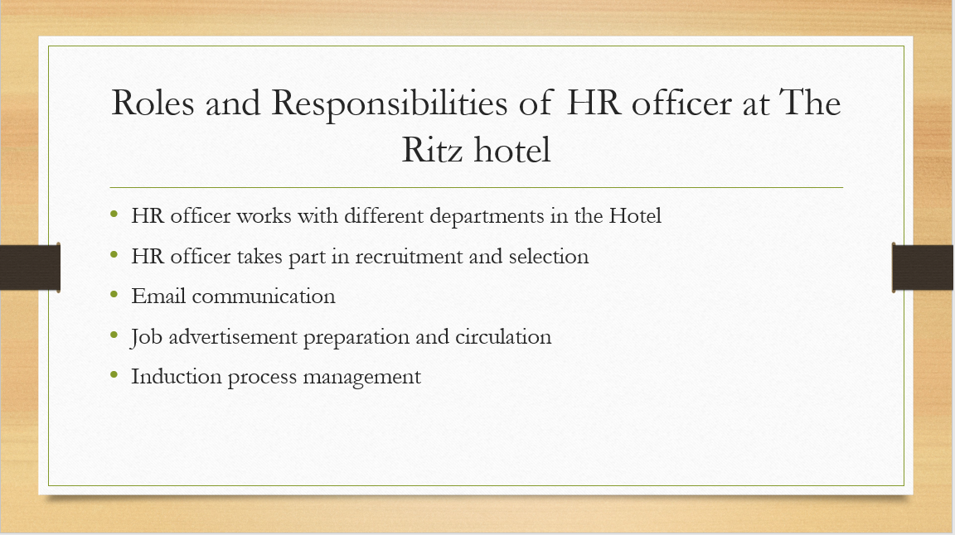
Roles and Responsibilities of HR officer at The Ritz hotel
The HR officer in this hotel needs to work with different departments of the hotel such as Accounting and Finance, Marketing, Operation, Maintenance, etc. The HR manager also needs to take part in recruitment and selection by preparing shortlisted candidates’ lists and emailing them for the interview. The HR officer also prepares the Job advertisement and publishes it in the Job portals such as Glassdoor, Indeed, etc. As the hotel works with many blue-collar employees the HR officer also needs to inform the HR head if there is any maltreatment. HR manager in this hotel also maintains the database to keep track of employees’ absence and Salaries. HR officer in this hotel is also responsible for the induction process and suggesting different training for the employees.
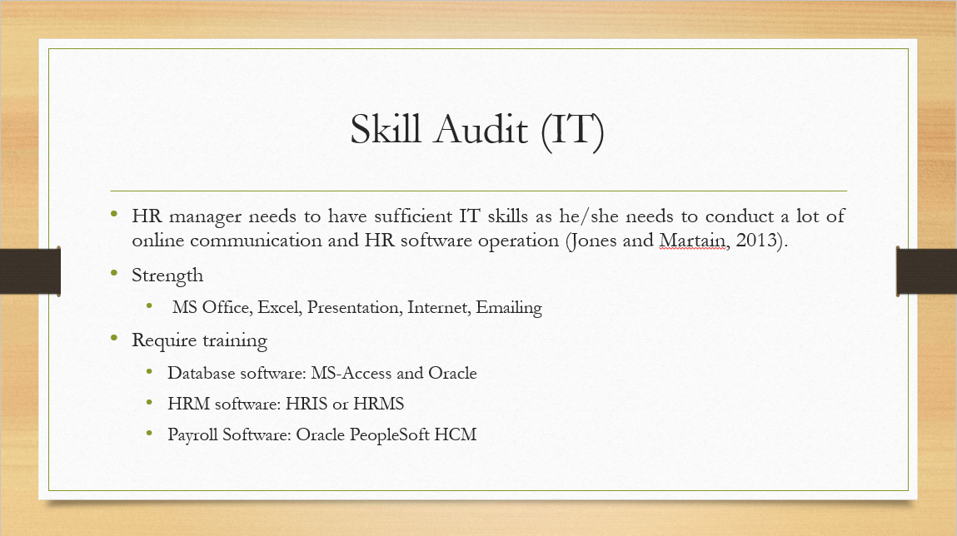Skill Audit (IT)
IT skills are important for an HR officer because in the present day an HR manager needs to conduct a lot of communication online and has to operate different HR software (Jones and Martain, 2013). I am proficient in using MS Office, Excel, and Presentation. However, the things I lack in this criterion is a Database management and HR software management. Therefore I will need training of different database software that the hotel use such as MS-Access and Oracle. I will also need training on HRIS or HRMS software. I also need training on different payroll software such as Oracle PeopleSoft HCM.
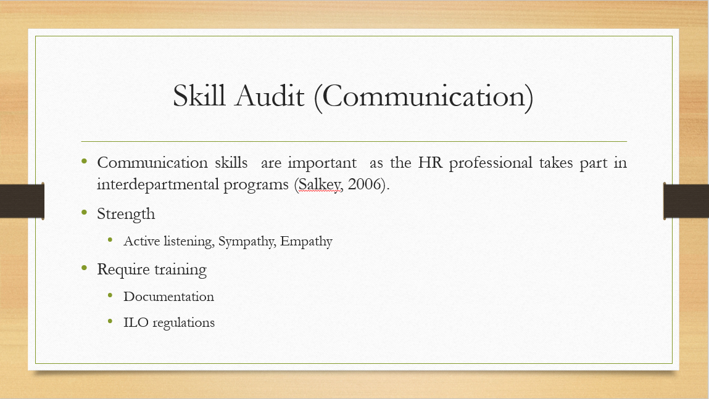Skill Audit (Communication)
Communication skills play an important role for HR professionals as he/she has to take part in multiple interdepartmental programs (Salkey, 2006). I am proficient in active listening, practicing sympathy, empathy, constructive criticism. However, I lack skills in documentation such as preparing an offer letter, appointment letter. I also lack in-depth knowledge of ILO rules which are essential regulations to know because I have to detect if employees are underpaid or working more hours than prescribed in the ILO rules.
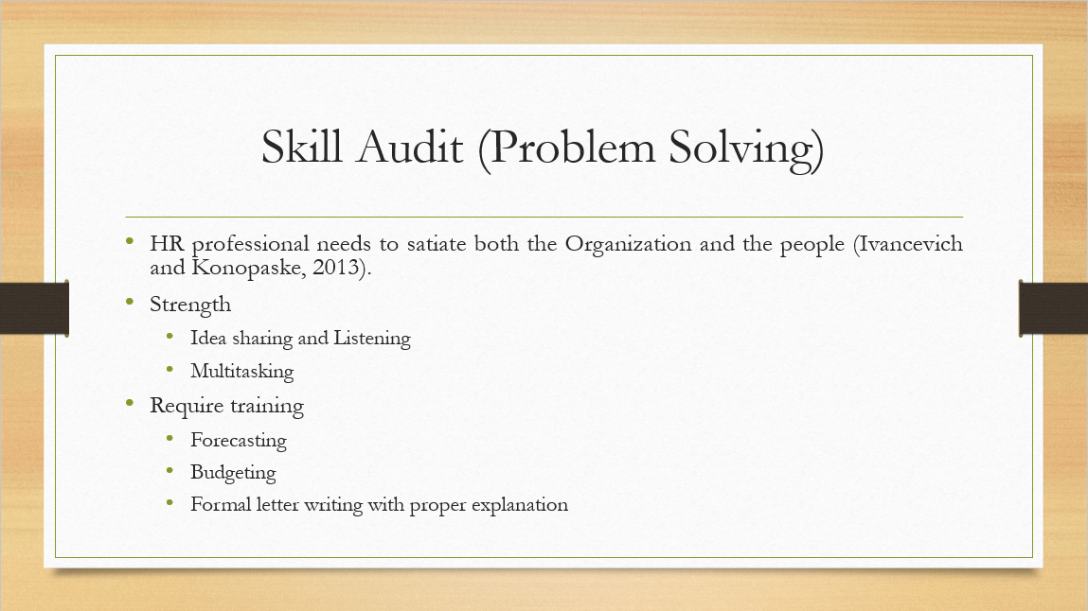Skill Audit (Problem Solving)
The job of HR professionals is not only to satisfy the organizational need but also to satisfy employees’ needs and that is why problem-solving skills are important for an HR officer (Ivancevich and Konopaske, 2013). I encourage others to express their opinion and I am good at multitasking. However, I need the training to solve problems that require a proper understanding of numbers. For example: At Ritz hotel, the HR officer needs to forecast the budget that would be needed to organize a training session. I, therefore, need training in forecasting and budgeting. I also hesitate to be strict with people and therefore I need to develop my writing skills to prepare letters with a proper explanation for the golden handshake, termination, or suspension.
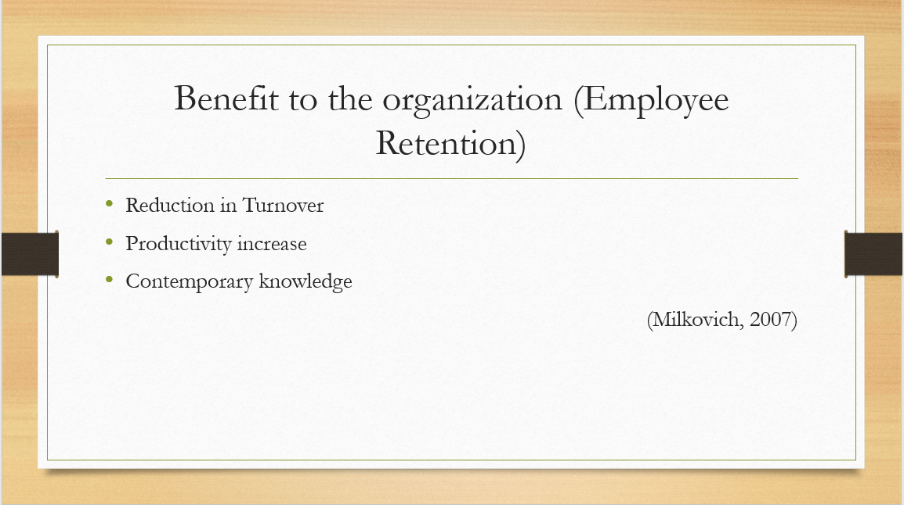Benefit to the organization (Employee Retention)
Hotel Ritz can ensure employee retention by providing training because proper training will make employees believe that the hotel aims to develop their attributes. As a result, employees will feel that they have a chance to grow and think not to switch the job quickly. As a result, turnover will reduce. Besides proper training will help employees to accelerate in their tasks. Consequently, the productivity of the hotel will increase. Training and development are essential for an organization because training not only provides contemporary knowledge but also keeps the employees motivated (Milkovich, 2007)
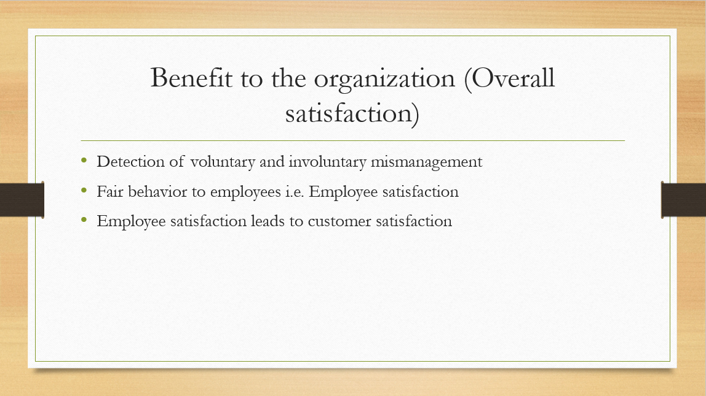Benefit to the organization (Overall satisfaction)
Training and development will give me contemporary knowledge and equip me with the necessary skillsets such as Software skills, Numeric Skills, Budgeting, and Forecasting, etc. As a result, I will be able to better support the HR operation and practices. I will be able to detect voluntary and involuntary mismanagement. Consequently, employees will receive fair behavior that will ensure their satisfaction. Satisfied employees will better serve the customers which will lead to improved customer satisfaction.
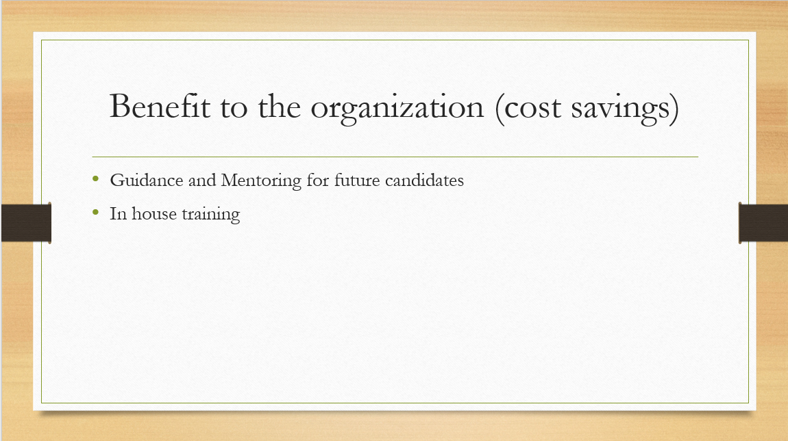Benefit to the organization (cost savings)
Through proper training, I will be able to know the Hotel’s policy, regulations, and practices. My improved knowledge through proper training will aid me in mentor and guide future candidates. Consequently, the hotel can rely on existing professionals to conduct in house training that will save costs for the hotel.
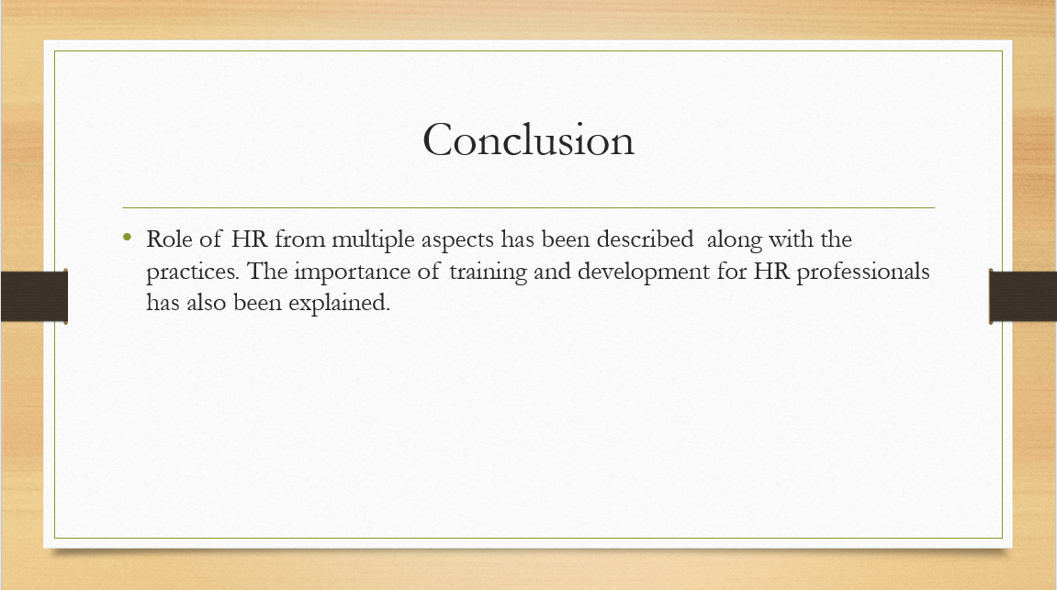Conclusion
The presentation has explained the role of an HR officer from disparate aspects. Different HR practices have been portrayed in the presentation and the training necessary has been indicated. The importance of training and development for the organizational perspective has also been articulated.
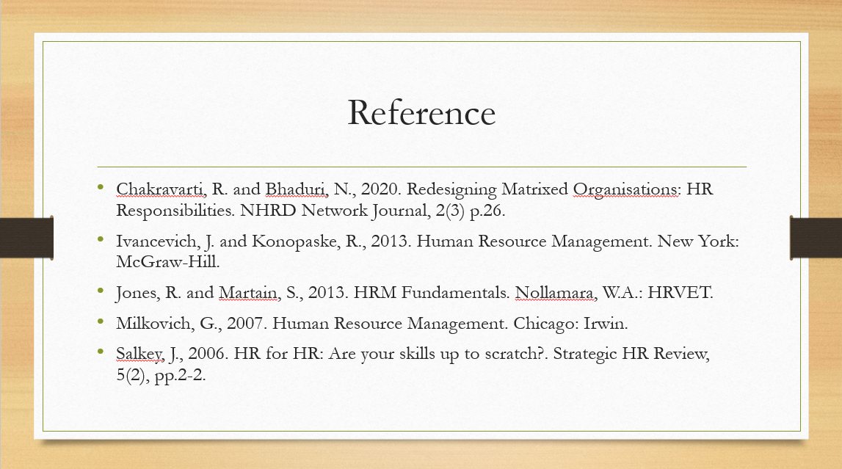Reference
Chakravarti, R. and Bhaduri, N., 2020. Redesigning Matrixed Organisations: HR Responsibilities. NHRD Network Journal, 2(3) p.26.
Ivancevich, J. and Konopaske, R., 2013. Human Resource Management. New York: McGraw-Hill.
Jones, R. and Martain, S., 2013. HRM Fundamentals. Nollamara, W.A.: HRVET.
Milkovich, G., 2007. Human Resource Management. Chicago: Irwin.
Salkey, J., 2006. HR for HR: Are your skills up to scratch?. Strategic HR Review, 5(2), pp.2-2.

Appendix


