COMPONENT 1: INFORMATION BOOKLET OF LONGTERM CONDITION MANAGEMENT

Student name: Shirsat Palavben Mahendrabhai
Student ID: 2534450
Module code and title: LCHS7003- Community Care and Management of Longer-term Conditions
Lecturer’s name: Muhammed Khan

Table of Contents
1. Introduction 4
1.1 Clinical Definition and Classification 4
1.2 Global and United Kingdom Prevalence 4
1.3 Pathophysiology, Risk Factors, and Aetiology 5
2: Bio-Psychosocial and Familial Impacts of CKD 5
2.1 Physical Symptomatology and Complications 5
2.2 Psychological Implications 6
2.3 Social and Occupational Disruptions 7
2.4 Systemic Impact on Family Caregivers 7
3: Evidence-Based Clinical Management within the NHS 7
3.1 Pharmacological Interventions 7
3.2 Management of Secondary Complications 8
3.3 Renal Replacement Therapies (RRT) 8
4: Theoretical Perspectives and Frameworks for Long-Term Management 9
4.1 Comparative Analysis of Healthcare Models 9
4.2 Application to Chronic Kidney Disease Pathways 10
5: Political Agendas and Health Policy Implementation in the UK 11
5.1 The NHS Long Term Plan (2019) 11
5.2 Cardiovascular Disease (CVD) Outcomes Strategy and Major Conditions Strategy 11
5.3 Core20PLUS5 Health Inequalities Agenda 11
5.4 NHS England Renal Services 12
6: Clinical Recommendations for Practice Improvement 12
a. Standardisation of Digital Personalised Care and Support Plans (PCSPs) 12
b. Expansion of Formal Digital Self-Management Infrastructure 13
c. Early Integration of Conservative Kidney Management (CKM) Pathways 13
d. Implementation of Coordinated Caregiver Support Packages 13
7. Conclusion 14
Reference list 15

Information Booklet: Comprehensive Management of Chronic Kidney Disease (CKD)

Target Audience: Health and Social Care Professionals in the United Kingdom

1. Introduction

1.1 Clinical Definition and Classification
Chronic Kidney Disease (CKD) is defined as a persistent kidney structure or function abnormality of more than three months duration, with significant impact on people's health (Gela et al. 2024). The National Institute for Health and Care Excellence guidelines state that CKD is defined and classified using two main parameters: The Glomerular Filtration Rate (GFR) and the Albumin to Creatinine ratio (ACR) (NICE, 2021).
The staging system categorizes GFR from G1 to G5, and ACR from A1 to A3:
- G1: Normal or high (≥ 90mL/min/1.73 m²)
- G2: Mildly decreased (60-89 mL/min/1.73 m²)
- G3a: Mildly to moderately decreased (45-59 mL/min/1.73 m²)
- G3b: Moderately to severely decreased (30–44 mL/min/1.73 m²)
- G4: Severely decreased (15-29 mL/min/1.73 m²)
- G5: Kidney failure (< 15 mL/min/1.73 m², or requiring renal replacement therapy)
As the nephrons become structurally damaged over time, the ability of the kidney to discharge metabolic waste, maintain fluid and electrolyte balance, and prevent cardiovascular and systemic disease increases (Salajova et al. 2024)

1.2 Global and United Kingdom Prevalence
Chronic Kidney Disease (CKD) is a growing public health problem worldwide. The estimation of prevalence on the basis of epidemiological data is around 9.1% to 13.4% worldwide, which makes CKD as one of the predominant causes of mortality worldwide (Kovesdy, 2022).
In the United Kingdom, the burden is similarly profound:
- Estimated Diagnosed Population: Kidney Research UK (2023) estimates that there are approximately 3.25 million people with stages 3-5 CKD in England.
- Asymptomatic renal decline: The estimated number of people with early stages of renal decline who are undiagnosed in primary care networks is 1 million (Stewart et al. 2024).
- Economic Impact: It is estimated that the cost to the National Health Service (NHS) is approximately £1.45 billion per year representing about 1.3% of the total NHS budget, more than half of which is spent on Renal Replacement Therapy (RRT) (haemodialysis and peritoneal dialysis) (Kidney Research UK, 2023).

1.3 Pathophysiology, Risk Factors, and Aetiology
Metabolic and vascular disorders such as diabetes mellitus and hypertension are the two main causes of Chronic Kidney Disease (CKD) in the United Kingdom. There are further differences in disease progression and inequalities in the outcomes of CKD throughout the UK, according to NICE (2021) and Kidney Research UK (2023) and increasing age, ethnicity and socioeconomic deprivation further influences this disease progression.
Primary Risk Factors | Secondary and Modifying Factors
Diabetes Mellitus: Hyperglycaemia leads to advanced glycation end-products, which result in Kimmelstiel-Wilson nodules and glomerular hyperfiltration (NICE, 2021). | Ageing: Natural senescent decrease of GFR after the 4th decade of life (Figuer et al. 2021).
Hypertension: The systemic hypertension causes arteriolosclerosis, leads to narrowing of lumens, leads to ischaemia, and gets you glomerulosclerosis (Poznyak et al. 2022). | Ethnicity: Black, Asian and other ethnic minority groups experience more rapid progression, with hypertensives and diabetics (Kidney Research UK, 2023).
Primary Glomerulonephritis: Chronic inflammatory pathways of the immune system led to damage of the podocytes and basement membrane (Poznyak et al. 2022). | Socioeconomic Status: People living in deprived areas have a higher risk associated with their language access to food and difficulty accessing primary care (Grant et al. 2023).

2: Bio-Psychosocial and Familial Impacts of CKD

2.1 Physical Symptomatology and Complications
Failure of the renal function results in the development of multiple organ system failure caused by uremic toxins and fluid imbalances that result from the failure of the kidneys.
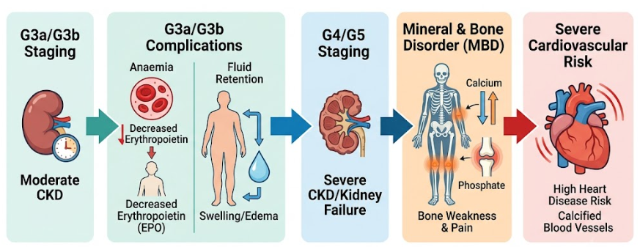
Figure 1: Pathophysiological Progression and Secondary Systemic Complications of Stage 3 - 5 CKD
(Source: NICE, 2021)
CKD is a progressive condition, as shown in figure 1, which can cause a variety of systemic complications, including reduced kidney function. As kidneys fall into Stage G3 to Stage G5, fluid retention and oedema develops due to impaired sodium and water elimination; renal anaemia develops because of the EPO deficiency. Progressively disturbed calcium, phosphate and vitamin D metabolism leads to Chronic Kidney Disease – mineral and bone disorder (CKD-MBD) which contributes to fractures. In addition, long-term hypertension, vascular calcification and fluid overload significantly raise the cardiovascular disease risk, which is the leading cause of death for patients with CKD in the United Kingdom (UK) (NICE, 2021; Tarantini et al., 2023).
- Cardiovascular Disease (CVD): Mortality is significantly raised by chronic fluid overload and arterial stiffness. Cardiovascular events continue to be the leading cause of mortality over end-stage kidney disease (ESKD) in CKD patients (Tarantini et al. 2023).
- Renal Anaemia: Normocytic, normochromic anaemia due to low erythropoietin secretion from interstitial fibroblasts contributes to fatigue and intolerance to exercise (NICE, 2021).
- Chronic Kidney Disease-Mineral and Bone Disorder (CKD-MBD): Secondary hyperparathyroidism is due to the disturbance of phosphate excretion and the deficiency of Vitamin D activation (1,25(OH)₂D₃), which results in bone resorption, fragility of the skeleton and the vascular calcification (Shroff et al. 2022).

2.2 Psychological Implications
The mental strain of having to endure a progressive and incurable disease is significant. The prevalence of clinical depression is higher for stage 4-5 CKD populations (20%-40%) compared to the general population (Alshelleh et al. 2022).
Patients lose personal autonomy, have issues with body image caused by dialysis access (fistula and/or catheter) and cognitive impairment caused by uremic encephalopathy. Complex medication regimens, fluid restrictions (usually 1-1.5 litres per day) and dietary restrictions means that there is a psychological burden associated with treatment which often results in poor treatment adherence and clinical burnout (Pourhabibi et al. 2022).

2.3 Social and Occupational Disruptions
CKDs fundamentally change the social life of an individual. Structural barriers are especially high for those doing in-centre haemodialysis, who also have to come in for three sessions per week, four hours each (Damery et al. 2024). This schedule restricts employment, and after initiation of dialysis, high unemployment rates.

2.4 Systemic Impact on Family Caregivers
It is difficult and complex to care for someone with advanced CKD. Family members are informal care coordinators who coordinate complicated prescriptions, diet, transportation, and managing dialysis complications (Pruette et al. 2022). This lifelong commitment can lead to "caregiver burden" that may include physical fatigue, clinical anxiety, and financial stress.
Some of the key changes a family can experience due to a partner becoming a full-time care-taker, such as changes to household relationships, can also impact on life satisfaction for the whole family. Despite this influence, healthcare systems are generally not providing those guiding and psychological services needed for informal caregivers that are provided formally.

3: Evidence-Based Clinical Management within the NHS
NHS policy on the clinical management of CKD is split into three areas of interest: slowing the progression, reducing cardiovascular risk and relieving symptoms.

3.1 Pharmacological Interventions
Neurohormonal blockade is the most important component of slowing the decline of GFR.
- Renin-Angiotensin-Aldosterone System (RAAS) Inhibition: Use of Angiotensin-Converting Enzyme Inhibitors (ACEi) like ramipril and/or Angiotensin Receptor Blockers (ARB) like losartan is essential in patients with proteinuria (ACR >30 mg/mmol) (Morales, and Handelsman, 2023). These drugs cause a dilation of the efferent arteriole to lower intraglomerular pressure which in turn decreases proteinuria and helps maintain the architecture of the nephrons (NICE, 2021).
- Sodium-Glucose Cotransporter-2 (SGLT2) Inhibitors: Drugs such as dapagliflozin have revolutionized renal medicine. In clinical trials, including DAPA-CKD, SGLT2 inhibitors have been shown to decrease the likelihood of ongoing GFR decline and of cardiovascular death whether or not patients have T2D (McEwan et al. 2024). While SGLT2 inhibitors have been shown to significantly reduce renal decline and cardiovascular mortality, they are not without being questioned on cost-effectiveness, the long-term maintenance and access inequalities in socioeconomically deprived populations. Additionally, the majority of clinical trial studies have limited representation of ethnically diverse populations, which means that this can only be applied to a specific population of the UK.
- Cardiovascular and Metabolic Control: NICE (2021) recommends to the left that aggressive lipid management with Atorvastatin (20mg daily) should be the standard in primary prevention of cardiovascular events in CKD. The target blood pressure is set at <140/90 mmHg or <130/80 mmHg in case of albuminuria
- .

3.2 Management of Secondary Complications
- Anaemia Management: Erythropoiesis-Stimulating Agents (ESAs) e.g., epoetin alfa may be used with intravenous iron to achieve targeting of haemoglobin levels between 100-120 g/L (NICE, 2021).
- Mineral and Bone Disorder: Hyperphosphatemia is treated by dietary phosphate restriction, and oral phosphate binders (e.g., sevelamer carbonate) given with food to reduce the absorption of phosphate in the gastrointestinal tract (Raju, and Saxena, 2025).

3.3 Renal Replacement Therapies (RRT)
A shared decision-making process will be conducted to discuss renal replacement options when a patient is in the late stages of kidney disease (Stage 5) (Figure 2).
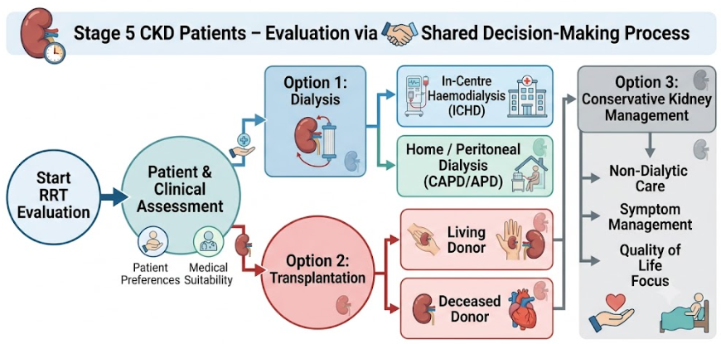
Figure 2: Clinical Decision-Making Pathway for Stage 5 CKD Management
(Source: Cheetham et al. 2024)

- Haemodialysis (HD): Can be provided at In-Centre Haemodialysis (ICHD) or Home Haemodialysis (HHD). HHD provides increased cardiovascular stability and flexibility, but only with a lot of training and appropriate home set-up (Cheetham et al. 2024).
- Peritoneal Dialysis (PD): Uses the patient's peritoneum as a filter. It can be Continuous Ambulatory Peritoneal Dialysis (CAPD) or Automated Peritoneal Dialysis (APD). Although PD spares more residual renal function than does HD, over time there is a risk for peritonitis and membrane failure in PD (Driehuis et al. 2024).
- Renal Transplantation: Best treatment for those who are suitable, has better long-term survival and quality of life than dialysis (Shi et al. 2023). It does however, need life-long immunosuppression, for example, tacrolimus, mycophenolate mofetil, and because donor organs are scarce.

4: Theoretical Perspectives and Frameworks for Long-Term Management
Structured healthcare frameworks are integrated into clinical practice to enhance patient outcomes and standardise care.

4.1 Comparative Analysis of Healthcare Models
Feature | The Chronic Care Model (CCM) - International | The NHS House of Care Framework - United Kingdom
Origin / Context | Developed by Wagner (1998) in the USA and widely used in the international health system (Goh et al. 2022). | Adapted for the NHS setting from the Coalition for Collaborative Care (Lizano-Díez et al. 2022).
Core Components | 1. Health System Organisation  2. Clinical Information Systems  3. Decision Support  4. Delivery System Design  5. Self-Management Support  6. Community Resources. | Four Walls:  1. Engaged, informed patient  2. Committed, skilled professionals  3. Robust organizational processes  4. Responsive commissioning.  Foundation: Re-allocation of local resources.
Strengths | Provides a framework at a higher level for the system-wide restructuring of healthcare systems; stresses the use of evidence-based decision tools. | Highly practical for integrated UK care pathways; shifts the conversation on personalised care planning to the centre.
Limitations | Difficult to achieve in public systems with limited resources without significant effort in the structures. | Must adapt a cultural change from a traditional paternalistic approach, and will be challenged by busy, time-constrained clinical personnel.  Whilst the House of Care system encourages shared decision making and a personalised approach to care plans, there is not yet a complete uniformity of implementation in NHS trusts as a result of workforce issues, limited consultation times and inconsistent organisation support. The effectiveness of the framework may therefore rely more on local infrastructure than on the model.

4.2 Application to Chronic Kidney Disease Pathways
Implementing the incorporation of these frameworks in CKD care changes the interaction of the clinical care. Biochemical markers (such as creatinine levels) are not the sole focus, but rather working with the House of Care approach which allows the clinician to have a structured and collaborative consultation.
The clinical team gives pre-marriage data to the patient through a bio-data (including trend lines of GFR, ACR etc.). This helps to keep the consultation focused on collaborative goal setting, emotions, symptom burden and fluid adjustments (Stewart et al. 2024). This structural change helps create care plans in cooperation with patients, leading to higher patient satisfaction and compliance with treatment.

5: Political Agendas and Health Policy Implementation in the UK
National political agendas in the UK that seek the move from medicine towards prevention, integration and equity influence the delivery of CKD services.

5.1 The NHS Long Term Plan (2019)
The NHS Long Term Plan has clear targets that are relevant to renal services:
- Integrated Care Systems (ICSs): ICSs are required to be established to break down the silos between acute hospital renal units (nephrology departments), primary care practices and social care providers (Major et al. 2025). This connection has the benefit of enabling smooth transitions for a CKD patient from primary care to specialist nephrology care.
- Cardiovascular Prevention Targets: The plan aims to identify and treat interlinked metabolic conditions early, such as hypertension, type 2 diabetes and early disease of the kidneys (CKD) with improved screening networks in primary care and to achieve a step change in the prevention of unnecessary acute kidney injury (AKI) and strokes.

5.2 Cardiovascular Disease (CVD) Outcomes Strategy and Major Conditions Strategy
Multi-morbidity is not an exception but the rule as outlined in the CVD Outcomes Strategy and the evolving Major Conditions Strategy (Hossain et al. 2023). Chronic kidney disease shares close associations with cardiac failure and metabolic syndromes, which encourage treatment of multi-morbidities as one. It is a multi-morbidity focus, enabling dual benefit drugs to be used in primary care, minimising the potential need for multiple, separate specialist referrals.

5.3 Core20PLUS5 Health Inequalities Agenda
As of figure 3, Systemic inequalities in health are tackled directly by the NHS England Core20PLUS5: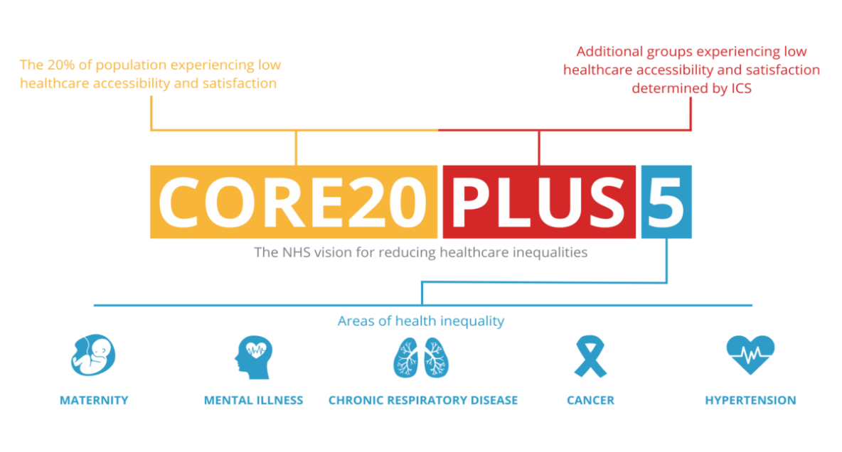

Figure 3: The NHS Core20PLUS5 Framework for Targeting and Reducing Healthcare Inequalities
(Source: Bladon et al. 2024)
Within renal care, this agenda focuses on the advanced CKD prevalence among low-income households and among Black and South Asian communities (Bladon et al. 2024). The policy seeks to decrease the disparities in disease progression and access to living donor transplantation by funding targeted community screening and delivering culturally adapted education resources.

5.4 NHS England Renal Services
These concepts are illustrated in the practical examples provided in the UK. The regionally coordinated services are coordinated by the UK Kidney Association and NHS England Renal Networks whilst services such as Renal Patient View provide direct access to the laboratory for patients to improve their own management, as championed by the House of Care model. Moreover, collaboration with Kidney Care UK and the growing number of living donor transplant services is a tangible aspect of national policy that leads to clinical change.

6: Clinical Recommendations for Practice Improvement
Four key systemic interventions are suggested to further improve the quality of care for CKD throughout the health system in the UK:

a. Standardisation of Digital Personalised Care and Support Plans (PCSPs)
- Rationale: In an era where care planning is more traditionally biochemical rather than patient-centred quality of life measures (Dharmagunawardene et al. 2025).
- Action: Develop digital PCSPs that are available to all primary care, nephrology and social care teams across the NHS spine. Such plans must include patient-centred lifestyle targets, psychological health and treatment preferences, as well as traditional biomedical targets.

b. Expansion of Formal Digital Self-Management Infrastructure
Self-management for CKD will involve the patient taking multiple medications, as well as monitoring blood pressure at home, strict dietary control, and fluid management, all of which are complex areas of treatment and require compliance and education (Faldu, and Knicely, 2025). There is also an optimized cardiovascular benefit with the addition of structured exercise. Supporting people with the use of digital health apps (such as My Kidneys My Health) in conjunction with NHS personalized care plans and the Patient Activation Model increases their knowledge, skill and confidence in taking personal responsibility for their health. Yet there is a critical balance, such self-management efforts are very beneficial to people with an activation, but they could create health disparities.
- Rationale: When the patient manages their own treatment, the number of acute hospital admissions can be reduced and the patient is able to manage their dietary and medication regimes.
- Action: Introduce scale platforms such as My Kidneys My Health, throughout all Integrated Care Boards (ICBs). Digital tools should include real-time monitoring of fluid intake, blood pressure trend charts, alerts for medications, and peer networks, for low-literacy and non-English speaking populations.

c. Early Integration of Conservative Kidney Management (CKM) Pathways
- Rationale: Dialysis initiation may improve quality of life for frail or elderly patients with high comorbidities, but without survival benefit (Davison et al. 2024).
- Action: Make it clear that patients with Stage 4 CKD should be referred to Conservative Kidney Management (CKM) pathways. Within a palliative approach, CKM aims to manage symptoms, provide psychological support and advanced care planning without committing to unnecessary burdensome haemodialysis, if it is not in keeping with the patient's wishes and priorities.

d. Implementation of Coordinated Caregiver Support Packages
- Rationale: Family caregivers are often highly burdened, and when they burn out they can end up being admitted to an emergency ward (Ghahramani et al. 2022).
- Action: Make formal assessment of risks to the caring of patients with renal disease by carers a part of renal service pathways. ICBs should offer special support, such as specific respite care facilities for home-dialysis families, peer support and direct access to psychological services.

7. Conclusion
CKD continues to be a public health problem and a major physical, psychological, social and economic burden on individuals, families and health care systems throughout the world. Health care for patients with CKD should go beyond a disease-based approach to a more integrated, person-centred approach to care that focuses on the biopsychosocial profile of populations affected by CKD. Although improved clinical outcomes in the era of new therapies, the wide development of renal replacement technology and adherence to evidence-based guidelines, the field continues to have numerous challenges, such as delayed diagnosis, inequities, workforce issues, and inconsistent access to psychosocial support services. The Chronic Care Model and the House of Care in the NHSP offer useful frameworks for collaborative, holistic care, which can be adapted or applied in different settings. Moving forward the aim of CKD management should be to create personalised pathways for management and to ensure that patients are encouraged to pursue early conservative pathways which will enable them to take greater control of their care, provide support for families and create the best possible outcomes for long-term clinical care across the National Health Service.

Reference list
Alshelleh, S., Alhouri, A., Taifour, A., Abu-Hussein, B., Alwreikat, F., Abdelghani, M., Badran, M., Al-Asa’d, Y., Alhawari, H. and Oweis, A.O., 2022. Prevelance of depression and anxiety with their effect on quality of life in chronic kidney disease patients. Scientific Reports, 12(1), p.17627.
Bladon, S., Ashiru-Oredope, D., Cunningham, N., Pate, A., Martin, G.P., Zhong, X., Gilham, E.L., Brown, C.S., Mirfenderesky, M., Palin, V. and van Staa, T.P., 2024. Rapid systematic review on risks and outcomes of sepsis: the influence of risk factors associated with health inequalities. International Journal for Equity in Health, 23(1), p.34.
Cheetham, M.S., Ethier, I., Krishnasamy, R., Cho, Y., Palmer, S.C., Johnson, D.W., Craig, J.C., Stroumza, P., Frantzen, L., Hegbrant, J. and Strippoli, G.F., 2024. Home versus in‐centre haemodialysis for people with kidney failure. Cochrane Database of Systematic Reviews, (4).
Damery, S., Lambie, M., Williams, I., Coyle, D., Fotheringham, J., Solis-Trapala, I., Allen, K., Potts, J., Dikomitis, L. and Davies, S.J., 2024. Centre variation in home dialysis uptake: A survey of kidney centre practice in relation to home dialysis organisation and delivery in England. Peritoneal Dialysis International, 44(4), pp.265-274.
Davison, S.N., Pommer, W., Brown, M.A., Douglas, C.A., Gelfand, S.L., Gueco, I.P., Hole, B.D., Homma, S., Kazancıoğlu, R.T., Kitamura, H. and Koubar, S.H., 2024. Conservative kidney management and kidney supportive care: core components of integrated care for people with kidney failure. Kidney international, 105(1), pp.35-45.
Dharmagunawardene, D., Kularatna, S., Halahakone, U., Purtell, L., Bonner, A., Healy, H.G. and Senanayake, S., 2025. Health system related kidney supportive care interventions for adults with chronic kidney disease: A systematic review. Journal of renal care, 51(1), p.e12517.
Driehuis, E., Eshuis, M., Abrahams, A., François, K. and Vernooij, R.W., 2024. Automated peritoneal dialysis versus continuous ambulatory peritoneal dialysis for people with kidney failure. Cochrane Database of Systematic Reviews, (9).
Faldu, C.T. and Knicely, D.H., 2025. Advanced chronic kidney disease and patient education. Kidney and Dialysis, 5(3), p.32.
Figuer, A., Bodega, G., Tato, P., Valera, G., Serroukh, N., Ceprian, N., de Sequera, P., Morales, E., Carracedo, J., Ramírez, R. and Alique, M., 2021. Premature aging in chronic kidney disease: the outcome of persistent inflammation beyond the bounds. International journal of environmental research and public health, 18(15), p.8044.
Gela, Y.Y., Limenh, L.W., Simegn, W., Ayenew, W., Chanie, G.S., Seid, A.M., Beyna, A.T., Esubalew, D., Mitku, M.L., Mengesha, A.K. and Melese, M., 2024. Poor sleep quality and associated factors among adult chronic kidney disease patients. Frontiers in Medicine, 11, p.1366010.
Ghahramani, N., Chinchilli, V.M., Kraschnewski, J.L., Lengerich, E.J. and Sciamanna, C.N., 2022. Improving caregiver burden by a peer-led mentoring program for caregivers of patients with chronic kidney disease: randomized controlled trial. Journal of patient experience, 9, p. 35210.
Goh, L.H., Siah, C.J.R., Tam, W.W.S., Tai, E.S. and Young, D.Y.L., 2022. Effectiveness of the chronic care model for adults with type 2 diabetes in primary care: a systematic review and meta-analysis. Systematic Reviews, 11(1), p.273.
Grant, C.H., Salim, E., Lees, J.S. and Stevens, K.I., 2023. Deprivation and chronic kidney disease—a review of the evidence. Clinical Kidney Journal, 16(7), pp.1081-1091.
Hossain, M.Z., Khan, M.M., Islam, R., Nahar, K. and Kabir, M.F., 2023. Formulation of a Multi-Disease Comorbidity Prediction Framework: A Data-Driven Case Analysis on of Diabetes, Hypertension, and Cardiovascular Risk Trajectories. Journal of Computer Science and Technology Studies, 5(3), pp.161-182.
Kidney Research UK, 2023. Kidney disease: A UK public health emergency. [Online]. Available at: https://www.kidneyresearchuk.org/wp-content/uploads/2023/06/Economics-of-Kidney-Disease-full-report_accessible.pdf [Accessed on: 01.07.2026].
Kovesdy, C.P., 2022. Epidemiology of chronic kidney disease: an update 2022. Kidney international supplements, 12(1), pp.7-11.
Lizano-Díez, I., Amaral-Rohter, S., Pérez-Carbonell, L. and Aceituno, S., 2022. Impact of home care services on patient and economic outcomes: a targeted review. Home Health Care Management & Practice, 34(2), pp.148-162.
Major, R.W., Lakhani, N., Ahmed, Y., Atkin, J., Baines, R., Balment, R., Cheung, C.K., Graham-Brown, M.P., Ellwood, C., Harding, L. and Iyasere, O., 2025. Integrated primary and secondary care optimizes the management of people with CKD—the LUCID project. Clinical Kidney Journal, 18(4), p.sfaf049.
McEwan, P., Gabb, P.D., Davis, J.A., Garcia Sanchez, J.J., Sjöström, C.D., Barone, S., Kashioulis, P., Ouwens, M., Cassimaty, S., Correa-Rotter, R. and Rossing, P., 2024. The long-term effects of dapagliflozin in chronic kidney disease: a time-to-event analysis. Nephrology Dialysis Transplantation, 39(12), pp.2040-2047.
Morales, J. and Handelsman, Y., 2023. Cardiovascular outcomes in patients with diabetes and kidney disease: JACC review topic of the week. Journal of the American College of Cardiology, 82(2), pp.161-170.
NICE, 2021. Chronic kidney disease: assessment and management. NICE guideline. [Online]. Available at: https://www.nice.org.uk/guidance/ng203/chapter/recommendations [Accessed on: 01.07.2026].
Pourhabibi, N., Mohebbi, B., Sadeghi, R., Shakibazadeh, E., Sanjari, M., Tol, A. and Yaseri, M., 2022. Determinants of poor treatment adherence among patients with type 2 diabetes and limited health literacy: a scoping review. Journal of diabetes research, 2022(1), p.2980250.
Poznyak, A.V., Sadykhov, N.K., Kartuesov, A.G., Borisov, E.E., Sukhorukov, V.N. and Orekhov, A.N., 2022. Atherosclerosis specific features in chronic kidney disease (CKD). Biomedicines, 10(9), p.2094.
Poznyak, A.V., Sadykhov, N.K., Kartuesov, A.G., Borisov, E.E., Sukhorukov, V.N. and Orekhov, A.N., 2022. Atherosclerosis specific features in chronic kidney disease (CKD). Biomedicines, 10(9), p.2094.
Pruette, C.S., Ranch, D., Shih, W.V. and Ferris, M.D.G., 2022. Health care transition in adolescents and young adults with chronic kidney disease: focus on the individual and family support systems. Advances in Chronic Kidney Disease, 29(3), pp.318-326.
Raju, S. and Saxena, R., 2025. Hyperphosphatemia in kidney failure: pathophysiology, challenges, and critical role of phosphorus management. Nutrients, 17(9), p.1587.
Salajova, K.B., Malik, J. and Valerianova, A., 2024. Cardiorenal syndromes and their role in water and sodium homeostasis. Physiological Research, 73(2), p.173.
Shi, B., Ying, T. and Chadban, S.J., 2023. Survival after kidney transplantation compared with ongoing dialysis for people over 70 years of age: a matched-pair analysis. American Journal of Transplantation, 23(10), pp.1551-1560.
Shroff, R., Wesseling-Perry, K. and Bacchetta, J., 2022. Chronic kidney disease–mineral and bone disorder (CKD-MBD). In Pediatric Nephrology (pp. 1751-1778). Cham: Springer International Publishing.
Stewart, S., Kalra, P.A., Blakeman, T., Kontopantelis, E., Cranmer-Gordon, H. and Sinha, S., 2024. Chronic kidney disease: detect, diagnose, disclose—a UK primary care perspective of barriers and enablers to effective kidney care. BMC medicine, 22(1), p.331.
Stewart, S., Kalra, P.A., Blakeman, T., Kontopantelis, E., Cranmer-Gordon, H. and Sinha, S., 2024. Chronic kidney disease: detect, diagnose, disclose—a UK primary care perspective of barriers and enablers to effective kidney care. BMC medicine, 22(1), p.331.
Tarantini, G., Tang, G., Fovino, L.N., Blackman, D., Van Mieghem, N.M., Kim, W.K., Karam, N., Carrilho-Ferreira, P., Fournier, S., Pręgowski, J. and Fraccaro, C., 2023. Management of coronary artery disease in patients undergoing transcatheter aortic valve implantation. A clinical consensus statement from the European Association of Percutaneous Cardiovascular Interventions in collaboration with the ESC Working Group on Cardiovascular Surgery. EuroIntervention, 19(1), p.37.

