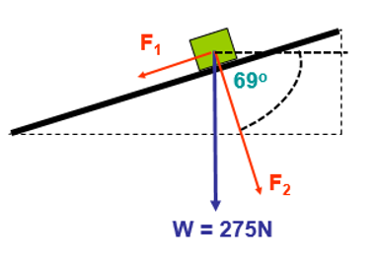
Science coursework

1)
a) i) $90-69=21°$
$$275\sin\left(21\right)=98.55 N$$
ii)
$$180-\left(90+21\right)=69°$$
iii)
$$275\cos\left(21\right)=256.73 N$$
b)
i)
$$p=mv$$

ii)
$${kgms}^{-2}$$
c)
i)
$$\frac{275}{9.81}=28.03$$
$$28.03×2.5=70.08 N$$
ii)
$$28.03×7.5=210.23{ kgms}^{-2}$$
iii)
$$\frac{12.5}{3.2}=Ans$$
$$Ans×5=19.53 N$$
2)
a)
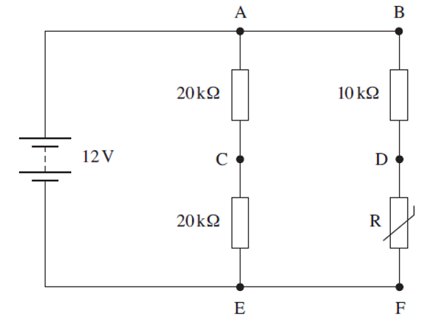
i)
$$\frac{1}{40}+\frac{1}{15}=\frac{11}{120}$$
$$\frac{120}{11}=10.9KΩ$$
ii)
$$\frac{12}{10.9}=1.1 Amps$$
iii)
$$P=IE$$
$$I=\frac{E}{R}$$
$$\frac{12}{20}=ans$$
$$ans×12=7.2$$
$$\frac{12}{10}=ans$$
$$ans×12=14.4$$
$$\frac{12}{5}=ans$$
$$ans×12=28.8$$
$$7.2+7.2+14.4+28.8=57.6 KW$$
b)
i)

3)
a) The moment of force around a point is comparing the amount of force needed to rotate an object round a pivot and the distance between the applied force and the pivot point.
b)

i)
$$Moment=F×D$$
$$0.048×250=12Nm anticlockwise$$
ii)
$$\frac{12}{0.027}=444.4N$$
iii)
$$F=kx$$
$$444.4×0.015=6.67Nm$$
v)
$$444.4×0.027=12Nm$$
c)
i)
$$Power=\frac{energy}{time}$$
$$J/S$$
ii)
$$power=\frac{?}{2.2}$$
d) 2

