

Postgraduate/Distance Learning
Assignment coversheet & feedback form

THIS SHEET MUST BE THE FIRST PAGE OF THE ASSIGNMENT YOU ARE SUBMITTING (DO NOT SEND AS A SEPARATE FILE)

For completion by the student:
Student Name: Fernanda Paiva

Student University Email: 1808194@student.uwtsd.ac.uk

Module code: HPCA 7008  Module title: Heavenly Discourses | Student ID number:  1808194 |  |  | Educational support needs:  Yes/No  no
Assignment title: Compare and contrast two primary sources representing the sky.

Assignment due date: 08/06/2020
This assignment is for the 1st 2nd 3rd 4th 5th 6th X module of the degree
I confirm that this is my original work and that I have adhered to the University policy on plagiarism.
Signed ……Fernanda Paiva………………………………………………………
Email submission:if you are submitting this form via email, please tick this box □
(as a substitute for your signature) to confirm that you agree to the above declaration.
Assignment Mark
1st Marker’s Provisional mark
2nd Marker’s/Moderator’s provisional mark
External Examiner’s mark (if relevant)
Final Mark

NB. All marks are provisional until confirmed by the Final Examination Board.

For completion by Marker 1 :
Comments:

Marker’s signature: |  |  | Date:
For completion by Marker 2/Moderator:

Comments:

Marker’s Signature: |  | Date:
External Examiner’s comments (if relevant)

External Examiner’s Signature: |  | Date:

Compare and contrast two primary sources representing the sky
Word count: 2062

Introduction:

This essay aims at comparing and contrasting two primary sources in their representation of the sky, using Vincent van Gogh’s painting The Starry Night (Figure 1), and the tarot card XVII, The Star, from Aleister Crowley’s deck (Figure 2). The task will be accomplished via two themes: how they both represented the stars in their work, and how the sky is depicted in connection to divine inspiration in both works; but before doing that it is important to talk about the context surrounding the two primary sources and their authors.

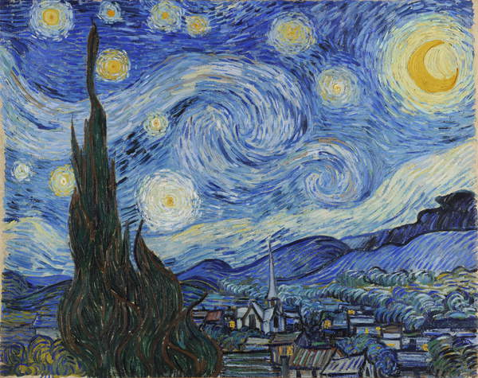
Figure 1: Vincent Van Gogh (1853-1890), The Starry Night, 1889, oil on canvas, 73.7x92.1 cm, Museum of Modern Art, New York, USA. Image: Bridgeman Images.
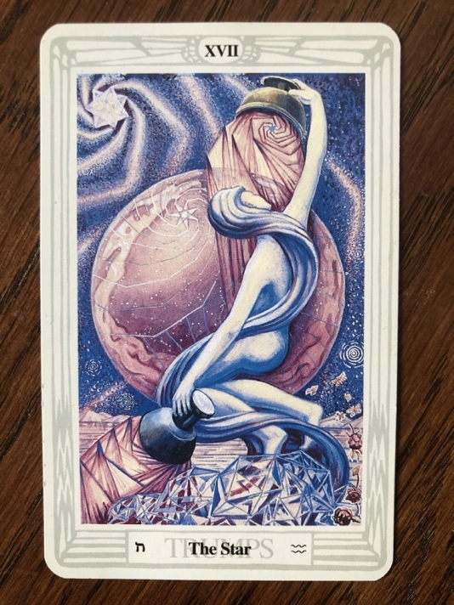
Figure 2: Lady Frieda Harris (1877-1962) and Aleister Crowley (1875-1947), XVII The Star, Book of Thoth Tarot Deck, 1996 [1944], published by AGMüller, Image: Fernanda Paiva.

Context:

Aleister Crowley was born in 1875 and had an inheritance which allowed him to be financially secure for most of his life, and to explore his lifelong interest in the occult. Finding academic and reliable sources of information on Lady Frieda Harris was proven to be challenging and for that reason this paper focus on Crowley as, although she painted the pictures, he was the designer behind it.

Vincent van Gogh was born in 1853 and decided to become an artist when he was 27 years old, ten years before he killed himself and, according to Colin Martin, ‘triggered an enduring archetype of the mentally unstable artist’. The Starry Night was painted in a mental hospital, which van Gogh committed himself voluntarily from May 1889 to February 1890, and ‘during a critical turning point in his art and in his life’. That was a ‘turning point’ because it was during this period that a shift occurred in the style van Gogh used in his paintings which became known as a change from Impressionism to Expressionism. According to Randolph Schwabe Expressionism is defined as the artist’s ‘insistence on feeling rather than on the visualisation and reproduction of the external world’ and in Figure 3 we can see an example of van Gogh’s painting before this shift occurred, where there was an emphasis on portraying reality.

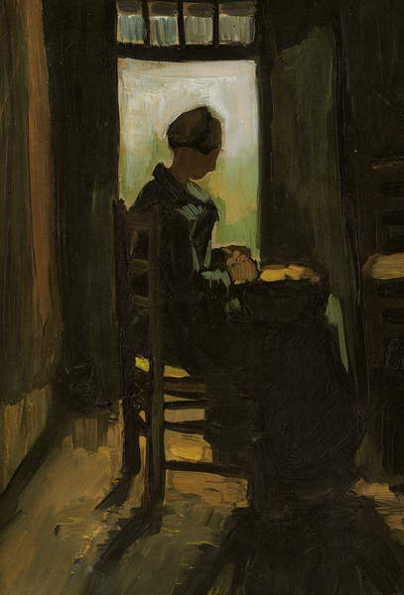
Figure 3: Vincent Van Gogh (1853-1890), Woman Seated Before an Open Door Peeling Potatoes, 1885, oil on canvas, 36.5x25 cm, Private Collection. Image: Bridgeman Images.

The tarot is a pack of 78 cards, with 22 of them called Major Arcana or also known as Trumps, and Crowley’s tarot deck, entitled ‘The Book of Thoth’, was designed by him, painted by Lady Frieda Harris, and finished in 1944. Although card games were introduced from Islam into Europe in the beginning of the fourteenth century, and tarot specifically from the fifteenth century, it was only in the eighteenth century that the first connections between tarot and occult ideas were made with a method of ‘cartomancy’ created in 1783, and interestingly, with a tarot pack also entitled ‘The Book of Thoth’, however, no further evidence of similarity, apart from the name, was found between the two decks as more research on the topic is required.

Card XVII, The Star, belongs in the sequence of the 22 Major Arcana cards, with card XVI, The Tower, coming before and followed by card XVIII, The Moon. Coralle Grebe suggested that the Major Arcana cards are the ‘representation of a spiritual journey’ and this information is important to keep in mind as we proceed further in this paper. See below in Figures 4 and 5 two more examples of The Star card from two other tarot decks.

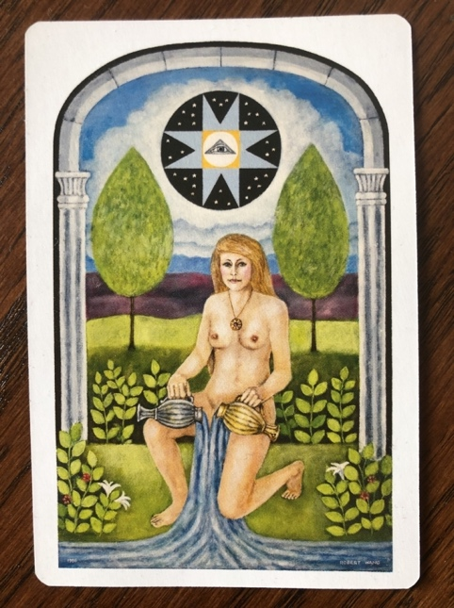
Figure 4: Robert Wang (unknown), The Star, The Jungian Tarot Deck, 2018, Published by U.S Games Systems INC., Image: Fernanda Paiva

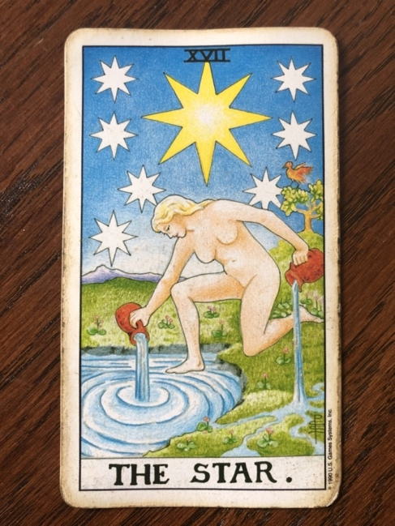
Figure 5: Pamela Colman Smith (1878-1951) and Arthur Edward Waite (1857-1942), The Star, Rider Waite Tarot Deck, 1990 [1910], published by U.S Games System INC., Image: Fernanda Paiva.

The stars depicted in each primary source:

This section will explore the comparison of how the stars were depicted in the chosen primary sources. In both works the stars in the sky are represented in a similar manner, depicting a kind of spiral shape in the sky, although Crowley’s star on the top left has a more geometric shape compared to the small ones in the background and van Gogh’s stars which are more round in shape (see Fig. 1 and 2). However, there is a main difference in their representation of the stars, and that is a connection between the stars and astrological knowledge as well as the narrative in the tarot sequence itself versus van Gogh’s painting which was based on imagination and feelings rather than an attempt to represent any system of knowledge.

Patrick McCafferty talked about the sky as ‘a tapestry embroidered by the human imagination’ and Rebecca Solnit argued that ‘stars are made of flaming gases, but constellations are made of stories’ and she claimed that ‘constellations connect the stars to each other, but in a way that no longer speaks of stars but of animals, goddesses, and heroes’. Aleister Crowley’s card makes reference to the astrological glyph of Aquarius in the bottom right (Fig. 2), reflecting what Solnit spoke as the stars representing a story when connected to each other in the formation of a constellation. Crowley also referred to the geometrical star on the top left as Venus representing love, another reference to astrological symbolism, as according to astrologer Liz Greene, Venus symbolically represents, amongst other things, ‘self-love and self-value’ as well as ‘the urge for love and relationships’. In Crowley’s words: ‘behind the figure of the goddess is the celestial globe. Most prominent among its features is the seven-pointed Star of Venus, as if declaring the principal characteristic of her nature to be Love’. The card of the Star also, according to Kathleen Raine, brings a message of hope, another example of how the stars in the tarot card relates to a message and connects itself to different narratives.

Van Gogh’s stars, on the other hand, as Tim Ingold has pointed out, connects us with feelings. He claimed that The Starry Night ‘appeals to us precisely because it both resonates with our experience of what it feels like being under the stars and affords us the means to dwell upon it’. What Ingold said reflects the poetic allure that the image and the stars have, or in his words ‘what it feels like’, when we are looking at the starry night in general, invoking feelings rather than conveying a message, like in the case of Crowley’s card. According to Lauren Soth, the lunar phase depicted in The Starry Night does not comply with the real lunation at the time it was painted, agreeing with what has already been discussed earlier in this essay, regarding the fact that he was painting the sky with the intention to express an imaginative vision imbued with emotions rather than the outer reality.

In this section we compared the two primary sources through the different ways that they represented the stars in their work. It was discussed that although they both have used a similar spiral shape there is a fundamental difference between the two, that is, in Aleister Crowley’s tarot card allusions to astrology were made in which the stars are connected with a narrative, whereas van Gogh’s stars links us with the feeling of being under the night sky, an idea that also can be attributed to the fact that he was painting from imagination and emotional inspiration.

The sky in connection to divine inspiration:

There are many different ways in which we can relate to the sky, for instance, Rebecca Solnit argued that ‘the night sky is a clock, a compass, and a calendar for those who know how to read it’ and, at the same time, she also said that ‘the sky is the realm of portents and prophesies’. In this theme we will compare and contrast how the similar choice of colours in the two primary sources connected the sky with what Solnit spoke as ‘the realm of portents and prophecies’, or rather, ‘spirituality’ as defined by Nalini Nadkarni as ‘the part of a human associated with the mind and feelings as distinguished from the physical body’.

The sky has been talked about as a ‘mood creator’ and when we observe the representation of it in both primary sources, there is a similarity in the created atmosphere based on the colours composing the night sky in both (see Fig. 1 and 2). They have used blues and purples, and according to Pavel Florensky, these colours are connected with the ‘notion of spirituality’. Florensky claimed that ‘Thomas Aquinas sees in the colour hyacinth the contemplation of heavenly things’ and continued saying that ‘the hyacinth garment of the high priest (…) symbolizes the elevation of the heart above earthly things’. Based on the choice of colours used in the two primary sources (see Fig. 1 and 2), the sky could be connected with spirituality and what Florensky talked as ‘the elevation of the heart above earthly things’.

Lauren Soth said that, for van Gogh, the colours he used in The Starry Night ‘had spiritual associations to him’ and Julian Stamm called The Starry Night a ‘religious epic’. The turning point in van Gogh’s style of painting and the expression of his intense emotions was so powerful that, according to Denis J. Billy, he became ‘a symbol of postmodern man’s restless search for transcendence’. According to B. from the MOMA, where The Starry Night can be found, the subject of this picture had haunted van Gogh for most of his life and in a letter to his brother Theo, regarding painting realistically, he said ‘that does not prevent me having a terrible need of –shall I say the word- religion. Then I go out to paint the stars’. This quotation reveals the connection that the stars and the sky had to van Gogh in terms of spirituality and religious needs.

Crowley’s card of the Star has also made use of blues and purples, especially the hyacinth colour which was mentioned earlier in relation to spiritual elevation, and although Coralle Grebe claimed that in general the Star card in the tarot relates to spirituality, with the water portrayed in the card representing ‘baptism and rebirth’, the other two decks (see Figures 4 and 5) did not use purple or hyacinth in their depiction of the sky.

The card preceding the Star, number XVI The Tower, according to Grebe, represents ‘the impermanence of physical things’; the following card after the Star, number XVIII The Moon is, as Grebe argued, connected with ‘intuition and femininity’. The Star then, through the process represented in the Major Arcana in the Tarot deck, seems to symbolise a shift into spirituality from the disillusionment signified by the Tower and the impermanence of things in the physical realm that Grebe spoke about. The card of the Star then, represents a portal through which we enter another dimension within the sky, the sky as spiritual and divine. Aleister Crowley claimed that the card of the Star in his deck represents the Egyptian goddess Nuit, ‘the starry heaves’, echoing this idea of the sky in connection to divinity and resonating with what has been discussed about van Gogh’s Starry Night.

This theme has discussed how the sky can be related to and interpreted in different ways, like for example as time keeper, and how the two primary sources’ similarity in their author’s choice of colours, blues and purples, reflected their representation of the sky as divine and spiritual, using Nalini Nadkarni’s definition of spiritual as the human parts that are ‘distinguished from the physical body’.

Conclusion:

This paper aimed at comparing and contrasting two primary sources in their representation of the sky, using Vincent van Gogh’s painting The Starry Night (Fig. 1), and the tarot card XVII, The Star, from Aleister Crowley’s deck (Fig. 2), via comparing their representation of the stars and how they both depicted the sky in connection to divinity.

Some of the contextual information regarding the two works and their authors’ lives composed the following segment, for example how van Gogh’s painting represents a turning point in his art and a shift from Impressionism to Expressionism.

The following section was about how the stars have been represented differently by both sources, with Crowley’s tarot card making allusions to astrological knowledge through the symbol of the constellation of Aquarius as well as depicting Venus as a star connected with notions of love, in contrast to the stars in van Gogh’s painting bringing up feelings of being under the night sky rather than conveying a specific message.

In the last part, it was claimed that both primary sources, by choosing blues and purples to represent the night sky, created a similar mood in which the sky can be seen in relation to spirituality and divinity. This argument was sustained by the symbolism of the colours as well as the circumstances surrounding van Gogh’s life and how his painting has been interpreted as a ‘religious epic’, as well as how the tarot card of The Star symbolises a turning point from material disillusionment to a more spiritual realm in the sequence of the Major Arcana cards.

Table of Images:

Figure 1: Vincent Van Gogh (1853-1890), The Starry Night, 1889, oil on canvas, 73.7x92.1 cm, Museum of Modern Art, New York, USA. Image: Bridgeman Images.
Figure 2: Lady Frieda Harris (1877-1962) and Aleister Crowley (1875-1947), XVII The Star, Book of Thoth Tarot Deck, 1996 [1944], published by AGMüller, Image: Fernanda Paiva.
Figure 3: Vincent Van Gogh (1853-1890), Woman Seated Before an Open Door Peeling Potatoes, 1885, oil on canvas, 36.5x25 cm, Private Collection. Image: Bridgeman Images.
Figure 4: Robert Wang (unknown), The Star, The Jungian Tarot Deck, 2018, Published by U.S Games Systems INC., Image: Fernanda Paiva
Figure 5: Pamela Colman Smith (1878-1951) and Arthur Edward Waite (1857-1942), The Star, Rider Waite Tarot Deck, 1990 [1910], published by U.S Games System INC., Image: Fernanda Paiva.

Bibliography:

Primary sources:

Gogh, Vincent Van, The Starry Night, 1889, oil on canvas, 73.7x92.1 cm, Museum of Modern Art, New York, USA. Image: Bridgeman Images.

Harris, Lady Frieda and Aleister Crowley, XVII The Star, Book of Thoth Tarot Deck, 1996 [1944], published by AGMüller, Image: Fernanda Paiva.

Secondary sources:

B., ‘Van Gogh’s “Starry Night”’, The Bulletin of the Museum of Modern Art, Vol. 9, No. 2, (Nov. 1941), pp. 2-3.

Billy, Denis J., ‘Under the Starry Night’, New Blackfriars, Vol. 76, No. 889, (January 1995), pp. 43-48.

Crowley, Aleister, The Book of Thoth, (Berlin: Weiser Books, 2000 [1944]).

Florensky, Pavel, ‘The Turquoise Environment of Sophia and the Symbolism of Sky-Blue and Dark-Blue’, in The Pillar and Ground of the Truth (Princeton: Princeton University Press, 1997), pp. 390-406.

Grebe, Coralee, ‘Tarot Card Symbolism in the “Star Wars” Films’, Mythlore, Vol. 20, No. 2, (Spring, 1994), pp. 27-31.

Greene, Liz and Howard Sasportas, The Inner Planets, (Boston: Weiser Books, 1993).

Ingold, Tim, 'Reach for the Stars! - Light, Vision and the Atmosphere', in The Imagined Sky: Cultural Perspectives, edited by Darrelyn Gunzburg, (Sheffield: Equinox Publishing, 2016),
pp. 215- 233.

Martin, Colin, ‘Exhibition: Vincent van Gogh’s life and work through his letters’, The Lancet, Vol. 375, (February 2010), pp. 629-630.

McCafferty, Patrick, ‘Comets and Meteors: The Ignored Explanations for Myths and Apocalypse’, in The Imagined Sky: Cultural Perspectives, ed. by Darrelyn Gunzburg, (Sheffield: Equinox Publishing, 2016), pp. 23-43.

McWilliams, Stuart, ‘Aleister Crowley’s Graphomania and the Transformations of Magical Inscriptivity’, Preternature: Critical and Historical Studies on the Preternatural, Vol. 5, No. 1, (2016), pp. 59-85.

Nadkarni, Nalini M., ‘Spirituality and Religion’, in Between Earth and Sky, (California: University of California Press, 2008), pp. 214-242.

Penco, Carlos, ‘Dummett and the Game of Tarot’, Teorema: Revista Insternacional de Filosofia, Vol. 32, No. 1, (2013), pp. 141-155.

Raine, Kathleen, ‘Yeats, the Tarot, and the Golden Dawn’, The Sewanee Review, Vol. 77, No. 1, (Winter, 1969), pp. 112-148.

Schwabe, Randolph, ‘Expressionism’, The Burlington Magazine for Connoisseurs, Vol. 33, No. 187, (1918), pp. 140-141.

Solnit, Rebecca, ‘Reaching for the Sky’, in Storming the Gates of Paradise, (California: University of California Press, 2007), pp. 140-175.

Soth, Lauren, ‘Van Gogh’s Agony’, The Art Bulletin, Vol. 68, No. 2, (June 1986), pp. 301-313.

Stamm, Julian L., ‘Vincent Van Gogh: Identity Crisis and Creativity’, American Imago, Vol. 28, No. 4, (Winter 1971), pp. 363-372.

Stuart McWilliams, ‘Aleister Crowley’s Graphomania and the Transformations of Magical Inscriptivity’, Preternature: Critical and Historical Studies on the Preternatural, Vol. 5, No. 1, (2016), p. 60.
Colin Martin, ‘Exhibition: Vincent van Gogh’s life and work through his letters’, The Lancet, Vol. 375, (February 2010), p. 629.
Julian L. Stamm, ‘Vincent Van Gogh: Identity Crisis and Creativity’, American Imago, Vol. 28, No. 4, (Winter 1971), p. 367; B., ‘Van Gogh’s “Starry Night”’, The Bulletin of the Museum of Modern Art, Vol. 9, No. 2, (Nov. 1941), p. 3.
B., ‘Van Gogh’s “Starry Night”’, The Bulletin of the Museum of Modern Art, Vol. 9, No. 2, (Nov. 1941), p. 3.
Randolph Schwabe, ‘Expressionism’, The Burlington Magazine for Connoisseurs, Vol. 33, No. 187, (1918), p. 140.
Aleister Crowley, The Book of Thoth, (Berlin: Weiser Books, 2000 [1944]), pp. XII, XIII.
Carlos Penco, ‘Dummett and the Game of Tarot’, Teorema: Revista Insternacional de Filosofia, Vol. 32, No. 1, (2013), pp. 143, 146.
Coralee Grebe, ‘Tarot Card Symbolism in the “Star Wars” Films’, Mythlore, Vol. 20, No. 2, (Spring, 1994), p. 28.
McCafferty, Patrick, ‘Comets and Meteors: The Ignored Explanations for Myths and Apocalypse’, in The Imagined Sky: Cultural Perspectives, ed. by Darrelyn Gunzburg, (Sheffield: Equinox Publishing, 2016), p. 24; Solnit, Rebecca, ‘Reaching for the Sky’, in Storming the Gates of Paradise, (California: University of California Press, 2007), p. 145.
Greene, Liz and Howard Sasportas, The Inner Planets, (Boston: Weiser Books, 1993), p. 74.
Aleister Crowley, The Book of Thoth, (Berlin: Weiser Books, 2000 [1944]), p. 109.
Kathleen Raine, ‘Yeats, the Tarot, and the Golden Dawn’, The Sewanee Review, Vol. 77, No. 1, (Winter, 1969), p. 126.
Tim Ingold, 'Reach for the Stars! - Light, Vision and the Atmosphere', in The Imagined Sky: Cultural Perspectives, edited by Darrelyn Gunzburg, (Sheffield: Equinox Publishing, 2016), pp. 220, 221.
Lauren Soth, ‘Van Gogh’s Agony’, The Art Bulletin, Vol. 68, No. 2, (June 1986), p. 305.
Rebecca Solnit, ‘Reaching for the Sky’, in Storming the Gates of Paradise, (California: University of California Press, 2007), pp. 146, 144.
Nalini M. Nadkarni, ‘Spirituality and Religion’, in Between Earth and Sky, (California: University of California Press, 2008), p. 215.
Rebecca Solnit, ‘Reaching for the Sky’, in Storming the Gates of Paradise, (California: University of California Press, 2007), p. 144.
Pavel Florensky, ‘The Turquoise Environment of Sophia and the Symbolism of Sky-Blue and Dark-Blue’, in The Pillar and Ground of the Truth (Princeton: Princeton University Press, 1997), p. 398.
Pavel Florensky, ‘The Turquoise Environment of Sophia and the Symbolism of Sky-Blue and Dark-Blue’, in The Pillar and Ground of the Truth (Princeton: Princeton University Press, 1997), p. 390.
Florensky, ‘Turquoise’, p. 390.
Lauren Soth, ‘Van Gogh’s Agony’, The Art Bulletin, Vol. 68, No. 2, (June 1986), p. 307; Julian L. Stamm, ‘Vincent Van Gogh: Identity Crisis and Creativity’, American Imago, Vol. 28, No. 4, (Winter 1971), p. 370.
Denis J. Billy, ‘Under the Starry Night’, New Blackfriars, Vol. 76, No. 889, (January 1995), p. 44.
B., ‘Van Gogh’s “Starry Night”’, The Bulletin of the Museum of Modern Art, Vol. 9, No. 2, (Nov. 1941), p. 3
Coralee Grebe, ‘Tarot Card Symbolism in the “Star Wars” Films’, Mythlore, Vol. 20, No. 2, (Spring, 1994), p. 30.
Grebe, ‘Tarot Card’, p. 30.
Aleister Crowley, The Book of Thoth, (Berlin: Weiser Books, 2000 [1944]), p. 40.
Nalini M. Nadkarni, ‘Spirituality and Religion’, in Between Earth and Sky, (California: University of California Press, 2008), p. 215.

