Lisa Thomas 1812477
Introduction to research in care
Written Report on The Effects of Evidence Based Practice in Dementia Assignment 1 component 1 1500-word report
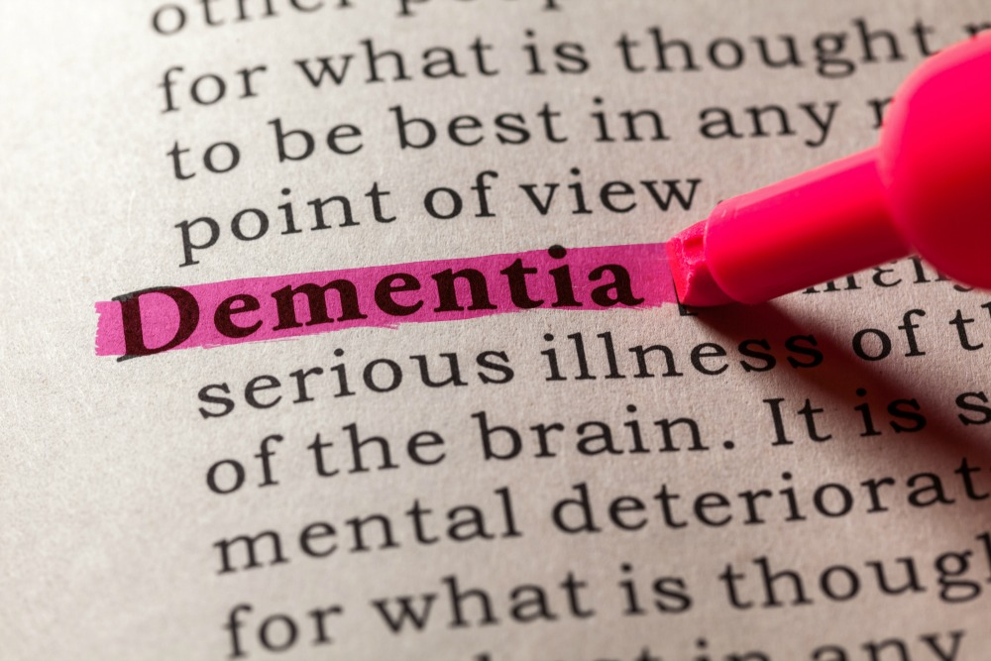

Contents page
Title page…p.1
Contents page…p.2
Introduction…p.3
Search strategy…p.4
Review…p.5-p.8
Conclusion…p.9
Reference list…p.10-p.12

Introduction
A widely accepted definition of dementia is a chronic or persistent disorder of the mental processes caused by brain disease or injury and marked by memory disorders, personality changes, impaired reasoning (Oxford Languages). For this task It is vital to research a number of different sources in order to gain a good understanding on this topic, it is important to research this topic as there is many complex discussions to be had within this topic, it is important to research information from sources with different backgrounds in order to make conclusions that are not influenced by individual sources- this is important as you need to consider different sources to choose which one is most relevant. It is important to use Evidence-based practice, this can be defined as a procedure that includes the best available research, professional expertise, and input from youth and families to identify and deliver services that have been demonstrated to achieve positive outcomes for youth, families, and communities (Administration for children and families). This report will focus on one chosen article and will look into the methods that the article uses, any ethical issues, any study samples used and also look and consider the findings found during the research.
In order to establish a search strategy, it is vital to consider a number of key terms, to write this study I used the journal search library website JSTOR, this brought up many topics that were relevant to topic and helped me gain a wide variety of different sources. I narrowed down the search’s to only find only the most relevant information by using the provided search filters- I made sure I limited searches to only journals and I made sure all searches were within in the last ten years in order to only find to articles that were up to date and relevant to a modern day era- it is important to do this so the article I discuss are relevant to the topic and can also be applied to the modern world. . This gave my over 30,000 different journals to choose from and I then read a number of these articles in order to gain a good level of understanding of which articles would be most useful to include in this report. It was important that all articles were relevant to effects of an evidence-based approach on dementia.
Article background
The journal that this essay will focus on is a journal written by Lindsey Clemson in 2018- this is important as it is a recently written article so it is most likely still relevant to this day, it is important to note that this was written before the covid 19 pandemic so this could possibly also differ to how things are currently. This journal discusses evidence-based care on dementia patients and tries to reach conclusions on if it improves the quality of life of dementia patients and also the carer’s whose job it is to look after them. The article discusses a study conducted in Australia and the key aim of this study was to be able to find out the strategies and processes that enable the Care of People with dementia in their Environments
program (The article refers to this as the COPE program) to be implemented into existing dementia care services in Australia- this could be somewhat of a problem
with the study as it could be different within the UK, but the results would likely be similar if they were conducted within the UK as Australia isn’t too dissimilar to the UK. The article defines the COPE program as an effective non-pharmacological treatment that reduces functional disability and changed behaviours in people with dementia- the article also mentions that a negative to programs like the COPE program are that they are not widely available.

Methodology and methods
This article discusses the study used. The article says that in order to conduct the study they used a mixed methods approach to test an implementation strategy. The COPE intervention (up to ten consultations with an occupational therapist and up to two consultations with a nurse) will be put in place with a number of strategies, an example being planning (such as developing and building relationships with dementia care community service providers), an increased level of teaching putting more time into training professionals in how to apply the intervention), restructuring (organisations establishing referral systems; therapist commitment to provide COPE to a number of different patients after training) and also a higher level of quality management (better coaching, support, reminders and fidelity checks). It was important to keep both Qualitative and quantitative data in order to gain the best possible understanding of how the COPE procedure was adopted and implemented. Feasibility, fidelity, acceptability, uptake and service delivery contexts needed be researched and a cost/benefit assessment needed to be conducted in order to find out if it could be done with the resources available. Client outcomes of activity engagement and caregiver wellbeing needed to be assessed in a evaluation at the end of the study.

Study Sample
The article mentioned that the research team had made prior agreements with around 10 to 20 different organisations or individual services to gain access to possible participants. All organisations will provide services for people with dementia and will employ occupational therapist- this helps give a good sample size as the study will have access to different participants from different organisations which makes the study more representative.
Occupational therapists and nurses who worked at the organisations involved were be put forward to take part in the study by their participating organisation. Participating occupational therapists and nurses will attend training and will be asked to select five people with dementia and their carers to take part in the study. They will deliver the intervention with these five people and their careers and provide data on these clients for the purposes of the project. The study also made sure to get at least 30 therapists to participate- this allowed the study to be more representative and also increased the validly of results while also making room for dropouts and other circumstances which may prevent therapists from providing the COPE program to five dementia patients.

Ethics

Be wary of the ethical issues of a study is very important while conducting a study such as the one mentioned in the study (David B. Resnik, J.D., Ph.D)
If a study so not ethically conducted, then it may hold less weight and be viewed by others as morally wrong- this will cause it to reduce support and acceptance from the public of the findings from a study. In the study mentioned it is particularly important that the conductor is wary of any ethical issue that may occur during the study- perhaps the most important potential ethical issue about this study is consent- people who struggle with dementia may not be in a position to consent to this study. The journal mentions that they were wary of this during the study- a quote from the study that mentions how they dealt with these potential issues is ‘Participants deemed to be unable to consent will still be included in discussion about the study and verbal assent will be obtained as well as proxy consent.’ It is also important to keep participants anonymous in order protest their data during this study

Evaluation
it is important to evaluate the advantage and disadvantages to an evidence-based approach to treatment. A huge positive is that evidence based practice include the ability change and also to make it so treatment is more unique to each individual, it is also important as it may reduce the cost of treatment ( Morgan Knowles 2018). Knowles (2018) also continues to discuss advantages and states that Evidence-based practice has contributed more to advancement of healthcare, causing every method of care to be based on the best available credible evidence and to restrict the opinions of experts to be taken only as opinions rather than proven facts quote from the article written by Knowles discusses credible evidence as:. “Credible evidence is a combination of findings from a study that must include research documentation of accuracy, validity, appropriateness of data, verification and corroboration of multiple data sources, and validation of data findings by professional research colleagues.”
An article written by pha an article written by Pharbara Wittin 2018 discusses the advantages of this method. The article discusses the high amount time and money used in order to get this method right. The article also mentions insurance complies can make it difficult for this method to work as the risks involved of the method now working can cost a lot of a money.

Conclusion

In conclusion, this study is set up very well. It considers all ethical issues possible and goes out of its way to make sure that it is following moral guidelines. The studies sampling methods are also a key strength as they ensure that the study is representative by choosing a large sample size or people with different backgrounds. In conclusion we can also establish that there are many positives and negatives to an evidence-based approach.

Reference list
In Case You Haven't Heard… - 2020 - Mental Health Weekly - Wiley Online Library (uwtsd.ac.uk)
In Case You Haven't Heard… (uwtsd.ac.uk)
David, H., 2017. Evidence Based Practice. [online] Administration for children a family. Available at: <https://www.acf.hhs.gov/sites/default/files/fysb/evidencebasedpractice20120829.pdf#:~:text=Evidence-based%20practice%20is%20a%20process%20that%20brings%20together,achieve%20positive%20outcomes%20for%20youth%2C%20families%2C%20and%20communities.> [Accessed 8 June 2021].
Clemson, L., 2018. Implementation of an evidence-based intervention to improve the wellbeing of people with dementia and their carers: study protocol for 'Care of People with dementia in their Environments (COPE)' in the Australian context. [online] Available at: <https://pubmed.ncbi.nlm.nih.gov/29739358/> [Accessed 9 June 2021].
Watt, P. (2018). General Practitioners' Code of Conduct. Retrieved 21 June 2021, from https://www.ehow.co.uk/facts_7630972_general-practitioners-code-conduct.html

Evidence-Based Practice: Advantages & Disadvantages. (2017, July 6). Retrieved from https://study.com/academy/lesson/evidence-based-practice-advantages-disadvantages.html.

Resnick, D., 2018. What Is Ethics in Research & Why Is It Important? - by David B. Resnik, J.D., Ph.D.. [online] National Institute of Environmental Health Sciences. Available at: <https://www.niehs.nih.gov/research/resources/bioethics/whatis/index.cfm> [Accessed 21 June 2021].

