
IMPLEMENTATION PLAN
IRINA KITLEY 2219546

January 12, 2026
University of Wales Trinity Saint David

Summary
This implementation plan addresses the persistent gender imbalance in mechanical engineering in the UK and Romania, with a particular focus on women’s progression into leadership roles. Drawing on contemporary leadership theory, comparative national analysis and evidence from education and organisational research, the plan demonstrates that underrepresentation is not driven by women’s ability or aspiration, but by systemic barriers embedded in education pathways, organisational practices, power structures and workplace culture. The contrast between the UK’s low participation and high attrition rates and Romania’s relatively strong STEM pipeline but limited leadership outcomes highlights the need for an integrated and context-sensitive approach.

The plan proposes a set of SMART objectives supported by a phased timeline, a Gantt chart and a detailed action plan. Key interventions include early identity-building educational initiatives, retention-focused organisational redesign, transparent progression systems, sponsorship-based leadership development and mechanisms to strengthen psychological safety and employee voice. Framed by the Four V’s model of ethical leadership, the plan emphasises alignment between values, vision and everyday leadership behaviour. By combining educational reform with organisational accountability and long-term governance, the implementation plan offers a realistic and sustainable route to improving gender balance, leadership diversity and workforce resilience within mechanical engineering across both national contexts.

Table of Contents
Summary 1
Table of Figures 2
1. Implementation Plan 3
1.1 Introduction 3
2. Rationale 4
2.1 Aims and Objectives 4
2.2 Action Plan 5
2.2.1 Time Plan 6
2.2.2 Risk Management and Strategies 7
3.Recommendations 8
4.Conclusion 9
Bibliography 10
Appendix 14
Appendix 1 14
Appendix 2 15
Appendix 3 16
Appendix 4 17

Table of Figures
Figure 1 – Gender Gap in Engineering in the UK 3
Figure 2 – Proposed Action Plan 5

Implementation Plan

Introduction

Leadership in contemporary organisations is increasingly framed as a social and ethical practice rather than a purely positional function, with emphasis on inclusive cultures, communication, self-awareness and the responsible use of power (Rees and Porter, 2015; Armstrong, 2016; Mullins and Christy, 2016; Yukl and Gardner, 2020; Northouse, 2021). These themes are highly salient in mechanical engineering, where gendered occupational norms and informal power networks can shape who is seen as “credible” and who progresses into leadership. Recent research shows that gender imbalance in STEM is sustained less by capability differences than by stereotypes, organisational cues, and inclusion climates that influence belonging and persistence (Verdugo-Castro, García-Holgado and Sánchez-Gómez, 2022; Hall, 2023). A UK–Romania comparison illustrates why leadership must be analysed contextually: Romania has one of the EU’s highest shares of women among tertiary STEM graduates (Eurostat, 2024), yet this does not automatically translate into leadership representation, suggesting barriers in organisational culture, progression systems and political dynamics (Oncioiu, 2023).

The UK, meanwhile, continues to report persistent underrepresentation of women across engineering and mid-career attrition, indicating that retention and advancement are as critical as recruitment, with evidence showing a small, worrying decline in women aged 35–44 remaining in engineering roles (EngineeringUK, 2024; EngineeringUK, 2025). These patterns suggest that systemic and cultural dynamics within organisations influence women’s progression to leadership roles as much as early education and entry rates (House of Commons Science and Technology Committee, 2023; EngineeringUK, 2025). In both contexts, addressing gender imbalance therefore requires leadership approaches that align values and systems: how talent is developed, sponsored, evaluated, and heard, with ethical consistency and cultural change.

Figure 1 – Gender Gap in Engineering (UK)
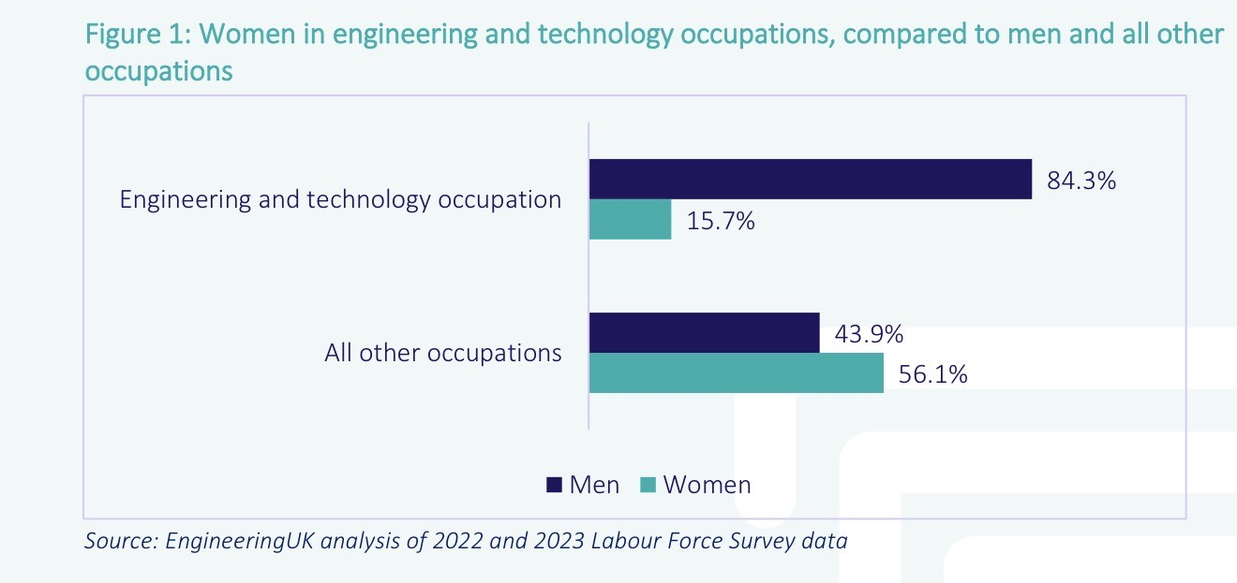

2. Rationale
A targeted implementation plan is necessary because gender imbalance in mechanical engineering is sustained by systemic, multi-level barriers rather than a simple lack of interest or ability. UK evidence shows women remain persistently underrepresented in engineering and the gains made over time have been slow and fragile, indicating that attraction alone is insufficient without stronger retention and progression structures (Horton, 2023). Internationally, recent research continues to show that women’s participation and progression in STEM is shaped by cultural expectations, stereotypes and institutional conditions that influence belonging and persistence (Martínez, 2023). In addition, the leadership gap reflects well-evidenced constraints in organisational opportunity structures, such as biased advancement systems, limited sponsorship, and barriers embedded in organisational culture, rather than uniform differences in women’s aspirations (Galsanjigmed and Sekiguchi, 2023).

2.1 Aims and Objectives

The aim of this implementation plan is to increase the participation, retention and progression of women into leadership roles in mechanical engineering in the UK and Romania through ethical, inclusive and evidence-based leadership and organisational practices.

Objectives:
Increase participation:
1.By 2029, increase female enrolment in mechanical engineering pathways (degrees and apprenticeships) by 10% in the UK and 5% in Romania, measured annually using national education and workforce data.

Improve retention:
2.By 2028, reduce mid-career attrition of women in mechanical engineering roles by 15% in participating organisations, measured through turnover and exit data.

Strengthen leadership progression:
3.By 2030, increase the proportion of women in technical leadership and first-line management roles in mechanical engineering by 20% within organisations implementing the plan, measured through internal promotion data.

Enhance organisational culture:
4.By 2027, achieve a minimum 15% improvement in employee survey indicators related to psychological safety, inclusion and leadership fairness in participating organisations, benchmarked against baseline measurements.

2.2 Action Plan

Figure 2 – Proposed action plan
Action | Objective | Timeline | Stakeholders | Support | Key risks
1.Inclusive ME identity modules in secondary education | Increase participation | 36 months | School, Universities, employers, education ministries | Teacher training, outreach funding, employer ambassadors | Low uptake mitigated by curriculum alignment and incentives
2.Annual ME science and visibility days for girls | Increase participation | 12-60 months | Universities, professional bodies, employers | Facilities, transport funding, communications | Tokenism mitigated through follow-up activities
3.Retention hotspot analysis and targeted interventions | Improve retention | 6-48 months | HR, senior leadership, line managers | HR analytics, coaching, employee voice systems | Manager resistance mitigated through accountability
4.Sponsor-led leadership pathways and critical assignments | Leadership progression | 6-60 months | Senior leaders, HR, engineering directors | Transparent criteria, monitoring tools | Bias mitigated through promotion calibration
5.Transparent promotion frameworks and calibration panels | Leadership progression | 6-60 months | HR, executive leadership | Policy development, governance oversight | Inconsistent use mitigated through audits

The SMART action plan consolidates the objectives designed to address gender imbalance in mechanical engineering through systemic, evidence-based interventions. Increasing female participation in mechanical engineering pathways requires early and sustained educational engagement that strengthens girls’ STEM identity and sense of belonging. Research demonstrates that outreach programmes combining hands-on learning, visible role models and curriculum integration significantly improve girls’ interest and intentions towards engineering, particularly when implemented before key subject-choice transitions (Sáinz,Garcia-Cueto and Meneses, 2022; Prieto-Rodríguez, Gore and Holmes, 2022). Nationally coordinated approaches, such as Finland’s STEM strategy and LUMA Centre network, show that long-term, teacher-supported interventions can be scaled effectively and contribute to comparatively strong female participation in STEM education (Mäkelä et al., 2022; European Commission, 2025).
Improving retention, especially at mid-career stages, addresses a critical leakage point. Evidence indicates that women’s exits from engineering are strongly linked to inflexible work design, lack of recognition and exclusionary cultures rather than reduced commitment (McKie and Jyrkinen, 2024). Structured returner programmes and retention “hotspot” interventions have been shown to facilitate re-entry and reduce attrition when organisational support and credible progression routes are provided (Women in STEM, 2021; UK Government, 2024).
Strengthening progression into leadership roles requires deliberate redesign of recruitment, promotion and development systems. Studies show that structured interviews, transparent promotion criteria and calibrated decision-making reduce gender bias compared with informal or network-driven processes (Kith, Eikmann and Melchers, 2022; Hing, Bobocel and Zanna, 2023). In addition, sponsorship (distinct from mentoring), has been empirically linked to improved access to high-visibility assignments and leadership advancement for women in male-dominated fields (Gröschl, 2024; Xu, 2024).
Finally, enhancing organisational culture underpins all other objectives. Evidence from organisational research indicates that psychological safety, effective speak-up mechanisms and inclusive leadership practices are associated with improved employee voice, reduced misconduct risk and more equitable outcomes, particularly when leadership accountability is explicit (O’Donovan, McAuliffe and DeBrun, 2020; Dietl, Dierksen and Lang, 2023). Together, this evidence base demonstrates that the SMART action plan objectives are not aspirational but grounded in interventions that have proven effective across multiple national and organisational contexts, making them both feasible and ethically robust for implementation in the UK and Romania.

2.2.1 Time Plan

The implementation timeline for the proposed actions is structured to balance early impact with long-term sustainability, reflecting evidence on effective organisational and educational change. In the first 6 months, foundational activities focus on governance, baseline data collection, curriculum design, and the development of transparent recruitment and promotion frameworks. This phase establishes ethical and structural consistency across participating institutions (O’Donovan et al., 2020)..
Between 6 and 18 months, pilot initiatives are rolled out, including inclusive mechanical engineering identity modules in schools, university-led outreach events, returner programmes, sponsorship schemes, and leadership micro-learning for managers. This stage prioritises experimentation, feedback and early cultural signalling (CIPD, 2022).
From 18 to 36 months, successful pilots are scaled and embedded, with retention hotspot analysis, calibrated promotion panels and speak-up mechanisms becoming routine organisational practices (Ahmed and Sadiq, 2025).
Finally, the 36–60 month phase focuses on consolidation, policy alignment, benchmarking and longitudinal evaluation to ensure durability and transferability across the UK and Romanian contexts. This phased timeline supports behavioural change, reduces implementation risk and enables continuous learning (European Commission, 2023). The Gantt chart can be found in Appendix 3.

2.2.2 Risk Management and Strategies

The action plan carries several implementation risks that require proactive mitigation. A key risk is organisational resistance, particularly from middle managers who may perceive inclusion initiatives as competing with operational priorities or meritocratic norms. Research shows that change efforts fail when accountability and incentives are misaligned; this risk can be mitigated by embedding inclusion goals into performance management and leadership evaluation (Beer, 2020).
A second risk is symbolic or performative adoption, where actions such as outreach or sponsorship exist without altering underlying power structures. Evidence suggests that diversity initiatives are more effective when framed as systemic change rather than compliance activities (Dobbin and Kalev, 2021).
A further risk concerns psychological safety, as employees may be reluctant to use speak-up mechanisms due to fear of retaliation; this can be mitigated through visible senior role-modelling and consistent responses to reported concerns (Edmondson, 2023).
Finally, policy fragmentation between education, industry and government may limit long-term impact; coordinated governance and monitoring frameworks are therefore essential (OECD, 2021).

3.Recommendations
There is strong international evidence that early, sustained educational interventions combining role models, applied learning and teacher support can positively influence girls’ interest in engineering and related STEM careers. Large-scale evaluations demonstrate that hands-on engineering activities and exposure to real engineers significantly improve girls’ self-efficacy and intention to pursue engineering pathways, particularly when interventions occur before subject specialisation (EngineeringUK, 2023; Clavert, 2024). Finland provides a well-documented example of success through its nationally coordinated LUMA STEM strategy, which integrates teacher professional development, university outreach and long-term funding, resulting in consistently high female participation in STEM education (Mäkelä et al., 2022).

At organisational level, evidence shows that structured recruitment and promotion processes reduce gender bias in male-dominated professions. Studies demonstrate that structured interviews and transparent promotion criteria are significantly less prone to discrimination than informal or unstructured decision-making, supporting the inclusion of calibrated promotion panels and standardised criteria in the action plan (Kith et al., 2022; Xu, 2024). These mechanisms directly address informal power dynamics that often limit women’s access to leadership roles.

Retention-focused initiatives such as returner programmes have also shown positive outcomes. UK evaluations of STEM returnship schemes indicate high re-entry and retention rates for women returning after career breaks, alongside improved confidence and skill utilisation, making them an effective and scalable intervention (UK Government, 2024).

Progression into leadership is further supported by evidence distinguishing sponsorship from mentoring. Recent research shows that sponsorship—where senior leaders actively advocate for women’s advancement and allocation to high-visibility projects—has a measurable impact on promotion outcomes and leadership representation (Gröschl, 2024). Finally, interventions that strengthen psychological safety and speak-up cultures are associated with improved inclusion, reduced misconduct risk and stronger employee voice, particularly when leadership accountability is embedded (Jones et al., 2021). Together, this evidence demonstrates that the proposed actions are grounded in proven practice and adaptable across national contexts such as the UK and Romania.

4.Conclusion

This implementation plan has demonstrated that gender imbalance in mechanical engineering is not the result of individual deficit but of interconnected educational, organisational and cultural systems that shape participation, retention and leadership progression (EngineeringUK, 2024). The comparative analysis of the UK and Romania highlights that while access to STEM education is necessary, it is insufficient without aligned organisational practices, ethical leadership and sustained cultural change. The recommendations emphasise the importance of inclusive education pathways, transparent progression systems, sponsorship-based leadership development and psychologically safe organisational environments that enable women to remain and progress within the sector. Framed through the Four V’s model of ethical leadership, the plan underscores the need to align values and vision with consistent action and employee voice, ensuring that ethical intentions are translated into everyday leadership practice (Batz-Barbarich, Strah and Tay, 2024).
The SMART objectives, phased timeline and action plan provide a realistic and evidence-based route for implementation, balancing early intervention with long-term sustainability. Overall, the analysis reinforces that meaningful progress depends on leadership accountability, systemic redesign and the rejection of persistent assumptions about women’s aspirations in engineering. By embedding ethical leadership principles into policy and organisational practice, institutions and employers in both the UK and Romania can create more inclusive, resilient and effective mechanical engineering sectors (Dogaru, 2025).

Bibliography

Ahmed, S.Y. and Sadiq, M. (2025) ‘Effects of gender diversity, inclusive leadership, and psychological safety on contextual performance: exploring moderating role of cultural and social norms’, Population Review, 64(1), pp. 1–21.
Armstrong, M. (2016) Armstrong’s Handbook of Management and Leadership for HR: Developing Effective People Skills for Better Leadership and Management. Kogan Page.
Barber, J. and McCann, G. (2021) ‘Refining our Leadership Roles in Changing Times’, Trusts and Estates, pp.48.
Batz-Barbarich, C., Strah, N. and Tay, L. (2024) ‘The impact of changing engineering perceptions on women’s attitudes and behavioral intentions towards engineering pursuits’, International Journal of STEM Education, 11(23).
Beer, M. (2020) ‘Why leadership training fails—and what to do about it’, Harvard Business Review, 98(1), pp. 50–57.
Chartered Institute of Personnel and Development (CIPD) (2022) Inclusion at work: Perspectives on progressing diversity, equity and inclusion. Available at: https://www.cipd.org/uk/knowledge/reports/inclusion-at-work/ (Accessed 3 January 2026).
Chartered Institute of Personnel and Development (CIPD) (2024) Trust and psychological safety: An evidence review (Scientific summary). Available at: https://www.cipd.org/globalassets/media/knowledge/knowledge-hub/evidence-reviews/2024-pdfs/8550-psychological-safety-scientific-summary.pdf(Accessed 2 January 2026).
Chiriac, A. (2021) Women in Leadership: Challenges and Opportunities in the Romanian Business Environment. Editura ASE.
Clavert, M. (2024) ‘Increasing interest towards engineering in the context of university-led STEM outreach activities’, European Journal of Engineering Education, 49(2), pp. 215–231. Available at: https://www.tandfonline.com/doi/full/10.1080/03043797.2024.2440080(Accessed 4 January 2026).
Dârloșan, R. (2022) Leadership and Gender Equality in Romanian Organisations: A Contemporary Approach. Presa Universitara Clujeana.
Dietl, J.E., Derksen, F. and Lang, A. (2023) ‘How psychological safety fosters communication and increases safety’, Human Factors, 65(6), pp. 1012–1026.
Dobbin, F. and Kalev, A. (2021) ‘The promise and peril of sexual harassment programs’, Proceedings of the National Academy of Sciences, 118(41), e2109439118. https://doi.org/10.1073/pnas.2109439118.
Dogaru, M. (2025) ‘STEM career: essential factors for students’ Frontiers in Education, 43(1).
Dos Santos, L.M. (2022) ‘Female engineering students’ motivations, career decisions and decision-making processes: A Social Cognitive Career and Motivation Theory’, International Journal of Instruction, 15(4), pp. 437–454.
Edmondson, A.C. (2023) Right Kind of Wrong: Why Learning to Fail Can Teach Us to Thrive. Picador.
EngineeringUK (2023) Rapid evidence review: Girls’ STEM aspirations. Available at: https://www.engineeringuk.com/media/aeukdtqr/rapid-evidence-review-girls-stem-aspirations-engineeringuk-june-2023.pdf (Accessed 4 January 2026).
EngineeringUK (2024) Women in engineering and diversity challenges. Available at: https://www.engineeringuk.com/research-and-insights/industry-and-workforce/women-in-engineering-and-diversity-challenges/ (Accessed 4 January 2026).
EngineeringUK (2025) Engineering and technology workforce – May 2025 update. Available at: https://www.engineeringuk.com/research-and-insights/our-research-and-evaluation-reports/engineering-and-technology-workforce-may-2025-update/ (Accessed 4 January 2026).
European Commission (2023) She figures 2023: Gender in research and innovation. Publications Office of the European Union. Available at: https://research-and-innovation.ec.europa.eu/statistics/she-figures_en(Accessed 4 January 2026).
European Commission (2025) Education and Training Monitor 2025: Finland. Publications Office of the European Union.
Eurostat (2024) ‘Women totalled almost a third of STEM graduates in 2021’. Eurostat News (8 March). Available at: https://ec.europa.eu/eurostat/web/products-eurostat-news/w/ddn-20240308-2 (Accessed 11 January 2026).
Ewim, D.R.E. and Dosunmu, A.G. (2025) ‘Bridging gaps: the intersection of women in engineering and gender studies — challenges, advances, and future directions’, Discover Engineering, 3(43).
Galsanjigmed, E. and Sekiguchi, T. (2023) ‘Challenges women experience in leadership careers: An overview and future directions’, Administrative Sciences, 13(2), 21. Available at: https://www.mdpi.com/2673-8104/3/2/21 (Accessed 7 January 2026).
Gröschl, S. (2024) ‘The emergence and effects of sponsors for women leaders’, Gender, Work & Organisation, 31(2), pp. 455–472. https://doi.org/10.1111/gwao.13217.
Hall, W. (2023) ‘Collectively constructing gender-inclusive work cultures in STEM’. European Review of Social Psychology, 34(1), pp. 1–45. Available at: https://www.tandfonline.com/doi/full/10.1080/10463283.2022.2109294 (Accessed 3 January 2026).
Hing, L.S.S., Bobocel, D.R. and Zanna, M.P. (2023) ‘Gender inequities in the workplace: A holistic review of bias in evaluation and treatment’, Organisational Behavior and Human Decision Processes, 176, pp. 104–127.
Horton, J. (2023) Trends in women in the engineering workforce between 2010 and 2021 (UK Data Service working paper). Available at: https://ukdataservice.ac.uk/app/uploads/horton2023-02-02.pdf (Accessed 11 January 2026).
House of Commons Science and Technology Committee (2023) Diversity and inclusion in STEM: Government response (report). Available at: https://publications.parliament.uk/pa/cm5803/cmselect/cmsctech/1427/report.html(Accessed 8 January 2026).
Kith, S., Eikmann, A. and Melchers, K.G. (2022) ‘The structured interview’s resistance to gender discrimination in highly gendered jobs’, International Journal of Selection and Assessment, 30(3–4), pp. 388–402.
Mäkelä, T., Helfenstein, S., Lerkkanen, M.K. and Poikkeus, A.M. (2022) ‘Enablers and constraints of a nationwide STEM programme: Lessons from Finland’, Frontiers in Education, 7, 856640.
Martínez, M.(2023) ‘The gender gap in STEM careers: An inter-regional and experimental analysis’, Education Sciences, 13(7), 649. Available at: https://www.mdpi.com/2227-7102/13/7/649(Accessed 11 January 2026).
McKie, L. and Jyrkinen, M. (2024) ‘Women returners and re-entry to professional work’, Sociology, 58(5), pp. 1043–1060.
Mitroi-Luca, G. (2025) ‘Gender equality in Romania: challenges and progress’, Journal of European Social Policy, 32(1).
Mullins, L.J. and Christy, G. (2016) Management and Organisational Behaviour. 11th edn. Pearson.
Northouse, P.G. (2021) Leadership: Theory and Practice. 9th edn. Thousand Oaks.
O’Donovan, R., McAuliffe, E. and De Brún, A. (2020) ‘Interventions to improve speaking up and voice behaviour in organisations: A systematic review’, BMC Health Services Research, 20(101).
OECD (2021) Bridging the digital gender divide: Include, upskill, innovate. OECD Publishing. https://doi.org/10.1787/5890a0c8-en
Oncioiu, I. (2023) Female Entrepreneureship and Management in the Digital Era: The Case of Romania. Editura Economica.
Pânișoară, G. and Pânișoară, I.O. (2021) Management of Human Resources. 4th edn. Polirom.
Prieto-Rodríguez, E., Gore, J. and Holmes, K. (2022) ‘The impact of outreach interventions on secondary students’ STEM identity’, Gender and Education, 34(6), pp. 745–763.
Rees, W.D. and Porter, C. (2015) Skills of Management and Leadership: Managing People in Organisations. Bloomsbury Academic.
Royal Academy of Engineering (2023) Equality, Diversity and Inclusion: Evidence Review. Royal Academy of Engineering.
Sáinz, M., García-Cueto, E. and Meneses, J. (2022) ‘Interventions to increase young people’s interest in STEM: A scoping review’, Frontiers in Psychology, 13, 954996.
Smith, N.E. (2023) ‘Examining the Effectiveness of Gender Equity Initiatives to Change Organisational Culture in Engineering: Lessons from New Zealand’, Proceedings of the Institution of Mechanical Engineers, Part E: Journal of Process Mechanical Engineering, 237(1), pp. 45–55.
UK Government (2024) STEM ReCharge programme evaluation. Department for Science, Innovation and Technology. Available at: https://www.gov.uk/government/publications/stem-recharge-programme-evaluation(Accessed 5 January 2026).
Verdugo-Castro, S., García-Holgado, A. and Sánchez-Gómez, M.C. (2022) ‘The gender gap in higher STEM studies: A systematic literature review’, Heliyon, 8(8), e10300. Available at: https://pubmed.ncbi.nlm.nih.gov/36090203/ (accessed 3 January 2026).
Women in STEM (2021) Sector collaboration gets returners back on track. Available at: https://www.womeninstem.co.uk(Accessed 2 January 2026).
Wyatt, S. (2020) Leadership and Management in the 4’th Industrial Revolution, Kogan.
Xu, J. (2024) ‘The gender gap in executive promotions’, Labour Economics, 88, 102417.
Yukl, G. and Gardner, W.L. (2020) Leadership in Organizations. 9th edn. Pearson.
Zbuchea, A. and Brătianu, C. (2022) Contemporary Management and Leadership in Romania. Tritonic.

Appendix

Appendix 1

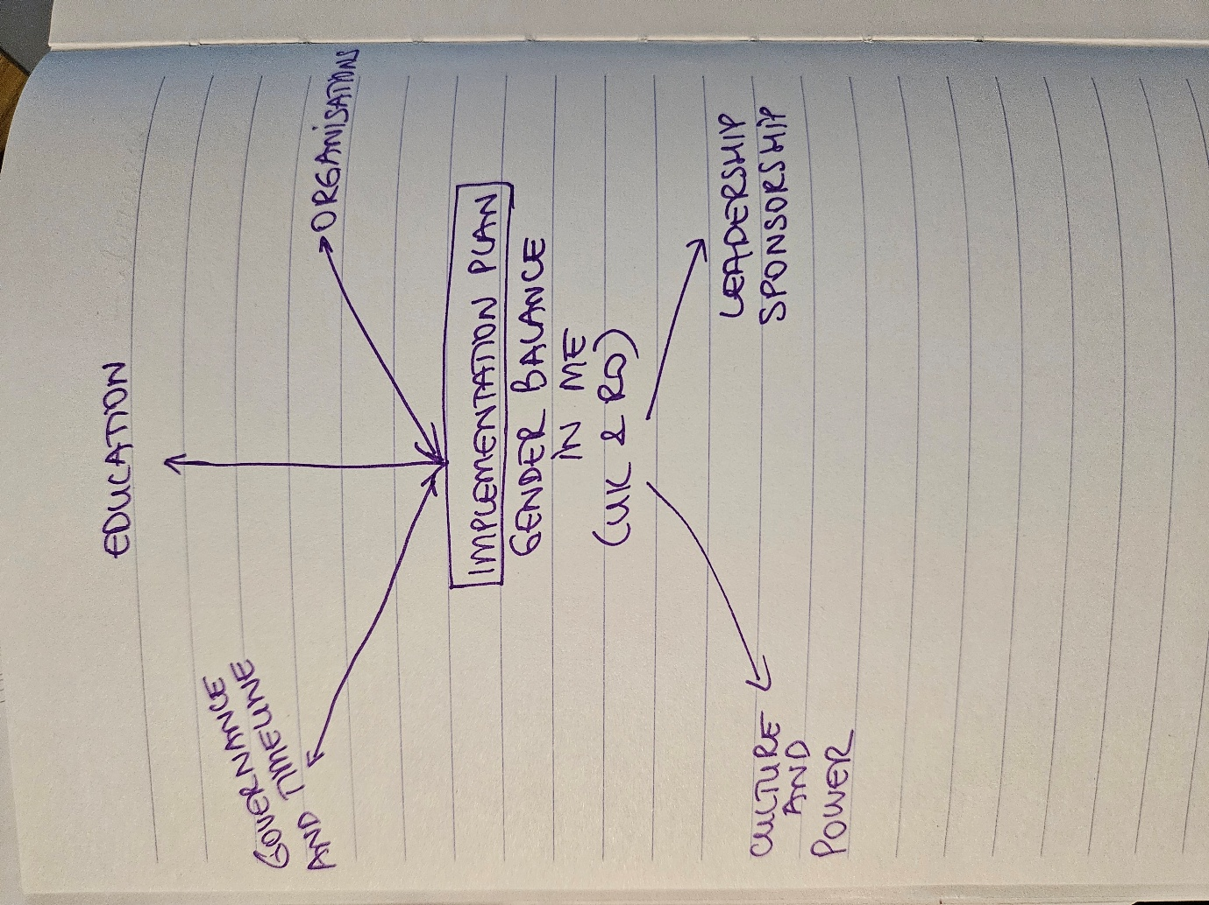

Appendix 2
Leadership Roles by Gender in Mechanical Engineering
(Royal Academy of Engineering, 2023)

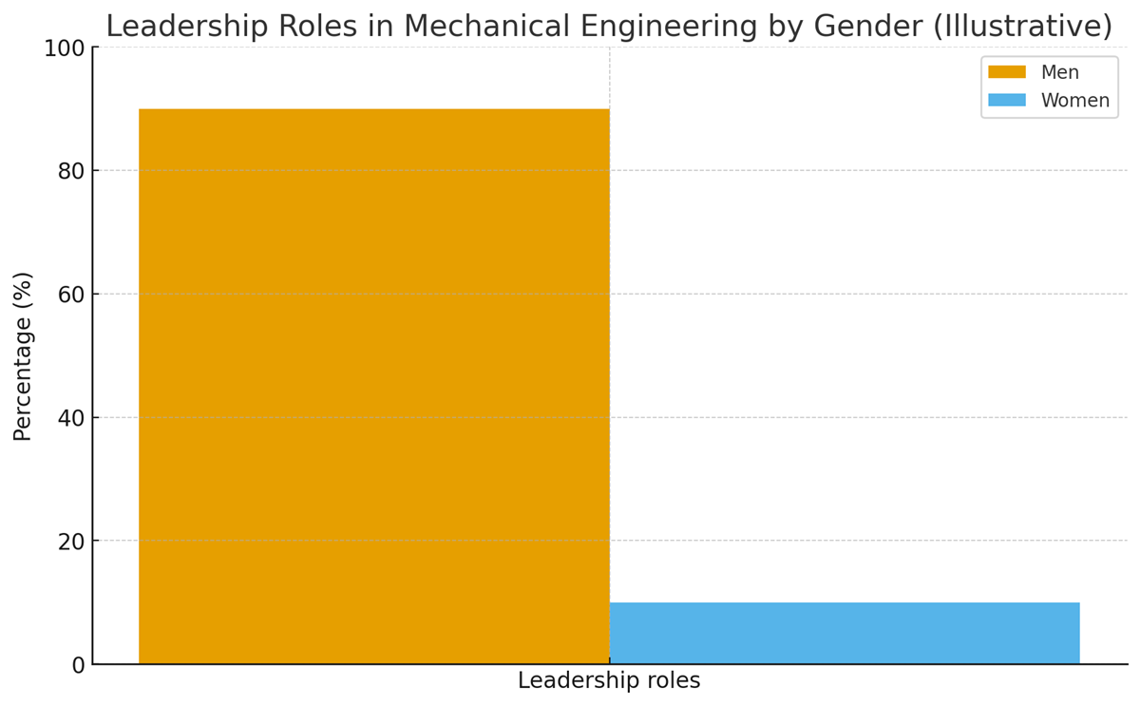

Appendix 3

The Gantt chart illustrates the phased implementation timeline for the recommendations set out in this report. Education and visibility interventions are prioritised in the early stages to address identity formation and public perception, followed by organisational reforms focused on retention, leadership progression, and cultural change. Policy alignment and benchmarking extend across the later phases to ensure sustainability and accountability.
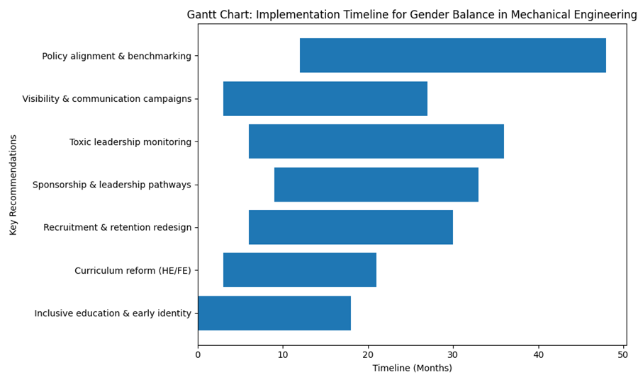

Appendix 4

4-V Model Element | How it links to women leaders in Mechanical Engineering | Why it matters now
Values | Female engineers often bring strong focus on safety, sustainability, inclusiveness and user-experience in design. | Mechanical engineering increasingly requires ethical decision-making: AI-driven systems, autonomous vehicles, automation impacts on workers.
Vision | Women leaders tend to emphasise human-centred innovation, mentoring and long-term societal benefit. | supports net-zero technologies, accessible design + gender-inclusive safety standards.
Voice | Women in leadership roles give visibility, challenge biases, and reshape masculine cultures. | Inspires more women into mechanical engineering → fixing the pipeline.
Virtue | Women often advocate transparency, fairness and accountability in organisations. | Strengthens ethical climate, reduces attrition and improves leadership legitimacy.
The 4 V Model

(Smith, 2023; Ewim and Dosumnu, 2025)

