Name:_Noah John________________________________

Student Number: _2502346_______________________
__________________________________________________________

WORKSHEET 3 – TESTING (Lap Times)

- Original code:
[Copy and paste your original code from Moodle into this box. Do not change it.]

lapTimes = []
laps = 1

print("Enter your lap times (in seconds):")

for counter in range(0,5,1):
lapTimes.append(float(input("Lap {}:".format(laps))))
while lapTimes[counter] > 10000 or lapTimes[counter] < 7:
lapTimes.pop()
lapTimes.append(float(input("Please enter a valid time for lap {}:".format(laps))))
laps = laps + 1

targetTime = float(input("What is your target lap time:"))
while targetTime > 10000 or targetTime < 7:
targetTime = float(input("Please enter a valid target lap time:"))

print("Your statistics:")
lapSum = sum(lapTimes)
print("1. Overall lap time for 5 laps was: {}".format(lapSum))

lapAverage = lapSum / 5
print("2. Average lap time was: {}".format(round(lapAverage,2)))

amountOfMinLaps = 0
lapMin = min(lapTimes)
for counter in range(0,len(lapTimes),1):
if lapTimes[counter] == lapMin:
lapNo = counter
lapTime = lapTimes[counter]
amountOfMinLaps = amountOfMinLaps + 1

if amountOfMinLaps > 1:
print("3. You had {} laps that was equally slow at {} seconds".format(amountOfMinLaps, lapMin))
else:
print("3. The fastest lap was lap {} in {} seconds".format(lapNo, lapTime))

amountOfMaxLaps = 0
lapMax = max(lapTimes)
for counter in range(0,len(lapTimes),1):
if lapTimes[counter] == lapMax:
lapNo1 = counter
lapTime1 = lapTimes[counter]
amountOfMaxLaps = amountOfMaxLaps + 1

if amountOfMaxLaps > 1:
print("4. You had {} laps that was equally slow at {} seconds".format(amountOfMaxLaps, lapMax))
else:
print("4. The slowest lap was lap {} in {} seconds".format(lapNo1, lapTime1))

targetLapBeat = 0
for counter in range(0,len(lapTimes),1):
if lapTimes[counter] <= targetTime:
targetLapBeat = targetLapBeat + 1
else:
continue
print("5. {} of your laps were better than or equal to your target".format(targetLapBeat))

print("6.")
for counter3 in range(0,len(lapTimes),1):
if counter3 == 0:
print("Lap {} was {}".format(counter3 + 1,lapTimes[counter3]))
elif lapTimes[counter3] == lapTimes[counter3 - 1]:
print("Lap {} was {} which was equal to the previous lap".format(counter3 + 1, lapTimes[counter3]))
elif lapTimes[counter3] > lapTimes[counter3 - 1]:
print("Lap {} was {} which was slower than the previous lap".format(counter3 + 1, lapTimes[counter3]))
else:
print("Lap {} was {} which was faster than the previous lap".format(counter3 + 1, lapTimes[counter3]))

- Code Testing
For each test below, run your code and show the results of the scenarios below. Present a screenshot of what happened when the programme ran. Did the programme behave correctly or did it do something unexpected, and if so, why?

- Test a lap time for your programme:
- 42 seconds
- 2 seconds
- -4 seconds
- 53444 seconds
- Test the target lap time – show that the values entered are reasonable

- Using the same five lap times as the sample output ie

Lap 1: 42.3
Lap 2: 42.1
Lap 3: 44
Lap 4: 44
Lap 5: 39.4

Examine each statistic (1-6) and comment on whether the correct answer(s) are displayed or not. (If any statistics were incomplete after Phase 1 (code completed in class) simply write “Unfinished”)

- Test two further sets of lap times of your own choice.

Template for tests:
Test: a) i) 42 seconds

Screenshot(s) of output:
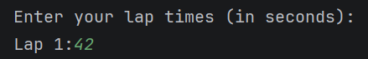
Result: Did the programme behave as expected ie syntactically and logically correct?
YES
If YES, comment on what happened.
If NO, what went wrong and why? Suggest how things could be improved

The input of 42 seconds was accepted by the program with no issues as designed.

Test: a) ii) 2 seconds

Screenshot(s) of output:
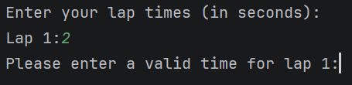
Result: Did the programme behave as expected ie syntactically and logically correct?
YES
If YES, comment on what happened.
If NO, what went wrong and why? Suggest how things could be improved

The input of 2 seconds was not accepted by the program as designed. The program asks the user to re-enter a valid input as a lap time of 2 seconds is not logically correct. This validation is achieved through this while loop:

while lapTimes[counter] > 10000 or lapTimes[counter] < 7:
lapTimes.pop()
lapTimes.append(float(input("Please enter a valid time for lap {}:".format(laps))))
Test: a) iii) -4 seconds

Screenshot(s) of output:
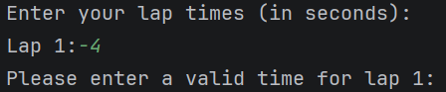
Result: Did the programme behave as expected ie syntactically and logically correct?
YES
If YES, comment on what happened.
If NO, what went wrong and why? Suggest how things could be improved

The input of -4 seconds was not accepted by the program as designed. The program asks the user to re-enter a valid input as a lap time of -4 seconds is not logically correct. This validation is achieved through this while loop:

while lapTimes[counter] > 10000 or lapTimes[counter] < 7:
lapTimes.pop()
lapTimes.append(float(input("Please enter a valid time for lap {}:".format(laps))))
Test: a) iv) 53444 seconds

Screenshot(s) of output:
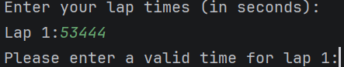
Result: Did the programme behave as expected ie syntactically and logically correct?
YES
If YES, comment on what happened.
If NO, what went wrong and why? Suggest how things could be improved

The input of 53444 seconds was not accepted by the program as designed. The program asks the user to re-enter a valid input as a lap time of 53444 seconds is not logically correct. This validation is achieved through this while loop:

while lapTimes[counter] > 10000 or lapTimes[counter] < 7:
lapTimes.pop()
lapTimes.append(float(input("Please enter a valid time for lap {}:".format(laps))))
Test: a) v) Test the target lap time – show that the values entered are reasonable

Screenshot(s) of output:
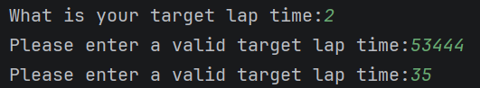
Result: Did the programme behave as expected ie syntactically and logically correct?
YES
If YES, comment on what happened.
If NO, what went wrong and why? Suggest how things could be improved

As demonstrated in the provided screenshot, the program will not accept illogical target lap times such as 2 or 53444 seconds and will ask the user to re-enter a valid input, in this instance, 35 seconds. This validation is achieved through this while loop:

while targetTime > 10000 or targetTime < 7:
targetTime = float(input("Please enter a valid target lap time:"))
Test: b) Using the same five lap times as the sample output ie

Lap 1: 42.3
Lap 2: 42.1
Lap 3: 44
Lap 4: 44
Lap 5: 39.4

Examine each statistic (1-6) and comment on whether the correct answer(s) are displayed or not. (If any statistics were incomplete after Phase 1 (code completed in class) simply write “Unfinished”)
Screenshot(s) of output:
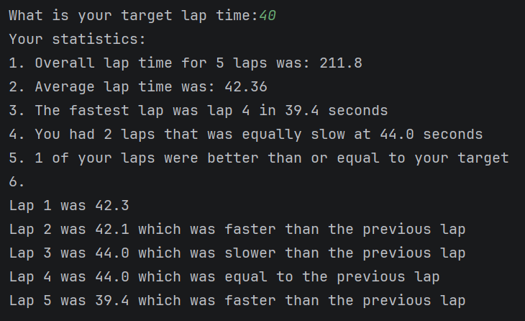
Result: Did the programme behave as expected ie syntactically and logically correct?
NO
If YES, comment on what happened.
If NO, what went wrong and why? Suggest how things could be improved

Using the testing parameters, along with a target lap time of 40 seconds, it can be observed that the statistical outputs were mostly valid. 1 and 2, overall and average lap times over 5 laps are correct. However, number 3, fastest lap time is incorrect. It should say “The fastest lap was lap 5 in 39.4 seconds” it instead says, “lap 4”. This is because the lap number is equal to the counter in the related for loop and due to the counter beginning on 0 it counts a number behind. To fix this I need to add a one to the variable in concern. And because number 4, slowest lap time works in the same logic I will also amend the same issue even though no problems occurred during this test. These amendments are shown below. The outcome of statistics 5 and 6 were correct.

else:
print("3. The fastest lap was lap {} in {} seconds".format(lapNo+1, lapTime))
Test: c) i) Test two further sets of lap times of your own choice.

Lap 1: 45.4
Lap 2: 40.5
Lap 3: 43.9
Lap 4: 37.2
Lap 5: 40.8

Screenshot(s) of output:
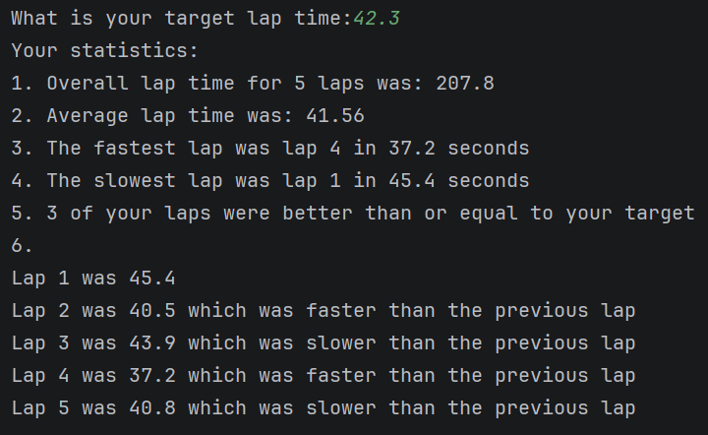
Result: Did the programme behave as expected ie syntactically and logically correct?
YES
If YES, comment on what happened.
If NO, what went wrong and why? Suggest how things could be improved

No problems occurred; all statistics are correct.
Test: c) ii) Test two further sets of lap times of your own choice.

Lap 1: 54.3
Lap 2: 42.8
Lap 3: 38.5
Lap 4: 48.4
Lap 5: 47.4
Screenshot(s) of output:
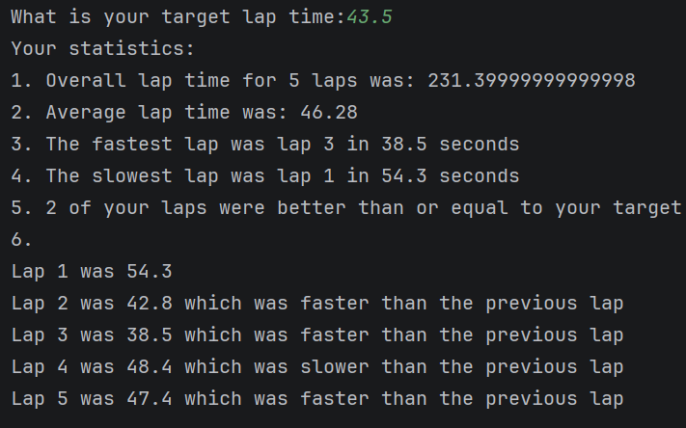
Result: Did the programme behave as expected ie syntactically and logically correct?
NO
If YES, comment on what happened.
If NO, what went wrong and why? Suggest how things could be improved

Nothing is technically wrong about these outputs, although statistic 1, overall time should be rounded down to 2 decimal places which I’ve amended here:

print("1. Overall lap time for 5 laps was: {}".format(round(lapSum,2)))

- Consider the results of the above tests and revisit your original code in order to address any tests that failed and/or improve code efficiency.

(Note: you may not be able to solve all of the problems that were encountered, but solve as many as you can.)

Paste your full revised code here :

[Copy and paste your full revised code here – note, do not use a screenshot]

lapTimes = []
laps = 1
print("Enter your lap times (in seconds):")
for counter in range(0,5,1):
lapTimes.append(float(input("Lap {}:".format(laps))))
while lapTimes[counter] > 10000 or lapTimes[counter] < 7:
lapTimes.pop()
lapTimes.append(float(input("Please enter a valid time for lap {}:".format(laps))))
laps = laps + 1
targetTime = float(input("What is your target lap time:"))
while targetTime > 10000 or targetTime < 7:
targetTime = float(input("Please enter a valid target lap time:"))
print("Your statistics:")
lapSum = sum(lapTimes)
print("1. Overall lap time for 5 laps was: {}".format(round(lapSum,2)))
lapAverage = lapSum / 5
print("2. Average lap time was: {}".format(round(lapAverage,2)))
amountOfMinLaps = 0
lapMin = min(lapTimes)
for counter in range(0,len(lapTimes),1):
if lapTimes[counter] == lapMin:
lapNo = counter
lapTime = lapTimes[counter]
amountOfMinLaps = amountOfMinLaps + 1
if amountOfMinLaps > 1:
print("3. You had {} laps that was equally slow at {} seconds".format(amountOfMinLaps, lapMin))
else:
print("3. The fastest lap was lap {} in {} seconds".format(lapNo+1, lapTime))
amountOfMaxLaps = 0
lapMax = max(lapTimes)
for counter in range(0,len(lapTimes),1):
if lapTimes[counter] == lapMax:
lapNo1 = counter
lapTime1 = lapTimes[counter]
amountOfMaxLaps = amountOfMaxLaps + 1
if amountOfMaxLaps > 1:
print("4. You had {} laps that was equally slow at {} seconds".format(amountOfMaxLaps, lapMax))
else:
print("4. The slowest lap was lap {} in {} seconds".format(lapNo1+1, lapTime1))
targetLapBeat = 0
for counter in range(0,len(lapTimes),1):
if lapTimes[counter] <= targetTime:
targetLapBeat = targetLapBeat + 1
else:
continue
print("5. {} of your laps were better than or equal to your target".format(targetLapBeat))
print("6.")
for counter3 in range(0,len(lapTimes),1):
if counter3 == 0:
print("Lap {} was {}".format(counter3 + 1,lapTimes[counter3]))
elif lapTimes[counter3] == lapTimes[counter3 - 1]:
print("Lap {} was {} which was equal to the previous lap".format(counter3 + 1, lapTimes[counter3]))
elif lapTimes[counter3] > lapTimes[counter3 - 1]:
print("Lap {} was {} which was slower than the previous lap".format(counter3 + 1, lapTimes[counter3]))
else:
print("Lap {} was {} which was faster than the previous lap".format(counter3 + 1, lapTimes[counter3]))

