Student Name |  |  | Andrei Welkens-Covaci
Student ID |  |  | 1818820
Module Title |  |  | Academic And Employability Skills (BMSW4001_LON)
Assignment Title |  |  | Academic and Employability Skills
Module Lecturer |  |  | Lloyd Beharry
Word Count |  |  | 1920 |  |  |  | Date Submitted |  | 29.08.2019

Contents
1.0 Introduction 4
2.0 Employability and academic skills: Relevant literature 4
2.1 DOTS model 4
2.2 Competency model 6
2.3 Pickle Jar theory 8
2.4 Communication theory 9
2.5 Measurement model 10
3.0 Understanding/ Knowledge of Subject and analysis of personal academic and employability skills 10
4.0 Practical Application/ Deployment and skills for professional practice 11
5.0 Conclusion 12
Reference list 13
Appendix: 14
Appendix 1 14
Appendix 2 15
Appendix 3 16
Appendix 4 17
Appendix 5 18
Appendix 6………………………………………………………………………………...18
Appendix 7………………………………………………………………………………...19

1.0 Introduction
This report primarily discusses relevant models and theories associated with employability and academic skills. The DOTS model, Competency model and more are discussed and compared with my personal progress in the class. Furthermore, practical applications and a thorough understanding of the subject are demonstrated through this study.

2.0 Employability and academic skills: Relevant literature
Enhancing one’s personal competence to compete for employment is one of the key factors being considered for personal and professional sustenance in the market (Small et al. 2018). It is important to consider a few relevant models and theories relating to certain employability as well as academic skills which may be used to improve my personal and professional attributes for enhancing my scope of employability. In this regard, the DOTS model, the competency model, the Pickle jar theory and communication theory are explored to develop a sound understanding of the related subjects for employability.

2.1 DOTS model
Developed in 1977 by Law and Watts, the DOTS model is considered to be one of the most successful and effective models or theories for self-evaluation and self-improvement for enhancing one's employability skills (de Blaquière et al. 2019). As depicted in Figure 1, the DOTS model is based on four major postulates:
- Self-awareness: Being aware of one’s personal interests, hobbies, skills, values and abilities is essential, is termed as self-awareness (de Blaquière et al. 2019). My personal hobbies do not include participating or being interested in any kinds of sports, such as football or cricket (Refer to Appendix 8). Thus, being employed in a firm related to sports is not likely for me. Furthermore, it is to be stated in this context that I have a hobby for travelling and explored places and activities, as is evident from me travelling to Birmingham and visiting the London Eye (Refer to Appendix 8). Hence, being employed in a travel agency may be a possibility and looking for the opportunity is discussed next.
- Opportunity awareness: Being aware of the opportunities as they present themselves is also crucial as a part of employability skills. The knowledge of the requirements, as well as the existence of the opportunities, is necessary for developing one's employability scope (de Blaquière et al. 2019).
- Decision-making or learning: Being able to formulate opinions and thereby make decisions is vital for developing academic and employment skills. Certain designations and managerial positions require the ability to judge circumstances and undertake relevant and effective decisions in par with the existing situation (Jackson and Wilton, 2017).
- Transition learning: Transition learning is mentioned to reflect on the presentation and job searching skills (Jackson, 2017). Looking for and finding jobs that match one’s academic and personal attributes is crucial as well.
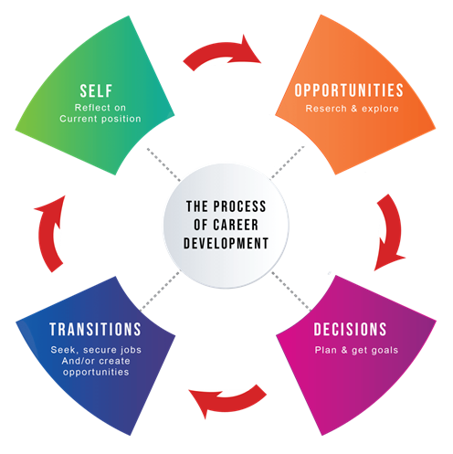
Figure 1: DOTS model
(Source: Lcat, 2019)

2.2 Competency model
According to Mullen (2014), the competency model is fundamentally a framework developed in order to map the requirements, knowledge and relevant skills for a particular job. There are several types of competency models widely prevalent in the business enterprises to assess and evaluate the hard and soft skills of a potential recruit and the suitability for the particular designation. Furthermore, it is to be taken into account that the standards or levels of competency are decided as per the company or business standards and the requirements of the company.
- Job-specific model: Performance of certain particular actions relevant to the job specifications chiefly governs this type of competency model. Former experience, education and training are major components which are taken into account in this context (Mullen, 2014).
- Core competency model: The underlying values of an individual must reflect the belief and value system of an organisation in order to represent the enterprise (Clarke, 2018). It is to be noted in this regard that the specific activities are paid importance in this model. For instance, being an English teacher requires the knowledge of Parts of Speech, comprehension abilities and vocabulary, as is represented in Appendices 6 and 7.
- Building and mapping competency model: Competency models are generally developed with the objective of being subject to frequent changes and modifications to cope with the evolving requirements of the enterprise (Clarke, 2018). The accomplishments to be addressed are considered primarily for the development of the competency model. In addition to that, brainstorming to identify the relevant skills and competencies are also undertaken (Clarke, 2018).
- Management models: In the case of management models, it is generally assumed that the individual is competent with the core competencies. Certain skills, such as leadership as well as the ability to identify and evaluate job roles and competencies for others is also expected in this regard (Clarke, 2018).
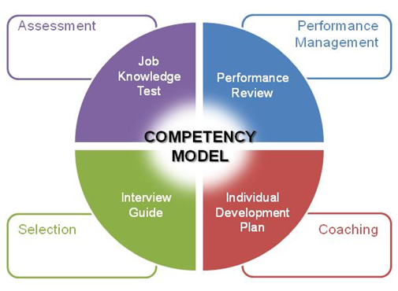
Figure 2: Competency model
(Source: Orgwide, 2019)
The major activities involved in the competency model are assessment or evaluation, which focuses on the knowledge of the job or the subject which is discussed in a later segment. This is followed by selection or interview guide, and coaching, which is characterised by an individual development plan (Clarke, 2018). Lastly, performance management can be identified with a review of the performance of the individual.

2.3 Pickle Jar theory
Time management is identified as one of the major and key factors influencing the employability of an individual. Though the former theories/ models identified in this case highlight the academic as well as certain personality traits, the pickle jar theory strongly focuses on outlining the significance of time management in organisational and academic roles. As illustrated in Figure 3, the pickle jar theory discusses time management as a core competency by identifying, categorising and addressing the significance of the tasks at hand. As evident in Figure 3, the Pickle jar categorises tasks or activities to be performed as sand, pebbles and rocks. According to Mulder (2017), small and less important activities are referred to as sand, while Pebbles are a task with mediocre importance. In a pickle jar, the major components of the pickle essentially lay at the bottom of the jar, sinking due to their weight. A similar concept is evident in this regard as well, as the rocks refer to quite significant and bigger tasks and are characterised as being at the bottom of the jar (Mulder, 2017).
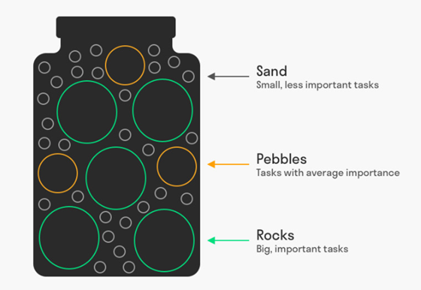
Figure 3: Pickle Jar theory
(Source: Mulder, 2017)

2.4 Communication theory
Communication skills constitute a core concept within employability skills. One of the major aspects within the communication theory can be identified as the information theory, which refers to the gathering, quantification storage and communication of information (Pitan and Atiku, 2017). This may be supported by evidence in the form of Appendices 1 to 5, which demonstrate my understanding and communication of English grammar or English language.

2.5 Measurement model
According to Hanapi et al. (2018), it has been evident that there are certain elements identified to play a crucial role in the employability of an individual. The elements have been identified as communication skills, problem-solving skills, teamwork skills, organising and planning skills, enterprise and initiative skills, self-management skills, technology skills, learning skills, personal qualities as well as workplace and health safety (Sunardi et al. 2016).

3.0 Understanding/ Knowledge of Subject and analysis of personal academic and employability skills
It is to be noted in this context that a proper understanding of the importance of employability skills is crucial, as well as an understanding of the English language. Being able to rephrase sentences have been key elements in my exercises, as is demonstrated in Appendices 1 to 5. This requires a thorough knowledge of grammar, vocabulary and proper sentence construction. As depicted in Appendix 1, I have performed fairly in my test, as evident from my teacher's comments. This indicates that despite having an understanding and comprehension of the subject, I fail to use certain appropriate terms, and often confuse the implication of terms. For instance, it is evident from Appendix 1, I have referred to a social entrepreneur as a social worker, and the professionals are quite distinct and different. This has resulted in my overall performance, being rated fair instead of good.
Another instance, is the second assignment in my 1st term, was to paraphrase given sentences. However, I was expected to complete both exercises 1 and 2 in a span of 1 hour, which I failed to achieve, and the exercise 2 could not be attempted due to a distinct lack of time management skills (Refer to Appendix 2). Appendices 4 and 5 also serve as supporting evidence of my abilities to paraphrase sentences, demonstrating a strong knowledge and comprehension of the English language. Regardless of my inability to efficiently manage time, I have succeeded in getting all the sentence structure rearrangement correct (Refer to Appendix 3). This indicates that my knowledge of the English language is more than average, and is fairly represented. However, taking the extensive competition existing in the global market, it is to be noted that in order to be employed, it is crucial to develop one’s skills further, along with the improvement in the knowledge and comprehension of the related subject.

4.0 Practical Application/ Deployment and skills for professional practice
It is to be mentioned in this regard that the theories and models formerly identified and discussed in this report, maybe actively implemented to one's attributes to improve the employability skills. For instance, I have taken the Pickle Jar theory into account, following my poor time management performances, as evident in my test results (Appendices 1 and 2). I have started to segregate my tasks or activities at hand into sand, pebbles and rocks to efficiently manage time and be able to focus on other skills such as communication (Mulder, 2017). It may be stated in this context that deployment in certain fields such as the teaching profession, or working for print media companies may be best suited to consider my strengths and weaknesses. However, working for an organisation requires the competency of being able to maintain and perform diligently within allocated deadlines. Hence, I am currently focused on using the Pickle Jar theory in my professional development.
Additionally, I have also considered the use of the Information theory, an integral part of the communications theory, which involves the proper evaluation, implementation and application of the information in the tasks that one undertakes. I have also considered the DOTS model to improve my chances of employability, as it aids in identifying my personal weaknesses and strengths. Developing an awareness of the opportunities and the ability to make decisions and implement them effectively for better outcomes can also be noted through the use of the DOTS model. In addition to that, the transition learning, which is a part of the DOTS model, also provides scope for deployment into an appropriate and suitable field of profession. Lastly, the competency model is followed by organisations, looking to recruit individuals or candidates based on their key skills. Nevertheless, it may be used for identifying significant personal and professional attributes and focus on improving the same. Thus, I have also considered implementing this along with the measurement model, considering the major characteristics identified as key employability skills.

5.0 Conclusion
This report chiefly identifies and outlines the major theories and models for evaluating employability and academic skills for an individual. The measurement model identifies communication skills, problem-solving skills, teamwork skills, organising and planning skills, enterprise and initiative skills, self-management skills, technology skills, learning skills, personal qualities as well as workplace and health safety as the key characteristics of the employability skills of an individual. Furthermore, the pickle jar theory has been discussed as a potent method for managing time effectively, and I have considered implementing the same for the improvement of my employability skills.

Reference list
Clarke, M., 2018. Rethinking graduate employability: The role of capital, individual attributes and context. Studies in Higher Education, 43(11), pp.1923-1937.
De Blaquière, G., Nolan, J.E. and Wray, K., 2019. Joining up the dots: Telling the story of skills. How can students in Higher Education be supported to understand better and articulate their employability? Journal of Teaching and Learning for Graduate Employability, 10(2), pp.15-35.
Jackson, D. and Wilton, N., 2017. Career choice status among undergraduates and the influence of career management competencies and perceived employability. Journal of Education and Work, 30(5), pp.552-569.
Lcat, 2019. How technology is revolutionizing career guidance and planning. [online] LCAT BLOG. Available at: https://www.lcat.in/blog/how-technology-is-revolutionizing-career-guidance-and-planning/ [Accessed 12 Aug. 2019].
Mulder, P., 2017. Pickle Jar Theory, a powerful time management tool | ToolsHero. [online] ToolsHero, 2019. Available at: https://www.toolshero.com/time-management/pickle-jar-theory/ [Accessed 12 Aug. 2019].
Mullen, E., 2014. Are They Fit For Purpose? Exploring Managers' Experiences of UK HR Graduates & Employability Implications: A Pilot Study.
Pitan, O.S. and Atiku, S.O., 2017. Structural determinants of students’ employability: Influence of career guidance activities. South African Journal of Education, 37(4).

Small, L., Shacklock, K. and Marchant, T., 2018. Employability: a contemporary review for higher education stakeholders. Journal of Vocational Education & Training, 70(1), pp.148-166.

Appendix:

Appendix 1
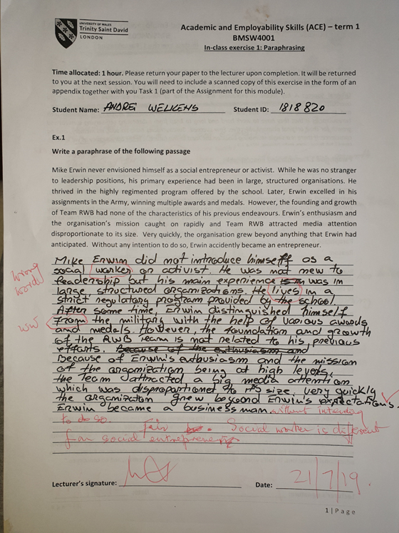

Appendix 2
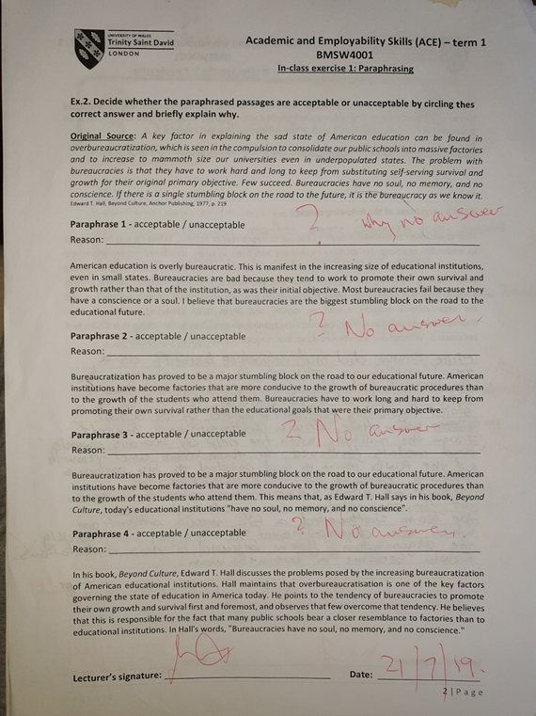

Appendix 3
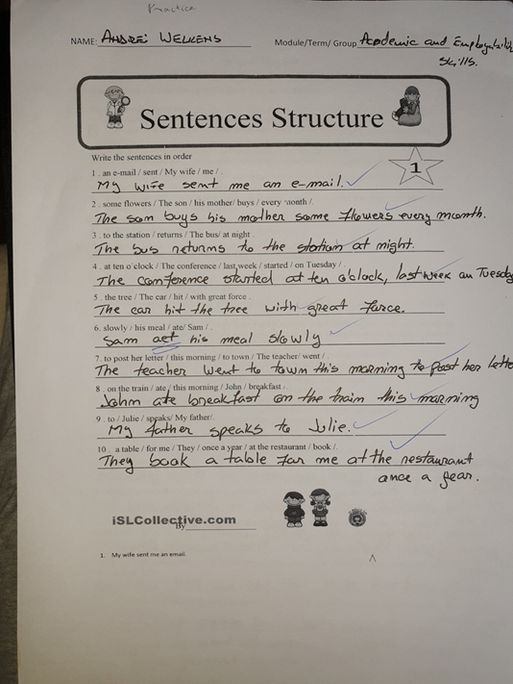

Appendix 4
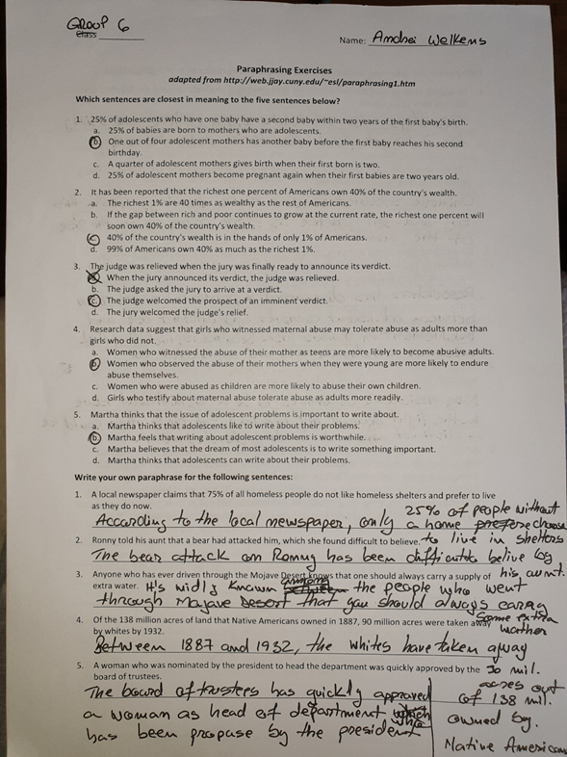

Appendix 5
\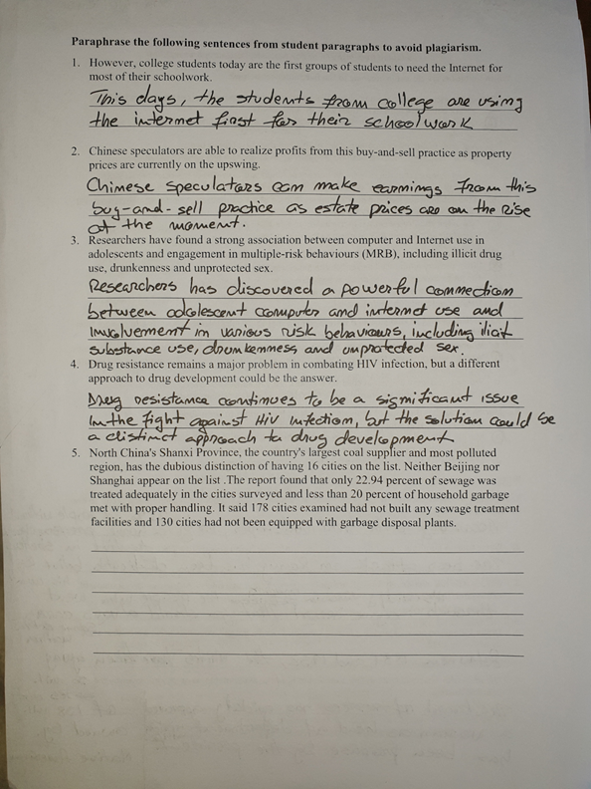

Apendix 6
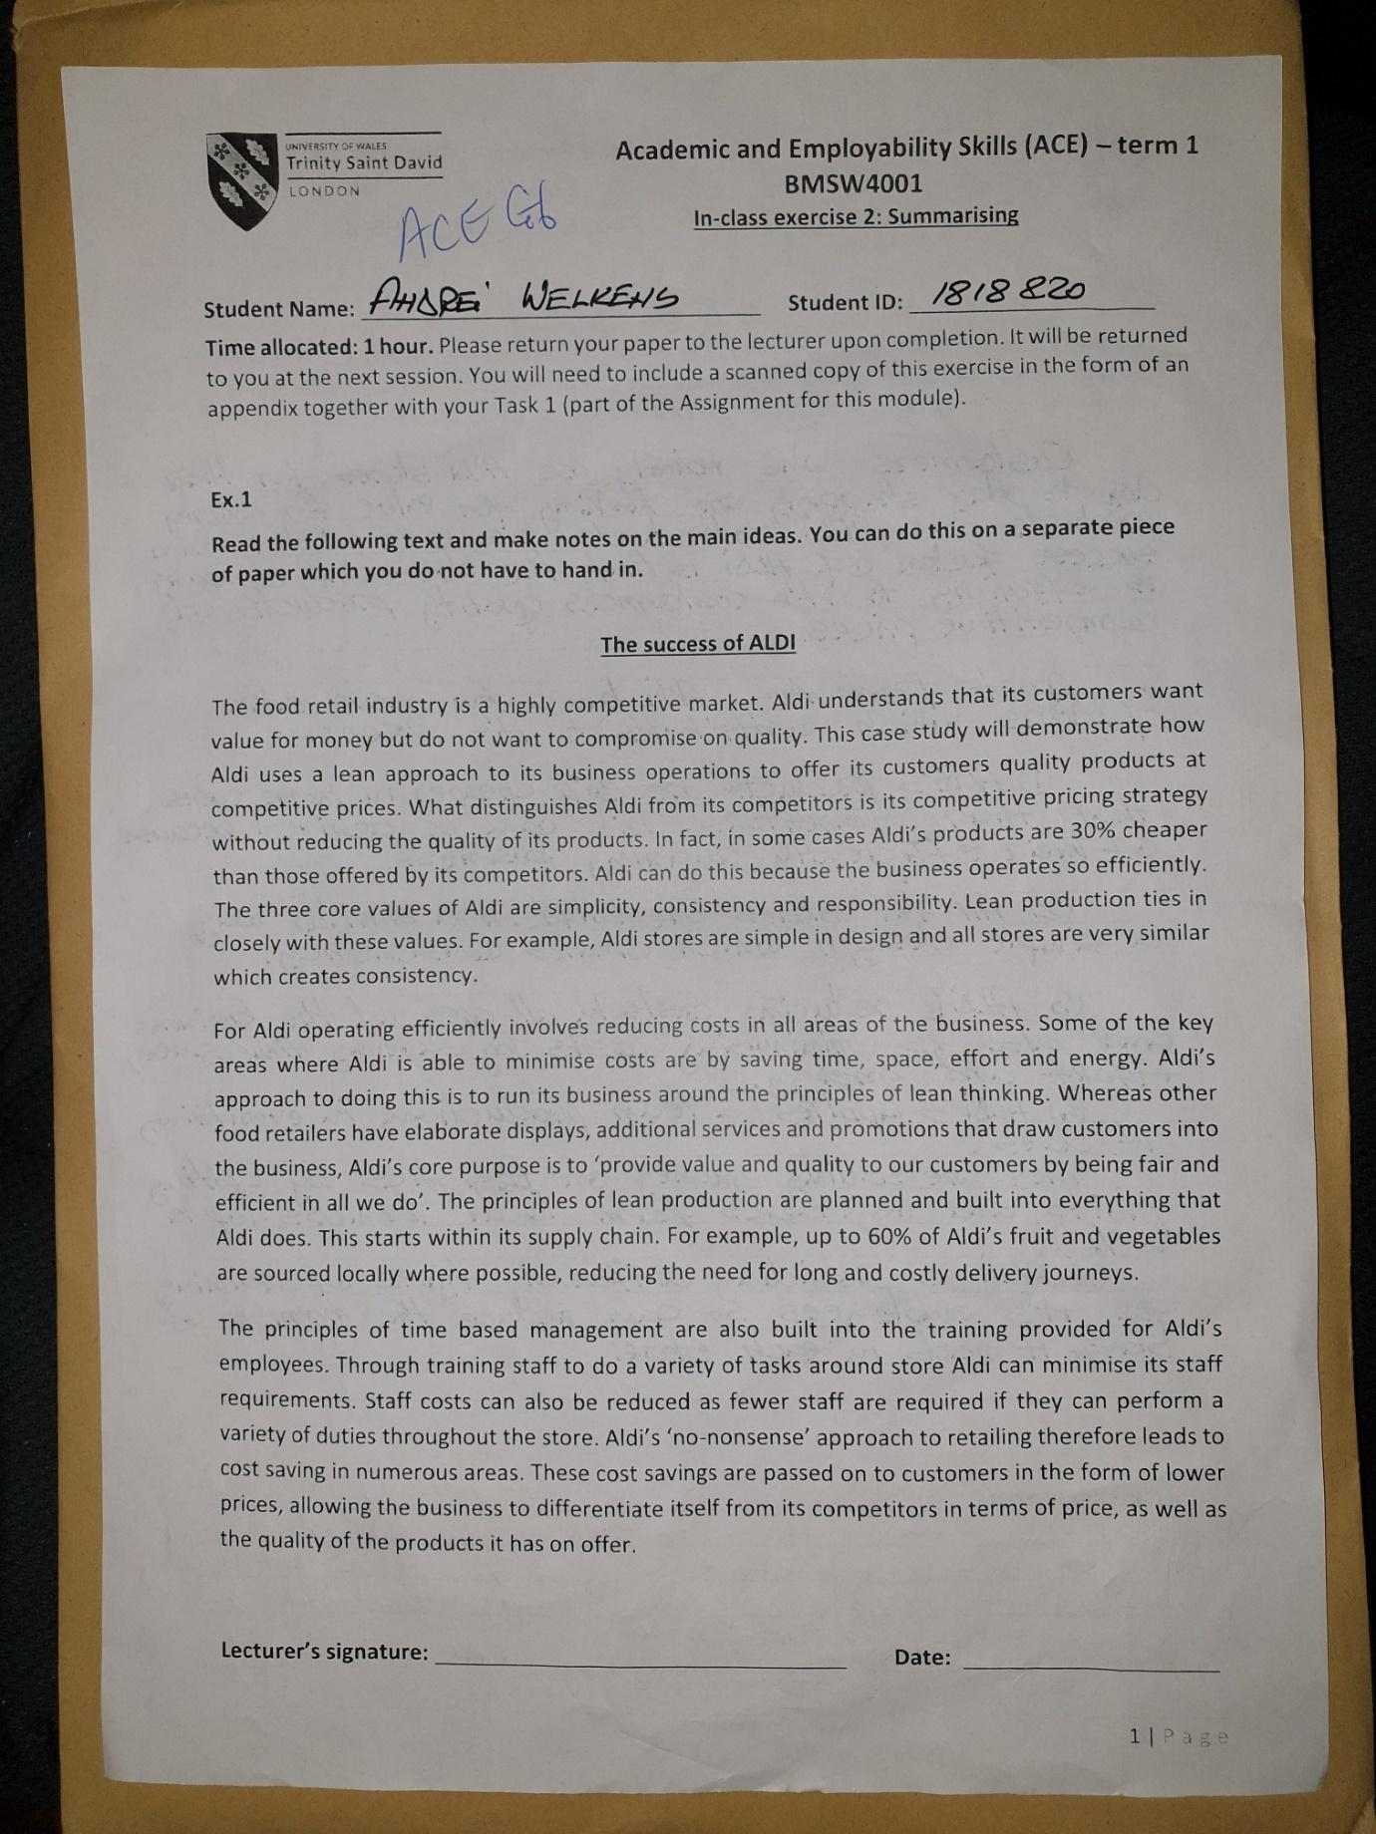

Apendix 7

