

Name: James Cullen
Student Number: p151951
Module Title: Built Environment Services
Module Code: M5X01836
Assignment Title: Design Criteria – Water Supply and Waste Drainage

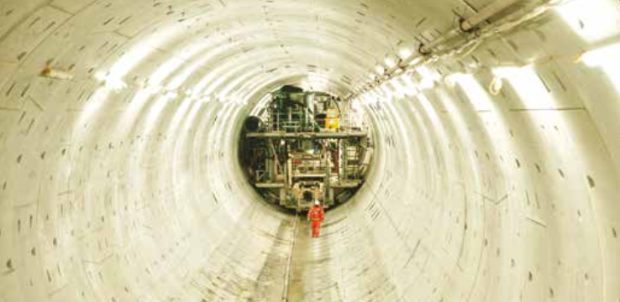

Contents
- Page 1: Introduction

- Page 2: Sewerage of the City of London

- Page 6: Hot and Cold Water supply systems of dwellings in Wales

- Page 10: List of Figures

- Page 11: Reference List

Introduction
This report will outline the systems employed in Britain to provide hot and cold water to housing and the methods implemented to remove and transport waste water from dwellings. Particular focus will centre upon the city of London to provide an overview of the historical development of its sewerage structure there, as well as the initiatives being undertaken to protect future generations. Also, to demonstrate water supply methods, the case study of housing stock in Wales will be analysed to portray any trends in the type of system utilised and the age of the properties.

Sewerage of the City of London
Fuelled by technological advances and the industrial revolution the population of London exploded to the point that to just over 1 million people resided there by 1800. At this time, the City was served by a primitive sewerage system which exploited the River Thames as an open sewer to transport waste away. “A condition called summer diarrhoea was common, as was typhoid, while cholera killed thousands in a series of epidemics” (Burns 2018), with poor sanitation and the repugnant River Thames, infested with faeces being blamed. The media campaigned for change and applied pressure on Parliament to commission new works on the City’s sewers. Unfortunately all the proposals were dismissed due to the expense of the works.

(Figure 1: Punch, 1858)
The situation worsened in 1858 when the hot summer temperatures accelerated the situation and produced an event known as the ‘Great Stink’. “That particular Summer, all of London was feeling the affects of an oppressive heat wave and as a result, all the sewage in the Thames began to ferment in the scorching sun” (Lemon, 2018). With the Houses of Parliament situated on the banks of the Thames the problem was brought directly to the attention of legislators who could not ignore it any longer. Soon a bill was passed into law and the Chief Engineer to the Metropolitan Board of Works Joseph William Bazalgette was tasked with designing and delivering a new sewer network for the City.
Previously, the sewer system consisted of a number of pipes that collected sewage and transported and then deposited it directly into the River Thames at many discharge points throughout the River’s course in London. In addition, many other dwellings were served only by cess pits. Bazalgette devised an elaborate system which intercepted “the sewage from street sewers to far downstream where it could be collected and dumped, untreated, into the Thames to be carried away at high tide” (Roberts, date unknown). The extent of his designs are depicted below:
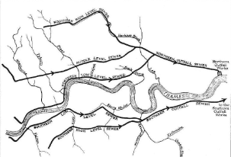
(Figure 2: Roberts, Date Unknown)
Bazalgette pioneered the use of ‘egg shaped’ brick walled tunnels to facilitate the flow in the sewers and also built several large pumping stations such as at Crossness and Abbey Mills which are still in operation today. These served to pump sewage to two outfall sites outside the limits of the City where it was deposited and carried off by the tide.
While Bazagette’s work dissipated much of the direct effect of the ‘Great Stink’ by cleansing the Thames in Central London, the fact remained that untreated sewage was still being dumped into the River, albeit downstream. This factor was brought sharply into focus in 1878 when the paddle steamer Princess Alice sunk following a collision with another ship, the Bywell Castle. “Though the accident was close to the shore the death toll was in excess of 650” (Vanner, 2017). It is thought that the loss of life would have been far less if the incident had no occurred directly adjacent to the Thames sewerage outfall’s that Bazalgette has constructed. “Many who found themselves engulfed in this ghastly sludge died by asphyxiation” (Vanner, 2017). Events such the sinking as well as the continued population increase of the City necessitated the need for the treatment of sewage being deposited into the Thames.
By the end of the 20th Century, the system was no longer fit for purpose. Although Bazalgette had designed the sewers far larger than were required in 1858, he could not have envisaged the rate of Urbanisation London would undergo and by 2001, the population had reached an estimated 7.2 million people. Other external factors had also rendered the system outdated. Not only had the population itself increased but consequently the amount of impermeable surfaces in city meant that instead of rainfall percolating slowly in the substrate, it is quickly drained off the surface into drains which in the vast majority of instances connect to the sewer system. This issue is further exacerbated by the effects of climate change, where “rainfall patterns have changed since Bazalgette's day: rain today is less steady and more prone to intense bursts that overwhelm the Victorian system” (Jeffries, 2014). Essentially the sewers of London not only had to cope with more effluent, but also increased amount of rain water. In turn, this had to lead to more flooding incidents where the capacity of the sewers are unable to cope and sewage albeit diluted, appears at the surface, on streets of London. In addition, this has resulted in increased ‘spills’ from the sewer network into the Waterways of London. The spills occur via Combined Storm Overflows (CSO’s) and help to relieve sewers running near to full capacity, but the effluent deposited is largely untreated leading to Environmental problems and consequent financial penalties due to the legislation developed to safeguard rivers over time in conjunction with the ‘Polluter Pays’ theory.
For these reasons, Thames Water and the UK government selected the Thames Tideway Tunnel scheme as “the best and most cost-effective way to boost the capacity of a sewerage system which was originally built in the 1850s” (Thames Water, 2017). The primary essence of the program involves the construction of a 7 metre wide tunnel spanning 25 kilometres between Acton in West London to Beckton Sewage Works. The Tunnel which will reach depths of up to 65 metres below the City is depicted in orange on the plan below:
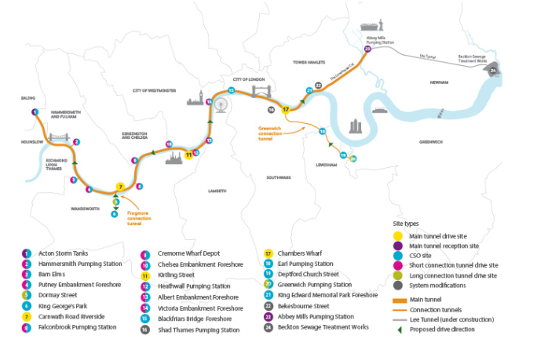
(Figure 3: City Metric, 2015)
The ‘Super Sewer’, said to be the “biggest infrastructure project ever undertaken by the UK water Industry” (Tideway, 2018) will connect several of the highest spilling CSO’s in the region with the aim of reducing their spilling events to 4 per year at each site. Presently occupying around 24 separate construction sites, the cost of the venture is currently estimated at around £4.2 billion. Planning permission was granted in 2014, with construction starting in 2016, while the works are due to be completed in 2023. Presently, the scheme is progressing with the excavation of several shafts on ongoing. Some have already been completed, with the tunneling program having commenced and the first tunnel ring of the project has been assembled. In other locations, jet grouting and the erection of an acoustic enclosure are also underway.
Whilst Thames Water has lauded the scheme and stated that platforms created as part of the scheme “will celebrate the Capital’s watersports, arts scene, and ecology, while also paying homage to city’s industrial past” (Thames Water, 2018), it has come under scrutiny from other sectors. Financially, the scheme has come under scrutiny with customers “paying for the entire project through the increased charge on their water bills” (Plimmer, 2018). There have also been allegations of tax evasion, while Chris Binney of the steering group who first recommended the project later remarked that “In broad terms, I think it is a waste of £4 billion” (Gayle et al, 2015) citing that the model used to assess the impact of the scheme was neither robust or verified. In 2013, Lord Berkeley in the House of Commons accentuated this point stating the proposals “are based on some seriously flawed data” (Lord Berkeley, 2013). There are also fears that property prices in the vicinity will experience a downturn. Socially, although there are provisions to provide green spaces and the creation of jobs, the London Evening Standard reported that “Super-sewer tunneling set to force hundreds from their homes” (Beard, 2012). Other sources cite major disruption as a significant issue, with the tunneling consisting of 24 hour drilling. Environmentally, groups such as DEFRA are agreed the initiative will benefit the ecology of the region, whilst Thomas stated that works “are an essential part of the delivery of improvements to the water quality of the Tidal River Thames”. Conversely, it is accepted that a scheme of this magnitude will also pose a short-term risk to ecology.

Hot and Cold Water Supply systems of dwellings in Wales
A variety of differing systems have developed in line with the evolution of dwellings that provide a supply of water to into homes. While ancient civilisations formulated elaborate methods to transport water closer to dwellings, in Wales a running water supply in homes has only become commonplace in the last one hundred years and in some rural areas, a lot more recent.
Cold water supply to domestic residences can be broadly divided into direct and indirect systems. A standard arrangement for the direct form is detailed below:

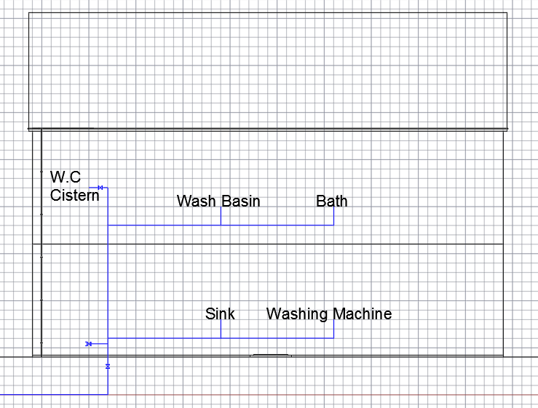
(Figure 4: Cullen, 2018)
This category is characterized by a water pipe entering the property and feeding all fixtures “so all taps and other water feeds are at mains water pressure” (practicalDIY, 2019). Water is also distributed to a water tank or storage cistern usually on a high floor in the property for use in the hot Water System.
In contrast, in the indirect system as profiled below, cold water supply to fittings arrives via a cold water tank or cistern in the house which is fed via a water pipe into the dwelling from the mains. Besides the cistern, only a downstairs sink is usually fed directly, while cold water is transported via a series of pipes from the cistern to the other fittings such as other taps, toilets and to the hot water cylinder.

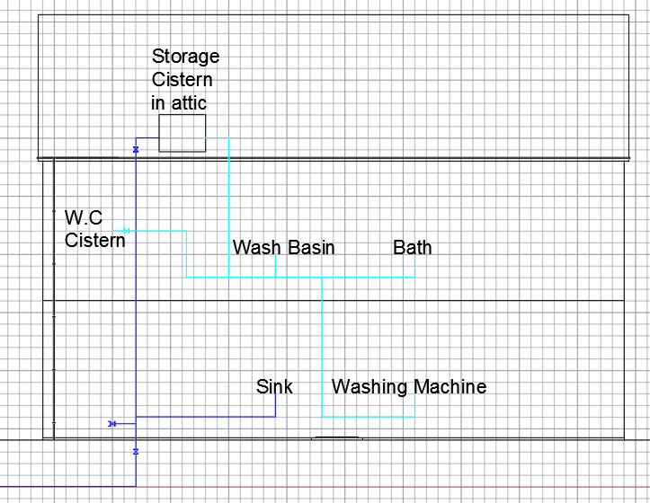
(Figure 5: Cullen, 2018)
Hot water provision in houses can also be divided into direct and indirect varieties. Direct systems involve a feed into properties which pass through a Combination (combi) boiler and produce hot water at taps instantaneously “without the need to store water” (APHC, 2019) as per diagram below:

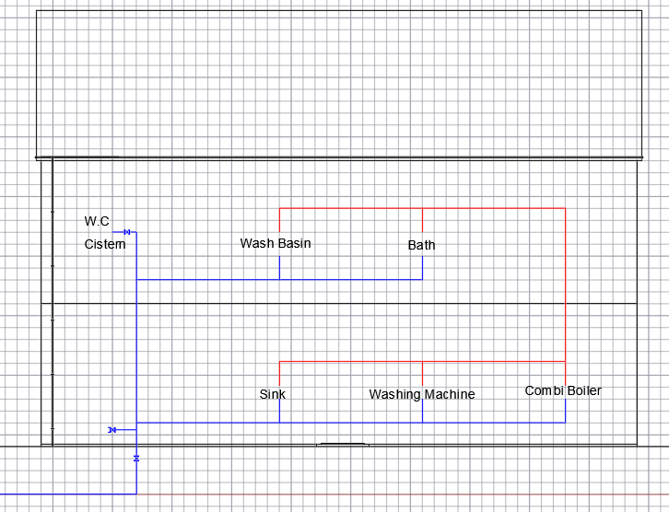
(Figure 6: Cullen 2018)
An indirect system involves storing water on site in a cistern which is fed by a rising main entering the house. This cistern (which can be used in conjunction with a cold water system) then feeds a cylinder in which the water is heated and travels to taps via pipework. However, once a large quantity of hot water is expended, it can take some time before more hot water maybe available via hot water taps as the cylinder must refill and heat. An indirect hot water system is pictured below:

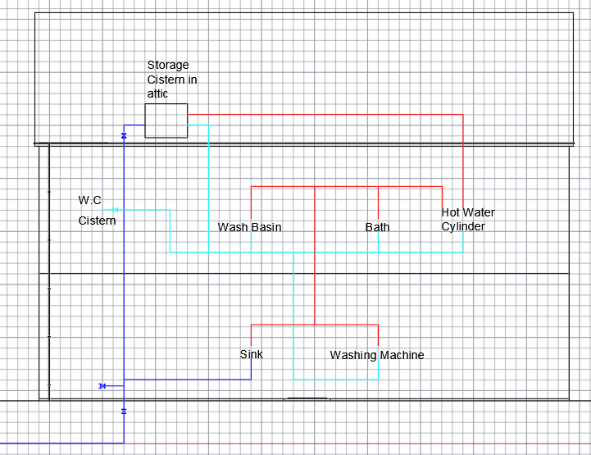
(Figure 7: Cullen, 2018)
Research data for Wales suggests that the nation does possess an ageing housing stock. The graphic below detailing Welsh Assembly Government data on housing age construction implies that the largest percentage of dwellings in Wales were constructed prior to 1919:

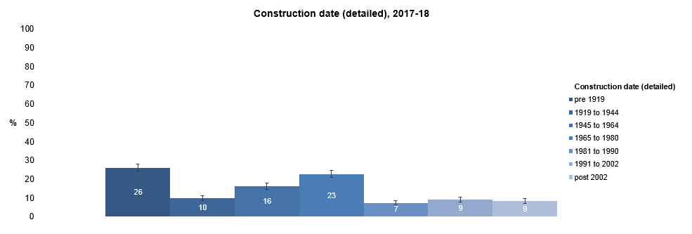
(Figure 8: Welsh Government, 2018)

Superficially, these statistics would suggest that the majority of the houses in Wales would possess an indirect cold and hot water supply as they would out date the invention of the combination boiler, while the vast majority of modern housing will possess a ‘combi’. However, evidence also suggests that a lot of older housing would also now possess Combi boilers as the upkeep, maintenance and sourcing of parts for older style boilers is difficult, so they may have been replaced. Also a lot of renovated houses will have had their large, space consuming cisterns removed to make way for combi boilers with their instantaneous hot water supply and direct cold water provision. Many local authority and housing association rental accommodation in Wales do now work off Combination boilers.
Property type may also produce differentiation in the method of water supply. The diagram below displays the statistics for housing type in Wales:

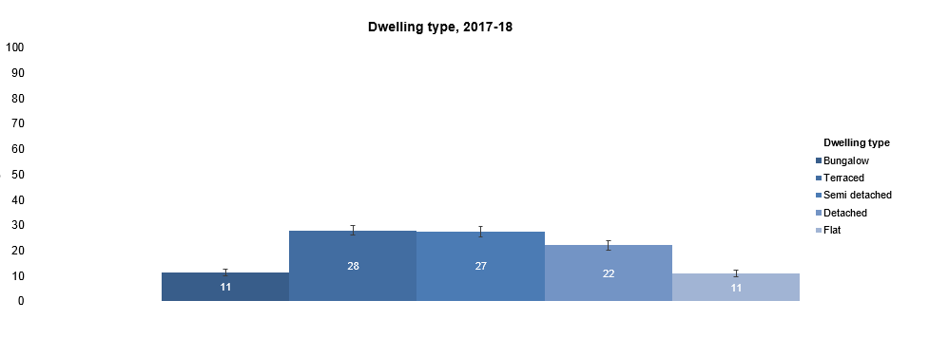
(Figure 9: Welsh Government, 2018)
While single home housing is likely to be served by direct systems, it is possible that even new developments involving flats may still utilise older style supply systems. Possessing a large cistern within flat blocks could be an advantage as the large number of occupants would still have some water supply if the mains supply had to be turned off or was out of commission. In high rise flats, having a water tank situated on the top floor could also remedy any pressure issues the residents may experience.

List of Figures
Cover Page (1): Sutherdean (2015), View inside one of the Tideway Tunnels, Ingenia, Issue 63 (June 2015), UK
Cover Page (2): Victoria Plum (2018), View of Shower Head, https://victoriaplum.com/blog/posts/how-to-save-water-in-your-home, UK
Figure 1: Punch (1858), The Silent Highwayman, Punch Magazine, Vol: 35, p 137, 10 July 1858, UK
Figure 2: Roberts (date unknown), Plan depicting extent of Bazalgette’s sewer work, CIBSE, UK
Figure 3: CityMetric (2015), Plan depicting extent of Tideway’s sewer work, CityMetric, UK
Figure 4: Cullen (2018), Diagram depicting Direct Cold Water supply into the home, Author’s own collection, UK
Figure 5: Cullen (2018), Diagram depicting Indirect Cold Water supply into the home, Author’s own collection, UK
Figure 6: Cullen (2018), Diagram depicting Direct Hot Water supply into the home, Author’s own collection, UK
Figure 7: Cullen (2018), Diagram depicting Indirect Hot Water supply into the home, Author’s own collection, UK
Figure 8: Welsh Government (2018), Diagram depicting Construction date of Housing in Wales, Welsh Housing Conditions Survey, UK
Figure 9: Welsh Government (2018), Diagram depicting differing housing types in Wales, Welsh Housing Conditions Survey, UK

Reference List
APHC (2019), Consumer Advice Guide – Understanding Cold Water Systems in the Home, Association of Plumbing and Heating Contractors, UK
APHC (2019), Consumer Advice Guide – Understanding Hot Water Systems in the Home, Association of Plumbing and Heating Contractors, UK
Berkeley (2013), Thames Tideway Tunnel – To ask her Majesty’s Government what assessment they have made as part of the Proposals for the Thames Tideway Tunnel, Hansard – House of Lords, 24 October 2013, Vol: 748, UK
Burns (2018), Too Hot? In 1858 a Heatwave turned London into a Stinking Sewer, BBC News, https://www.bbc.co.uk/news/education-45009749, UK
CityMetric (2015), What’s a Super Sewer, and why does London need one?, CityMetric, https://www.citymetric.com/horizons/whats-super-sewer-and-why-does-london-need-one-635, UK
Cook (2001), Construction of London’s Sewers: the Vital Role of Joseph Bazalgette, History of Medicine, Vol: 77, pp 802-804, UK
Gayle et al (2016), London Super Sewer is a Waste of £4bn, says Assessor, The Guardian, https://www.theguardian.com/uk-news/2016/nov/14/london-super-sewer-is-waste-of-4bn-says-assessor, UK
Jeffries (2014), Water, Super-Sewers and the Filth Threatening the River Thames, The Guardian, https://www.theguardian.com/environment/2014/jul/22/water-thames-victorian-london-150-years-sewer-system, UK
Lemon (2018), The Great Stink, Cholera and the Thames, https://www.choleraandthethames.co.uk/cholera-in-london/the-great-stink/, UK
Plimmer (2015), Critics Decry Cost of London’s £4.2bn ‘Super Sewer’, Financial Times, https://www.ft.com/content/6c8974ca-31e9-11e5-91ac-a5e17d9b4cff, UK
Plimmer (2018), Investors Reap Rewards of London Super Sewer Long before it is Built, https://www.ft.com/content/32f0a802-d6bc-11e8-ab8e-6be0dcf18713, UK
Porter (2001), The Great Stink of London: Sir Joseph Bazalgette and the Cleansing of the Victorian Metropolis by Stephen Halliday, Victorian Studies, Vol: 43, no.: 3 (Spring 2001), pp 530-531, Indiana University Press, USA
Practical DIY (2019), Direct Water Supply, PracticalDIY, https://www.practicaldiy.com/plumbing/water-supply/direct-water-supply.php, UK
Roberts (date unknown), Sir Joseph Bazalgette and London’s Intercepting Sewer System, CIBSE Heritage Group, UK
Smith (2002), The Great Stink of London: Sir Joseph Bazalgette and the Cleansing of the Victorian Metropolis by Stephen Halliday, Environmental History, Vol: 7, no.: 1 (Jan 2002), pp 131-133, Oxford University Press, UK
Sutherden (2015), London’s Deepest Tunnel and Shafts, Ingenia, Issue 63 (June 2015), UK
Thames Water (2017), Why is the Thames Tideway Tunnel needed, Thames Water, https://corporate.thameswater.co.uk/About-us/thames-tideway-tunnel/why-is-it-needed, Uk
Thomas et al (2011), London’s Tideway Tunnels: Tackling London’s Victorian Legacy of Combined Sewer Overflows, Water Science Technology, 63(1), pp 80-87, UK
Tideway (2018), The Engineering - Construction, Tideway, https://www.tideway.london/, UK
Tideway (2018), Tideway is Building the Thames Tideway Tunnel – London’s New Super Sewer, Tideway, https://www.tideway.london/, UK
Vanner (2017), The Princess Alice Disaster 1878, The Dawlish Chronicles, https://dawlishchronicles.com/princess-alice-disaster-1878/, UK
White (2018), London’s £4.2bn Thames Tideway Super Sewer is an Unprecedented Planning Victory to Build into the River, Homes and Property, https://www.homesandproperty.co.uk/property-news/buying/new-homes/londons-new-super-sewer-to-open-up-the-thames-with-acres-of-public-space-for-watersports-arts-and-a123641.html, UK

