

LOCATION: Swansea | LLEOLIAD: abertawe
LEVEL 4 | LEFEL 4
EXAMINATION PERIOD | CYFNOD ARHOLIADAU
MAY 2024 | 2024

MODULE CODE: ACDA4006
Electrical and Electronic Principles
Programme: BEng. Electrical and Electronics Engineering

TIME: 2 HOURS
Maximum Marks : 100
answer All the questions

Equipment or materials required – Calculator, Formula sheet, Graph sheet,
Adnoddau neu ddefnyddiau sydd eu hangen - Cyfrifiannell

ANSWER ALL THE QUESTIONS

Question 1 [25 Marks]
- A power supply requires 25W of input power and produces an output power of 20W. Calculate its efficiency in percentage and the total power loss. [5 Marks]
- A solar yard light has a solar collector that can provide 1.0W of power for charging the 3.0V batteries. What is the maximum charging current the solar collector could supply to the fully discharged 3.0V batteries? [4 Marks]
- For the circuit shown in fig.1, calculate the following.
- Equivalent Resistance, [6 Marks]
- Current flowing through $20Ω$ Resistor [3 Marks]
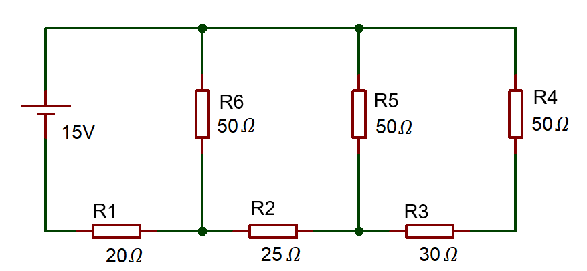
Fig:1
- Determine the voltage across each resistor in the circuit shown in fig.2.
[4 Marks]
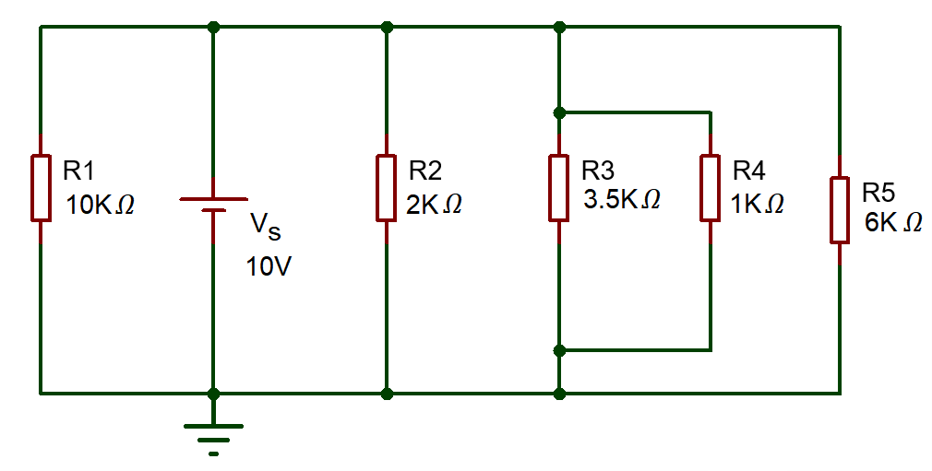
Fig.2
- Define Kirchoff’s Current Law. [3 Marks]
Question 2 [25 Marks]
- Determine the current across each resistor in the circuit shown in fig.3, using mesh analysis (Kirchhoff’s Voltage Law) [16 Marks]
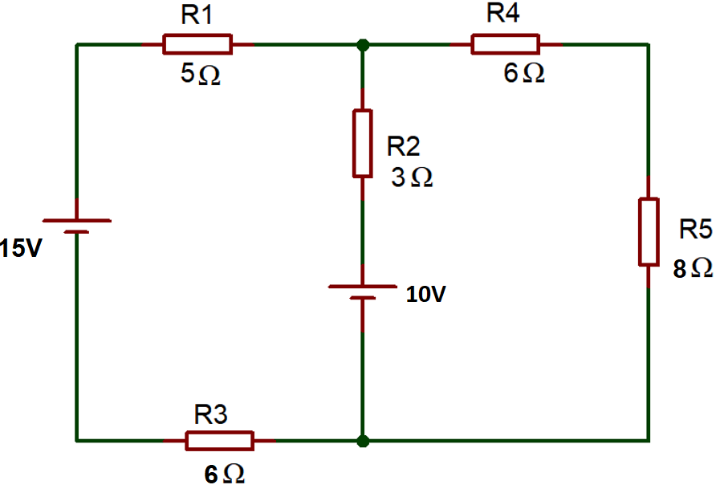
Fig.3
- For the circuit shown in fig 4, determine the following
- Total impedance [5 Marks]
- Circuit current [2 Marks]
- Phase angle [2 Marks]
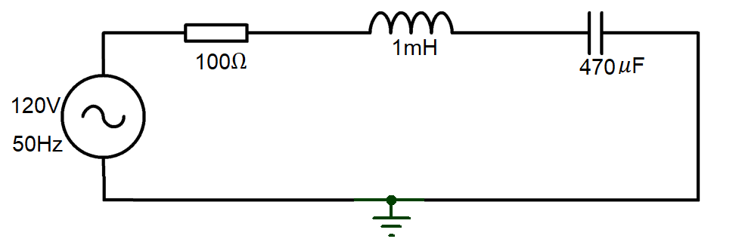
Fig.4
Question 3 [25 Marks]
- Define the following terms
- Resistance [2 Marks]
- Impedance [2 Marks]
- Reactance [2 Marks]
- Voltage Rating [2 Marks]
- The alternating current is given by $i=40 sin314t$. Determine the following
- Maximum Value of current [1 Mark]
- RMS Value of Current [2 Marks]
- Frequency [2 Marks]
- What is the use of the circuit shown in fig.5? Describe the functions of each stage of the circuit with necessary diagrams. [12 Marks]
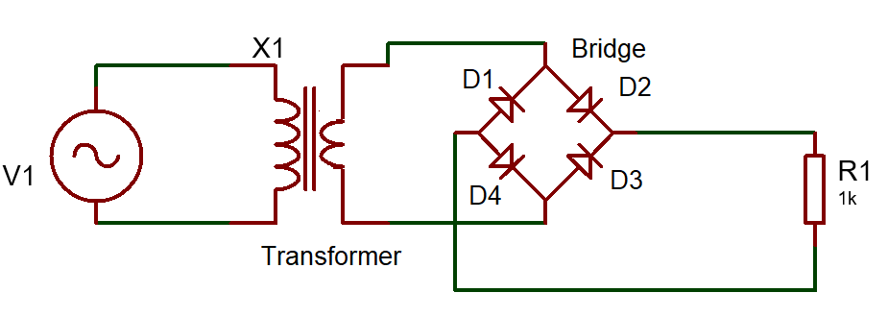
Fig.5
Question 4 [25 Marks]
- A 12 V Battery has an internal Resistance of 12Ω, Calculate the power dissipated by various load resistances given in the below table and complete the table. [15 Marks]
Load Resistance (Ω) | Load power (W)
4
8
12
16
20
- Plot a graph of the load Power against the load resistance,. [10 Marks]

Diwedd/End

