Problem solving and decision making

(BMSW4004_LON)
Lecturer: Balendran Kandasamy

Defining a complex Problem and Proposing solutions to a work-based problem.
By Raúl Torres (2115143)

Table of contents

Table of Contents
Table of contents 2
Introduction 3
Nature of the complex problem 4
Problem solving techniques: 5
PESTLE Analysis 5
Cause-and-effect analysis 8
Alternative solutions and their evaluation using PMI Tool 10
Implementation plan 12
References 14
Appendix 15

Introduction
In this report I am going to analyse a complex problem that can be found in any small or large retail company, including its scope and impact.
I am going to analyse the information gathered from the workers, to propose a range of alternative solutions to the identified problem.
I am going to develop a plan to implement a solution and communicate it to the stake holders and after, assess monitoring and review the plan to ensure the success of the solution implemented.

Nature of the complex problem

After the conversation with employees, it was found that the main points of unsatisfaction in the workplace were:
- Company is highly Understaffed. As stated by Contributor (2020), this can create significant problems. This leads to overworked employees, with not enough rest throughout their shifts. In addition, they don’t have a good work/Personal life balance. This leads to employee’s stress, anxiety, sick leaves, as well as potential resignation. Moreover, members with additional responsibilities may have difficulties reaching their own goals Over one fifth of small businesses believe that understaffing is damaging to their businesses.
- Difficulties to operate effectively. Long waiting and poor service in store. Volume of sales may decrease as a result. Staff need appropriate training to have an impeccable and consistent service to lower the current rate of client’s complaints and gain loyalty from them.
- Poor Management structure. Management only focus is the generation of revenue and procrastinates staff members values and needs and benefits. Lacking a general manager who makes final decisions and delegates appropriate tasks to lower management to achieve a better operation. Joseph (2020) says that having a good structure is indeed important to have success in a company. Having that may avoid having communication problems or having too many bosses which may lead to employees being confused as they might have different messages from different bosses. Also, the employees might put one boss against each other, which can lead to friction between them.
It also can be found the lack of innovation in ideas as the communication in the team might be non-existing, meaning these ideas never reach the right sources in order to be developed, and consequently upcoming ideas from employees might be kept for themselves.
Lack of teamwork or cooperation within colleagues and departments is one of the consequences of a poor structure, workers might be only focused on their own tasks unless directed to do so by direct management orders.

Problem solving techniques:

PESTLE Analysis
PESTLE example for retail industry as at November 2021 (CIPD, 2021)

Political:
- The decision by the UK to leave the EU has left the pound weaker and an uncertainty with future trade restrictions in Europe.
- Profit margins are bound to be affected by this move.
- Many stores are in City centre locations; past and potential terrorist threats have affected tourism and footfall in shopping malls, having lowered the traffic in many instances and has affected the revenue in many small businesses. The footfall still lower than what was recorded in year prior to the Covid-19 pandemic.
- Elimination of VAT return (Unless exporting goods). After Leaving the EU the UK government has removed the possibility to have the VAT back when tourists living in other countries purchase in the UK. This led to tourists selecting other destinations for their shopping trips, i.e., Paris in France.
- Since Brexit, businesses have seen a longer waiting when goods are coming from abroad, delaying product and making costumers waiting longer for their products and in many cases leading to cancellations and refunds of the goods.

Economical:
- Exchange rate conversions remain volatile, affecting negotiations with suppliers.
- Uncertainty continues in the UK business markets and investors due to the UK leaving the EU.
- COVID-19 pandemic has added to poor market performance and greater dependence of online shopping.
- Consumer spending habit changes put pressure on certain goods whilst others are in decline.

Social:
- Cultural diversity and preferences by region or country.
- Our clothing range does not cater to all ages and sizes of people.
- The demographic with the most disposable income sits within the 40–65-year-olds.
- Investment is required in market research to determine a move towards a more inclusive approach.
- In some regions local demographic labour markets do not want to work in retail for minimum/living wage. Stores might not be sustainable if understaffed, and as mentioned previously on this report, this might lead to employees being overworked.

Technological:
- Website ease of use for customers. Consider smartphone apps for ordering goods.
- Data storage confidentiality and consumer rights. (See legal)
- Need to improve technology for analytics and buying intelligence.
- Rise in cybercrime risk to data protection and operational stability. An attack on a company’s server could let them inoperable.

Legal:
- Wage rates and National Minimum Wage increases yearly.
- Concerns over family-friendly implications as most of these were brought in by the EU.
- Compliance with the Modern Slavery Act particularly important for retail.
- Introduction of workplace pensions.
- Each company that stores client data must follow GDPR (General Data Protection Regulation) by law, since 2018)

Environmental:
- The rise in ethically and environmentally conscious shoppers.
- Ethical sourcing has pushed the price up of our goods however, Customer relationships have improved since we introduced and publicised our ethical sourcing policy and CSR intentions.
- Supply-chain disruptions due to Brexit.

Cause-and-effect analysis

4 main root causes of employee dissatisfaction were identified and are as follows:

Poor Management:
-A lack of communication between line managers and Employees lead to misunderstanding between them. Directions given by different managers to the staff, sometimes misleading the employee.
- Poor leadership. The establishment doesn’t have a clear leader which has a final word and clear decisions which delegates task to junior management.
-Non-solid team. The overworked employees don’t have time during the shifts to bond with their colleagues, therefore no sense of camaraderie is in the team. In addition, the team need to train the newcomers on top of their personal duties, and this extra job can carry difficulties at the time of sympathising with new team members.

Over Workload:
-As stated previously on this report, the overworked employees can have a conflict between their work/Life balance that might lead to stress at work and at home. This can affect their personal life and relationships as well as at their workplace. This at the same time can cause a high sickness rate.

Payment:
According to Johnson (2018) being underpaid or with minimum wage is one of the first reasons of employee satisfaction. Employees might have difficulties to meet their financial commitments, such as rent, utility bills or insurances. This also can lead to stress and dissatisfaction at their workplace.

Poor training:
Gendron (2022) argues that when an employee of a company is not well trained, he/she doesn’t have the necessary tools or skills needed to perform the role at the workplace. When these are not in place, this will most probably lead to low performance and a less successful outcome from the employees in comparison to the individuals that have a good training. Therefore, training is imperative whilst running a successful organisation.

Visualise these causes on the following fishbone diagram:

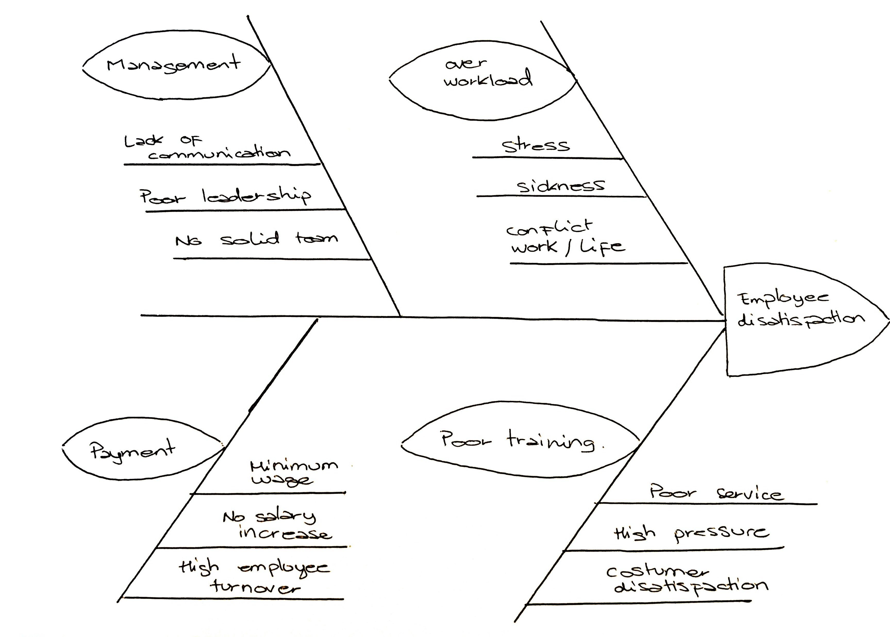

Alternative solutions and their evaluation using PMI Tool
- Solution 1: Hire a general manager which will stablish a clear and effective operational hierarchy and implementation of staff trainings on a regular basis, as well as hire new members of staff to have a complete team.
- Solution 2: Create a Company Academy where the staff has the possibility to assist workshops to develop further knowledge and skills, where at the end of the program the participating members can opt for a promotion.
- Solution 3: Increase the salary of existing members of the staff. Offer a competitive salary for newcomers, and implement rewards and incentives to increase revenue and keep employees engaged, as well as employee benefits (Such as: Dietary lunch vouches, Gym passes, Therapy).

Solution 1:
Pluses:
- Clearer company hierarchy.
- Effective operations throughout the shifts.
- Increase on customer satisfaction and service quality.
- Reduction of complaints.
- Respect for staff members rotas and breaks.
- Elimination of overtime.
Minuses:
- Longer time to find appropriate staff for respective roles.
- Time for team to adjust to new management.
Interesting:
- New Team Dynamics

Solution 2:
Pluses:
- Employee engagement and productivity.
- Clear understand of company policies and goals.
- Employees gaining necessary skills to apply at their role.
- Deliver superior value to customers.
Minuses:
- Greater company expenses with no income in return.
- Longer time of implementation.
- Current staff needing to leave their respective roles during working hours to assist trainings.
Interesting:
- Team Building, learning from each other in workshops.

Solution 3
Pluses:
- Attract of higher amount of job hunters.
- Employee wellbeing.
- Enhances employee's loyalty.
Minuses:
- Greater company expenses.
- Need to find external companies to set deals with them to achieve company benefit offer to employees.
Interesting:
- See how the dynamics of the team changes one working for the same goal.

Implementation plan
To develop and ensure the success of the implementation plan, we want the employees and stake holders to be aware and engage with the upcoming changes. We want them to desire and support the change for the company’s and their personal growth.
Our Strongest focus on hiring a new Store manager which will lead the daily basis operations. This manager will be the final decision maker. This one will be training existing line managers to implement new procedures for them to become better leaders, support and motivate their teams. Strong focus on building a positive culture in the company and a good working environment.
A Daily Briefing is recommended by the university of Exeter (N/D) to bring management and teams altogether as it’s an excellent way of communication a daily basis where questions can be asked, and feedback can be asked. Knowing what to do on the day, reminding product knowledge, and introduce team building activities to accomplish bonding.
A monthly touch base between line managers and Employees are to be set. These will record employee’s performance and action to be followed accordingly. Also, staff preferences, Ideas, or complaints will be discussed, and it will be a time where they can feel listened. ‘A 2019 Gallup study found that managers who meet with their employees experience three times greater employee engagement than managers who don’t’ (Fellow, 2021)
Yearly Appraisals will be introduced to discuss and set Employees future goals and reward success when targets are met. This Implementations will help having a strong team with the same vision where the team will increase performance and develop opportunities.
New staff will be hired in a prompt manner and an employee handbook will be created so they can be trained prior start serving on the shopfloor. This handbook will introduce newcomers to the brand history and clearly state the in-house rules and will indicate what is expected from them. This will set company standards and will ensure consistency during service of each of the company employees. Introduction of KPI’s for an excellent customer Service and help achieve individual targets. These increase customer satisfaction, will help tackle Customer complaints and reduce waiting times. With a full team we scratch the need for overtime and employees will have their breaks, which will result to a balanced employee wellbeing and better work/life balance. In addition, Yearly reviews to assess implementation success, achievements, and further implementations proposals to keep increasing employee satisfaction.

References
-CIPD (2021) PESTLE example for retail industry as at November 2021. Available at: https://www.cipd.co.uk/Images/PESTLE-example-for-retail-industry-2021_tcm18-27108.pdf (Accessed: 16 August 2021)

- Contributor (2021) What Occurs When an Organization Is Understaffed for a Prolonged Period of Time? Chron. Available at: https://smallbusiness.chron.com/occurs-organization-understaffed-prolonged-period-time-34557.html (Accessed: September 2nd 2022)

- Fellow (2021) Touch Base Meetings: Why and How They Work. Available at: https://fellow.app/blog/meetings/touch-base-meetings-why-and-how-they-work/ (Accessed: September 2nd, 2022)

- Gendron, R. (2022) How the Lack of Training Affects Your Organization. The training associates. The training associates. Available at: https://thetrainingassociates.com/blog/lack-training-affects-organization/ (Accessed: September 2nd, 2022)

- Johnson, R. (2018) Key Reasons for Job Dissatisfaction and Poor Employee Performance. Chron. Available at: https://smallbusiness.chron.com/causes-job-satisfaction-workplace-21851.html (Accessed: September 2nd, 2022)

- Milano, S. (N/D) What Is the Impact of Poor Organizational Structure Relative to Growth? Chron. Available at: https://smallbusiness.chron.com/impact-poor-organizational-structure-relative-growth-75327.html (Accessed: September 2nd, 2022)

-University of Exeter (N/D). What is a team briefing? University of Exeter. available at: https://www.exeter.ac.uk/staff/news/teambrief/teambriefing/ (Accessed: September 2nd, 2022)

Appendix

Assignment 1, Part 1– Role play script

On this roleplay we are going to go through a conversation between Lilia, who is a worker from a small luxury retail company called Vibes London, and Raul, a consultant from a firm that is been hired to listen to the employees of the stated company. The aim is to identify the ongoing problems that the company has, that led to a high volume of unsatisfied employees.

-Raul (Consultant): Hello Lilia my name is Raul, and I am a management consultant for SoVo consulting group. The reason we are here today, is to have a conversation with you, so you can explain to me the problems that you might have at your workplace. This is totally confidential, so please be comfortable and most importantly very honest, so we can get to the root of the problem and try and get a solution.
- Lilia: Nice to meet you, Raul.
-Raul: Lilia please, could you tell me how are you feeling now at your workplace?
-Lilia: To be completely honest, at this moment not very good. I am mostly exhausted, not motivated, and I feel Undervalued.
-Raul: Could you explain to me what causes that?
-Lilia: At work, I don’t stop during the shift because we are a very busy shop, and we are constantly understaffed. We never have enough cover to serve accordingly the client turnover. That means that we don’t have much time to rest or take breaks from the shopfloor. Sometimes I go on lunch at late hours, and it’s even difficult to even go to the loo because of that reason.
On top of that, we always need to stay overtime after the shift to finish the closing duties and leave the shopfloor ready for the next day, and all that time extra is not even paid!

Raul: How do you feel that affects to your interaction with the clients?
Even if I try my best, I can’t give the best client experience as the interaction is always fast, so we can go back to serve everyone else that is on the queue, as the main complaint is always that they need to wait for too long. That means that I can’t take enough time to be with any of them, and the clients feel rushed and not happy with the service. On the other hand, most of the team are new starters, and they don’t really know what to do, I need to be always on top of them giving them directions. This altogether makes me feel really stressed.

-Raul: That seems like a lot of work. Do you think this situation is affecting your personal life?
-Lilia: Absolutely, when I get home, I am so tired I don’t want to do anything else but rest. On my days I don’t have energy to do the things that I enjoy and that really puts down, because I miss doing my hobbies. Also, I can see that I am always in a bad mood, and my partner is getting tired of it…

-Raul: I am so sorry to hear that. How is your relationship with your managers? Do they give you enough support?
-Lilia: To be honest the main issue is that they don’t give clear orders on what to do, each of them gives different directions. Their focus is that all the people that is waiting is served. They barely smile, and do not motivate us employees. They don’t make a good atmosphere to work in. That’s why my colleagues always call sick and most of us want to leave.
-Raul: To finish for now, at the beginning of the conversation you said that you felt undervalued, could you tell me what makes you feel like this?

-LiIia: I have been 4 years in the company, and I am a hard worker. In all these years, I never had a salary increase. I always go beyond my duties to make sure the store runs correctly, and no one takes it in consideration. The management can see my hard work, but they never have time to sit down with me and talk about my career. I feel unheard and stuck in my position.

-Raul: Lilia, Thank you very much for your time. I will take on board all what you said today and hopefully we can change something to make you happy.

-Lilia: Thank you.

Assignment 1, Part 2 – PowerPoint presentation:

