BSC Applied Computing
Network Operating Systems and Services ACCA 5023



LONDON
UNIVERSITY OF WALES TRINITY SAINT DAVID
STUDENT NAME: JOLANTA PACEK
STUDENT NUMBER: 2413830

5th December 2025
MD. Sadeque Imam Shaikh

Table of Contents
Introduction 2
Task 1 3
Research on Hypervisor 3
Research on Routing 5
Research on Network Service 6
Task 2 7
Deliverables 7
2.1. Hypervisor 7
2.2 Download and Setup 8
2.3 Configure IP Addressing 13
2.4. Test and Troubleshoot 17
Task 3 22
Deliverables 22
3.1 Reflect on the following 22
3.1.2 Personal Reflection (With Academic Integration) 22
Bibliography 23

Introduction

In my capacity as an IT Technician for the multinational corporation NOSS2026,
which operates across its Swansea and London branches, I am responsible for researching and implementing the network infrastructure outlined in the provided topology.
As organisations increasingly rely on virtualised infrastructures, traditional approaches to network design and management are being transformed, delivering heightened flexibility, optimised resource utilisation, and improved operational resilience. [1]
Within this coursework, my aim is to critically evaluate contemporary virtualisation methodologies and apply them in constructing a virtualised network environment that meets the operational and strategic requirements of NOSS2026. Considering the organisation’s dual-site configuration, it is imperative that the proposed solution supports seamless inter-site connectivity and ensures the consistent and secure delivery of network services. To inform this process, I draw upon current academic and industry literature to justify the selection of suitable virtualisation technologies and to develop a functional network environment that reflects sound decision-making, technical precision, and professional competence.[2]

Task 1

Research on Hypervisor

Advancements in VLSI technology and the increasing throughput of modern server systems have significantly expanded available computing capacity;
however, this capacity is frequently underutilised due to inefficient resource management. Virtualisation addresses this limitation by abstracting physical hardware into flexible, logical units, allowing multiple systems to share resources effectively. Through this abstraction,
users and applications operate independently of the underlying hardware, increasing adaptability and efficiency. This is achieved through a hypervisor, or Virtual Machine Monitor (VMM), which forms a software layer between the physical hardware and operating systems to allocate and schedule resources.
Hypervisors are broadly categorised into Type 1 and Type 2 architectures.
A Type 1, or bare-metal, hypervisor executes directly on the system’s hardware resources, functioning independently of any host OS layer resulting in superior performance, isolation, and security.
Examples include VMware ESXi and Xen. Because the VMM directly manages CPU, memory, and device interactions, Type 1 hypervisors are well-suited for enterprise environments that host multiple virtual workloads.
In contrast, a Type 2 (hosted) hypervisor operates as an application on top
of a conventional operating system. I/O operations are handled by the host OS, which introduces additional overhead and reduces performance. While suitable for testing
or lightweight deployments, hosted hypervisors are less appropriate for large-scale
or security-sensitive infrastructures.
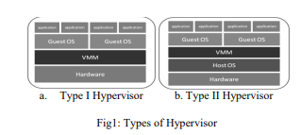
Figure 1. Illustration types of Hypervisors
Given the requirements of the SWANSEA.ACCA domain, supporting Windows Server 2022, Debian services, mixed-OS workloads, and future expansion,
a Type 1 hypervisor presents the most suitable solution. It’s hardware-level efficiency, strong isolation mechanisms, and robust scalability ensure consistent performance
for critical services such as Active Directory, DNS, and Debian-based functions.
Thus, a Type 1 hypervisor provides the optimal balance of reliability, security and cross platform compatibility for this topology.[3][4]

Research on IP Addressing

Understanding how digital information travels across the Internet reveals
the complexity of modern communication systems. When data such as messages, emails,
or multimedia content is transmitted, it is first converted into binary signals, represented
as electrical pulses, light signals, or radio waves, that propagate through wired and wireless communication media. Rather than being sent as a single continuous stream, this data
is segmented into smaller units known as packets.
Each packet contains a fragment of the original information along with metadata specifying its source and intended destination.
This process, referred to as packet switching, enables highly efficient use of shared network infrastructures by allowing multiple data streams to coexist on the same transmission paths.
As packets traverse the network, they are routed through intermediary devices such as switches and routers, which determine the most appropriate path based on current network conditions. Upon arrival at the destination device, the packets are reassembled to reconstruct the original data.
The speed at which this occurs, typically within milliseconds, creates the perception
of instantaneous communication for end users. A suite of protocols, including HTTP, FTP
and the TCP/IP model, coordinate the rules governing data transmission, ensuring accuracy, reliability and orderly delivery across diverse network environments.
This collaborative protocol stack forms the foundation of the Internet’s operational effectiveness and its ability to support global communication.[5]

Research on Routing

Routing protocols represent a foundational element of network architecture, facilitating
the efficient and accurate transmission of data packets between source
and destination nodes across diverse and interconnected systems.
As digital communication continues to underpin critical societal, commercial
and technological functions, comprehensive knowledge of routing mechanisms has become indispensable for scholars, practitioners, and industry specialists.
This discussion critically examines the fundamental principles and operational dynamics
of routing protocols, highlighting their essential role within contemporary networking infrastructures.
The reliability of data delivery is central to the effectiveness and performance
of modern communication systems. Without robust routing mechanisms,
networks are exposed to latency, packet loss, service degradation, and heightened security threats. Therefore, routing protocols possess both technical and strategic relevance, contributing directly to the resilience, stability, and overall integrity
of network operations.
Subsequent sections provide an analytical overview of the primary categories
of routing protocols, assess their internal mechanisms, and contrast their respective strengths and limitations. As networking technologies continue to evolve rapidly, regular reassessment of routing strategies is imperative to ensure continued efficiency, scalability, and security.
A deeper understanding of routing protocols enables readers to appreciate their pivotal influence on digital connectivity and their sustained importance in shaping the future
of network communication.[6]

Research on Network Service

Virtual Private Networks (VPNs), the Dynamic Host Configuration Protocol (DHCP),
Active Directory Domain Services (AD DS), and Certificate Authorities (CAs) constitute core components of contemporary enterprise network infrastructures. VPNs facilitate the establishment of encrypted, authenticated communication channels over public
or otherwise untrusted networks, thereby ensuring the confidentiality, integrity
and authenticity of transmitted data. Robust VPN deployment requires adherence to best practices, including the implementation of strong cryptographic standards such
as AES-256, multi-factor authentication, and granular access control policies to reduce network exposure.
DHCP streamlines the assignment of IP addresses and associated configuration parameters, reducing administrative overhead and minimising the likelihood
of address conflicts. Effective DHCP administration relies on well-structured IP scope planning, the use of address reservations for critical systems, and tight integration with DNS to maintain accurate and consistent name-resolution services.
Active Directory Domain Services provide a centralised identity and access management framework for Windows-based enterprise environments.
Core capabilities include Kerberos-based authentication, hierarchical organisational structures, and Group Policy enforcement for broad configuration management.
An effective AD DS administration depends on secure delegation, logical OU design, rigorous replication monitoring, and enforcement of least-privilege principles to ensure operational resilience and security.[7]
Certificate Authorities underpin public key infrastructures (PKI) by issuing, validating, and revoking digital certificates essential for authentication and encryption.
Secure CA management requires disciplined certificate lifecycle governance, protection of root Cas, preferably in offline environments and adherence to strong cryptographic policies.
Collectively, these services enable secure communication, centralised management, and trusted authentication. Their coordinated deployment enhances organisational reliability, scalability, and regulatory compliance, forming a foundational pillar
of modern enterprise networking.[8]

Task 2

Deliverables

2.1. Hypervisor

Following a review of academic literature and technical specifications, Oracle VirtualBox, a Type-2 hypervisor, was selected as the platform for the virtual network. Type-2 hypervisors suit laboratory and academic environments because they run on top of a host OS, offering easy deployment, broad hardware compatibility and reduced administrative overhead. [9]
VirtualBox supports multiple guest systems such as Windows and Debian reliably and provides advanced networking options, including NAT, Bridged, Host-Only and particularly Internal Networking.[10] Internal Networks enable fully isolated communication between VMs, which is essential for implementing two independent, non-routed networks.
VirtualBox also supports multi-VM environments, aligning with future expansion into services such as DNS, DHCP, Active Directory and web hosting. Research highlights its strong device integration and stable virtual drivers, making it suitable for long-term
deployments. [11] Its ease of use and efficient host–guest interaction also simplify evidence collection required for the assessments.[12]
Overall, VirtualBox is justified by its reliability, networking capabilities and suitability for ongoing coursework tasks.

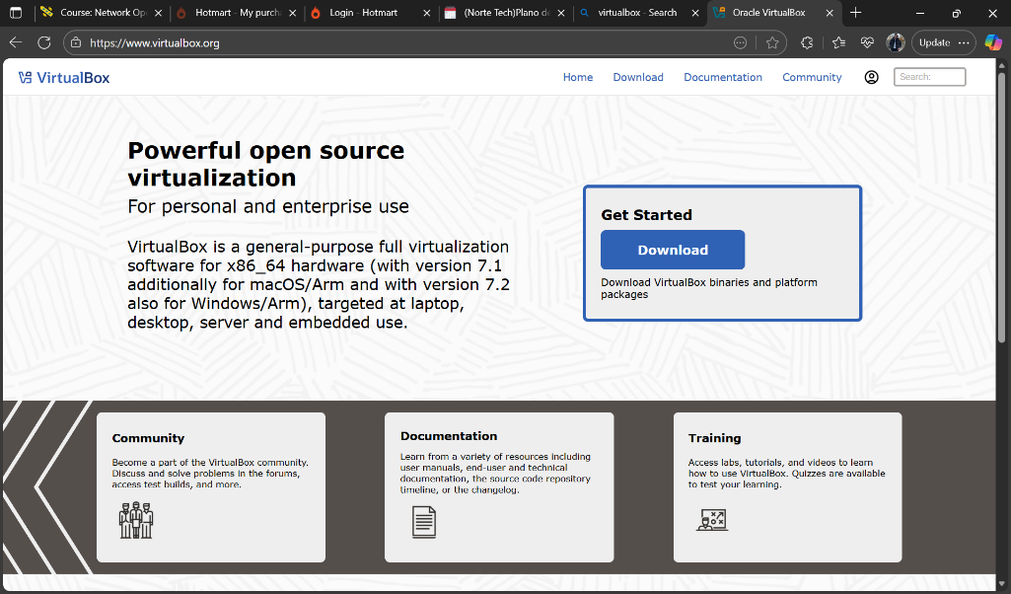
Figure 2. Image of Hypervisor: Oracle VirtualBox Manager

2.2 Download and Setup

In line with academic integrity and cybersecurity best practices, all required software was downloaded exclusively from official and reputable sources.
- Oracle VirtualBox was sourced directly from Oracle’s official website.
- Windows ISO images were downloaded from the Microsoft Evaluation Centre.
- Debian Linux ISO was retrieved from the official Debian repository.
Timestamped screenshots confirm each step of the download process, from navigating to the correct source to receiving the final installation files. This approach not only ensures authenticity but also demonstrates appropriate technical judgement.
Network Deployment in Accordance with the Topology
Creation and Configuration of Virtual Machines
Four virtual machines were created:
- Windows Client Machine 1
- Windows Client Machine 2
- Debian Linux Machine 1
- Debian Linux Machine 2
Each VM was provisioned with:
- 2 GB RAM
- 20 GB virtual storage
- 1–2 virtual CPUs
- Virtual optical drive containing the downloaded ISO
Screenshots with timestamps verify each stage of configuration as well as successful installation and initial startup.[13]

Network Adapter Assignment
The topology required two isolated networks. Accordingly:
- Both Windows VMs were assigned to InternalNetwork1.
- Both Debian VMs were assigned to InternalNetwork2.
These assignments were applied in VirtualBox under Network → Adapter 1 → Internal Network, ensuring each VM’s communication was restricted to its intended domain. Timestamped screenshots confirm all NIC assignments.
This network isolation is consistent with the behaviour that internal segments are fully isolated unless a routing entity is present.

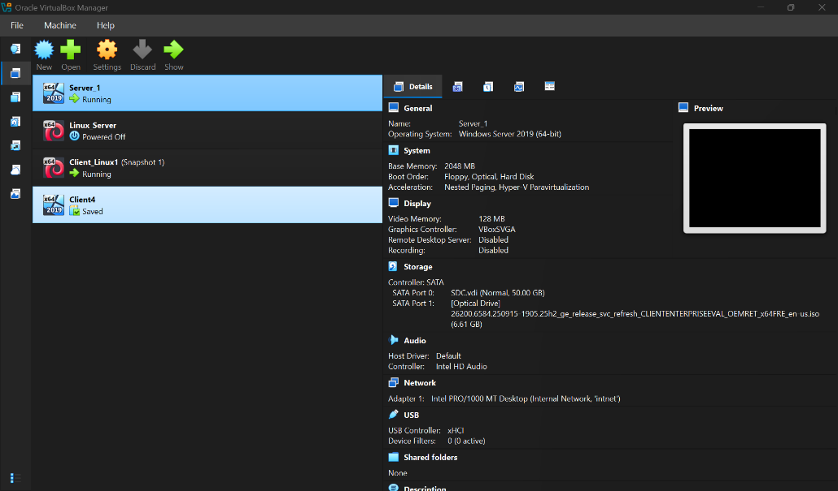
Figure 3. Image of Creating of Virtual machine windows 1 and 2 (1 screenshot)
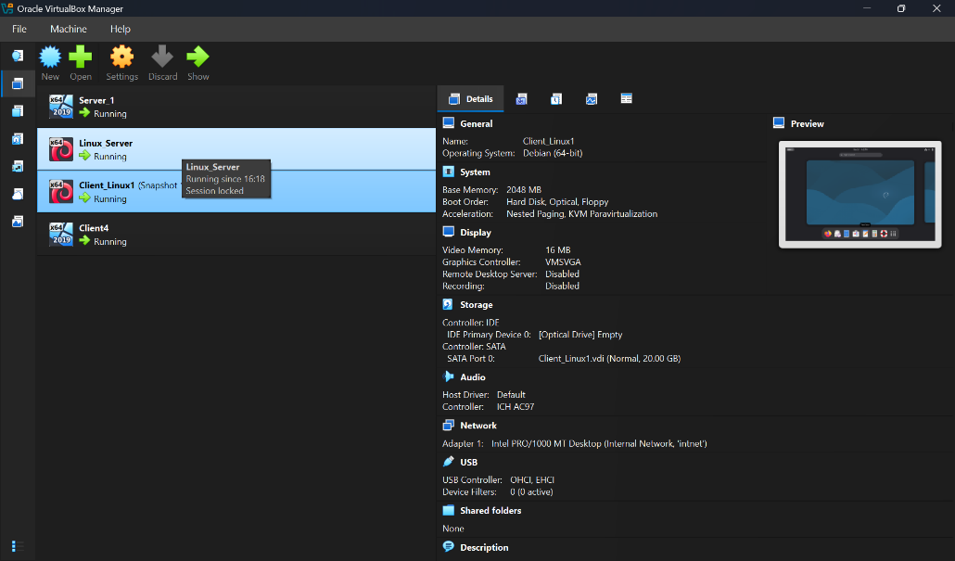
Figure 4. Image of Creating of Virtual machine Linux Devian 1 and 2(1 screenshot)
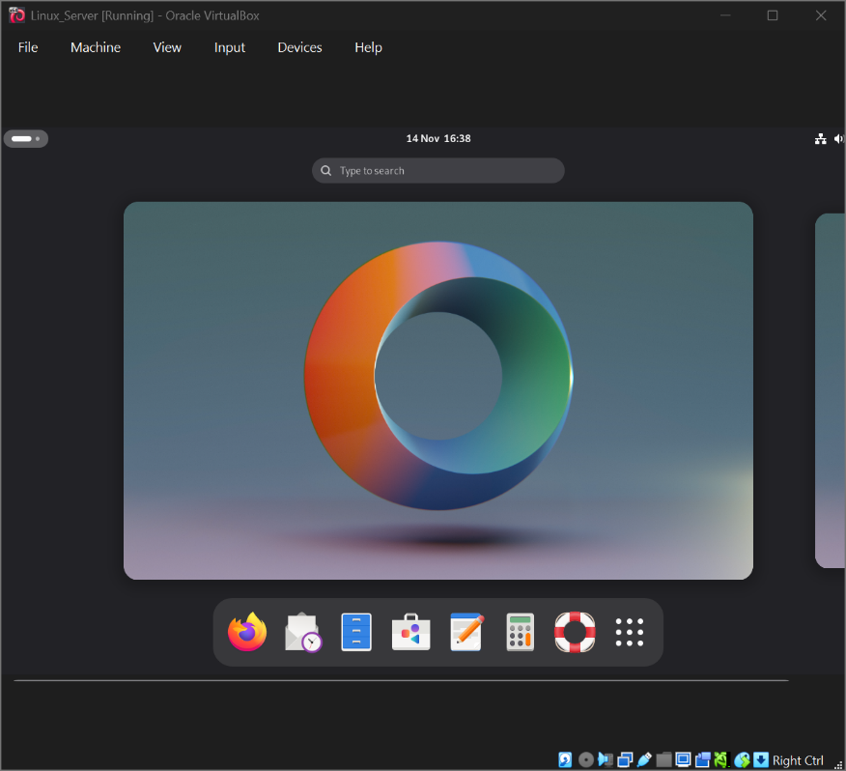
Figure 5. Images of Installing Windows and Linux OS (Start 4 Machines and take desktop screenshots)
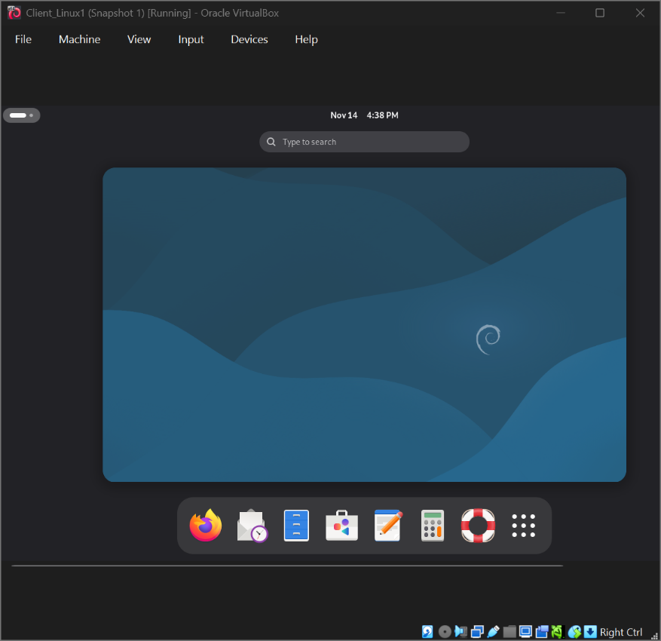

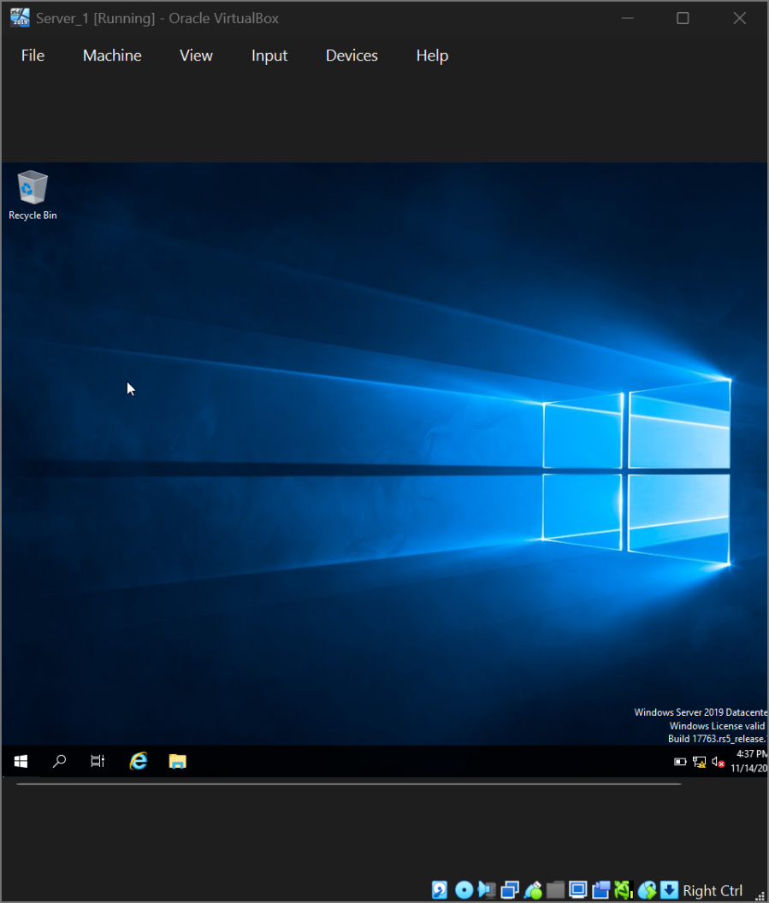

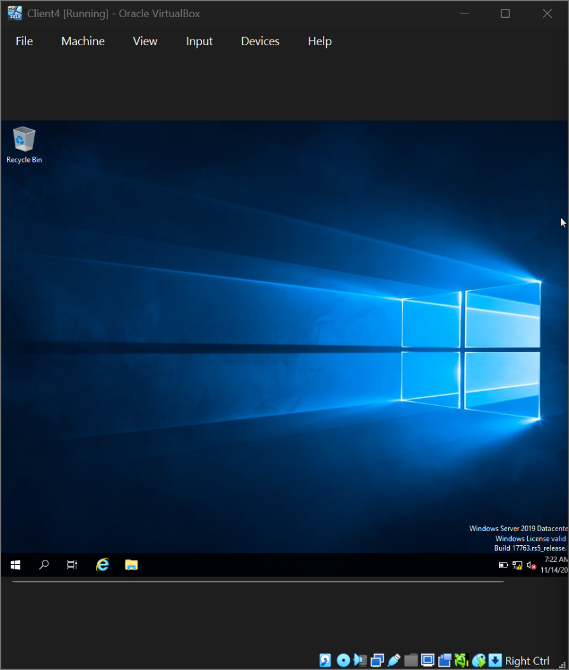

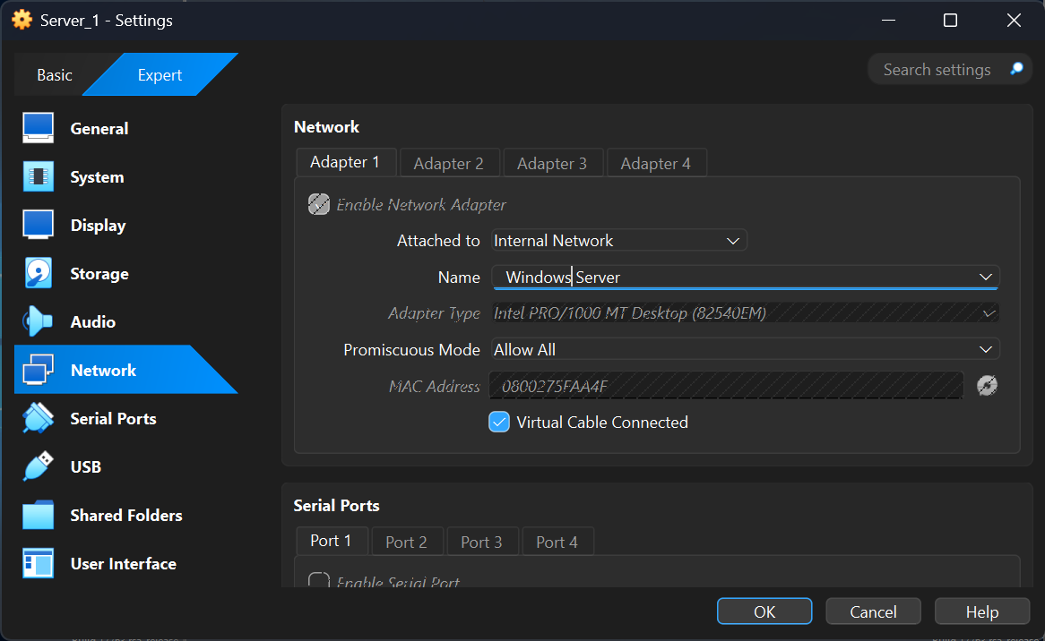
Figure 6. Image of Creating Network with Internal Network for windows (1 screenshot)
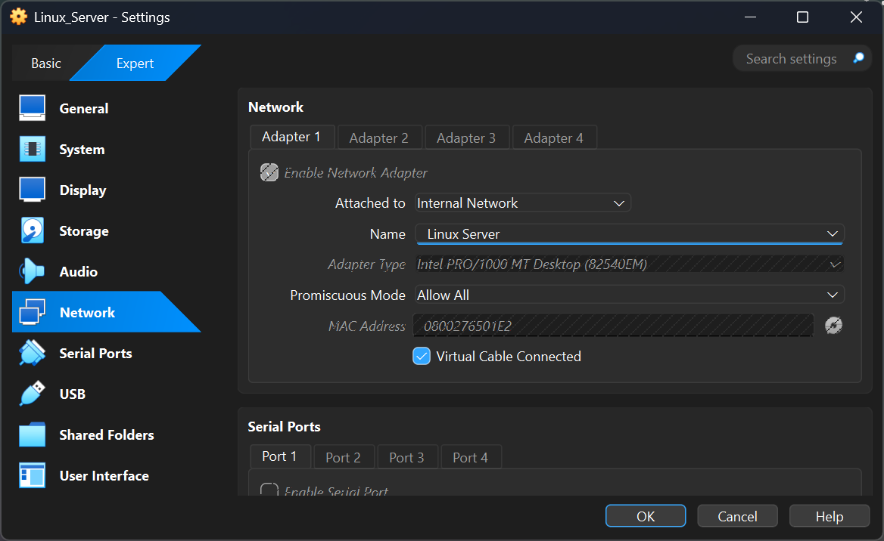
Figure 7. Image of Creating of Network with Internal Network 2 for Linux (1 screenshot)

Figure 8.Image 2 of 2 Windows PCs relate to Internal Network (2 screenshot)
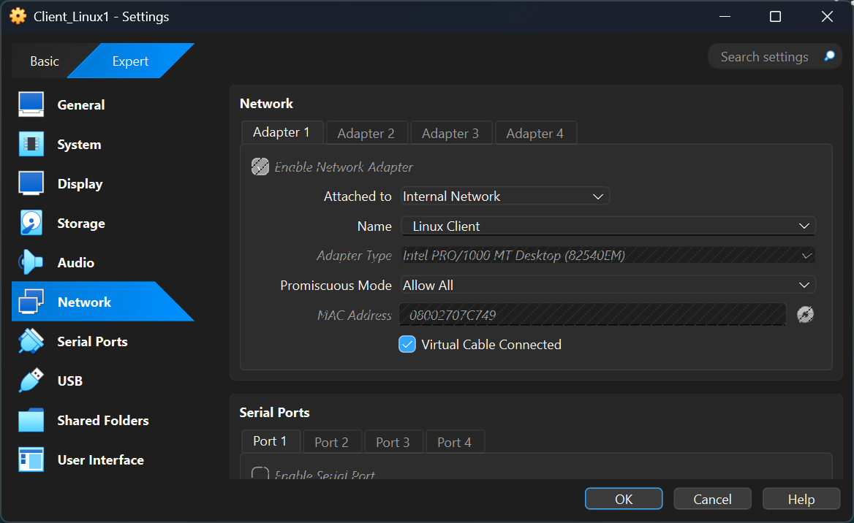
Figure 9. Image of 1 of 2 Linux PCs relate to Internal Network2 (2 screenshot)
Figure 10. Image of 2 of 2 Linux PCs relate to Internal Network2 (2 screenshot)

2.3 Configure IP Addressing

Design and Application of the Addressing Scheme
To demonstrate advanced technical capability, a custom VLSM-based addressing scheme, rather than the default topology values was designed and implemented. This approach aligns with the exceptional grading criterion.
The addressing scheme was structured as follows:
Internal Network 1 (Windows Network) — 192.168.50.0/24
- Windows 1: 192.168.50.10
- Windows 2: 192.168.50.20
- Subnet Mask: 255.255.255.0
- No gateway (segmented network)
Internal Network 2 (Linux Network) — 10.10.100.0/24
- Linux 1: 10.10.100.10
- Linux 2: 10.10.100.20
- Subnet Mask: 255.255.255.0
- No gateway

The configuration was validated on each system using:
- ipconfig (Windows)
- ip add show (Linux)
Timestamped screenshots demonstrate that all IPs were applied correctly. This structured design aligns with the strategic planning principles outlined emphasise accurate subnetting as a core element of virtualised network deployments. [14]
Evidence of IP address configuration on two Windows machines and two Linux machines was collected. The ipconfig command was used on the Windows systems, while the IP add show command was executed on the Linux systems. Four screenshots documenting these results are provided.

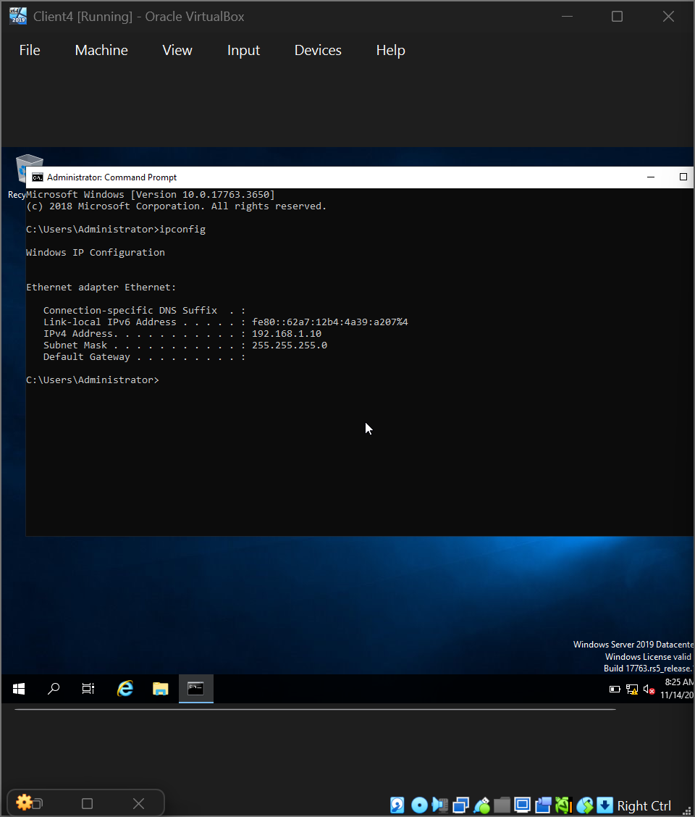

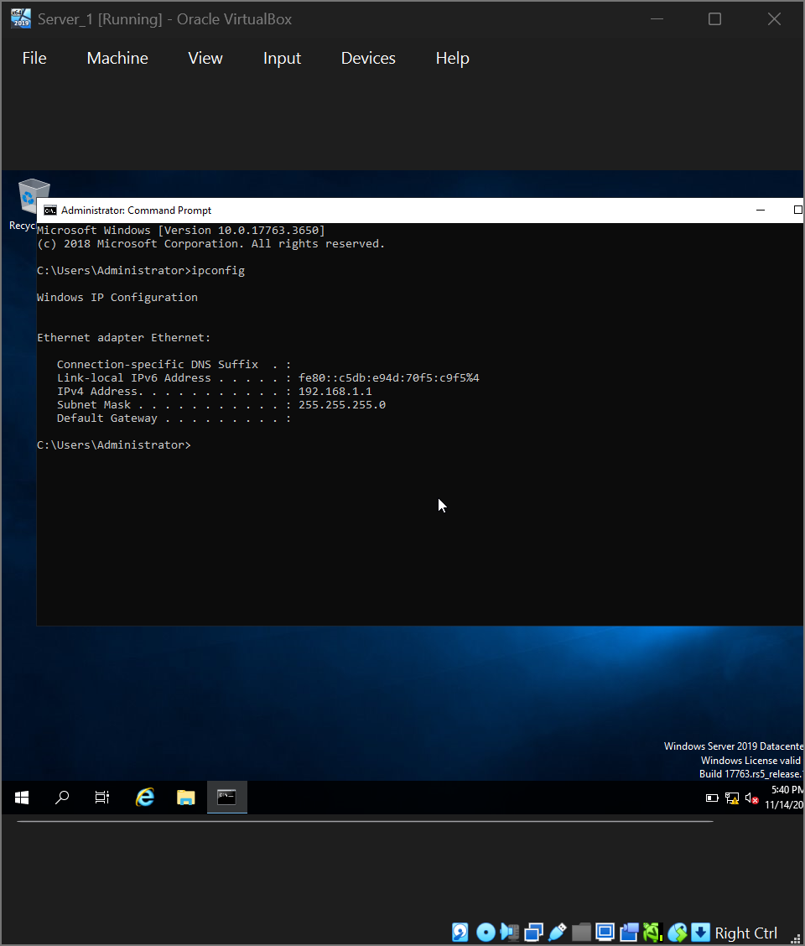

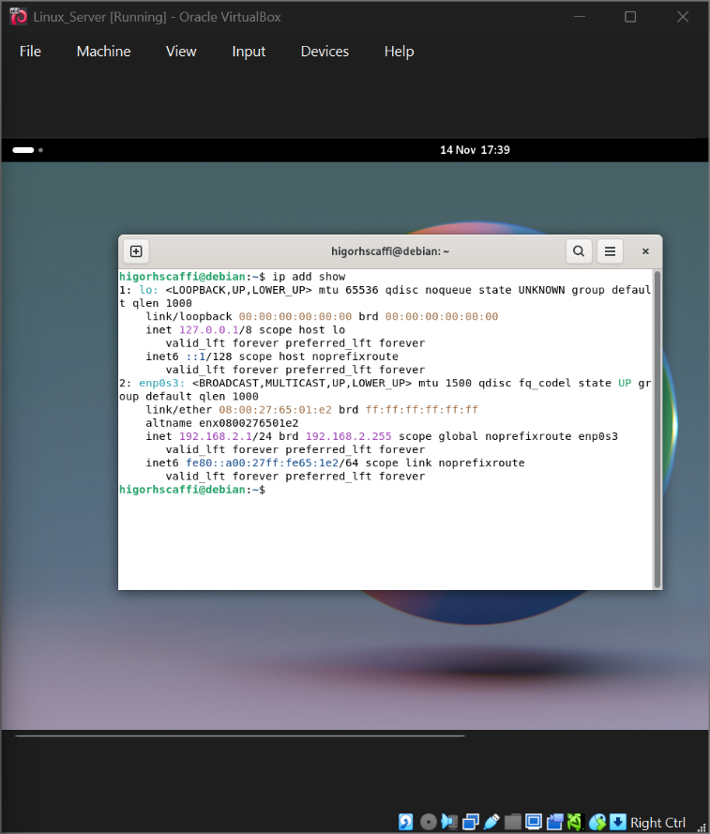

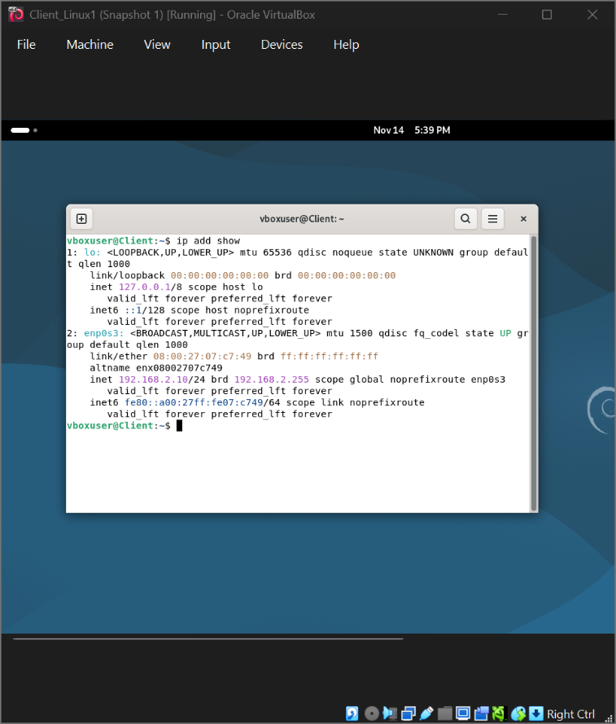

The topology above provides the network addresses for the respective networks. The network IP address obtained from the Internal Network 1 segment for the Windows system
is documented and presented in a single screenshot.

Figure 11. Recorded IP address of the Linux host within Internal Network 2 (1 screenshot
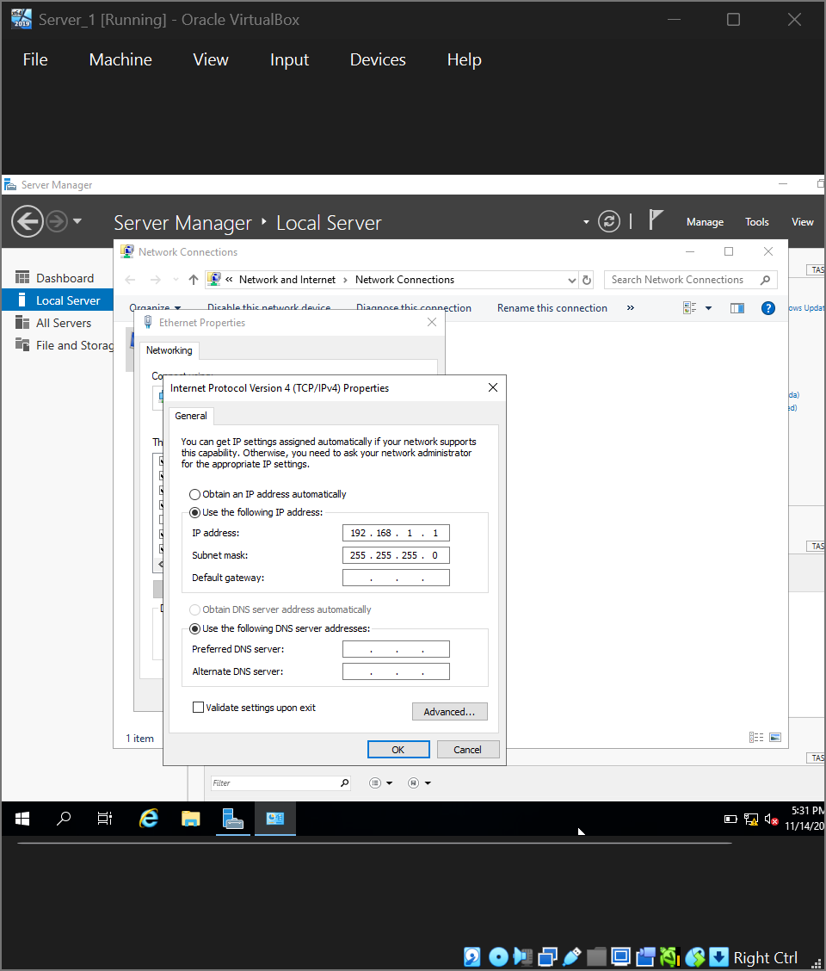
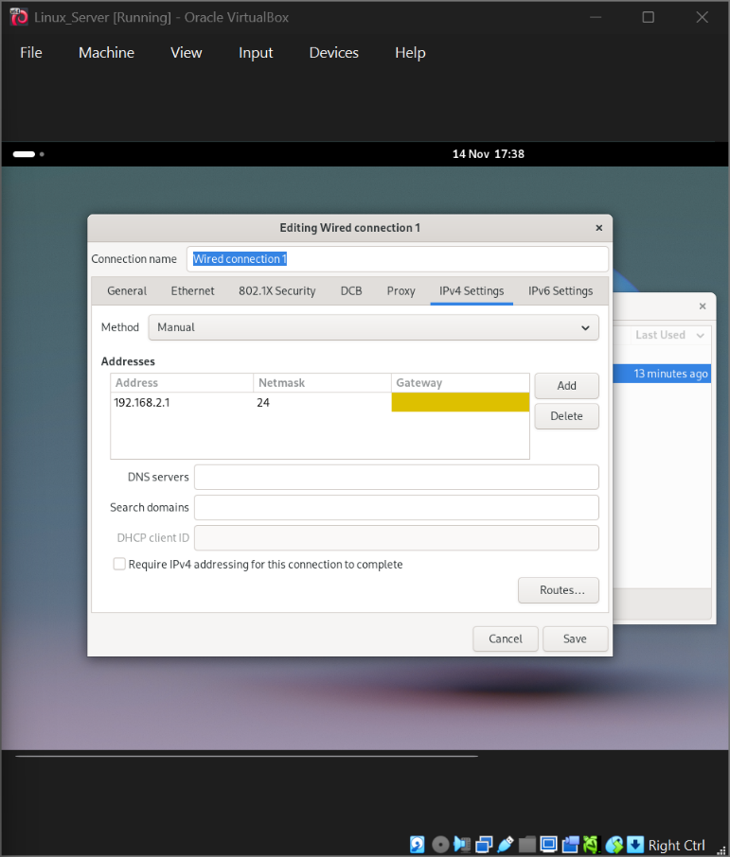

2.4. Test and Troubleshoot

Connectivity tests

Outcome 1: Successful Connectivity Within the Same Network
Windows Network:
Ping tests amongst Windows 1 and Windows 2 were successful, confirming correct NIC assignment and IP addressing.
Linux Network:
Ping tests between Linux 1 and Linux 2 were also successful.
Timestamped screenshots provide evidence of each successful result.

Outcome 1: Successful connectivity within Linux network. (2 screenshots)

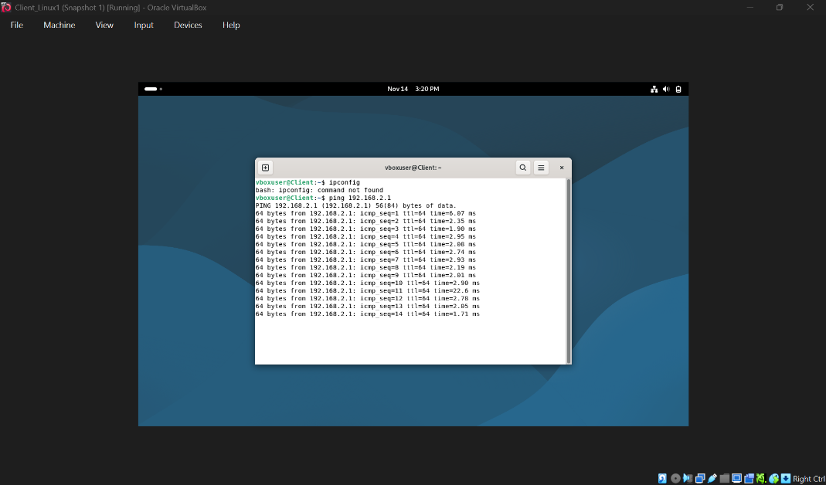
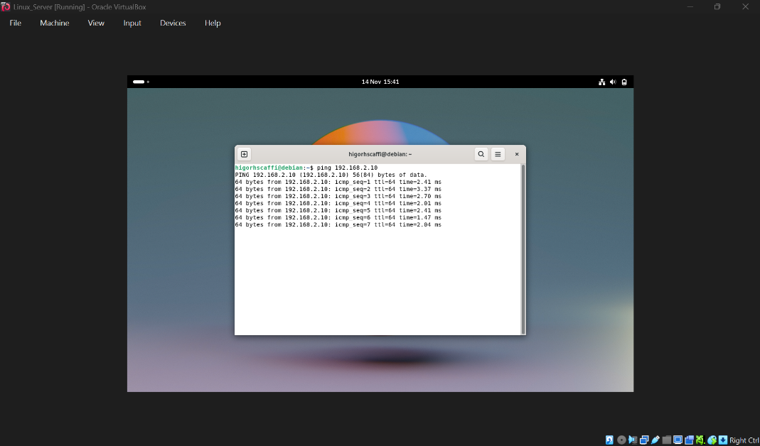
Figure 12.Successful connectivity within windows network. (2 screenshots)

Figure 13. Network IP address from Internal Network 2 for Linux (1 screenshot)
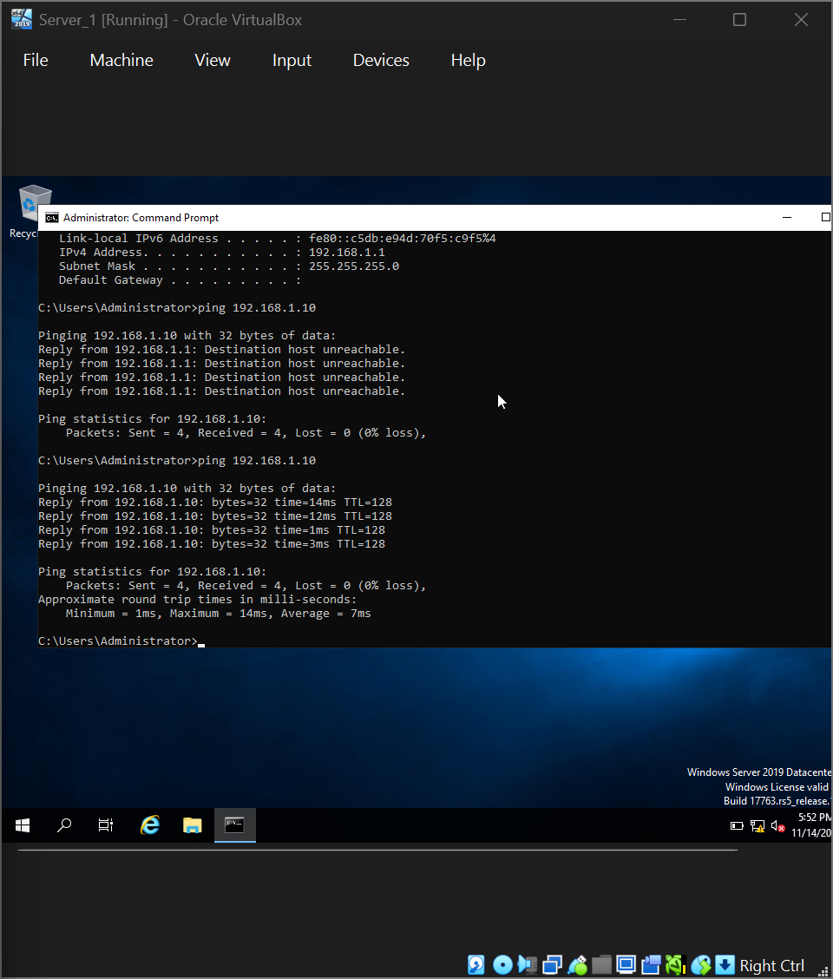
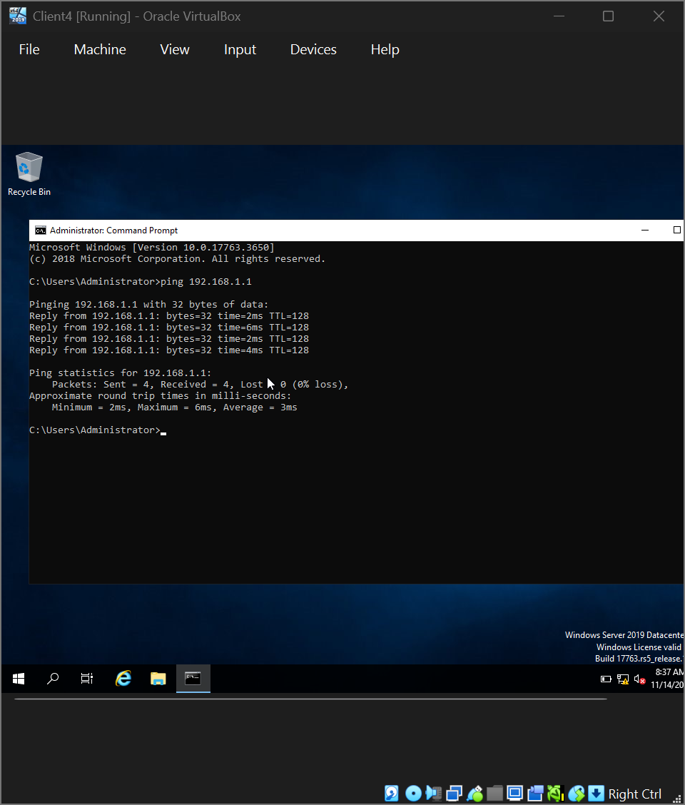

Attempts to ping between the Windows and Linux machines failed as expected, consistent with Rao’s assertion that isolated Layer 3 networks cannot communicate without routing. These results verify that the topology was correctly implemented and that network segments remained properly isolated.
Outcome 2: Failure of Layer-3 connectivity between Linux and Windows hosts
(2 screenshots).
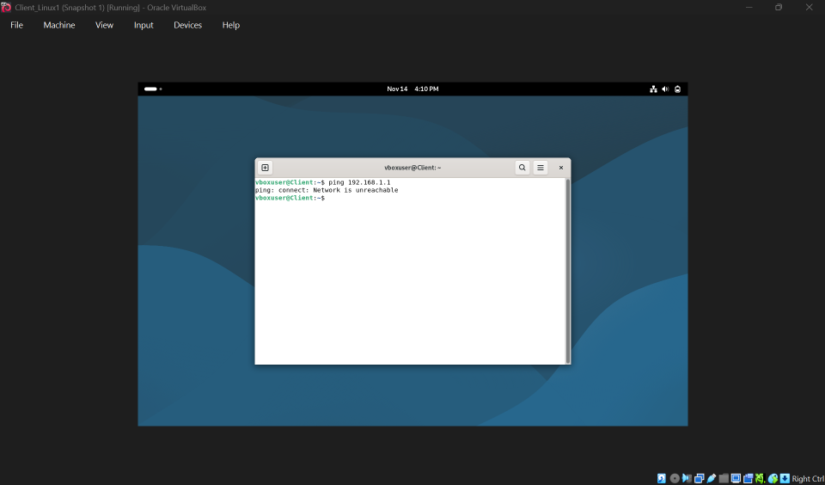

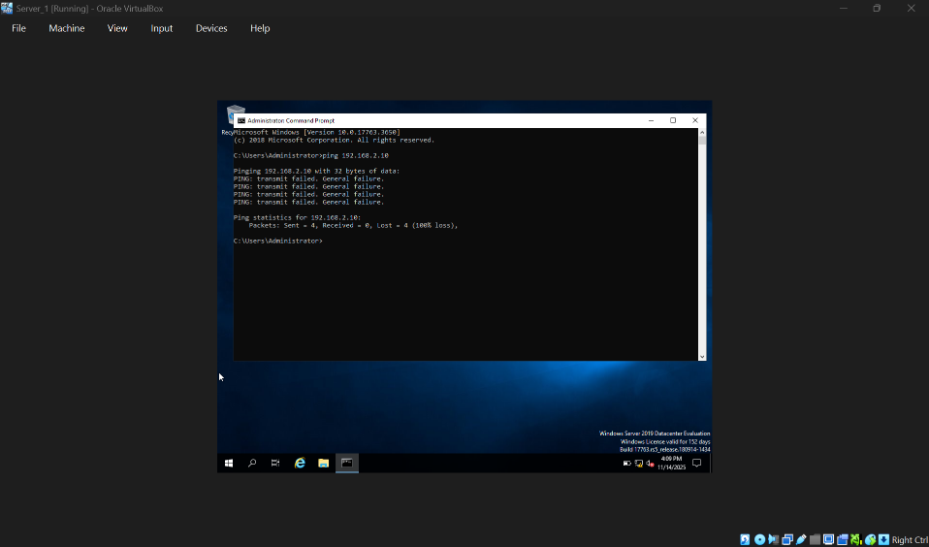
Figure 14. Failure of inter-network communication between Linux- and Windows-based hosts (2 screenshots).

A structured, evidence-based troubleshooting approach was applied. Initial connectivity issues were traced to firewall restrictions, with Windows Defender and Debian’s UFW blocking ICMP traffic; enabling echo responses resolved the problem. One VM had been assigned to the wrong internal network, causing further failures until corrected in VirtualBox. Duplicate IP addresses were also identified and resolved by reapplying the VLSM scheme. Minor DNS and hostname-resolution issues on Linux were corrected by reviewing resolv.conf. All troubleshooting steps were documented with timestamped screenshots.

Task 3

Deliverables

3.1 Reflect on the following

The deployment and testing of the virtual network environment in Oracle VirtualBox exhibited several technical challenges that intensified my understanding of virtualisation and network configuration. During initial setup, IP address conflicts occurred on the Windows network because both machines were inadvertently assigned overlapping addresses. Using ipconfig and cross-checking the planned addressing scheme allowed me to identify and correct the issue quickly. A similar problem arose with DNS resolution on the Linux machines,
where incomplete entries in /etc/resolv.conf prevented hostname lookups. Diagnostic decrees such as ip add show and nslookup helped detach the problem, and updating DNS configuration restored normal function.
Another major obstacle involved firewall restrictions. Windows Defender Firewall initially blocked ICMP traffic, resulting in failed connectivity tests despite correct IP assignments
. After enabling ICMP Echo-Allow rules, exchange proceeded as expected.
The Linux network required parallel adjustments to UFW to permit echo requests. Additionally, one VM was attached to the wrong internal network in VirtualBox, causing unexpected isolation. Reviewing adapter configurations and reassigning the correct Internal Network resolved the issue.

3.1.2 Personal Reflection (With Academic Integration)

From an individual standpoint, this task pointedly enriched my troubleshooting skills and reinforced the importance of systematic problem-solving. I became more confident using diagnostic tools across both Windows and Linux platforms and gained deeper perception into how insignificant configuration errors can affect network behaviour. Capturing timestamped evidence throughout the task also adjusted my organisation and credentials skills.
Overall, Task 2 strengthened my technical confidence and organised me for more advanced network service arrangement in Coursework 2.

Bibliography

References
[1] Stacy Norman, "A Technical Look At How Data Is Transmitted On The Internet," March 18 2025.
[2] "Trends, Challenges and Best Practices, Communications surveys & tutorials," vol. 23 no.4, pp., pp.1120–1139, 2021.
[3] R. O. A. Desai P.Sharma. B.Patel, "Hypervisor: A Survey on Concepts and Taxonomy, International Journal of Engineering Research," vol. n2 o 3., pp.222–225, February 2013.
[4] Science Direct Topics. "introduction to hypervisors in Computer Science , Science Direct Topics." https://www.sciencedirect.com/topics/computer-science/hypervisor
[5] J. P. J. Mogul FRC 950, "Internet Standard Subnetting Procedure," 1985. Available: https://Https://datatracker.ietf.org./doc/rfc950
[6] R.Kumar and&nbsp and M.Singh, "Virualization Technologies and Modern Network Deployment Strategies , "Strategies ogf Network Systems," vol. 18 no.3, pp.45–59, 2022.
[7] D.Francis, "Mastering Active Directory 3rd edition," no. Packt Publishing , Birmingham, pp.34–35,
[8] Debian, "Debian Project, "Debian -Official ISO Images", Debian org." Sat, Aug 16 UTC 2025. Available: https://www.debian.org/distrib
[9] A.Desai, R.Ozra, P.Sharma, B.Patel, "Hypervisor: A survey on Concepts and Taxonomy," International Journal of Engineering Research," vol. 2 no 3, pp.222–225, February 2013.
[10] Virtual networking. "Oracle Corporation, Oracle VM VirtualBox User Manual." https://www.virtualbox.org/manual/ch06.html
[11] Oracle Corporation. "Oracle Corporation, "Internal Networking, "VirtualBox Manual," https://www.virtualbox.org/manual/ch06.html#network_internal
[12] R. 9. J.Mogul and J.Postel. "Internet Standard Subnetting Procedure."
[13] Oracle Corporation. "Oracle Corporation, Oracle VM VirtualBox User Manual – Chapter 1:First Steps (Creating Virtual Machines)." https://www.virtualbox.org/manual/ch01.html
[14] J. Mogul and J. Postel, and RFC 950:, "Internet Standard Subnetting." https://datatracker.ietf.org/doc/rfc950/


