
BMHP5015 Changemakers Portfolio
Module: Changemakers: Building your Personal Brand for Sustainable Employment
BSc Health and Social Care

Table of Contents
Task 1: Personal Employability Skills 2
Task 2: Building Your Personal Brand 3
Task 3: Professional Identity and Self-Awareness 4
Task 4: Communication and Patient Outcomes 5
Task 5: Resilience and Wellbeing 6
Task 6: Career Planning and Development 7
Task 7: Sustainable Employment and Future Vision 9
References 9

Task 1: Personal Employability Skills
Health and social care careers require a lot of so-called softer skills. According to the Department of Labour (Mush, 2023), Ready for Work means professional behaviour, communication (both verbal and written) skills, teamwork and critical/ problem-solving thinking. They are essential as they help professionals work together, advocate for patients, and manage difficult situations (Zahoor, 2024) to provide safe and compassionate care. Soft or interpersonal skills make your brand. Your patients and the companies that are responsible for your treatments gauge you both on these traits as well (Yansen, 2023).
I have good empathy and listening skills but I need to work on my organizational and leadership skills. I hope to close this gap by attending leadership seminars, seeking mentors, and practicing reflective practice. The below bar chart demonstrates the importance of "soft skills" in health and social care (EURES European Union, 2024).

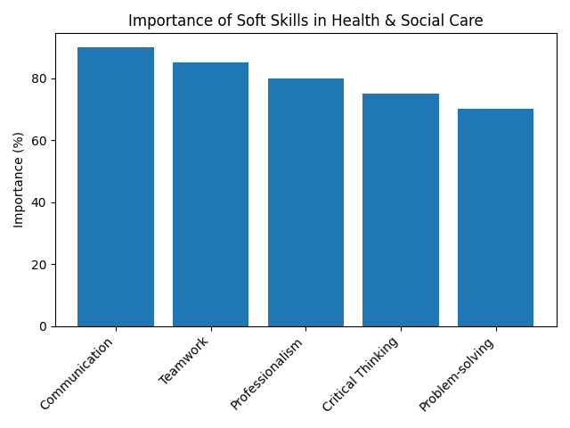
According to the Department of Labour, health and social care workers need soft skills, as seen in Figure 1 (Kucharska, 2024).

Task 2: Building Your Personal Brand
Personal branding — How to position yourself in a way that is unique for everyone (Zahoor, 2022)
In a study published in Frontiers in Psychology, it was found that personal branding behaviours increase employability and work satisfaction among individuals. Draw a distinction of yourself by creating and marketing a personal brand on social media & Technology (Van Zoonen, 2022).
Empathy, professionalism and teamwork should be key components of personal branding for health and social care workers. My Statement was Thelen, 2024: A compassionate health and social care professional focused on enabling patients to self-determine via advocacy in communication of evidence-based practice and equitable access to care.
I will decide to build my brand, therefore:
Create a professional online presence (., LinkedIn) of accomplishments, and holding values (Bonsu Osei, 2024).
Share what you are learning through blogs or professional forums (Wondiwoy, 2024.
Gather feedback from others to improve my professional brand (Shutaleva, 2022)

Task 3: Professional Identity and Self-Awareness
Start thinking, acting, and feeling with the status of a professional in your industry. It promotes belonging and ethics. Competent practitioners – with values and ethics, expertise, leadership, and professional comportment (Pekkala 2022).
Good mental health, job contentment and patient care are helped by a strong professional identity. I will cement my professional identity by:
Integrate theory and clinical experiences with reflective practice (Sangal, 2024).
Engage in interprofessional education to learn and respect the role of other professional disciplines (Pahos, 2025).
Compassion, Code of Conduct and Patient Advocacy (Osei, 2024)
The following radar graphic contrasts my self-assessed skills versus the health and social care practitioner requisites. Improvement is in the areas of leadership and adaptability.

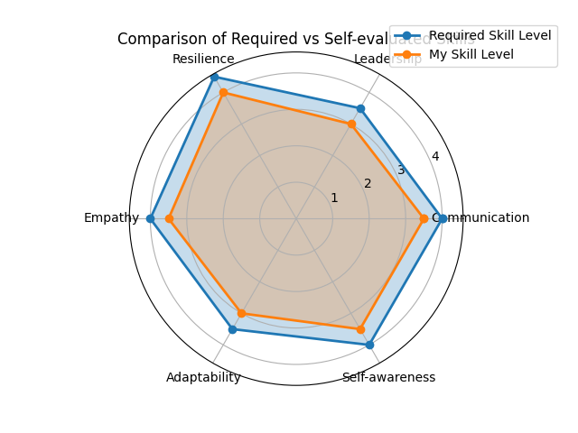
Figure 2: Required skill levels vs. self-evaluation. Leadership and adaptability need improvement.

Task 4: Communication and Patient Outcomes
Effective communication is essential to the delivery of safe, high quality health and social care. A preliminary review demonstrates that satisfactory communication with elderly patients enhances patient-centered results such as quality of mental and physical health, treatment quality, and patient satisfaction. Trust, anxiety reduction, and adherence to treatment are all enhanced by active listening coupled with empathy and clear explanation (Stanciu, 2019).
I would form ISBAR (Identify, Situation, Background, Assessment and Recommendation) to make sure handovers that are unambiguous. And I will also confirm the patient's understanding using plain language and teach-back (Zahoor, 2024).
Surveys assessing the quality of communication and outcomes are a widely used research method demonstrating a positive correlation between communication and patient satisfaction. Bar chart in Task 1: Soft skill priority by Communication Above-mentioned, the communication may have a better patient outcome (Thelen, 2024).

Task 5: Resilience and Wellbeing
This enables health and social care workers to endure stress in dealing with the adversities, learn from errors, cope better and provide high quality services. Research on resiliency in the face of a pandemic showed that resiliency is bolstered by professional identity, good coworker support, strong leader communication, and opportunities for growth and self-care (Osei, 2024). Resilience can help minimize occupational stress, anxiety and burnout.
To enhance resilience, I will:
Data inputs up to Oct 2023 CEW Apply ← You have a strong professional identity by generating value and ethical action, eg., constant learning: Musch (2023)
Listen collegially via peer support groups and reflective supervision (Kucharska, 2024)
(Sangal, 2024) Do Self-Care (MindfulnessExerciseWork–Life Balance)
Actively ask supervisors for feedback on how you can improve as well as what they appreciate about your work (Wondiwoy, 2024).
Fostering psychological safety, normalising open communication and encouraging self-care will help keep employees in their roles. Mental health patients maintaining their careers through supportive environments were cited in a 2026 article in Nursing Reports (Zahoor, 2024).

Task 6: Career Planning and Development
This needs career planning, you know what you want to achieve and few of the things which will take you there. Knowledge-based environments, a supportive presence of staff and adaptability, in addition to strong undergraduate preparation facilitate retention and recruitment of skilled care home nurses (Pekkala, 2022). The survey explained the 33% drop in registered nurses, 17,000 fewer jobs, a turnover rate of 41.5 percent in 2019-20 and a 9.9 percent vacancy rate at adult social care in the year which come before (2020-21).
My ideal job/senior community health practitioner For this, I'll:
Pursuing masters in public health and community leadership
Training is focused on working in community clinics and outreach programs to enhance cultural competence (Shutaleva, 2022).
Connect with senior specialists and enroll in leadership qualification programs.
— Engage in study projects that could strengthen your academic-stature and evidence-based practice (Pekkala, 2022).
Below is a pie chart that tells about the critical factors in career planning. Structured learning, promotion of a healthy workspace and leadership development are highlighted (Osei, 2024).
Supporting factors for career planning and development (in %) Source: Empirical study Follow-up research of career planning between actors in the interprofesional working group Jörg Belschner / Alfred Bell Demonstration of career anchors On the contrary, different inquiries longing and needs are established that would let leach many other approaches in an interdisciplinary context fewer place or completely occupy.

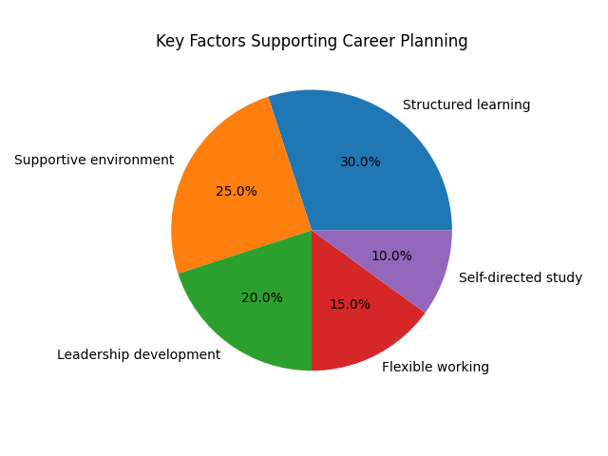
Figure 3: Key factors supporting career planning and development.

Task 7: SustainableEmployment and Future Vision

To remain employable, you need to become a great human being who works gracefully in interesting projects, so that is a normal part of any successful company and creates the long-standing good profession — find meaningful work, learn from it, build relationships with knowledgeable experts in your field. A 2026 Nursing Reports study noted that psychological safety, fair treatment, flexible job arrangements and multilayered support systems founded on organization and government pledge can assist people with mental health illnesses retain their employment.This is a series of blogs on my vision for a sustainable career in health and social careWorking for the company that cares about employees'' health, offers flexible working hours and promotes a friendly environment.Ongoing education and attending conferences to maintain my awareness of changes in the field that advocated for better working conditions and mental health care for health professionals.Planning career priorities, and when to interrupt these priorities with life events so that we do not burnout while remaining steadfastThis portfolio demonstrates that I mean business when it comes to my personal brand, working on in-demand skills for employers, and preparing for a career in social care and health now and long-term. Reading books and applying some of my own ideas will help develop me further as a carer and practitioner.

References
Bonsu Osei, A. and Anim-Wright, K. (2024) ‘Personal Branding: A Systematic Literature Review’, International Journal of Marketing Studies, 16(1), pp. 1–30. Available at: https://ideas.repec.org/a/ibn/ijmsjn/v16y2024i1p30.htmlideas.repec
EURES (European Union) (2024) ‘Building and improving your personal brand’. Available at: https://eures.europa.eu/building-and-improving-your-personal-brand-2024-07-30_eneures.europa
Kucharska, W. (2024) ‘Self-Perceived Personal Brand Equity of Knowledge Workers by Gender in Light of Knowledge-Driven Organizational Culture: Evidence From Poland and the United States’, SAGE Open, 14(1).ideas.repec
Musch, K.L.E., Tyler, L.S., Vest, T.A. and Ivey, M.F. (2023) ‘A personal brand strategy to elevate the new practitioner’s career’, American Journal of Health-System Pharmacy, 80(21), pp. 1531–1534. doi:10.1093/ajhp/zxad162.pubmed.ncbi.nlm.nih
Osei, A.B. and Anim-Wright, K. (2024) ‘Personal Branding: A Systematic Literature Review’, International Journal of Marketing Studies, 16(1), pp. 1–30. Available at: https://ideas.repec.org/a/ibn/ijmsjn/v16y2024i1p30.htmlideas.repec
Pahos, N., Polyportis, A., Kyriakopoulos, N. and Heijden, B.I.J.M. (2025) ‘The effects of personal brand equity on hiring recommendation: why, how, when…?’, Journal of Brand Management, 32(5), pp. 458–475.ideas.repec
Pekkala, K. and van Zoonen, W. (2022) ‘Work-related social media use: The mediating role of social media communication self-efficacy’, European Management Journal, 40(1), pp. 67–76.ideas.repec
Sangal, S. (2024) ‘Use of ChatGPT in Digital Marketing: Applications, Benefits and Limitations’, IBMRD’s Journal of Management & Research, 13(2), pp. 51–55.scholar.google
Shutaleva, A.V., Novgorodtseva, A.N. and Ryapalova, O.S. (2022) ‘Self-presentation in Instagram: promotion of a personal brand in social networks’, Economic Consultant, 37(1), pp. 27–40.ideas.repec
Stanciu, S., Vîrlănuță, F.O., Vochin, O.A., Ionescu, R.V. and Antohi, V.M. (2019) ‘Fast Moving Consumer Goods (FMCG) Market in Romania. Features and Trends’, Amfiteatru Economic, 21(S13), pp. 778–778.ideas.repec
Thelen, P.D., Yue, C.A. and Venciute, D. (2024) ‘Leaders’ personal branding and communication on professional social media platforms: motivations, processes, and outcomes’, Journal of Brand Management, 31(1), pp. 38–57.ideas.repec
Van Zoonen, W., Pekkala, K. and others (2022) ‘Work-related social media use and communication self-efficacy’, European Management Journal, 40(1), pp. 67–76.ideas.repec
Wondiwoy, W.G., Yansen, E. and others (2024) ‘Facial Coding Study of the Effect of Halal Claims on Purchase Intention of Electronic Products: Linking Maslow’s Hierarchy of Needs Theory’, Jurnal Indonesia Sosial Sains, 5(05), pp. 994–1002.scholar.google
Yansen, E., Sijabat, R., Bernato, I. and Widjaja, A.W. (2023) ‘The Role of Personal Brand Orientation and Brand Orchestration in Social Commerce’, Journal of Pharmaceutical Negative Results, pp. 2860–2875.scholar.google
Zahoor, H. and Mustafa, N. (2022) ‘The association between healthcare staff personal branding and patients’ perceived service quality: An evidence based research of the healthcare sector in Pakistan’, InTraders International Trade Academic Journal, 5(2), pp. 138–154.scholar.google
Zahoor, H. (2024) ‘Enhancing Sustainable Healthcare: A Comprehensive Review and Implementation Proposal for Green Human Resource Management in Hospitals’, in Contemporary Approaches in Health Sciences, pp. 84–112.scholar.google

