

Electrical and Electronic Principles

Name: Ffion Scourfield

Student No: 2506135

L4 – Electrical and Electronic principles

(ACDA4006)

Beng Electrical & Electronic Engineering Degree Apprenticeship

2025-2026

Abstract
This work involved building a RLC circuit in two ways: first, as a Proteus simulation and then as a physical breadboard prototype. The simulated model was tested over a range of input frequencies to discover the resonant point, and the results were compared with the resonant frequency predicted by theory and the measurements from the real circuit. The measured data were then plotted to show how attenuation changed with frequency. As expected, the breadboard readings showed small variations because real components have tolerances and non-ideal behaviour, but the overall response curve closely matched the trend seen in the simulation.

Table of Contents
Abstract 2
List of Figures: 4
List of Tables: 4
Introduction 5
Simulation setups 6
Results 7
Results from the Proteus simulation 7
Results from the breadboard circuit testing: 9
Discussion 12
Conclusion: 13
References 14

List of Figures:
Figure 1 - RLC circuit designed in Proteus 6
Figure 2 - Proteus circuit being simulated 7
Figure 3 - Graph that was created using the Proteus simulation values 8
Figure 4 - Set up of breadboard circuit 10
Figure 5 - Graph created using the results from the breadboard testing 11

List of Tables:
Table 1 - Table of results from the Proteus simulation of the RLC circuit 6
Table 2 - Table of results from the simulation on the breadboard 9
Table 3 - List of Components used 10

Introduction
Resonant RLC circuits are widely used in electronics because they respond strongly at a particular frequency while attenuating others. This behaviour can hold up applications such as filter networks in audio and instrumentation, and impedance matching in communication and control systems. In practical designs, the sharpness of the resonance and the losses introduced by real components determine how well the circuit can isolate or reject a narrow band of frequencies. For that reason, it is useful to compare an the ideal simulation with measurements from a physical prototype, where component tolerances, wiring effects, and measurement equipment can influence the observed response.
In this assignment, a parallel RLC circuit was tested using both software and hardware. The circuit used nominal values for a 1 kΩ resistor, a 1 μF capacitor, and a 1 mH inductor (Figure 1) connected in parallel, driven by a sine-wave source. By sweeping the input frequency and observing the output on an oscilloscope, the circuit’s frequency response and resonant points were then identified.
Resonance occurs when the inductive and capacitive reactance balance, causing the net reactive component to cancel. “In a parallel RLC circuit, this results in maximum impedance and minimum supply current” [1]. The way this appears depends on whether the components are in series or parallel. In a series RLC circuit, the overall impedance dips at resonance and the current reaches a maximum, so the circuit effectively “accepts” that frequency band [2]. In a parallel RLC circuit, the impedance rises sharply at resonance, and the supply current is at its minimum, which is why it is commonly described as a band-stop characteristic.
Selectivity is often summarised by the quality factor, Q. A larger quality factor indicates that the circuit response is concentrated in a narrower band around resonance, whereas a smaller quality factor corresponds to a flatter, wider response with reduced ability to discriminate between nearby frequencies [3].
Before running any simulations, an expected resonant frequency was calculated from the component values using the equation below:
Fr = 1 / (2π × √(L × C)).

To compare frequency responses consistently, the output was expressed as attenuation (dB). For voltage measurements, this is calculated as Attenuation (dB)

= 20 log₁₀(V_{out}/V_{in}),

Where negative values indicate a loss. The half-power points used to estimate bandwidth occurance when the output magnitude falls to 0.707 of its maximum value, corresponding to −3 dB. The bandwidth is therefore given by BW = F2 − F1, using the two −3 dB frequencies, and the quality factor can be estimated as
Q = f_{r}/BW, where f_{r} is the noted resonant frequency.

For this report, the quality factor was obtained from the measured −3 dB bandwidth using Q = f_{r}/BW, as this method applies directly to the plotted curve on the graph.
After completing the frequency testing, results from both simulations were organised into tables and plotted as attenuation – frequency curves. The simulation output and the breadboard measurements were then compared to highlight agreement with theory and to discuss the causes of any differences.

Simulation setups
The Proteus simulation was configured so the source frequency could be noted while monitoring the relevant node voltages. Measurements were taken over a wide range of frequencies (100 Hz to 20 kHz) to capture the full response, then repeated with finer steps around the resonant region to pinpoint the minimum attenuation.
At each frequency, V_{in} and V_{out} were recorded and converted into attenuation in decibels using the voltage ratio shown. The input was maintained at a constant 2 V peak-to-peak sine wave for all readings. Once the response approached its best (least negative) attenuation, additional points were gathered on either side of resonance so the −3 dB frequencies could be identified on the plotted graph. The y-axis was formatted in Excel to make the −3 dB level easier to read and mark.
Figure 1 below shows the circuit diagram from Proteus.
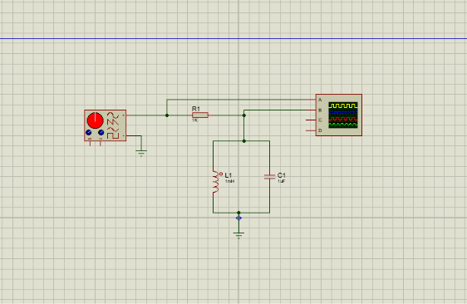
Figure 1 - RLC circuit designed in Proteus
Below is an image showing how my Proteus circuit performed in simulation, along with the output waveform I received after inputting the relevant figures.
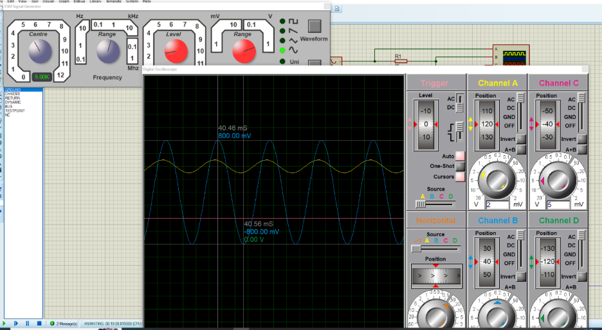
Figure 2 - Proteus circuit being simulated

Results

Results from the Proteus simulation
The Proteus circuit was tested from 1 kHz up to 20 kHz. The measured values and calculated attenuation are summarised in Table 1.
Frequency (Hz) | Voltage (in) | Vout | Gain | Attenuation (dB)
1000 | 2 | 0 | 0
2000 | 2 | 0.02 | 0.01 | -40
3000 | 2 | 0.06 | 0.03 | -30.4576
3500 | 2 | 0.09 | 0.045 | -26.9357
4000 | 2 | 0.125 | 0.0625 | -24.0824
4500 | 2 | 0.3 | 0.15 | -16.4782
4800 | 2 | 0.81 | 0.405 | -7.8509
5000 | 2 | 1.6 | 0.8 | -1.9382
5200 | 2 | 0.625 | 0.3125 | -10.103
5400 | 2 | 0.36 | 0.18 | -14.8945
5600 | 2 | 0.26 | 0.13 | -17.7211
6000 | 2 | 0.16 | 0.08 | -21.9382
6500 | 2 | 0.11 | 0.055 | -25.1927
7000 | 2 | 0.09 | 0.045 | -26.9357
10000 | 2 | 0.04 | 0.02 | -33.9794
20000 | 2 | 0.02 | 0.01676 | -41.5472
Table 1 - Table of results from the Proteus simulation of the RLC circuit
Using the data in Table 1, attenuation was plotted against frequency to visualise the circuit response. From this curve, the half-power (−3 dB) points were then located, as shown in Figure 3.

Figure 3: - Graph that was formed using the Proteus simulation values
Table 1 shows that attenuation increases steadily as frequency approaches resonance, reaching a minimum of approximately −1.94 dB near 5 kHz. The plotted response forms the expected resonant “peak” (least loss) where energy exchange between L and C is strongest, and then the attenuation becomes more negative again as the frequency moves away from this region.
From Figure 3, the −3 dB (half-power) frequencies were read as f₁ = 4800 Hz and f₂ = 5200 Hz. The bandwidth is therefore BW = f₂ − f₁ = 400 Hz. Using a resonant frequency of 5000 Hz gives an estimated quality factor of Q = f_{r}/BW = 5000/400 = 12.5 [3].

Results from the breadboard circuit testing:
For the physical test, the same nominal component values (1 k ohm resistor, a 1 μF capacitor, and a 1 mH inductor) were assembled on a breadboard as shown in Figure 4. A function generator supplied a 2 V peak-to-peak sine wave, and the frequency was stepped across the same range as the simulation. At each step, V_{in} and V_{out} were recorded on the oscilloscope and converted to dB attenuation. Extra measurements were taken in smaller steps around the best (least negative) attenuation so the resonant frequency and the −3 dB points could be identified more reliably.
Frequency (Hz)  Frequency (Hz) | Voltage (in) | Vout | Attenuation | Attenuation (dB)
1000 | 2 | 0 | 0 | 0
2000 | 2 | 6.4 | 0.0064 | -49.89700043
3000 | 2 | 10 | 0.01 | -46.02059991
3500 | 2 | 11.6 | 0.0116 | -44.73144013
4000 | 2 | 14.2 | 0.0142 | -42.97483303
4500 | 2 | 17.6 | 0.0176 | -41.11034656
4800 | 2 | 19.8 | 0.0198 | -40.08729611
5000 | 2 | 22.4 | 0.0224 | -39.01563955
5200 | 2 | 24.6 | 0.0246 | -38.20189777
5400 | 2 | 24 | 0.024 | -38.41637508
5600 | 2 | 22.4 | 0.0224 | -39.01563955
6000 | 2 | 19.6 | 0.0196 | -40.17547849
6500 | 2 | 17 | 0.017 | -41.41162149
7000 | 2 | 14.2 | 0.0142 | -42.97483303
10000 | 2 | 9.4 | 0.0094 | -46.55804284
20000 | 2 | 4.2 | 0.0042 | -48.4958210
Table 2 - Table of results from the simulation on the breadboard
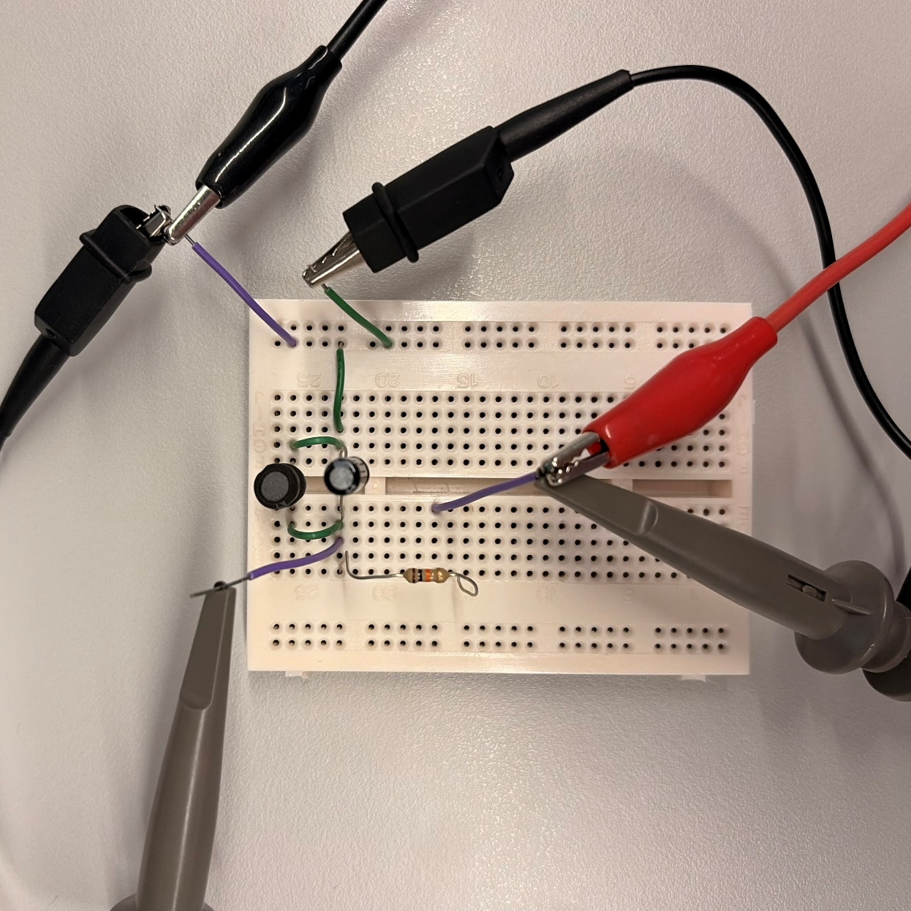
1
2
3
Figure 4 - Set up of breadboard circuit

Table 3 - List of Components used
Component Number: | Component
1 | 1 mH inductor
2 | 1 µF Capacitor
3 | 1 kΩ resistor

Figure 5 - Graph created using the results from the breadboard testing.

Compared with the Proteus plot, the breadboard response in Figure 5 is noticeably flatter, and the least attenuation occurs at a different level. This indicates greater loss and a lower effective quality factor in the physical simulation. The half-power frequencies were observed at approximately 4800 Hz and 5600 Hz, which is a wider span than in the simulation and therefore corresponds to a larger bandwidth for the real circuit.

Discussion
The simulated circuit produced a resonance at about 5.0 kHz, while the breadboard measurements indicated a resonance closer to 5.2 kHz. A small shift like this is expected when moving from an ideal model to real components because the actual inductance and capacitance can differ slightly from their nominal values. Since resonance depends on where the reactance of the inductor and capacitor balance, even modest changes in value can shift the resonant point [4].
The −3 dB points also differed between the two tests. In Proteus, they were read at 4.8 kHz and 5.2 kHz, whereas the breadboard curve extended out to roughly 5.6 kHz on the high-frequency side. This broader physical response increases bandwidth and reduces selectivity, meaning the breadboard circuit rejects/accepts a wider spread of frequencies than the simulation [3].
Another key difference is the peak height: the simulated response is taller and narrower, while the measured curve is lower and wider. In practice, extra resistance is introduced by the inductor’s winding resistance, contact resistance in the breadboard, and the finite resistance of wiring. Higher loss reduces the energy stored each cycle, which lowers the peak response and broadens the curve—behaviour consistent with typical RLC damping effects [5].
The test instruments can also influence the outcome. When the circuit is probed, the oscilloscope input and probe introduce an effective resistance and capacitance at the measurement point, which can slightly alter the circuit conditions and the observed voltage ratio [6]. This loading effect becomes more noticeable as frequency increases because the probe capacitance provides an additional current path [7].
Similarly, the function generator is not an ideal source: its output impedance and any limits in amplitude/frequency stability can affect the delivered signal and, therefore, the measured attenuation [7]. Finally, external noise and electromagnetic interference can introduce small fluctuations in the readings, particularly when the measured output is low, which may contribute to scatter in the plotted response [8].
Breadboards add their own non-ideal behaviour. At the same time, the inductor’s series resistance (and any contact resistance) increases damping. Combined with probe loading, these effects tend to reduce the apparent peak and spread the −3 dB points further apart, giving a larger measured bandwidth than the ideal simulation.
Accuracy could be improved by reducing the number of characteristics and using measured component values. Building the circuit on a soldered stripboard or a PCB would reduce wiring length and make the layout more repeatable. Measuring the actual inductance and capacitance with an LCR meter would also allow the theoretical resonant frequency to be calculated from real values rather than nominal ones. On the measurement side, using a 10× probe and a short ground connection helps minimise loading, and taking more closely spaced data points around resonance would give a more precise estimate of f_{r}, f₁ and f₂.

Conclusion:
This investigation compared a parallel RLC circuit modelled in Proteus with a physical breadboard build using the same nominal component values. The simulation produced a sharper resonance and lower attenuation close to the resonant frequency, whereas the breadboard results showed a broader peak and higher losses. The resonant frequency was similar between the two approaches (approximately 5.0 kHz in Proteus and 5.2 kHz on the breadboard), but the measured −3 dB bandwidth was larger for the physical circuit, resulting in a lower calculated quality factor and reduced selectivity. Overall, the trends in the measured response matched the simulation, and the observed differences are consistent with real-world effects such as component tolerances, parasitic resistance/inductance/capacitance in wiring, and the influence of measurement equipment.

References
[1] LibreTexts Physics, “RLC Series AC Circuits,” 2026. [Online]. Available: https://phys.libretexts.org/Bookshelves/College_Physics/College_Physics_1e_%28OpenStax%29/23%3A_Electromagnetic_Induction_AC_Circuits_and_Electrical_Technologies/23.03%3A_RLC_Series_AC_Circuits. [Accessed: 07-May-2026].
[2] Electronics Tutorials, “Series Resonance Circuits,” AspenCore, Inc., 2026. [Online]. Available: https://www.electronics-tutorials.ws/accircuits/series-resonance.html. [Accessed: 07-May-2026].
[3] All About Circuits, “Q Factor and Bandwidth of a Resonant Circuit,” 2026. [Online]. Available: https://www.allaboutcircuits.com/textbook/alternating-current/chpt-6/q-and-bandwidth-resonant-circuit/. [Accessed: 07-May-2026].
[4] EE Power, “Determining Series RLC Circuit Resonance Frequency,” May 02, 2023. [Online]. Available: https://eepower.com/technical-articles/determining-series-rlc-circuit-resonance-frequency/. [Accessed: 02-May-2026].
[5] Active Learning, “Resonance in RLC Circuits,” 2019. [Online]. Available: https://activelearning-fork.readthedocs.io/en/latest/docs/Activity_08_ResonanceRCL.html. [Accessed: 11-May-2026].
[6] Tektronix, “How Oscilloscope Probes Affect Your Measurement,” 2026. [Online]. Available: https://www.tek.com/en/documents/application-note/how-oscilloscope-probes-affect-your-measurement. [Accessed: 12-May-2026].
[7] Electrical Engineering Stack Exchange, “How Does Input Impedance of an Oscilloscope Affect a Circuit?,” Aug. 2024. [Online]. Available: https://electronics.stackexchange.com/questions/676048/how-does-input-impedance-of-oscilloscope-affect-circuit. [Accessed: 10-May-2026].
[8] ScienceDirect, “High-Frequency Electromagnetic Interference Induced by Power Electronics in New Electric Power Systems,” Oct. 2025. [Online]. Available: https://www.sciencedirect.com/science/article/pii/S2096511725001033. [Accessed: 12-May-2026].

