Essay one:

Assess the effectiveness of independent bodies (e.g. IOPC, HMICFRS) in holding the police to account.
Support your answer with relevant evidence drawn from academic sources.
Word limit: 1000 words.

Wherever there is a case where any serving member of the police force displays negative behaviours and poor conduct which could have the potential to cause a detrimental reaction from any media source or result in negative public perception, then these members must be held to account for any transgression.

There are a number of statutory and non-statutory bodies which oversee and enforce holding the police to account for their shortcomings and any breaches of professional conduct, with the statutory bodies including the Police Federation, the Professional Standards Department (PSD) and the College of Policing.

This essay shall focus on one of the non-statutory bodies which act independently of the police force, namely His Majesty’s Inspectorate of Constabulary, Fire and Rescue Services (the HMICFRS), but will also allude to statistics collated from the Independent Office of Police Conduct (IOPC), another non-statutory body which oversees professional policing conduct. Legislation, social norms and technological advancements have changed the way in which the law of the land and the way in which society communicates and another aim of this essay is to outline how HMICFRS in particular has strived to remain relevant and continually effective in the disciplines it bestows upon police officers and police staff.

This essay will also document a brief history of high-profile police conduct up until the modern day, as well as display and assess amounts of recorded police complaints to try to identify any patterns or possible correlation with the aforementioned high-profile cases, as well as societal changes.

The HMICFRS was originally founded in 1856, having originally being only the ‘HMIC’ (Her Majesty’s Inspectorate of Constabulary) - a body purely dealing with police conduct. As the HMICFRS is over 150 years old, it has had to adapt to the everchanging demands of the changing societal landscape.

So-called ‘heavy-handed’ policing in England and Wales has resulted a great deal of austerity and public backlash, particularly from the 20th century until today. High-profile incidents involving negative reports against police officers include the ‘Battle of Cable Street’ in 1936 which involved a major clash between Oswald Mosley’s British Union of Fascists and some 20,000 anti-fascist protestors which mounted police intervened in, resulting in many of the demonstrators reporting use of excessive force by police, the heavily scrutinised Brixton Riots in 1981 (which eventually gave rise to the Police and Criminal Evidence, PACE act 1984), the death of Richard O’Brien who died while drunk in police custody in 1994 and the unlawful killing of bystander Ian Tomlinson during the 2009 G-20 summit protests in London, whereas recent years have brought with them news stories involving serving UK police officers, such as the kidnapping and murder of Sarah Everard by serving Metropolitan Police officer Wayne Couzens in 2021.

IOPC data documenting the amounts of complaints recorded against police (2001 – 2020)

Between 2001 and 2020, the IOPC recorded and analysed complaint cases against police, with these findings being broken down into year-by-year amounts recorded. These findings determined that approximately 16,600 complaints were filed in 2001, this figure decreased slightly before a massive increase was recorded with just under 23,000 complaints recorded in the year 2004. This figure then increased – according to the figures – by an average of roughly 1,500 – 2,000 complaints per year until the end of 2010, with 33,000 recorded in in this year and just over 30,000 recorded in 2011. Complaints reached an all-time high in 2014 when 37,000 were received from members of the public. The findings do indicate however, that the most recent figures for 2019/20 displaying just over 28,000 complaints. When these figures are broken down, over 28,700 complaints are received ever year on average, this equated to 86 complaints made by the public on a daily basis.

Since the turn of the Millennium, it is clear to see that complaints against police have increased dramatically, and that to accommodate this, those who enforce the law on the law enforcers must introduce new innovations. In 2014, the PEEL assessments were introduced by the IOPC to assess the efficiency, effectiveness, and legitimacy of the 43 forces across England and Wales and as recent as 3 years ago, the Policing and Crime Act 2017 (PACA) which came into force in February 2020 sought to dispel ‘damaging blame culture’ within the police disciplinary system (Open Access, University of Bristol, 2020). At the time, the complaints system that was in place was considered insufficiently independent of the police and the aforementioned reforms aimed to make it more ‘transparent and robust’ (Hansard, 7 March 2016), as well as to provide the public better access to the right resources with which to make a complaint. Implementation of the PACA sought to increase the disciplinary system in terms of its integrity in England and Wales, as well as increasing the ‘lessons that could be learned’.

Despite the introduction of these new measures, according to an article published by Mattha Busby of The Guardian in 2021, figures released by the IOPC (the Independent Office for Police Conduct, another non-statutory disciplinary body) indicated that “641 officers in England and Wales may have so seriously breached standards that they were liable to be sacked between 2015 and 2020, but just 54 (8.4%) were fired after disciplinary action was conducted internally.”

In conclusion, it may be possible to summarise that throughout its lengthy history, HMICFRS (as well as the police force itself) has undergone monumental change, to adapt to the times and toward the people they serve. From the police force’s humble beginnings and later the amalgamation of force areas, the introduction of a more diverse workforce due to changes in society and with the introduction of new laws and legislation year on year, there will never be a time in which police complaints do not occur due to the wrong attitude or behaviours displayed or conveyed by police officers or police staff. This essay has briefly outlined that as the years pass, non-statutory bodies will continue to introduce new ways in which to analyse police performance and the implementation of the code of ethics, with a view to oversee the professional conduct of the police, just as the police will continue to evolve and adapt to serve the public for which it stands. But as these forces continue to shrink and grow in number, and as more and more new officers are recruited. Upon analysis of different IOPC data, there is not much of a pattern in the number of complaints received against the police, with the amounts year on year seemingly fluctuating, but seems to have increased dramatically between 2002 and 2004 possibly due to the advent of the internet and increased means of communication.

(1,107 words)

‌

‌

Essay two:

“Organised crime is serious crime planned, co-ordinated and conducted by people working together on a continuing basis. Their motivation is often, but not always, financial gain” (Home Office, 2013). Outline potential links between serious and organised crime and public protection issues.
Your answer must be based on academic research, but you may refer to relevant case studies.
Word limit: 1000 words.

In October 2013, the Crown Prosecution Service (CPS) launched a strategy to implement key areas of the Government’s Serious and Organised Crime Strategy to bring Organised Crime Group (OCG) members, both foreign and domestic, to justice. Other objectives of the strategy were to prevent the groups causing further harm and to recover their assets. The aforementioned ‘Serious and Organised Crime Strategy’ which was augmented by the CPS’ new strategy was published by the Home Office in 2013 and aimed to ‘substantially reduce the level of organised crime in the UK, and to reduce levels of serious crime which requires a national response’ [The Government’s Serious and Organised Crime Strategy – Oct. 2013, paragraph 3.1].

Within the CPS report, ‘Organised Acquisitive Crime’ outlines the facts surrounding organised criminals and their main motive for committing crime being to generate profit, which is described as a “common thread”, with OCG’s concentrating their offending on those areas that generate the highest profits, whilst threatening the most minimal level of threat of detection (including - but not limited to - insider dealing, bribery and corruption).

The CPS identified eleven main areas of work central to the implementation of the strategy, which included both Criminal Justice System and International engagement, both drug and firearms trafficking among others. This essay will aim to focus on the areas which involve a direct link to the safety and protection of members of the public, such as County Lines, Child Sexual Exploitation, Cyber Crime and ‘Organised Acquisitive Crime’. This essay will also outline public concerns about organised crime as a whole and how organised crime affects the most vulnerable members of society.‌

The report – based on findings from interviews conducted with 1,000 members of the public - concluded that most respondents participating in the survey thought that organised crime caused “serious harm” to the country and that the levels of which had increased exponentially between 2004 and 2006 (the latter of which being the year the survey was conducted). The harmful effects, according to those participating in the survey generated harm at both local and national levels and also generated a ‘great deal of individual worry’. Many respondents assessed the harm inflicted as a result of organised crime and concluded that the most harmful areas of organised crime which affected them individually (as opposed to on a wider scale affecting wider society and businesses etc.) The most harmful elements effecting the ‘individual’ included crimes such as counterfeiting and fraud, whereas areas involving drug dealing were deemed to generate high levels of harm both on a much wider, national scale as well as within communities. [Karen Bullock, Rezina Chowdhury and Polly Hollings – GfK NOP Social Research – Research Report 16 Key Implications, published 2009]

A 2018 article on theconversation.com delves into the effect media coverage, television and film has on society and its attitudes towards organised crime as a whole. The article states that members of the public are often “sanguine” in relation to the phenomena of organised crime, with the public’s general opinions centring on the police focusing more on ‘everyday’ crime (such as antisocial behaviour and property damage), although it does go on to outline a study they conducted amongst communities based within Scotland, which focuses more on the first-hand experiences of local people trying to better understand how organised crime not only affects their day-to-day lives, but how it continues to operate and “sustain itself”. The article contrasts Scottish views of organised crime somewhat against those of other parts of the UK, where the former is said to consist of fact-obscuring high-profile media coverage of organised crime, with the latter associating more “chaotic” violence which is linked to drug-related gang incidents.

The article alludes to case studies conducted in Scotland where a culture which somewhat mirrors that of the mafia-esque culture, similar to that adopted by the USA, in which members of the public are fearful of encountering or ‘crossing’ OCG members, out of fear of dramatic and sometimes life-altering (or even life-ending) consequences. Under this guise, the OCG member is seen as something of a saviour of the people, offering the vulnerable money, drugs or other ‘gifts’ in exchange for favours in return. This method of grooming is often extremely prevalent in County Lines crime where the OCG member singles-out and exploits a vulnerable person (particularly where they use the ‘cuckooing’ technique).

In conclusion, it is apparent that throughout the UK, organised crime is an ongoing and ever-growing problem, with OCG members acting as predators and the poorest, weakest citizens acting as their prey. Organised crime continues to exploit these vulnerable members of society by extracting profit through its criminality, flourishing in fractured communities containing the most disadvantaged members of society. Organised Crime Group members target and exploit those suffering with mental health issues, financial debt and even troubled childhoods to get them into their pockets by adopting a ‘mafia’ image, where they introduce themselves into the lives of the vulnerable as the friend or the problem-solver, all the while turning the tables on that individual or vulnerable group and ultimately demanding something in return such as a place to store their drugs or stolen goods, or leaving that person in even worse debt than when they had begun, with the consequences of that debt being much worse and more life-threatening than bankruptcy. To say that organised crime has a detrimental effect on society would be a colossal understatement, and that it is a virus plaguing society, one for which a vaccine seems a million years away.

(918 words)

‌

‌
Essay three:

Is early intervention the most effective means of preventing young people from becoming involved in gangs?
Your answer must be based on academic research, but you may refer to relevant case studies.
Word limit: 1000 words.

As explained in a 2019 BBC article, it is almost impossible to estimate the amount of people in gangs, this is due to different definitions of what may constitute a ‘gang’ or ‘gang member’.

Within Blackstones (2022), under section 34(5) of the Policing and Crime act 2009, a ‘gang’ is defined as ‘a group that consists of three or more individuals and use a name, emblem or a certain colour/other identifiable characteristic and associate with a particular geographical area and may conflict with other gangs’ (Home Office, 2012c).

The effective policing of communities cannot be achieved without the use of a ‘multi-agency approach’, particularly with identifying disruptive and concerning behaviours of the younger members of society. Standard response police officers must employ the help of their Neighbourhood Policing Team (NPT) counterparts, who identify ‘community triggers’ where each person’s needs and vulnerabilities are assessed so that lower level anti-social behavioural (ASB) incidents such as under-age drinking, graffitiing and petty vandalism can be addressed and those responsible can be dealt with effectively. This process of ‘early intervention’ can help to direct young offenders away from worsening behaviour and can assist with the escalation of their future criminal behaviour. This form of acting proactively rather than reactively from a policing perspective echoes the ‘Problem-Orientated Policing’ (POP) concept first developed by Herman Goldstein in 1979, which was later elaborated in 1987 by the ‘Scanning, Analysis, Response and Assessment’ (SARA) model, implemented by Eck and Spelman in 1987. Other agency partners utilised by the police forces across the UK include schools, social services, and Youth Offending Teams (YOT’s) but to name a few.

This is further echoed within an article published on youth.gov, who state that to ‘prevent younger and more vulnerable members of the community becoming inducted into gangs due to their susceptibility to recruitment tactics, early, prevention efforts are extremely necessary. This can be achieved by multiple sectors working together’ – Gang Involvement Prevention (youth.gov, 2011).

In the UK, according to research conducted by the Early Intervention Foundation (EIF) in 2018 – in which the roles of Primary Schools and their staff is assessed in relation to early detection and prevention of gang and youth violence - risk factors for gang involvement and youth violence can be spotted as early as age seven years old in children, with their report also concluding that gang-related knife and gun crime is on the rise across the country (not just in London boroughs where the report is primarily focussed) and that the ‘County Lines’ issue that continues to plague the country sees gangs target vulnerable children, before coercing them into selling drugs in more rural and coastal areas across the UK. The report, however, does state that “it is notoriously difficult to say how much of the serious youth violence is gang-related” (EIF report, 2018, p10). The report also features a review of ‘effective programs’, which underlines the importance of Primary Schools, with the highlighting of the social and emotional skills delivered in schools and how these foundations instilled within children can lead to a positive outcome where gang involvement is avoided.

Some recent statistics relating to UK gang activity estimated by the Children’s Commissioner in 2019 indicated that approximately:

- 60,000 children may self-identify as a gang member themselves or know a gang member who is a sibling.
- 300,000 children may know a gang member.
- 34,000 children may know a gang member and have been a victim of violence in the previous 12 months.

(Source: bbc.co.uk – How do we know how many children are in gangs? – published 28th February 2019)

“There comes a point where we need to stop pulling people out of the river, sometimes we must swim upstream to find out why they are falling in in the first place” (Bishop Desmond Tutu, date unknown)

It is a very difficult task to evaluate the different types of early intervention as there are no standard evaluation measures. To appropriately assess the effectiveness of early intervention, multiple forms of assessment and following-up are required over a large amount of time, often years. The Home Office continues to trial interventions to tackle early, on-set risk factors such as one-to-one interventions with individuals (mentoring, school inclusion), family-based programmes, mental health support and environmental interventions (which aim to reduce risk factors within specific geographical areas, treating violence as a ‘population-level threat’ as opposed to a localised issue. The aforementioned Home Office report, published in April 2019, states that £22 million was committed over 2 years for an ‘Early Intervention Youth Fund’ and a further £200 million was invested by the government to cover a ten-year period to build evidence for early intervention.

In terms of obtaining accurate, up-to-date figures and statistics, there is a vast array of differing figures collated and published by separate sources. In addition to the above-mentioned measures which are taken to determine risks posed by children and young people, the UK government continues to implement possible solutions. In October 2021, then Prime Minister Boris Johnson’s government published its ‘Beating Crime Plan’. This plan continues to be implemented on a yearly basis, but realistic statistics to gauge the amount of criminality caused by gangs in England and Wales seems to be a grey area, with estimates and most of the data published in online sources either being out-dated or based entirely on the gang crime that is conducted in the London area. Therefore, it appears that the effectiveness of early intervention on preventing youths from being recruited into gangs remains relatively undeterminable.

(914 words)

Essay four:

“When the public looks markedly different to its police service, it creates a distance between the two and a sense the police service no longer serves their community” (Orr Munro, n.d.). Assess the effectiveness of police strategies to overcome this distance (e.g. the Code of Ethics, PACE, neighbourhood policing strategies, targeted recruitment).
You must use academic research, rather than personal opinion, to support your answer.
Word limit: 1000 words.

In 1829, Sir Robert Peel, formerly a politician and two-time Prime Minister of the United Kingdom, who is today referred to in certain circles colloquially as the ‘father of modern community policing’, created London’s Metropolitan Police Force. Sir Robert’s creation of the inaugural authoritative force was built on a set of proposed principles under which they would become efficient in the implementation and maintenance of safety within communities going forward, alleviated by a strong foundation of the laws of the land. Shortly thereafter, Sir Robert and his commissioners established a list of policing principles which remain as crucial today as they were two centuries ago. The set of principles focus on public approval, public trust and co-operation, maintaining positive relationships, the importance of public opinion and how the police must remain impartial towards these opinions. Perhaps the most important of these principles is the ‘historic tradition’ that ‘the police are the public and the public are the police’, with the police being deemed members of the public who are simply paid to uphold and to enforce the law, with those other members of the public expected to perform supplementary roles to enhance the safety of fellow members of the public.

In an article by the contributing editor of Policing Insight, Tina Orr Munro – who references Sir Robert’s principles – states that the police must integrate themselves within fellow members of the community and avoid any ideology that they are above them or superior to them in any way, “…the officers they (the public) deal with could just as easily be members of their community”, further stating the fact the communities are not simply geographic and can be defined by a range of shared characteristics such as age, gender or culture, among others. Orr argues that the diversity of the police force’s representatives and ambassadors should “reflect all sections of society” and that if the police can recruit a diverse mix of employees, then it ‘tells’ the public that “we are just like you and, just like you”, with an emphasis on keeping communities safe.

‘The existence of police authority requires individuals to willingly sacrifice a degree of personal freedom and liberty in order to secure a greater degree of collective freedom and liberty’ (Blackstones handbook for policing students, 2022, p.29) – this sentiment has been echoed explicitly by seventeenth-century English philosopher Thomas Hobbes who coined the Latin term ‘Bellum omnium contra omnes’ (‘the war of all against all’), and argued that this way of life would be ‘unacceptable’, before proposing the creation of an authoritative state (De Cive, 1642 and Leviathan, 1651). This necessity for authority has been opposed in more recent times by American philosopher Robert Nozick (Anarchy, State, and Utopia, 1974) and by author J.C. Simmons in 2001, who have both argued that this necessity for authority must be considered before questioning the legitimacy of authority (Blackstones handbook for policing students, 2022, p.30).

Throughout its existence and - as demonstrated by Hobbes - even prior to its inception, the legitimacy of the role of the police has been a divisive and often prevalent topic of conversation. Today, in 2023, a key element of modern policing is that the police implement their ‘powers’ in such a way that is ‘by the consent’ of the public for which it stands to serve and protect, and to mirror the diverse societies and communities which they serve, it is imperative that a continuous aim of police recruitment is to make those employed as diverse as possible. Put simply, this means that today, the notion of ‘policing by consent’ remains an important part of police legitimacy, with this legitimacy being of a moral standpoint, in addition to being consensual. For the police force, the diverse recruitment of its members has undergone tremendous change, particularly in recent years. Chief Inspector Tony Alogba of Greater Manchester Police writes about this in a 2020 article, stating that within his role of being the head of the Positive Action team, his primary focus was to increase the representation within policing of members of the BAME (Black, Asian and minority ethnic) community, and female officers, with only 7% of officers identifying as BAME and roughly 30% identifying as female (Home Office, 2019).

The increases in numbers of those members of BAME and female officers recruited is demonstrated by the below figures from www.gov.uk:

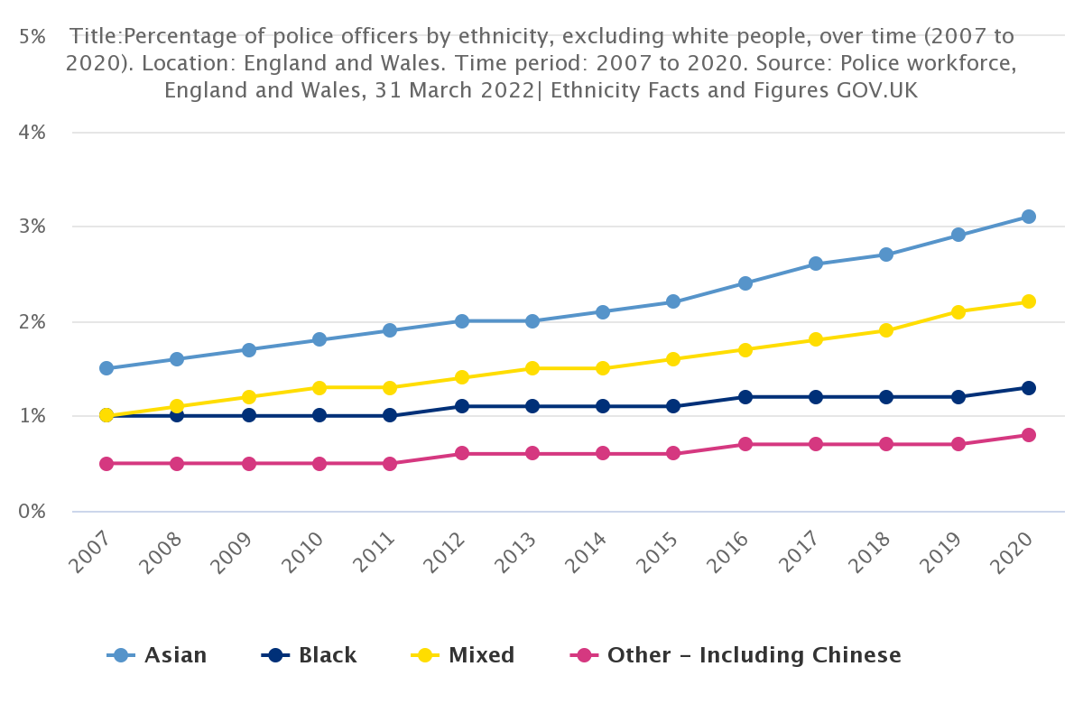
Source: https://www.ethnicity-facts-figures.service.gov.uk/workforce-and-business/workforce-diversity/police-workforce/latest#by-ethnicity-over-time-2007-to-2020-police-officers

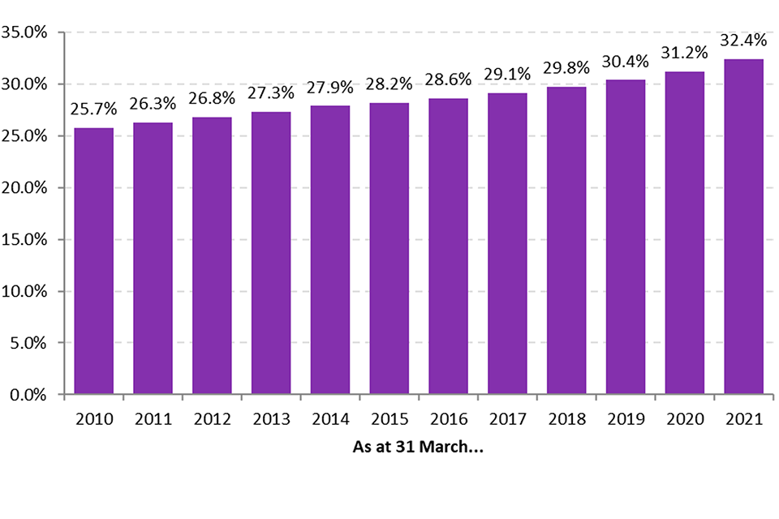
Source: https://www.gov.uk/government/statistics/police-workforce-england-and-wales-31-march-2021/police-workforce-england-and-wales-31-march-2021 (fig 6.7)

In addition to trust and a diverse workforce, an issue police forces across England and Wales are often faced with is a sense of confidence in its services. Following several attempts by UK government officials dating back to the 1960’s and given the catalyst of the unfair use of stop and search powers as well as other “serious miscarriages of justice…”, which culminated in the 1981 Brixton riots. In 1982, the first version of the Police and Criminal Evidence act (known as PACE) was introduced and later implemented in 1984. The principle aims of the act were to ensure police complied with procedures and were treating others with respect and a degree of fairness and impartiality.

Based on ethnicity facts and figures also published on gov.uk, studies conducted between 2017 and March 2020 showed that only 65% of Black students while 83% of White students had confidence in their local police, 76% of White people in employment had confidence in comparison to 71% of BAME members in employment, with figure relatively close in the unemployed, with 71% of White people having confidence in police and 74% of unemployed BAME members. Moreover, according to a 2022 study by yougov.uk, the number of Britons with confidence in the police to deal with crime in their local area was ‘split’, with a ‘fair amount of those people having confidence in police’ fluctuating but showing an overall decrease from 55% in July 2019 to 43% in January 2022, juxtaposed with ‘not many people at all having confidence in the police’ increasing from 42% in July 2019 to 47% in January 2022. These results show that confidence in police has fallen most amongst Labour voters than Conservative ones, with Labour voters making up a large quantity of UK citizens.

The confidence and trust in police seems to continue to fluctuate year-on-year, but mostly decrease steadily when viewing statistics on a vaster timescale. Despite ongoing efforts from both UK governments and the 43 police forces across England and Wales themselves - seemingly in spite of the continual focuses on Sir Robert’s principles - the implementation of more modernised legislation, the introduction of a reviewed policing ‘code of ethics’ (introduced in 2014) and its ongoing efforts to recruit a more diverse workforce to represent and serve their communities.

(1,100 words)

Bibliography

Essay 1
- His Majesty’s Inspectorate of Constabulary and Fire & Rescue Services (HMICFRS) – Home. (n.d.). The History of Her Majesty’s Inspectorate of Constabulary, The First 150 Years. [online] Available at: https://www.justiceinspectorates.gov.uk/hmicfrs/publications/the-history-of-hmic/ - (Accessed 27/04/2023)

- Torrible, C. (2020). Police complaints and discipline: integrity, lesson learning, independence and accountability: some implications of the reforms under the Policing and Crime Act 2017. Policing and Society, 31(9), pp.1–16. doi:https://doi.org/10.1080/10439463.2020.1838516. – (Accessed 27/04/2023)

- Constabulary, H.M.I. of and Fire (2021). What is PEEL? [online] HMICFRS. Available at: https://www.justiceinspectorates.gov.uk/hmicfrs/peel-assessments/what-is-peel/. (Accessed 27/04/2023)

- Busby, M. (2021). Fewer than one in 10 police officers fired after gross misconduct finding. [online] the Guardian. Available at: https://www.theguardian.com/uk-news/2021/jan/18/fewer-than-one-in-10-police-officers-fired-after-gross-misconduct-finding. (Accessed 27/04/2023)

Essay 2
- Crown Prosecution Service (2019). Organised Crime - Strategy | The Crown Prosecution Service. [online] Cps.gov.uk. Available at: https://www.cps.gov.uk/organised-crime-strategy. (Accessed 09/05/2023)

- GOV.UK. (n.d.). Public concerns about organised crime. [online] Available at: https://www.gov.uk/government/publications/public-concerns-about-organised-crime. (Accessed 10/05/2023)

- Hamilton-Smith, Ni. (2018). How organised crime affects the most vulnerable communities. [online] The Conversation. Available at: https://theconversation.com/how-organised-crime-affects-the-most-vulnerable-communities-98262. (Accessed 10/05/2023)

Essay 3
- CEBCP (2010). Problem-Oriented Policing | Center for Evidence-Based Crime Policy. [online] Cebcp.org. Available at: https://cebcp.org/evidence-based-policing/what-works-in-policing/research-evidence-review/problem-oriented-policing/. – (Accessed 17/05/2023)

- College of Policing. (n.d.). Using the community trigger to address anti-social behaviour. [online] Available at: https://www.college.police.uk/article/using-community-trigger-address-anti-social-behaviour. – (Accessed 17/05/2023)

- Intervening early to prevent gang and youth violence: The role of primary schools (2018). Intervening early to prevent gang and youth violence: The role of primary schools. [online] Early Intervention Foundation. Available at: https://www.eif.org.uk/report/intervening-early-to-prevent-gang-and-youth-violence-the-role-of-primary-schools. – (Accessed 17/05/2023)‌

- Butcher, B. and Schraer, R. (2019). How do we know how many children are in gangs? BBC News. [online] 28 Feb. Available at: https://www.bbc.co.uk/news/uk-47388890. – (Accessed 17/05/2023)

- www.goodreads.com. (n.d.). A quote by Desmond Tutu. [online] Available at: https://www.goodreads.com/quotes/954454-there-comes-a-point-where-we-need-to-stop-just. – (Accessed 17/05/2023)
‌
- youth.gov. (n.d.). Gang Involvement Prevention | Youth.gov. [online] Available at: https://youth.gov/youth-topics/preventing-gang-involvement#:~:text=In%20an%20effort%20to%20replace%20older%20adult%20gang – (Accessed 17/05/2023)

Essay 4
- Police1. (n.d.). A minute with Sir Robert Peel: What the father of modern policing can teach field training officers. [online] Available at: https://www.police1.com/police-training/articles/a-minute-with-sir-robert-peel-what-the-father-of-modern-policing-can-teach-field-training-officers-LQtEx3UDo8uJnHO7/. – Accessed 01/06/2023

- Law Enforcement Action Partnership (2022). Sir Robert Peel’s Policing Principles. [online] Law Enforcement Action Partnership. Available at: https://lawenforcementactionpartnership.org/peel-policing-principles/. – Accessed 01/06/2023

- allpolicejobs.co.uk. (n.d.). Why it is important we have a diverse police service. [online] Available at: https://allpolicejobs.co.uk/blog/why-it-is-important-we-have-a-diverse-police-service#:~:text=However%2C%20when%20the%20public%20looks%20markedly%20different%20to – Accessed 01/06/2023

- Alogba, T. (2020). Recruiting for diversity. [online] College of Policing. Available at: https://www.college.police.uk/article/recruiting-diversity. – Accessed 01/06/2023

- Office for National Statistics (2021). Confidence in the Local police. [online] Service.gov.uk. Available at: https://www.ethnicity-facts-figures.service.gov.uk/crime-justice-and-the-law/policing/confidence-in-the-local-police/latest. – Accessed 01/06/2023

- Kirk, I. (2022). Confidence in the police sinks in two years | YouGov. [online] yougov.co.uk. Available at: https://yougov.co.uk/topics/politics/articles-reports/2022/03/15/confidence-police-sinks-two-years. – Accessed 01/06/2023

