Changemakers: Building your Personal Brand for Sustainable Employment (BMHP5015_LON)
Lecturer: Caroline Salami
Student name: Deborah Flores Rodrigues
Student Id :2336878

Table of Contents
- Introduction………………………………………………………...3
- Weeks 1 and 2…………………………………………………...3-4
  - 2.1 Ambition……………………………………………2-4
  - 2.2 Setting Goals………………………………………...4-5
- Weeks 3 and 4…………………………………………………...5-6
  - 3.1 Boundaryless Career………………………...………6
  - 3.2 Networking………………………………………….6-7
    - 3.2.1 Historical Perspective of Networking…...6-7
  - 3.3 Bureaucracy and Hierarchy………………………...7-8
- Weeks 5 and 6………………………………………………...8
  - 4.1 Success and Opportunities in Health and Social Care………8
  - 4.2 Perception……………………………………………………9
  - 4.3 Opening Doors to Job Opportunities……………………….9-10
- Weeks 7 and 8………………………………………………………….11-12
  - 5.1 Limiting Beliefs…………………………………………….12
  - 5.2 Discuss the impact of changes due to technology………….12-13
  - 5.3 Understand social learning theor …………………………….13
- Conclusion……………………………………………………………. …..14
References……………………………………………………………….15-16

1. Introduction
The “Changemakers: Building Your Brand for Sustainable Employment” program provided profound insights into personal and professional growth strategies. The course explored four main areas: personal branding, boundaryless careers, networking methods, and emotional intelligence frameworks. Each module emphasized resilience, lifelong learning, and adaptability in evolving workplace environments. Through practical exercises, reflective tasks, and discussions, I gained hands-on knowledge to guide career progression, enhance professional development, and strengthen self-awareness. The program also emphasized understanding one’s unique value, fostering purpose-driven goals, and cultivating meaningful professional relationships. Furthermore, it encouraged participants to critically evaluate personal strengths and weaknesses, recognize opportunities for continuous learning, and adopt strategies for effective decision-making in complex work environments. By integrating theory with practical applications, the program highlighted the importance of emotional intelligence in navigating workplace challenges, managing stress, and collaborating effectively with diverse teams. Overall, the program reinforced the connection between self-knowledge and career success, showing that sustainable employment is not only about opportunities but also about continuous self-improvement, adaptability, and the ability to create lasting professional impact through thoughtful engagement and purposeful actions.

2. Weeks 1 and 2

2.1 Ambition is a fundamental aspect of personal and professional growth. It represents the strong desire to achieve goals, succeed, and continuously enhance one’s skills (Rhode, 2021). When balanced, ambition encourages individuals to work diligently, remain focused, and persevere through challenges. Ambitious individuals actively seek opportunities, pursue further education, and aim for meaningful career advancement. However, ambition must align with ethical standards to prevent stress, unhealthy competition, or dissatisfaction (Resta et al., 2022). Integrating ambition with responsibility, resilience, and ongoing learning often leads to sustainable success and professional fulfilment. Furthermore, ambition helps individuals identify purpose-driven work, motivating them to contribute positively to society. It also promotes self-reflection and critical thinking, as ambitious people regularly assess their progress, adapt strategies, and refine their goals. In addition, ambition fosters the development of leadership skills, teamwork, and emotional intelligence, which are essential for navigating complex professional environments. By combining vision with determination and ethical practice, ambition empowers individuals not only to achieve personal milestones but also to inspire and support others in their growth, creating a broader positive impact in both professional and community settings.
while maintaining personal wellbeing. 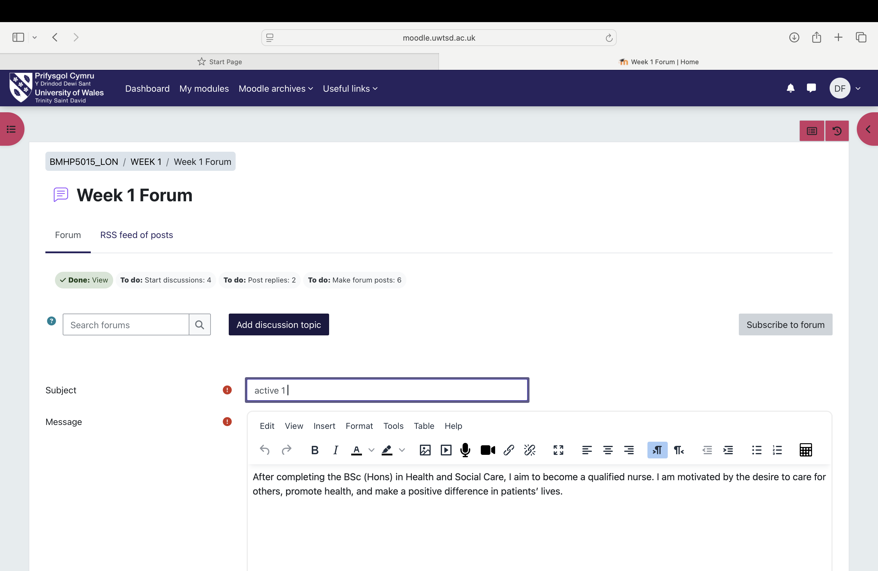

2.2 Setting Goals
Setting goals is essential for guiding personal and professional development. Goals provide clarity, focus, and a roadmap for success. Clear objectives make planning, prioritization, and progress evaluation more effective. One widely used approach is the SMART framework—Specific, Measurable, Achievable, Relevant, and Time-bound which transforms general ideas into actionable plans (Cheng, 2023). Well-defined goals enhance productivity, time management, and confidence. Regularly reviewing and adjusting goals is necessary, as circumstances, interests, and career paths evolve. In addition, goal setting strengthens motivation by creating tangible markers of achievement, encouraging persistence, and cultivating self-discipline. By integrating reflection into goal setting, individuals can identify strengths, address weaknesses, and maintain alignment with long-term aspirations. 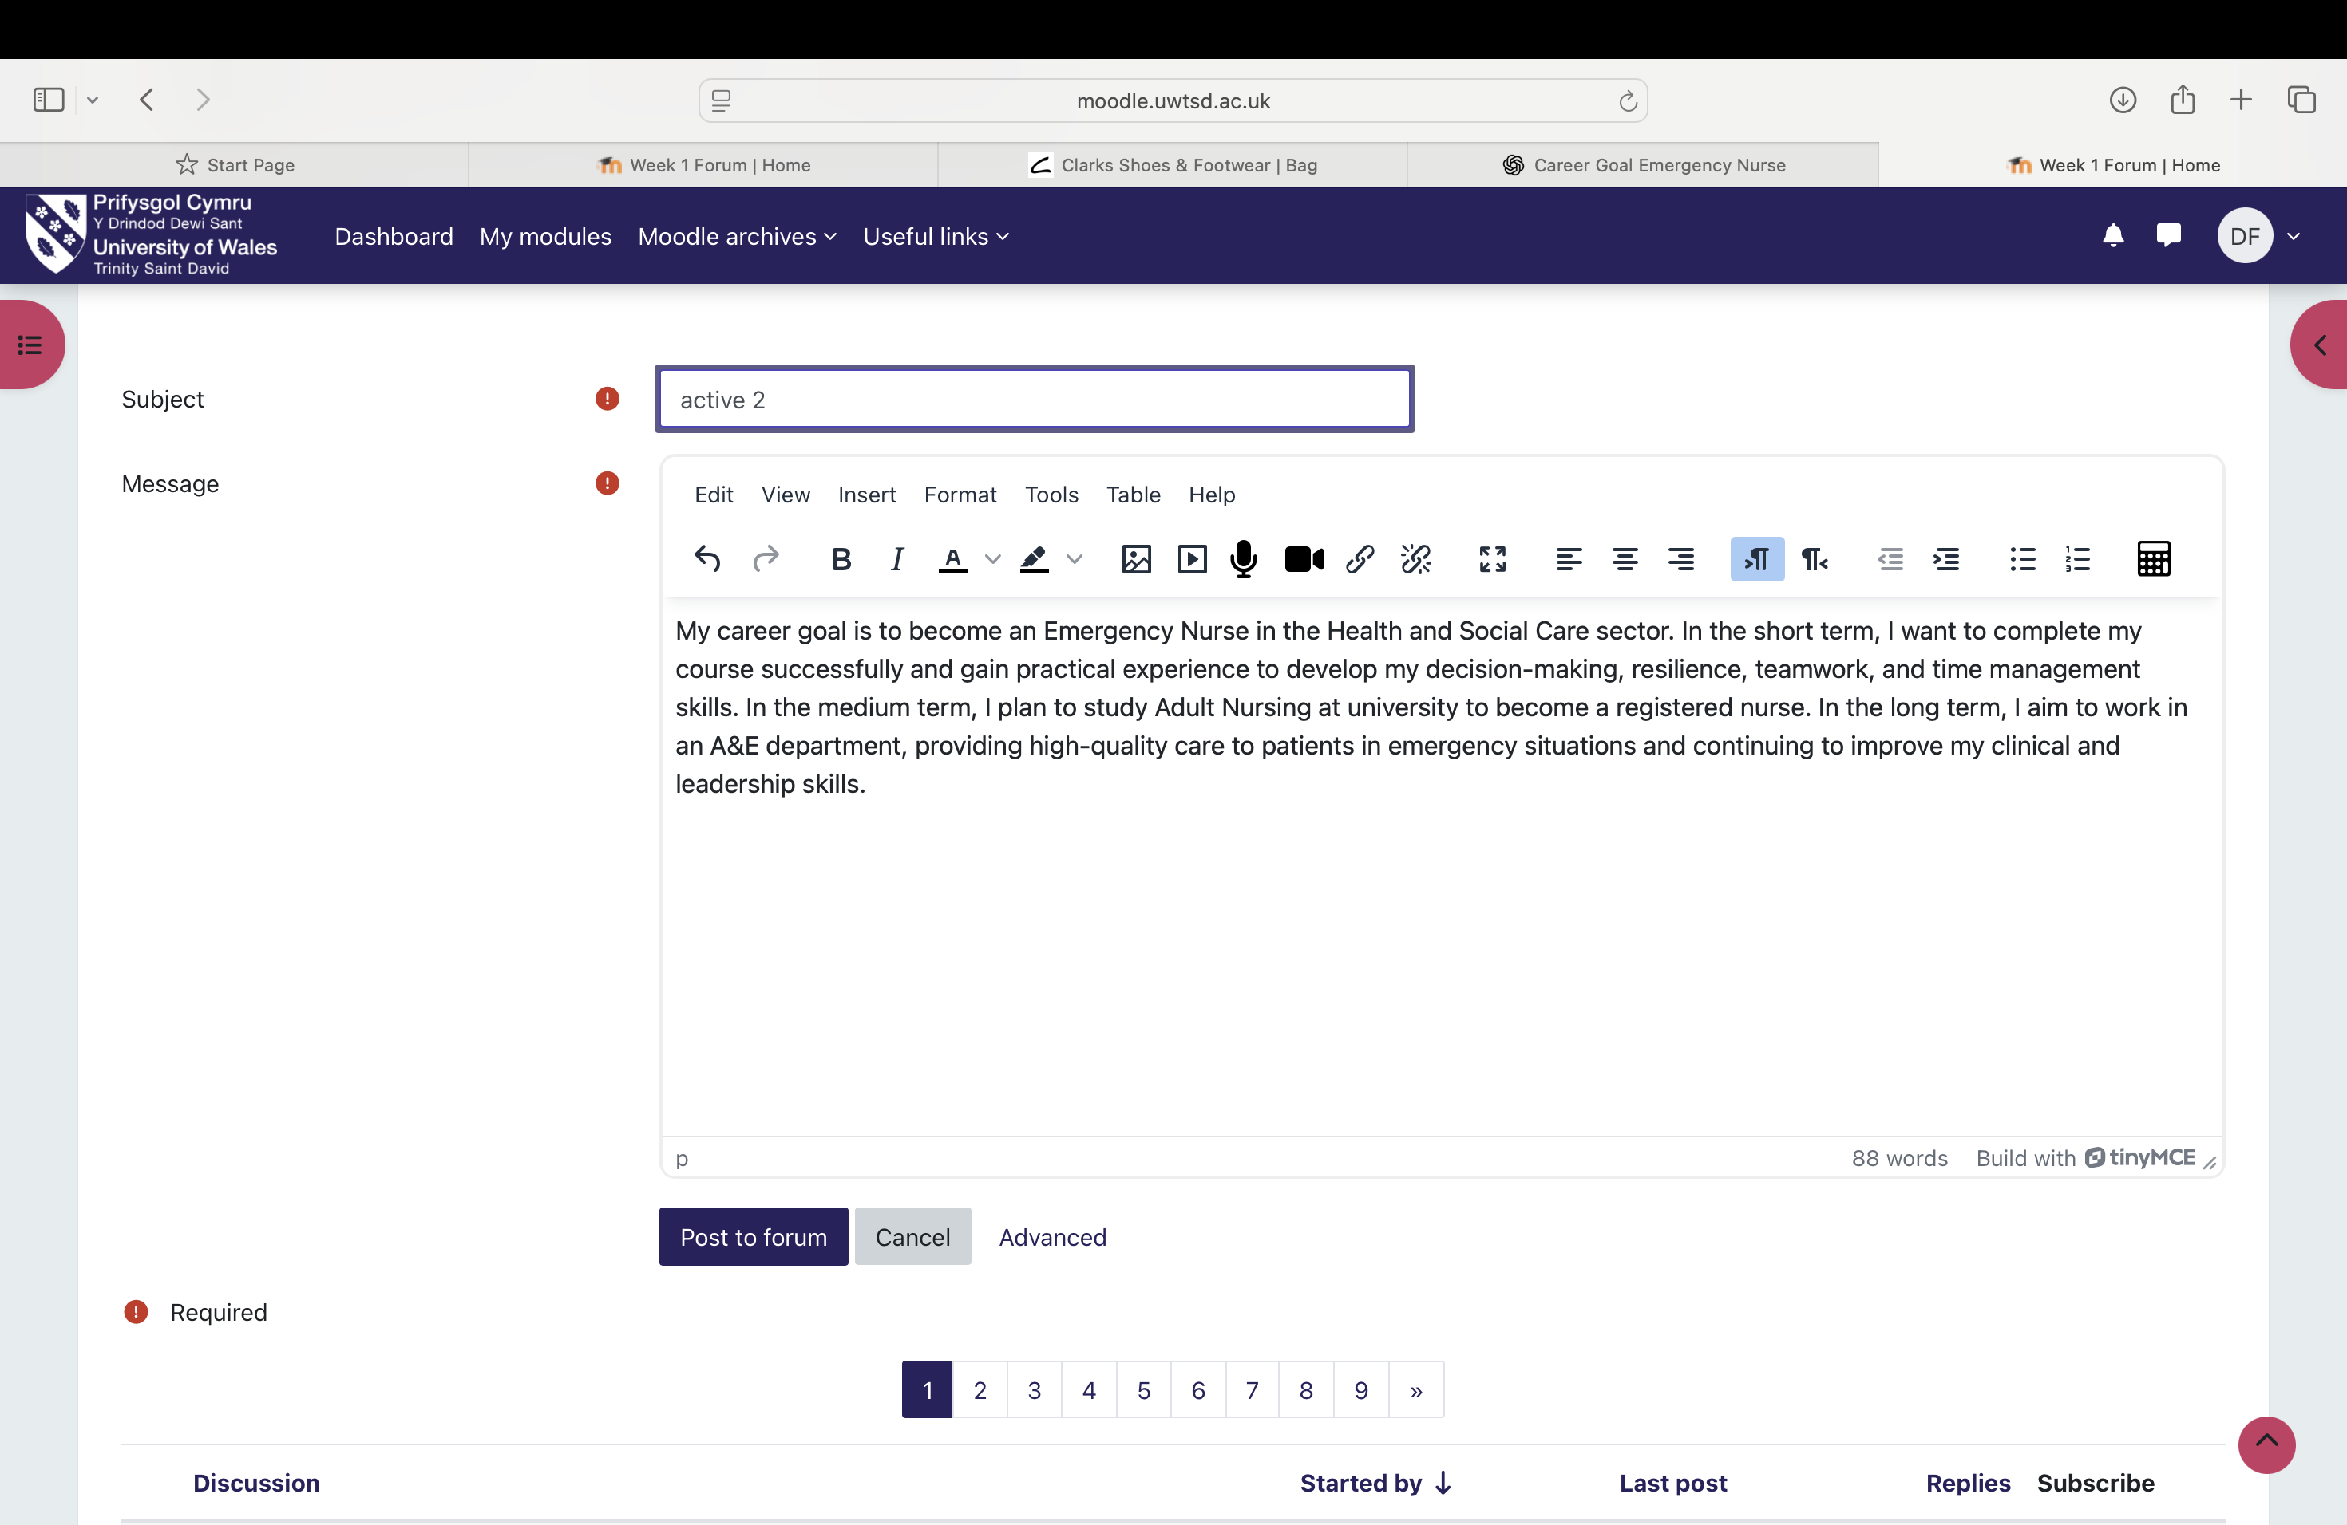

3. Weeks 3 and 4

3.1 Boundaryless Career
The concept of a boundaryless career reflects the modern professional landscape, where careers are not restricted to a single organization (Bartel, 2021). Traditionally, professionals spent most of their working life with one employer. Today, globalization and technological advances allow individuals to move across organizations, industries, and even countries. Success in this model relies on skills, experience, and professional networks rather than loyalty to a single company. Continuous learning, adaptability, and strategic networking are essential for managing long-term career trajectories (Etemad, 2024). This career model empowers individuals to take ownership of their development but requires self-discipline, foresight and proactive engagement with opportunities. 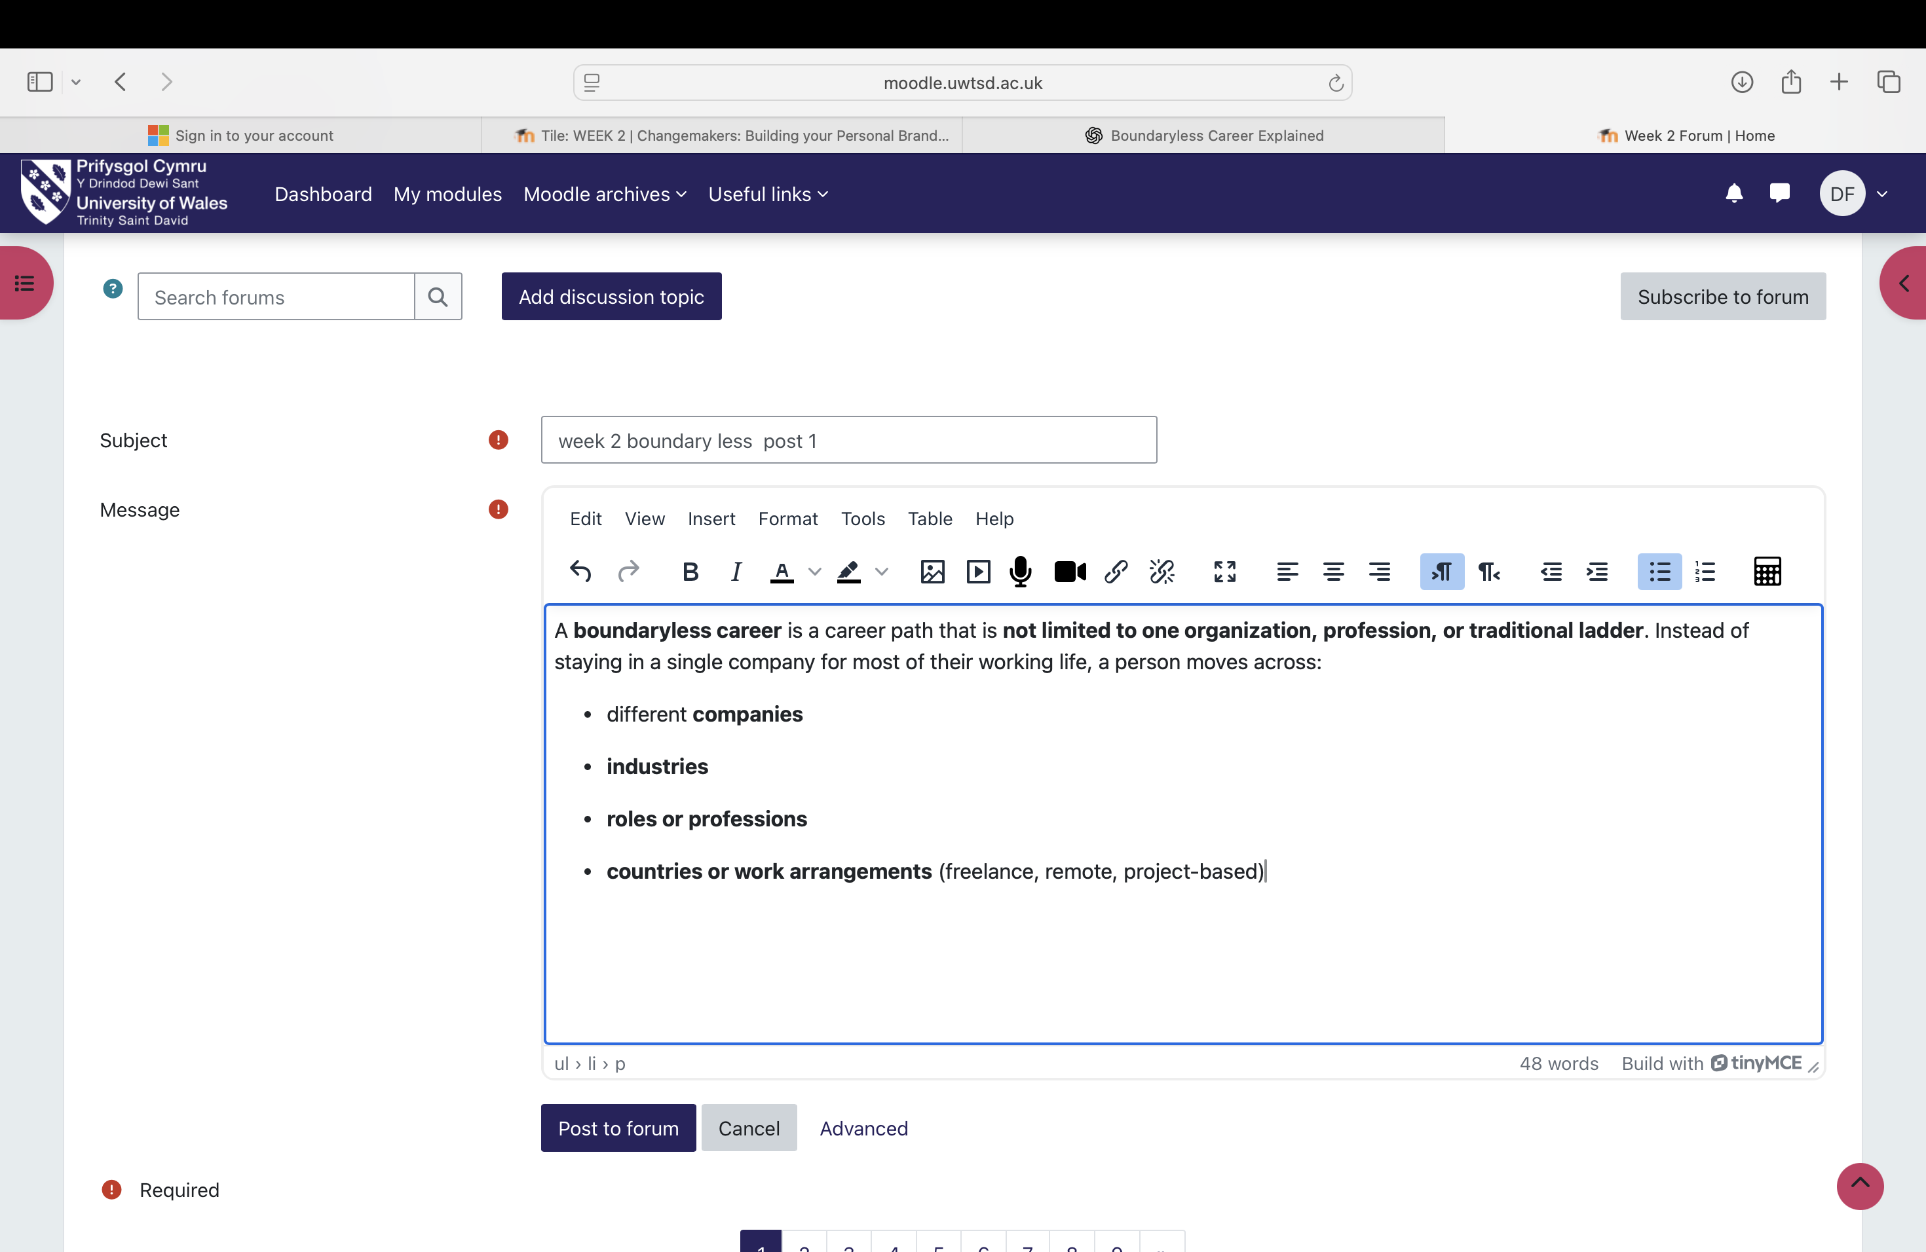

3.2 Networking
Networking is the process of building and maintaining relationships that support personal and professional growth. It involves connecting with colleagues, mentors, and professionals across sectors to exchange experiences, advice, and opportunities (Maerz, 2021). Effective networking occurs both in-person and through digital platforms, professional events, and social media. It focuses on relationship-building, knowledge sharing, and mutual support rather than simply seeking Favors (Wani, 2024). Strong networks enhance learning, collaboration, and career advancement, providing access to resources and opportunities that may not be available through formal channels.

3.2.1 Historical Perspective of Networking
Historically, networking relied on local communities, workplaces, or family connections, with job opportunities often arising from personal recommendations. As industries expanded and digital platforms emerged, networking now spans cities and countries, enhancing collaboration while preserving the core principle of relationship-building and knowledge-sharing (Wani, 2024). This historical perspective emphasizes that networking is timeless: it is not solely about technology but about cultivating genuine connections and fostering trust over time. 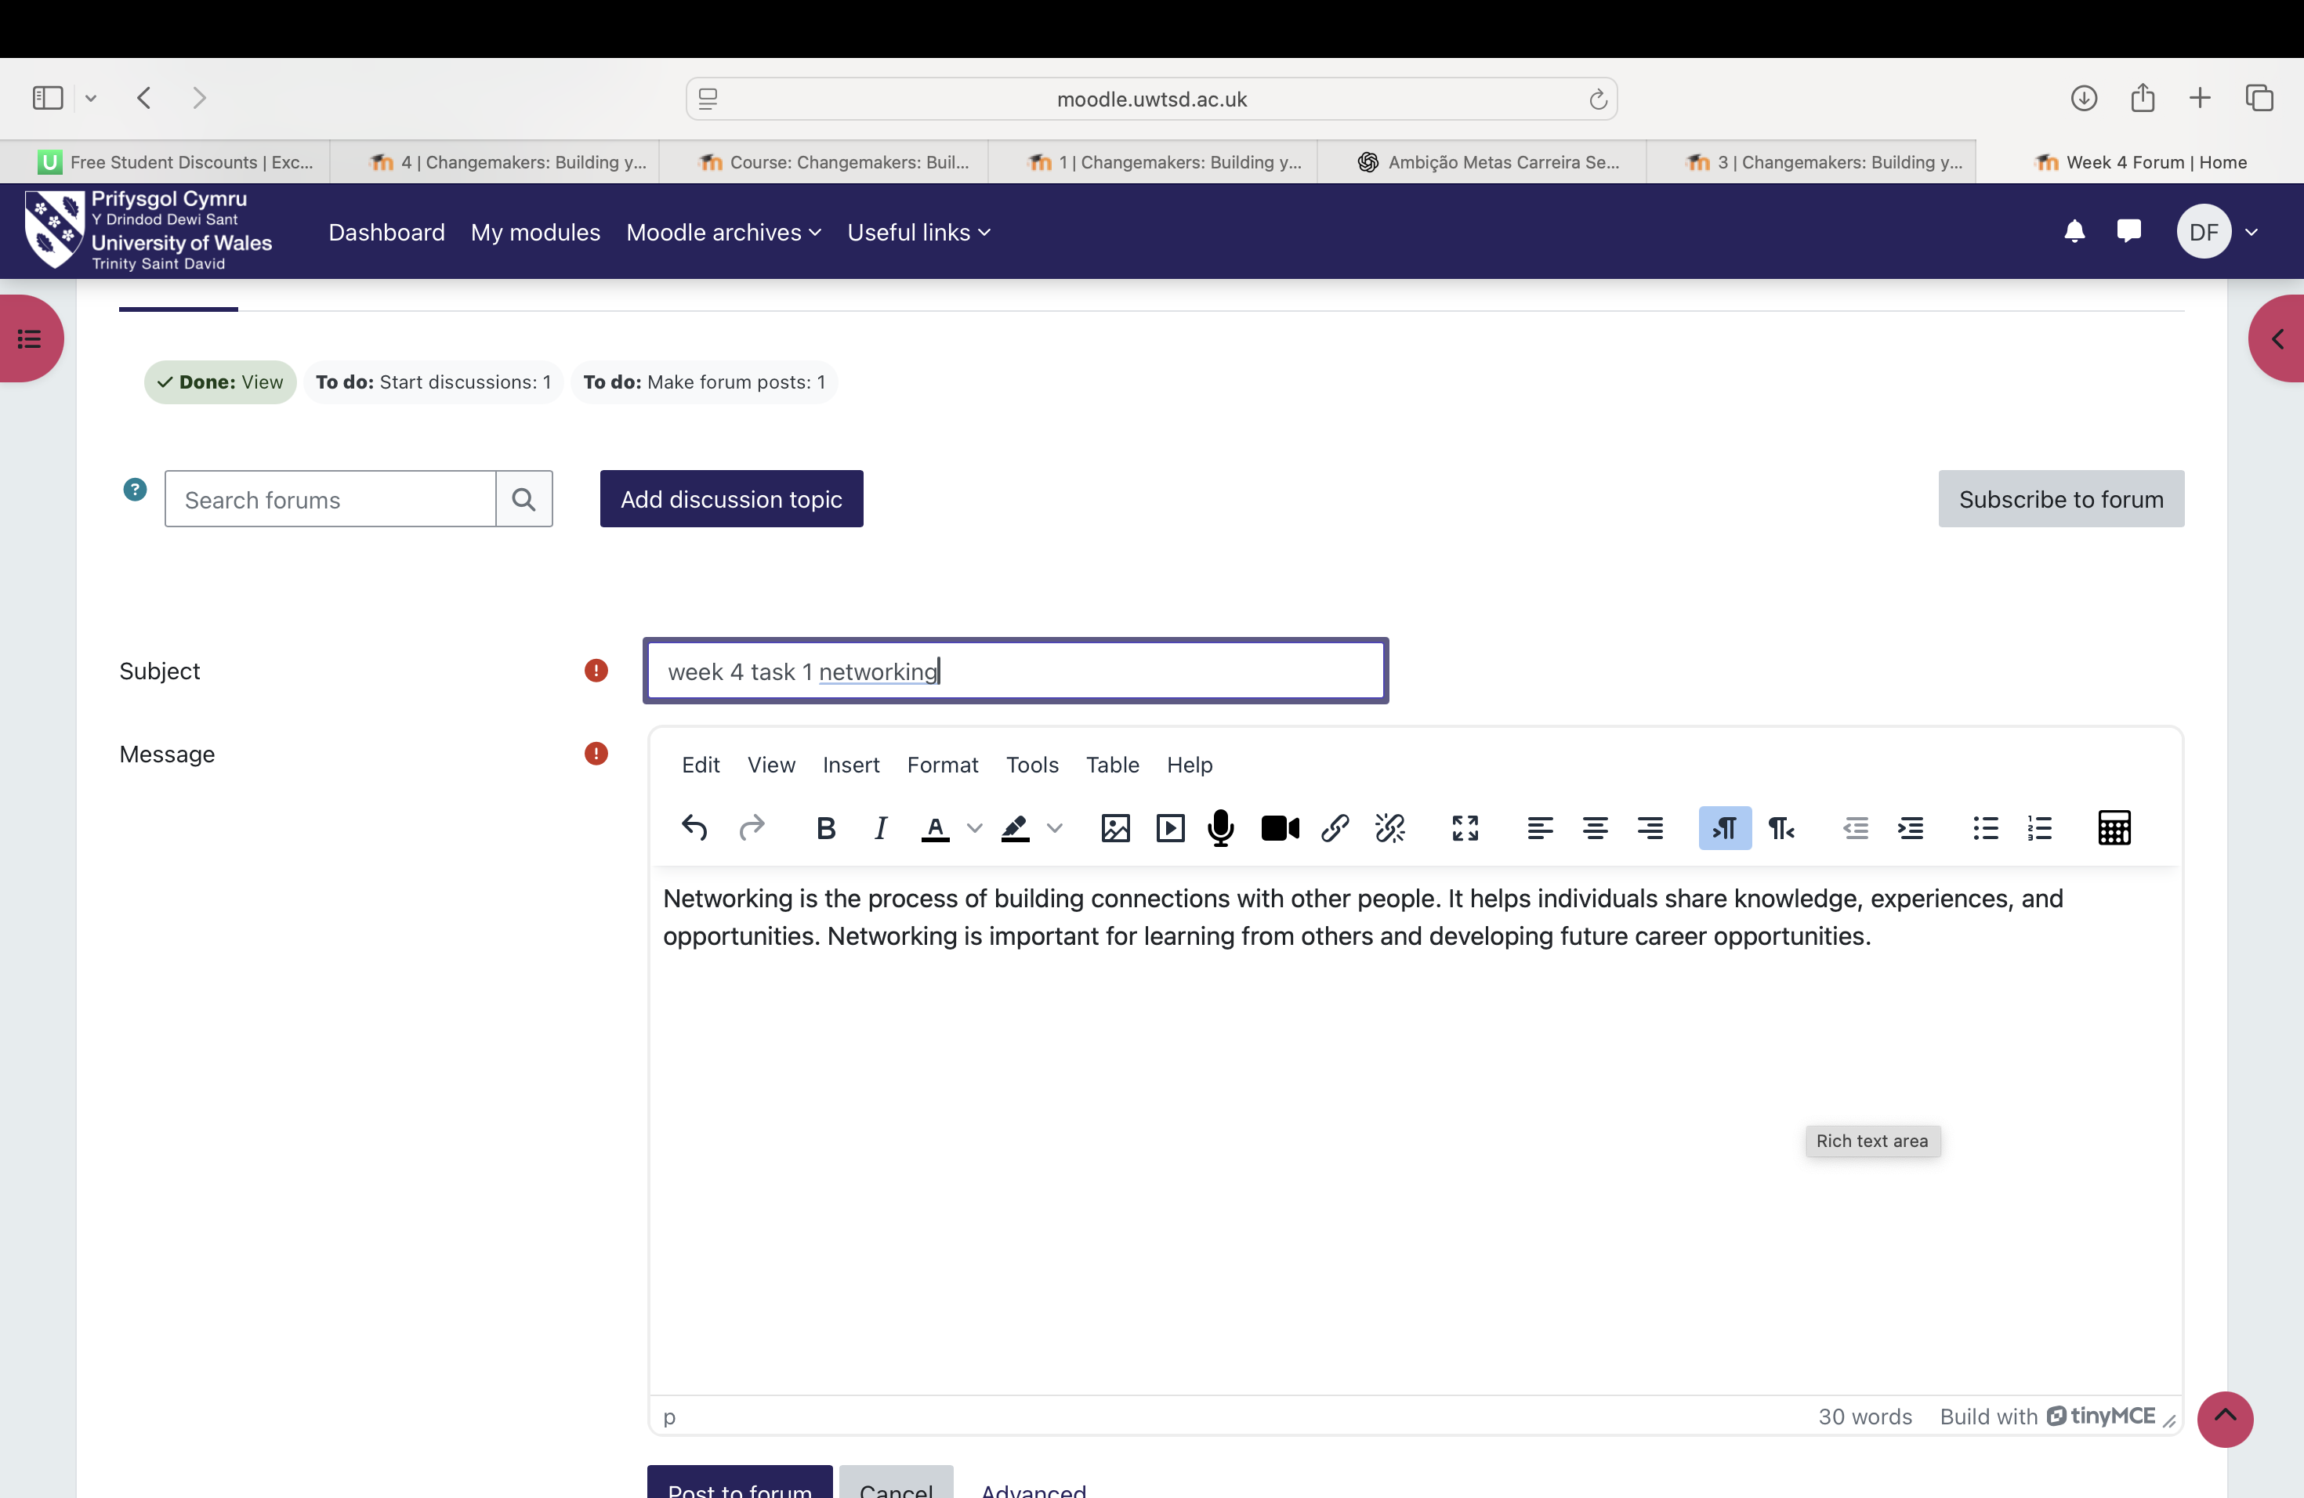

3.3 Bureaucracy and Hierarchy
Bureaucracy refers to structured rules, procedures, and responsibilities designed to maintain organizational efficiency and fairness. Hierarchy defines authority levels, with managers making strategic decisions while employees execute daily operations (Olney et al., 2021). While these systems historically provided order, modern workplaces increasingly emphasize flexibility to encourage innovation, faster decision-making, and collaborative problem-solving (Stachova & Stacho, 2017). Understanding bureaucracy and hierarchy is essential for navigating organizational structures effectively, building professional influence, and contributing meaningfully within teams. 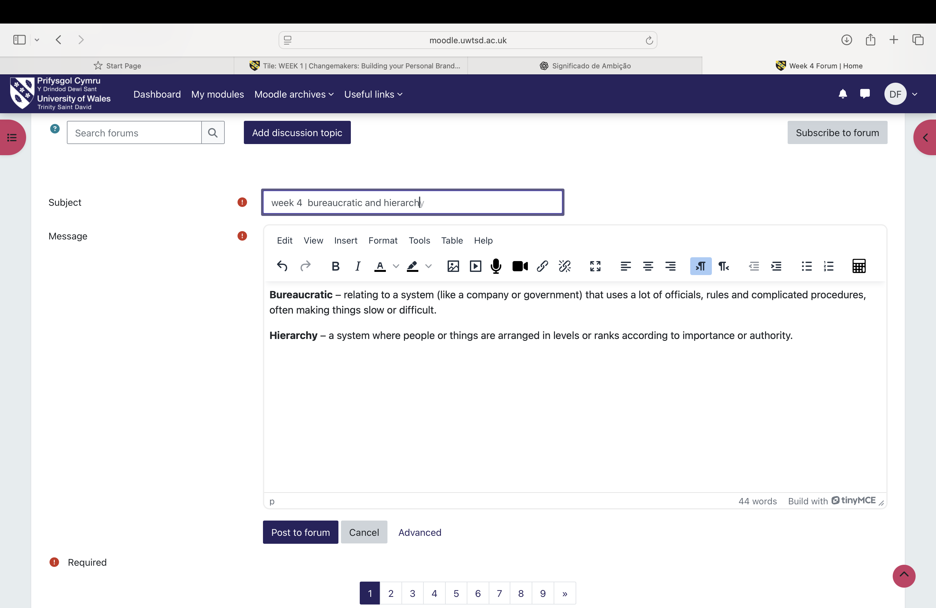

4. Weeks 5 and 6

4.1 Success and Opportunities in Health and Social Care
Success in the health and social care profession requires dedication, ethical values, and a commitment to improving others’ wellbeing (NHS, 2023). Several skills and attitudes contribute to professional growth:
- Compassion and Empathy: Essential for building trust and delivering high-quality care (Skills for Care, 2022).
- Continuous Learning: Staying updated with evolving practices ensures safe and effective care (WHO, 2022).
- Communication and Teamwork: Coordination with colleagues, families, and interdisciplinary teams enhances outcomes (NHS, 2023).
- Responsibility, Patience, and Resilience: Enable professionals to manage stress, maintain focus, and achieve long-term success (Skills for Care, 2023).
These attributes highlight that professional growth depends not only on knowledge but also on ethical behaviour, emotional intelligence, and relational skills. 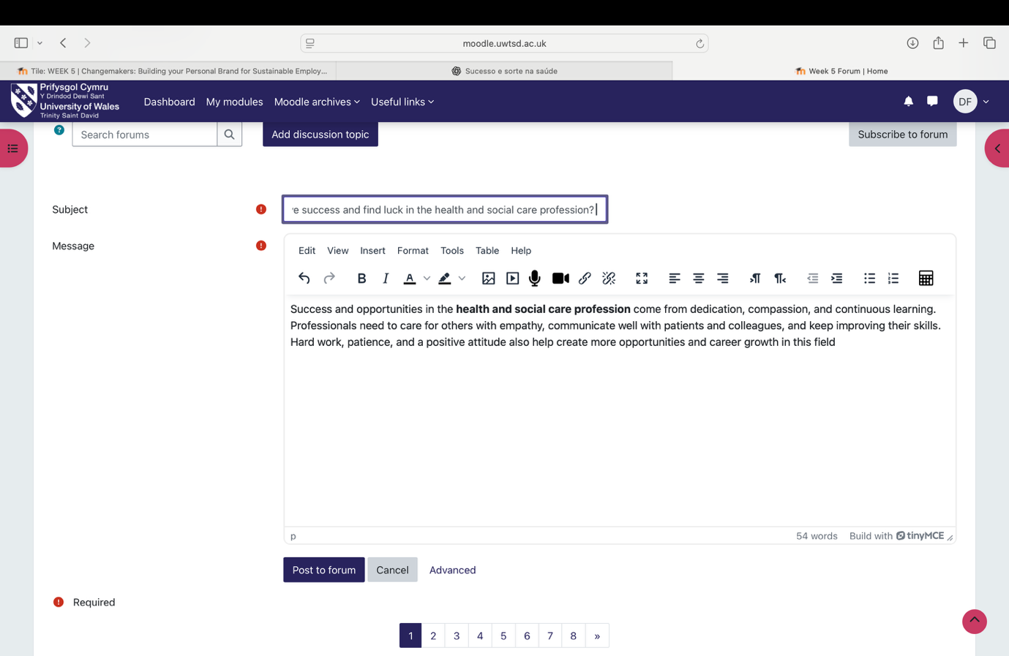

4.2 Perception
Perception is the process of interpreting sensory input through both bottom-up (raw input) and top-down (experience-driven) mechanisms. The brain organizes sensory data by grouping elements, separating figure and background, and filling in gaps. Perception is influenced by biology, emotions, culture, and personal experience, meaning it is not always a precise reflection of reality (Pinna et al., 2026). Understanding perception improves self-awareness, communication, and decision-making, helping professionals interpret environments more accurately and respond effectively in complex situations. 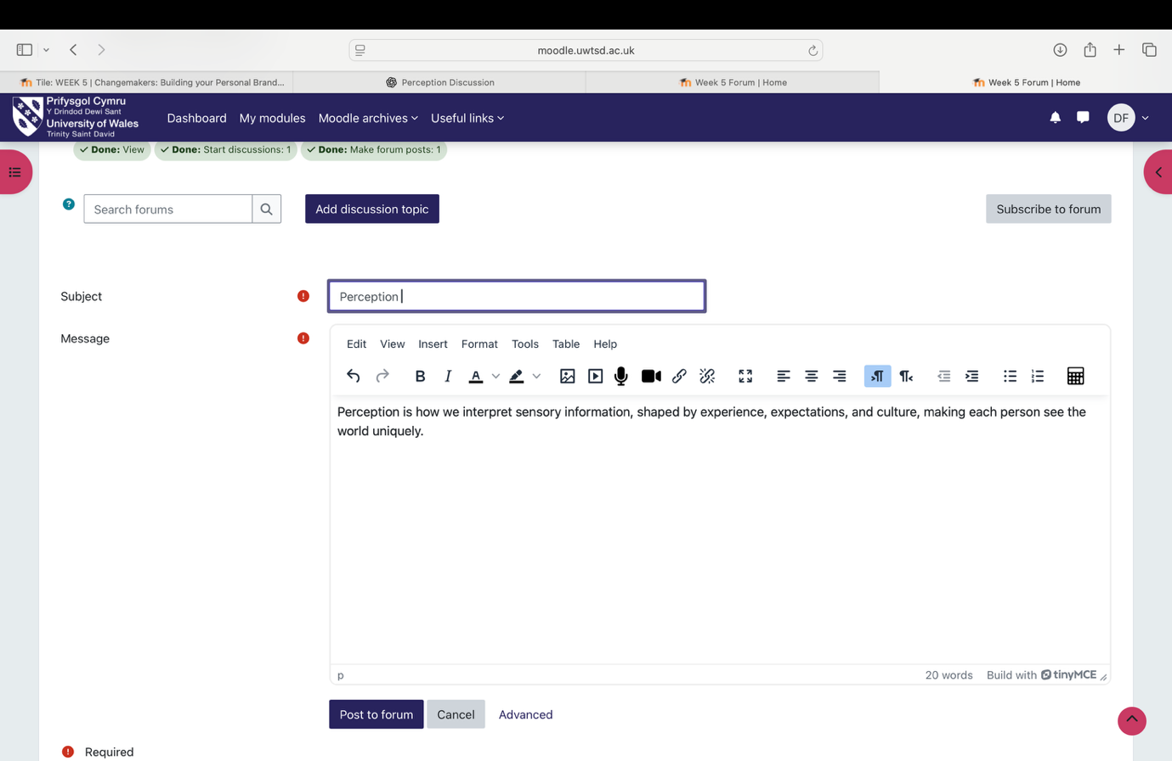

4.3 Opening Doors to Job Opportunities
Career development relies on proactivity, continuous learning, and relationship-building. Networking and maintaining professional connections often reveal opportunities beyond formal applications (Gravette, 1973). Developing both technical and soft skills enhances employability and adaptability (World Economic Forum, 2020). Proactive strategies, such as applying for internships, volunteering, or contacting recruiters, strengthen experience and visibility (Jackson, 2016). Professional presentation, including CVs and online profiles like LinkedIn, is critical for recognition (Brown & Hesketh, 2004). Flexibility ensures readiness for unexpected opportunities, reinforcing that sustained success combines initiative, skill, and strategic engagement. 

5. Weeks 7 and 8

5.1 Limiting Beliefs
Limiting beliefs are deeply rooted assumptions that constrain potential and hinder goal pursuit. They emerge from early experiences, social messages, or repetitive thinking patterns, often emphasizing perceived inadequacies, such as “I’m not capable” or “I don’t deserve success” (Pinckney, 2025). Recognizing and challenging these beliefs is essential for personal and professional development. By addressing limiting beliefs, individuals can cultivate adaptive thinking, increase self-confidence, and overcome barriers that restrict growth. Over time, this leads to enhanced performance, better decision-making, and more meaningful engagement in both personal and professional contexts. 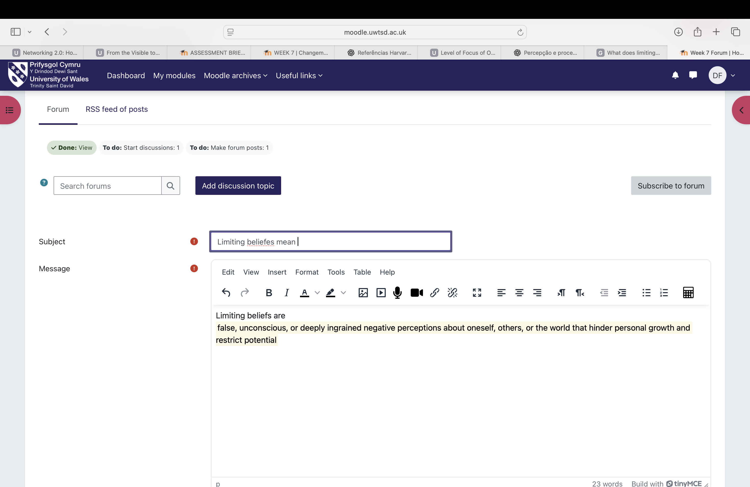.week 8
- 5.2 Discuss the impact of changes due to technology
- Understanding the impact of technological change is very important in today’s world because it helps people use technology more effectively and responsibly in their daily lives.
- Firstly, it helps individuals improve their performance in work and education. By understanding the benefits of technology, people can use digital tools, online platforms, and artificial intelligence to increase productivity and enhance learning (United Nations, 2020).
- Secondly, it develops critical thinking. When people are aware of both the positive and negative effects of technology, they become more conscious of risks such as excessive social media use, misinformation, and mental health issues (Grantham, 2023). This awareness allows them to make more balanced and informed decisions.
- Another important benefit is better preparation for the job market. Technology is present in almost all professions, and understanding its changes helps individuals adapt to new demands, develop digital skills, and remain competitive (Kuş, 2025).
- In addition, this knowledge supports digital and social inclusion. By recognizing the digital divide, people and institutions can work towards providing equal access to technology, helping reduce social and economic inequalities (United Nations, 2020).
- Finally, it encourages responsible decision-making. Understanding technology’s impact promotes ethical use and supports the development of sustainable solutions for society (Antonucci et al., 2017).

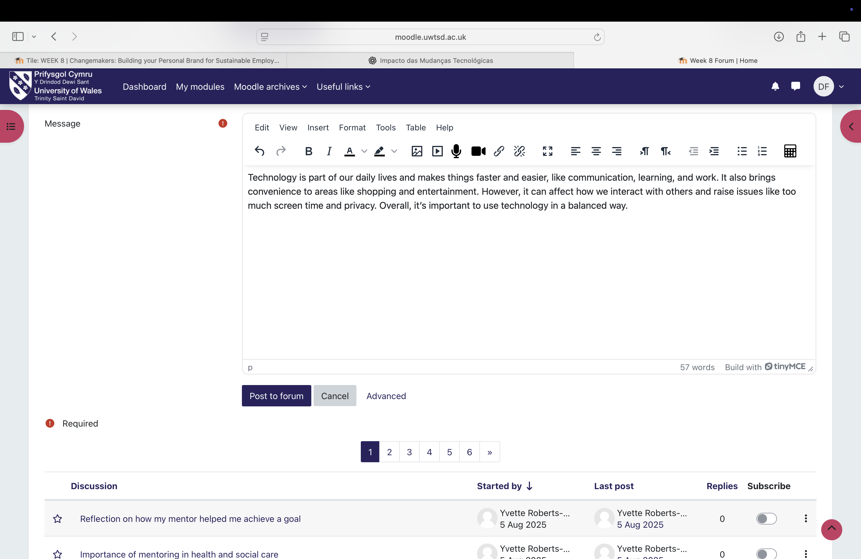
- 5.3 Understand social learning theory
- Social Learning Theory, first proposed by Bandura (1977), explains that people learn by observing others, remembering what they see, and then imitating behaviours, especially when those behaviours are socially reinforced (Bandura, 1977). It highlights four key stages: attention, retention, reproduction, and motivation. Observers watch others (models), internalize observed behaviours, and may later reproduce them, even without direct practice (Bandura, 1977).
- Research in the United Kingdom has applied Social Learning Theory to clinical education, focusing on how medical students learn from role models during clinical placements. One qualitative study conducted with final-year medical students and clinical teachers analysed how learners internalize observed professional behaviours. The study found that students’ learning was often complex and inconsistent, requiring attention to role models, retention of key behaviours, practice, and motivation via feedback or reinforcement (Wright, Wong, & Newill, 2018). Barriers included fragmented exposure to role models and limited awareness of cognitive processes involved (Wright, Wong, & Newill, 2018).
- The authors concluded that making the stages of Social Learning Theory explicit to both students and teachers can help structure observational learning, enhancing professional skill development in UK medical education (Wright, Wong, & Newill, 2018).

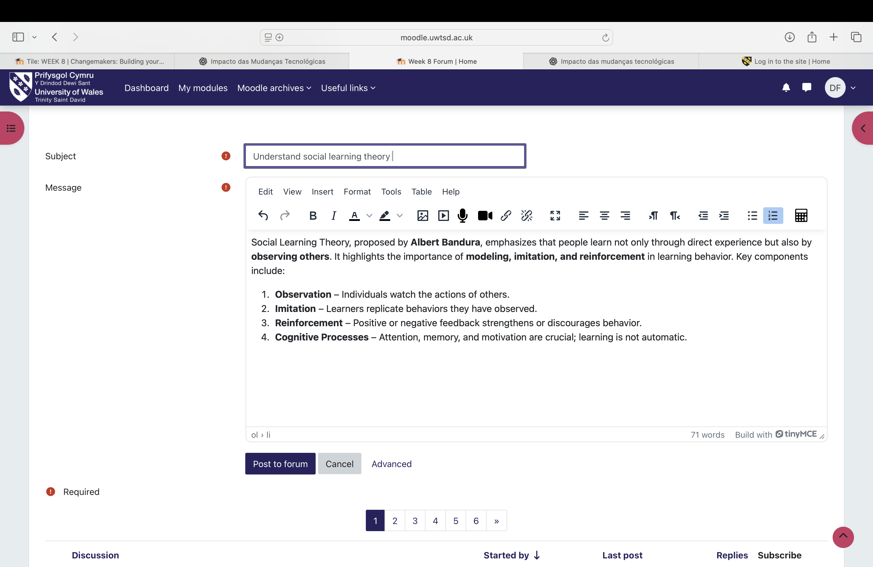

6. Conclusion
The “Changemakers” program highlighted how deeply interconnected personal growth, career development, and professional success truly are. Rather than existing in isolation, ambition, goal setting, and networking operate together to shape meaningful and sustainable career pathways. This aligns with broader perspectives on employability, which emphasise adaptability and continuous development as key to long-term success. At the same time, it has become clear that ambition must be balanced, as excessive pressure can lead to stress and unrealistic expectations.
Through this experience, I have developed a stronger awareness of the importance of reflective practice and lifelong learning. Reflecting on personal strengths and limitations has allowed me to better understand my own career direction, while actively engaging with new opportunities has shown how professional growth often occurs outside of comfort zones. In particular, networking has emerged as a valuable tool in accessing opportunities and building supportive professional relationships.
Within health and social care, these insights are especially significant. Success in this field goes beyond technical competence, requiring empathy, communication, and emotional resilience. These qualities not only enhance professional effectiveness but also ensure that care remains person-centred and meaningful. However, working in such environments can also be emotionally demanding, reinforcing the need for resilience and self-care.
Ultimately, career development is not a linear process but a dynamic and evolving journey. While challenges and uncertainty are inevitable, they are also essential for growth. This experience has reinforced my understanding that long-term success is built through self-awareness, adaptability, and intentional action, alongside a genuine commitment to continuous personal and professional development.

- Reference
- • Bandura, A., 1977. Social Learning Theory. Englewood Cliffs, NJ: Prentice Hall. [Accessed: 09 April 2026].
- • Bartel, J.-N., 2021. ‘How boundaryless are partner careers in consulting firms? A two-country optimal matching analysis’, International Journal of Human Resource Management, 32(20), pp. 4311–4336. Available at: https://doi.org/10.1080/09585192.2019.1681493 [Accessed: 26 March 2026].
- • Brown, P. and Hesketh, A., 2004. The mismanagement of talent. Oxford: Oxford University Press. [Accessed: 09 April 2026].
- • Cheng, X., 2023. ‘Looking through goal theories in language learning: A review on goal setting and achievement goal theory’, Frontiers in Psychology, 13, p. 1035223. Available at: https://doi.org/10.3389/fpsyg.2022.1035223 [Accessed: 22 February 2026].
- • Etemad, H., 2024. ‘The artificial intelligence, digital economy, and global connectivity: Implications and lessons for international entrepreneurship’, Journal of International Entrepreneurship, 22(4), pp. 409–432. Available at: https://doi.org/10.1007/s10843-025-00388-7 [Accessed: 24 February 2026].
- • Granovetter, M., 1973. ‘The strength of weak ties’, American Journal of Sociology, 78(6), pp. 1360–1380. [Accessed: 09 April 2026].
- • Jackson, D., 2016. ‘Re-conceptualising graduate employability: The importance of pre-professional identity’, Higher Education Research & Development, 35(5), pp. 925–939. Available at: https://www.tandfonline.com [Accessed: 27 February 2026].
- • Kuş, M., 2025. ‘Impact of technology on academic performance’, Frontiers in Psychology. Available at: https://www.frontiersin.org/articles/10.3389/fpsyg.2025.1524645 [Accessed: 08 April 2026].
- • Olney, R., Shluzas, L. and Leifer, L., 2021. ‘Analytical framework for innovation in hierarchical and bureaucratic organizations’, in 2021 IEEE Technology & Engineering Management Conference – Europe (TEMSCON-EUR). IEEE, pp. 1–5. Available at: https://doi.org/10.1109/TEMSCON-EUR52034.2021.9488640 [Accessed: 02 March 2026].
- • Pinna, B., Porcheddu, D. and Šķilters, J., 2026. ‘From the visible to the invisible: On the phenomenal gradient of appearance’, Brain Sciences, 16(1), p. 114. Available at: https://doi.org/10.3390/brainsci16010114 [Accessed: 05 March 2026].
- • Psychology Today, 2026. Social Learning Theory. [online] Available at: https://www.psychologytoday.com/gb/basics/social-learning-theory [Accessed: 09 April 2026].
- • Resta, E. et al., 2022. ‘Marie Curie vs. Serena Williams: Ambition leads to extremism through obsessive (but not harmonious) passion’, Motivation and Emotion, 46(3), pp. 382–393. Available at: https://doi.org/10.1007/s11031-022-09936- 3 [Accessed: 08 March 2026].
- • Rhode, D.L., 2021. Ambition: For what? New York: Oxford University Press. [Accessed: 09 April 2026].
- • Stachová, K. and Stacho, Z., 2017. ‘Level of focus of organizations operating in Slovakia on flexible organizational structure’, International Review of Management and Marketing, 7(1), pp. 245–250. [Accessed: 09 April 2026].
- • United Nations, 2020. The impact of digital technologies. Available at: https://www.un.org/en/un75/impact-digital-technologies [Accessed: 08 April 2026].
- • Wani, P., 2024. ‘Connecting for success: The role of networking in medical education’, Cureus, 16(11), p. e74643. Available at: https://doi.org/10.7759/cureus.74643 [Accessed: 16 March 2026].
- • Wright, S., Wong, A. and Newill, C., 2018. ‘A skill to be worked at: using social learning theory to explore the process of learning from role models in clinical settings’, BMC Medical Education, 18, p.77. Available at: https://bmcmededuc.biomedcentral.com/articles/10.1186/s12909-018-1251-x [Accessed: 09 April 2026].
- • World Economic Forum, 2020. The future of jobs report 2020. Available at: https://www.weforum.org/reports/the-future-of-jobs-report-2020 [Accessed: 20 March 2026].

