
developing Workplace Critical Thinking



Table of Contents
Introduction 1
Management Theories 1
Scientific Management Theory: 2
Contingency Management Theory: 3
Human Relations Management Theory: 4
Systems Management Theory: 4
Bureaucratic Management Theory: 5
How Would Social Distancing Be Managed, and How Would Employees Be Monitored if Isolated in Tesco, Applying the Key Management Theories? 6
Critical Assessment of the Theories to evaluate How Someone with Different Beliefs, Attitudes and Values Might Interpret the Theory Differently 9
Relationship between Beliefs, Attitudes, and Values within a Workplace 9
Critical Assessment of Organization’s Own Beliefs, Attitude and Values and Their Impact on Workplace Behavior 10
Critical Assessment of an Appropriate Management Theory to Evaluate How Someone with Different Beliefs, Attitudes and Values Might Interpret The Theory Differently 11
Recommendation and Conclusion 12
References 14

Developing Workplace Critical Thinking

Introduction
Since the outbreak of COVID-19, people seemed to do nothing but staying at home. There were a lot of uncertainty regarding how to get through this curse. Thus people were suggested to maintain social distance while wearing face coverings as a must. Almost all countries in the world imposed lockdown across the country to reduce or stop the spread of this infectious virus for quite some months. While reducing its spread proportionally, they lift up or normalize the lockdown and thus, second wave has broken out in many countries across the globe. On the other hand, amid Covid-19 most companies start running their business in order to sustain and, in turn, employees are required to join the workplace (AfricArXiv, 2020). As a result, it is very essential to reshape the workplace to make workers feel comfortable, supported and able to do their jobs effectively.
Tesco PLC is the largest groceries and merchandise retailer in the UK, while third-largest retailer in the world measured by gross revenue and the ninth-largest retailer measured by the revenues. It is seen that 2020 an wonderful year for Tesco as the company transformed one of the biggest threats into its greatest strengths through strong leadership and management. For example, through boosting online sales and hiring more employees, Tesco registered a 10.5% percent growth in July to September of 2020. As Tesco has increasingly prioritized employee wellness, including public health, it should initiate workplace assessments to identify where physical changes can help to alleviate germs. And further holistic problem examination, considering COVID-19-related attitude and behavioral shifts, could bring success in creating a powerful support tool for worker morale, public health and business continuity.

Management Theories
Management is the process of planning. Organizing, supervising, controlling, and directing people, tasks, and things. Management theory can be defined as the collection of understandings and findings that help managers best support their teams and goals. These allow people to communicate each other in the workplace, are also useful in simplifying decision making and encouraging staff participation which in turn help them work effectively. Furthermore, when the theory which may fit for one situation may not be pertinent to another situation then it is significant to explore the option of developing a new theory that would lead a more applicable direction. Firstly, the industrial revolution brought extraordinary change to the workplace and forever transformed the way companies operate, gave birth to variety of management theories and concepts which in turn help to increase productivity. Many of those theories and concepts are still relevant and important in today’s workplace. Moreover, since the end of industrial revolution many management theories and concepts have developed as society continues to evolve (Rath, n.d.). There are elucidated some popular management theories in below:
Scientific Management Theory: according to Fredrick Taylor, forcing people to work hard wasn’t the best way to optimize results. Instead, he emphasized on simplifying tasks so as to increase productivity (Taylor, 2012). Therefore he suggested four major principles of scientific management and these are given below:
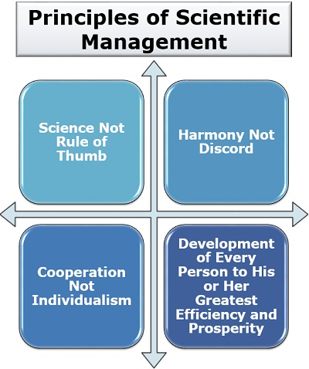

Science Not Rule of Thumb: He criticized the traditional approach as it was based on the trial and error method. Then, it was summarized that if science is applied instead of the rule of thumb to any job, it standardizes that work as workers gets a specialized way of performing the task. Moreover, by using scientific method, wastage of a lot of time, cost and resources can be avoided.
Harmony Not Discord: Taylor believed that conflict among the managers and the workers will result in lower productivity and thus, there should be a mental revolution in the organization to maintain harmony and peach in the workplace.
Cooperation Not Individualism: teamwork and cooperation is always fundamental to business success. Thus, employees should work together to achieve common organizational goal, and workers should not oppose the management by putting up irrelevant demands while management should encourage the workers to give suggestions and create an open communication system in the organization.
Development of Every Person: training and development improve the competency, skills and learning of the workforce. Hence, he believed that the workers should be given proper training of the task they perform as no human being is perfect, and there is always scope of improvement.
In the aftermath, many people claimed that F.W. Taylor ignored human beings while over emphasizing on scientific method. However, the scientific management theory has been practiced worldwide since its inception.
Contingency Management Theory: contingency management theory doesn’t believe the particular best way to manage but emphasizes on different circumstances and environment when performing management activities such as planning, controlling, and so on (Ghofar and Islam, 2015). Here managers always need to pay heed to the current situations and then assemble strategy on the basis of their experience and knowledge, while leaders have to adapt themselves their management and working styles according to the needs of their co-workers and organization. And leaders ought to be quick to identify the particular leadership style suitable for particular situation. Moreover, contingency theory helps organizations to lodge flexible and transform their strategies based on the changing situation and helps to identify effective leadership style. Although it is one of the most practiced approaches, perhaps the most effective one, in the workplace, there are also have some limitations. As there is no one way solution, mangers can try as much as they want in search of solutions. Hence it may sometimes lead to extermination of resources, time and money. This theory is possibly applicable for any organization including Tesco when dealing with different uncertainty like COVID-19 situation.
Human Relations Management Theory: Before World War Two, there was only talk of Scientific Management, which treated human beings as machines, and manly emphasized on productivity and efficient division of labor. Afterwards Elton Mayo developed Human Relations Theory, which viewed individuals as “social person” and thus, people should be treated as individuals, not machines, with individual needs. Elton Mayo showed that people naturally desire to be part of a supportive team, wants to be valued and like to receive attention that may motivate them to get more out of themselves for benefit of the organization. In Hawthorne studies, light effect, duration breaks and working hours had significant change in employee behaviors. Then, it was concluded that individuals must be seen as members of a group, salary and good working conditions are important but sense of belonging to a group is more important. And informal groups have a strong influence on the behavior of employees. So it was believed that productivity increased because of relationships and supportive groups. As a result, managers should take social needs seriously. In the past few decades, Tesco mostly applies this approach in the workplace in order to increase its productivity.
Apart from that, Motivation theory possibly fits with human relations in management. Maslow’s needs hierarchy theory includes five needs including basic, safety, love, esteem and self-actualization, which are motivating factors in an employee’s work value (Zvavahera (PhD) and Tandi, 2019). At the same time, MacGregor stated that if employees feel responsible and valued, they are likely to contribute more to the organization. However, as emotion, respect, and interpersonal relationships trigger an emotional sense in employee, these interactions can sometimes weaken or eliminate rational logic.
Systems Management Theory: System management theory focuses on the interactions and on the relationships between multiple components of business and believes that business is like human body in which all components need to have perfect for smooth functioning (What is Systems Theory?, 2020). Therefore, the success of an organization doesn’t lay in one or two components of a business but lays in other elements such as synergy, interdependence, and interrelations among different subsystems. Managers and workers are the most vital components of a company while departments, workgroups and business units are also crucial to the success of a business. Hence, the main responsibility of the managers is to evaluate pattern and events in their companies so as to set the best management approach. Like this, they are able to work together on various programs as if they can work as a collective whole rather than as an isolated unit. Moreover, it is criticized that though relationship amongst parts of organization is emphasized, exact nature of inter-dependence and relationship between internal and external environment of the organization are not defined. Nevertheless, this theory has been practiced in Tesco workplace in order to ensure better productivity.
Bureaucratic Management Theory: Max Weber developed this theory and proposed six principles of it (Ivanenko, 2018) . These are as follows:
Task Specialization: putting right people at right place for task accomplishment can lead to more productivity.
Hierarchical management structure: authority and responsibility are defined clearly for each position. Top-down management approach has been practiced in the organization, which in turn is highly criticized.
Formal Selection Process: employee selection and promotion are according to experience, competence while there is no nepotism.
Career Orientation: while employees are recruited and promoted on the basis of experience and expertise, it is possible to build a desire career.
Formal Rules and Regulations: managers and leaders must follow organizational rules and regulations to ensure reliable and predictable behavior of employees.
Impersonality: finally rules should be applied equally to everyone. Sometimes, Tesco applies these bureaucratic principles in the workplace in order to maintain a strong discipline. However, this theory is often criticized for having reduced productivity and innovation.

How Would Social Distancing Be Managed, and How Would Employees Be Monitored if Isolated in Tesco, Applying the Key Management Theories?
To implement social distancing in the workplace is barrier almost every company is facing right now. Encouraging people to do their best work while keeping them apart is the main responsibility of management. But it is not a small challenge as people naturally like a sense of belonging and praise. Along with Brexit uncertainty, like other companies in the UK Tesco also needs to deal with COVID-19 threats. Although Tesco has shown extraordinary resilience amid even this pandemic by reinventing itself to serve to the rise in online grocery sales, it should reshape the workplace in order to make sure sustainable resiliency in the future by changing management and leadership policies and practices. Scientific management principles could be used for maintaining social distancing. Since it denies individuals as human beings, but considers as machines, it is directly contradictory to the human relations approach, which is required to motivate and satisfy the workplace which in turn will lead to more productivity and resilience of the company. Tesco thereby can use it partly to maintain social distance in the workplace (Weinschreider, 2020).
Though system theory puts a focus on s strong interrelationship among components of the business, it cannot also be used as whole because of the lack of exact information about internal and external components and their relationship. In addition, in some cases, bureaucratic management style can be applied in order to maintain social distance strictly. However, as Tesco aims not only to mitigate germs but also to keep human needs in mind which in turn will sustain its position in the market, contingency approach could best fit to the current situation and the future one to come.
Employees generally resist any kind of change that is made by the management. Thus, in order to adopt social distancing in the workplace, Tesco should let the employees know the changes that are going to be happened and therefore, they are more likely to comply with them. Tesco should develop action plans to reduce COVID-19 as part of its business continuity. The action plan should be monitored and updated and the workers should be consulted and participated in the development, monitoring and updating of the workplace COVID-19.
At the same time, sometimes increasing employee participation in making social distance polices in order to feel them more than individuals, and valued in the workforce could help to achieve organizational goals effectively.
There are given an effective five-phase rollout plan to bring social distance policies to the workplace of Tesco:
Developing clear expectation: in the first phase, in order to develop clear expectations, leadership of Tesco should see what the guidelines WHO, OSHA and other relevant organizations suggested for workplace distancing. It also includes the factors should be considered while setting social distancing in the workplace. WHO recommended bestowing sufficient space, at least 10 square meters, for every employee in the workplace Besides, physical distance guidelines should be more practical and feasible in the context of tasks so that it will be acceptable both workers and employers. Then, risk assessment and consultation between employers and employees is vital to implement social distance at the workplace. it is also recommended that if social distance is not feasible for certain tasks, additional protective measures are highly needed or the work can be suspended. Tesco should also see what the challenges are and policies changes need to be taken etc.
Communicating expectations: after taking a set of clear expectations for social distancing, Tesco should communicate them broadly across the workforce. While communicating, confusion or misunderstanding must be avoided. Adopting new social distancing guidelines could take time for employees as they need to break old habits first. Thus, it is required to be consistent with communication and positive tone is essential to encourage compliance.
Reshaping the workplace: it is the practical phase where workplace has been reconfigured through new social distancing guidelines. It is needed to show employees the commitment to the new social distancing expectations through physical examples of change in the workspace. Tesco can distribute workplace across home, office, and satellite offices. Besides, four day work week and 6 hour work day can lead to employee satisfaction and to increase productivity.
One way circulation could be used for reducing crowd, but there might have other spaces allowed people to pass with sufficient distance. Besides, Tesco can mark floor and wall with graphics to define how to maintain distance in other areas such as cafes, kitchen etc. It might make sure that employees has sufficient space in the office and office seating chart should be designed using social distance guidelines (Dhondt and Van Hootegem, 2015).
Apart from that, Tesco should modify workstations, change the use of common spaces and transport vehicles based on social distance guidelines to mitigate social mixing at the workplace. Additional protective measures such screens, sneeze guards, face masks, ventilation and disinfection should be bestowed.
Creating distancing protocols: new protocols is required alongside new expectations and a new workplace which in turn govern how employees can keep social distancing at the workplace. Tesco can use copper, anti-microbial paint and other cleaning protocols to kill COVID-19 germs at the workplace. Technology is going to play the most significant role in dealing with post-COVID requirements. During this pandemic, companies seem to search alternative to collaborate between the workers and employers. However, technologies that allow people to perform their functions without touching a single public surface will be suitable. Using Zoom or other video conferencing apps, people can interact with the workplace while staying mindful of distance. Tesco should provide separate, quite, calm and private rooms for employee’s heads-down works, just a restful break or personal phone calls.
Promoting accountability: though employees perhaps will not rebel openly against new polices, reluctance is real. Thus, management of Tesco should guide and encourage employees to adopt changes. It is necessary to put socially distant habits into workplace culture. Once it becomes part of culture, it will be second nature to employees. By using this road man Tesco possibly can bring social distance while keeping human relation aspects in mind. By adopting social distancing and monitoring software, Tesco can monitor socially distance workplace as well. Hence, it is possibly required to keep updating with the new technological inventions and skills to operate them (Brown-Shafii, 2014).

Critical Assessment of the Theories to evaluate How Someone with Different Beliefs, Attitudes and Values Might Interpret the Theory Differently

Relationship between Beliefs, Attitudes, and Values within a Workplace
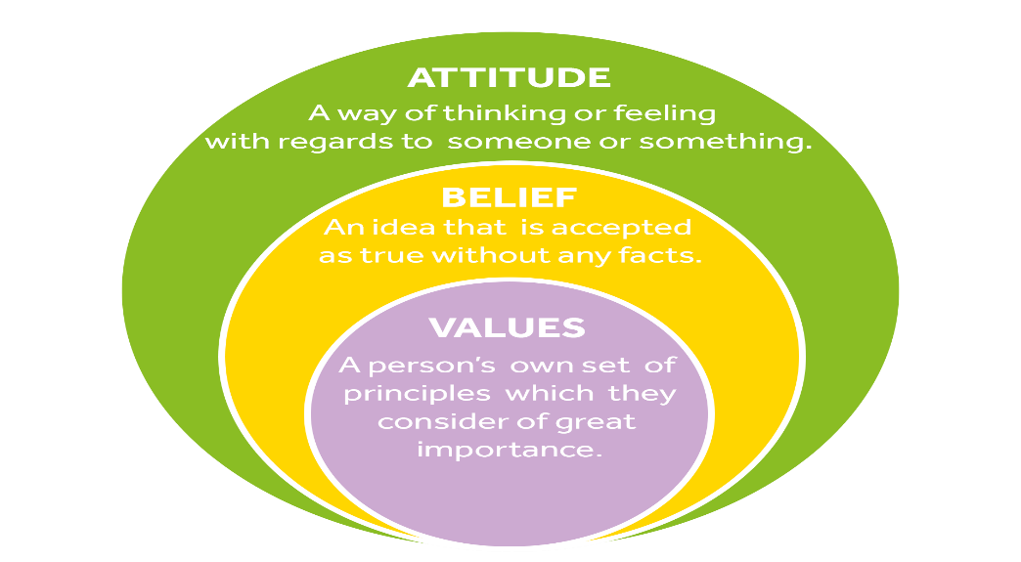
As human beings, every person have his or her own set of attitudes, beliefs and values. Therefore, it is necessary that managers will always not impose their own views on their personnel or client.

Attitudes refers to the way a person responds to his or her environment, either positively or negatively. A person with positive attitude can increase the spirits of their subordinates, while people with negative attitude can lower their spirits at the workplace. Employee’s work performance and performance of the co-workers would be affected by attitudes (Hand, 2020).
Beliefs are the assumptions people make themselves, about other on the earth and about how exactly they hope things to be. Individuals have different beliefs that may affect all facet of their daily lives such as how they dress in the workplace, it could be influenced by religious, or social traditional.
Values are a set of principles that determine morality and conduct. Workplace can be strongly influenced by both the value of employees and employers. When an employee has values such as honesty, discipline, transparency, and hard work, and he will possibly to exhibit those traits in the workplace. This person may therefore be a more efficient employee and a more positive role model to others than a worker with opposite values.
There is needed an improved knowledge of basic reasoning and process of critical thinking which are indispensable in making good decision and building relationships. In dealing with conflict between staff, it is required to assess challenges with negative aspects of the discord. And when argument between staff exits mangers should deal with it calmly in an assertive and professional manner.

Critical Assessment of Organization’s Own Beliefs, Attitude and Values and Their Impact on Workplace Behavior
Organizational culture perhaps plays a crucial part while heavily influencing workplace behavior. Beliefs, attitudes and values can be infectious and can influence the behavior of the employees as well. Thus, it is recognized that person’s attitudes can be influenced and, in turn, their behavior too. Tesco often influences its employees by proving positive work environment, job satisfaction, improving reward system, and providing a code of conduct. By showing these positive attitudes, employees get motivated or inspire as a result both the employee’s work performance and the performances of co-workers have increased.
Beliefs can be increased from what management of Tesco see, experience, read and think about. Understanding customer, colleague and community needs, and then trying to meet to those needs in an improved manner, is at the heart of Tesco.
Tesco look after their colleagues in a culture of trust and respect is key to the success of the company (Seewann and Verwiebe, 2020). It also focuses on teamwork where employees are supported with required assistance, are recognized and awarded for the work they do together which in turn create a positive workplace and increase productivity. This way, Tesco maintain trust and transparency in the business. These value have become an influential part of the organization culture, help guide employees to growth and success.

Critical Assessment of an Appropriate Management Theory to Evaluate How Someone with Different Beliefs, Attitudes and Values Might Interpret The Theory Differently
Cultural divergences can be a huge task for a manger working to a group of staff with different beliefs, attitudes and values. Dealing with different kinds of employees is the main responsibility of a manger though they don’t same thinking as mangers. The important thing once and for all thinking manager to assume that they should always find ways to solve any and every problem.
Some managers may not give simple expression of encouragement or credit and praise their co-workers and other employees who just have a great job. As some have different varieties of leadership, they treat individuals as machines and focus only on productivity while ignoring human relations (Fierke, n.d.). Therefore, many employees see this leadership as harsh and insensitive. However, Managers of Tesco must apply an effective management approach that recognizes the employees for what they have done as well as offer encouragement to motivate employees.
Human relation theory focuses on how leaders behave. To encourage, motivate and support employees, leaders determine what need to be achieved and require the team in decision making. There are different types of leadership, some are making decision without collaborating with their member of staff, but they expect as affective outcomes form their workers. Others follow an inclusive leadership style to make decision; however there in needed team arrangement since it is hard to choose when there is a lot of opinions, ideas. Furthermore, other managers allow the team to take many of the decisions while they do not participate however this process is likely to fail. Since contingency management theory doesn’t believe in the one way solution, all of these leadership style is suggested to apply while considering the right style for each situation. Hence, global crises like COVID-19 uncertainty where both personal and organizational beliefs, attitudes and values are difficult to accumulate and thus, contingency theory can best fit to this situation.

Recommendation and Conclusion
There are given some recommendations for specific organizational changes for the post –COVID mindset in terms of beliefs, attitudes and value systems that may help Tesco to tackle the challenges they face now and create more resiliency in the future:
- To prevent and control COVID-19, there should have cooperation between management and workers and their representatives. In addition, employers, workers and their organizations must collaborate with health authorities as well. Engaging with workers in assessing risks and developing responses, collaborating with health and safety representatives are essential when designing preventive measures. It is also needed to respect international labour standards on the rights and responsibilities of the workers and employers in occupational safety and health (Post-COVID-19 global health strategies: the need for an interdisciplinary approach, 2020).
- Tesco should consult with workers and their representatives, plan and execute measures to control and reduce COVID-19 at the workplace through engineering and administrative controls. Employers also should provide personal protective equipment and clothing based on the risk assessment.
- At higher risk of developing severe disease, such as those age 60 and over, or with underlying medical condition, and so on relevant, there are required special measures to protect the employees. Frequent hand-washing with alcohol based hand sanitizer, respiratory hygiene and so on relevant should be applied at the workplace. Moreover, to increase awareness COVID-19, clear policies and messages, training and education for both workers and manages are impeccable.
- Tesco should ensure a workplace where all people should be treated equally, including access to information, occupational health services and mental health and psychological support.
- As teleworking become popular during COVID-19, Tesco could allow higher risk people, 60 or above age and sick people working from home and should provide technological support if employees need so (Blake, 2017).
- It is vital to create or update crisis contingency plans which may suggest to a long-term working practice. For example, many companies have introduced teleworking for the first time and adopt it as a modern, long-term working practice.
- Tesco should always welcome new technologies and adequate number of technologies should be brought in the workplace. Since it may require to have update information, knowledge and skills in order to adopt new technologies, Tesco could train existing employees and hire skillful employees.
- Sufficient space in office is a mandatory now and rest rooms, video conference rooms must be increased in order to maintain social distance in the workplace. Beside, Tesco should abide by social distancing rules and regulations.
- When people start working remotely, it is seen how fast people can adapt new ways and can move faster and act in more agile ways than they thought. As people are learning how to do work from socially distant workplace, culture is required to have trust, transparency and openness than ever. This changing behavior of workplace needs to change in management and leadership competences as well. Thus, managers should have digital skills, leadership skills focus on empathy as transformation.
Above all, it is concluded that organizational attitudes, beliefs and value systems highly influence workplace behaviors. Managers or leaders are likely to apply different leadership styles in the workplace in different situations. Though employers have to play major role to mitigate and control COVID-19 and tackle challenges at the workplace, employees are responsible to follow the measures for occupational safety and health and infection prevention, and to take part in training programs provided by the employees. They should inform their supervisors any situation which is possibly to serious danger of their life or health. While people are getting used to new normalcy, above mentioned suggestions should be brought in the workplace.

References


