Investigating Emerging Web Technologies
uwtsd
Emerging web technology
Sophie Novak
2019
Table of Contents
Introduction 2
Web Technologies 3
Cascading Style Sheets (CSS) 4
CSS Selectors 5
Element selector 5
Id selector 5
Class selector 5
Example of CSS 6
NoSQL 9
SQL vs NoSQL- CRUD and ACID 9
SQL vs NoSQL- Relational data 9
SQL vs NoSQL- Scalability 9
SQL vs NoSQL- Retrieval of data 10
MongoDB 10
MongoDB example 10
Oracle 10
Create Table- Oracle 10
Constraints- Oracle 11
Insert Into table- Oracle 11

Introduction
This report will contain a brief encounter of some web technologies, alongside a more in-depth discussion about the chosen web technology, CSS. It will look at the positive and negative features of CSS, including how complex coding is, but elements of CSS must be put within a HTML document for the website to appear readable. There will also include code and screenshots of the application created to show what CSS does. Furthermore, this report will also contain a description about NoSQL databases, with a comparison including SQL databases and NoSQL databases. Finally, there will be description of a NoSQL database, which is Oracle, showing the good and bad features of Oracle, alongside some code on how to create an Oracle database.

Web Technologies
A web technology refers to the way the computers interact with each other through using languages and multimedia packages. There are numerous web technologies which web developers should be aware of, as the web technologies are created to aid the web developers to develop a more desirable website. Some of the web technologies are [1], [2]:
- Client-side, this supports users browsing of hyperlinked documents.
- HTML, which is a document which supports hyperlinks and sets out all of the information included on the webpage, ready for the users to see.
- Javascript, this is an interpreted language which operates website elements within the document.
- CSS, also known as a Cascading Style Sheet which produces a clearer and more coherent website which users are able to navigate through as it is not complex. It changes the colours, fonts, layouts and others on the webpage.
- Frameworks, such as Wordpress, which is a content management system (CMS) within PHP which has around 20% of all websites who run on Wordpress.
- Databases, which includes MySQL, which is a very popular database and is usually used within Wordpress websites.
The web technology which this report will be looking at is going to be cascading style sheets, CSS, the reason for this is that if the webpage did not have any type of styles then the website would not look any different to other websites and it would not draw any attention from users.

Cascading Style Sheets (CSS)
Cascading Style Sheets has developed into one of the leading elements of the Web, CSS is seen as a complex and time-consuming section of creating a website [3]. However, the outcome is a visually pleasing website with specific colours and fonts relevant to the website and the information included. The main motive of a style sheet language such as CSS is to understand how users would navigate through the website, in order to create a more specific website which will relate directly to the user. The two basic topics involving the difficulty of the coding of the Style Sheet which should be improved for an easier way for the developers to code the CSS are [3]:
- Code effectiveness, making sure the style sheet is effective and if the content within the website is set out correctly. Furthermore, verifying that the style properties are as intended, and the colours should not contrast each other as users will not be able to read the content. Therefore, leaving the website, all of these should be discussed and considered before creating the stylesheet.
- Code efficiency, creating the CSS to be efficient which will be easier to maintain. The way CSS is developed and implemented has a very strong significance on the conditions of the HTML.

CSS Selectors

Element selector
Within CSS there are a very small number of selectors which are heavily used, these are the element selector, the id selector and the class selector. The element selector selects every HTML element with a specific name [3]. For example: <h1>Hello World<h1>, the h1 is the element selector and it will alter every heading which adopts the <h1> tag. The code within the Cascading Style Sheet will look like:
h1{
color:red;
font-size:20px;}

Id selector
There is also the id selector selects the HTML elements by their id attribute and will identify them with a ‘#’ on the Style Sheet. Furthermore, the id will be defined in the HTML page by an id which looks like: <div id="helloWorldHeader">Hello World</div>. This suggests if the developer wants to alter something about this specific tag only, such as make it bold, then the developer must write the code in the Style Sheet which relates directly to this tag only. The code on the CSS page will view as:
#helloWorldHeader{
font-weight: bold;}

Class selector
The class selector works very similar to the id selector but instead of changing the style of one specific item, it will change the whole of the items within the class to the same font or colour. The HTML page will define all of the items within the class, which will look similar to:
<div class=”animals”>
<p>The most common animals in the UK are badgers, deers, foxes and hedgehogs. </p>
</div>

<div class=”animals”>
<p> The most common animals in the US are the bald eagle, coyotes, moose and racoons. </p>
</div>
To alter the styles of the “animals” classes so they all look the same the Cascading Style Sheet page will look similar to:
.animals{
font-family: Tahoma;
font-size: 15px;}
Through having all of the elements within each class tag looking the same, the website will then look more professional and clearly set out.

Example of CSS
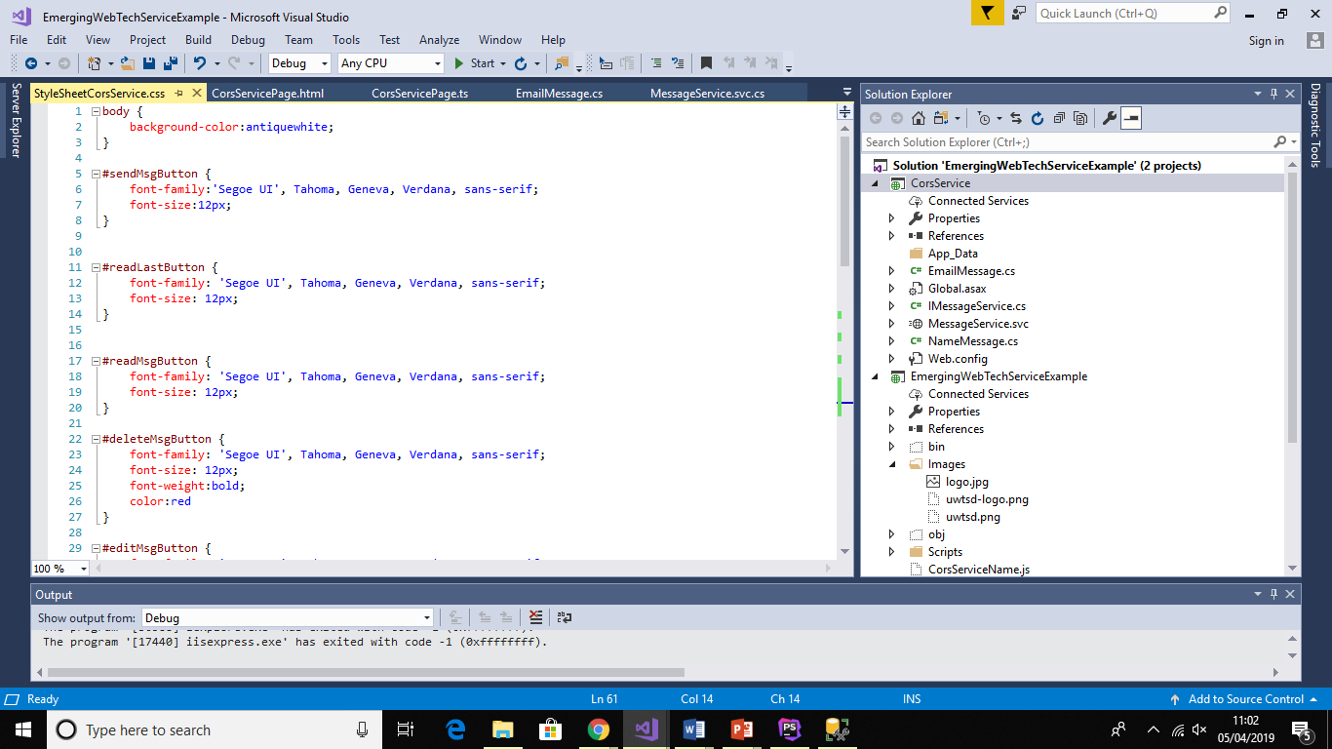
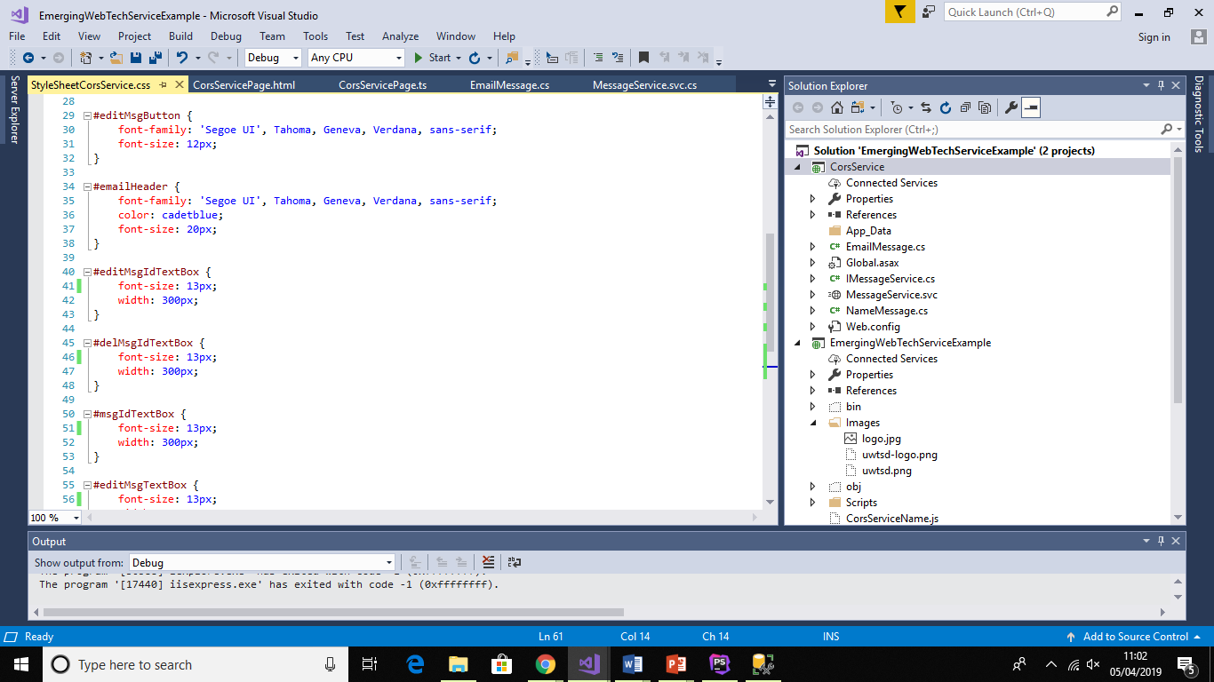
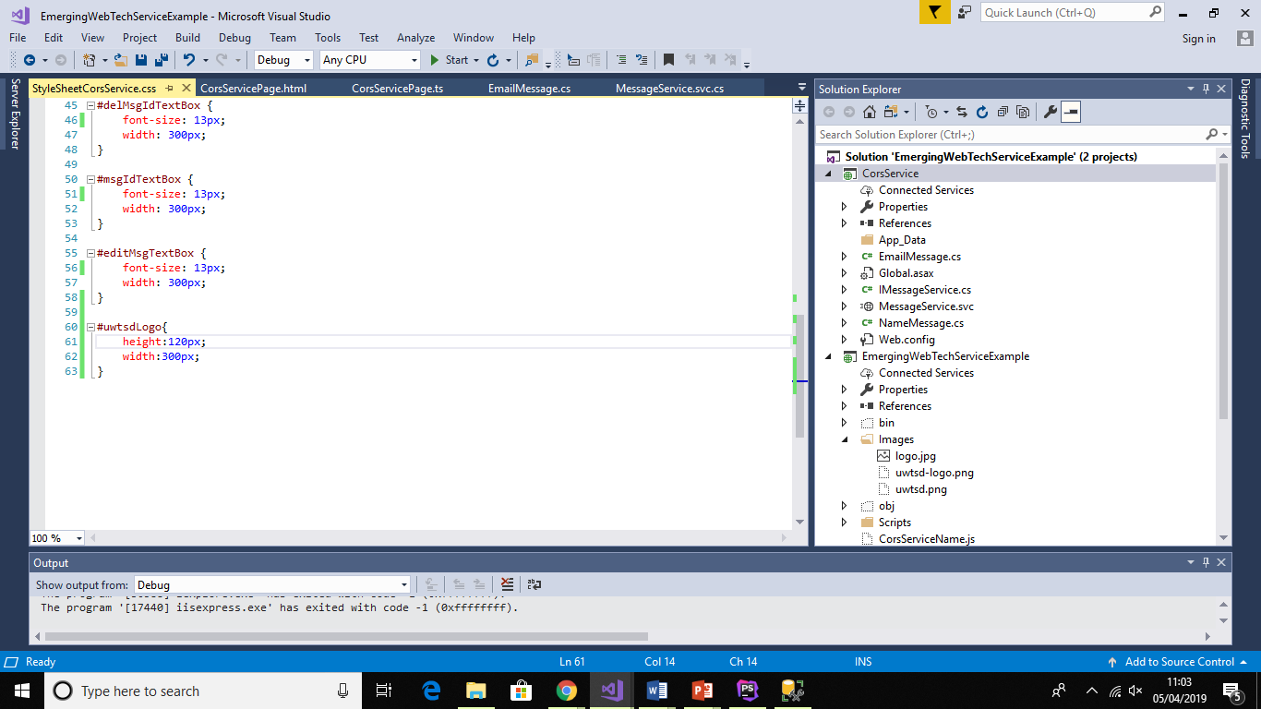
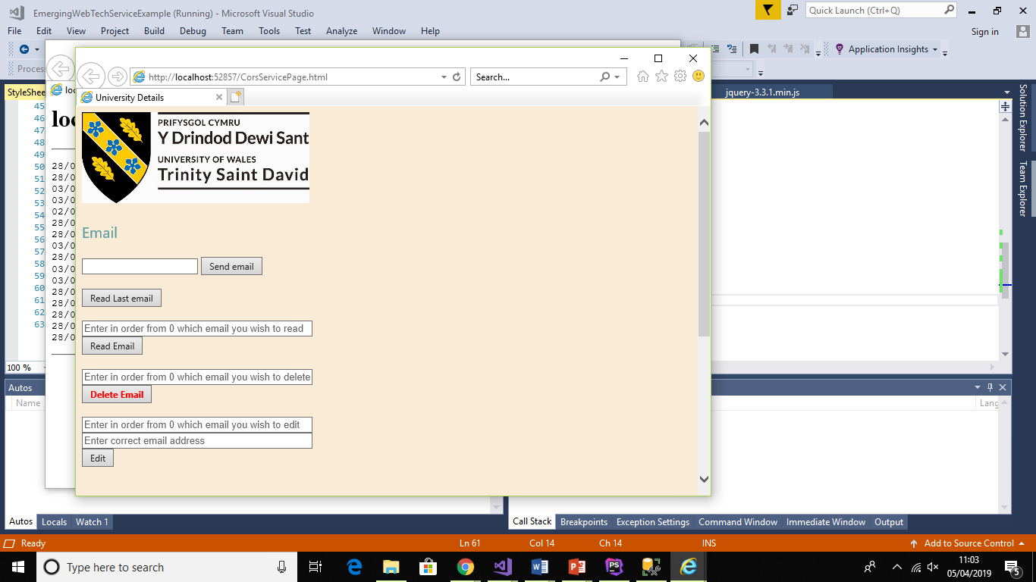
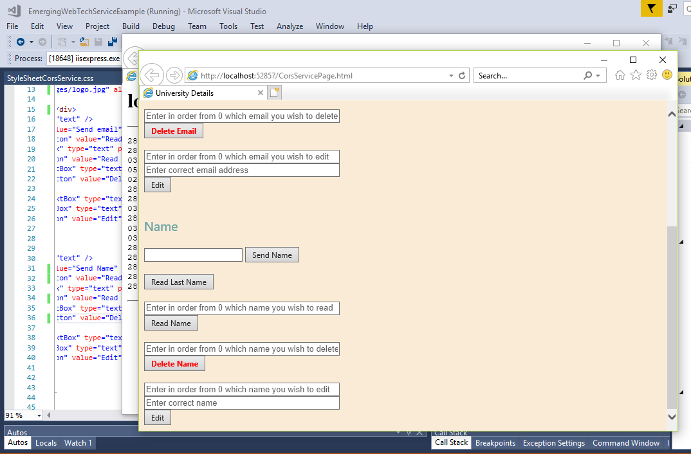

Using CSS within the application which has been developed for the assignment was very useful, as it was possible to add an image which related directly to the website. Alongside the image, it was possible to write information within each text box which would describe to users what they must do to get the correct information, but once they click on this box the information would disappear. This would allow them to then type in their own information after reading the description. If the user was to click on the box accidentally without reading the information, they are able to click on another box and the information would then appear again. The delete email and delete name buttons both have red, bold words on them, so the user knows that it is permanent as users perceive the colour red as danger.

NoSQL
NoSQL adopts many characteristics of an SQL database, and has been developed through an SQL database. NoSQL databases have been seen to perform more efficiently than SQL databases this could be due to the NoSQL database having a non-relational and easy replication support [4]. Both SQL databases and NoSQL databases have been seen to be competitors of each other. NoSQL database systems are a very efficient way to collect and maintain large data which have been dispersed over numerous servers [4]. It is believed that BigTable was the first NoSQL database, BigTable has three keys which are- row key, column key and timestamp [5]. The majority of NoSQL databases have been established through storing key-value pairs, a certain key-value pair is a column-family database, which is made up of columns as well as super-columns [5]. A super column gathers numerous columns which have a relation and accesses them as a singular unit. NoSQL databases are usually implemented for more advanced key-value stores whereas SQL databases are not [5]. A study [5] has been carried out to compare NoSQL databases with SQL databases, the SQL implementation usually involved Oracle, and the NoSQL implementation usually involved MongoDB, but the databases could use either. It is reported that, through having a large amount of records, the insertion time for Oracle is more of a factor than MongoDB alongside the update and delete times. It is also shown that not all of the NoSQL databases perform better than the SQL databases [5].

SQL vs NoSQL- CRUD and ACID
There are four main operations which are regularly used to access the database, the four operations are known as CRUD, which stands for: Create, Read, Update and Delete which is in relation to the data [6]. These four operations use SQL. ACID properties, also known as: Atomicity, Consistency, Isolation and Durability [7] are the most important attributes of an SQL database, which is the main difference between a NoSQL database and an SQL database [6]. This is because NoSQL does not use the ACID properties [7]. Instead NoSQL databases seem to target Availability and Partitioning more which provides the database with consistency [4]. SQL puts consistency before availability, whereas NoSQL databases do not.

SQL vs NoSQL- Relational data
SQL database systems use the relational data model in order to collect and store information, within SQL databases the information is stored in rows and columns and tables which have connections can be connected together [4]. On the other hand, NoSQL database systems uses a non-relational data model, this follows a schema-free collection of information, which can be seen in numerous ways such as: Documents, forms, graphs.

SQL vs NoSQL- Scalability
The SQL database system follows a vertical scalability compared to the horizontal scalability which NoSQL has adopted [4]. The vertical scalability has the ability to make the performance of the single node better through having additional resources like memory or processors within the same node [4]. Whereas, the number of nodes within the horizontal scalability is increased for the ability for the database to share the system load [4].

SQL vs NoSQL- Retrieval of data
Within the SQL database system, numerous amounts of tables are interlinked, and for users to look at other connected tables the user must use the JOIN statement to create Views, which can be very time consuming [4]. However, NoSQL information is collected in objects which accommodate all related information. Therefore, this eradicates the combination process which in turn, saves time [4].

MongoDB
The two main databases within the NoSQL databases are; MongoDB and Oracle. The MongoDB is written in C++ and it is document oriented with a flexible schema [4]. A record in MongoDB is also knowns as a document and a table is known as a collection, MongoDB allows the use of arrays and objects inside the documents [4].

MongoDB example
An example of a MongoDB is shown below [4]:
name: { first: “Joe”, last: “Bloggs”},
birth: new Date(‘Oct 15 1982’)

Oracle
Oracle will be the NoSQL database which will be discussed in more detail within this report. An oracle database is an object-relational database management system which has been created and implemented by Oracle Corporation [5]. It is very substantial and intense; the management system is also quite complex [10]. However, Oracle is one of the most frequently used and a very dependable database management system, and it can be written in C++, C and Java [5]. Oracle databases supports excellent transitions of a sizeable database alongside the numerous users, the database is able to deal effectively with numerous (over 30,000) records [11]. Oracle keeps data in tables and records, the information is kept in specific storage nodes which relies upon a hashed value of a primary key of the table [4]. Oracle is great when it comes to portability, it runs on over one hundred hardware platforms and over twenty networking protocols [11]. Another positive feature about Oracle is that it provides the user with ‘point-in-time’ recovery [11], which means that Oracle backs up the database. Furthermore, Oracle is also able to access and alter information which belongs to other databases, even databases that do not use Oracle themselves [11].

Create Table- Oracle
The Oracle databases adopts the most used SQL language, which includes CREATE, UPDATE, SELECT and DELETE. This aids users to create and modify tables with ease, as the users are usually aware of the language it uses. Tables can be created through using the statement below [5]:
CREATE TABLE student(
studentId INT NOT NULL,
firstName VARCHAR(30) NOT NULL,
lastName VARCHAR(30) NOT NULL,
course VARCHAT (50) NOT NULL
);

Constraints- Oracle
It is possible to add constraints relatively easily to Oracle databases, such as if the developer wants to add a primary key to the table, they can add the following onto the bottom of the table before it has been created:
CONSTRAINT student_pk PRIMARY KEY (studentId)

Insert Into table- Oracle
Through using Oracle, it is simple to insert values into the records in a table. Below shows how to do this:
INSERT INTO student( studentId, firstName, lastName, course) VALUES(908, ‘Alun’, ‘Davies’, ‘Web Development’);

References

[1] | G. C. Fox, “Introduction to Web Technologies and Their Applications,” New York, 1997.
[2] | C. Flynn, “Differential,” 27 January 2015. [Online]. Available: https://differential.com/insights/14-technologies-every-web-developer-should-be-able-to-explain/. [Accessed 29 March 2019].
[3] | M. Keller and M. Nussbaumer, “CSS Code Quality: A Metric for Abstractness; Or Why Humans Beat Machines in CSS Coding,” in Seventh International Conference on the Quality of Information and Communications Technology, Porto, Portugal, 2010.
[4] | S. Rautmare and D. M. Bhalerao, “MySQL and NoSQL database comparison for IoT application,” in IEEE International Conference on Advances in Computer Applications (ICACA), Coimbatore, India, 2016.
[5] | F. Bugiotti, L. Cabibbo, P. Atzeni and R. Torlone, “Database design for NoSQL systems,” in International Conference on Conceptual Modeling, 2014.
[6] | Y. Li and S. Manoharan, “A performance comparison of SQL and NoSQL databases,” in IEEE Pacific Rim Conference on Communications, Computers and Signal Processing (PACRIM), Victoria, BC, Canada, 2013.
[7] | H. Fatima and K. Wasnik, “Comparison of SQL, NoSQL and NewSQL databases for internet of things,” in IEEE Bombay Section Symposium (IBSS), Baramati, India, 2016.
[8] | V. Sharma and M. Dave, “International Journal of Advanced Research in,” International Journal of Advanced Research in Computer Science and Software Engineering, vol. 2, no. 8, pp. 20-27, 2012.
[9] | V. Anand and C. M. Rao, “MongoDB and Oracle NoSQL: A technical critique for design decisions,” in International Conference on Emerging Trends in Engineering, Technology and Science (ICETETS), Pudukkottai, India, 2016.
[10] | A. Boicea, F. Radulescu and L. I. Agapin, “MongoDB vs Oracle -- Database Comparison,” in Third International Conference on Emerging Intelligent Data and Web Technologies, Bucharest, Romania, 2012.
[11] | Z. Ling, L. Qi, Z. Qianyuan and C. Wei, “The Study of Adjustment and Optimization of Oracle Database in Information System,” in International Conference on Computational and Information Sciences, Shiyang, China, 2013.
[12] | R. Anju and B. P. Swathi, “MongoDB vs. Oracle: A comparative study using classification algorithms,” in IEEE International Conference on Computational Intelligence and Computing Research (ICCIC), Chennai, India, 2016.

Appendix


