

Programme: Master Of Business Administration

Module Code: LCMB7035

-Dissertation

Student Name: Dhruvin Anghan

Student ID: 2429348

Lecturer/supervisor: Dr. Muhammad Tariq

Brewing Engagement in the UK Coffee Market



Abstract
The research examined to understand the key factors that influence consumer engagement in the UK coffee market by concentrating on customer experience, digital communication, branding and sustainability behaviours. This research followed quantitative method along with deductive approach in a survey strategy. The primary data has been gathered and analysed using a structured questionnaire with the use of both descriptive and inferential statistics among the consumers of coffee in the UK. The empirical data show that consumer involvement in the UK coffee market highly depends on the complex of emotional and transactional factors. Branding aspects including brand recognition, storytelling and perceived authenticity has been identified to play a significant role in increasing emotional attachment and loyalty. Transactional drivers such as the loyalty programme and the perception of value were also important in maintaining repeat engagement. Furthermore, sustainability and ethical sourcing have been also powerful factors and a significant percentage of consumers expressed their readiness to consume and pay more money to the brands of ethically responsible coffee.
Digital channels have influenced the interaction by increasing brand awareness, trust and engagement through online reviews, social media promotion and influencer recommendations though some differences have been witnessed among demographic groups. The results suggest that the coffee brands in the UK have no opportunity but to implement a combination of an engaging strategy that would keep balance among the experiential branding, ethical positioning and effective digital communication. This research was important to conduct because it adds to the limited amount of UK-specific empirical literature as it gives a comprehensive insight into the interactions of various drivers of engagement in such a competitive market of services. Based on the findings of the research, it has been suggested that coffee brands can be advised to invest in the real sustainability communication, emotionally appealing branding and digitally controlled interactions to develop long-term relationships with consumers.
Keywords: UK coffee market, Consumer Engagement, Branding, Digital Marketing, Customer Experience, Sustainability.

Acknowledgement
I may like to state my great appreciation to my supervisor in their guidance and support that was invaluable during this research. This study would also not have been achievable without the insights of the academic staff and all participants who generously gave their time and responses.

Table of Contents
Abstract 2
Acknowledgement 3
Declaration 4
Chapter 1: Introduction 8
1.1 Background 8
1.2 Problem Statement 10
1.3 Research Rationale 11
1.4 Research Aim Objectives and Question 11
1.5 Research Significance 12
1.6 Research Structure 13
Chapter 2: Literature Review 14
2.1 Introduction 14
2.2 Concepts and Theoretical Understanding of Consumer Engagement 14
2.3 Factors Influencing Consumer Interest in the Coffee Market: Emotional and Transactional Drivers 16
2.3.1 Emotional Motivators of the Consumer Interest 16
2.3.2 Transactional Consumer Interests Drivers 17
2.3.3 Affective and Transactional Factor 18
2.4 Branding and Marketing Approaches in Promoting Consumer Loyalty and Interest 19
2.4.1 Brand Equity and Loyalty 19
2.4.2 Brand Recognition, Emotional Attachment and Trust 19
2.4.3 Marketing Communication and Development of Relationship 20
2.4.4 Customer Experience as a Branding Result 20
2.5 Demographic Differences in Consumer Engagement with Coffee Brands 21
2.5.1 Consumer Engagement between the Aged 21
2.5.2 Income-Effects on the Patterns of Engagement 21
2.5.3 Differences in Geographical Location and Contextual Engagement 22
2.5.4 Demographic Variables Interaction 23
2.6 Role of Digital Platforms and Social Media in Consumer Engagement 23
2.6.1 Digital Platforms, Social Media and Consumer Engagement 23
2.6.2 eWOM, Influencers and Trust Formation 24
2.6.3 AI, Mobile Applications and Digital Loyalty Tools 24
2.7 Research Gap 25
2.8 Conceptual Framework 26
Chapter 3: Research Methodology 28
3.1 Introduction 28
3.2 Research Philosophy 28
3.3 Research Approach 29
3.4 Research Design and Research Strategy 29
3.5 Data Collection Method 31
3.6 Population and Sampling Strategy 31
3.7 Data Analysis Techniques 32
3.8 Reliability and Validity 32
3.9 Ethical Considerations 33
3.10 Methodological Limitations and Mitigation 33
Chapter 4: Data Analysis 34
4.1 Introduction 34
4.2 Results 34
4.3 Cross Tabulation Analysis 47
4.4 Reliability Testing 50
4.5 Hypothesis Testing 50
Chapter 5: Discussion 57
5.1 Introduction 57
5.2 Discussion 57
Chapter 6: Conclusion and Recommendations 60
6.1 Introduction 60
6.2 Conclusion 60
6.3 Recommendations 63
6.4 Future Recommendations 64
6.5 Implications 65
6.6 Research Limitations 65
References 66
Appendix 75
Appendix 1: Questionnaire 75
Appendix 2: Ethics Form 78
Appendix 3: Data Set 79
Appendix 4: SPSS Output Sheet 79
Appendix 5: Microsoft Link 79
Appendix 6: Histogram 79

Chapter 1: Introduction

1.1 Background
The Coffee industry is one of the most developed and consumed markets in the global food and beverage industry (FAO, 2025). Millions of people all around the world drink coffee every day to enjoy the functional value of coffee and also due to its social and cultural value. Around 2 billion cups of coffee are drunk each day globally (Mowbray, 2022). Consumption of coffee has changed with time, as it has become a lifestyle-based activity. People relate consuming coffee to a way of relaxing, being productive and also a social activity (Aten, 2020). This change has pushed coffee brands to look further than the quality and price of their products. It also puts pressure on the companies to put more emphasis on branding, experience and consumer interaction as a way of remaining competitive. The graph below represents the global coffee market size, with a forecast depicting the increase in demand. This rapid growth and lifestyle-oriented consumption highlight the increasing importance of understanding how consumers engage with coffee brands beyond functional product attributes.
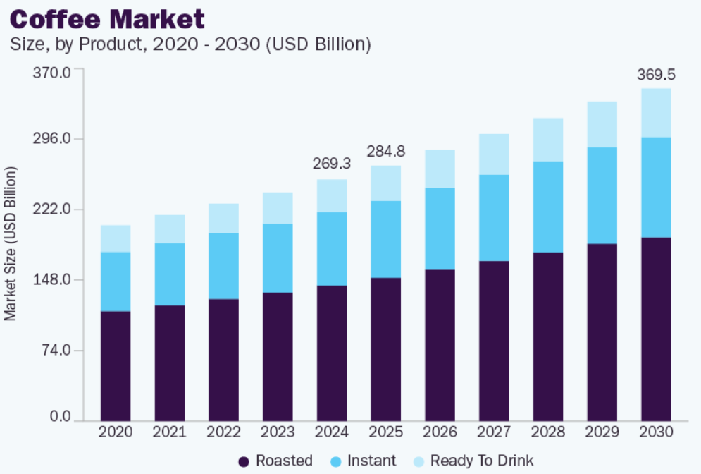
Figure 1: Global Coffee Market
(Source: GVR, 2025)
The European coffee market is regarded as a mature and highly competitive business sector, mainly because the spread of the cafe culture and changing effects of consumers have significantly contributed to this shift (RAM, 2024). United Kingdom is one of the most vibrant coffee markets in Europe in the past years. According to market research, the coffee shop industry in the UK has been over 6-billion pounds in 2024 which is a reflection of the increasing number of consumers who drink coffee outside of their homes and the growth of both the branded and the independent coffee shops (Statista Cafe, 2025). The rising number of cafes in large urban centres such as London, Manchester and Birmingham is a pointer to the relevance of coffee in day to day lives. The diversification of the consumer demand can be demonstrated by the specialisation of coffee products on offer, focus on high quality blends and the establishment of plant-based alternatives (Lestari, et al., 2025). These trends show that consumer engagement and not availability or market growth has become the core of differentiating and customer retention of coffee brands in the UK.
As the market has grown, the level of competition and saturation has increased. Consumers are offered a broad spectrum of choices in terms of the prices, quality, convenience and atmosphere. With this stiff competition, traditional differentiation strategies such as price and physical expansion, have become ineffective, compelling coffee brands to concentrate on creating authentic, long-lasting relations with customers (Czarniecka, 2021). Customer retention has become as significant as customer acquisition especially in a market where changing brands is as easy as drinking water and the substitutes are very easy to obtain. Therefore, consumer interaction becomes a vital strategic solution to the saturation as the brands can build loyalty and lasting relationship in the highly competitive market.
However, consumers are becoming more sensitive in terms of ethical and environmental issues. The concept of sustainability, ethical sourcing and social responsibility have become central topics of concern in the coffee sector (Wright, et al., 2024). The younger generations, including students and young professionals are more concerned about these issues. These challenges are important in light of the environmental and social effects of producing coffee. Companies focusing on responsible practices will tend to receive consumers trust, positive brand perceptions, and improvement in the degree of engagement (Agu, et al., 2024). Branding is vital in the translation of such values as well as the perception of consumers (Jahan, et al., 2024). Good brand identities allow the companies to convey quality, authenticity and emotion. In the UK, mass chains are more focused on branding, store layout and message uniformity to develop familiarity and independent cafes are usually more focused on locality, craftsmanship and personal service (BBB, 2025). Successful branding creates an emotional attachment with customers that would lead to its frequent visits and devotion in a competitive environment. This difference brings to the fore of branding as an important tool of building emotional attachment and consumer engagement in a wide variety of retailing formats.
Another determinant that is decisive in the consumer behaviour in the UK coffee industry is customer experience. Other than the quality of the beverage, customers are becoming more appreciative of the efficiency of service, store atmosphere and convenience. Consumer expectations are being influenced by the increased use of digital technologies such as mobile ordering, contactless payments and loyalty applications. These tools are more convenient and they allow the brands to get in touch with consumers more directly. The digital interaction has also reshaped the coffee brand interaction with the consumers (Maspul, 2023). Social media platforms, online reviews and digital communities have an effect on brand visibility and consumer choice.
Online reviews and online recommendations are the most preferred by many consumers in selecting coffee shops, especially in urban settings. Digital space also enables brands to be constantly in touch with their consumers and build a relationship even after they have purchased the product. These developments indicate that digital interaction has become integral to consumer engagement, warranting systematic academic examination within the UK coffee context. Consumer engagement and loyalty are two of the major concerns of coffee brands. Consumer expectations have been changed by market saturation, sensitivity regarding ethics and digitalisation. However, despite recognition of these factors, there remains limited empirical understanding of how branding, sustainability, customer experience and digital engagement collectively shape consumer engagement in the UK coffee market.

1.2 Problem Statement
The UK coffee market has shown a consistent growth in the past few years due to urbanisation, the rising number of out-of-home consumption and the growth of the branded coffee chains, as well as the independent cafes (CBI, 2022). Nevertheless, even with this increased growth, the number of coffee brands that are able to sustain high levels of consumer interest and loyalty is low. The market is very competitive and saturated, with consumers having a wide choice and low switching, making customer retention difficult. This saturation has resulted not only in intense competition but also in increasingly unstable consumer engagement, as customers frequently switch between coffee brands with limited long-term attachment.
The contemporary consumer does not focus on just quality and price of the products, but the priority is authenticity, service experience, sustainability and digital convenience. The UK consumers have turned into the focal point of ethical sourcing and environmental responsibility (Adamson, 2024). However, social media, review sites and mobile apps are online platforms that have a strong impact on brands perception and buying intentions. The loyalty of consumers in the UK coffee sector is still weak despite the increase in branding, sustainability campaigns and online marketing. Although loyalty is expressed in terms of repeat buying, the main problem is its continuity of a meaningful consumer interaction that follows and underlies long-term loyalty.
The current industry and scholarly literature recognise the significance of branding, sustainability and digital interaction, but there is limited empirical research to combine the three aspects to provide a description of consumer involvement within the UK coffee industry. This disparity highlights the need by coffee brands to outline those factors that increase consumer interest and prompt frequent purchases. Based on this, this research paper is an empirical study of the joint effect of branding, customer experience, sustainability, and digital interaction on consumer engagement in the coffee market in the United Kingdom.

1.3 Research Rationale
This study is performed because the consumer behaviour in the UK coffee market is becoming increasingly complex. Although coffee brands encounter an ever-growing market, they are still experiencing a challenge in retaining their customers as the market has been saturated and consumer expectations continue to increase. Additionally, consumers are becoming more critical about the brands in terms of their experiential, ethical and digital qualities instead of product characteristics (Kent, 2025). These developments justify the need for a focused study on driving factors of consumer interest in the UK coffee industry. Together, these shifts indicate that traditional product-focused explanations are insufficient, reinforcing the need to examine consumer engagement drivers specific to the contemporary UK coffee market.
Despite the growing volume of research on coffee consumption and service marketing, limited studies have examined how branding, sustainability, customer experience and digital interaction are considered together when explaining consumer engagement in the UK coffee market. The research is performed to give a systematic insight into the impact of branding, customer experience, sustainability and digital interaction on consumer behaviour in a highly competitive service environment. The study deals with the existing market conditions and the changing consumer needs and offers new insights according to the modern trends concerning consumer-interactions and service marketing. In contrast to the existing literature that is typically centred on a single factor or non-UK situation. The research is based on an integrated framework where the researchers are specifically interested in consumer engagement in the UK coffee market.

1.4 Research Aim Objectives and Question
Aim
This study aims to identify issues that affect consumer involvement in the UK coffee sector and analyse how branding, customer experience and sustainability impact consumer behaviour.
Objectives
- To explore emotional (brand attachment, loyalty) and transactional (purchase frequency, value perception) drivers of consumer interest in UK coffee brands.
- To assess how branding and marketing approaches can be used to promote consumer loyalty and interest in the coffee market.
- To determine the demographic differences in the level of consumer engagement on coffee brands in the UK, such as age, income and geographical location.
- To investigate the role of digital platforms and social media in consumer engagement in coffee in the UK, comprising reviews, influencers and online communities.
Research Questions
- What are the key determinants of consumer interest in coffee brands in the United Kingdom?
- How do branding and digital marketing campaigns influence consumer engagement and loyalty in the UK coffee market?
- How do sustainability and ethical sourcing influence the consumer behaviour of coffee brands in the United Kingdom?
- Are there demographic variations in consumer interest in coffee franchises in the United Kingdom?

1.5 Research Significance
This research is relevant because it adds to the understanding of consumer involvement and loyalty in the UK coffee industry. This industry is characterised by intensive growth and the presence of a strong rivalry. The experiential, ethical and digital factors are becoming more important in influencing consumer loyalty within the coffee industry, instead of the price (Fanarioti, 2024). The empirical investigation of these impacts contributes to the literature on consumer behaviour in service-based industries, particularly within the context of ethical and digital branding strategies. In practice, the results offer coffee brands and marketers evidence-based information to support strategy design, customer relationship management and loyalty programme development that are consistent with the emerging consumer expectations in the UK market.

1.6 Research Structure

Figure 2:Research Structure
(Source: Author)

Chapter 2: Literature Review

2.1 Introduction
The chapter is a critical review of literature on consumer involvement in UK coffee market. It combines scholarly theory, research and corporate investigation in order to determine the major aspects of consumer engagement. It is discussed in relation to the research aims of the study and includes emotional and transactional drivers, branding and marketing strategies, demographic differences and the place of digital platforms and social media. Peer-reviewed journal articles, academic books and reliable industry reports are the main sources used in this chapter to guarantee the theoretical rigour and the practical relevance. The review provides a solid theoretical base, identifies gaps in the research and guides the formulation of the conceptual framework and anticipations of the empirical stages of this study. The literature is critically compared by examining converging and opposing viewpoints across studies, highlighting patterns, inconsistencies and contextual limitations in relation to consumer engagement in the UK coffee market.

2.2 Concepts and Theoretical Understanding of Consumer Engagement
Service and marketing literature is now focusing on consumer engagement and not just the transactional perspective of consumption anymore. The research that followed on early engagement focused on behavioural measures like repeat purchase or advocacy and contended that engagement leads to improved firm performance by raising loyalty and positive word-of-mouth (Rather, 2019). However, according to more recent research, the outcome-driven view is not the most appropriate one and engagement should be perceived as a complex and multifaceted construct encompassing cognitive, emotional and interactive aspects (Lim and Rasul, 2022). This conceptual extension emphasises that the process of engagement is not simply a result of consumption but is a process that occurs in relation to unrelenting interaction.
Although there is consensus among scholars on its multidimensional nature, the creation and maintenance of engagement differ. Lim and Rasul, (2022) claim that digital interaction and particularly through social media, redefines customer engagement because it can now engage in real-time conversation and value co-creation. Prentice and Nguyen (2020) advise against the use of technology-based interaction, like the use of AI-enabled service as it can undermine emotional relationships when it is not accompanied by real human interaction. According to their results, the engagement cannot be completely automated and requires the quality of the service and the competence of employees, particularly in the context of experiential services.
The customer experience theory adds to the discussion of engagement. Kuppelwieser and Klaus, (2021) focus on the fact that engagement is highly dependent on perceived experience quality across various touchpoints and suggest that experience consistency occurs more strongly in relation to service encounters. In agreement with this, Meeprom and Kokkhangplu, (2025) have shown that sensory and emotional experiences are important in satisfaction and engagement in coffee consumption. Nonetheless, there is also mention that experience is not a likely predictor of long-term participation, especially in low switching costs markets (Rather, 2019). This distinction implies that positive customer experiences may generate short-term satisfaction, but without consistency and emotional reinforcement, they may not translate into long-term consumer engagement.
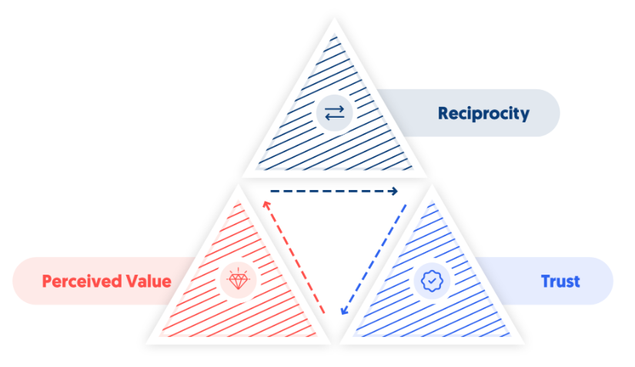
Figure 3: Core Elements of Social Exchange Theory in Consumer Engagement
(Source: Arab, 2025)
The above figure illustrates the social exchange mechanism underlying consumer engagement, highlighting how perceived value, trust and reciprocity interact to shape sustained relational engagement between consumers and service providers. Within this study, perceived value, trust and reciprocity are treated as underlying mechanisms through which emotional, branding and digital factors influence consumer engagement. The figure therefore informs the selection of key independent variables by illustrating how relational exchanges shape sustained engagement rather than isolated consumption outcomes. Social exchange theory is another explanation that provides engagement as a mutual relationship that is founded on perceived fairness and value. Hsiao, et al., (2023) emphasise the result of the culturally competent service, trust and loyalty, which support the engagement process with social reciprocity. Likewise, Li, et al., (2023) discovered that social interaction enhances the use of digital commerce scenarios, but its performance is conditional on personal and situational characteristics.
Overall, the literature demonstrates an agreement in engagement as a relational construct but disagreement in the key drivers of engagement. The existence of these discrepancies underlines the importance of a unified model that considers all the experiential, technological and social factors in the UK coffee market.

2.3 Factors Influencing Consumer Interest in the Coffee Market: Emotional and Transactional Drivers
According to Busalim, et al., (2019), consumer interest is highly influenced by factors such as emotional, social, technical and motivational factors that guide consumers in being interested in products or brands for consumption and experiential value. This emphasises the fact that consumers get pleasure and emotional satisfaction out of commodities that are not only useful but also serve to offer experiences to a consumer.
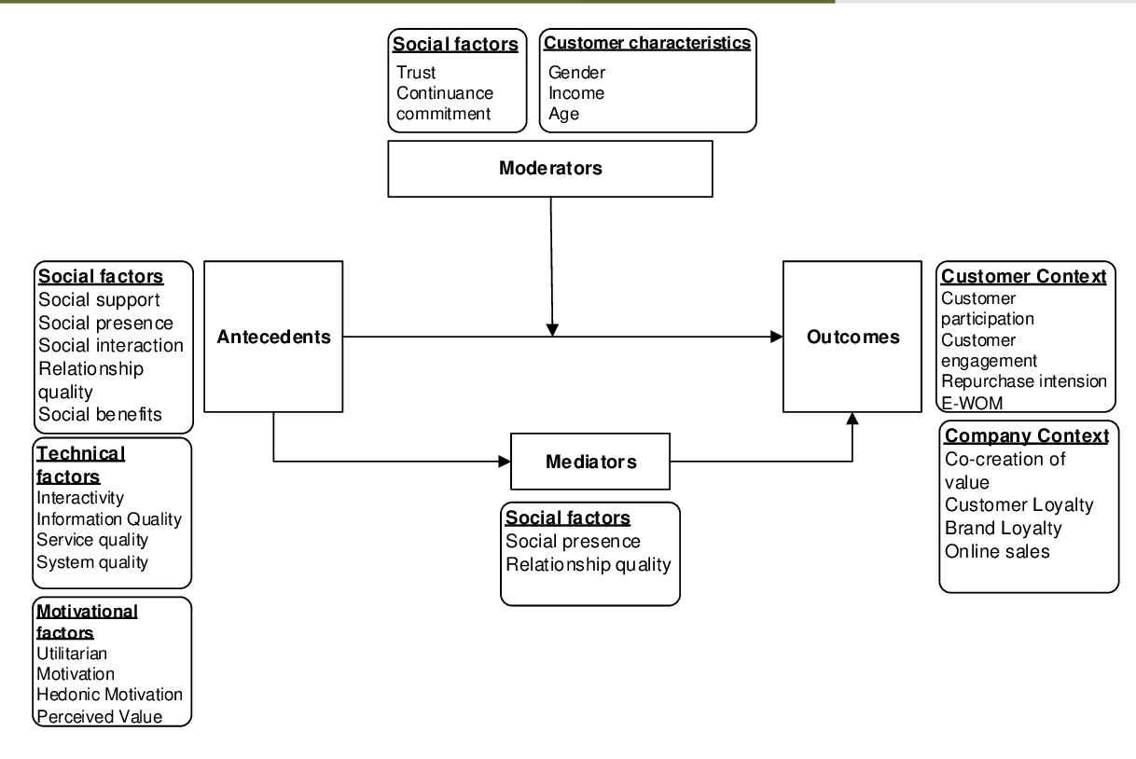
Figure 4: Factors affecting Consumer Interest
(Source: Busalim, et al., 2019)
However, these emotional and transactional drivers extend beyond interest by actively shaping ongoing consumer engagement, interaction intensity and long-term brand relationships.

2.3.1 Emotional Motivators of the Consumer Interest
As per Jamil, et al., (2024), the use of coffee is often incorporated into individual diets, leisure time and socialisation processes, which makes it more emotional. It has been proposed that sensory characteristics such as aroma, flavour intensity and appearance presentation may stimulate responses of emotions that can increase perceived pleasure and interest. The outcomes of these emotional reactions are a shift in consumer attitudes, where there is the establishment of positive affective associations leading to interest and repetitive consumption (Chen and Pham, 2019).
Furthermore, Sihvonen, (2019), assessed that the emotional attachment also arises by way of symbolic consumption. The consumers consider the product as an extension of their own self and choose a brand that aligns with their values, lifestyles and dreams. Consumers are more interested in goods that represent their intended self-image or social identity, which strengthens emotional attachments to brands. This bond increases the psychological commitment, which creates a stronger consumer interest in competition substitutes. Coffee, being a culturally representative product, usually tends to be linked with creativity, productivity, social inclusion and sophistication (Maspul, 2025). However, Natrah Jamaludin and Nik Hashim, (2024), argued that experiential consistency can cause decreased stimulation and diminish emotional interest. Monotonous experiences can foster the development of habitual consumption based on convenience and not real emotional connection and loyalty becomes weak when new or more stimulating substitutions are introduced.

2.3.2 Transactional Consumer Interests Drivers
Based on the research by Redda, (2020), the influence of transactional factors are rational and utilitarian considerations that influence consumer interest by evaluating the value. Consumers make choices based on the perceived advantages over costs. However, Habibi and Rasoolimanesh, (2021), argued that the sensitivity of price is still dominant in the transactional factors, especially in the normally used commodities. The price corresponds with the quality expectations and this leads to an increase in consumer interest because the perceived risk is less. Also, the transactional drivers are linked to sustained consumer engagement, as value perceptions, convenience and rewards can foster ongoing interaction, commitment and relationship continuity beyond mere repeat purchasing behaviour.
Furthermore, Zellner, (2022), claimed that there is also the critical role of quality perceptions in terms of transactions. Evaluative cues are objective qualities such as the quality of ingredients, reliability, freshness and the standard of preparation that led consumers to make their judgments. Consumers use such cues to make rational justifications of preferences, especially when decisions need to be rationalised. Moreover, Roy, et al., (2020), argued that transactional interest is also strengthened by convenience since time economy and convenience affect the rate of consumption. The convenience and the ability to incorporate them into everyday life make consumers very active in consumable goods. Transactional interest is also affected by promotional agencies, such as incentives, loyalty and rewards varying in value. These plans lower the switching cost and stimulate repeat buying by creating a sense of perceived economic advantage (Nastasoiu and Vandenbosch, 2019). Thus, transactional drivers facilitate long-term interest by providing logical reasoning towards further consumption.

2.3.3 Affective and Transactional Factor
Based on the research by Zhang and Chang, (2021), emotional and transactional drivers are dynamic in their interaction to form consumer interest. The affective and cognitive evaluations have a joint effect on decision-making. Interest can be developed through emotional attraction and the interest can be maintained through transactional evaluation. As an instance, the emotional preferences of consumers to purchase a product are usually justified by the consumer referring to quality or value factors (Wang, et al., 2020). Further supported by Yoo, et al., (2022), the integration is permitted by experiential marketing through the evidence that emotional narratives increase perceived value and reinforce both affective and rational appeal. Goods that effectively balance emotional satisfaction and transactional value tend to have a higher interest in the long-term consumer. The interaction reveals the need to understand consumer interest as a multidimensional phenomenon based on both mechanisms of emotional resonance and rational evaluation.
However, Aeron and Rahman, (2023), states that consumer interest is largely affected by a rational assessment and that emotional stories only have a short-term effect. They argue that price sensitivity, quality evaluation and convenience are more important in making decisions on long-term interest compared to experiential storytelling.
To conclude, the emotional and transactional drivers are considered separately and very few empirical studies have integrated the two in settings of consumable products. The longitudinal studies examining the relationship between emotional attachment and rational value evaluations across time to determine long-term consumer interest and engagement are still lacking. However, it remains unclear how emotional and transactional drivers jointly interact over time to sustain long-term consumer engagement rather than short-term interest or isolated purchasing decisions.

2.4 Branding and Marketing Approaches in Promoting Consumer Loyalty and Interest

2.4.1 Brand Equity and Loyalty
According to Arslan, (2020), the idea of branding has been considered to be one of the strategic tools for developing consumer loyalty and long-term interest. The brand equity model, brand awareness, perceived quality, brand associations and brand loyalty are some of the core assets that determine consumer behaviour. Powerful brands help to mitigate the risk factor, build trust and give mental shortcuts that make the decision-making processes easy. Similarly, Panwar and Khan, (2020), assessed that in competitive markets, branding acts as a differentiator, through which consumers recognise a product and repeatedly buy the same product. The brand equity is positively correlated with repurchase intention, willingness to pay higher prices and switching resistance behaviour.
Moreover, Agyeiwaah, et al., (2022), argued that loyalty is not only behavioural but also attitudinal. Loyalty is a great sense of commitment which cannot be affected by circumstances. Attitudinal loyalty is enhanced through branding in that emotional meaning and symbolic value are instilled in products. Consumer loyalty is habitual and self-perpetuating when consumers connect brands with reliability and consistency. However, Anyanwu and Okpalaeke, ((2022), argued that customer loyalty is not always consistent and long-lasting, as it can change with the price, convenience and trends. Also, the attitudinal loyalty can be diminished in case brand promises have not been fulfilled, which ruins the habitual and emotional attachment.

2.4.2 Brand Recognition, Emotional Attachment and Trust
As per Ahmadian, et al., (2023), the identity of the brand serves as one of the most important factors in enhancing loyalty due to the emotional attachment. The brand identity is both tangible and intangible and it entails what a brand prefers to be known as. This implies that consumers tend to be more loyal to the brand that can portray their self-concept and personal values. However, Lee, et al., (2021), argued that emotional attachment and trust are intimately linked to loyalty, which encourages continuance consumer behaviour in service markets, including interaction, advocacy and involvement along with repurchase intentions.
Moreover, Marmat, (2025), stated that successful branding requires trust as it minimises uncertainty and augments the faith in the future brand performance. The repetition of the positive brand experience helps build reliability perceptions, which uphold long-term loyalty. Studies by Tan, et al., (2021), states that respected brands attain consumer forgiveness in times of service failure and show loyalty despite the competition. Emotional attachment and trust thus work in harmony to strengthen consumer interest as well as loyalty.

2.4.3 Marketing Communication and Development of Relationship
According to Hollebeek and Macky, (2019), the level of interaction on consumer engagement is greatly influenced by the marketing communication strategy, as it strengthens the brand's image and fosters meaningful interaction. Integrated marketing communication also guarantees uniformity of message delivery through the mediums which serves as a strong brand recall builder as well as a strong loyalty motivator. Further supported by Kang, et al., (2020), the marketing through stories increases the emotional appeal, where functional products can be turned into experiences. Narrative communication helps the consumer connect personally to the brands, making them more memorable and connected.
Additionally, Hendler, et al., (2022), states that relationship marketing is also conducive to loyalty because it focuses on long-term interactions as opposed to exchanges. One-on-one communication, loyalty programmes and feedback systems strengthen relationships and create. Moreover, Ramesh, et al., (2024), assessed that the digital marketing platforms enhance such runs through, allowing real-time and personalised communication. The digital interactions are interactive and lead to a sense of community, positively affecting commitment and advocacy. Value-based marketing communication thus maintains the interest of the consumer as well as enhances loyalty.

2.4.4 Customer Experience as a Branding Result
As stated by Zha, et al., (2020), the customer experience has become one of the core branding deliverables that directly influences loyalty. Experience-based branding focuses on the holistic relationship between consumers and brands through various factors. The positive experiences promote satisfaction, emotional attachment and behavioural loyalty. Brand promises and maintenance of interest are also reliant on service quality, responsiveness and consistency of experience. Based on the research by Legendre, et al., (2020), the experiential satisfaction strengthens memory associations and thus makes brands salient in subsequent purchases. The excellent customer experiences result in improved retention and long-term loyalty. The branding and marketing models that place greater emphasis on experience management are more effective in the long term in maintaining consumer interest.
This concludes that branding and marketing decisions are important in achieving consumer loyalty and long-term interest by creating brand equity, emotional bonding, trust, effective communication and customer experience. However, it mainly focuses on these factors separately, which increases the necessity for the investigation of unified frameworks that can evaluate the combined and extended impact of these factors on the development of loyalty.

2.5 Demographic Differences in Consumer Engagement with Coffee Brands

2.5.1 Consumer Engagement between the Aged
According to Mukhtar, et al., (2021), one of the most critical demographic variables that affects the consumer engagement level is age because there are differences in the cognitive processing, consumption priorities and social pressure among different life stages. The idea that consumption habits of individuals change over their lifespan and how individuals interact with brands. As per Ihtiyar, et al., (2019), the younger shoppers are usually characterised by a greater degree of experimentation, innovation, receptiveness and sensitivity to experience and symbolic brand features. Their activity is frequently motivated by social prominence, identity formation and peer confirmation, creating more interactive and discovering patterns of consumption.
The research by Appiah, et al., (2019), proves that younger generations are more inclined to brand switching and low behavioural loyalty because of the tendencies of innovation seeking that prevail over habitual preferences. Interaction with the younger consumers is often driven by emotional stimulation and experience, but not by commitment. On the other hand, Rather and Hollebeek, (2021), claim that the older generation consumer is more concerned with reliability, consistency and usefulness and therefore their engagement behaviours are more stabilised. As age increases, consumers form a sense of existing preferences and routines and this makes them less experimental and habitually loyal.

2.5.2 Income-Effects on the Patterns of Engagement
Based on the research by Roy, et al., (2021), the income level forms consumer interactions by determining purchasing power, perceived affordability and value expectations. The disposable income influences the consumption flexibility, which allows consumers to focus on doing something experiential and symbolic in addition to basic utility. As per Almutairi, (2025), the consumers with high income usually have better involvement with the brands that are characterised by high quality, exclusiveness and experience differentiation. The consumer invests more in products which portray personal values, lifestyle aspirations and social status, which increases emotional and attitudinal involvement.
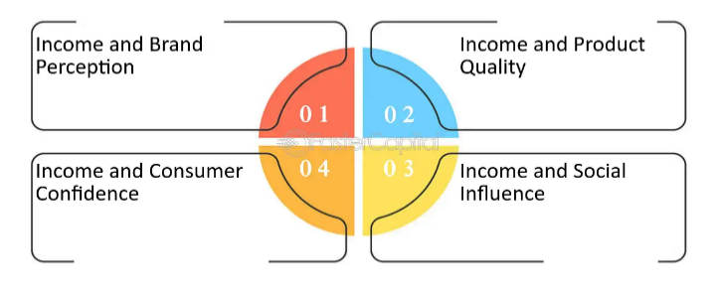
Figure 5: Income affecting Customer engagement
(Source: Faster Capital, 2025)
Studies by Safeer and Liu, (2023), highlight that the higher the income group is, the more tolerant they become of paying extra when the brand conveys perceived authenticity, ethical appropriateness, or experience. This financial flexibility enables interaction to go beyond transactional factors and creates loyalty and support in the long term. On the other hand, Kartomo, (2024), states that less wealthy customers are more price-sensitive and risk-averse, which leads them to have engagement behaviours that are based mainly on the value-for-money feature. The promotional incentives, discounts and functional benefits play a very important role in determining the rate and level of engagement.

2.5.3 Differences in Geographical Location and Contextual Engagement
According to Ajetunmobi and Laobangdisa, (2024), the contextual factors of accessibility, infrastructure and the socio-cultural norms make geographical location affect consumer engagement. The exposure, frequency of interaction and familiarity with a brand are directly influenced by the closeness to the retail setting and availability of services. Consumers in high-density locations tend to have more choice and competition and this can lead to more interaction by experimenting and comparing. On the other hand, Ratcliffe, et al., (2019), states that access in fewer concentrated areas can limit the opportunity to get involved and support the idea of habitual consumption. Cultural geography also describes how local customs, social activities and mutual meanings determine consumption behaviour. Interaction with brands is usually influenced by socially constituted rituals, in which consumption plays a group but not necessarily an individual role. These contextual forces determine the interaction frequency and intensity and assign meaning to the consumption experiences consumers have.
Additionally, Bowden and Mirzaei, (2021), emphasised that engagement behaviours are also facilitated by infrastructure differences such as digital connectivity and retail distribution. The increased accessibility enables the repetition of the interaction and prolonged engagement, whereas the limited access inhibits exposure and participation. However, Osei-Frimpong, (2019), states that the engagement behaviours do not always rely on the infrastructure because, despite poor digital connection or access to retailing, consumers can be highly engaged when motivated personally, under social influence, which challenges interaction based on accessibility.

2.5.4 Demographic Variables Interaction
Studies by Hollebeek and Macky, (2019), state that the demographic variables hardly work in isolation. The age, income and geographical location are interconnected to generate complicated engagement patterns. Both exploratory and high engagement intensity in younger high-income consumers and the value and familiarity focus by older low-income consumers. The study by Nur and Siregar, (2024), states that the interactions are a crucial step towards properly interpreting consumer engagement behaviour and formulating effective segmentation strategies.
In conclusion, even though age, income and geographical location are regarded as the determinants that influence consumer engagement, the current research analysis focuses on these determinants independently. The limited studies have been done to determine the interaction between demographic variables to influence the extent of engagement, establishing loyalty and creating enduring consumer-brand associations in the context of beverage consumption.

2.6 Role of Digital Platforms and Social Media in Consumer Engagement

2.6.1 Digital Platforms, Social Media and Consumer Engagement
Consumer engagement in the service industries has taken the central position in digital platforms. They transform the way that consumers engage with brands along the customer path. According to Lim and Rasul, (2022), social media has made engagement not a passive outcome but an interactive and continuous process with dialogue, co-creation and common participation. Verhoeff, et al., (2021) reinforce this perspective by proposing that digital transformation helps companies combine various touchpoints, thus leading to a higher level of consistency and responsiveness of engagement. From this perspective, the digital platforms enhance brand-consumer relationships through sustained, in-person interaction before, at the time of purchase and post-purchase.
However, Srivastava, et al., (2025) cautiously observe that digital communication does not necessarily result in more profound interactions and that content overload may result in loss of concentration and substantial involvement. On the same note, Zheng and Ling (2021) note that social media fatigue has become an increasingly important issue. They also claim that information overload and repetition of brands make consumers less responsive and less engaged in the long run. These contradictory statements show that digital platforms have greater possibilities to engage, but their usefulness depends on the strategic and selective use.

2.6.2 eWOM, Influencers and Trust Formation
Influencer marketing and electronic word of mouth (eWOM) have become well-known as effective forces of consumer interaction, especially among younger consumers. Sahir and Fahlevi, (2024) demonstrate that the interaction on social media and eWOM positively impact trust and loyalty among Generation Z consumers of coffee, which indicates that peer-to-peer opinions and online reviews are important factors. This is also supported by Ngo, et al. (2024), who discovered that eWOM credibility greatly influences purchase intention and the role of perceived authenticity in online content.
Engagement is another benefit of influencer marketing as it creates brand advocacy and identity alignment. As shown by Szymczak, (2024), influencers assist coffee brands in communicating lifestyle values and emotional stories, which improve consumer connection. However, critical views do not support the sustainability of the influencer-based engagement. Lim and Rasul, (2022) argue that influencers should not be pushed into commercialisation as it diminishes credibility, decreasing trust and long-term interest. Zheng and Ling, (2021) also note that the issue of continuous exposure to sponsored content leads to digital fatigue, which could eliminate influencer strategies. These opposing results indicate that influencers and eWOM can reinforce engagement, but excessive dependence can destroy consumer confidence.

2.6.3 AI, Mobile Applications and Digital Loyalty Tools
Digital engagement has also been changed by artificial intelligence and mobile apps which allow personalised and convenient service experiences. According to Chen and Prentice, (2025), AI-driven personalisation will boost the customer experience by customising the engagement based on their individual preferences, thus improving the engagement. Similarly, from the views of Hardcastle, et al., (2025), AI-based personalised journeys enhance the perceived relevance and emotional attachment, which is a positive result of engagement.
Repeat behaviour and increased engagement are also associated with mobile applications and loyalty tools. Sharma and Bhargav (2023) emphasise that mobile applications contribute to increased engagement with the application by being easy to use, containing rewards and communicating in real-time. Additional empirical research by Riaz, et al., (2022) and Londoño-Giraldo, et al., (2024) also suggests that cognitive and affective experiences enabled by digital apps have a positive impact on repurchase intention and loyalty in a food service setting. These findings are encouraged by evidence in the industry, since it has recorded high growth in the number of individuals who participate in the loyalty scheme, due to the improvement of the Starbucks mobile application (Inviqa, 2025).
Although these were good results, there are scholars who warn about over-reliance on technology. Verhoff, et al., (2021) caution that too much automation can make things seem less warm, rendering emotions less meaningful. According to Srivastava et al. (2025) digital loyalty instruments can be used to foster a transactional behaviour instead of authentic relational interaction. These contrasting opinions suggest that digital tools can be successful in creating convenience and personalisation, but they will require a balance between technological effectiveness and the experience of an authentic customer.
Across the reviewed studies, a consistent pattern emerges indicating that digital platforms enhance consumer engagement primarily through interactivity, personalisation and social validation. Social media, eWOM and influencer content strengthen engagement when perceived as authentic and value-adding, while AI and mobile applications improve engagement through convenience and relevance. However, excessive automation, content saturation and over-commercialisation repeatedly appear as limiting factors, reducing emotional connection and trust. These patterns suggest that digital engagement is most effective when technological efficiency is balanced with authenticity and meaningful consumer–brand interaction.
Irrespective of the thorough research about digital platforms, eWOM and engagement based on AI, current research is disjointed and context-specific. There is a scarcity of UK-specific studies that explore the overall impact of digital interaction on consumer engagement in the coffee industry, which this study aims to fill.

2.7 Research Gap
The existing literature provides a reasonable understanding of consumer engagement, but it is not complete. Most of the past research tends to compare emotional and transactional drivers, branding and loyalty mechanisms, demographic influences and digital engagement factors as independent determinants instead of relating to each other as processes (Loureiro, et al., 2020; Arslan, 2020; Mukhtar, et al., 2021). The majority of empirical data are context-dependent and relate to general retail or hospitality contexts and there is not much information about the coffee market in the UK (Lim and Rasul, 2022; Verhoff, et al., 2021). Therefore, a clear research gap exists in the form of UK-focused empirical studies that integratively examine how emotional and transactional drivers, branding and marketing approaches, demographic characteristics and digital platforms collectively shape consumer engagement in the coffee sector.

2.8 Conceptual Framework
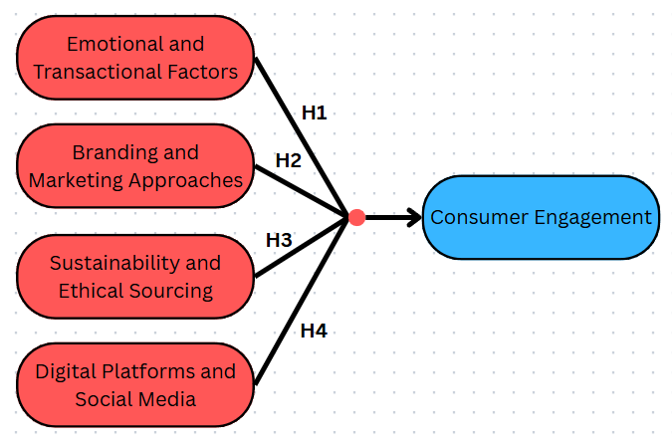
Figure 6: Conceptual Framework
(Source: By Author)
The framework shows a representation of the consumer engagement in the UK coffee market as the outcome variable influenced by four important determinants. It suggests that consumer engagement will be determined by emotional and transactional considerations, brand and marketing strategies, sustainability and ethical sourcing and digital platforms and social media. These determinants are derived directly from the preceding literature review, where emotional and transactional drivers, branding and marketing strategies, demographic influences and digital platforms are identified as key backgrounds of consumer engagement. The model looks into the interaction of these variables to condition consumer involvement and engagement behaviour.
Hypothesis
H1: Consumer involvement in the UK coffee market is significantly shaped by both emotional and transactional factors related to coffee consumption.
H2: Branding and marketing approaches play a significant role in strengthening consumer involvement and loyalty towards coffee brands in the United Kingdom.
H3: Sustainability and ethical sourcing practices are positively associated with higher levels of consumer involvement with coffee brands in the UK.
H4: Digital platforms and social media activities are significantly associated with variations in consumer involvement in the UK coffee market.

Chapter 3: Research Methodology

3.1 Introduction
This chapter describes the methodology utilised in meeting the research aim and objectives of investigating consumer engagement in the UK coffee market. This chapter aims to justify the research philosophy, approach, research design, data collection methods, sampling strategy, and data analysis techniques applied in the research. The chosen methodology promotes testing the stated hypotheses and allows conducting a systematic study of the impact of emotional and transactional variables, branding and marketing strategies, sustainability practices, and digital platforms on consumer engagement. A quantitative method was employed as it enabled the testing of measurable relationships and literature-based hypotheses. The initial part of the chapter is about the research philosophy and approach. It then describes the design, the methods of collecting data and sampling, analysis methods and ethical issues and constraints. This methodological design addressed the gap in empirical UK-based studies by enabling a comprehensive examination of emotional, transactional, branding, sustainability, and digital determinants of consumer engagement in the coffee market.

3.2 Research Philosophy
Research philosophy is a set of assumptions regarding the methods of knowledge construction in a research study and the way of perception of reality (Gannon, et al., 2022). Positivism, interpretivism, and pragmatism are the most widespread philosophies in business and management. Positivism assumes that reality is objective and measurable using observable data. Interpretivism emphasises the subjective meanings and aims at interpreting the phenomena in terms of personal viewpoints (Ali, et al., 2021). Pragmatism is more adaptive and chooses positions of philosophy and approaches that are more practical when it comes to the research problem at hand (Elgeddawy and Abouraia, 2024).
This research followed a positivist research philosophy. This is a suitable decision as the study will analyse quantifiable correlations among specific variables, such as emotional and transactional variables, branding and marketing strategies, sustainability, online interactions, and customer participation. These constructs were transformed into quantifiable items such as engagement levels, branding perceptions, and frequency of digital interaction, enabling objective measurement and statistical testing. The research is hypothesis-based and is based on quantitative data that are gathered using structured questionnaires, which is also consistent with the positivist focus on objectivity and empirical testing. It is possible with positivism to systematise the data and generalise the results to every coffee drinker in the UK and provide solid conclusions about the engagement patterns.

3.3 Research Approach
The research approach describes the relationship between theory and empirical data in research. In research, two main approaches include the deductive and inductive approaches. The deductive method starts with the already existing theories and concepts and based on them, the hypotheses are formulated and then confirmed or disproved by the use of empirical data. Conversely, the inductive approach is a process of producing new theories out of the patterns that arise from gathered data, usually by qualitative inquiry (Kumar and Ujire, 2024).
The research approach used in this study is deductive research because this methodology is suitable since the research is based on existing theories and preceding empirical studies concerning consumer engagement, branding, sustainability, and digital interaction. Referring to the review of literature, a conceptual framework was elaborated and turned into definite hypotheses (H1-H4), according to which the empirical research is conducted. The deductive method allows the systematic testing of these hypotheses on the basis of quantitative data obtained with the help of the UK coffee consumers. Using statistical analysis to test the suggested relationships, the research determines the degree to which the currently existing theoretical explanations of consumer engagement can be applied in the context of the UK coffee market. Although the deductive approach allowed systematic hypothesis testing, it limited exploration of deeper subjective meanings of engagement, which is acknowledged as a methodological constraint consistent with the quantitative design. This weakness is identified as a methodological limitation in line with the quantitative nature of the study.

3.4 Research Design and Research Strategy
Research design gives the broad structure within which the research is organised and conducted to answer the mentioned research objectives. The research was guided by Saunders’ Research onion framework that provides the systematic model to align the major methodological decisions, such as the research philosophy, the research approach, the choice of methods, the research strategy and time horizon. The use of this framework ensures consistency throughout the research process and promotes the internal validity of the research (Saunders, et al., 2023).

Figure 7: Illustration of the Research Onion Framework
(Source: Saunders, et al., 2023)
The research method used in the study at the methodological choice layer was quantitative. This decision is explained by the purpose of the study to analyse the correlations between well-defined variables and to test pre-established hypotheses empirically. The operational variables of consumer engagement, branding perceptions, sustainability awareness, and digital interaction are converted to quantifiable indicators by quantitative research, which enables objective statistical analysis of a significant number of respondents (Ghanad, 2023).
Concerning the research strategy, a survey-based design was used. Survey research is suitable for research that aims at capturing the attitudes and behaviours of the consumer in a standardised and comparable fashion. A structured questionnaire enables the use of a varied sample of UK coffee consumers in order to gather data in the most efficient way and conduct the investigation of several variables at the same time. This approach coincides with the holistic character of the conceptual framework, which takes multiple contributing factors as a unit.
In terms of the time horizon, the study was a cross-sectional study, in which data is gathered at one moment in time (Maier, et al., 2023). This plan is appropriate to capture the existing patterns of consumer engagement in the UK coffee market and to examine how modern branding, sustainability, and digital practices can affect consumer behaviour in the current market conditions. Other qualitative or mixed-method designs were not implemented due to the fact that the main aim of the research is the empirical testing of the hypotheses and the quantification of relationships between variables, but not the thorough investigation of the subjective meanings.

3.5 Data Collection Method
The research relies on the primary data collection, thereby enabling the research to obtain original and context-specific data directly aligned with the research objective, research aim, and research hypotheses (Lim, 2025). Primary data was especially appropriate to research consumer engagement, as it will allow testing the existing consumer perceptions and behaviours in the UK coffee market, as opposed to secondary interpretations.
The research used a survey technique with a structured questionnaire to gather primary data. The survey technique fits a quantitative study because it allows the collection of measurable information on a large population of respondents in a systematic and standardised manner. The structured questionnaire ensures consistent responses and facilitates statistical analysis of the relationships between variables.
The questionnaire comprised closed-ended questions, which aim at capturing consumer perceptions regarding branding and marketing strategies, sustainability and ethical sourcing methods, digital marketing practices, and general consumer engagement. The responses are indicated on a five-point Likert scale between strongly agree and strongly disagree. This scale is widely used in consumer behaviour research, and the questionnaire items were adapted from prior empirical studies to ensure content validity and reliable measurement of consumer perceptions.
The deductive research approach is facilitated by the use of a structured questionnaire based on a Likert scale, as it allows the research to test the hypotheses put forward directly. The collection of data takes place online with the help of Google Forms, which ensures effective distribution, consistency of data recording and anonymity of the respondents.

3.6 Population and Sampling Strategy
The population of the study is the consumers in the UK who make purchases and consume coffee in both branded and independent shops. This group is viable because it comprises people directly involved in branding, sustainability practices, digital interactions, and customer experience in the UK coffee market.
A stratified random sampling was used to choose respondents in this population. Stratified sampling consists of subdividing the population into separate subsets (strata) on the basis of common properties and then picking at random those members of a group to have a proportionate representation (Makwana, et al., 2023). The stratification in this work applies to age, gender, and coffee brand preference, whereby the various categories of consumers are sufficiently represented. This minimised the sampling bias and enable meaningful intergroup comparison. A sample size of 120–150 respondents was considered sufficient for this quantitative study. Recent services marketing research indicates that samples within this range are appropriate for regression-based analysis and hypothesis testing when examining relationships among multiple variables (Ali, 2026). The selected sample size provided adequate statistical power, supported reliable estimation of relationships, and met the analytical requirements of the study. Therefore, the sample size was suitable for addressing the research objectives and testing the proposed hypotheses.

3.7 Data Analysis Techniques
The systematic process of analysing and interpreting data and extracting meaningful insights to address the research objectives is known as data analysis (Islam, 2020). The questionnaire survey in this study has been analysed with the help of the Statistical Package of the Social Sciences (SPSS), which is a reliable and efficient tool in the analysis of quantitative data, accessed through the university’s licensed academic software provision.
The analysis starts with descriptive statistical analysis, through which data are summarised and presented in a clear and understandable format. To determine patterns and trends in consumer perceptions regarding branding, sustainability, digital marketing, and consumer engagement, descriptive statistics like frequencies, percentages, means and standard deviations are used. The findings are displayed using tables and graphical figures to make it clear and easy to interpret.
A Pearson correlation analysis is used to investigate the links among the independent variables with consumer engagement, and this directly answers RQ1-RQ4 (emotional, branding, sustainability, digital influences). Hypotheses H1-H4 are then tested using multiple regression analysis in which the strength of prediction of these variables on consumer engagement is determined. A combination of these methods can give an empirical foundation to the hypothesis testing and evidence-based suggestions to improve the consumer engagement strategy in the UK coffee market.

3.8 Reliability and Validity
Reliability and validity are needed to determine the quality and credibility of research findings. The predictability or stability of measurement is called reliability and was evaluated with Cronbach alpha to test the internal consistency of main constructs, such as consumer engagement, branding perceptions, sustainability awareness, and the measures of digital interaction (Izah, et al., 2023). Any alpha more than 0.7 would mean satisfactory reliability.
Validity investigates whether the questionnaire measures what it is intended to measure. Content validity is taken care of through matching the items with the existing literature and conceptual framework. Construct validity is facilitated by operationalisation of variables that are made clear based on empirical studies conducted before.

3.9 Ethical Considerations
Ethical considerations refer to the guidelines and codes that govern responsible research when there is the participation of human subjects and data management (Ajuwon, 2020). The considerations taken into this research are that participation in this research is voluntary, as the respondents are given a clear understanding of the aim of the research prior to their participation. All the participants are informed to provide informed consent before data collection. In order to safeguard privacy, no personally identifiable data is gathered, and all responses will be processed with the highest level of anonymity and confidentiality.
All data used is safely stored and used for academic purposes. The data interpretation is grounded on the basis of the statistical analysis without any alteration, manipulation or distortion of responses. The study adheres to the accepted academic and institutional ethical standards, so there are integrity, objectivity, and ethical accountability in the data collection and analytical procedure. This research was conducted in accordance with institutional ethical guidelines for academic research involving human participants, ensuring compliance with established standards of responsible data collection and participant protection.

3.10 Methodological Limitations and Mitigation
The methodological limitations of this research are as follows. The survey conducted with the help of a questionnaire might not provide as much insight because the answers are based on self-reported impressions. In order to mitigate this, structured and well-worded items are employed to minimise ambiguity. The cross-sectional type of design only captures consumer behaviour at a point in time without considering how it would change with time, but it is suitable for studying the current patterns of engagement. It could not cover all groups of consumers in online data collection, thus it does not have broad generalisability. This limitation would be minimised by distributing the survey on various digital platforms and results are interpreted with due caution.

Chapter 4: Data Analysis

4.1 Introduction
The chapter provides the analysis of primary data obtained with the questionnaire survey to answer the research objectives and the proposed hypotheses. The data are processed in SPSS to discuss the trends of consumer participation in the UK coffee market. Descriptive statistics, crosstabulation analysis, reliability testing, correlation and regression analysis are contained in the chapter. These analytical methods enable the study to directly address the research objectives and test the proposed hypotheses by examining how branding, sustainability, digital interaction and emotional factors influence consumer engagement in the UK coffee market.

4.2 Results
Section A: Demographics
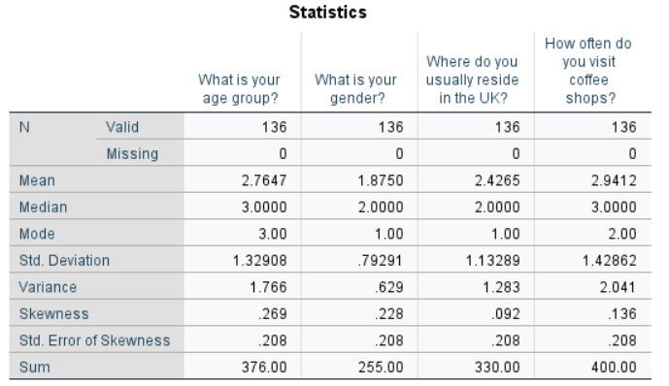
Figure 8: Statistics for demographics
Q1. What is your age group?
Table 1: Responses for Question 1
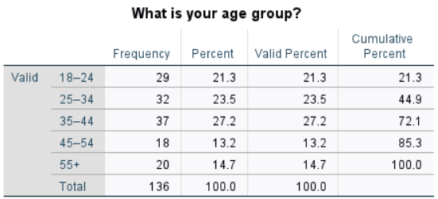 | 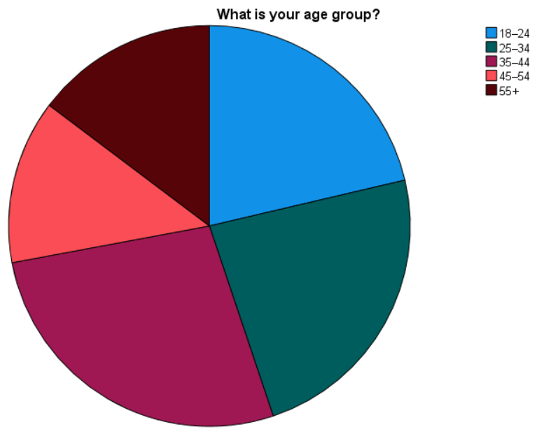
The age distribution expressed as percentages indicates that most respondents are between 35-44 (27.2%), 25-34 and 18-24 (23.5% and 21.3% respectively). There is also representation of older age groups, such as 45-54 (13.2%) and 55+ (14.7%), which means that the age is very diverse. Descriptive statistics indicate that the mean age group is 2.76 and the median is 3.00, which reaffirms the fact that the respondents are clustered towards the middle age groups. The standard deviation value of 1.33 represents the medium dispersion, whereas the skewness value is small (0.269), which implies a rather symmetric distribution. In general, this even distribution of ages contributes to the examination of consumer involvement at various stages of their lives in the UK coffee market.
Q2. What is your gender?
Table 2: Responses for Question 2
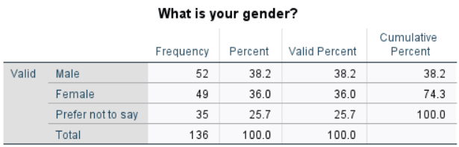 | 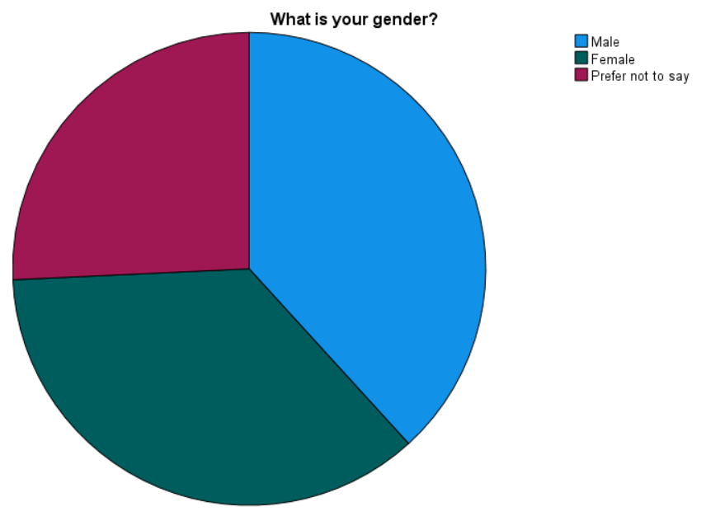
Male respondents make up 38.2% of the sample, with females closely following at 36.0 and the remaining 25.7% of the respondents not wanting to mention their gender. It is observed to be representative of a fairly balanced gender distribution. The descriptive statistics depict a mean of 1.88 and a median of 2.00, which represents the predominance of the first two response categories. The standard deviation is rather small (0.79), implying there is little deviation in the responses. Skew value is indicative of no strong bias towards a particular category (0.228). In general, the gender balance suggests that the consumer engagement behaviours in the study are not prone to being significantly driven by gender imbalance.
Q3. Where do you usually reside in the UK?
Table 3: Responses for Question 3
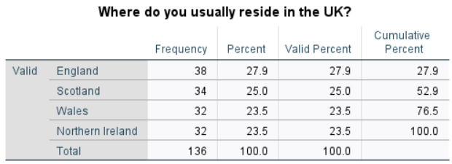 | 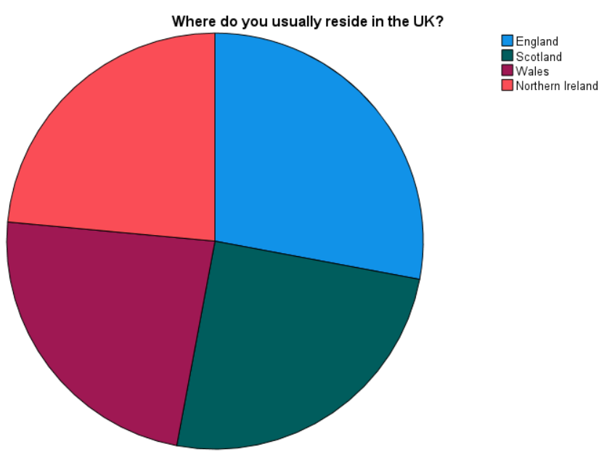
The distribution of respondents in the region is quite balanced, with England topping the list with 27.9%, Scotland with 25.0% and both Wales and Northern Ireland with 23.5% each. This equal percentage distribution improves the geographical representativeness. The descriptive statistics indicate that the mean is 2.43 and the median is 2.00, implying that the data is clustering in the central areas. The standard deviation equals 1.13, which means moderate variability and skewness equals 0.092, which means that the distribution is nearly symmetrical. These findings suggest that the information on consumer engagement based on the results is UK-wide, but not region-specific.
Q4. How often do you visit coffee shops?
Table 4: Responses for Question 4
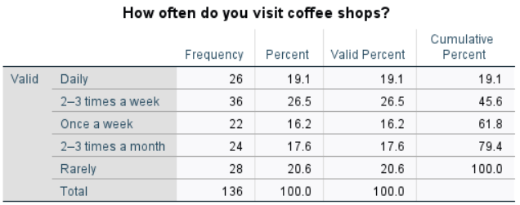 | 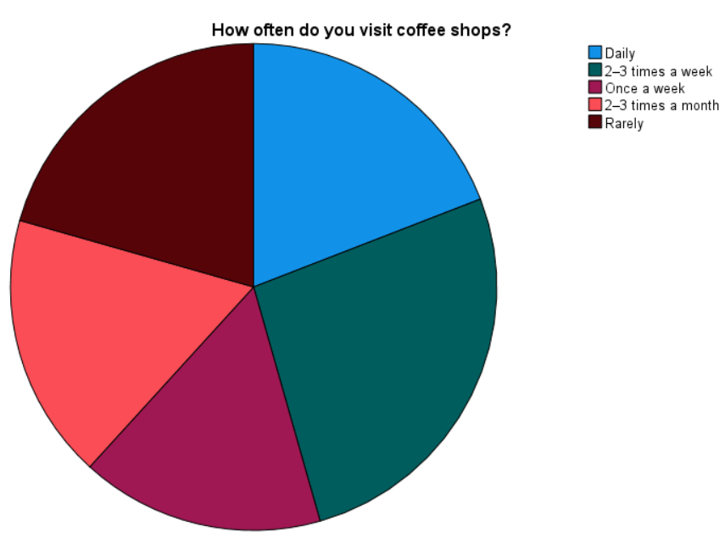
The frequency analysis indicates that the majority of respondents frequent coffee shops most of the time, with the 26.5% visiting coffee shops 2 to 3 times per week and 19.1% visiting coffee shops daily. Some visits are also frequent, such as once a week (16.2%) and 2-3 times a month (17.6%), whereas 20.6% indicate instances of rare visits. Descriptive statistics give the mean of 2.94 and median of 3.00, which means that there is moderate to high visit frequency on average. The standard deviation of 1.43 indicates a significant change in the behaviour of visiting and skewness (0.136) indicates a balanced distribution. This difference helps to consider various degrees of consumer engagement intensity. Overall, the demographic and visit-frequency profile provides a suitable foundation for analysing variations in consumer engagement across different age groups and consumption intensities, supporting the study’s objective of examining engagement behaviour within the UK coffee market.
Section B: Branding and Marketing
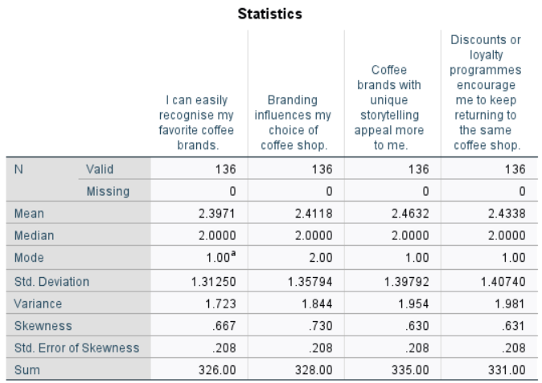
Figure 9: Statistics for branding and marketing
Q5. I can easily recognise my favorite coffee brands.
Table 5: Responses for Question 5
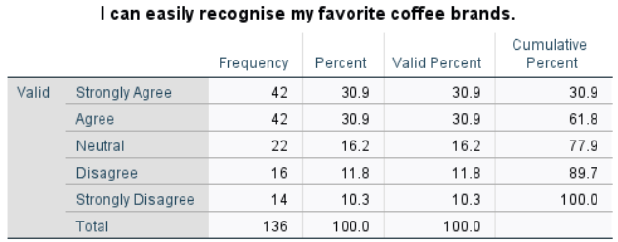 | 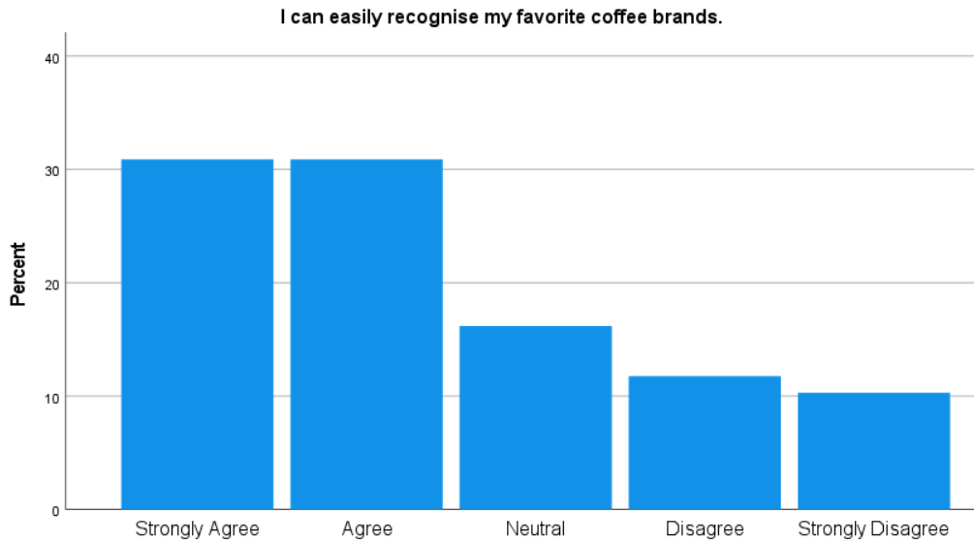
Combined 61.8% strongly agreed (30.9%) or agreed (30.9%) that they can readily identify their preferred coffee brands and only 22.1% disagreed. This trend is further supported by descriptive statistics, with the mean score of 2.40, a median of 2 and mode of 1 which show that most of the responses were agreement-dominant. The standard deviation is fairly steady (1.31), which indicates that there is a fairly good consistency among the respondents. Generally, the results suggest that brand awareness and recognition are strong in the UK coffee market, which supports the relevance of branding as one of the highly important aspects of consumer interaction.
Q6. Branding influences my choice of coffee shop.
Table 6: Responses for Question 6
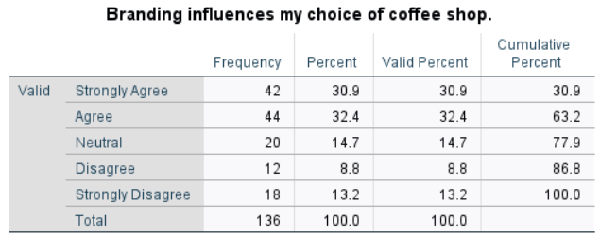 | 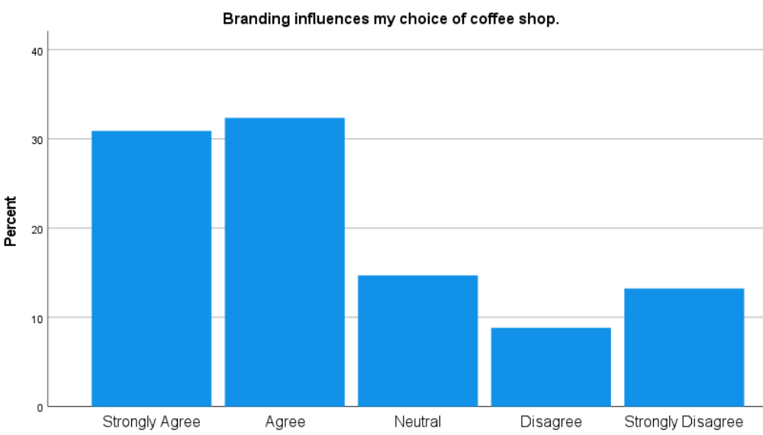
According to the percentage distribution, branding plays a significant role in the consumer choice, in which 63.2% of the respondents answering in agreement or strongly agree, whereas 22% answered in disagreement or strongly in disagreement. The descriptive statistics show that the mean value is 2.41, the median is 2 and the mode is 2, which shows a general agreement. Standard deviation (1.36) indicates the average deviation of opinions. These findings directly support H2 by demonstrating that branding and marketing strategies significantly influence consumer engagement and loyalty in the UK coffee market. The findings underscore branding as a strategic process on which coffee brands can affect consumer participation in a competitive UK market.
Q7. Coffee brands with unique storytelling appeal more to me.
Table 7: Responses for Question 7
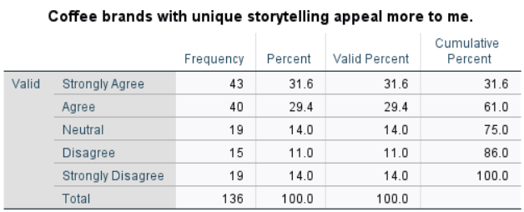 | 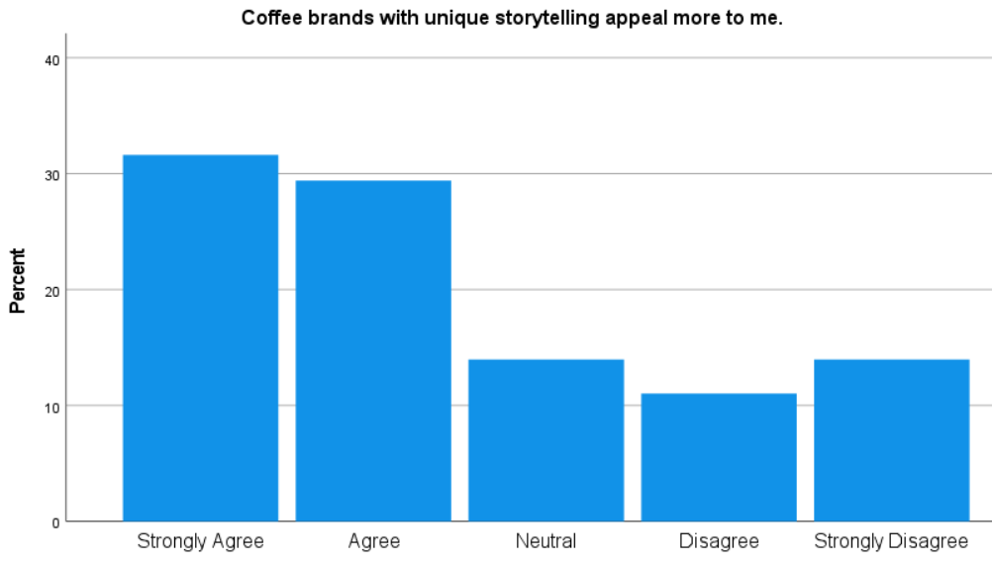
The results demonstrate a positive consumer reaction to brand storytelling, the percentage of respondents who agreed or strongly agreed with the fact that coffee brands with a unique storytelling attract them more is 61.0% and the percentage of those who disagreed with this is 25.0%. The descriptive statistics indicate a mean of 2.46, a median of 2 and a mode of 1, which indicates that there is a tendency towards agreement. The standard deviation (1.40) shows that there was moderate variation in responses. These findings imply that branding that is emotional and narrative boosts customer interest and involvement. The information gathered through storytelling seems to reinforce emotional dependence, which is the reason why an affective branding approach can be used in maintaining consumer involvement in the UK coffee sector.
Q8. Discounts or loyalty programmes encourage me to keep returning to the same coffee shop.
Table 8: Responses for Question 8
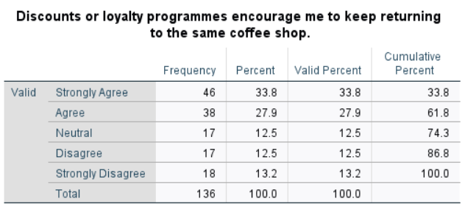 | 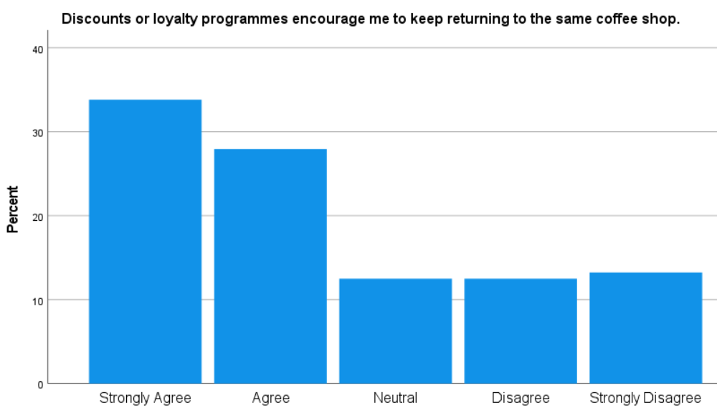
The findings indicate that repeat behaviour is highly affected by transactional incentives. Combined, 61.7% of the respondents agreed or strongly agreed that discounts or loyalty programmes influence repeat visits, whilst 25.7% disagreed. This pattern is supported by the descriptive statistics, where the mean score is 2.43, the median is 2 and the mode is 1, which gives an indication of leaning towards an agreement. The standard deviation (1.41) indicates that there is a range of consumer perceptions. These results indicate that transactional aspects like rewards and loyalty programmes are relevant in maintaining consumer involvement, as well as emotional and branding motivational factors in the UK coffee market. Together, these results indicate that both emotional branding elements and transactional incentives contribute to consumer engagement, reinforcing the multidimensional nature of involvement highlighted in the research objectives.
Section C: Sustainability and Ethical Sourcing
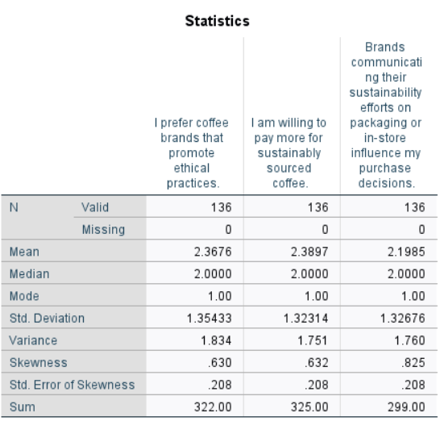
Figure 9: Statistics for sustainability and ethical sourcing
Q9. I prefer coffee brands that promote ethical practices.
Table 9: Responses for Question 9
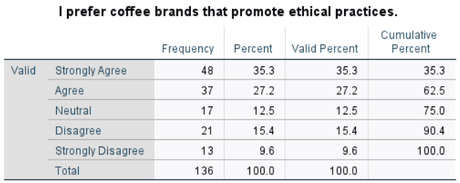 | 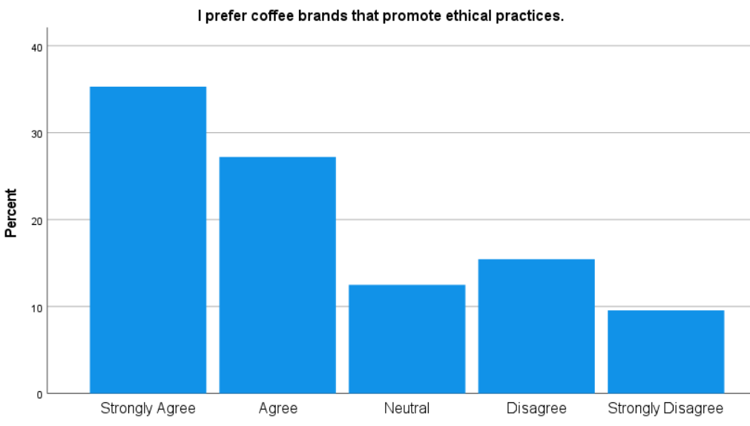
The percentage distribution shows that an ethically responsible coffee brand is highly desired, with a strong majority of 35.3% strongly agree and 27.2% agree, which translates to 62.5% of the respondents having a positive attitude towards ethically responsible coffee brands. The number of neutral responses is 12.5% and 25% are in disagreement to different extents. This trend is further supported by descriptive statistics that have a mean score of 2.37, a median of 2 and a mode of 1, which reveals that there is a general agreement that is inclined to strong agreement. The average standard deviation (1.35) implies the presence of variation, but also general agreement. This finding indicates that the issue of ethics is a significant motivation for consumer interest and brand loyalty within the UK coffee sector.
Q10. I am willing to pay more for sustainably sourced coffee.
Table 10: Responses for Question 10
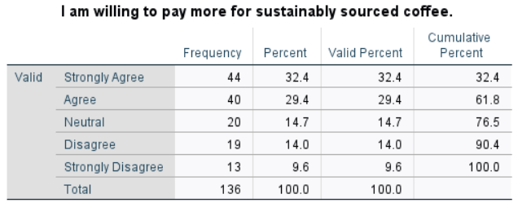 | 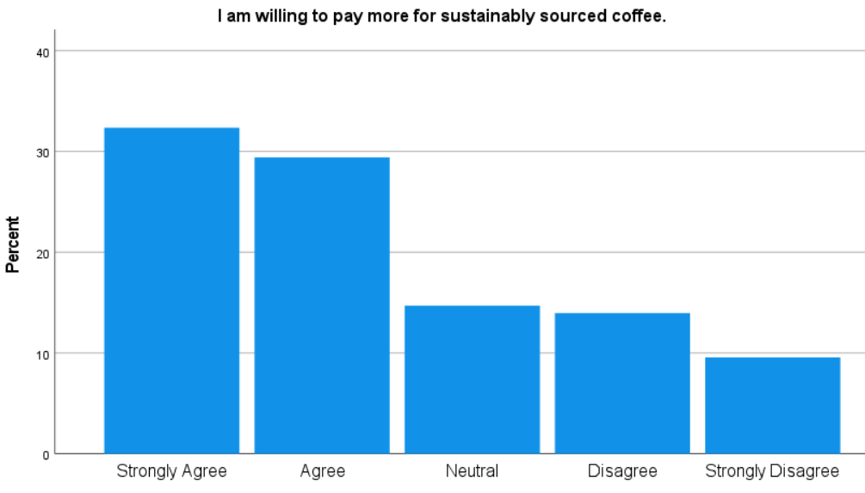
The findings indicate that 32.4% concur strongly and 29.4% concur that they are ready to pay more for sustainably sourced coffee and the summation of the two amounts to 61.8% positive answers. The responses that are neutral are 14.7% and those who disagree are 23.6%. The descriptive statistics depict that the mean is 2.39 with a median of 2 and a mode of 1, which supports a generally positive attitude towards paying a sustainability premium. The standard deviation (1.32) is a measure of moderate dispersion. Such results indicate that sustainability is not just a value of preference but also reflects practical buying values, which justifies its ability to enhance consumer interest.
Q11. Brands communicating their sustainability efforts on packaging or in-store influence my purchase decisions.
Table 11: Responses for Question 11
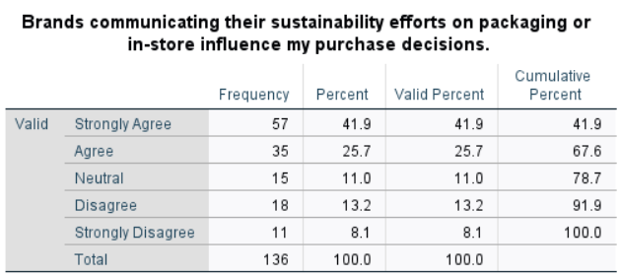 | 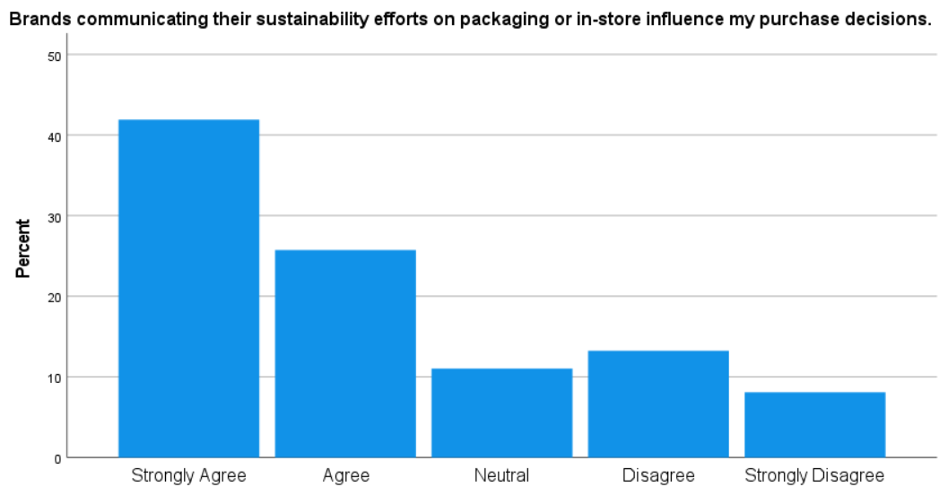
The percentage of respondents who recognise the effects of sustainability communication is extremely high, as 41.9% strongly agree, 25.7% agree, which makes 67.6% positive answers. Neutral answers are 11% and only 21.3% disagree. This trend is supported by the descriptive statistics, which report a low mean score of 2.20, a median score of 2 and a mode of 1 and shows a high level of agreement. The standard deviation (1.33) indicates that there might be varying views, but the entire skew in favour of an agreement points to the fact that a visible sustainability message has a major influence on purchasing behaviour. This finding supports H3 by indicating that visible communication of sustainability and ethical practices strengthens consumer trust and engagement with coffee brands. Overall, sustainability emerges not only as a value-driven preference but as a strategic engagement driver that enhances both emotional and behavioural involvement.
Section D: Digital Marketing and Social Media
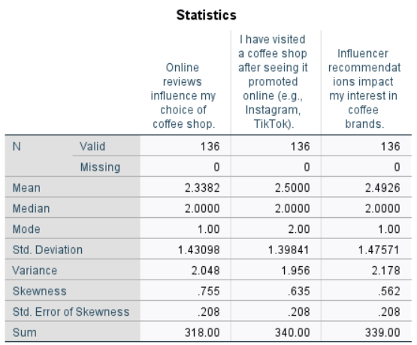
Figure 10: Statistics for digital marketing and social media
Q12. Online reviews influence my choice of coffee shop.
Table 12: Responses for Question 12
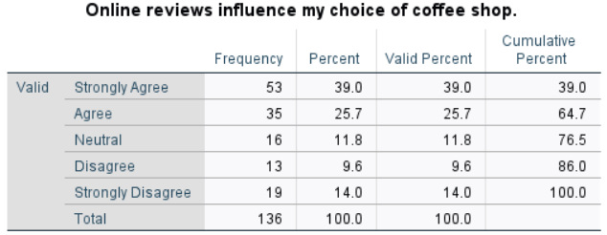 | 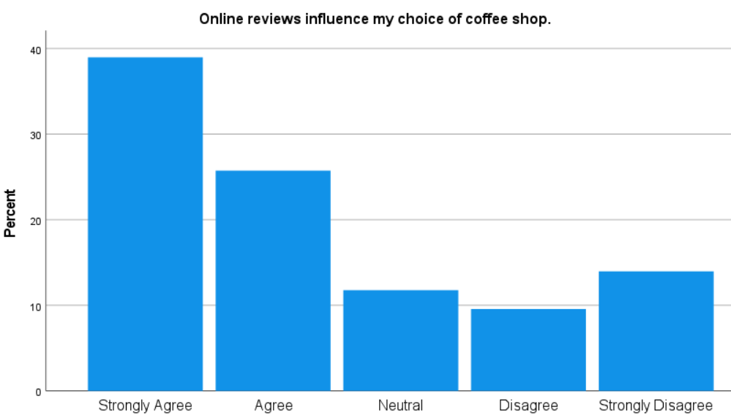
The findings indicate that a significant majority of participants view online reviews as the ones that affect their choice of coffee shops. About 64.7% of the respondents strongly agreed and agreed and only 23.6% disagreed and strongly disagreed. This trend is further supported by the descriptive statistics, whose mean score was 2.34, median 2 and mode 1, which show that people are in agreement. The standard deviation of 1.43 is moderate, implying variation in opinions. In general, the results suggest that online reviews can be an important factor in consumer decision-making, which justifies the relevance of digital word-of-mouth in consumer interaction in the UK coffee market.
Q13. I have visited a coffee shop after seeing it promoted online (e.g., Instagram, TikTok).
Table 13: Responses for Question 13
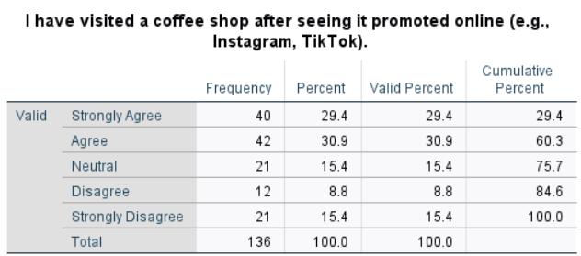 | 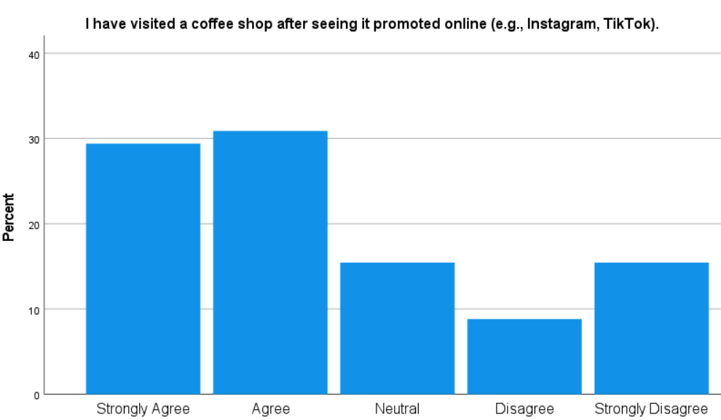
The results show that consumer behaviour is strongly impacted by digital promotions. Approximately 60.3% of the respondents strongly agreed or agreed that they had visited a coffee shop after it was advertised on the internet and 24.2% disagreed. As depicted by the descriptive statistics, the mean is 2.50, the median is 2 and the mode is 2, depicting a positive tendency in general, with respect to online promotions. The standard deviation (1.40) indicates that dispersion in the responses is moderate. It means that digital exposure is successfully transformed into physical presence on social media platforms, which explains their significance in the context of active consumer interaction in the UK coffee market.
Q14. Influencer recommendations impact my interest in coffee brands.
Table 14: Responses for Question 14
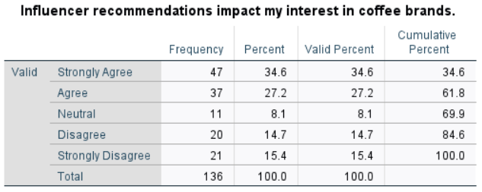 | 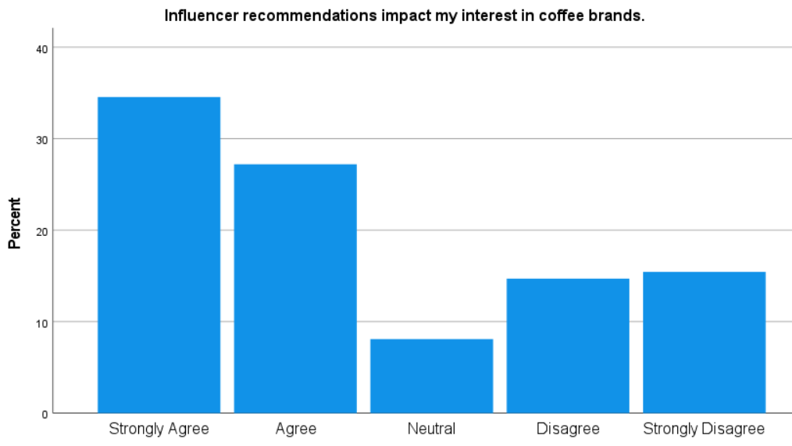
The findings indicate that the effect of influencer marketing on consumer interest is observable. About 61.8% of participants strongly agreed or agreed that the recommendation of influencers influences their interest in coffee brands and 30.1% did not agree or strongly disagreed. The descriptive statistics reveal that the mean value is 2.49, the median is 2 and the mode is 1, meaning that there is general agreement. The standard deviation (1.48) is relatively large, implying a wider diversity in consumer perceptions. These results partially support H4 by confirming the influence of digital platforms on engagement, while also indicating that the effectiveness of influencer marketing varies across consumer segments. Collectively, these findings highlight digital interaction as a key determinant of consumer engagement, particularly through reviews, social media exposure and online visibility.
Section E: Consumer Engagement
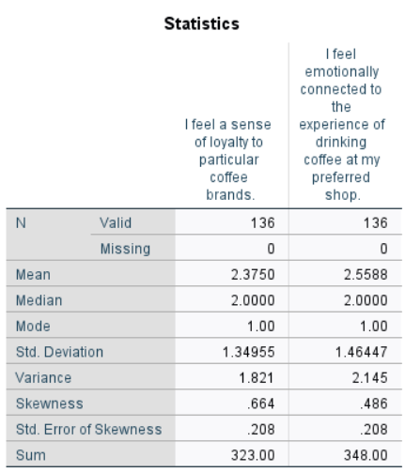
Figure 11: Statistics for consumer engagement
Q15. I feel a sense of loyalty to particular coffee brands.
Table 15: Responses for Question
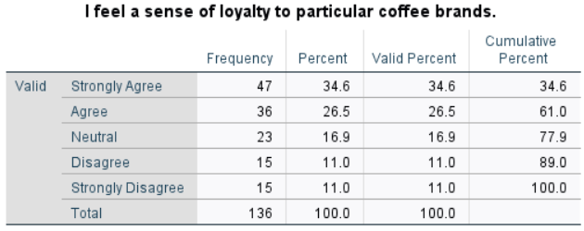 | 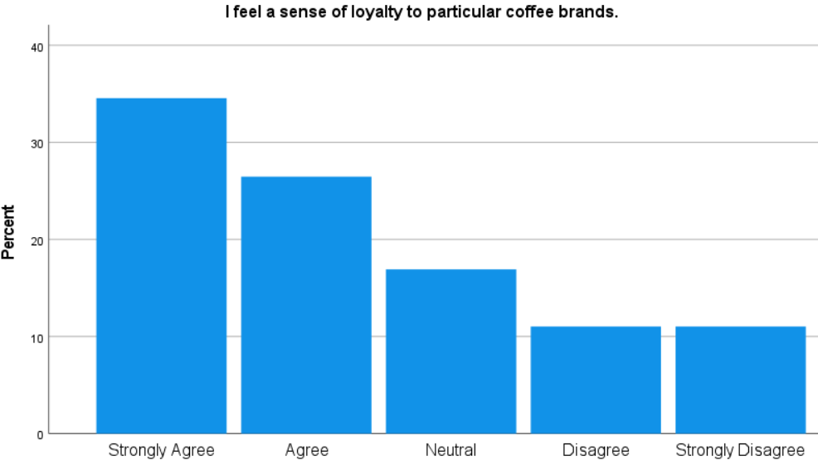
The findings reveal a fairly positive attitude of brand loyalty, according to the respondents. 61.1% of the respondents strongly agreed (34.6%) or agreed (26.5%) with the statement that they are loyal to specific coffee brands, with 16.9% having neutral views and 22.0% disagreeing. This trend can also be further supported by the use of descriptive statistics whose mean score equals 2.38, median equals 2 and mode is 1, which shows general agreement. The standard deviation (1.35) is moderate, which means that there is a certain range of loyalty, but the results show that a significant portion of consumers have brand attachment, which means that there is a substantial consumer involvement in the UK coffee industry.
Q16. I feel emotionally connected to the experience of drinking coffee at my preferred shop.
Table 16: Responses for Question 16
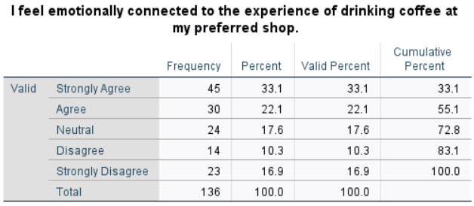 | 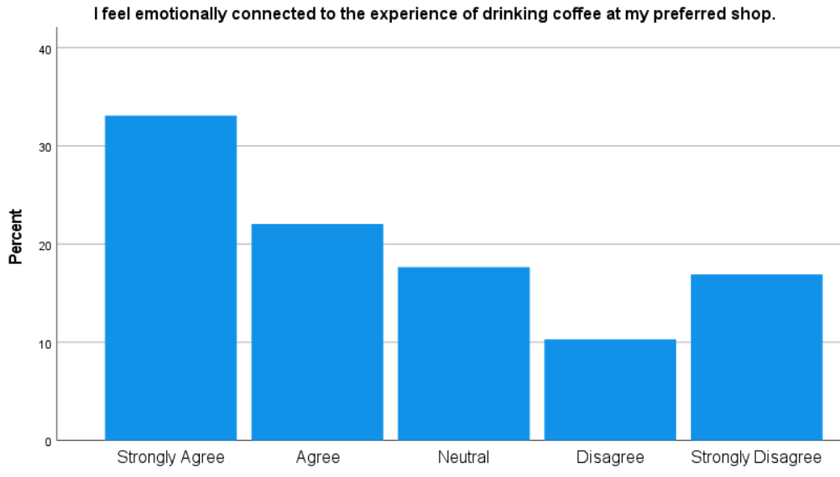
Responses indicate emotional attachment is there, but more varied amongst consumers. Approximately 55.2% of the respondents said that they agreed or strongly agreed with the statement, 17.6% said that they were neutral and 27.2% selected that they disagreed to some extent. The general inclination to agree, though not as strong as brand loyalty, can be suggested by the average value of 2.56, the median of 2 and the mode of 1. The standard deviation is higher (1.46) and shows more dispersion in the emotional responses. In general, the results indicate that although emotional connection is a part of engagement, the connection is not retrospectively achieved, which indicates differences in consumer emotional connection to the coffee consumption experience. This distinction between loyalty and emotional attachment aligns with the study’s objective of examining engagement as a multidimensional construct rather than solely repeat purchasing behaviour.

4.3 Cross Tabulation Analysis
Cross-tabulation between questions 1 and 15
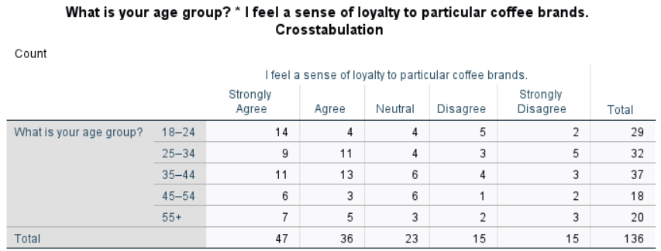
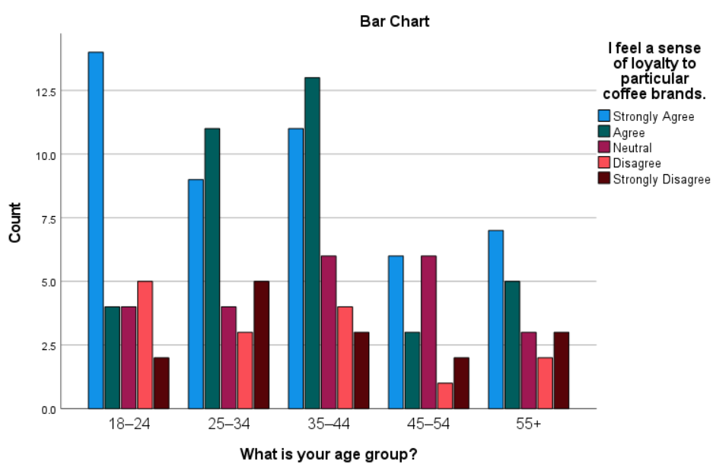
The crosstabulation of the age group (Q1) with the sense of loyalty to specific coffee brands (Q15) demonstrates significant differences in the age groups. The brand loyalty proportion of respondents aged 18-24 was relatively high (14 of 29) and implies attachment at an early stage, although there is a certain disagreement, which implies mixed stability. The age groups of 25-34 and 35-44 represent a balanced score between strong agreement and agreement with the 35-44 age group recording the highest combined number of agreement (24 out of 37). This is an indication of consistent and stable patterns of loyalty that are fuelled by habitual consumption and familiarity with the brand.
Conversely, there is a higher concentration of neutral responses among the respondents aged between 45 and 54, which implies moderate or situational loyalty but not strong attachment. The age bracket of 55 and above has moderate levels of agreement and a considerable proportion of disagreement as well, meaning that they are selectively loyal based on the considerations of habits or values and not on the basis of emotional attachment.
These patterns indicate that age moderates consumer engagement, directly addressing the research objective related to demographic differences in engagement behaviour.
Cross-tabulation between questions 4 and 16
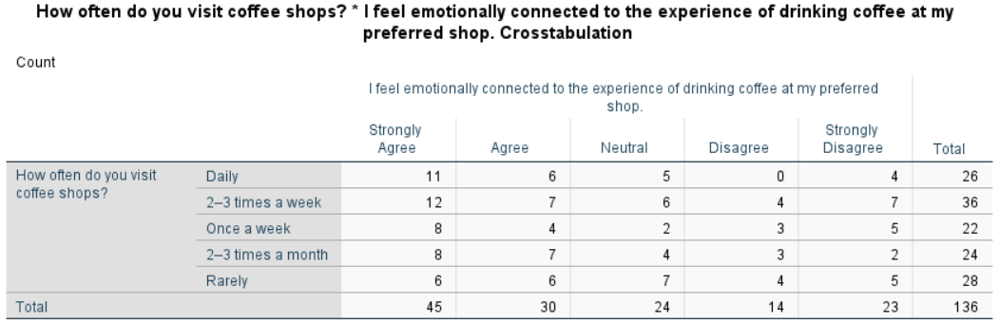
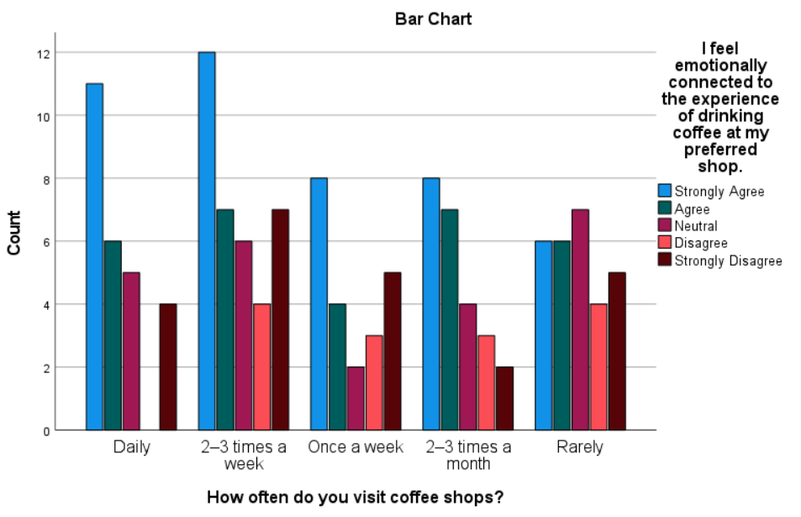
The crosstabulation shows that there is a definite correlation between the frequency of visits to coffee shops and the emotional attachment to the experience of drinking coffee. Emotional attachment is more pronounced in respondents who frequent coffee shops, especially those who visit on a regular basis, that is, daily and 2-3 times during the week. A significant percentage of the daily visitors have a high level of agreement (11) or agree (6) that they have an emotional connection, showing that with repeated experience and frequent visits, people are emotionally engaged with the coffee shop experience. On the same note, the highest number of strong agreement responses (12) is reported by those who visit the restaurant 2-3 times a week, which once again supports the association between visit frequency and emotional engagement.
Conversely, respondents who frequent coffee shops can hardly be described as having a more scattered distribution of answers, with the neutral (7), disagree (4) and strongly disagree (5) categories having larger numbers. This implies that there is less emotional attachment in the case of infrequent visitors. Infrequent visitors (once a week or 2-3 times a month) indicate the presence of moderate emotional attachment, with responses being categorised in agreement and neutrality.
Overall, the pattern indicates that frequent interaction with coffee shops contributes to stronger emotional connections, supporting the view that experiential repetition plays a key role in fostering consumer engagement. This finding aligns with the study’s emphasis on emotional factors as critical drivers of consumer engagement in the UK coffee market. This supports H1 by demonstrating that repeated experiential interaction strengthens emotional engagement over time.

4.4 Reliability Testing
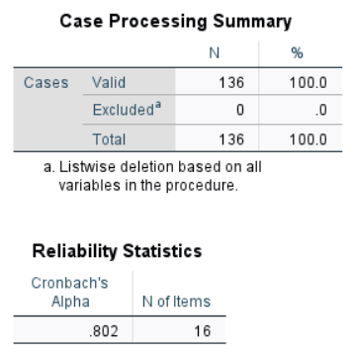
Figure 12: Statistics for the reliability test
The reliability study shows that there is a high internal consistency of the measurement tool adopted in this research. The Cronbach's alpha value of 0.802 on 16 items is greater than the generally accepted alpha of 0.70 and therefore it is true that the questionnaire items are providing a reliable measurement of the underlying constructs of consumer engagement, branding, sustainability and digital interaction. The case processing summary indicates that all 136 responses were valid and none of the cases were omitted, which gives completeness of the data. On the whole, they indicate that the scale is statistically sound and can be used in the context of additional analysis, which confirms the validity and soundness of the consequent findings and hypothesis test.

4.5 Hypothesis Testing
H1: Consumer involvement in the UK coffee market is significantly shaped by both emotional and transactional factors related to coffee consumption.
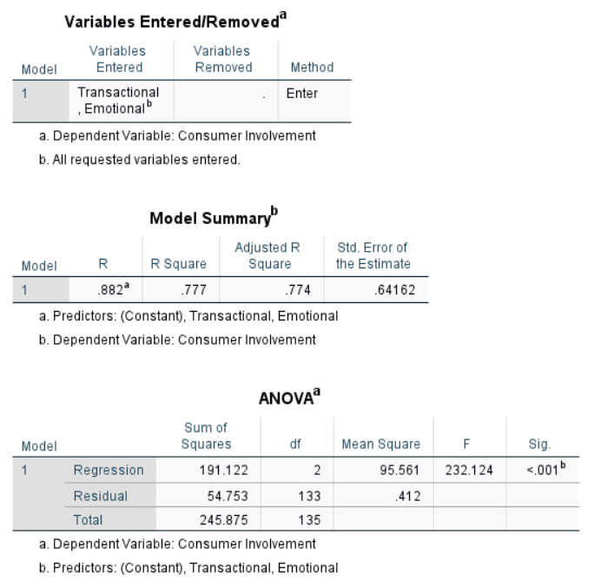
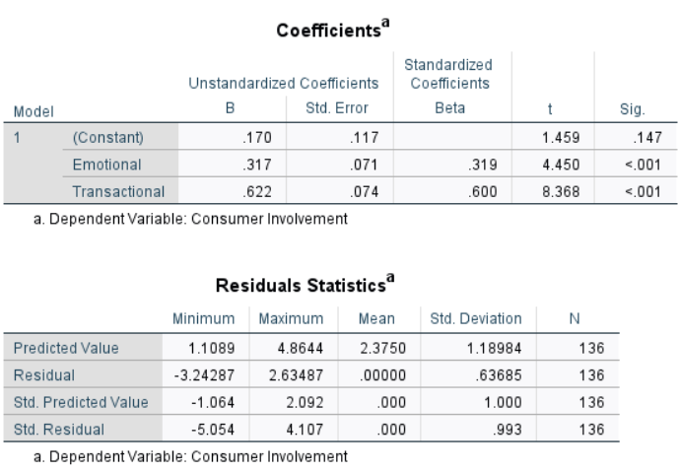
Figure 13: Hypothesis Testing 1
The regression analysis provides robust empirical support for H1. The model summary demonstrates a strong positive relationship (R = 0.882) between emotional and transactional variables and consumer involvement. The R² value of 0.777 indicates that 77.7% of the variance in consumer involvement is explained collectively by these predictors highlighting substantial explanatory strength. The high Adjusted R² of 0.774 confirms model reliability with minimal overfitting. The ANOVA results reinforce the model’s significance with a highly significant F-value of 232.124 (p < 0.001), confirming that emotional and transactional factors meaningfully predict consumer involvement. The coefficients table shows that both variables contribute significantly, although their strengths differ.
Transactional factors exhibit the strongest influence (β = 0.600, p < 0.001) suggesting that incentives such as loyalty schemes and discounts are powerful drivers of involvement. Emotional factors also play a significant role (β = 0.319, p < 0.001) indicating that feelings of attachment and preference contribute meaningfully but to a lesser degree. Residual statistics and the histogram of standardised residuals demonstrate an approximately normal distribution supports the validity of regression assumptions (refer to appendix 6). Hence, these findings confirm that consumer involvement is shaped through an interplay of emotional engagement and transactional motivations by providing strong empirical backing for H1.
H2: Branding and marketing approaches play a significant role in strengthening consumer involvement and loyalty towards coffee brands in the United Kingdom.
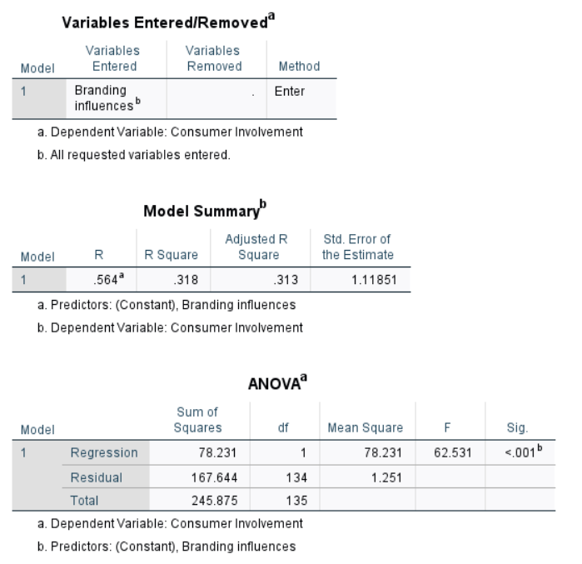
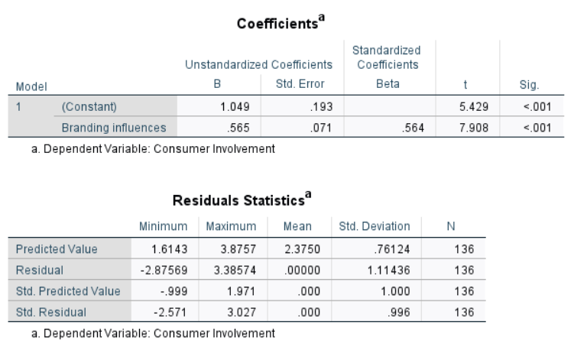
Figure 14: Hypothesis Testing 2
The regression test was done to test H2, which is that branding and marketing strategies have a significant impact on consumer participation in the coffee market in the UK. The summary of the model shows that there is a positive relation between branding influences and consumer involvement, which is strong (R = 0.564). The R-squared is 0.318 and this indicates that about 31.8% of the variance in consumer involvement is attributed to the effects of branding and this has significant explanatory power. The results of the ANOVA test prove that the regression model is significant (F = 62.531, p < 0.001), which means that branding is a reliable predictor of consumer involvement.
This result is further supported by the coefficients table, where branding influences have a positive and significant standardised beta coefficient (0.564, p < 0.001). This implies that more perceptions in branding and marketing are related to a greater degree of consumer involvement. Also, the residual statistics and histogram of standardised residuals do not show any significant violations of normal conditions, which validates the assumptions of the regression (refer to appendix 6). In general, these findings have a considerable empirical foundation of H2, proving that branding and marketing strategies are relevant to enhancing consumer involvement and loyalty to coffee brands in the United Kingdom.
H3: Sustainability and ethical sourcing practices are positively associated with higher levels of consumer involvement with coffee brands in the UK.
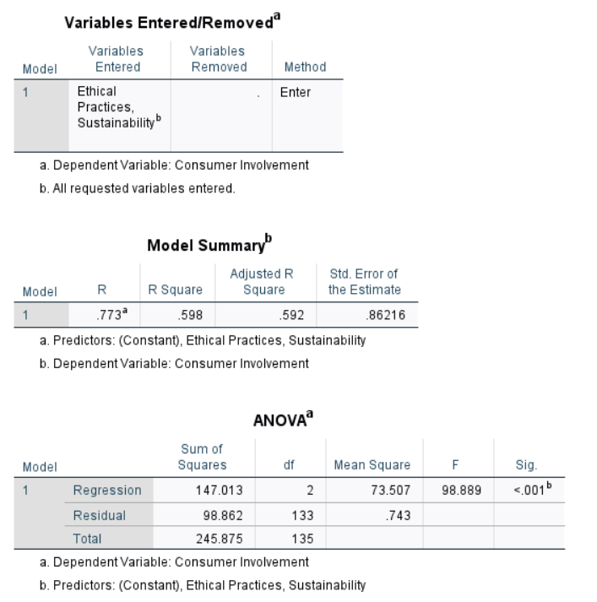
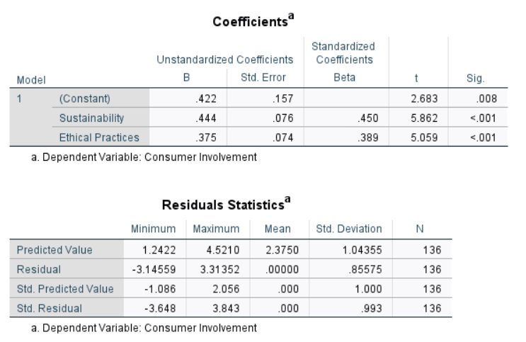
Figure 15: Hypothesis Testing 3
The regression results provide strong empirical support for H3. The model summary shows a high positive correlation (R = 0.773) between sustainability, ethical practices and consumer involvement. The model explains a substantial proportion of variance with an R² value of 0.598 indicating that 59.8% of consumer involvement is influenced by sustainability and ethical sourcing factors. The Adjusted R² of 0.592 confirms strong model reliability with minimal loss of explanatory power. The ANOVA table indicates that the overall model is highly significant (F = 98.889, p < 0.001) confirming that sustainability and ethical practices meaningfully predict consumer involvement.
Analysis of coefficients demonstrates that both predictors contribute significantly, though in varying strengths. Sustainability shows the strongest effect (β = 0.450, p < 0.001) suggesting that environmentally responsible sourcing and sustainable production practices strongly encourage consumer engagement. Ethical practices also exert a significant influence (β = 0.389, p < 0.001) indicate that fair trade, transparency and ethical labour standards enhance consumer trust and involvement. Residual statistics and the histogram confirm normality and model validity (refer to appendix 6). These findings strongly support H3, demonstrating that consumers are more involved with brands that prioritise sustainability and ethical sourcing.
H4: Digital platforms and social media activities are significantly associated with variations in consumer involvement in the UK coffee market.
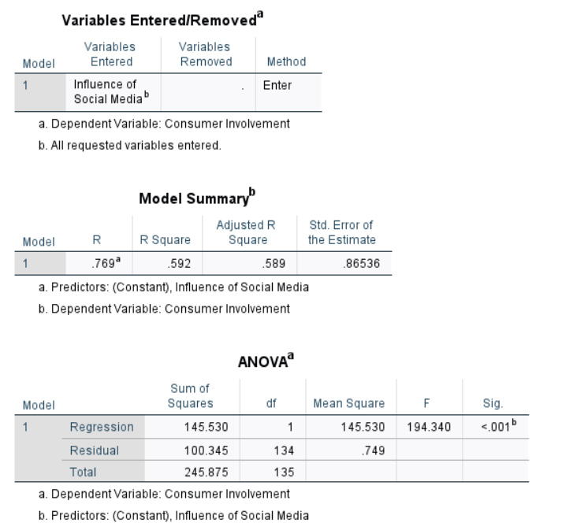
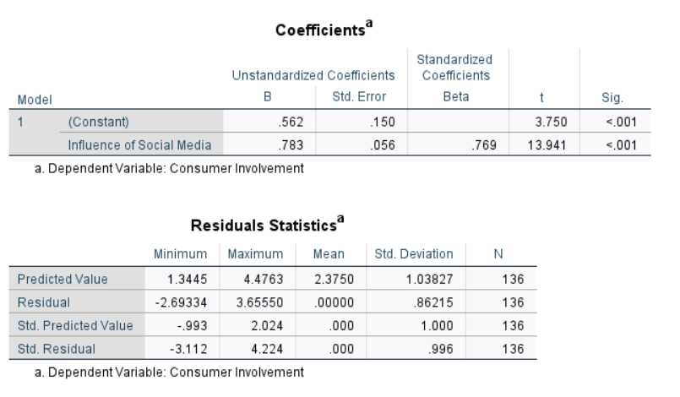
Figure 16: Hypothesis Testing 4
Hypothesis 4 was tested by using simple linear regression with consumer involvement as the dependent variable and influence of social media as the independent variable. The model summary indicates a strong positive relationship between social media activities and consumer involvement (R = 0.769). The R² value of 0.592 demonstrates that approximately 59.2% of the variation in consumer involvement in the UK coffee market is explained by digital platforms and social media influence, reflecting substantial explanatory power. The adjusted R² (0.589) further confirms the robustness of the model. The ANOVA results show that the regression model is statistically significant (F = 194.340, p < 0.001) indicate that social media influence is a reliable predictor of consumer involvement.
This finding is reinforced by the coefficients table, where the unstandardised coefficient (B = 0.783) and the standardised beta coefficient (β = 0.769, p < 0.001) suggest a strong and positive effect. This implies that increased engagement with digital platforms and social media activities leads to higher levels of consumer involvement. Additionally, residual statistics indicate no major deviations from normality by supporting the validity of the regression assumptions (refer to appendix 6). The empirical evidence provides strong support for H4, confirming that digital platforms and social media activities plays a significant role in shaping consumer involvement in the UK coffee market.

Chapter 5: Discussion

5.1 Introduction
This chapter provides a critical discussion of the study results by combining the knowledge of the literature review with the empirical evidence of the data analysis. The arguments are structured based on the main factors of consumer concern and participation in the UK coffee market that are emotional and transactional motivators, branding and marketing strategies, sustainability and ethical sourcing, digital platforms and social media and demographic factors. The discussion directly answers the research question that is “What are the key determinants of consumer interest in coffee brands in the United Kingdom?” by synthesising theory and evidence.

5.2 Discussion
H1: Consumer involvement in the UK coffee market is significantly shaped by both emotional and transactional factors related to coffee consumption.
The literature review highlighted that consumer engagement is a multidimensional construct that includes emotional, cognitive and behavioural components instead of repeat purchase behaviour only (Lim and Rasul, 2022). Analysis of the data showed that the coffee market consumers in the UK are not only behavioural loyalty where 61.1% of them reported loyalty to specific brands but also have emotional attachments to the process of coffee consumption 55.2% of them agreed. Nevertheless, the greater dispersion between emotional attachment and loyalty means that repeat patronage is a fairly widespread behaviour where more emotional attachment is different among consumers.
However, Natrah Jamaludin and Nik Hashim, (2024) narrated that habitual consumption does not always have a high level of emotional attachment especially of low switching costs with markets like retailing coffee. The emotional and transactional drivers to collectively determine consumer interest (Zhang and Chang, 2021). Concerning the transactional aspect, 61.7% of the respondents concurred that discounts and loyalty programmes motivate revisiting, supporting the fact that utilitarian value, convenience and economic incentives (Redda, 2020). Similarly, emotional motivators as brand storytelling narrative attracted 61.0% favorable feedback. Sihvonen, (2019), claimed that symbolic and identity-driven consumption reinforces the consumer interest. The presence of these effects also proves that the UK coffee consumers justify the preferences in emotions by value-based reasons (Wang, et al., 2020). Therefore, consumer desire of coffee brands is not only emotional or rational but a product of their dynamic interaction.
H2: Branding and marketing approaches play a significant role in strengthening consumer involvement and loyalty towards coffee brands in the United Kingdom.
The strategies of branding and marketing are one of the key factors of consumer engagement that supports the existing literature regarding the brand equity and loyalty (Arslan, 2020). Empirical evidence confirms that the branding has a statistically significant, positive effect on consumer involvement with a correlation coefficient of R= 0.564, the R²= 0.318 and p-value=0.001. The one-third of the difference in consumer involvement is due solely to branding and marketing variables that is considerable related to behavioural research. 61.8% of participants mentioned high brand awareness and 63.2% admitted that branding is a decisive factor in choosing a coffee shop as a cognitive shortcut and helps to reduce the perceived risk and increase familiarity. Further, brand storytelling has a unique narrative quality that corresponds to the fact that story-based marketing fosters emotional attachment and long-lasting engagement with more than just functional features (Hollebeek and Macky, 2019). However, the remaining unexplained variance also suggests that branding alone is insufficient to sustain engagement without reinforcement from experience, ethics and digital interaction.
H3: Sustainability and ethical sourcing practices are positively associated with higher levels of consumer involvement with coffee brands in the UK.
Sustainability and ethical sourcing have become a common place issue of the academic discussion, especially when it comes to ethically conscious consumers and younger audiences (Wright, et al., 2024). 62.5% of the respondent indicated their desire to buy coffee brands that act responsibly in their ethical practices and 61.8% respondents were willing to pay a higher price on coffee that is sourced in a sustainable manner. Additionally, 67.6% participants said that they use tangible communication of sustainability initiatives to impact on their buying choices. These results mean that sustainability risks two purposes as an affective measure of value and a rational measure of quality by strengthening trust and sense of authenticity (Jahan, et al., 2024). Sustainability communication appears to strengthen consumer involvement by making ethical values tangible and observable that ethical branding enhances long-term engagement rather than short-term interest.
H4: Digital platforms and social media activities are significantly associated with variations in consumer involvement in the UK coffee market.
Online platforms and social media are among the strongest influencing factors of consumer involvement variability that are interpreted aligned with the current focus on digital interaction in the modern research (Verhoeff, et al., 2021). The influence of social media and consumer involvement have a strong association with a correlation coefficient, R = 0.769, R² = 0.592 and p-value value below 0.001. Therefore, the role of digital interaction explains almost 60% of the differences in consumer involvement which is significantly higher than the one. It can be aligned with branding that explains why the primacy of digital touchpoints in the coffee market of the United Kingdom. Descriptive statistics also support this result that 64.7% of the respondents confirm that they use online reviews, 60.3% said that they went to coffee shops after online ads and 61.8% admitted that they were influenced by social media influencers.
Sahir and Fahlevi, (2024), state that the importance of electronic word-of-mouth and peer validation in the development of trust and engagement. However, the higher dispersion in responses with influencers might indicate that digital fatigue and perceived inauthenticity can be disruptive to influencer marketing when it is overused (Zheng and Ling, 2021). The cross-tabulation findings show that the loyalty patterns of middle-aged consumers are the most consistent and loyal. Engagement stabilises with age as they get used to it and are less prone to experiment (Rather and Hollebeek, 2021). The younger consumers are more variable that are aligned with older consumers are more pragmatic and selective in their loyalty behaviours (Appiah, et al., 2019). Moreover, the emotional attachment is increased among regular visitors that more frequent experience with an event leads to a stronger engagement (Kuppelwieser and Klaus, 2021). All these indicators imply that the engagement strategies need to be developed with the use of the segmentation approach based on age and usage frequency to obtain the best possible effectiveness.
Therefore, from the findings, it has been explored that all the hypothesis of this research has been accepted and none of the hypothesis has been rejected. Interest is affected by both emotional and transactional drivers, structural familiarity provided by branding and marketing, sustainability brings an ethical sense and trust and digital platforms are potent enhancers of engagement. The most influential determinants are considered to be digital interaction and social media, then there are branding and sustainability. Therefore, the consumer interest in the UK coffee market can be best understood as a holistic notion as a result of the experiential, ethical and digital engagement model that would work in specific demographic settings.

Chapter 6: Conclusion and Recommendations

6.1 Introduction
This is the final chapter that summarises the key findings and implements them into practical conclusions. It summarises how the research addressed its goals, the research question and outlines the key factors that determine the consumer interest in the UK coffee brands. Further, it provides practical and evidence-based recommendations for industry professionals recognises the methodological limitations and define future research that can contribute to the enhancement of academic research and management practice.

6.2 Conclusion
This conclusion synthesises the empirical findings to demonstrate how the research objectives have been achieved and what they imply for consumer engagement in the UK coffee market.
Concerning the 1st objective, it can be concluded that there is an apparent change in service and marketing research with a more transactional focus to a more comprehensive concept of consumer engagement as a multidimensional phenomenon. The behavioural outcomes include repeat purchase and advocacy, whereas recent research has conceived of engagement as containing cognitive, emotional and interactive aspects that arise in the process of ongoing interaction. Real-time interaction and co-creation of values through digital platforms, especially social media have transformed the interaction processes, but the overuse of automation can undermine any emotional connection in an experience service. The customer experience theory also provides additional emphasis on regular and high-quality service encounters in cultivating engagement and admits the constraints of low switching cost markets.
In the coffee market, the interest depends on consumers being motivated by emotional factor such as sensory pleasure, symbolic consumption, self-identity and transactional factor such as price, quality, convenience, rewards drivers. Therefore, emotional attraction and rational evaluation are dynamically related to sustainable consumer interest and involvement are maintained by establishing the balance between the affective resonance and the perceived value over time. However, the findings of data analysis highlight that emotional and transactional factors determine consumer interest in UK coffee brands, but transactional factors are stronger. Emotional attachment contributes to consumer engagement, UK coffee consumers place greater emphasis on tangible value and economic incentives in a highly competitive and low-switching-cost market. The degree of emotional attachment to favourite coffee brand was varied with more than 55.2% of the respondents indicating that they are emotionally attached with the brand and 27.2% of the respondents who disagreed. Moderate levels of emotional involvement are demonstrated by descriptive statistics (mean= 2.56, SD=1.46). Transactional drivers had a stronger presence with 61.7% said that discounts and loyalty reward and the mean score was less (2.43) with a mode of 1. These findings affirm that value-oriented incentives are core in determining interest in consumers.
The findings of 2nd objective states that branding functions is not only considered as a promotional tool but act as a strategic mechanism that decreases perceived risk, supports long-term consumer loyalty in the UK coffee market and strengthens trust. Branding is defined as a strategic tool that develops consumer loyalty due to the establishment of brand equity by creating brand awareness, perceived quality, associations and trust. Strong brands ensure less uncertainty, ease in decision-making and the feeling of repurchase intentions and resistance in switching. Loyalty is perceived to be both behavioural and attitudinal, reinforced when the brands have symbolic value, emotional connotation and performance consistency. The involvement is maintained with emotional attachment and trust that makes the consumers committed even in a condition of service failures. Marketing communication also drives the loyalty by strengthening the brand identity, memorable experiences and facilitates personalised communication through online channels. Long-term relationships and brand recognition are developed as a result of relationship marketing, storytelling and integrated communication.
Customer experience plays a crucial role as positive interactions reinforce satisfaction, reliability and long-term retention. Branding, trust, communication and experience collectively shape loyalty by highlighting the need for frameworks that assess their combined influence. As per the findings of data analysis, branding and marketing activities have a significant impact in enhancing consumer interest in UK coffee brands. The item with branding orientation had a concentration of positive responses as more than 60% of the participants reported that brand identity, promotion visibility and marketing messages impact their preference to certain coffee brands. 15% of respondents expressed limited influence with the rest of the respondents displaying neutral tendency. These trends exhibit that the level of branding, promotional messages and repetitive marketing of product plays a crucial role in influencing consumer perception, credibility and interaction in the coffee market.
Concerning the 3rd objective, these findings highlight the significance of demographic segmentation suggesting that engagement strategies need to be effective rather than uniformly applied across diverse consumer groups. Age, income and geographical location play a significant role in consumer engagement that determines how people treat brands in various situations. More experimental, emotive and brand-switching young consumers are more likely to have more consistent engagement patterns as compared to older consumers who consider reliability and consistency. Income also creates additional behavioural distinction, where greater-income consumers are more involved in high-income, high-experience and high-value-expressive brands, whilst lower-income consumers are associated with low-cost, minimising-risk and practical utility. Geographical location influences engagement by accessibility, cultural practices and infrastructure, highly populated and well-connected geographical features help to engage more and experiment, whereas restricted access stimulates habitual and routine-related consumption. Hence, the demographic variables do not work alone but interplay to create complicated patterns of engagement including high involvement of younger high-income consumer groups and value-based engagement of older low-income consumer groups. The data illustrates the clear differences in the way consumers are engaged demographically. The highest level of interaction was found among the younger participants where more than 50% of the participants indicated a high level of interaction with coffee brands as opposed to older consumers who were found to have low levels of interaction with coffee brands with about 40% experiencing less frequency of interaction. Income also played a role in behaviour with higher-income respondents registering more than 55% engagement levels indicating more interest in premium and experience offerings whilst lower-income groups exhibited less committed engagement.
Concerning the 4th objective, it can be concluded that through digital platforms, the engagement between the consumer has been reshaped to facilitate continuous, interactive consumer communication throughout the customer experience. Social media enhances brand consumer relationships through co-creation and real-time interaction, although excessive content and digital fatigue can diminish engagement. Trust, authenticity and emotional attachment are reinforced by influencer marketing and electronic word-of-mouth, especially with younger consumers, but over-commercialisation and over-exposure to sponsored content may compromise credibility. Engagement is facilitated by the artificial intelligence technologies and mobile applications that provide personalised, convenient and emotionally impactful experiences and loyalty aids in fostering repeat behaviour.
Nonetheless, over automation is fraught with erosion of human warmth and interaction to mere transactions. The balance between interactivity, authenticity and personalisation without excessive content and overdependence on influencers or bots, digital engagement can work best. Digital tools are used to provide relevance, social validation and convenience that enrich the engagement but their long-term efficiency relies on the preservation of trust and meaningful brand relationships. The results show that online platforms and social media have a significant influence on consumer interaction with coffee brands in the UK. The digital interaction item reflected that more than 55% of the respondents indicated that online reviews, social media posts and influencer activity affect their interest in coffee brands. They were about 20% neutral and about 15% of the participant were minimum impact. Responses related to mobile app were also found to be highly involved with more than 50% indicating an increase in engagement with rewards, notifications and convenience.
Therefore, the research indicates that consumer engagement in UK coffee market is shaped through the influence of transactional value, branding consistency, emotional attachment, digital interaction and sustainable credibility.

6.3 Recommendations
Strategic Digital Engagement and Content Authenticity: Social media and online platforms are the key tools that can help to determine consumer interaction in the UK coffee market. Coffee brands need to make their strategic digital interactions focus on authenticity and not exclusively on promotion. This goal may be realised through interactive media including user-created reviews, backstage information on sourcing mechanisms and storytelling brand content that is shared on social media platforms. Trust is also supported with the encouragement of two-way communication which is enhanced by the use of comments, polls and feedback mechanism that encourages long-term relational interactions. Brands can foster credibility by placing digital communication and community-building platforms as communication pathways of continued consumer engagement. Therefore, this strategy can help coffee brands to provide a strong and statistically significant relationship between digital platforms and consumer engagement.
Integrated Branding and Experiential Storytelling: To make a difference among the coffee brands in an extremely competitive market, a strong and consistent branding communication strategy is necessary. The brands are to make an integrated choice, matching the visual identity, in-store experience and storytelling. It involves maintaining consistency in terms of packaging, store design and online communication and incorporating experiential storytelling with regard to heritage, quality and lifestyle values. These practices aid in nurturing a sense of emotional attachments and they lead to brand recognition that consumers are able to develop stronger associative links with coffee brands other than based on functionality. Thus, this recommendation can encourage coffee brands to provide effective branding and marketing activities that significantly influence consumer trust, loyalty and preference.
Transparent Sustainability and Ethical Communication: The concepts of sustainability and ethical sourcing are becoming more and more relevant in the arena of consumer interaction. Coffee brands need have in place a transparent communication mechanism that outlines the ethical operations, environmental policies and responsible sourcing programmes. Practical application could include the clear labelling of products and easy access to sustainability reports on the internet and stories that expect supply-chain transparency. By integrating sustainability as a fundamental brand value, instead of an isolated marketing strategy, the brands can expand their consumer base by increasing consumer loyalty and engaging in long-term relationships with socially responsible customers. Hence, this strategy can provide a strong and positive association between sustainable practices, ethical sourcing and high level of consumer involvement in the coffee industry.
Balanced Emotional and Transactional Value Creation: Transactional value is supported by emotional appeal to give consumer participation strength. Coffee brands can develop loyalty and promotion tactics that bring forth the personalised experiences with the physical reward, including individualised offers, experiential awards and reward-based loyalty programs alongside the traditional price promotions. Seeking a balance that includes both economic gains and emotionally connecting experiences, brands can trigger support to be repeated multiple times, adding to a stronger emotional appeal and keeping the consumer interested that can provide a competitive edge on the UK coffee market. Thus, this initiative can help the brands for emotional attachment that contributes towards engagement and transactional incentives such as loyalty rewards and discounts provide a stronger influence on the behaviour.

6.4 Future Recommendations
Future studies can consider adopting mixed methods research to attain detailed qualitative information related to emotional attachment and brand meaning in the UK coffee market. Longitudinal research can also explore how consumer engagement evolves over time related to digital innovation and sustainable initiatives. Furthermore, the future research needs to expand the geographical scope beyond the UK to allow cross-cultural comparison of engagement drivers. The research also examine emerging technologies such as artificial intelligence drive personalisation and their ethical implications can also provide valuable information for academics and practitioners.

6.5 Implications
The study has major implications to the UK coffee industry and to academic literature in the field. Academically, it widens the currently available research on consumer involvement and engagement by empirically incorporating emotional, transactional, ethical and digital determinants into one market setup. The results also indicate a strong need to introduce the coffee brands to holistic approaches that ensure branding, sustainability and digital interaction as opposed to tactical marketing approaches that are fragmented. Also, the research informs decision makers about the changing consumer expectations, hence assisting in the designing of consumer-focused, ethic-based and digitally-sensitive business strategies in competitive markets of service providers.

6.6 Research Limitations
The research has a number of limitations related to the scope and focus of the research. To begin with, the research is limited to the UK coffee market that may not be generalisable to other cultures or geographic areas. Moreover, the consumer perceptions and involvement were measured at one point in time thus, it limits the knowledge of the changes of preferences. Consumer attitudes can be biased in the method of self-reporting.

References
Adamson, V. (2024) Environment and buying sustainably drives consumer focus [Online]. Available at: https://ahdb.org.uk/news/consumer-insight-environment-and-buying-sustainably-drives-consumer-focus [Accessed on: 14 December 2025].
Aeron, S. and Rahman, Z. (2023) Discrete emotions effect on consumer evaluation and behaviour: A contextual perspective and directions for future research. Journal of Consumer Behaviour, 22(6), pp.1543-1573.
Agu, E.E., Iyelolu, T.V., Idemudia, C. and Ijomah, T.I. (2024) Exploring the relationship between sustainable business practices and increased brand loyalty. International Journal of Management & Entrepreneurship Research, 6(8), pp. 2463-2475.
Agyeiwaah, E., Dayour, F. and Zhou, Y. (2022) How does employee commitment impact customers' attitudinal loyalty?. Journal of Hospitality and Tourism Insights, 5(2), pp.350-376.
Ahmadian, S., Sahraei, B. and Khosro, S.K. (2023) Brand attachment, brand experience, brand image, perceived quality, perceived value and brand loyalty. Journal of Humanities Social Sciences And Business (JHSSB), 3(1), pp.257-269.
Ajetunmobi, O.A. and Laobangdisa, S. (2024) The Effect of Cultural and Socio-economics Factors on Consumer Perception. Consumer Perceptions and Food, pp.23-44.
Ajuwon, A.J. (2020) Ethical principles & responsible conduct in research. African Journal of Biomedical Research, 23(SE2), pp.11-13.
Ali, F. (2026) Sample size practices and guidelines in services marketing survey research. The Service Industries Journal, pp.1-26.
Ali, M., Shah, A.A. and Shah, S.A.A. (2021) Positivism and interpretivism. Qlantic Journal of Social Sciences, 2(1), pp.20-26.
Almutairi, E.M. (2025) Effect of brand inclusivity and brand personality on consumer-based brand equity in B2C market: moderating roles of gender and personal income. Future Business Journal, 11(1), p.226.
Anyanwu, I.B. and Okpalaeke, V.C. (2022) Brand Switching Costs and Customer Retention in Food Service Operations: Pricing and Inconvenience Switching Incidents Perspectives. Journal of Tourism and Heritage Studies© IB Anyanwu & VC Okpalaeke, 11(1), p.70.
Appiah, D., Ozuem, W., Howell, K.E. and Lancaster, G. (2019) Brand switching and consumer identification with brands in the smartphones industry. Journal of Consumer Behaviour, 18(6), pp.463-473.
Arab, A. (2025) Building Loyalty and Engagement Through Social Exchange: Applying Psychological Insights to CX and EX. [Online]. Available at: https://www.newmetrics.net/insights/building-loyalty-and-engagement-through-social-exchange-applying-psychological-insights-to-cx-and-ex/ [Accessed on: 20 December 2025].
Arslan, I.K. (2020) The importance of creating customer loyalty in achieving sustainable competitive advantage. Eurasian Journal of Business and Management, 8(1), pp.11-20.
Aten, J. (2020) 3 Scientific Reasons Coffee Makes You Happier and More Productive [Online]. Available at: https://www.inc.com/jason-aten/3-scientific-reasons-coffee-makes-you-happier-more-productive.html [Accessed on: 14 December 2025].
BBB. (2025) The essential guide to opening a cafe or coffee shop [Online]. Available at: https://www.startuploans.co.uk/support-and-guidance/business-guidance/business-inspiration/open-coffee-shop [Accessed on: 14 December 2025].
Bowden, J. and Mirzaei, A. (2021) Consumer engagement within retail communication channels: an examination of online brand communities and digital content marketing initiatives. European Journal of Marketing, 55(5), pp.1411-1439.
Busalim, A.H., Hussin, A.R.C. and Iahad, N.A. (2019) Factors influencing customer engagement in social commerce websites: A systematic literature review. Journal of theoretical and applied electronic commerce research, 14(2), pp.1-14.
CBI. (2022) The United Kingdom’s market potential for coffee [Online]. Available at: https://www.cbi.eu/market-information/coffee/united-kingdom/market-potential [Accessed on: 14 December 2025].
Chen, C.Y. and Pham, M.T. (2019) Affect regulation and consumer behavior. Consumer Psychology Review, 2(1), pp.114-144.
Chen, Y. and Prentice, C. (2025) Integrating artificial intelligence and customer experience. Australasian Marketing Journal, 33(2), pp.141-153.
Czarniecka-Skubina, E., Pielak, M., Sałek, P., Korzeniowska-Ginter, R. and Owczarek, T. (2021) Consumer choices and habits related to coffee consumption by poles. International Journal of environmental research and Public Health, 18(8), p. 3948.
Elgeddawy, M. and Abouraia, M. (2024) Pragmatism as a research paradigm. In European Conference on Research Methodology for Business and Management Studies, 71-74.
Fanarioti, V. (2024) Why “sustainability” has become a buzzword in the coffee industry [Online]. Available at: https://perfectdailygrind.com/2024/11/why-sustainability-is-a-buzzword-in-coffee/#:~:text=From%20packaging%20to%20green%20coffee,more%20resilient%20and%20equitable%20industry. [Accessed on: 14 December 2025].
FAO. (2025) Markets and Trade [Online]. Available at: https://www.fao.org/markets-and-trade/commodities-overview/beverages/coffee/2/en#:~:text=Commodity%20in%20focus,of%20millions%20of%20smallholder%20producers. [Accessed on: 14 December 2025].
Faster Capital. (2025) Consumer behavior: Exploring the Income Effect on Consumer Decision Making [Online]. Available at: https://fastercapital.com/content/Consumer-behavior--Exploring-the-Income-Effect-on-Consumer-Decision-Making.html [Accessed on: 20 December 2025].
Gannon, M.J., Taheri, B. and Azer, J. (2022) Contemporary research paradigms and philosophies. Contemporary research methods in hospitality and tourism, pp. 5-19.
Ghanad, A. (2023) An overview of quantitative research methods. International journal of multidisciplinary research and analysis, 6(08), pp.3794-3803.
GVR. (2025) Coffee Market (2025 - 2030) [Online]. Available at: https://www.grandviewresearch.com/industry-analysis/coffee-market [Accessed on: 14 December 2025].
Habibi, A. and Rasoolimanesh, S.M. (2021) Experience and service quality on perceived value and behavioral intention: Moderating effect of perceived risk and fee. Journal of Quality Assurance in Hospitality & Tourism, 22(6), pp.711-737.
Hardcastle, K., Vorster, L. and Brown, D.M. (2025) Understanding customer responses to AI-Driven personalized journeys: impacts on the customer experience. Journal of Advertising, 54(2), pp.176-195.
Hendler, F., LaTour, K.A. and Cotte, J. (2022) Temporal orientation and customer loyalty programs. Cornell Hospitality Quarterly, 63(4), pp.448-464.
Hollebeek, L.D. and Macky, K. (2019) Digital content marketing's role in fostering consumer engagement, trust and value: Framework, fundamental propositions and implications. Journal of interactive marketing, 45(1), pp.27-41.
Hsiao, A., Ma, E., Manfreda, A., Baker, M. and Xu, J. (2023) A social exchange perspective on boosting customer loyalty through culturally competent servers. Journal of Hospitality Marketing & Management, 32(4), pp.555-577.
Ihtiyar, A., Barut, M. and Ihtiyar, H.G. (2019) Experiential marketing, social judgements and customer shopping experience in emerging markets. Asia Pacific Journal of Marketing and Logistics, 31(2), pp.499-515.
Inviqa. (2025) Transformed Starbucks app boosts loyalty scheme membership by 67%. [Online]. Available at: https://inviqa.com/case-studies/starbucks [Accessed on: 20 December 2025].
Islam, M. (2020) Data analysis: types, process, methods, techniques and tools. International Journal on Data Science and Technology, 6(1), pp.10-15.
Izah, S.C., Sylva, L. and Hait, M. (2023) Cronbach's alpha: A cornerstone in ensuring reliability and validity in environmental health assessment. ES Energy & Environment, 23, p.1057.
Jahan, T., Jahan, A., Pallavi, M., Alekhya, M. and Lakshmi, M.S. (2024) A study on importance of branding and its effects on products in business. International Research Journal on Advanced Engineering and Management (IRJAEM), 2(04), pp. 656-661.
Jamil, S., Raza, M.L., Naqvi, S. and Zehra, A. (2024) Behavioral and psychological aspects of coffee consumption. Progress in Brain Research, 289, pp.151-168.
Kang, J.A., Hong, S. and Hubbard, G.T. (2020) The role of storytelling in advertising: Consumer emotion, narrative engagement level and word‐of‐mouth intention. Journal of Consumer Behaviour, 19(1), pp.47-56.
Kartomo, T. (2024) The Role Of Discounts And Promotions In Enhancing Consumer Loyalty. Marketica: Jurnal Ilmiah Pemasaran, 1(4), pp.181-190.
Kent, J. (2025) Cafes & Coffee Shops in the UK - Market Research Report (2015-2030) [Online]. Available at: https://www.ibisworld.com/united-kingdom/industry/cafes-coffee-shops/6242/ [Accessed on: 14 December 2025].
Kumar, S. and Ujire, D.K. (2024) Inductive and deductive approaches to qualitative research. International Journal of Multidisciplinary Educational Research, 13(1), pp.58-63.
Kuppelwieser, V.G. and Klaus, P. (2021) Measuring customer experience quality: The EXQ scale revisited. Journal of Business Research, 126, pp.624-633.
Lee, C.H., Chen, C.W., Chen, W.K. and Lin, K.H. (2021) Analyzing the effect of social support and customer engagement on stickiness and repurchase intention in social commerce: A trust transfer perspective. Journal of Electronic Commerce Research, 22(4), pp.363-381.
Legendre, T.S., Cartier, E.A. and Warnick, R.B. (2020) The impact of brand experience on the memory formation. Marketing Intelligence & Planning, 38(1), pp.15-31.
Lestari, A. R., Noer, I., Analianasari and Fitriani. (2025) Consumer demand and satisfaction preferences regarding organic coffee products. Journal of International Conference Proceedings, 8(1), 199-214.
Li, X., Tian, L. and Wang, S. (2023) Impact of social interaction on customer engagement in China’s social commerce—a moderated chain mediation model. Behavioral Sciences, 13(7), p.541.
Lim, W.M. (2025) What is qualitative research? An overview and guidelines. Australasian Marketing Journal, 33(2), pp.199-229.
Lim, W.M. and Rasul, T. (2022) Customer engagement and social media: Revisiting the past to inform the future. Journal of Business Research, 148, pp.325-342.
Londoño-Giraldo, B., López-Ramírez, Y.M. and Vargas-Piedrahita, J. (2024) Engagement and loyalty in mobile applications for restaurant home deliveries. Heliyon, 10(7).
Loureiro, S.M.C., Bilro, R.G. and Japutra, A. (2020) The effect of consumer-generated media stimuli on emotions and consumer brand engagement. Journal of Product & Brand Management, 29(3), pp.387-408.
Maier, C., Thatcher, J.B., Grover, V. and Dwivedi, Y.K. (2023) Cross-sectional research: A critical perspective, use cases and recommendations for IS research. International Journal of Information Management, 70, p.102625.
Makwana, D., Engineer, P., Dabhi, A. and Chudasama, H. (2023) Sampling methods in research: A review. International Journal of Trend in Scientific Research and Development, 7(3), pp.762-768.
Marmat, G. (2025) Moderating effects of uncertainty on relative brand trust–love. Global Knowledge, Memory and Communication, 74(3/4), pp.1257-1274.
Maspul, K.A. (2023) Digital Innovation in the Specialty Coffee Market: Revolutionizing Business and Competitive Advantage. EKOMA: Jurnal Ekonomi, Manajemen, Akuntansi, 3(1), pp.323-335.
Maspul, K.A. (2025) Coffee Culture's Role In Community Resilience: A Case Study Of Buraidah Speciality Coffee. Journal Health of Indonesian, 3(01), pp.1-16.
Meeprom, S. and Kokkhangplu, A. (2025) Customer experience and satisfaction in coffee consumption: an experiential marketing perspective. Cogent Business & Management, 12(1), p.2450296.
Mowbray, S. (2022) What Coffee Means to 6 Different Countries [Online]. Available at: https://www.discovermagazine.com/what-coffee-means-to-6-different-countries-44355 [Accessed on: 14 December 2025].
Mukhtar, B., Usman, K., Zubair, M. and Baig, A. (2021) Cognitive Age and Consumption Pattern among Aging Population-Moderating Impact of Self Confidence and Social Involvement. PSYCHOLOGY AND EDUCATION, 58(1), pp.1859-1870.
Nastasoiu, A. and Vandenbosch, M. (2019) Competing with loyalty: How to design successful customer loyalty reward programs. Business Horizons, 62(2), pp.207-214.
Natrah Jamaludin, N.A. and Nik Hashim, N.M.H. (2024) Exploring the role of hedonic emotions on attitudinal loyalty and EWOM: a contingency framework and propositions. Journal of Foodservice Business Research, pp.1-51.
Ngo, T.T.A., Vuong, B.L., Le, M.D., Nguyen, T.T., Tran, M.M. and Nguyen, Q.K. (2024) The impact of eWOM information in social media on the online purchase intention of Generation Z. Cogent business & management, 11(1), p.2316933.
Nur, M.F. and Siregar, A. (2024) Exploring the use of cluster analysis in market segmentation for targeted advertising. IAIC Transactions on Sustainable Digital Innovation (ITSDI), 5(2), pp.158-168.
Osei-Frimpong, K. (2019) Understanding consumer motivations in online social brand engagement participation: Implications for retailers. International Journal of Retail & Distribution Management, 47(5), pp.511-529.
Panwar, T. and Khan, K. (2020) Ingredient branding: A differentiation strategy for the commoditized world. Paradigm, 24(2), pp.149-163.
Prentice, C. and Nguyen, M. (2020) Engaging and retaining customers with AI and employee service. Journal of retailing and consumer services, 56, p.102186.
RAM. (2024) Europe Coffee Market Outlook, 2029 [Online]. Available at: https://www.researchandmarkets.com/reports/5952978/europe-coffee-market-outlook?srsltid=AfmBOooJL_yvj3jAInFgEkgXTfB6Whrxh__aXkysFdqBrrAzdMl46jVq [Accessed on: 14 December 2025].
Ramesh, T., Kani, R.M., Prakash, A., Srinivasan, A. and Mishra, S.K. (2024) AI for Real-Time Personalization in Digital Marketing Campaigns. Frontiers in Health Informatics, 13(8).
Ratcliffe, E., Baxter, W.L. and Martin, N. (2019) Consumption rituals relating to food and drink: A review and research agenda. Appetite, 134, pp.86-93.
Rather, R.A. (2019) Consequences of consumer engagement in service marketing: An empirical exploration. Journal of Global Marketing, 32(2), pp.116-135.
Rather, R.A. and Hollebeek, L.D. (2021) Customers’ service-related engagement, experience and behavioral intent: Moderating role of age. Journal of Retailing and Consumer Services, 60, p.102453.
Redda, E.H. (2020) The influence of utilitarian and hedonic consumption values on consumer attitude towards online shopping and purchasing intentions. Journal of Reviews on Global Economics, 9, pp.331-342.
Riaz, H., Davidaviciene, V., Ahmed, H. and Meidute-Kavaliauskiene, I. (2022) Optimizing customer repurchase intention through cognitive and affective experience: An insight of food delivery applications. Sustainability, 14(19), p.12936.
Roy, G., Debnath, R., Mitra, P.S. and Shrivastava, A.K. (2021) Analytical study of low-income consumers’ purchase behaviour for developing marketing strategy. International Journal of System Assurance Engineering and Management, 12(5), pp.895-909.
Roy, S.K., Shekhar, V., Quazi, A. and Quaddus, M. (2020) Consumer engagement behaviors: do service convenience and organizational characteristics matter?. Journal of Service Theory and Practice, 30(2), pp.195-232.
Safeer, A.A. and Liu, H. (2023) Role of corporate social responsibility authenticity in developing perceived brand loyalty: a consumer perceptions paradigm. Journal of Product & Brand Management, 32(2), pp.330-342.
Sahir, S.H. and Fahlevi, M. (2024) The effect of social media and electronic word of mouth on trust and loyalty: Evidence from generation Z in coffee industry. International Journal of Data & Network Science, 8(1).
Saunders, M., Lewis, P. and Thornhill, A. (2023) Research methods for business students, 9th. Edition. Harlow: Pearson.
Sharma, P. and Bhargav, S. (2023) Unlocking Customer Engagement: The Power of Mobile Apps in Enhancing Customer Experience. International Journal of Frontiers in Medicine and Surgery Research, 5(3), pp.88-94.
Sihvonen, J. (2019) Understanding the drivers of consumer–brand identification. Journal of Brand Management, 26(5), pp.583-594.
Srivastava, R., Gupta, P., Kumar, H. and Tuli, N. (2025) Digital customer engagement: A systematic literature review and research agenda. Australian Journal of Management, 50(1), pp.220-245.
Statista Cafe. (2025) Cafes and coffee shops in the UK - statistics & facts [Online]. Available at: https://www.statista.com/topics/3650/cafes-and-coffee-shops-in-the-united-kingdom-uk/?srsltid=AfmBOorqNNvNsqD64LypP_2xChLtEbYQODyJfoVSz7iuseY4ZqmwAVY_#topicOverview [Accessed on: 14 December 2025].
Szymczak, F. (2024) Influencer Marketing in Building Coffee Communication: a Case Study of GBS Coffee. Coffee & Tea Marketing Journal, 1(2), pp.59-72.
Tan, T.M., Balaji, M.S., Oikarinen, E.L., Alatalo, S. and Salo, J. (2021) Recover from a service failure: The differential effects of brand betrayal and brand disappointment on an exclusive brand offering. Journal of Business Research, 123, pp.126-139.
Verhoef, P.C., Broekhuizen, T., Bart, Y., Bhattacharya, A., Dong, J.Q., Fabian, N. and Haenlein, M. (2021) Digital transformation: A multidisciplinary reflection and research agenda. Journal of business research, 122, pp.889-901.
Wang, X., Guo, J., Wu, Y. and Liu, N. (2020) Emotion as signal of product quality: Its effect on purchase decision based on online customer reviews. Internet Research, 30(2), pp.463-485.
Wright, D.R., Bekessy, S.A., Lentini, P.E., Garrard, G.E., Gordon, A., Rodewald, A.D., Bennett, R.E. and Selinske, M.J. (2024) Sustainable coffee: A review of the diverse initiatives and governance dimensions of global coffee supply chains. Ambio, 53(7), pp. 984-1001.
Yoo, S.R., Kim, S.H. and Jeon, H.M. (2022) How does experiential value toward robot barista service affect emotions, storytelling and behavioral intention in the context of COVID-19?. Sustainability, 14(1), p.450.
Zellner, D.A. (2022) The Effect of Visual Cues on Sensory and Hedonic Evaluation of Food. Nutrition and Sensation, pp.193-205.
Zha, D., Melewar, T.C., Foroudi, P. and Jin, Z. (2020) An assessment of brand experience knowledge literature: Using bibliometric data to identify future research direction. International Journal of Management Reviews, 22(3), pp.287-317.
Zhang, J.Z. and Chang, C.W. (2021) Consumer dynamics: Theories, methods and emerging directions. Journal of the Academy of Marketing Science, 49(1), pp.166-196.
Zheng, H. and Ling, R. (2021) Drivers of social media fatigue: A systematic review. Telematics and informatics, 64, p.101696.

Appendix

Appendix 1: Questionnaire
Section A: Demographics
1. What is your age group?
- 18–24
- 25–34
- 35–44
- 45–54
- 55+
2. What is your gender?
- Male
- Female
- Prefer not to say
3. Where do you usually reside in the UK?
- England
- Scotland
- Wales
- Northern Ireland
4. How often do you visit coffee shops?
- Daily
- 2–3 times a week
- Once a week
- 2–3 times a month
- Rarely
Section B: Branding and Marketing
(Please indicate your level of agreement with the following statements (1 = Strongly Agree, 5 = Strongly Disagree):
5. I can easily recognize my favorite coffee brands.
- Strongly Agree
- Agree
- Neutral
- Disagree
- Strongly Disagree
6. Branding influences my choice of coffee shop.
- Strongly Agree
- Agree
- Neutral
- Disagree
- Strongly Disagree
7. Coffee brands with unique storytelling appeal more to me.
- Strongly Agree
- Agree
- Neutral
- Disagree
- Strongly Disagree
8. Discounts or loyalty programmes encourage me to keep returning to the same coffee shop.
- Strongly Agree
- Agree
- Neutral
- Disagree
- Strongly Disagree
Section C: Sustainability and Ethical Sourcing
9. I prefer coffee brands that promote ethical practices.
- Strongly Agree
- Agree
- Neutral
- Disagree
- Strongly Disagree
10. I am willing to pay more for sustainably sourced coffee.
- Strongly Agree
- Agree
- Neutral
- Disagree
- Strongly Disagree
11. Brands communicating their sustainability efforts on packaging or in-store influence my purchase decisions.
- Strongly Agree
- Agree
- Neutral
- Disagree
- Strongly Disagree
Section D: Digital Marketing and Social Media
12. Online reviews influence my choice of coffee shop.
- Strongly Agree
- Agree
- Neutral
- Disagree
- Strongly Disagree
13. I have visited a coffee shop after seeing it promoted online (e.g., Instagram, TikTok).
- Strongly Agree
- Agree
- Neutral
- Disagree
- Strongly Disagree
14. Influencer recommendations impact my interest in coffee brands.
- Strongly Agree
- Agree
- Neutral
- Disagree
- Strongly Disagree
Section E: Consumer Engagement
15. I feel a sense of loyalty to particular coffee brands.
- Strongly Agree
- Agree
- Neutral
- Disagree
- Strongly Disagree
16. I feel emotionally connected to the experience of drinking coffee at my preferred shop.
- Strongly Agree
- Agree
- Neutral
- Disagree
- Strongly Disagree

Appendix 2: Ethics Form

Appendix 3: Data Set
I Attached excel file this file is password protected and password is Walesproject

Appendix 4: SPSS Output Sheet

Appendix 5: SPSS input Sheet

Appendix 6: Microsoft Link
https://docs.google.com/forms/d/e/1FAIpQLSc-5RcSV7-UnT3B3Mfnf3z83vSBbxhCARwi84isBF0J-Jf13g/viewform?usp=publish-editor

Appendix 7: Histogram
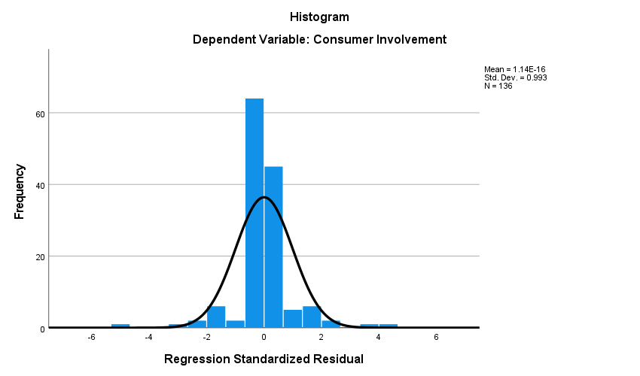
Figure 17: Histogram for H1
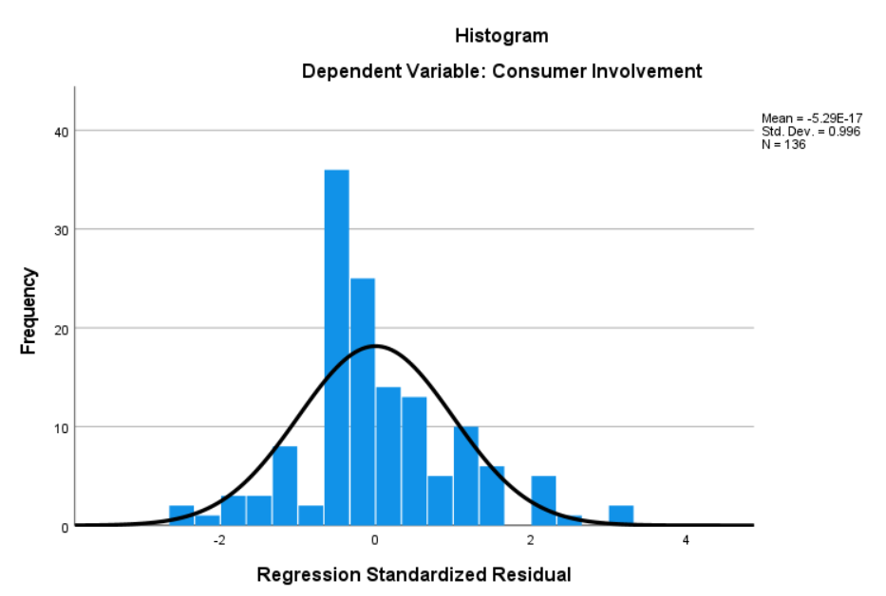
Figure 18: Histogram for H2
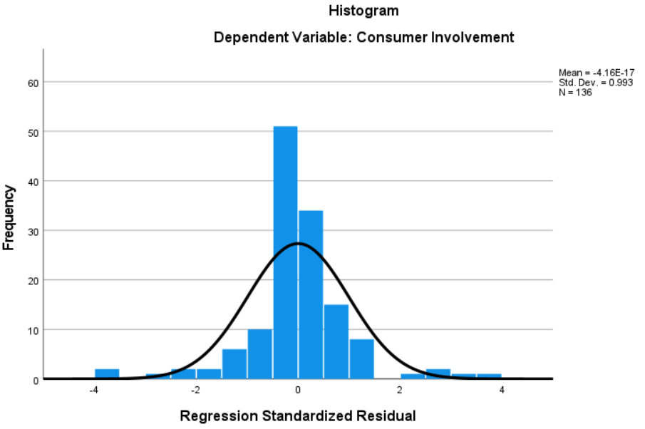
Figure 19: Histogram for H3
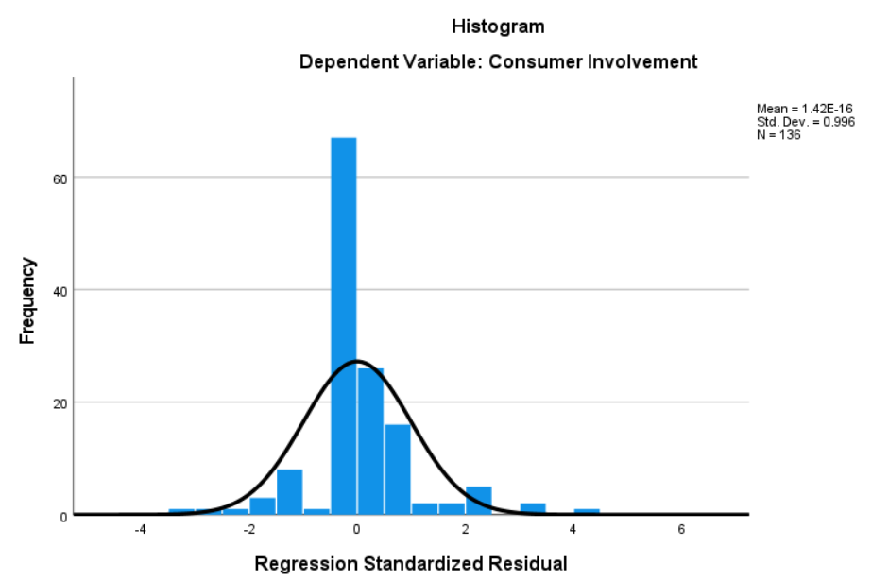
Figure 20: Histogram For H4

Appendix 8 : Participant Consent Form

Appendix 9 : Participant Information Sheet

