TITLE: PROGRAMME IMPROVEMENT PROJECT
PROGRAMME NAME: MSc DIGITAL SKILLS FOR THE HEALTH AND CARE PROFESSIONS
COURSE: DIGITAL TECHNOLOGY IN HEALTH AND SOCIAL CARE
COURSE CODE: BMDS7006
STUDENT ID: 2211947
ACADEMIC YEAR 2022/2023
DATE OF SUBMISSION: 3RD MARCH 2023

TABLE OF CONTENT
- TASK DESCRIPTION – page 3
- INTRODUCTION – page 4
- METHODOLOGY – Page 7
- RESULTS – Page 9
- DISCUSSION – page 27
- CONCLUSION AND RECOMMENDATION – page 30
- REFERENCE LIST – page 31

TASK DESCRIPTION
Currently, the health and care sectors use a variety of different systems and technologies.
Your task in this assessment is to identify a software product that has been adopted to support a particular team or function. As part of this assessment, you will be required to explore the applicability of the implemented solution to the underlying task. You should critically analyse the benefits and limitations of the product, identifying key areas that pose challenges.

Use the FITT framework (Ammenwerth et al., 2006: https://bmcmedinformdecismak.biomedcentral.com/articles/10.1186/1472-6947-6-3) to guide your approach to the evaluation.

Your document structure should follow the IMRAD structure as explained below with appropriate references for sources that you have cited.

In the Introduction, describe the service context and the purpose of the software product. In the Methods, describe the FITT framework and how you have applied it or varied from it. Also in this section, describe how you collected data (literature, observation, interviews with users, your personal experience or something else). In the Results section, give a summary of what data you collected and report any quantitative ratings or qualitative themes that emerged. In the Discussion, reflect on the key findings and relate them to other relevant domain knowledge from the literature. You may also wish to discuss the limitations of the FITT framework and describe alternative approaches that could have been used. Make sure that you discuss the value (and limitations) of the given software product on the provision of “seamless care”

INTRODUCTION
Swansea Bay University Health board is one of the busiest health boards in South Wales. It provides excellent health care services in broad and varying ways. NHS Health professionals under this Health board are spread across Swansea and Neath, in hospitals, GP surgeries, Clinics, care homes and community posts. The exchange of information amongst these health professionals is critical to the care of the patients under them. The GP records as well as the medical history of a patient is vital in making clinical decisions. It is also important that doctors and other health professionals have up to date records of patients at all times. This includes clinic letters, appointment letters and notes such as operation notes and discharge letters from different specialties. The unavailability of such information can lead to the loss of life or disability of a patient. Unnecessary delays lead to prolonged wait times for patients and this contributes to the high cost of running the Health board. Often times NHS health care professionals have to attend to patients who are originally outside the area covered by the Swansea University health Board. In such situations, information from their original health board will prove to be vital in the care given. The availability of trusted but secure information should therefore act as a game changer if accessed at a single point.
The Welsh Clinical Portal (WCP) was introduced in Wales in 2011 to solve the problems encountered by clinicians in Wales when trying to access patients’ health records. The transfer and exchange of clinical information has been made possible by this platform (WCP). The portal has many features that help provide NHS health professionals with vital digital health records of patients seen at different health care settings. One of the key features is Patients’ GP records. With this GP record, clinicians are able to view list of medications prescribed for a patient. This includes past and present medications. The same applies for tests and investigations requested for a patient and their results. Allergy status and warnings, which is a very important aspect of prescribing is also visible on this platform.
Another feature on the WCP is a section for documents such as referral letters, appointment letters, clinic notes and care plans.
WCP also has a feature that allows health professionals to request specific tests and investigations to be done at specified times. When these are ready, the clinician is able to view and sign them off electronically wherever they find themselves. They can then discuss the results if necessary with other health professionals who also have instant access. A new feature was introduced later on that allows clinicians to put patients on a watch list and follow them up closely. This ensures that high-risk patients are not lost to follow up. (Digital health and Care Wales, systems and services)

Literature Review
Advancement in technology has been one of the key components of globalisation. This advancement has made the transfer of information from one end of the world to another a seamless task. The health sector like many other sectors has benefited tremendously from the use of technology in the form of softwares and applications. This was not the case in recent past when health professionals had to rely on the exchange of information on printed materials. This often meant sending letters by post, fax or calling other health professionals for information. This caused unnecessary delays in the care of patients especially in emergencies. The introduction of technology has therefore improved significantly the care provided and helped save lives that would otherwise have been lost. Digital health Records are a key factor in improving the quality and safety of healthcare. They reduce negative outcomes for patients and decrease the costs of operation. By improving clinical research, digital health records also lead to best clinical performance. (De Benedict et al 2020)
It is believed that the age of computer and mobile applications is here to stay. The introduction of applications and software however does not come without challenges as hospitals continue to experience resistance from professionals to accepting digital technology. Some factors contributing to this resistance are the opinions and attitudes of the health care professionals using the technology (Safi et al 2018)
There has been successes and failures. Several factors have been identified as contributory factors towards the success or failure of a change. These are grouped into individual factors, technology or tools available and tasks related challenges. A users attitude towards change and technology, their skill set and other factors will contribute to the use of the new technology. Also the task to be performed if complicated and time consuming will act as a challenge. The availability of the hardware needed to assess the technology could also play a vital role. (Ammenwerth Et al 2006)

METHODOLOGY
Aim: To explore the applicability of the Welsh Clinical portal in providing digital health records to NHS health professionals.
Objectives
- To evaluate the attitude of NHS health professionals in Swansea Bay towards the use of the WCP.
- To identify the fit between the individuals, the task and technology
- To identify the challenges experienced by the users.
- To identify the benefits of the WCP
- To identify the limitations of the WCP
Based on the literature review, I used the FIIT Framework to identify the interaction of users, tasks and technology as the basis to understand how the Welsh Clinical Portal has been adopted.
The FIIT framework is based on the principle that adaptation of technology is based on the fit between the attributes of the individuals using the technology, the technology itself and the tasks to be performed.


Figure 1. image from The FITT framework: IT adoption depends on the FITT. FITT: fit between... | Download Scientific Diagram (researchgate.net)
The figure above shows the interaction between the individuals, the tasks and technology

In this research the users refer to the doctors in Swansea Bay University Hospital , the technology refers to the Welsh Clinical Portal and the Task refers to all the functions available on the portal.
Population of Study
The population of interest for this study was all doctors working in the mental health department of the Swansea Bay University Hospitals. The hospitals under the Trust are Cefn Coed Hospital, Neath Port Talbot Hospital, Tonna Hospital, Singleton Hospital and Morriston Hospital
Sampling
Doctors working under the mental health department of the trust were identified and used for the study. This includes GP trainees and psychiatrists.
Data collection
Survey in the form of questionnaire was created using google forms. The link created was shared to the WhatsApp group of doctors working in Cefn Coed hospital and Neath Port Talbot hospital under the mental health Service.

RESULTS.
A total number of thirty (30) responses were received from the questionnaires that were sent out. The number of doctors in the group was 53. This makes a response rate of 56 percent (56%).
From the data received, majority of the responders were in the age group of 25-34 years. This represented seventy percent (70%) of responders. Twenty percent (20%) were in the age group of 35-44 years old. The least represented group were those between 18 and 24 years (20%). None of the responders was above the age of 44 years old.
All grades of doctors responded to the questionnaire. The grade of doctors most represented was F1-F2/F3. These are foundation doctors, the most junior doctors in the NHS. They represented thirty (30%) of responders. ST1 and ST2 doctors with representation of 26.7% each followed them closely. Only one consultant and one higher trainee responded to the questionnaire. This represents 3.3% each.

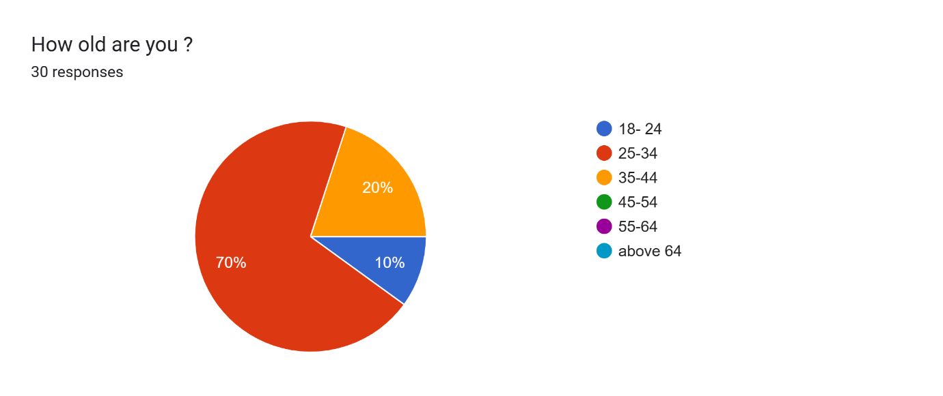
Figure 2.
Figure 2 shows the proportion of responders by age groups.
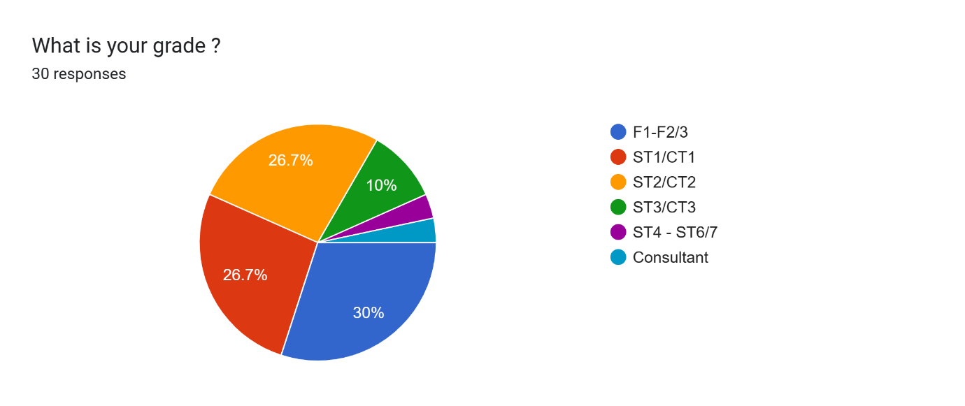
Figure 3.
The pie chart above shows the proportion of doctors in the various levels of training.
Of the 30 responders, only 5 (16.7%) had a certificate relating to information technology and only 11(36.7%) had used a similar platform prior to using the Welsh Clinical Portal. Almost two-thirds (66.3%) of the responders had no prior experience with a similar platform.

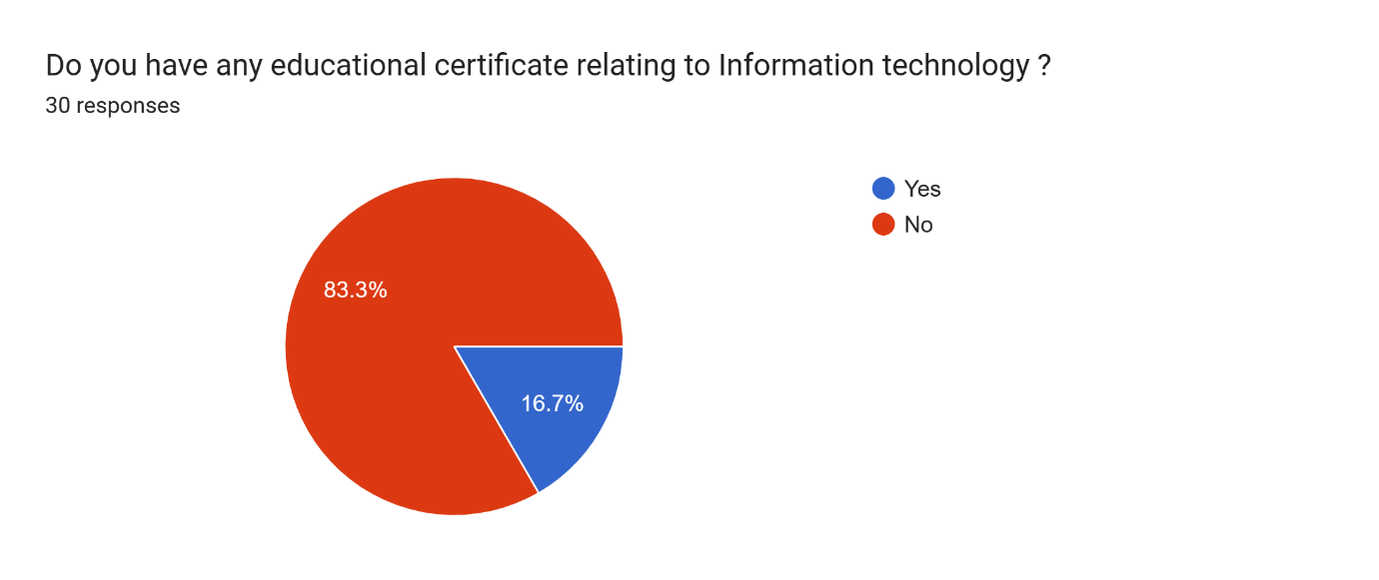
Figure 4.
Image showing the proportion of doctors who had some educational background in Information technology
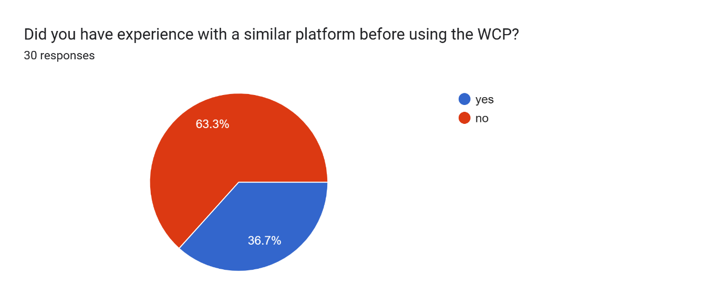

Figure 5.
Pie chart showing percentage of doctors who had experience with similar platforms prior to using the WCP.
Concerning training before the use of the Portal, half (50%) of the responders had no training while the other half had some training prior to the use of the portal (Fig. 6). Of those who had some form of training sixty percent (60%) had less than an hour of training. A third of them 33.3% had training sessions lasting between one hour and 12 hours. None of the responders had training session lasting more than a week. (Fig. 7).
Majority of the doctors (86.2%) do not receive further training when new features are introduce. Only 13.8 % had some training with new features. (Fig. 8)

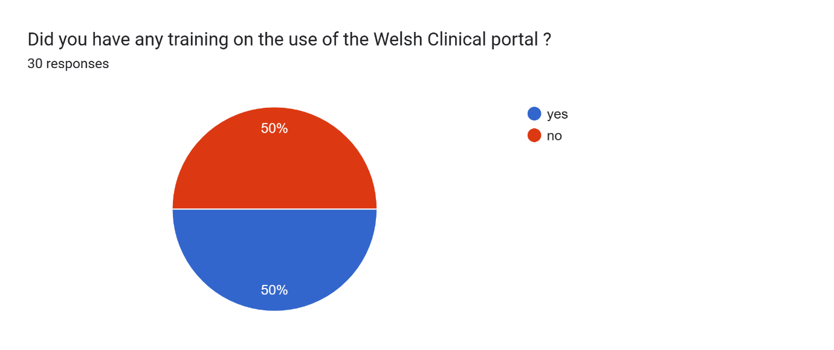
Figure 6.
The pie chart shows the proportion of doctors who received training before the use of the WCP.

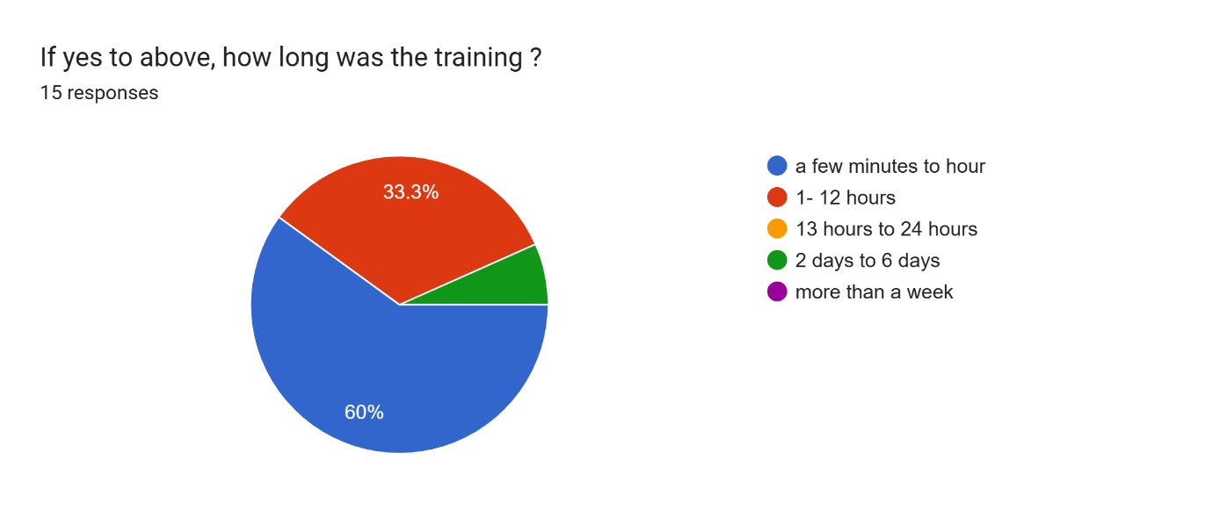
Fig. 7
Image showing the duration of training received.

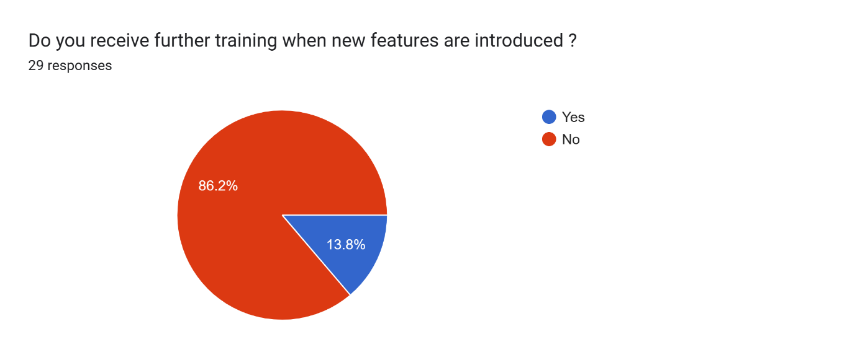
Fig. 8
Pie chart showing the proportion of doctors who receive further training with the introduction of new features.

Majority of doctors (63.3%) working in the mental health department of the hospital have used the portal for one to five (1-5) years. Thirty percent (30%) had used the portal for less than a year. Only two (2) responders (6.7%) have used the portal for more than 5 years. (Fig 9)
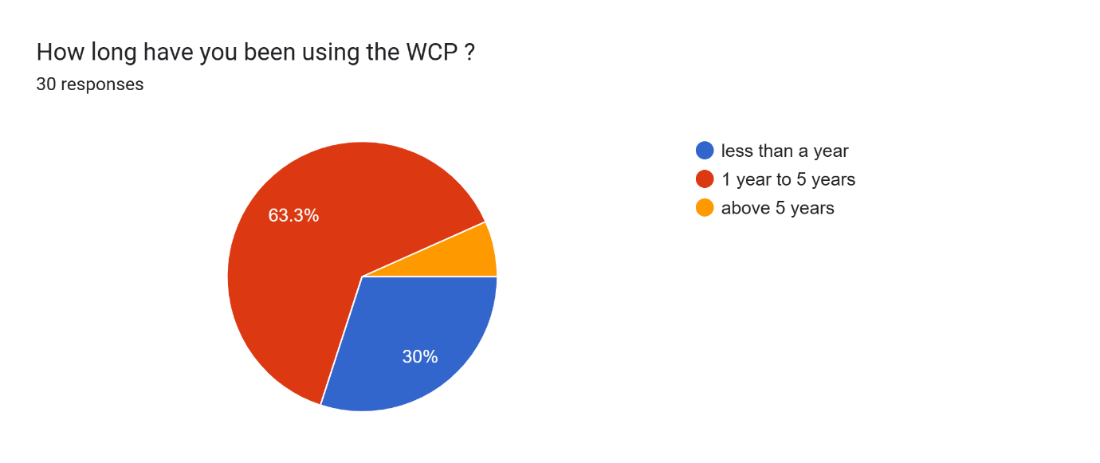
Fig 9
Image showing the percentage of doctors and their duration of use.

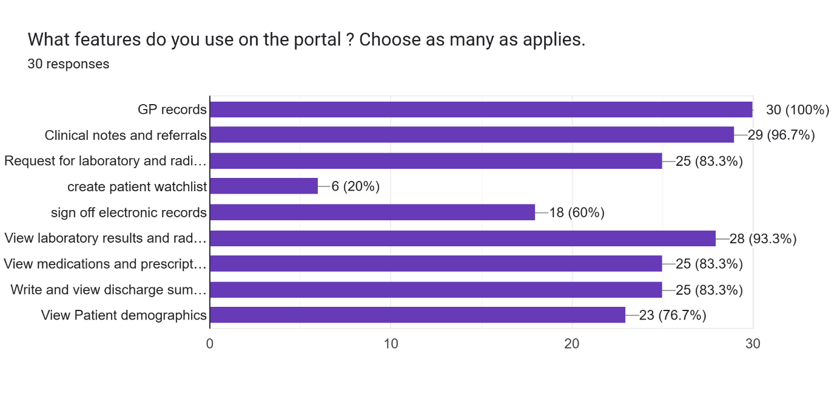
Fig 10
The bar chart above shows the features on the WCP and the percentage of doctors who use them.
The three most commonly used features are the GP records (100%), clinical notes and referrals (96.7%) and viewing of laboratory results and radiology images (93.3%). The least used feature for doctors in this group is the creating of patient watch list. (20%).
Concerning the skills needed to use the WCP, majority (93.3%) of responders strongly agreed (40%) or agreed (53.3%) to have the necessary skills needed to operate the Portal. None of the doctors (0%) disagreed to be skilful enough to operate the portal. (Fig. 11)
Two-thirds (66.6%) of the group felt it was easy using the WCP. 23.3% of the users strongly agreed to the statement while 43.3% simply agreed to the statement. Only 1 out of 30 responders (3.3%) strongly disagreed. (Fig 12)

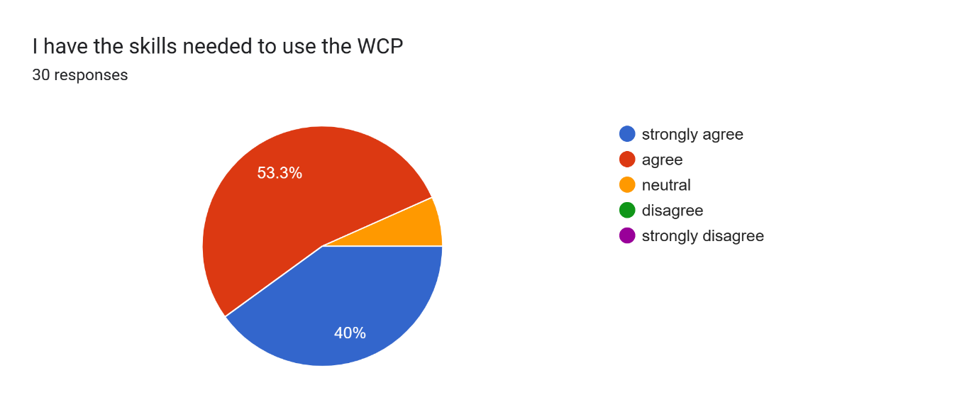
Fig 11.
The pie chart shows the proportion of responders who agreed they had the necessary skills to use the WCP.
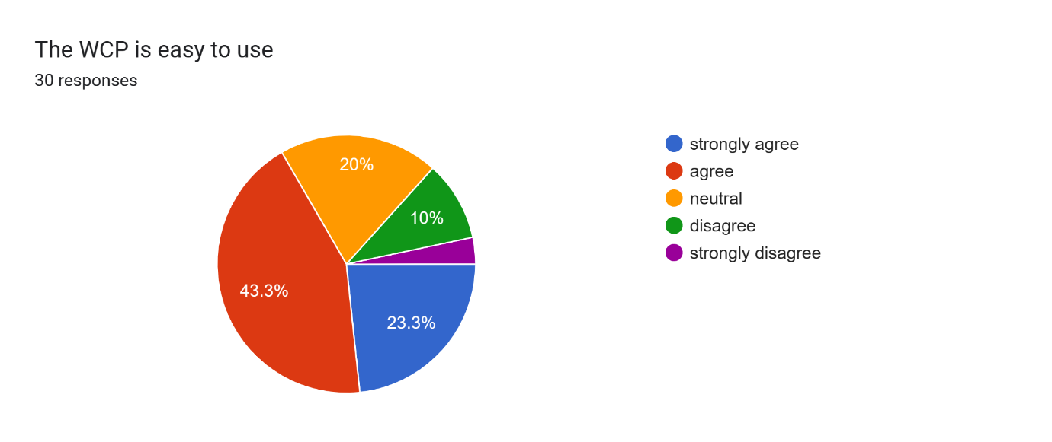
Fig 12.
Image showing the proportion of doctors who agreed and disagreed to the statement that the WCP is easy to use.

Majority of responders 86.7% agreed to some level (40%- strongly agreed. 46.7% agreed) that they enjoyed using technology to complete tasks. None (0%) of the doctors disagreed to the statement. (Fig 13.)
When it comes to completion of tasks on the portal, two-thirds (66.7%) of the group agreed to some degree that it took a reasonable amount of time to do so. Half (50%) agreed and 16.7% strongly agreed to the statement. Twenty percent (20%) of responders disagreed that completion of task on the portal takes reasonable amount of time but none of them strongly disagreed. (Fig. 14).
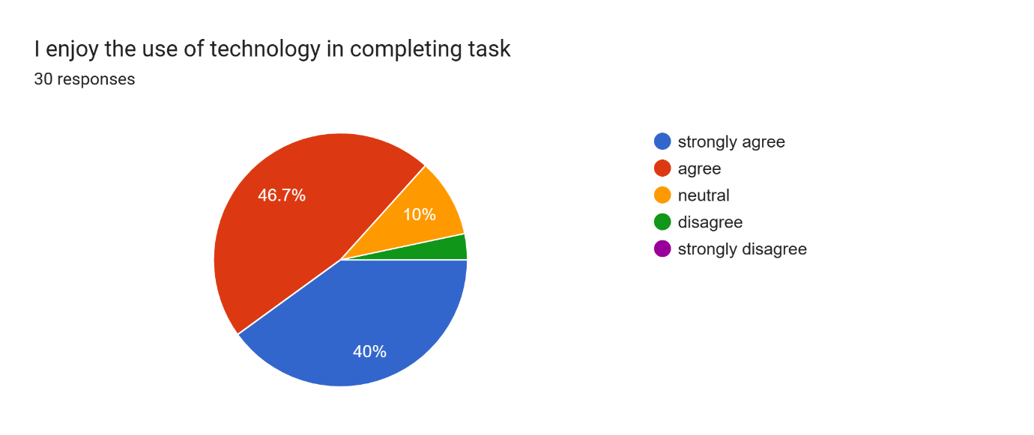
Fig 13.
Pie chart showing the percentage of doctors who agree and disagree to the statement, ‘I enjoy the use of technology in completing task’

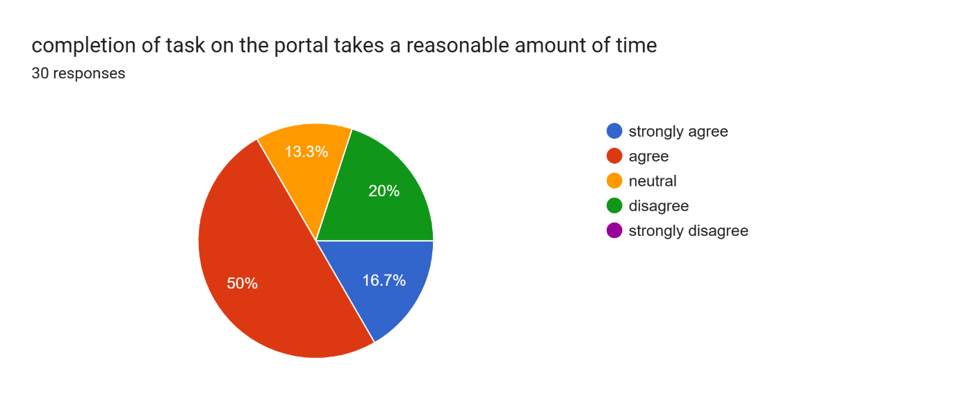
(Fig. 14) Pie chart showing the level of agreement of doctors to the statement ‘completion of task on the portal takes a reasonable amount of time’.

Concerning the availability of computers, half (50%) of responders disagreed that computer availability was not an issue. (13.3% strongly disagreed, 36.7% disagreed).13% of the remained neutral while 30% and 6.7% agreed and strongly agreed respectively. (Fig. 15)
Eighty percent (80%) of responders agreed to some degree (53.3% strongly agree, 26.7% agree) that mobile access would improve certain clinical situations. Only 6.7% of responders disagreed to the statement. (Fig. 16)
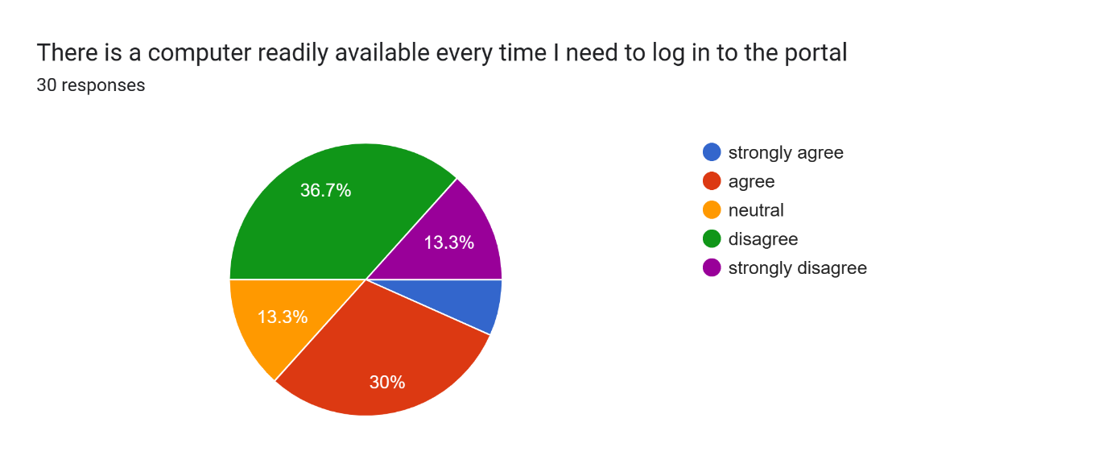
Fig 15.
Pie chart showing the degree of agreement to the statement, ‘there is a computer readily available every time I need to log in to the portal’.
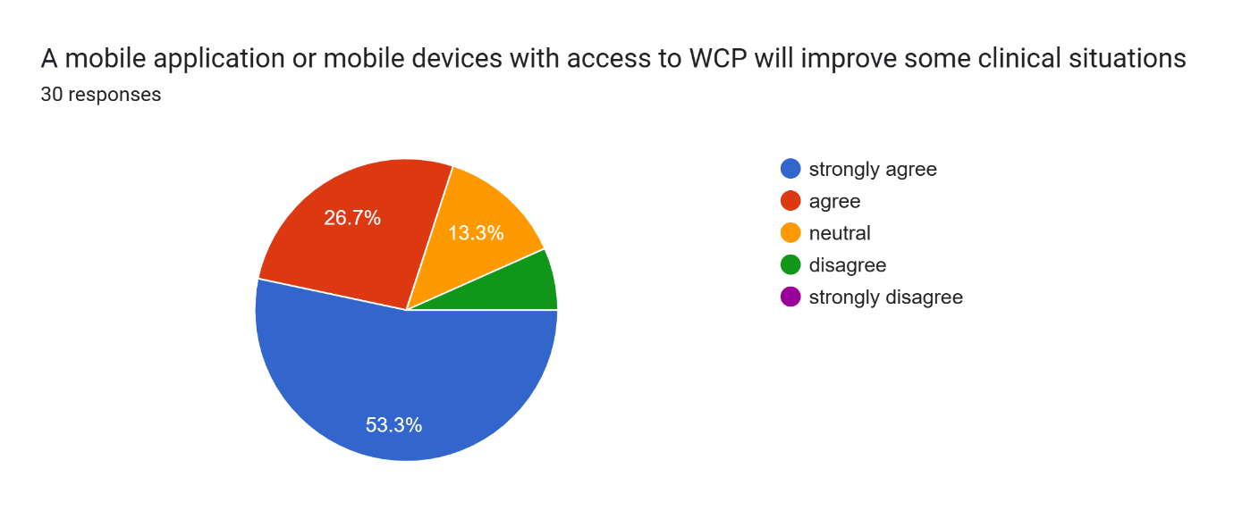Fig 16.
Image showing the degree of agreement to the statement, ‘a mobile application or mobile devices with access to the WCP will improve some clinical situations’.
Some doctors had some comments regarding mobile access. Below are some concerns shared by the responders:
- ‘’I think more computers/laptops would be more useful than other devices’’
- ‘’Very difficult to set up - no one seems to know why mine won’t work/no answers’’
- ‘’Whilst on my surgical placement there was a dire need to access blood results/investigations during ward rounds. Lack of computers available in the morning in surgical wards (MH) led to delays in the ward rounds and inefficient interpretation of results as there is a pressure to see all patients at a reasonable time. On occasion, this led to information being accessed later causing delayed communication to the patient. An app created to access this information could be a reasonable approach to combat this, and improve efficiency of ward rounds whilst keeping safe patient practice. Security and confidentiality concerns on private devices could be addressed by introducing a device specifically for each ward round with the core purpose to access WCP. This can be beneficial for minimising stressors during the ward round where majority of communication between junior doctors and consultants occur. Ease of access during this time would lead to improved communication between all members of the multidisciplinary team including patients and help to identify concerns from all members of the ward round, which would aid in clinical decision-making’’.
- ‘’I have mobile access to WCP and use it regularly when on Ward rounds or reviewing unwell patients where there is no available computer / I haven’t got time to go to a computer’’
- ‘’It would be very helpful for those without a base ward I.e. surgical doctors. However, safeguards would need to be in place to only access records in hours to prevent people working from home’’
- ‘’Two factor authentication would be needed to protect patient data and you should not be allowed to copy and paste into other apps on your personal device’’
- ‘’When moving from one ward to another ,it would be easier to have access via mobile’’
- ‘’When there are no computers available. E.g. 4 computers on the ward today, for 4 doctors, 5 nurses, ward Clark, HCA, pharmacist (we have online prescriptions too)’’
- ’’I only have reservations about having access to WCP on my personal device because it is already so hard to switch off from work. If we were given staff phones which you could turn off out of hours that would be more appropriate but obviously less likely to happen’’.
- ‘’Essential’’
- ‘’Not sure it would help much as need bigger screen. Laptops/5ablets might help’’.

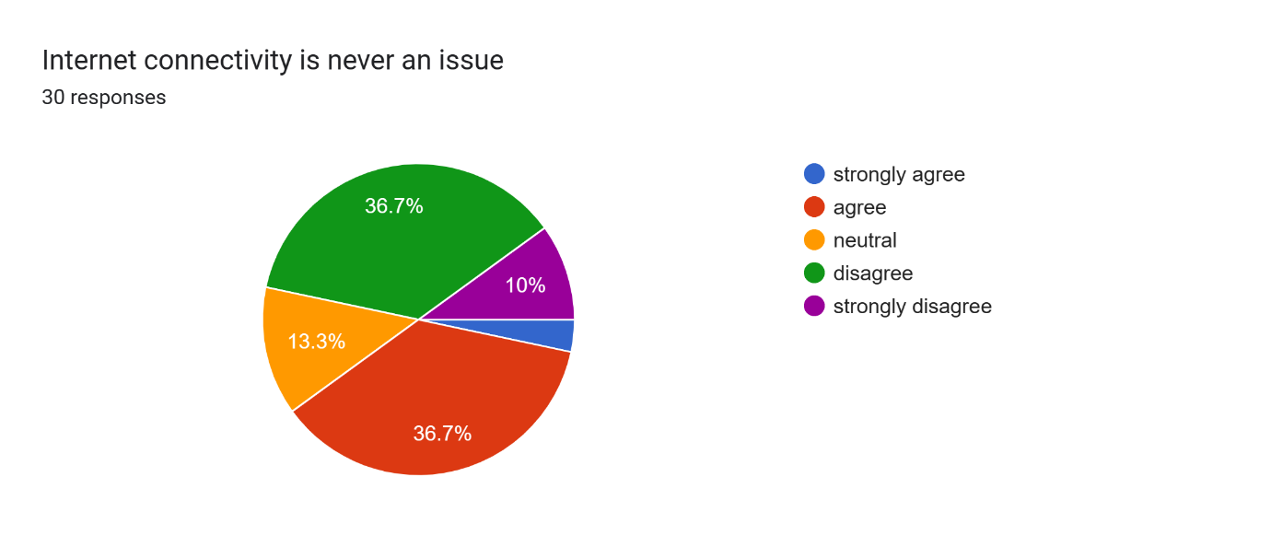
Fig 17.
Image showing the level of agreement of responders to the statement, ‘internet connectivity is never an issue’.
About internet connectivity, Forty percent (40%) of responders agreed (3.3% strongly agree, 36.7% agree) that internet connectivity was not an issue but 46.7% disagreed to this statement. (10% strongly disagree, 36.7% disagree). (Fig. 17)
The majority (93.4%) of doctors who responded agreed that the WCP has made their job easier. (26.7% strongly agreed, 66.7% agreed). Only one respondent making 3.3% of the group disagreed to this statement. (Fig.18)

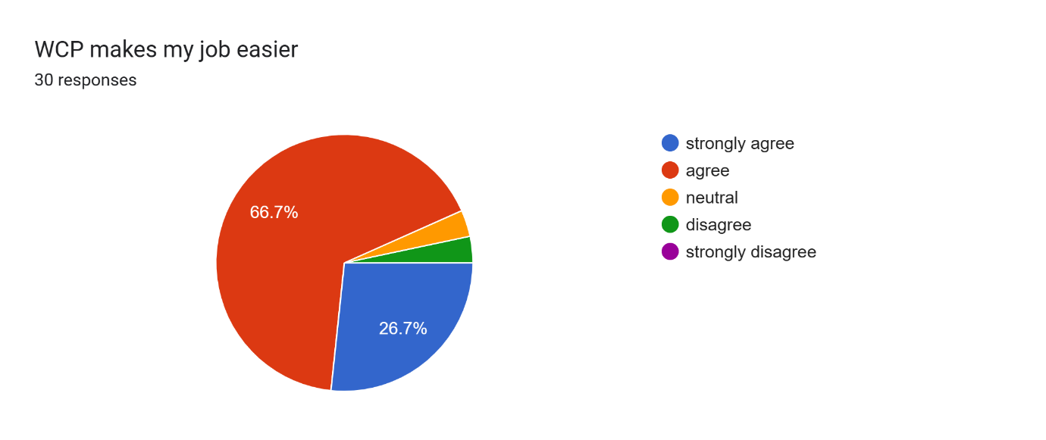
Fig. 18
Image showing the level of agreement to the statement. ‘WCP makes my job easier’
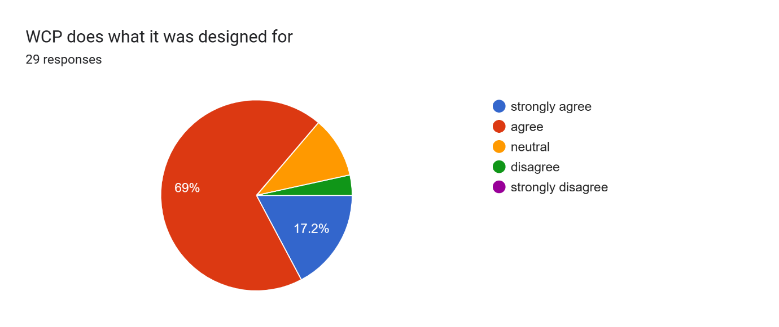
Fig 19.
Image showing the level of agreement to the statement, ‘WCP does what it was designed for’.
Concerning the functionality of the Portal, majority of the doctors (86.2%) felt the WCP did what it was designed to do. 17.2% and 69% of responders strongly agreed and agreed respectively to this statement. Only one person (3.4%) disagreed that the WCP does what it is supposed to do. (Fig. 19)
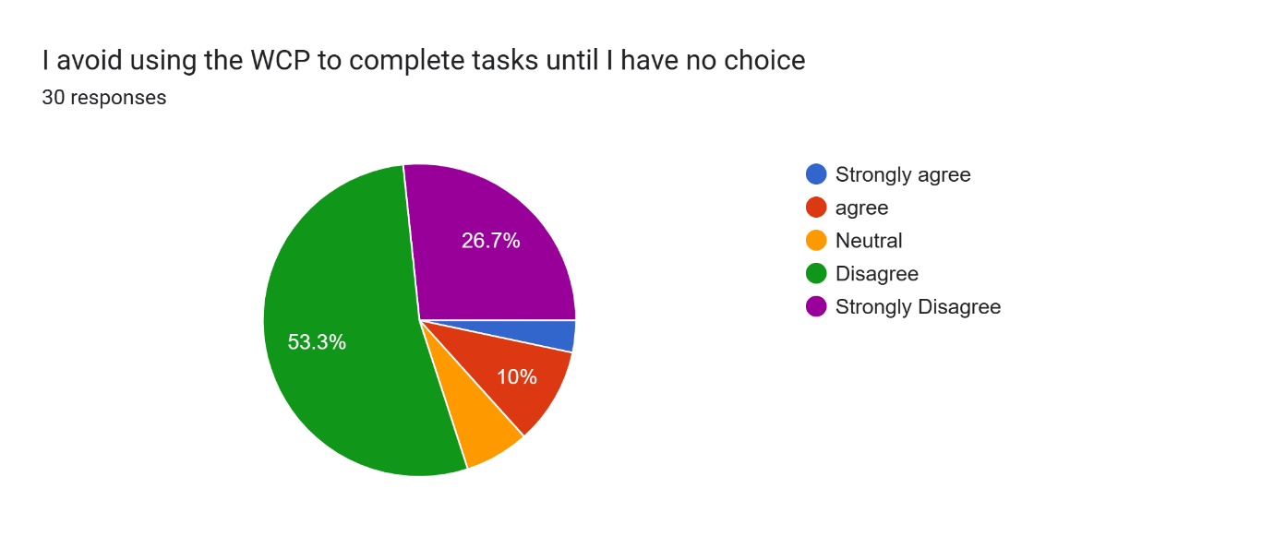
Fig 20.
Image showing the level of agreement to the statement, ‘I avoid using the WCP to complete tasks until I have no choice’
The data collected showed that some doctors avoid completing tasks on the WCP until they have no choice. 13.3% agreed to avoid the WCP until they had no choice. (10% agreed, 3.3% strongly agreed). Majority of the doctors however did not see themselves avoiding the WCP until they had no choice. Eighty percent (80%) disagreed to the statement in varying degrees. 53.3% disagreed while 26.7 strongly disagreed. (Fig. 20)
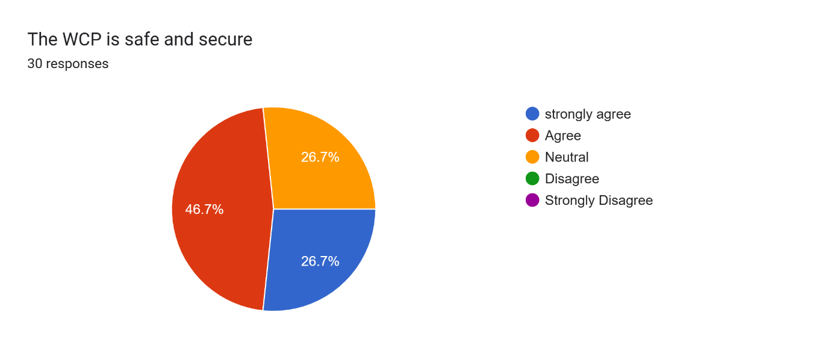
Fig 21.
Pie Chart showing the level of agreement to the statement, ‘The WCP is safe and secure’.
Concerning security, the majority (73.4%) of the responders agreed the WCP was safe and secure. (26.7% strongly agreed while 46.7% simply agreed). None (0%) of the doctors thought the WCP was unsafe and secure. 26.7% remained neutral. (Fig. 21)
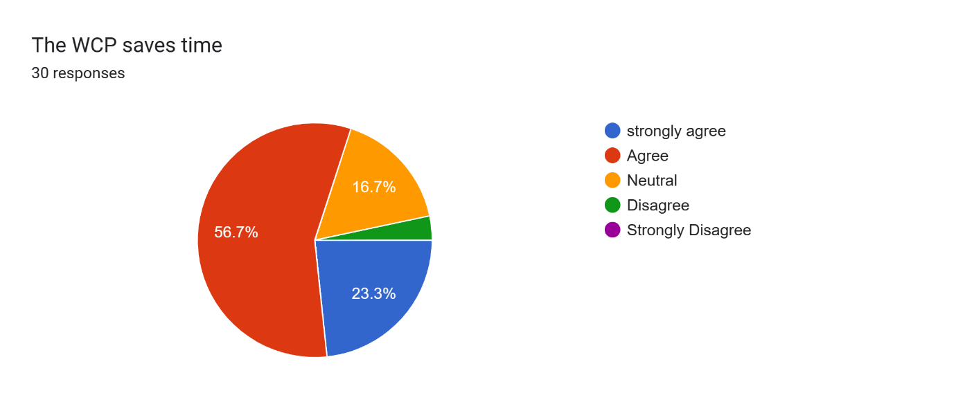
Fig. 22
The pie chart shows the level of agreement with the statement, ‘ The WCP saves time’.
Eighty percent 80% of responders felt the portal saved time in completing tasks. 56.7% and 23.3% agreed and strongly agreed respectively to the statement that the WCP saves time. One responder however disagreed to the statement. This represents only 3.3% of responders. (Fig. 22).
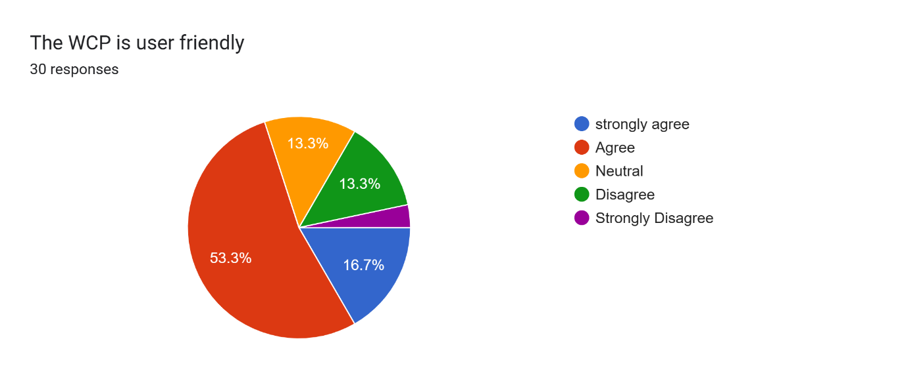
Fig 23
The Image shows the level of agreement to the statement, ‘The WCP is user friendly’.
Seventy percent (70%) of doctors were of the opinion that the Welsh clinical portal was user friendly. 16.7% strongly agreed while 53.3% agreed to the statement. In total 16.6% disagreed to the statement. (13.3% disagreed, 3.3% strongly disagreed) (Fig 23)
In addition, switching from one task to another is easy for 53.3% of doctors. (43.3% and 10% of doctors agreed and strongly agreed respectively). 26.6% disagreed to the statement that it was easy to switch from one task to another. (3.3% strongly disagreed while 23.3% disagreed). The remaining 20% stayed neutral. (Fig 24)

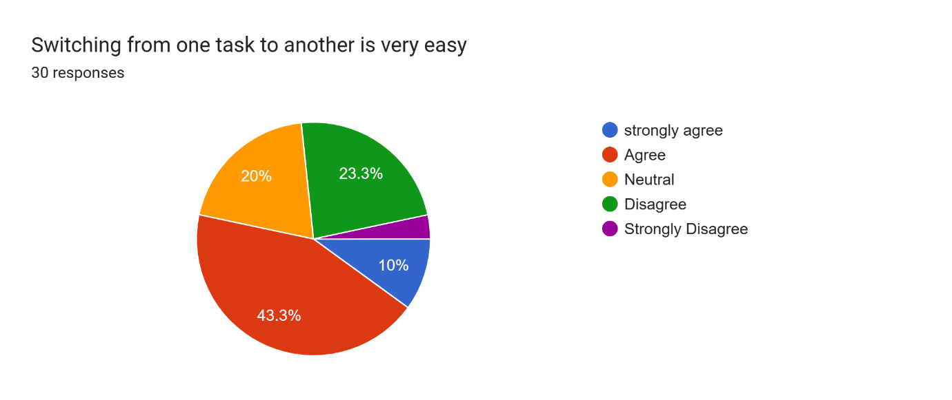
Fig. 24
The pie chart shows the level of agreement with the statement, ‘Switching from one task to another is very easy’.
Concerning help, a significant number of doctors could not get the help they needed at all times when they encountered problems with the WCP. 40% disagreed to some level that help is always available when needed. (13.3% strongly disagreed, 26.7% disagreed)
Only 26.7% agreed to the statement. (10% strongly agree, 16.7% agree). (Fig 25)
Out of the thirty doctors who responded, half (50%) agreed to some degree that the portal works smoothly but an appreciable number also disagreed at varying degrees. 13.3% of the doctors strongly disagreed while another 13.3% simply disagreed. (Fig 26)

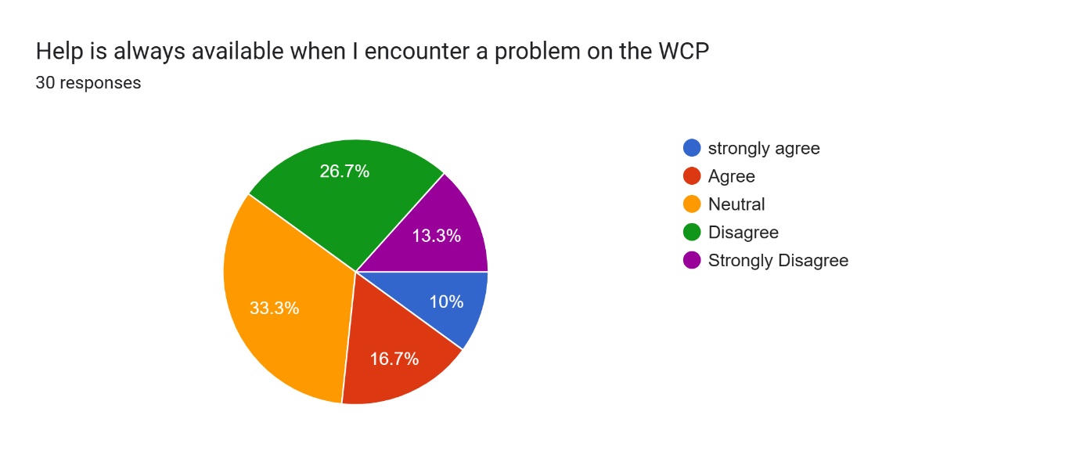
Fig 25.
The pie chart shows the level of agreement of responders to the statement, ‘help is always available when I encounter a problem on the WCP’.
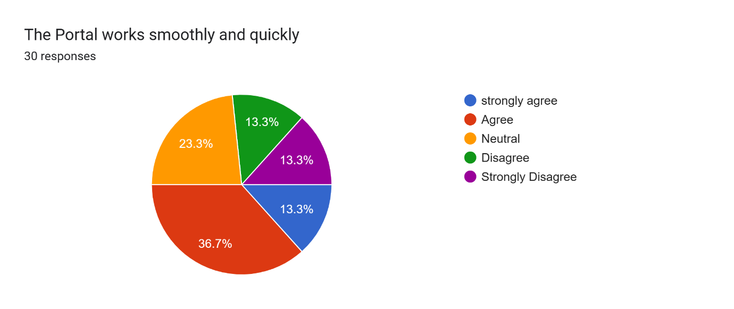Fig 26
Image showing the level of agreement with the statement. ‘The portal works smoothly and quickly’.
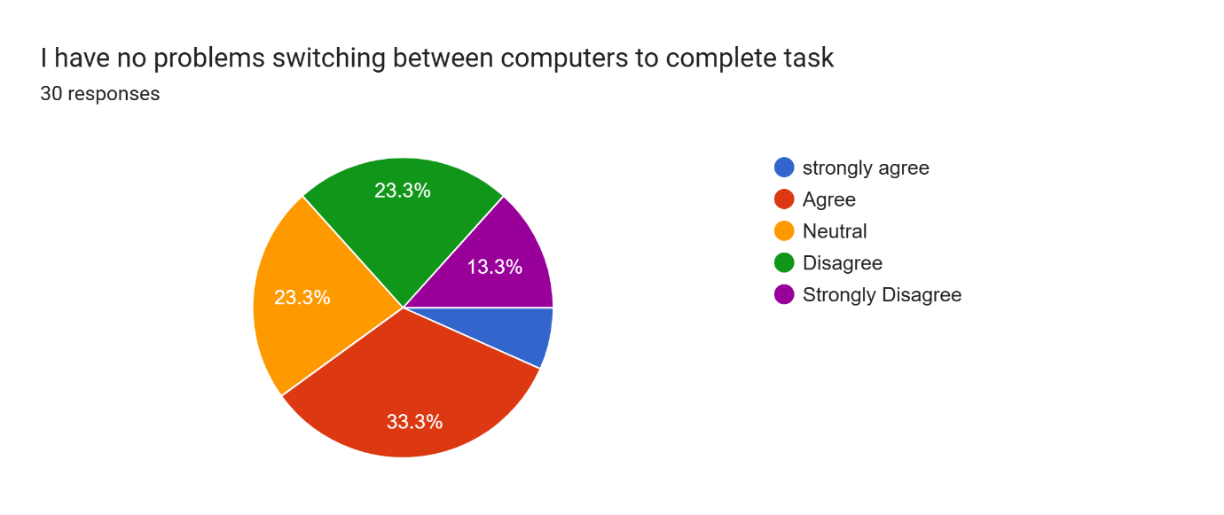
Fig 27
Pie chart showing the level of agreement to the statement, ‘ I have no problems switching between computers to complete task’.
Forty percent (40%) of responders had no difficulty switching between computers to complete tasks on the WCP. 33.3% agreed to the statement while 6.7% strongly agreed. Quite a significant proportion of the doctors (36.6%) disagreed that it was easy switching between computers.13.3percent strongly disagreed while 23.3% disagreed. (Fig 27)

The WCP has its own limitations. These are some of the responses received from the doctors when asked, ‘What limitations have you identified with the use of the WCP?’
- ‘’Mainly speed r computer as opposed to the actual platform - some computers cannot open some tabs et cetera’’
- ‘’Limited access- available only last few of years of documentation’’
- ‘’Sometimes it’s just stuck. May be due to internet issue’’
- ‘’Ease of access - as described above. - Access points for WCP (Lack of computers - this is time dependent e.g. mornings can find difficulty to find computers rather than afternoons). - DALs - time out period leads to loss of completed dal prior to submission (self-save for drafts)’’
- ‘’It is sometimes very slow and when I report to service desk they say they can’t fix that’’
- ‘’Unable to send blood test add-ons electronically. Unable to request scans via WCP. Unable to accept referrals or refer via WCP despite the function being there’’.
- ‘’It is slow. It lays out information poorly. It can be difficult to access certain parts of WCP. Searching for patients could be made easier There isn't always a pc available to use WCP on the ward You can't prescribe or request meds or investigations
- ‘’Unable to view psychiatry records for medical patients. Unable to view some outpatient documentation such as memory clinic. Unable to upload documents (specific cases of patients who are out of area and their GP’s have sent me documents which are super relevant but honestly was such a pain to try and get uploaded). It should have a specific tag for DNAR orders and be made easily accessible (separate to warnings list). It would be useful to have a tag for palliation decision making and it come up with a warning when people try and request bloods. I have never requested radiology, how do you even do that? I would be useful if signal/WCNR/WCP spoke to each other it’s so frustrating having to swap between systems - would be useful if DALs could auto populate with information, and then the discharging team need to review before them being signed off. Honestly so frustrating when you go to an old DAL just to find it empty. - should be the ability to create a DAMA form to have an online record of this - medics discharging from ED need to create a DAL, and I’m not sure a lot of my colleagues know how to do this - ability to put internal referrals onto the system for audit control - blood tests should auto populate to the base ward and consultant of the patient not the requestor’’
- ‘’Doesn't have all patients on it’’
- ‘’It can be slow sometimes’’
- ‘’WCP gets off often, very slow to process or on requesting info’’
- ‘’Every time it asks for an update security!’’

DISCUSSION
In general, the WCP has proven to be a good addition in improving patient care.
The discussion of the results will follow the FITT framework. This will focus on the individuals (doctors), the task and technology (WCP).
Concerning the individuals, the majority of users of the portal are junior doctors who need to make a lot of assessment and referrals. The study showed that majority of responders were juniors. Representation of doctors in the group may however be because many senior doctors are not on the platform and majority of seniors (consultants) on the WhatsApp platform do not read their messages. The few that read messages do not engage in discussions. This may also account for the lower age range of responders. (18-44 years).
Having knowledge in information technology could affect the attitude of health workers towards the use of a software.(Olok et al, 2015). The group studied had very limited knowledge or certification in information technology, most of them had no prior experience with a similar portal and training on the WCP was done for a few and for a few hours. In addition, the doctors do not receive further training when new features are introduced. This could explain why some doctors had challenges with the use and why some avoided the use of the portal until they had no choice. One doctor did not know how to request for radiological imaging and did not think it was possible. Improving the level of skills by way of training could improve the applicability of the WCP. It is however commendable that majority of the doctors felt they had the skills needed to use the portal. The skills needed to operate the portal could have been gained from learning from other health workers or learning on the job.
Tasks- the WCP has provided doctors with the platform to perform several tasks. Majority of the doctors use these features and have agreed that the introduction of an Electronic Health Record has helped saved time and made their work easy. The features used the most were GP records, clinical notes and letters and viewing of laboratory results and radiological images. This forms the chunk of duties performed by junior doctors on daily basis. It is therefore essential that any software introduced is able to do this seamlessly. Majority of the doctors agreed their job has been made easier with the introduction of an electronic health record. They are able to save time by using the WCP. Most of the doctors could switch computers to complete tasks. Some doctors had difficulties requesting certain laboratory investigations on the platform while others said they could not prescribe medications with the portal. This is an important feature that will be beneficial to the care of patients.
Technology – The components that make up the technology play a vital role in the applicability of any technology. In this study, the technology includes computers, internet connectivity, scanners and printers, the software and its updates and IT help desks.
Availability of computers seem to be a problem for the doctors. This means that doctors have to queue to take turns and low priority jobs have to postpone for urgent ones. This would in turn affect patient wait times and discharges from the hospitals. For example, if a patient is waiting to be seen by a specialist before discharge, the typing and sending of the referral letter could be delayed because of the queue. A mobile application could also be helpful in certain situations like ward rounds. Sometimes information needed during these ward rounds is not readily available. Either a doctor has to leave the rounds to go fetch the information or add on to the list of things to do. Without the information, some decisions cannot be made thus prolonging time needed to make decisions which delays care. Also adding such a needless task to the already tall long list of the junior doctor adds to the stress they go through. A few doctors said they had mobile access during these situations and it makes the job easier.
A significant number of doctors said help was not available at all times when needed. Without prompt help, things would slow down and several tasks would not be performed.Time is of the essence in health care. The WCP helps in saving time but more time could be saved with little input like readily available IT desk helpline.
Many doctors disagreed that internet connectivity was never an issue. For a platform that relies on internet a break in internet, connectivity will slow down everything in the hospitals, as most tasks requires communication. Some doctors said it could be slow sometimes and this needs to be worked on.

Limitations of the study-
Ideally, some questions should have been asked about the clinical practice before the introduction of the WCP, however most of the population studied started working in the health board way after the introduction of the WCP in 2011. The studies thus focused on the clinical practice after the introduction of the WCP. Also a wider and more varied responders could have helped explore challenges encountered in other specialties. Due to time constraints and resources, the study was limited to a small group of doctors in the health board

CONCLUSION AND RECOMMENDATIONS
- The Welsh Clinical Portal has been very instrumental in the advancement of Health Care. It has saved millions of lives and will continue to do so. To improve upon applicability and efficiency of use, more resources should be geared towards the training of individuals and the provision of logistics needed to use the software.
- Further research into the area should consider a wider group of doctors
- Management should make improvement of the WCP a priority .
- Stake holder consultations should be done periodically to understand the changing needs of healthcare.

REFERENCE LIST

- Ammenwerth, E., Iller, C. & Mahler, C. IT-adoption and the interaction of task, technology and individuals: a fit framework and a case study. BMC Med Inform Decis Mak 6, 3 (2006). https://doi.org/10.1186/1472-6947-6-3
- De Benedictis A, Lettieri E, Gastaldi L, Masella C, Urgu A, Tartaglini D (2020) Electronic Medical Records implementation in hospital: An empirical investigation of individual and organizational determinants. PLoS ONE 15(6): e0234108. https://doi.org/10.1371/journal.pone.0234108
- https://bmcmedinformdecismak.biomedcentral.com/articles/10.1186/1472-6947-6-3)
- Olok, G.T., Yagos, W.O. & Ovuga, E. Knowledge and attitudes of doctors towards e-health use in healthcare delivery in government and private hospitals in Northern Uganda: a cross-sectional study. BMC Med Inform Decis Mak 15, 87 (2015). https://doi.org/10.1186/s12911-015-0209-8
- Safi S, Thiessen T, Schmailzl KJ Acceptance and Resistance of New Digital Technologies in Medicine: Qualitative Study JMIR Res Protoc 2018 https://www.researchprotocols.org/2018/12/e11072
- The FITT framework: IT adoption depends on the FITT. FITT: fit between... | Download Scientific Diagram (researchgate.net)
- Welsh Clinical Portal - Digital Health and Care Wales (nhs.wales), (assessed on 06/02/23)

