Report on the Impact of Virtual Learning Environment Students of the University of Wales
Trinity Saint David London

Student Name: Vasilica Ioana Timbalariu
Student Number: 2111475
Modul Number: BMSW4003
Modul Title: Digital Skills and Research Methods
Lecturer Name: Soban Sadiq

Table of Content

- Introduction………………………………………………………..
- Literature review…………………………………………………
- Aims and Objectives…………………………………………….
- Methodology……………………………………………………….
  - Data collection…………………………………………..
  - Data classification………………………………………
  - Sample and sample size……………………………..
- Results and Analysis………………………………………………
  - Primary research…………………………………………
  - Secondary research…………………………………….
- Discussion……………………………………………………………..
- Conclusion……………………………………………………………..
- Appendix………………………………………………………………..
- References……………………………………………………………..

Introduction

Virtual Learning Environments have a very big impact on the learning students. We need to find what impact is having Moodle has on the students on this report.
Moodle provides to students many pieces of information about courses, assignments, online library, and calendar for the deadline. To demonstrate my research findings using a questionnaire distributed to various individuals.

Literature review
Virtual learning environments (VLEs) were developed to help students transition from passive to active learners. Active learning fosters critical thinking skills necessary for transferring and applying classroom knowledge in the clinical setting. Clinical skill development in a variety of disciplines is becoming an increasingly important component.
Education is undergoing a rapid transformation as e-learning gains traction, especially as blended learning becomes more common. This form of traditional instruction can be done in many ways, including online learning and blended learning. We will take a closer look at some of the important roles in this literature review.
A special focus of the review is on professional bachelors' education and teacher training, and it is concerned with factors that affect these two areas using eLearning, online learning, and blended learning to influence learning experiences. The researchers propose to investigate:
-This review discusses what determines whether e-learning or blended learning is effective in terms of learning outcomes.
A review of research papers in the review indicates that some factors are dominant among the many more: education in online environments, interactions between the teachers, students, and content, and the design of education, campus-related and practice-related activities are connected both online and off-campus.
The challenges of online education and the adoption of educational technologies have opened a new avenue for obtaining indicators of students' learning. Students' interactions in VLEs regarding their online learning activities are all obtained and stored, as is the case with most information systems. This digital data can be analyzed to identify behavioral patterns that may provide indicators of educational practice.
Moodle can be difficult to use and understand if you have never used it before. Moodle is simple to set up but difficult to use. Following a review of the literature on environmental influences, the paper’s final section summarises the analysis and suggests specific areas for future research. In terms of functionality, it has easily configurable features that allow the creation of students as well as the management of their tasks with their timetable, in addition to providing a wide range of complementary tools. It includes 44 peer-reviewed articles and papers published from 2014 to 2017. It was conducted based on systematic database searches in January 2017.
Researchers and educators seeking to make the best decisions about their students and educational institutions want to know which format produces the best results. However, the following studies show that compared to formats of education, other factors impact learning outcomes, student satisfaction, retention, etc. Our discussion of the literature on e-learning introduces and discusses descriptions of e-learning, hybrid learning, and blended learning, and we report a comparison between different online teaching formats and traditional on-campus/face-to-face instruction. We aim to explore which factors impact students' learning experiences in higher education's various online formats, especially teacher training and professional education.
As mentioned in the literature review, there has been a great deal of study which determined whether computer-mediated education, which includes e-learning, blended learning, and hybrid learning, is as effective as traditional face-to-face teaching factors such as learning outcomes and student satisfaction.

Aims and Objectives
This project aims to investigate the impact of a Virtual Learning Environment. The interest is in the ways by which the VLE provides students’ and lecturers’ needs and means of supporting communication and the sharing of resources.
The following objectives will support the project aims: -
The purpose of this study is to examine the impact of VLEs from students', researchers', and lecturers' perspectives.
Analyses implementations of VLEs and experiences of stakeholders, considering policies, strategies, and priorities.
VLE software and applications and related technologies will be reviewed.
The current debate and future directions of VLEs, including social media and the impact of Web 2.0.

Methodology
Data classification:
-Qualitative Research Method: “data which we can describe”
-Quantitative Research Method: “data which we can measure with numbers”
Data Collection:
-Primary data is the information that we collect from questions or interviews.
-Secondary data is the information that we don’t collect but we found in another place.
To collect data for this report, I used both primary and secondary data, as I compiled information from both my previous and further literature research.
Data classification
To mitigate risk and maintain data governance policies, organizations use data classification to answer important questions about their data.
Sample and Sample size
Researchers may choose or select a sample from a larger population using a predefined selection method to obtain a smaller set of data.
For the answer to our questionnaire, I talked with the students from UWTSD, most from the London campus. So, 12 students answered the questions. In total, we discuss 8 questions: 4 close-ended, 2 scale/rate types, and 2 open-ended questions.

Results and Analysis

My result includes 8 graphics extracted from 8 questions from the questionnaire made about “ The Impact of Virtual Learning Environment”.
The Graphic results are:
Question 1.
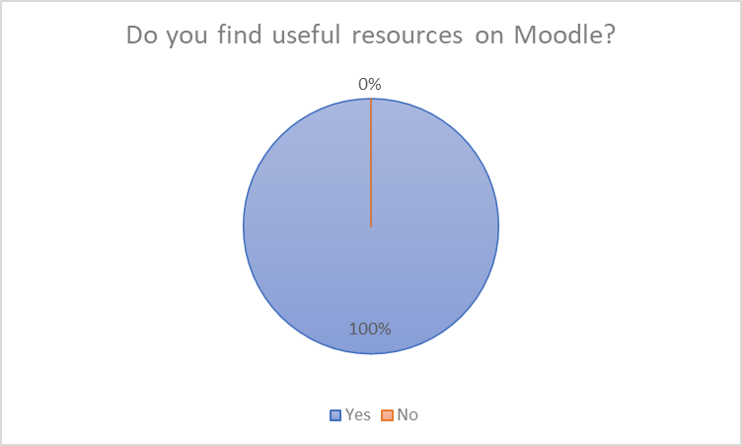
Question 1 Analysis:
How we can see all 12 students answer with yes to the questions.
A 2-D pie shows the bigger percentage who believe the resources which they found on Moodle are very useful for the studies. At the same time, they can get support for any problem that they found in studies for example: when they use PowerPoint when they needed support for the final assignment and the list can continue if is about studies.
So, 100% agree with the resources on Moodle are very useful.

Question 2.
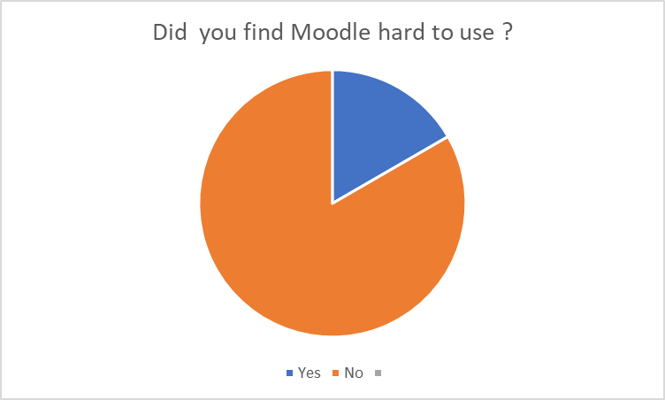
Question 2 Analysis.
As we can deduct from the graph above, we can see the percentage of 17% encounters problems using the module and those of 83% declare that the module is very effective to use it.
This means Moodle is very easy to use and the students can be found everything that they needed.

Question 3.
How often do you use Moodle?
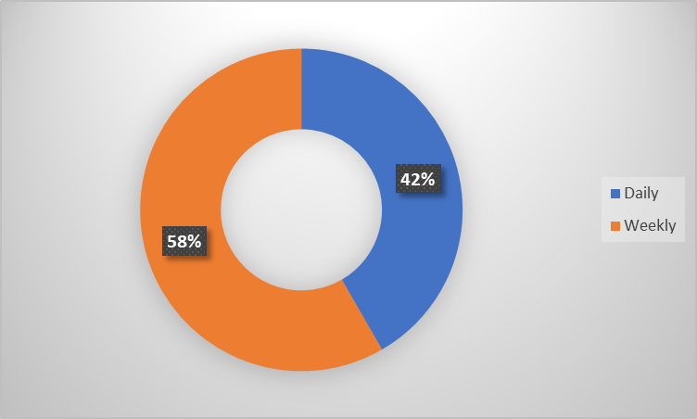
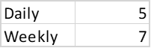

Question 3 Analysis.
As we can deduct from the above script, the 12 students access the weekly mood more often, and a percentage of 42% use it during the day.
This means that students prefer to use Moodle weekly.
Question 4.
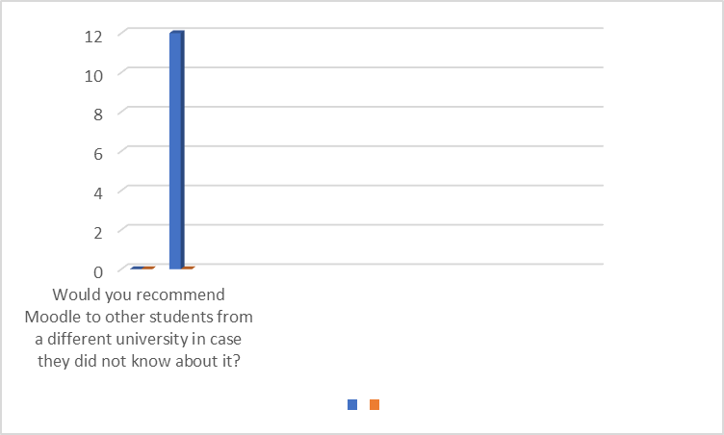

Question 4 Analysis.
The table that is attached with the chart deduces that the module is quite effective for the 12 students to recommend to other students and only, denotes those students are satisfied with the mode and is very satisfying when you need help.
Questions 5.
How satisfied are you when using the Virtual Learning Environment (Moodle) of this university (UWTSD)?

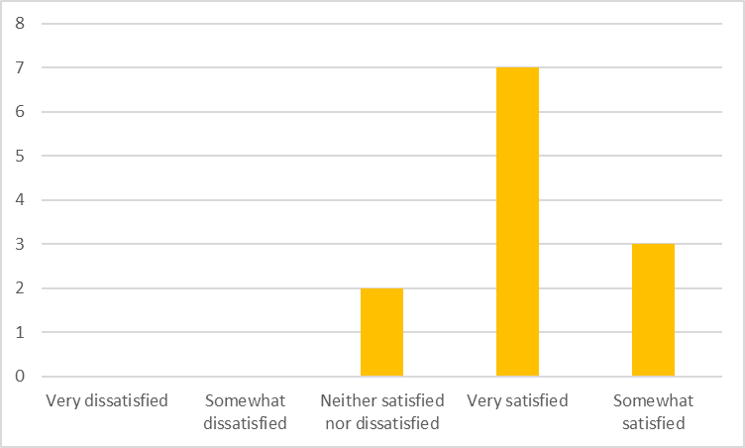

Question 5 Analysis.
As we can see from above most of the students voted that they are very satisfied when using Moodle, but we can not ignore and the rest of the students who voted neither or somewhat satisfied.
We can deduce that not all students are satisfied when they use the application.

Question 6.
How likely are you to recommend Moodle to your friend where 1 is not recommended and 5 is fully recommended?
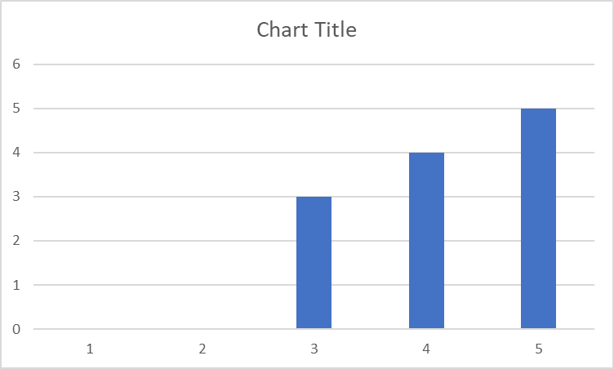
Question 6 Analysis.
When analysing this question we can see that the answer is divided.
Most of them voted with 5 but some of them voted with 3 and 4, this means that a large part of the students are satisfied with Moodle which makes them recommend it to others and the rest are less happy but still recommend it on a scale smaller.
Question 7.
How did Moodle help you in your academic study? Write in a few words.
So many resources. It is easy to upload my work to the university and it is proving that I am the author.
It does help for sure but the information is not up to date, it should be updated regardless of whether students are a level 4, 5, or 6. I am spotting always information on Moodle which needs to be uploaded or changed to lecturers in class but nothing ever gets done.
Good resources, easy to find books, articles, and information!
Useful links, module slides available to check for previous and upcoming classes, and more
Very useful
That’s you can study from everywhere
Help me a lot as I can see what is the weekly exercises and a lot more Moodle is very helpful because it has most of the things you need on there.
I can go over the lessons again to regain the knowledge
I can access the information easily
It enabled me to research particular topics in more depth.
Question 7 Analysis.
In this question, we can see that the answers are positive. Students find it very easy to find all the information they need for their studies, but 1% of students said they had a problem with Moodle and tried to talk to the teacher about it but only saw no change.

Question 8.
Do you think that Moodle provides you with all the resources and you don’t need to look for other websites for relevant information? Explain your answer in a few words.
No. It requires adding more information
Not exactly but most of them and which are in the course.
No, but maybe it could be yes and that we as students are still not fully aware of how to make good use of Moodle.
No, I still need to look for extra information on other websites!
It definitely does and one can for sure pass using only that information, but its also good to check out external sources just for the sake of research
No library need improvement
I get all the information which I need
Yes
It has most of the useful information so therefore you don’t need to look elsewhere
Yeah, somewhat- doesn’t provide all the information I need.
Yes I think so
No, I don't.
Question 8 Analysis.
After receiving the answers to this question we can see that many of the students have concluded that the information found on Moodle is not enough and they need to look for information on other sites.
Discussion
First of all, I will talk about the answers obtained to the questions in the questionnaires given to the students. Many of the students are happy with this application and others have suggested small changes to the application.
This report is based on a research report on the impact of the Virtual Learning Environment (VLE) - Moodle on the learning experience of students at the University of Wales Trinity Saint David London Campus. Attached to this report are 8 questions from which 12 students were asked, these 12 students concluded that online teaching has both positive and negative parts that need to be improved for the activity to take place. This virtual platform helps students to understand and practice previous lessons that were not clear to some students or otherwise when they were absent and need to recapitulate.
Conclusion
In the conclusion I obtained based on the questions in the report, I think that Moodle is a very good platform for students with a lot of information.
References
-Jeans S., Mayberry M., A review of the literature on the school environment., available at: https://eric.ed.gov/?id=ED271832 (accessed: 5 January 2022)
-Indian J. P. M., 2020, Sample size and its importance in research, available at: https://www.ncbi.nlm.nih.gov/pmc/articles/PMC6970301/ (accessed:7 January 2022)
- Tiakiwai SJ., Tiakiwai H., Kiore Enterprises Limited (March 2020), available at: https://www.educationcounts.govt.nz/publications/91416/105966/a-literature-review-focused-on-virtual-learning-environments (accessed: 27 December 2021)

Appendix 1
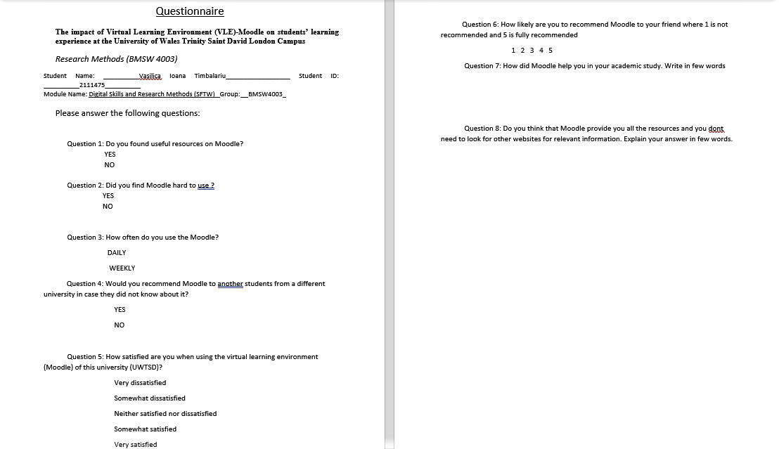

Appendix 2.

