
Digital Innovation and Professional Practice
A critical evaluation of the role of digital innovation in professional practice

February 2, 2024
Philippa Fitzgerald
UWTSD 1905945

Introduction
Digital innovation has become an integral part of professional practice in teaching, revolutionising traditional pedagogical approaches. This critical evaluation examines the role of digital innovation in enhancing teaching practices, considering its implications for educators and students alike. Digital innovation encompasses various technologies such as interactive whiteboards, educational apps, virtual reality, and online learning platforms. These tools offer opportunities for personalised learning experiences, active engagement, and real-time feedback (Hattie, 2015). There are many benefits to digital innovation, however with most things there are also some challenges. Technical issues, inadequate training, and the digital divide among students pose significant obstacles. Other issues to consider are concerns with privacy, data security and the reliability of information gathered. Advances in Digital technology have allowed for a plethora of students to be able to study and gain qualifications through not only open University courses but also other short courses available through further education establishments. This has also allowed for educators to enhance their skills and knowledge in a more flexible way, as the traditional classroom teaching is no longer the only way learning can be done (Anon, 2018). This assignment will look more in depth on how educators and learners are using digital innovation to enhance their journey. The focus will be on Microsoft teams this is a collaboration platform developed by Microsoft and designed to facilitate communication and teamwork within an organisation it has various built in apps available, such as video meetings, file sharing, chat function, breakout rooms, and Polly, there are other features available but will not be discussed in this assignment in depth.

The Role of Creativity and Digital Innovation (approximately 1,750 words)
In today's rapidly evolving digital landscape, the integration of technology and creativity has become essential in various aspects of education. This literature review aims to explore the multifaceted role of creativity and digital innovation in teaching and learning environments. It delves into how technology and pedagogy can complement each other, the ethical considerations associated with digital innovation, and the potential applications of emerging technologies in education. With virtual and augmented realities, artificial intelligence, and advanced simulations, educators now have radically new tools to spark imagination and engage students. However, reaping these benefits requires finding the right equilibrium between high-tech capabilities and human-centric learning. Teachers must utilize technology to enhance critical thinking, collaboration, and personalized discovery - not replace it. Likewise, safety, equitable access, data transparency, and bias prevention should drive development to uphold ethics. When purposefully designed and ethically applied, technology-enhanced creativity significantly transforms classrooms for the modern era. From reimagining assignments through game-based augmented worlds to providing customized feedback through machine learning, promising potentials abound. Preparing students for the 21st century workplace involves fluencies in both digital media and imaginative problem-solving. Synthesizing these through pedagogical innovation remains imperative and warrants extensive analysis through contemporary research. This review discusses such developments reshaping the educational applications of technology and creativity.

Technology and Pedagogy
The integration of technology and pedagogy represents a symbiotic relationship where each element enhances the other. Technology offers innovative tools and resources that can revolutionise teaching methods and facilitate personalised learning experiences (Ally, 2004). Digital platforms such as Microsoft teams provide opportunities for interactive and collaborative learning, enabling students to engage with educational content in dynamic ways (Shneiderman, 2003). For instance, virtual reality (VR) and augmented reality (AR) technologies offer immersive experiences that can transport learners to virtual environments, fostering deeper understanding and retention of complex concepts (Dalgarno & Lee, 2010). Additionally, multimedia resources such as videos, simulations, and interactive tutorials cater to diverse learning styles, accommodating the needs of all students (Mayer, 2001). The integration of technology into pedagogy empowers educators to adopt learner centred approaches, where students take an active role in constructing their knowledge (Garrison and Vaughan, 2008). Through online forums, blogs, and social media platforms, students can collaborate with peers, share ideas, and receive feedback from both peers and instructors (Dron and Anderson, 2009). This collaborative environment promotes not only content mastery but also critical thinking, problem-solving skills, and creativity, which are essential competencies for success in the digital age (Jonassen, 2000). The flexibility and adaptability of digital tools allow educators to personalise learning experiences to meet the diverse needs and preferences of students. By leveraging technology, instructions can tailor instruction, provide differentiated support, and offer alternative pathways to mastery, thereby fostering a more inclusive learning outcome (Tomlinson, 2001). This personalised approach acknowledges the individuality of learners and promote equity and access in education, aligning with principles of social justice and diversity (banks, 2012), this also aligns with the professional standards that include using digital technology to enhance the learning process (Educators Wales, 2024). However recent research shows the digital divide allows for unequal access to technology and the Internet based on socio economic status, geography, age, and other demographics. As education becomes increasingly digital, lack of access prevents students from fully participating, entrenching disadvantages (Smith, 2021). A 2021 study found students without home Internet access averaged lower scores in reading, maths, and science, impacting future opportunities (Johnson and Smith, 2021). If the digital access gap persists, virtual learning risks isolating already marginalised communities instead of empowering them (Lee, 2022). Multi-pronged strategies are essential, so innovations enhance, rather than inhibit, equitable quality education. As Lee (2022) summarises learners need to start on an equal footing within digital learning and not become an afterthought.

Ethics in Digital Innovation

While digital innovation holds immense potential for enhancing education, it also raises profound ethical concerns that must be addressed. One significant ethical consideration links to data privacy and security (Selwyn, 2011). Educational institutions today collect vast amounts of student data through various digital platforms such as learning management systems, online assessments, and digital portfolios. Safeguarding this sensitive information becomes paramount to protect students’ privacy and prevent unauthorised access or misuse that could prove harmful (Bennett, 2008). The Data Protection Act 2018 and UK GDPR legislate the processing and privacy of personal data in the United Kingdom. This includes student data collected by educational institutions. Schools and other education providers that process student personal data must comply with the data protection principles outlined in the Data Protection Act and UK GDPR. This includes processed lawfully, fairly, and transparently. Education institutions are obligated to implement appropriate security measures against unauthorized access, accidental loss, destruction, or damage to student data. Technical and organizational data security safeguards are required. Students/parents have various rights under the data protection regulations related to their personal information, including the right to access data held about them and have inaccuracies corrected (ICO, 2022).
Additionally, the ethical use of technology encompasses considerations of digital citizenship and responsible online behaviour (Ribble, 2015). Educators play a crucial role in cultivating digital citizenship skills among students, including respecting intellectual property rights, practising online safety, managing digital footprints, and critically evaluating online information sources (Richardson & Mancabelli, 2011). By integrating ethical principles and digital literacy into learning environments, educators can empower students to become responsible digital citizens capable of navigating complex ethical dilemmas in the digital age (Hollandsworth et al., 2011).
The holistic approach to digital ethics education not only ensures students' safety and wellbeing online but also fosters a culture of respect, integrity, and responsibility in the digital realm (Educators Wales, 2024). Through ongoing education on security, privacy, online etiquette, and critical thinking, schools reinforce positive social norms that will guide students to make wise choices in online spaces. Proactively addressing ethical considerations makes digital innovation more impactful and sustainable (Ribble & Bailey, 2021). With mounting reliance on technology, a comprehensive framework for digital ethics becomes crucial to promote students’ best interests. This encompasses company data handling practices, classroom policies upholding dignity, and curriculum teaching responsible usage. Though digital platforms offer boundless access to information and connectivity, they require renewed approaches ensuring human rights, safety, and wellbeing stay protected. We cannot take the ‘digital’ out of ‘digital citizenship’ – online and offline worlds are converging. Just as schools have a duty of care physically, so too digitally as technology permeates education. Tending to digital ethics is thus essential for benefiting from innovation while preventing harm.

Emerging Technologies in Education
The rapid advancement of technology continually introduces new possibilities for enhancing education. Emerging technologies such as artificial intelligence (AI), block chain, and the Internet of things (IoT) hold promise for transforming teaching and learning processes (Westera et al., 2020). AI powered adaptive learning systems can personalize instruction based on individual student needs, providing targeted interventions and adaptive feedback. As Vanlehn (2011) discusses, these intelligent tutoring systems dynamically adjust curricula based on real-time assessments to support mastery learning. Likewise, blockchain technology offers secure and transparent methods for verifying academic credentials, preventing fraud, and ensuring the integrity of educational records (Liu et al., 2019). The IoT enables the integration of physical devices and sensors into learning environments, creating immersive and interactive experiences that blur the boundaries between virtual and real-world contexts (Ali et al., 2021). Furthermore, the integration of emerging technologies facilitates innovative approaches to assessment and evaluation in education. Gamification, for example leverages game design principles to enhance engagement and motivation in learning activities (Kapp, 2012). By incorporating elements such as badges, leaderboards and rewards into educational tasks, gamified assessments can foster a sense of achievement and encourage continuous learning (Deterding et al., 2011). Similarly, adaptive testing algorithms powered by AI can dynamically adjust the difficulty of assessment items based on student performance, providing more accurate and meaningful insights into student mastery (Wang et al., 2019). The role of creativity and digital innovation in teaching and learning environments is multifaceted and transformative. By harnessing the synergies between technology and pedagogy, educators can create dynamic and engaging learning experiences catering to diverse student needs (Ritzhaupt et al., 2020). Virtual reality field trips, augmented science labs, AI-driven literacy apps, and robotics projects represent just a sample of what becomes possible. However, the ethical implications of digital innovation must be carefully considered to ensure equal access, privacy protection, and responsible use of technology (Selwyn, 2011). Socioeconomic gaps, commercial interests, and safety risks pose areas needing attention. Looking ahead, emerging technologies offer exciting opportunities for revolutionizing education and fostering innovation in teaching and learning practices (Spector et al., 2016). But this requires evidence-based implementation, teacher training, and putting sound ethical frameworks in place during development and deployment. Educators must have both the digital fluency and pedagogical foundations to evaluate and integrate technology effectively. Staying grounded in learning science - while embracing creativity - helps translate ideas into real academic and developmental outcomes. With student wellbeing at the core, transformative potential exists across administrative systems, instructional tools, assessment methods and learning spaces. By valuing human guidance along with AI capabilities, the bounties of new technologies can unfold equitably and responsibly. From personalized tutors to immersive worlds, the horizons keep expanding. But ultimately, it is the human heart behind innovation that determines its impact. Technology enables - educators empower. Keeping our common hopes as the ‘true north’ of progress remains imperative as society continues rapidly digitizing. What could be built next to make high-quality education more accessible? If we want technology to elevate learning, we must first understand what motivates people to invest their time in learning.

Selection and Justification of appropriate teaching tool(s)/resources - (approximately 1000 words)

SAMR stands for Substitution, Augmentation, Modification, and Redefinition. It is a framework developed by Dr. Ruben Puentedura that categorizes the process of technology integration in teaching and learning into four hierarchies (Puentedura, 2006):
Substitution: At the most basic level, new technologies simply substitute traditional educational tools with no functional improvements. For example, e- textbooks replacing paper texts or typing notes on a laptop rather than writing with paper and pen. When first adopting Microsoft Teams, educators often remain in the substitution phase where traditional teaching activities or tools are merely replicated digitally without meaningfully transforming learning (Puentedura, 2006). For example, using Teams chat and meetings to replace physical classroom discussions or telephone calls reflects digitization without pedagogical innovation. Likewise, having students access and turn in worksheet assignments via Teams templates rather than paper copies leaves the core activities fundamentally unaltered despite the online coating. Posting an electronic lesson plan on a Teams channel rather than printing it, or having students write reflective journal entries in Teams docs rather than notebooks largely mimics existing practices through bare minimum usage of features (Wang & Hsu, 2020). Discussing essay outlines over Teams calls versus face-to-face meetings demonstrates usage where the platform simply serves as a virtual room for customary exchanges now delivered via screens. While convenient, the essence of teaching and learning components remains unchanged. Such substitution usage misses the collaboration, creation, and critical thinking opportunities distinctly available through Teams integrated tools (Redecker & Punie, 2017). Simply replicating a physical classroom virtually or manually transferring offline activities online signifies surface-level adoption that has not meaningfully permeated paradigms. As with other edtech tools, viewing Microsoft Teams as just a container for existing practices rather than a gateway to redefining learning through built-in special affordances indicates inadequate integration (Yildirim & Reigeluth, 2019). Educators must consciously resist stopping innovation at the substitution stage, instead leveraging unique Teams capacities like collaborative workspaces, tablets, sharing channels, and other features supporting active creation of artifacts, gamified interactions, immersive simulations, and enhanced project designs that transform assignments and activities impossible offline (Puentedura, 2006). This escalates technology usage from mundane replacement towards enrichment.
Augmentation: The technology begins providing some enhancements over the traditional approach through supplementary features. For instance, an e-textbook with embedded multimedia enhances a paper textbook (Romrell et al., 2014). When educators progress beyond the substitution phase in adopting Microsoft Teams, they enter the augmentation stage, where the technology begins to provide some enhancements over the traditional approach through supplementary features (Puentedura, 2006). This phase signifies a significant step forward in integrating technology into teaching and learning practices. In the context of Microsoft Teams, augmentation could involve utilizing its collaborative features to enhance communication and interaction among students and educators (Johnson et al., 2018). For example, instead of simply replicating physical classroom discussions, educators can leverage Teams' chat and meeting functionalities to facilitate more dynamic and inclusive discussions that transcend the limitations of traditional face-to-face interactions. Furthermore, Teams' integration with multimedia tools allows educators to create engaging presentations and interactive learning materials that augment the learning experience beyond what is possible with traditional methods alone (Vrasidas & Glass, 2018). Augmentation also extends to the realm of assessment and feedback. Educators can use Teams' assignment features to streamline the process of collecting and grading student work, providing timely feedback through comments and annotations directly within the platform (Selwyn, 2020). Additionally, Teams' integration with other Microsoft applications, such as OneNote and PowerPoint, offers opportunities for students to collaborate on projects, annotate documents, and create multimedia presentations, fostering a more interactive and personalized learning environment (Lee et al., 2019). Overall, the augmentation stage in the integration of Microsoft Teams represents a crucial transition towards leveraging technology to enhance teaching and learning practices. By embracing the platform's supplementary features and functionalities, educators can create more engaging, collaborative, and interactive learning experiences that extend beyond the limitations of traditional approaches.

Modification: Technology allows significant redesigns of educational activities and lesson formats. For example, a learning management system facilitating blended online and in-class activities alters conventional instruction (Greene & Hale, 2017). As educators progress in their adoption of Microsoft Teams, they enter the modification stage, wherein technology allows for significant redesigns of educational activities and lesson formats, thus reshaping conventional instruction (Puentedura, 2006). Microsoft Teams, with its multifaceted features and integrations, serves as a catalyst for this transformative process. In the modification stage, educators leverage Microsoft Teams to create blended learning environments that seamlessly integrate online and in-class activities (Wang & Hsu, 2020). For instance, educators can utilize Teams to deliver asynchronous learning materials, such as pre-recorded lectures or interactive presentations, which students can access at their own pace. Concurrently, Teams facilitates synchronous collaboration and discussions, enabling real-time interactions among students and educators regardless of their physical locations (Lee et al., 2019). Microsoft Teams allows for the implementation of innovative instructional strategies, such as flipped classrooms, where traditional lecture-based content delivery is moved online, freeing up valuable class time for active learning and collaborative projects (Selwyn, 2020). Educators can use Teams to assign pre-class readings or videos, initiate discussions, and provide formative assessments, thereby fostering deeper engagement and understanding during in-person sessions. Additionally, Teams' integration with various educational tools and applications enables educators to personalize learning experiences based on students' individual needs and preferences (Vrasidas & Glass, 2018). For example, educators can use Teams to differentiate instruction by assigning tailored activities or resources to different groups of students, thereby accommodating diverse learning styles and abilities. Overall, the modification stage represents a paradigm shift in education, where technology, particularly Microsoft Teams, serves as a powerful enabler for reimagining instructional practices and enhancing student learning outcomes. By embracing the flexibility and versatility of Teams, educators can create dynamic and inclusive learning environments that empower students to thrive in the digital age.

Redefinition: The highest SAMR level represents technology enabling completely new, previously inconceivable kinds of learning unattainable without technology. Virtual reality field trips to remote locations demonstrate redefinition (Jowallah et al., 2022). In the redefinition stage, educators harness the power of Microsoft Teams to facilitate immersive and experiential learning experiences that transcend physical limitations. For example, educators can leverage Teams to orchestrate virtual reality (VR) field trips to remote locations, allowing students to explore and interact with environments and phenomena that would otherwise be inaccessible (Jowallah et al., 2022). Through VR simulations and immersive experiences, students can delve into historical events, scientific concepts, or cultural landmarks, gaining a deeper understanding and appreciation for diverse subjects. Furthermore, Microsoft Teams enables collaborative and interdisciplinary projects that redefine traditional notions of classroom activities. Educators can leverage Teams to facilitate global collaborations and cross-cultural exchanges, where students from different geographical locations collaborate on shared projects and engage in meaningful dialogue (Selwyn, 2020). By breaking down barriers of time and space, Teams empowers educators to foster connections and collaborations that enrich the learning experience and broaden students' perspectives. Moreover, Microsoft Teams serves as a platform for innovative assessment practices that redefine traditional methods of evaluating student learning. Educators can leverage Teams' multimedia capabilities to enable students to demonstrate their understanding through creative digital artifacts, such as videos, podcasts, or interactive presentations (Wang & Hsu, 2020). By shifting the focus from rote memorization to authentic expression and application of knowledge, Teams supports a redefined approach to assessment that values creativity, critical thinking, and problem-solving skills. Overall, the redefinition stage signifies a profound shift in education, where technology, particularly Microsoft Teams, empowers educators to reimagine learning experiences and redefine the possibilities of education. By embracing the transformative potential of Teams, educators can inspire curiosity, foster creativity, and empower students to become lifelong learners in an ever-evolving digital world.

The SAMR model, when coupled with the capabilities of Microsoft Teams, serves as a powerful guiding framework that empowers educators to navigate the complexities of integrating technology into education in a purposeful and systematic manner. By following the progression outlined in the SAMR model, educators are equipped with a roadmap for evolutionary adoption of technology, ensuring that technology integration is not merely a superficial enhancement but rather a catalyst for profound pedagogical transformation (Puentedura, 2006). As educators progress through the various stages of tech integration, from substitution to redefinition, they are able to unlock the full potential of Microsoft Teams to revolutionize teaching and learning practices. At the substitution level, educators may initially use Teams to digitize traditional classroom activities, such as distributing assignments or hosting discussions, thus laying the groundwork for further exploration and innovation (UNESCO, 2020). Moving beyond mere substitution, educators can leverage Teams' augmentative features to enhance and enrich the learning experience, fostering greater engagement and collaboration among students (Johnson et al., 2019). Through modification and redesign, educators can harness Teams' capabilities to create blended learning environments that seamlessly integrate online and in-person instruction, catering to the diverse needs and preferences of learners (Lee et al., 2020). Finally, at the redefinition stage, educators are able to leverage the transformative potential of Teams to create entirely new and innovative learning experiences that transcend the boundaries of traditional education (UNESCO, 2020). Whether through immersive virtual reality field trips, global collaborations, or personalized learning pathways, Teams enables educators to cultivate dynamic, engaging, and personalized learning experiences that prepare students for success in the digital age. In essence, the SAMR model, in conjunction with Microsoft Teams, empowers educators to embrace technology as a catalyst for pedagogical innovation and student-centered learning. By embracing the evolutionary adoption of technology outlined in the SAMR model, educators can leverage the full potential of Teams to create learning environments that inspire curiosity, foster creativity, and empower students to thrive in an ever-changing world.

This section requires you to take what you have learned about theory relating to digital innovation and creativity and apply this to select a teaching tool or tools that could be used in an area of your teaching. As part of this you should demonstrate how your chosen tool(s) are supported by theory from the field and demonstrate a synthesis between innovation, pedagogical theory and professional practice.

Your tutor will introduce you to a range of possible tools as part of your studies, but this is not an exhaustive selection and you can explore tools and resources beyond these if you wish.
Possible implementations could be making use of a tool for assessment (online quiz etc), developing a digital learning environment or even developing interactive content such as games/web content.

Application of the chosen learning tool(s) (equivalence 1000 words)

To teach online using Microsoft teams an invite must be sent to all the learners attending the meeting. By following these steps, you can easily set up a meeting invite in Microsoft Teams and efficiently coordinate with your learners.
- Open Microsoft Teams: Launch the Teams application on your desktop or mobile device.
- Navigate to the Calendar: Click on the "Calendar" tab located on the left-hand sidebar. This will display your calendar and upcoming meetings.
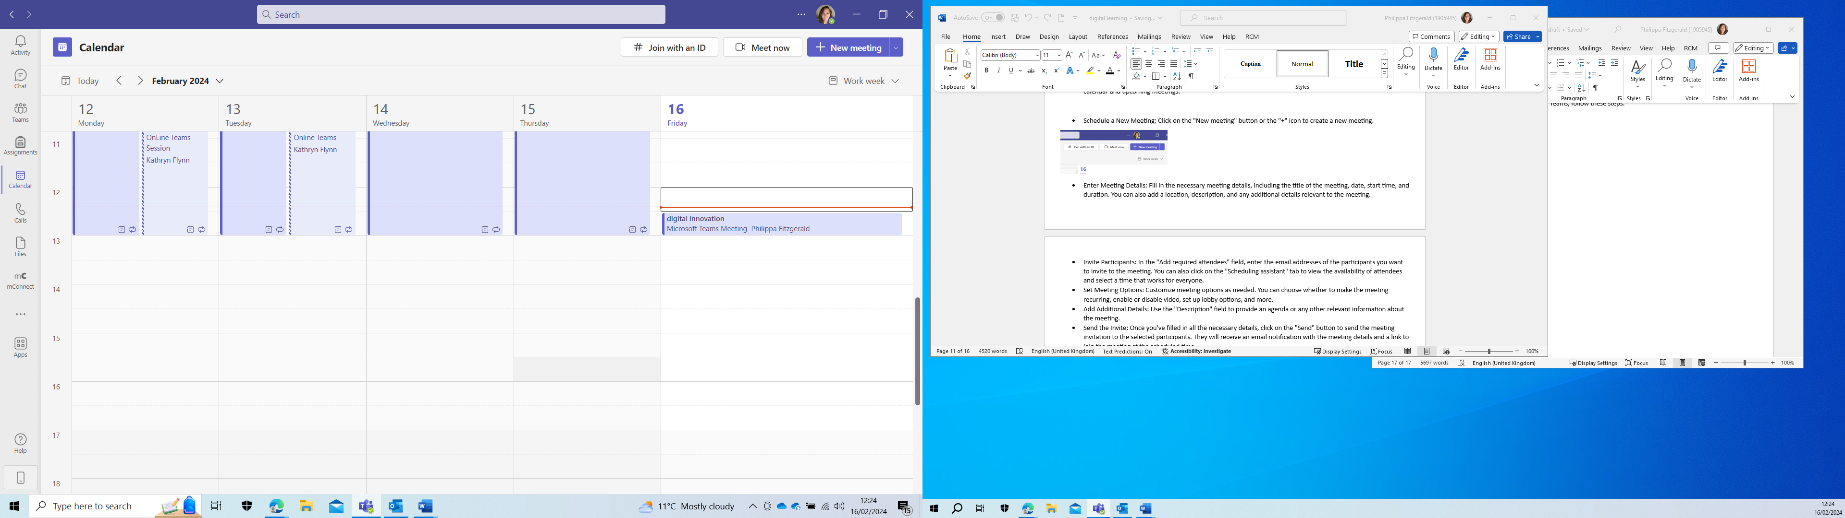
- Schedule a New Meeting: Click on the "New meeting" button or the "+" icon to create a new meeting.
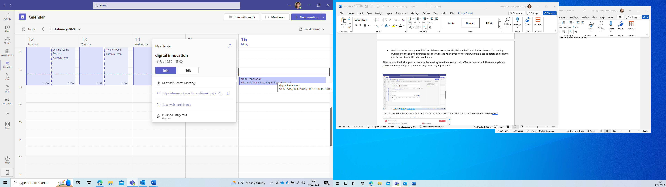
- Enter Meeting Details: Fill in the necessary meeting details, including the title of the meeting, date, start time, and duration. You can also add a location, description, and any additional details relevant to the meeting.
- Invite Participants: In the "Add required attendees" field, enter the email addresses of the participants you want to invite to the meeting. You can also click on the "Scheduling assistant" tab to view the availability of attendees and select a time that works for everyone.
- Set Meeting Options: Customize meeting options as needed. You can choose whether to make the meeting recurring, enable or disable video, set up lobby options, and more.
- Add Additional Details: Use the "Description" field to provide an agenda or any other relevant information about the meeting.
- Send the Invite: Once you've filled in all the necessary details, click on the "Send" button to send the meeting invitation to the selected participants. They will receive an email notification with the meeting details and a link to join the meeting at the scheduled time. 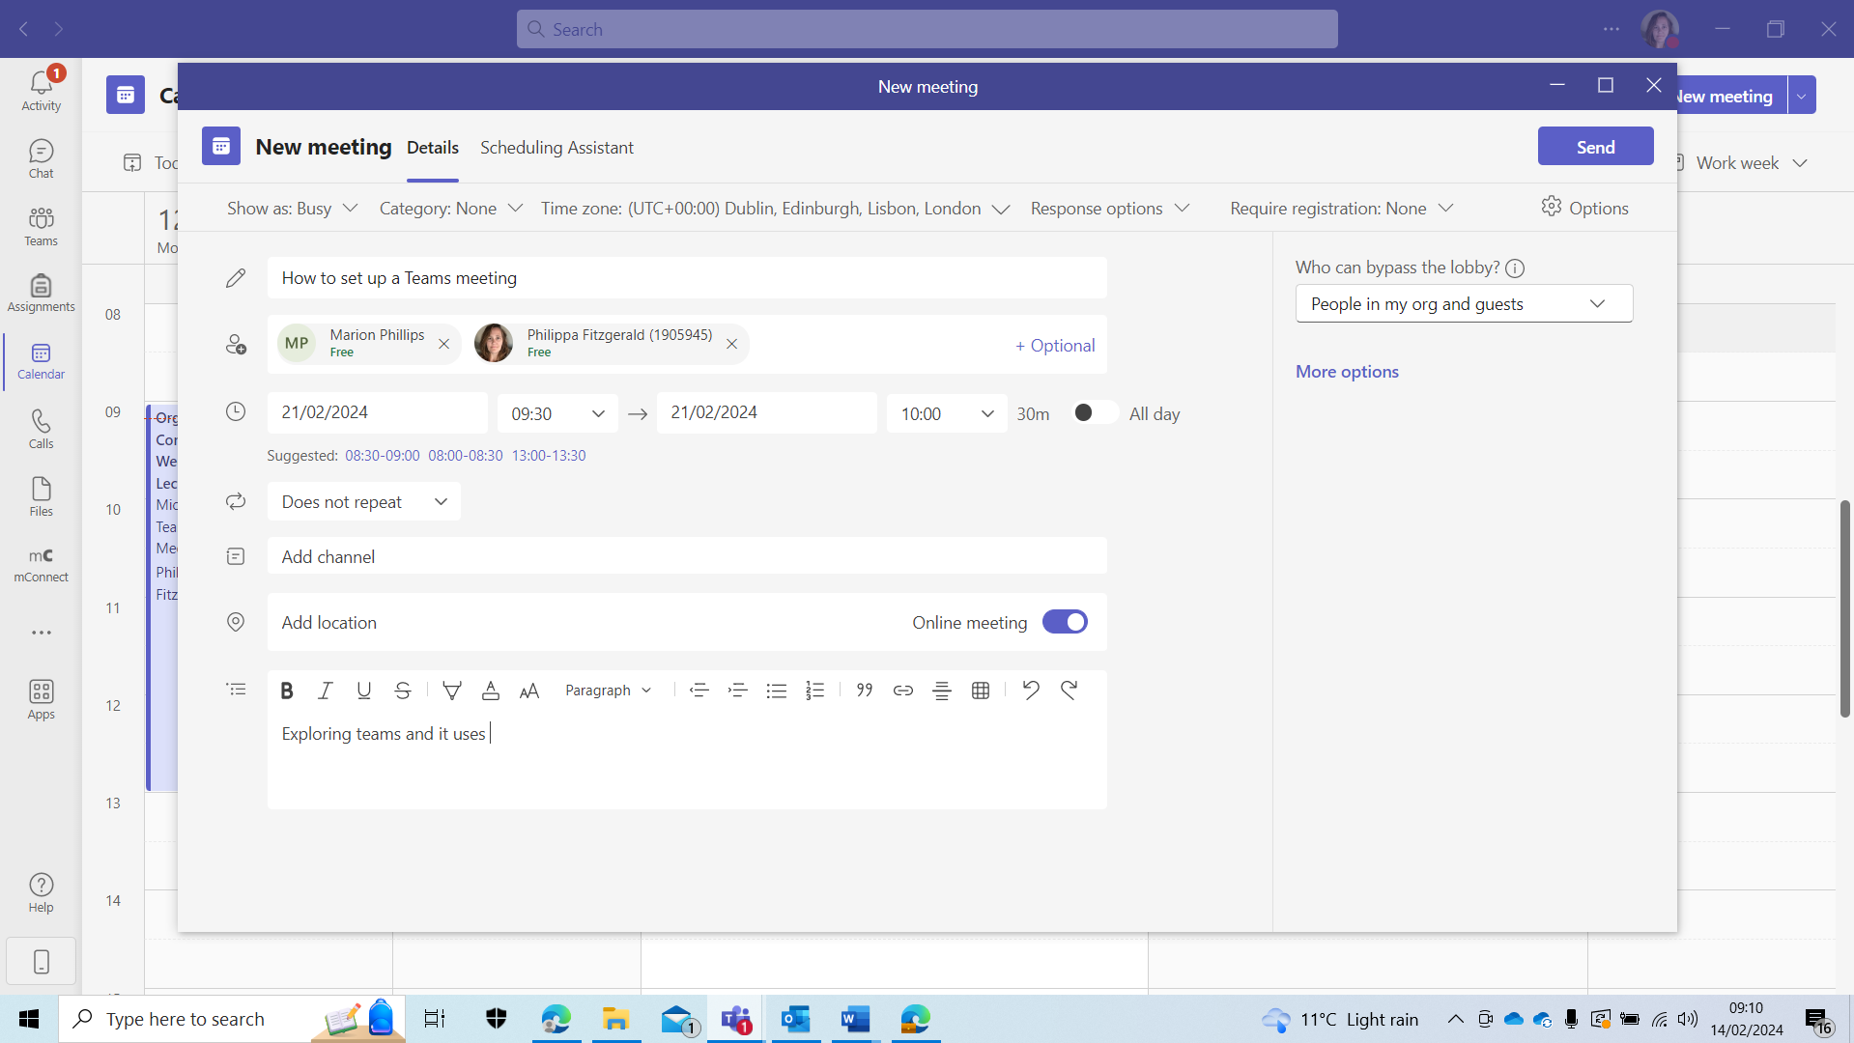
After sending the invite, you can manage the meeting from the Calendar tab in Teams. You can edit the meeting details, add or remove participants, and make any necessary adjustments.

Once an invite has been sent it will appear in your email inbox, this is where you can except or decline the invite.
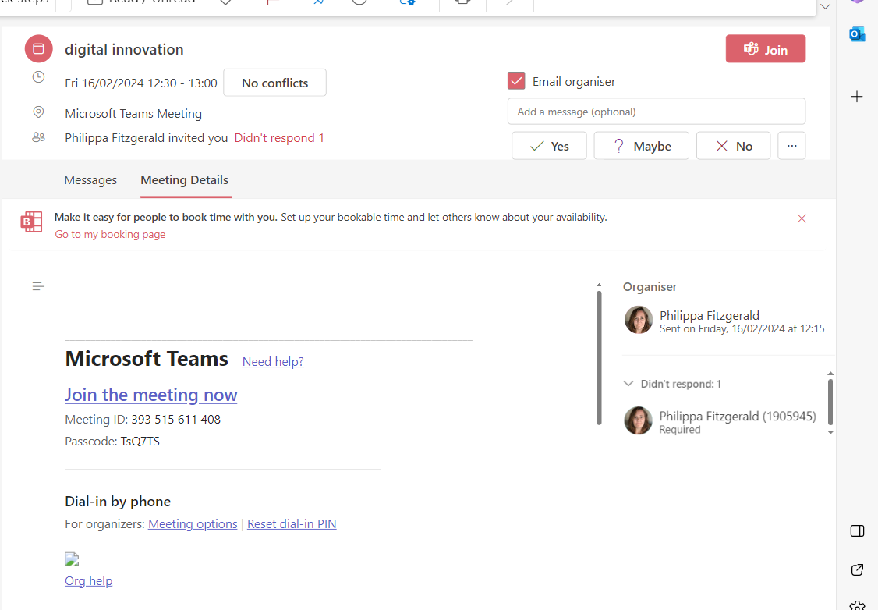
Once Excepted it will then appear in your calendar on teams.
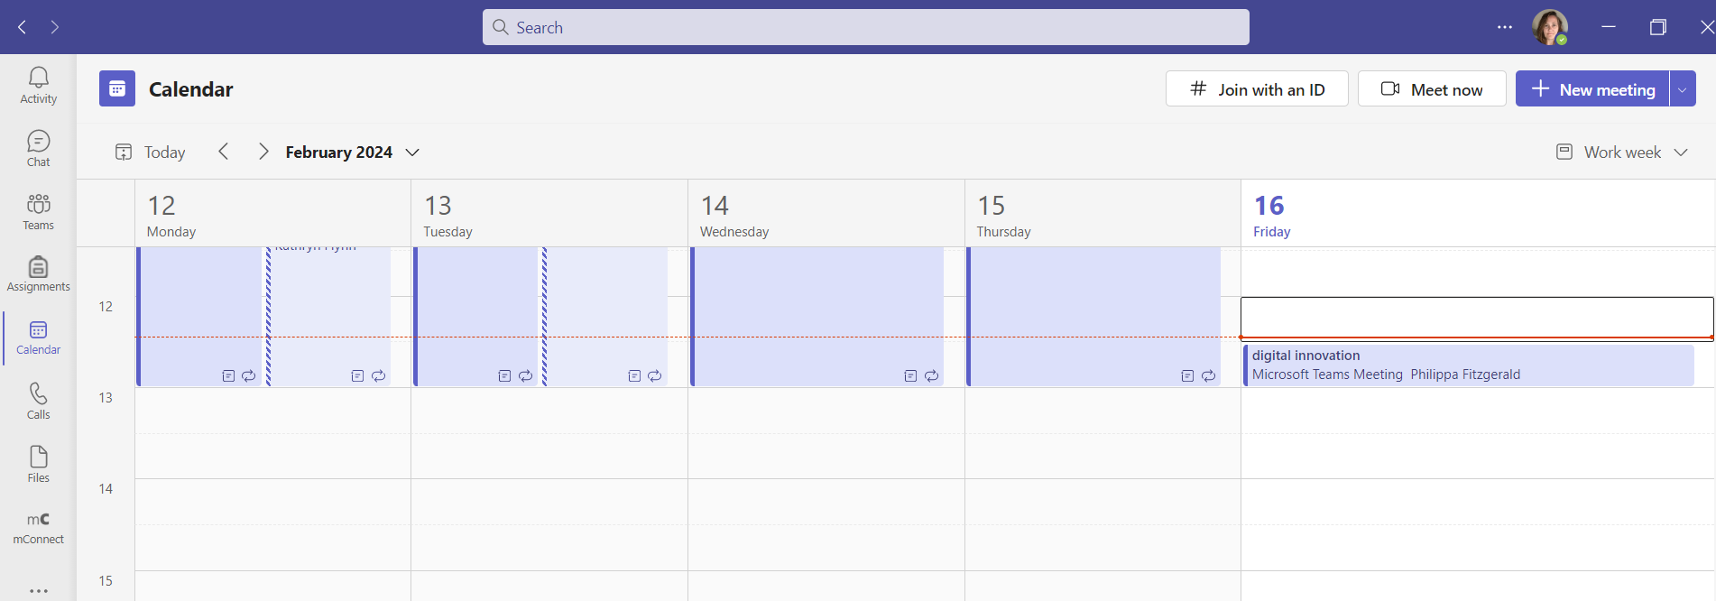

Those you have been invited can now join the meeting at the required time and date.

For the purpose of this assignment a lesson that was taught by the lecturer (Philippa Fitzgerald) to the students on Organisational Consultancy is as follows.


Lesson Plan

Topic: Analysis Tools and Frameworks |  | Class: Online Organisational Consultancy
Date:12/2/24 | Length of lesson: 4 hours |  | Number of students: 25-30
Resources required: Laptop, PowerPoint

Aim of Lesson
Improve understanding of different analysis tools and frameworks that can be used to analyse data and situations within Organisational Consultancy.

Learning Outcomes – The Learners Should Be Able To:
Develop reasons why we use analysis tools and frameworks.
How we can apply different tools and frameworks.

Previous student knowledge required for the session: No previous knowledge is required.

Anticipated difficulties (if applicable): Recognising the differences between similar tools. Internet connection failure or other IT problems.

Professional Standards (where are these being met within the session)
The lesson will align to Welsh FE standards,
Using a variety to learning tools to be inclusive for all learners, such as PowerPoint, video and activities.

Lesson Detail:

Stage | Focus | Strategy | Time
Introduction  Development  Plenary/conclusion | Discuss the benefits and limitations of the tools and frameworks.  15 minute activity to research tools and frameworks. Recap on any frameworks that are already known about.  Explain the following models.  The star model.  PESTLE  Porters 5 Forces (include short video (15 Minutes)  Include a 30 minute break.  CAGE framework.  SOSTAC Model  Race Framework  Have a group discussion to develop their knowledge on what 2 tools would support a consultancy project and why?  Summary and additional tools. Recap tools covered; Overview of additional analysis frameworks; Breakout rooms activity to apply knowledge to different scenarios (30 minutes). Q&A 5 minutes. |  | 30 minutes  2.5 Hours  1 Hour

Assessment Strategies: when and how are they included within the lesson?
Individual activity to research frame works and tools. Group discussion to increase Knowledge; Breakout rooms to apply analysis tools and frameworks.

Informal reflection (to be completed after the session)
The learners were engaged throughout the training and able to grasp the key differences between the analysis tools. Most were able to apply SWOT, PEST, and Porter's in the activities provided. In the future, may allow more time for tool application.

Outcome of the session slide to make learners aware of what to expect.


Breakout rooms were created to allow for smaller group activities this allows for inclusivity of all learners.
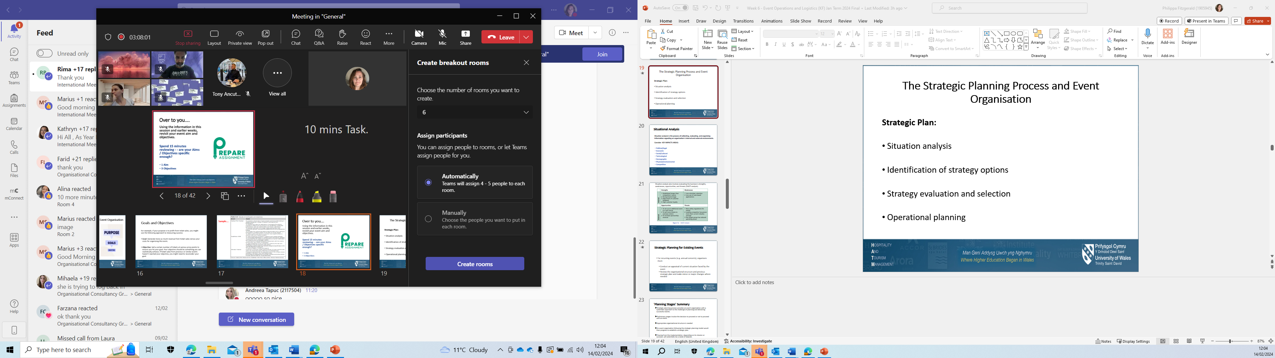
This group activity allowed students to apply the knowledge learnt in the session, this will encourage participation of quiet learners. Applying knowledge before using in real world situations helps to build confidence in learners abilities.


This section requires you to develop the application of your chosen tool/resource.
Evidence for the implementation could take the form of a submitted asset, annotated screenshots or a recorded demonstration of the tool.

Discuss how teams is a technology and using different aspects of it to enhance the student learning such as chat functions and breakout rooms possibly include polly in this. Official written feedback cannot be carried out until the end of the module, however verbal feedback has been noted.
You should provide a clear lesson plan that shows where and how this tool would be applied in context.

Evaluation and Reflection (approximately 1000 words)
This section requires you to critically evaluate the learning tool you have utilised and it’s impact on your teaching and learning. You should critically consider its implementation against intended outcomes and where possible seek feedback/data in the through testing with learners or peers that can support your evaluation. You should also show how the points raised as part of your evaluation have informed the development of your future practice in terms of digital technology and professional practice.
Prior to my teaching role, my preconceived notion of Microsoft Teams was that it served as a digital collaboration tool, enabling people to work together online, and transcending geographical boundaries. However, after several months of using it to teach online, I've come to realize that Teams is a versatile digital platform that offers far more than just collaborative features. Its multifaceted capabilities have not only enhanced my ability to educate others but have also provided immense benefits for my students. One of the key features of Microsoft Teams that has significantly impacted my teaching is its chat function. This feature allows for real-time communication and discussion among students, facilitating engagement and interaction even in virtual classrooms (Selwyn, 2020). The chat function has provided a space for students to ask questions, seek clarification, and share ideas, fostering a sense of community and collaboration in the online learning environment. Moreover, it has allowed me to provide immediate feedback and support to students, addressing their queries promptly and effectively. Another valuable component of Microsoft Teams is its breakout rooms feature. This feature enables educators to divide students into smaller groups for collaborative activities, discussions, or projects (Johnson et al., 2019). By utilizing breakout rooms, I've been able to cater to different learning styles and preferences, providing students with opportunities for peer-to-peer learning and collaboration. Additionally, breakout rooms have proved especially beneficial for quieter, more withdrawn students, as they provide a more intimate and supportive environment for them to express their thoughts and opinions without feeling overwhelmed by larger group settings (UNESCO, 2020). Furthermore, Microsoft Teams offers a range of additional features and functionalities that have enriched my teaching practice. From its seamless integration with other Microsoft applications such as Word, Excel, and PowerPoint to its robust file-sharing and collaboration tools, Teams has provided me with a comprehensive platform for delivering content, facilitating discussions, and assessing student learning (Wang & Hsu, 2020). Its versatility and user-friendly interface have made it an indispensable tool in my teaching toolkit.
While Microsoft Teams offers numerous benefits for teaching and learning, there are also potential negatives associated with its use: Technical Issues are one of the most common challenges with any digital platform. Connectivity issues, software glitches, and server outages can disrupt online classes and impede learning experiences, which has occurred with my lesson. This can lead to frustration for both educators and students and disrupt the flow of instruction, this was not something that had a big impact as the problem was solved very quickly and as I had preempted that this could happen my students already had a contingency to follow. Despite efforts to bridge the digital divide, disparities in access to technology and internet connectivity persist. Students from low-income households or rural areas may lack access to the necessary devices or reliable internet connections needed to participate fully in online learning using Microsoft Teams. This can exacerbate existing inequalities in education and widen the achievement gap. While technology can enhance teaching and learning, there is a risk of overreliance on digital tools like Microsoft Teams. Overuse of technology may lead to a passive learning environment where students become disengaged or dependent on technology for learning. Additionally, educators may rely too heavily on pre-packaged digital content, sacrificing creativity and critical thinking in instruction. Microsoft Teams collects and stores user data, including personal information and communication content. While Microsoft has robust security measures in place, there is always a risk of data breaches or privacy violations. Educators must be mindful of privacy laws and regulations when using Teams, especially when communicating with students or sharing sensitive information, another security risk is if my laptop was lost or stolen this could cause a security issue. Online learning environments, including those facilitated by Microsoft Teams, lack the social interaction and sense of community found in traditional classrooms. Prolonged periods of online learning can lead to feelings of social isolation and loneliness among students, impacting their mental health and well-being. This also prevents the social aspect of onsite lectures where student can relax and discuss things over coffee during break times. Integrating technology effectively into teaching requires pedagogical expertise and training. Some educators may struggle to adapt their teaching methods to an online environment or may lack the technical skills needed to navigate digital platforms like Microsoft Teams. This can hinder the effectiveness of online instruction and limit the potential benefits of technology in education, this can also be noted from the other side as a lecture who has little experience in face to face teaching relying on Microsoft teams is a comfort zone and to have that taken away can be a daunting prospect.

Overall, Microsoft Teams presents a plethora of advantages for teaching and learning, yet it is imperative for educators to remain cognizant of potential drawbacks and proactively address them to foster a balanced and effective learning environment. While the platform's features such as chat functions and breakout rooms facilitate communication, collaboration, and engagement, there are considerations regarding technical issues, the digital divide, overreliance on technology, privacy concerns, social isolation, and pedagogical challenges that necessitate attention.
Technical support for students, promotion of digital literacy skills, and the integration of diverse instructional approaches are crucial strategies for mitigating the negative impacts associated with online learning facilitated by Microsoft Teams. By aiding students encountering technical difficulties, educators can ensure smoother learning experiences. Moreover, fostering digital literacy skills empowers students to navigate digital platforms effectively and responsibly. Incorporating a variety of instructional methods, both digital and traditional, helps maintain engagement and cater to diverse learning styles.
Reflecting on my own experience with Microsoft Teams, I have witnessed its transformative potential in revolutionizing my teaching practice and enriching the educational journey for my students. The platform's chat function and breakout rooms have not only facilitated communication and collaboration but have also fostered a sense of community and inclusivity within the virtual classroom. Additionally, the platform's versatile features have enhanced my ability to deliver content dynamically and assess student learning effectively. Looking ahead, I am eager to continue exploring and leveraging the full potential of Microsoft Teams to create dynamic and engaging learning experiences for my students. By remaining attentive to both the benefits and challenges associated with the platform, I aim to cultivate a learning environment that maximizes student engagement, fosters critical thinking, and promotes lifelong learning skills. Through proactive measures and innovative approaches, Microsoft Teams will continue to serve as a valuable tool in advancing educational outcomes and preparing students for success in the digital age.

Referencing list

