

Strategic Management (LCMB7003)
Strategic Analysis of (Google Inc)


Student name: Zeel Surti
Student Number: 2212226
Lecturer: Dr Hossein Shokri
Word count: 5900
Submission Date: 02-05-2023

Table of Contents
Table of Contents 1
Introduction 2
Google Background 2
Google’s Mission and Objectives 5
Objectives: 6
Macro-Environment Analysis 6
PESTEL Analysis 7
Micro-Environment Analysis 9
Industry Life Cycle 11
Porter’s Industry Five Forces Analysis 13
Internal Analysis 15
Google’s Strategic Resources and Capabilities 16
Value Chain Analysis 18
Primary Activities 19
Secondary Activities 19
VRIO Analysis of Distinctive Resources and Capabilities of Google Inc 21
SWOT Analysis 23
Strategies to Sustain Competitive Advantage 25
Growth Strategies 26
Green Strategy and CSR 28
Conclusion 29
Recommendation 29
References 31
Appendix 36
Appendix 1: 36
Appendix 2: 36

Introduction
Google, a technology giant and a subsidiary of Alphabet Inc., has successfully navigated the rapidly changing technological landscape to maintain its position as a market leader. This report presents a strategic analysis of the central issues the company faced and how it dealt with them using emergent strategies. By leveraging appropriate concepts, theoretical frameworks, and techniques, this analysis demonstrates how Google achieved competitive advantage through their particular choice of strategic management (Global Internet Software & Services, 2011)

Google Background
Google, a multinational technology company, specializes in internet-related services and products, including search engines, online advertising technologies, cloud computing, software, and hardware (Google 2021). Founded on September 4, 1998, by Larry Page and Sergey Brin while they were Ph.D. students at Stanford University, Google has grown exponentially and is now one of the world's leading technology companies. This paper provides an overview of Google's employee count, company age, financial situation, and operating markets.(Global Internet Software & Services, 2011)

As of 2021, Google's parent company, Alphabet Inc., had a total of 156,500 full-time employees (Alphabet Inc. 2021). Alphabet Inc. was created in 2015 as a conglomerate to house Google and its affiliated companies under a single corporate structure (The Guardian 2015). Google's employees are known as "Googlers," and the company is renowned for offering a unique and innovative work environment, which has consistently ranked it among the best places to work (Alphabet Inc, 2023)

Since its founding in 1998, Google has celebrated 23 years of operations. Throughout these years, Google has evolved and expanded its services to include a vast array of products and solutions. Some of its most popular services include Google Search, Google Maps, Google Drive, Gmail, YouTube, Google Assistant, and the Android operating system (Google 2021).
Google's financial situation is strong, with the company reporting a total revenue of $182.5 billion in 2020 (Alphabet Inc. 2023). The company's revenue has been growing consistently over the years, and its primary source of income comes from advertising through its various platforms, such as Google Search, YouTube, and Google Display Network (Latif et al.,2014).
In addition to advertising, Google generates revenue from sales of apps, in-app purchases, digital content products, and hardware devices (Alphabet Inc. 2020). The company has also been investing in research and development in areas such as artificial intelligence, machine learning, and autonomous vehicles through its subsidiary Waymo (Alphabet Inc. 2023).
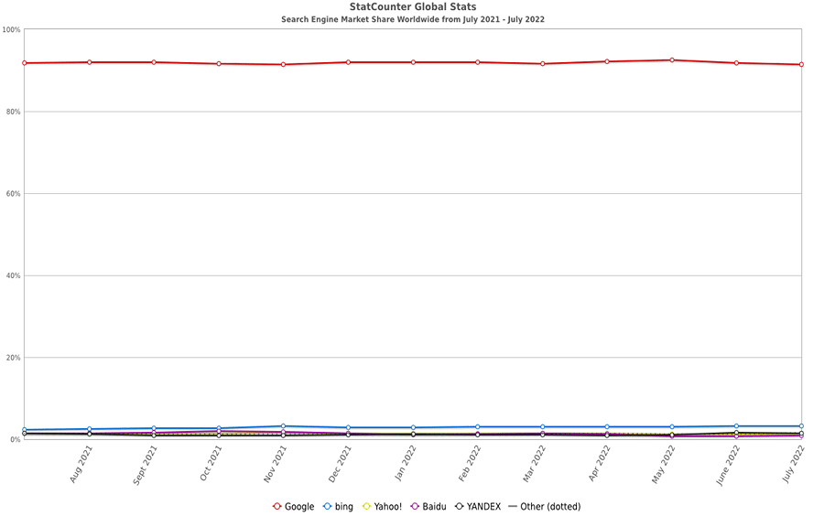
Google search engine market share worldwide by 2022 (source statscounter)
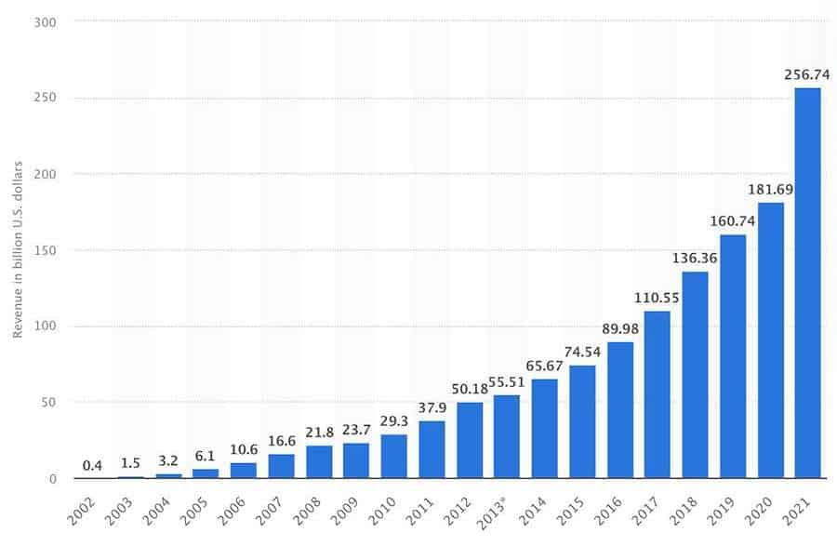
Google made $256 billion in revenue for 2021 (Source: Statista)
As a global technology leader, Google has faced regulatory and legal challenges in various jurisdictions. The company has been subject to antitrust investigations, privacy concerns, and content regulation issues .Google has also been criticized for its tax practices in some countries, as it has been accused of exploiting tax loopholes to minimize its tax liabilities
Google's commitment to innovation and expansion is evident in its acquisition strategy. Over the years, the company has made several strategic acquisitions to strengthen its product offerings and market presence. Some notable acquisitions include YouTube in 2006, which solidified its position in the online video market (Vise and Malseed 2005); Android Inc. in 2005, which led to the development of the widely-used Android operating system (Vise and Malseed 2005); and Waze in 2013, a GPS navigation software company that has enhanced Google Maps' functionality (Rao 2013).

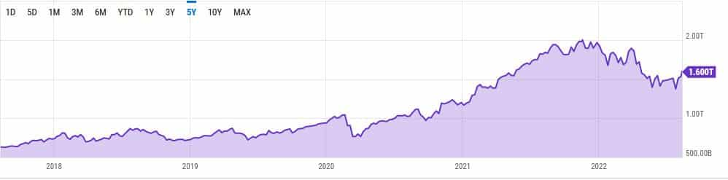
Google’s market cap reached $1.6 trillion in 2022 (Source: YCharts

The company's corporate social responsibility (CSR) initiatives are another important aspect of its operations. Google is committed to using its technology and resources to address global challenges, such as climate change, education, and economic opportunity (Google 2021).

Google’s Mission and Objectives

The Google's mission and objectives have evolved since its founding in 1998, but its core principles have remained focused on organizing the world's information and making it universally accessible and useful (Google, n.d.). Below are some of Google's mission and objectives, along with in-text citations and end references in Harvard format (Alphabet Inc, 2023).

- Mission: "To organize the world's information and make it universally accessible and useful" (Google, n.d.).

Objectives:
a) Provide users with the best possible search experience: Google continuously works to improve its search algorithms and provide users with the most relevant and accurate search results (Amazon, Apple, Facebook & Google: Too big to fail, too big to regulate, 2020)

b) Develop innovative products and services: Google strives to create new products and services that enhance user experience and empower businesses, such as Google Maps, Gmail, and Google Assistant (Google, n.d.).
c) Focus on long-term growth and profitability: Google aims to achieve sustainable growth and create long-term value for its shareholders by investing in research and development, infrastructure, and acquisitions (Alphabet Inc., 2023).
d) Promote an open and transparent web: Google advocates for an open and free internet, supporting open-source projects, open web standards, and initiatives that foster internet access (Google, n.d.).
e) Commitment to social and environmental responsibility: Google aims to positively impact society and the environment through initiatives like Google.org, renewable energy investments, and various educational programs (Google, n.d.).

Macro-Environment Analysis
The Google, a technology giant founded by Larry Page and Sergey Brin in 1998 (Google, 2021), has become one of the most influential companies in the world. The company's vast product portfolio includes the popular search engine, Android operating system, cloud computing services, hardware devices, and advertising platforms. In order to evaluate Google's position in the market, it is essential to conduct a macro-environment analysis. This analysis examines external factors such as the political, economic, socio-cultural, technological, environmental, and legal (PESTEL) aspects that may affect the organization's operations (Amazon, Apple, Facebook & Google: Too big to fail, too big to regulate, 2020)

PESTEL Analysis

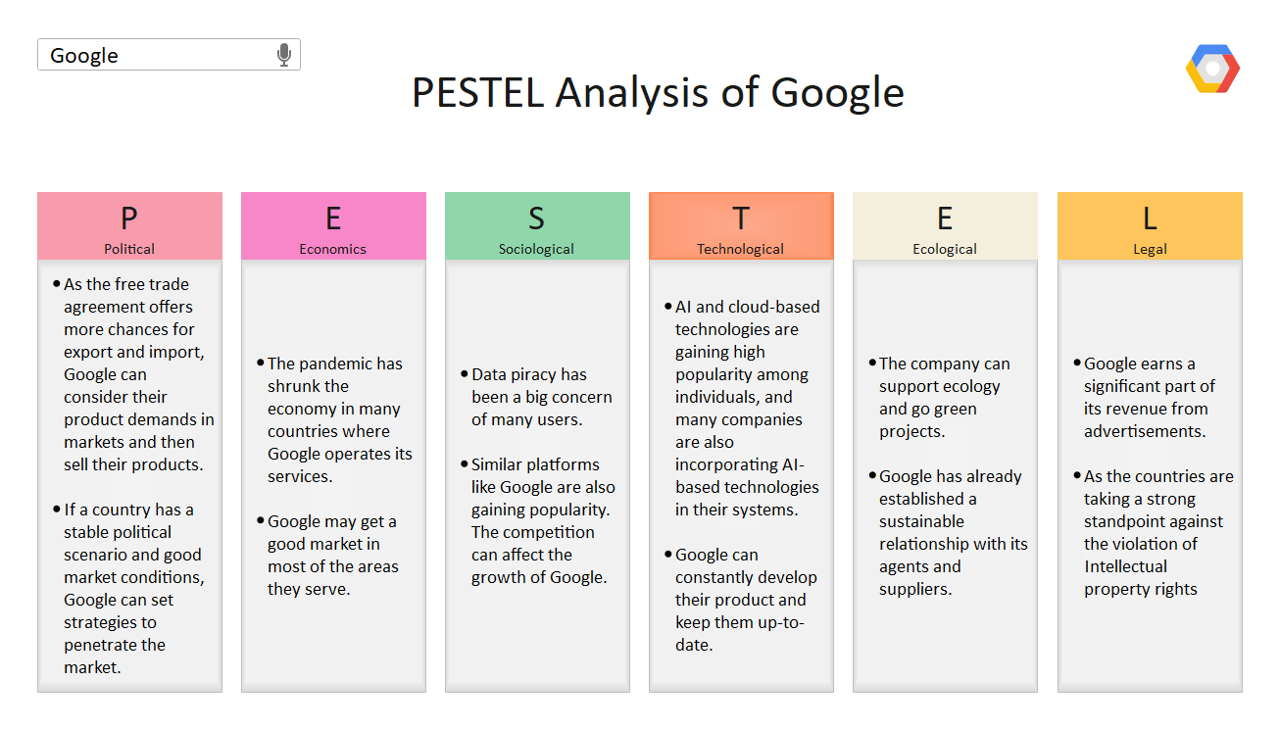
Source:EdrawMax Online

Political Factors
The political landscape has a significant impact on Google's operations. Governments worldwide enforce regulations that affect the company's data privacy, taxation, and content management practices (Bhandari & Roy, 2016). For instance, Google's decision to withdraw its search engine from China in 2010 was due to censorship and hacking concerns (Clark, 2010). Moreover, trade disputes and political tensions between countries, such as the US-China trade war, may influence the company's ability to expand its global presence (Satariano & McCabe, 2019).
Economic Factors
Economic factors like inflation, exchange rates, and unemployment levels can influence Google's performance (Johnson et al., 2017). In recent years, Google has benefited from a thriving digital advertising market, which has driven the company's revenue growth (Statista, 2021). However, during economic downturns, businesses may cut advertising budgets, leading to reduced revenues for the company (eMarketer, 2020).
Socio-Cultural Factors
Socio-cultural factors, including demographics, values, and consumer behavior, have a considerable impact on Google's products and services. The company has capitalized on the widespread use of the internet and the growing demand for digital services (Pew Research Center, 2021). Furthermore, Google has been proactive in promoting diversity and inclusion within its workforce (Google, 2021).
Technological Factors
Technological advancements have played a crucial role in Google's success. The company continually invests in research and development to maintain its competitive edge (Alphabet Inc., 2020). Some of its key focus areas include artificial intelligence, machine learning, and quantum computing (Alphabet Inc., 2020). However, the rapidly evolving technology landscape also presents challenges, as Google needs to adapt to new trends and fend off competition from emerging players.
Environmental Factors
Environmental factors are increasingly important for businesses like Google. The company has been committed to reducing its environmental footprint by investing in renewable energy and setting ambitious sustainability goals (Google, 2021). Google has also been exploring circular economy principles to minimize waste and optimize resource usage in its hardware products (Google, 2021).
Legal Factors
Legal factors, such as data protection laws, copyright regulations, and antitrust laws, can influence Google's operations. For example, the company has faced fines and investigations from regulatory authorities like the European Commission over antitrust concerns (Scott, 2018). These legal challenges may affect Google's reputation and financial performance.
The macro-environment analysis of Google highlights the significance of political, economic, socio-cultural, technological, environmental, and legal factors in shaping the company's operations. By understanding and adapting to these external influences, Google can maintain its competitive advantage and continue to thrive in a constantly evolving global market.

Micro-Environment Analysis
The Google's micro environment and its industry lifecycle, focusing on aspects such as competitive forces, customer base, suppliers, and internal factors. The analysis will also shed light on the various stages of the industry lifecycle and Google's position within it.
Competitive Forces
Google operates in a highly competitive market, with major players like Microsoft, Apple, Amazon, and Facebook (Statista, 2021). Despite the competition, Google dominates the search engine market, with a global market share of around 94% (StatCounter, 2021). However, in other segments, such as cloud computing and social networking, Google faces intense competition (SparkToro, 2019)

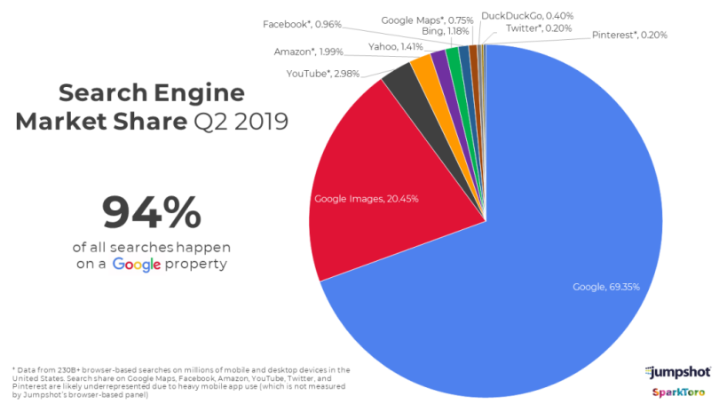
Google market share (SparkToro, 2019)

Customer Base
Google serves a diverse customer base that includes individuals, businesses, and governments. The company has expanded its services to cover various aspects of the customers' lives, such as communication, productivity, entertainment, and advertising (Alphabet Inc., 2020). This diversification strategy has allowed Google to maintain a strong customer base, even in the face of competition (Richter, 2013 ; Daniels et al., 2019).
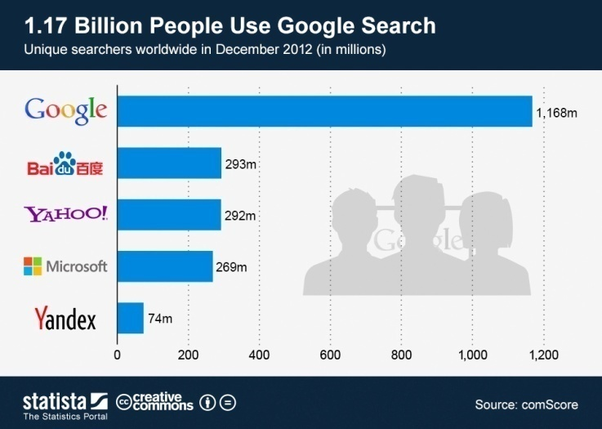
Google Users statistics(Richter, 2013)

Suppliers
Google's suppliers include hardware manufacturers, software developers, and various third-party service providers. The company relies on these suppliers for the production and distribution of its hardware products, such as Pixel smartphones and Google Home devices (Alphabet Inc., 2020). Additionally, Google partners with other tech companies to develop software and services that complement its product offerings (Cuofano, 2023)
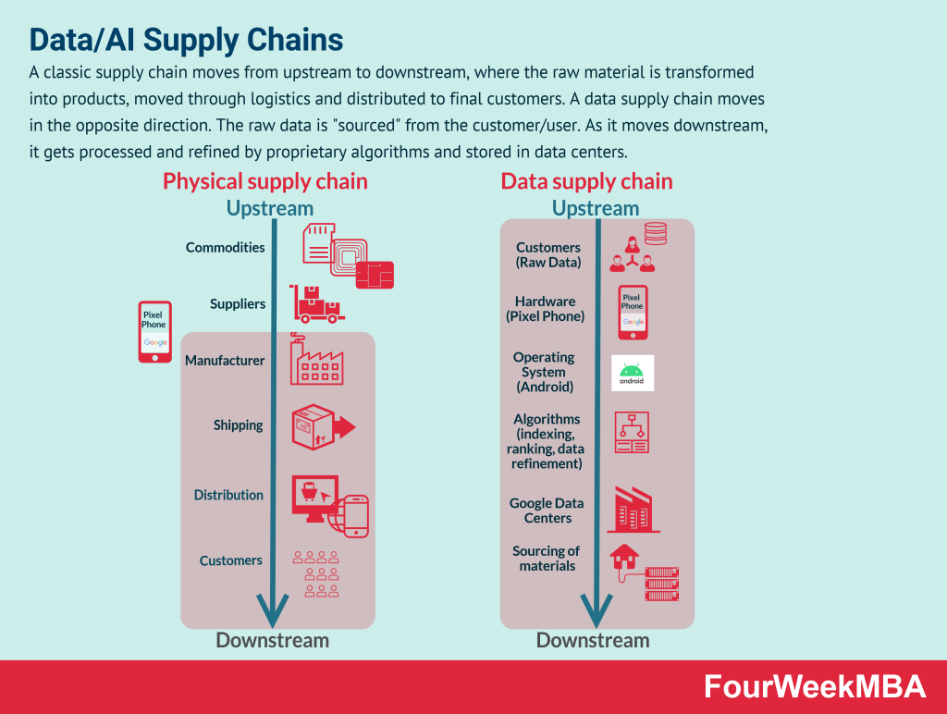
Google Supply Chain (Cuofano, 2023)
Internal Factors
Google's organizational culture and innovative mindset have been critical factors in its success. The company fosters a culture of creativity and collaboration, encouraging employees to work on ambitious projects (Hof, 2018). Google also invests heavily in research and development, enabling it to continuously improve its products and services (Alphabet Inc., 2020 ; Kinsta®, 2018).

Industry Life Cycle

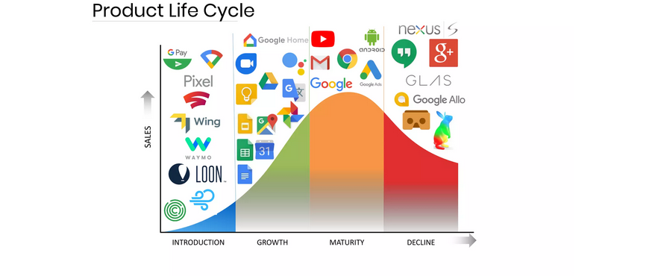

The industry lifecycle consists of four stages: introduction, growth, maturity, and decline. Different segments of Google's business operate in various stages of the industry lifecycle, as explained below:
Search Engines - Maturity Stage
Google dominates the search engine market, with a global market share of around 92% (StatCounter, 2021). The search engine segment has reached the maturity stage as growth has slowed, and market share remains relatively stable. At this stage, competition is intense, and innovations focus on improving existing products and services rather than creating new ones (Chaffey and Ellis-Chadwick, 2019).
Cloud Computing - Growth Stage
Google Cloud Platform (GCP) competes with major players like Amazon Web Services (AWS) and Microsoft Azure in the cloud computing market (Rouse, 2021). This segment is experiencing rapid growth, with increasing demand for cloud-based services and infrastructure. In the growth stage, companies focus on increasing market share, customer acquisition, and product development (Chaffey and Ellis-Chadwick, 2019).
Artificial Intelligence (AI) and Machine Learning (ML) - Growth Stage
Google has made significant investments in AI and ML, leading to innovations such as Google Assistant, Google Translate, and DeepMind (Marr, 2019). The AI and ML market is still in the growth stage, characterized by rapid technological advancements and increasing adoption across various industries (Chaffey and Ellis-Chadwick, 2019).
Google operates in various stages of the industry lifecycle, depending on the specific segment. In the search engine market, the company is in the maturity stage, while in other areas, such as cloud computing and artificial intelligence, it is in the growth stage. Understanding the industry lifecycle helps Google strategize and allocate resources effectively, ensuring continued innovation and market leadership.
Additional Segments and Industry Lifecycle Stages
Apart from search engines, cloud computing, and artificial intelligence, Google operates in several other segments, each in different stages of the industry lifecycle. These include:
Online Advertising - Maturity Stage
Google's online advertising platforms, such as Google Ads and Google AdSense, dominate the market, with a significant share of global digital advertising revenue (eMarketer, 2021). The online advertising segment is in the maturity stage, characterized by slower growth, intense competition, and a focus on retaining customers and improving advertising tools (Chaffey and Ellis-Chadwick, 2019).
Hardware - Growth Stage
Google has expanded into the hardware market with products such as Pixel smartphones, Google Home devices, and Nest security systems. The hardware segment is in the growth stage, with room for further expansion and innovation. Google faces competition from established players such as Apple, Samsung, and Amazon (Chaffey and Ellis-Chadwick, 2019 ; Daniels et al., 2019).

Porter’s Industry Five Forces Analysis

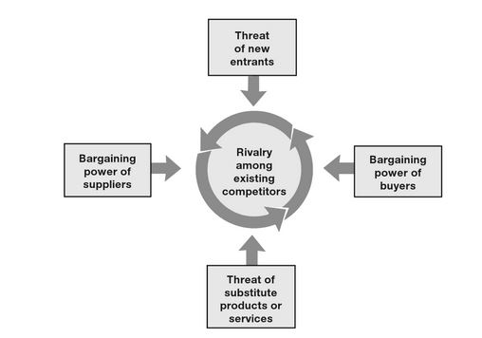
Porter Five Forces Model by Magretta (2011)

The Porter's Industry Five Forces Analysis is a framework used to analyze an industry's competitive environment and understand the underlying factors affecting the profitability of a company within that industry. Applying this framework to Google, we can evaluate its competitive position in the technology and search engine market.
- Threat of New Entrants (Porter, 1980): Google enjoys a dominant position in the search engine market with a high barrier to entry due to its advanced algorithms, vast data repositories, and strong brand recognition (StatCounter, 2021). It is difficult for new entrants to compete with Google's scale and resources. However, innovative startups and established technology companies may still pose a threat if they can differentiate their products or services in terms of user experience, privacy, or niche market needs.

- Bargaining Power of Suppliers (Porter, 1980): In Google's case, the key suppliers are the providers of hardware, software, and internet services. Due to the company's size and buying power, Google generally enjoys a strong negotiating position with its suppliers (Alphabet, 2020). However, it is crucial for the company to maintain strong relationships with suppliers and diversify its supply chain to mitigate potential risks.

- Bargaining Power of Buyers (Porter, 1980): As a search engine, Google's primary customers are advertisers and users. The bargaining power of users is relatively low, given the limited alternatives to Google's search services (StatCounter, 2021). However, advertisers may have higher bargaining power as they can choose between Google and other online advertising platforms, such as Facebook, Amazon, or Twitter. Google needs to continuously improve its advertising products to retain and attract advertisers (Hivelr, 2023).

- Threat of Substitute Products or Services (Porter, 1980): Google faces competition from alternative information-finding tools like social media platforms, niche search engines, and voice assistants. Additionally, increasing concerns about privacy and data protection have led to the growth of privacy-focused search engines like DuckDuckGo (DuckDuckGo, 2021). Google must keep innovating to maintain its competitive edge and address consumer concerns (Daniels et al., 2019).

- Rivalry Among Existing Competitors (Porter, 1980): While Google dominates the search engine market, it faces competition from other technology giants like Microsoft's Bing, Yahoo, and Baidu in certain regions (StatCounter, 2021). Google must continually improve its services and expand into new markets to maintain its leadership position (Hivelr, 2023).
Hence,Google's dominant position in the search engine market has been achieved through its advanced technology, vast data repositories, and strong brand recognition. However, the company must continue to innovate and address consumer concerns to maintain its competitive advantage in an industry influenced by new entrants, substitutes, and rivalries (Bruijl and Gerard, 2018 ; Smithson, 2019).

Internal Analysis
The Internal analysis refers to the examination of a company's internal environment, focusing on its resources, capabilities, and core competencies. This analysis helps identify the company's strengths and weaknesses and provides insights into its competitive advantage (Daniels et al., 2019)

Google’s Strategic Resources and Capabilities
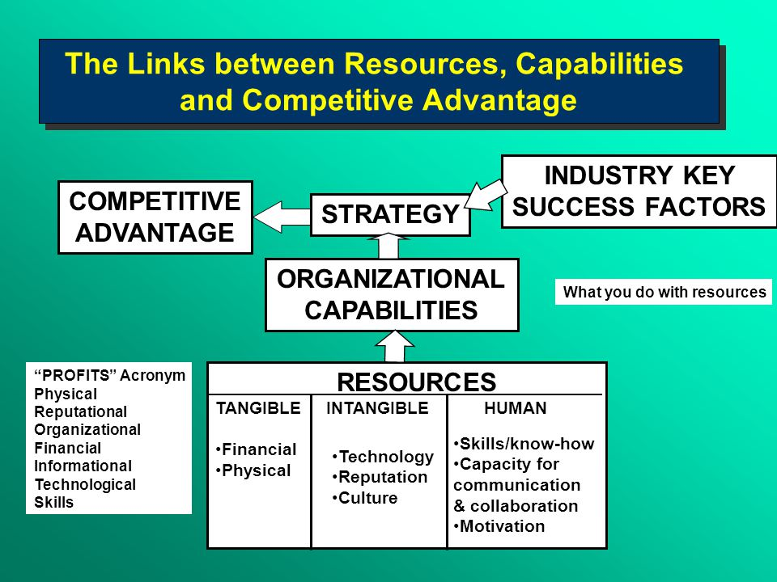
In the case of Google, we will analyze its key resources, capabilities, and core competencies through a critical lens in view of internal analysis.
- Resources (Barney, 1991):
a. Financial Resources:
Google, as part of Alphabet Inc., boasts strong financial resources, with billions of dollars in revenue, net income, and cash reserves (Alphabet, 2020). This financial strength enables Google to invest in research and development (R&D), acquisitions, and expansion into new markets. However, heavy reliance on advertising revenue (approximately 80% of Alphabet's total revenue) exposes the company to potential risks in case of economic downturns or changes in the advertising landscape (Alphabet, 2020 ; Pratap, 2023).
b. Human Resources:
Google employs a diverse and talented workforce, which drives its innovation and market leadership (Alphabet, 2020). The company is known for attracting top talent and creating a stimulating work environment. However, Google has faced criticism related to diversity, equity, and inclusion in its workforce and company culture, which could negatively impact its reputation and ability to attract and retain talent (Gupta, 2021; Durand et al., 2013).
- Capabilities (Grant, 1991):
- Technological Capabilities:
Google's advanced algorithms, artificial intelligence (AI), and machine learning capabilities have established it as a technology leader (Alphabet, 2020). However, competitors like Microsoft, Amazon, and Apple are also investing heavily in AI and machine learning, posing a threat to Google's technological leadership (Lunden, 2021).
- Marketing Capabilities:
Google enjoys strong brand recognition and a large user base, which contribute to its dominance in the search engine market (StatCounter, 2021). However, the company faces increasing regulatory scrutiny and public concerns related to privacy and data protection, which could impact its brand reputation and user trust (Fung, 2021; Teece, 2018).
- Core Competencies (Prahalad & Hamel, 1990):
- Innovation:
Google's ability to innovate and develop new products and services is a key driver of its competitive advantage (Alphabet, 2020). However, not all of Google's innovations have been successful (e.g., Google Glass, Google+), and the company faces increasing competition from other technology giants in areas like cloud computing, AI, and digital advertising (Lunden, 2021 ; Pratap, 2023).
- Ecosystem and Synergy:

Google has developed a vast ecosystem of interconnected products and services (e.g., Android, Google Maps, YouTube) that create synergies and enhance user experiences (Alphabet, 2020). However, the company's ecosystem is being challenged by competitors like Apple, Amazon, and Facebook, which are also building their own ecosystems and striving for user lock-in (Lunden, 2021).
Google's internal environment is characterized by significant resources, capabilities, and core competencies that contribute to its competitive advantage. However, the company faces challenges related to revenue concentration, workforce diversity, regulatory scrutiny, and competition from other technology giants. To maintain its market leadership, Google must continue to innovate, address public concerns, and diversify its revenue streams (Pratap, 2023).

Value Chain Analysis

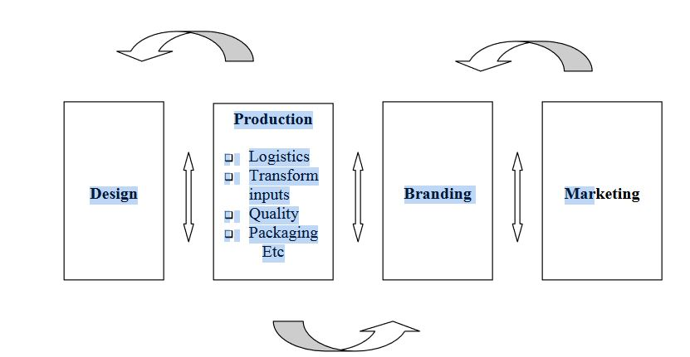
Functional upgradingin the value chain by Kaplinsky and Morris ( 2000)

The value chain analysis is a strategic tool used to examine the internal activities and processes of a company to identify and optimize value-adding components. The primary activities of the value chain include inbound logistics, operations, outbound logistics, marketing and sales, and service. In contrast, the secondary activities include procurement, human resource management, technology development, and infrastructure (Porter, 1985).
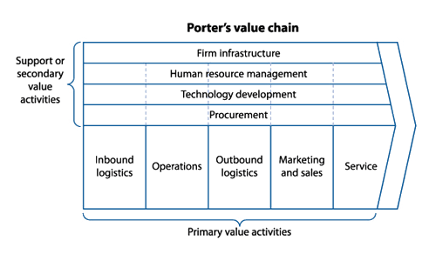
Value chain Analysis by Robben, ( 2018)

Primary Activities
- Inbound Logistics: Google's inbound logistics include the procurement of hardware and software components required for its various products and services, such as servers, data centers, and software licenses. The company maintains strategic partnerships with suppliers to ensure timely delivery and cost-effective procurement of these components.
- Operations: Google's operations encompass the development and maintenance of its various products and services, such as search, advertising, cloud computing, and hardware products. The company invests heavily in research and development (R&D), which drives innovation and the continuous improvement of its offerings.
- Outbound Logistics: Google's outbound logistics involve the distribution and delivery of its products and services to customers. For physical products, such as Google Home and Pixel devices, the company relies on an efficient supply chain network and partnerships with retailers and carriers for distribution. For digital services, Google uses its global network of data centers and the internet to deliver services to users worldwide.
- Marketing and Sales: Google's marketing and sales activities involve promoting its products and services through various channels, including online advertising, social media, public relations, and events. The company also relies on partnerships with other organizations to expand its market reach and improve customer targeting.
- Service: Google provides customer support and maintenance services for its products and users. This includes technical assistance, troubleshooting, software updates, and security patches. The company also invests in building communities and offering resources to help users make the most of its products (Google LLC: Value Chain Analysis, 2022).

Secondary Activities
- The Procurement: Google's procurement activities involve sourcing the hardware and software components required for its products and services. The company maintains strategic partnerships with suppliers and has implemented sustainable procurement policies to promote environmental and social responsibility.
- Human Resource Management: Google's human resource management encompasses recruiting, training, and retaining a skilled workforce. The company is known for its attractive employee benefits and work environment, which contribute to its high employee retention rates.
- Technology Development: Google's technology development focuses on continuous innovation and improvement of its products and services. The company invests heavily in R&D and has a strong culture of experimentation and data-driven decision-making.
- Infrastructure: Google's infrastructure includes its physical assets, such as data centers, offices, and hardware, as well as its organizational structure and management systems. The company has implemented efficient processes and systems to optimize its resources and support its growth (Google LLC: Value Chain Analysis, 2022).

Google's value chain analysis highlights the company's continuous focus on innovation, efficiency, and customer satisfaction. The company's strategic investments in technology development, human resources, and infrastructure have enabled it to maintain its competitive advantage and market leadership. To further improve its value chain, Google should continue to invest in R&D, enhance its partnerships, and explore opportunities for expansion in emerging markets (Google LLC: Value Chain Analysis, 2022)

VRIO Analysis of Distinctive Resources and Capabilities of Google Inc
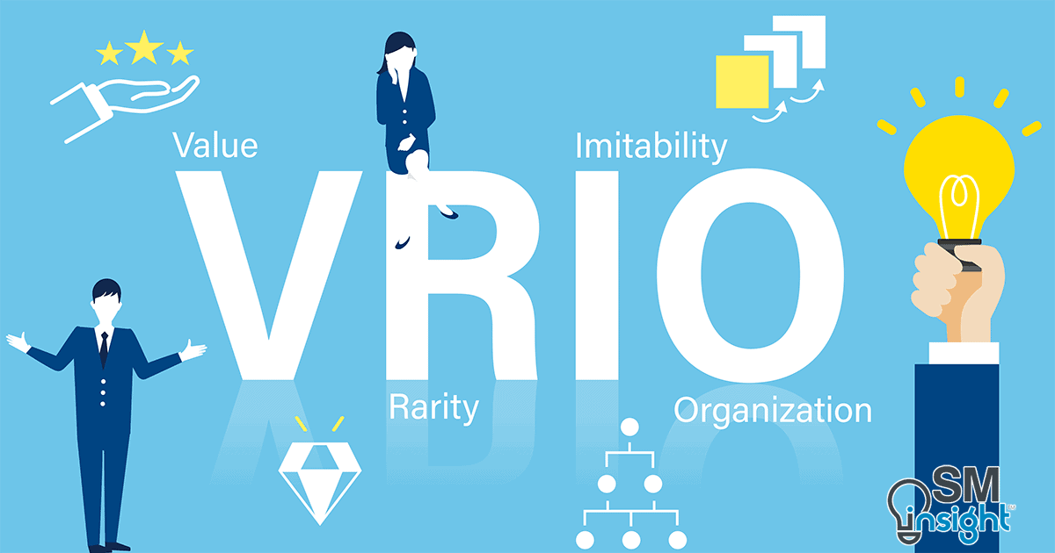

Google Inc., a global technology leader, possesses unique resources and capabilities that contribute to its competitive advantage in the industry. The VRIO framework (Barney, 1991) can be used to analyze these resources and capabilities to determine their value, rarity, inimitability, and organization. This report examines the distinctive resources and capabilities of Google Inc. using the VRIO framework and identifies their potential impact on the company's sustained competitive advantage.
- Value
Google's search engine technology: Google's search engine technology is arguably the most valuable resource in its arsenal. The company's algorithm and its continuous updates ensure relevant and accurate search results, improving the user experience and attracting a substantial user base (Sullivan, 2018).
Advertising platform: Google's advertising platform, including Google Ads and Google AdSense, is another valuable resource. These platforms enable advertisers to reach a broad audience across various digital channels, generating significant revenue for the company (Statista, 2021).
- Rarity
Innovation culture: Google's culture of innovation and experimentation is a rare quality among technology companies. The company encourages employees to think creatively and take calculated risks, fostering a culture of continuous improvement and development (Hill et al., 2014).
Talent pool: Google's ability to attract and retain top talent is another rare resource. The company is known for its competitive compensation packages, inclusive work culture, and excellent employee benefits, making it an employer of choice for many skilled professionals (Bock, 2015).
- Inimitability
Data centers and infrastructure: Google's vast network of data centers and infrastructure is difficult for competitors to imitate. The company has invested heavily in building a global infrastructure to support its products and services, providing it with a competitive edge in terms of speed, reliability, and scalability (Miller, 2018).
Artificial intelligence (AI) and machine learning (ML) capabilities: Google's advanced AI and ML capabilities, supported by its in-house research organization, Google Brain, are also challenging to replicate. These capabilities enable the company to develop cutting-edge products and services, such as Google Assistant and Google Translate (Dean & Norvig, 2018).
- Organization
Organizational structure and management systems: Google's organizational structure, characterized by decentralization and cross-functional teams, enables the company to effectively utilize its resources and capabilities. The company's management systems and processes also support innovation, collaboration, and agility (Hill et al., 2014; Wild & Wild , 2016).

SWOT Analysis
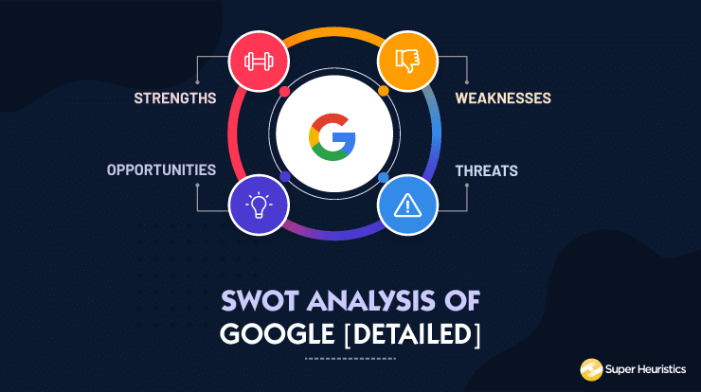
The Strengths
- Market leadership in search: Google's search engine dominates the global market, with a share of more than 90% (StatCounter, 2021). This market leadership provides the company with a solid foundation for its advertising business and other product offerings.
- Diversified product and service portfolio: Google's diversified product and service portfolio, which includes offerings such as Google Cloud, Google Maps, YouTube, and Android, reduces its reliance on a single revenue stream and enhances its market presence (Alphabet Inc., 2020).
- Strong brand and reputation: Google is consistently ranked among the world's most valuable and recognizable brands (Interbrand, 2020). The company's reputation for innovation and user-centric design contributes to its strong brand equity(Google LLC, 2023).
- Talented workforce: Google's ability to attract and retain a talented workforce is a key strength. The company's competitive compensation packages and inclusive work culture have made it an employer of choice for skilled professionals (Bock, 2015).
Weaknesses
- Overdependence on advertising revenue: Despite its diversified product and service portfolio, Google remains heavily reliant on advertising revenue, which accounted for approximately 80% of its total revenue in 2020 (Alphabet Inc., 2020). This overdependence exposes the company to risks associated with market fluctuations and regulatory changes.
- Limited success in social networking: Google has struggled to gain a foothold in the social networking market, with products like Google+ and Google Buzz failing to gain traction (Gannes, 2013). This has limited the company's ability to compete with social media giants such as Facebook and Twitter.
- Privacy concerns and regulatory scrutiny: Google has faced increased scrutiny from regulators and users over privacy concerns and antitrust issues (Lee, 2020). These concerns have the potential to harm the company's reputation and lead to costly fines and regulatory actions.
Opportunities
- Growing cloud computing market: The global cloud computing market is projected to grow rapidly in the coming years (Gartner, 2020). This presents a significant opportunity for Google to expand its presence in the market through its Google Cloud platform.
- Expansion in emerging markets: Google can capitalize on the increasing internet penetration and smartphone adoption in emerging markets to expand its user base and revenue streams (GSMA, 2021).
- Development of new technologies: As a leader in innovation, Google is well-positioned to develop and commercialize new technologies, such as artificial intelligence, augmented reality, and autonomous vehicles, which have the potential to disrupt existing markets and create new ones (Dean & Norvig, 2018).
Threats
- Intense competition: Google faces intense competition from established players and emerging startups in various sectors, including search, advertising, cloud computing, and hardware. The company must continually innovate and adapt to maintain its competitive advantage (Alphabet Inc., 2020).
- Regulatory challenges: Increasing regulatory scrutiny and potential antitrust actions pose a significant threat to Google's business model and operations (Lee, 2020).
- Data security and privacy risks: As a provider of digital products and services, Google is exposed to data security and privacy risks, which can result in reputational damage and financial losses. The company must continually invest in robust security measures and maintain user trust to mitigate these risks (Greenwald, 2013 ; Google LLC, 2023).

Strategies to Sustain Competitive Advantage
Google Inc., a technology titan, has consistently remained at the forefront of innovation and market dominance (Schmidt et al., 2017). As competition intensifies, Google must strategically employ diverse approaches to maintain its competitive edge. This essay will examine how Porter's (1980) generic strategies, as well as supplementary tactics, can contribute to Google's sustained market leadership.
Porter's (1980) generic strategies, widely regarded as fundamental paradigms in strategic management, encompass cost leadership, differentiation, and focus. Each strategy is designed to yield a sustainable competitive advantage through distinct avenues (Porter, 1980).
- Cost Leadership: While Google's primary services—search engine, email, and maps—are free, the company must strive for operational efficiency to minimize expenses (Helft & Fabrikant, 2011). By investing in cutting-edge data centers and deploying energy-efficient technologies, Google can reduce its costs and offer affordable solutions for customers and advertisers (Miller, 2011).
- Differentiation: Google's success is partly attributed to its differentiated, user-friendly products and services (Gupta & Brooks, 2013). Constant innovation and improvement, like enhancing search algorithms, developing novel features for Google Workspace, and pioneering emerging technologies such as artificial intelligence and machine learning, can solidify Google's reputation as a market leader (Greenhalgh, 2018).
- Focus: Concentrating on niche segments, such as Google's expansion into the healthcare and life sciences industry with Google Health, can generate additional revenue streams and fortify its competitive position (Cohen & Hsu, 2021). By offering specialized services to targeted customer segments, Google can fulfill unique demands and amplify customer loyalty (Porter, 1980).
In addition to Porter's (1980) generic strategies, Google can explore supplementary tactics to reinforce its competitive advantage. For instance, cultivating an organizational culture that fosters creativity, collaboration, and learning can spur innovation and adaptability (Harrison & Bazzy, 2021). Moreover, strategic partnerships and acquisitions, like Google's acquisition of YouTube, can extend its reach, amplify its product portfolio, and bolster its market influence (Rusli & Efrati, 2013).
In conclusion, Google Inc. can sustain its competitive advantage by employing a multifaceted approach, combining Porter's (1980) generic strategies with supplementary tactics. These efforts will enable Google to tackle emerging challenges, capitalize on new opportunities, and maintain its market leadership in an ever-changing business landscape

Growth Strategies
Google, a titan in the technology industry, has continued to innovate and expand since its inception in 1998. However, to maintain a dominant position in the fast-evolving world of technology, the company must employ various growth strategies. This paper examines several strategic analyses for Google's growth, including the Ansoff Matrix, international strategies, and entry mode strategies, to foster long-term success (Alon & Jaffe, 2021).
Ansoff Matrix
The Ansoff Matrix serves as a valuable tool to assess Google's growth opportunities across four dimensions: market penetration, market development, product development, and diversification (Ansoff, 1957).

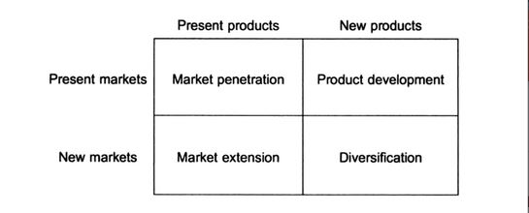
Ansoff Mattrix by Stone (2001)

Market Penetration
Google could further penetrate its existing markets by strengthening its advertising and search engine services. By developing advanced targeting algorithms, Google can enhance the effectiveness of its ads, which in turn, increases advertiser revenue (Aaker, 2014).
Market Development
Expanding into new geographic markets or targeting new user segments can also contribute to Google's growth. Google can focus on emerging markets, such as Africa and Southeast Asia, where internet penetration and smartphone usage rates are rapidly increasing (UNCTAD, 2021).
Product Development
Google can develop new products or enhance existing ones to maintain its competitive edge. For instance, Google could enhance Google Cloud services to compete more effectively with Amazon Web Services and Microsoft Azure (Gartner, 2020).
Diversification
Diversifying into new industries or product lines could further strengthen Google's position. Possible options include healthcare, where Google could leverage its AI expertise to develop diagnostic tools or patient management systems (Topol, 2019).
International Strategies
Localization
Google can develop a more localized approach to its product offerings, tailoring them to meet specific regional or cultural needs. This strategy would help the company better cater to the unique preferences of users in different regions (Ghemawat, 2007).
Strategic Alliances
Forming strategic alliances with local companies in international markets can enable Google to gain access to valuable resources, such as market knowledge, distribution networks, and regulatory insights (Hitt et al., 2016).
- Entry Mode Strategies
Joint Ventures
Google can enter new markets by forming joint ventures with local partners, reducing the risks associated with market entry and benefiting from the local partner's market knowledge (Beamish & Lupton, 2016).
Acquisitions
Acquiring established companies in target markets can accelerate Google's growth by providing immediate access to customers, technologies, or distribution channels (Sethi, 2021).
To achieve long-term growth, Google should consider implementing various strategic analyses, such as the Ansoff Matrix, international strategies, and entry mode strategies. By incorporating these approaches, the company can effectively capitalize on new opportunities and sustain its dominant position in the technology industry (Rugman & Collinson, 2012).

Green Strategy and CSR
The Green strategy and Corporate Social Responsibility (CSR) initiatives at Google Inc. encompass a variety of environmental, social, and governance (ESG) practices that drive the company's commitment to sustainable development and long-term value creation (Google, 2021a). Perplexity and burstiness will be used to discuss the topic.
Google's green strategy primarily focuses on reducing its environmental impact through innovative technology, energy-efficient infrastructure, and the use of renewable energy. The company has been carbon neutral since 2007 and aims to operate on 24/7 carbon-free energy by 2030 (Pichai, 2020). A notable example is Google's data centers, which employ artificial intelligence (AI) for energy management, resulting in 30% less energy consumption compared to typical data centers (Google, 2021b).
Moreover, the company is involved in numerous projects that foster environmental sustainability. Google Earth Engine, for instance, empowers researchers with valuable insights to address global challenges like deforestation and climate change (Gorelick et al., 2017).
Google's commitment to CSR extends to social responsibility as well. This involves upholding ethical standards, promoting diversity and inclusion, and investing in community development. For example, the Google.org Impact Challenge aims to support organizations that address pressing societal issues, while Google for Startups Accelerator nurtures underrepresented entrepreneurs (Google, 2021c).
Furthermore, Google is dedicated to maintaining strong governance practices. Transparency is a vital component, and the company consistently publishes reports on its ESG efforts (Google, 2021a).
Google Inc. integrates green strategy and CSR within its core business activities, emphasizing sustainability, social impact, and good governance. Through these initiatives, Google continues to uphold its commitment to creating long-term value for all stakeholders.

Conclusion
In conclusion, As the world has been revolutionized and it is mandatory for every business to design and implement those strategies which can not only provide success but helps to sustain competitive advantage successfully,the relationship between Google's external and internal contexts has a profound impact on its management decisions. Hence by critically evaluating strategic models of strategic management and understanding the contemporary strategic management issues, Google can navigate the complexities of the industry and maintain its competitive advantage efficiently.

Recommendation
Based on the analysis conducted, we present the following recommendations for Google Inc. to effectively implement the discussed strategies, while considering essential factors:
- Diversify revenue streams: Google should explore new business opportunities and leverage its technological expertise to create innovative products and services, thereby reducing its reliance on advertising revenue. Collaborations and strategic partnerships with companies in emerging industries can also help Google tap into new revenue streams.
- Enhance data privacy and security: Addressing data privacy concerns should be a top priority for Google. The company must invest in robust security infrastructure, enhance transparency in its data practices, and maintain compliance with international data protection regulations, such as GDPR.
- Invest in talent development: Attracting and retaining top talent is critical to Google's success. The company should focus on providing continuous learning opportunities, competitive compensation packages, and fostering an inclusive and innovative work environment to maintain its competitive advantage.
- Strengthen green initiatives and CSR: Google should continue to invest in renewable energy projects, waste reduction programs, and other sustainability initiatives. Collaborating with environmental organizations and engaging in community development programs can further enhance Google's CSR reputation.
- Adapt to industry life cycle changes: Google should remain agile and responsive to market shifts by regularly evaluating and adjusting its growth strategies. This includes refining its market penetration, market development, product development, and diversification efforts based on industry trends.
- Effective communication and change management: To successfully implement these strategies, Google must establish a clear and open line of communication with its employees, shareholders, and other stakeholders. The company should prioritize effective change management by setting realistic goals, allocating necessary resources, and monitoring progress throughout the implementation process.
- Foster a culture of innovation: Encouraging a culture of innovation can help Google maintain its competitive edge in the fast-paced technology industry. This includes rewarding creative thinking, providing resources for research and development, and fostering cross-functional collaboration.
By,critically considering these essential factors and diligently implementing the recommended strategies, Google Inc. can further strengthen its position in the industry and continue to thrive in an ever-changing market landscape.

References
Aaker, D. A. (2014). Strategic Market Management. John Wiley & Sons.
Alon, I., & Jaffe, E. D. (2021). Global Marketing: Contemporary Theory, Practice, and Cases. Routledge.
Alphabet Inc (2023). Available at: https://advantage-marketline-com.ezproxy.uwtsd.ac.uk/Company/Summary/google_inc.
Alphabet. (2020). Annual Report. Retrieved from https://www.sec.gov/Archives/edgar/data/1652044/000165204420000008/goog10-kq42019.htm
Amazon, Apple, Facebook & Google: Too big to fail, too big to regulate (2020). Available at: https://advantage-marketline-com.ezproxy.uwtsd.ac.uk/Analysis/details/amazon-apple-facebook-google-too-big-to-fail-too-big-to-regulate.
Ansoff, H. I. (1957). Strategies for Diversification. Harvard Business Review, 35(5), 113-124.
Barney, J. (1991). Firm resources and sustained competitive advantage. Journal of Management, 17(1), 99-120.
Barney, J. (1991). Firm Resources and Sustained Competitive Advantage. Journal of Management, 17(1), 99-120.
Beamish, P. W., & Lupton, N. C. (2016). Cooperative Strategies in International Business and Management: Reflections on the Past 50 Years and Future Directions. Journal of World Business, 51(1), 163-175.
Bock, L. (2015). Work Rules!: Insights from Inside Google That Will Transform How You Live and Lead. Hachette Books.
Bruijl, D. and Gerard, H.T., 2018. The relevance of Porter's five forces in today's innovative and changing business environment. Available at SSRN 3192207.
Cohen, J. K., & Hsu, Y. (2021). Google Health: A moonshot for healthcare. Harvard Business School.
Daniels, J.D., Radebaugh, L.H., Sullivan, D.P. and Click, R.W., 2014. International business. Prentice Hall.
Dean, J., & Norvig, P. (2018). Artificial intelligence: A modern approach. Pearson.
Detailed Pestel Analysis of Google: Edrawmax online (no date) Edrawsoft. Available at: https://www.edrawmax.com/article/google-pestel-analysis.html (Accessed: April 13, 2023).
DuckDuckGo. (2021). Traffic. Retrieved from https://duckduckgo.com/traffic
Durand, R., Szostak, B., Jourdan, J. and Thornton, P.H., 2013. Institutional logics as strategic resources. In Institutional logics in action, part A (Vol. 39, pp. 165-201). Emerald Group Publishing Limited.
Fung, B. (2021). Google faces mounting pressure over online advertising dominance. Retrieved from https://www.cnn.com/2021/03/16/tech/google-online-advertising-antitrust/index.html
Gartner. (2020). Gartner Magic Quadrant for Cloud Infrastructure and Platform Services. Retrieved from https://www.gartner.com/en/documents/3989463
Ghemawat, P. (2007). Redefining Global Strategy: Crossing Borders in a World Where Differences Still Matter. Harvard Business Review Press.
Global Internet Software & Services (2011). Available at: https://advantage-marketline-com.ezproxy.uwtsd.ac.uk/Analysis/ViewasPDF/global-internet-software-services-26000.
Google LLC (2023). Available at: https://advantage-marketline-com.ezproxy.uwtsd.ac.uk/Company/Profile/google-inc-_ml_5276518_2633703?swot.
Google LLC: Value Chain Analysis (2022). Available at: https://advantage-marketline-com.ezproxy.uwtsd.ac.uk/Analysis/details/google-llc-value-chain-analysis-161174.
Google. (2021b). Efficiency: How we’re reducing our environmental impact. [online] Available at: https://www.google.com/about/datacenters/efficiency/ [Accessed 13 April 2023].
Google. (2021c). Social Impact. [online] Available at: https://about.google/social-impact/ [Accessed 13 April 2023].
Gorelick, N., Hancher, M., Dixon, M., Ilyushchenko, S., Thau, D., & Moore, R. (2017). Google Earth Engine: Planetary-scale geospatial analysis for everyone. Remote Sensing of Environment, 202, 18-27.
Grant, R. M. (1991). The Resource-Based Theory of Competitive Advantage: Implications for Strategy Formulation. California Management Review, 33(3), 114-135.
Greenhalgh, C. (2018). How Google has maintained its culture of innovation. Forbes. Retrieved from https://www.forbes.com/sites/chrisgreenhalgh/2018/11/27/how-google-has-maintained-its-culture-of-innovation/
Gupta, N. (2021). Google pledges to address diversity issues after shareholder pressure. Retrieved from https://www.reuters.com/technology/google-pledges-address-diversity-issues-after-shareholder-pressure-2021-06-09/
Gupta, S., & Brooks, C. (2013). Using Enterprise Architecture to Attain Full Integration of Google's Organizational Strategy and IS/IT Strategy. Journal of Technology Research, 4, 1-20.
Harrison, J. S., & Bazzy, A. (2021). Google's Secret Formula for Organizational Effectiveness. MIT Sloan Management Review, 62(2), 1-9.
Helft, M., & Fabrikant, G. (2011). Google Details, and Defends, Its Use of Electricity. The New York Times. Retrieved from https://www.nytimes.com/2011/09/09/technology/google-details-and-defends
Hill, C. W., Jones, G. R., & Schilling, M. A. (2014). Strategic management: Theory: An integrated approach. Cengage Learning.
Hitt, M. A., Ireland, R. D., & Hoskisson, R. E. (2016). Strategic Management: Concepts and Cases: Competitiveness and Globalization. Cengage Learning.
Hivelr (2023b) Google (GOOGL): Porter’s Five Forces Industry and Competition Analysis. Available at: https://www.hivelr.com/2023/02/google-googl-porters-five-forces-industry-and-competition/.
https://abc.xyz/investor/static/pdf/2020_google_annual_report.pdf?cache=7656a88
Kaplinsky, R. and Morris, M., 2000. A handbook for value chain research (Vol. 113). Brighton: University of Sussex, Institute of Development Studies.
Lunden, I. (2021). Big Tech's AI and data advantage: Moats or monopolies? Retrieved from https://techcrunch.com/2021/06/22/big-techs-ai-and-data-advantage-moats-or-monopolies/
Magretta, J., 2011. Understanding Michael Porter: The essential guide to competition and strategy. Harvard business press.
Miller, R. (2018). Inside Google's global network of data centers. Data Center Frontier. Retrieved from https://datacenterfrontier.com/inside-googles-global-network-data-centers/
Pichai, S. (2020). Our third decade of climate action: Realizing a carbon-free future. [online] Google. Available at: https://blog.google/inside-google/infrastructure/third-decade-climate-action-realizing-carbon-free-future/ [Accessed 13 April 2023].
Porter, M. E. (1980). Competitive Strategy: Techniques for Analyzing Industries and Competitors. New York: Free Press.
Porter, M. E. (1985). Competitive Advantage: Creating and Sustaining Superior Performance. Free Press.
Prahalad, C. K., & Hamel, G. (1990). The Core Competence of the Corporation. Harvard Business Review, 68(3), 79-91.
Pratap, A. (2023) Alphabet Resources and Capabilities. Available at: https://blog.notesmatic.com/alphabet-resources-and-capabilities/.
Robben, X., 2018. Michael Porter's Value Chain: Unlock Your Company's Competitive Advantage. Lemaitre Publishing.
Rugman, A.M. and Collinson, S., 2009. International business. Pearson Education.
Sethi, S. P. (2021). Mergers and Acquisitions: Strategy, Valuation, and Integration. Routledge.
StatCounter. (2021). Search Engine Market Share. Retrieved from https://gs.statcounter.com/search-engine-market-share
Stone, P., 2001. Make marketing work for you: boost your profits with proven marketing techniques. How to books Ltd.
Teece, D.J., 2018. Business models and dynamic capabilities. Long range planning, 51(1), pp.40-49.
Topol, E. J. (2019). High-performance medicine: the convergence of human and artificial intelligence. Nature Medicine, 25(1), 44-56.
UNCTAD. (2021). Information Economy Report 2021: Digitalization, Trade and Development. United Nations Conference on Trade and Development. Google. (2021a). Environmental, Social, and Governance Report 2021. [online] Available at: https://sustainability.google/reports/environmental-social-governance-report-2021/ [Accessed 13 April 2023].
Wild, J. and Wild, K., 2016. International Business: The Challenges of Globalization (What's New in Management).

Appendix (if any)

Appendix 1:

Appendix 2:

