

Changemakers: Creativity and Value Creation
Professions (BMHP5014)
Component 1: Online portfolio of set exercises
Student name: Robson De Souza Silva
Student number: 2426585
Lecturer’s name: Laila Surani

Table of contents:
Introduction……………………………………………………………………………………………………….….…...1
Defining Key Concepts in Practice………………….……………………………………………….………………2
Innovation………………………………………………………………………...……...…..………………………...2.1
Creativity…………………………………………………………………...………………………..…….…………….2.2
Value Creation…………………………………………………………………….……….…………………………..2.3
Change……………………………………………………………………………………...…………………………….2.4
Mind Map…………………………………………………………………………………………...………………………3
Self-Reflection of Group Activity…………………………………………………………….…………………….…4
Self-Reflection of Group Activity……………………………………………………………………………………..5
Case Study Analysis of a UK Innovation…………………………………………………….………………….….6
Research Task…………………………………………………………………...………………………………………..7
Staff Stress and Burnout in Health and Social Care………………...………………………………………7.1
Exploring Digital Innovation in Health and Social Care…………………………...…...……………….……8
Benefit of Wearable Health Technologies……………………………………………………………..……… 8.1
How Electronic Health Records Improve Communication ………………………………………..…… 8.2
Digital Technology for Prevention and Health Promotion …………………………………….…….…….8.3
Understanding the NHS Leadership Framework…………………………………………….……...…………9
Summary of the NHS Leadership Framework…………………………………….……...…………………. 9.1
Leadership Behaviour: Inspiring Shared Purpose…………………………………………....................9.2
Reflective Journal Entry …………………………………………………………………….……………………..... 10
References……………………………………………………………………………………………………………..…11

Introduction:
This assignment explores four foundational concepts that underpin the Changemakers: Creativity and Value Creation module—innovation, creativity, value creation, and change. These concepts are essential for understanding how individuals and organisations in health and social care respond to complex challenges, improve services, and enhance outcomes for people and communities. By defining each concept, linking it to an appropriate academic model, and illustrating its relevance through practice-based examples, this section demonstrates how theoretical ideas translate into real-world improvement. The discussion highlights why these concepts matter for contemporary health and social care, where rising demand, inequalities, workforce pressures, and technological developments require new ways of thinking and working

1- Defining Key Concepts in Practice

Innovation
Innovation basically means bringing in new or improved ideas, tools, or ways of working to make services better (Tidd & Bessant, 2021). In health and social care, it helps deal with things like long waiting times, safety issues, and changing needs. Rogers’ theory explains how new ideas slowly spread through organisations as people start using them (Rogers, 2003). Example: Using remote monitoring for people with long-term conditions like heart failure helps them manage their health better and reduces hospital visits.

Creativity
Creativity is about coming up with ideas or solutions that are both new and useful (Amabile, 1996). It helps workers think differently and find person-centred ways to support people with complex needs. Amabile’s theory says creativity comes from knowledge, creative thinking skills, and motivation. Example: A support worker making a visual communication tool for someone who is non-verbal shows creativity because they are adapting their approach to help the person communicate.

Value Creation
Value creation means improving outcomes that matter to people while using resources in a smart way (Porter, 2010). Instead of focusing on how much work is done, it focuses on wellbeing, safety, and people’s experiences. Porter’s framework says value increases when outcomes improve without increasing costs. Example: A falls-prevention programme that reduces injuries and emergency admissions creates value because it improves people’s quality of life and reduces pressure on services.

Change
Change is the process of moving from the current way of doing things to a better one (Burnes, 2017). Health and social care services need to change often because of new evidence, policies, and population needs. Lewin’s model describes change in three steps: unfreezing old habits, introducing new ways of working, and then making those changes part of everyday practice. Example: Bringing trauma-informed practice into a service means training staff, shifting the culture, and reinforcing the new approach so it becomes normal.

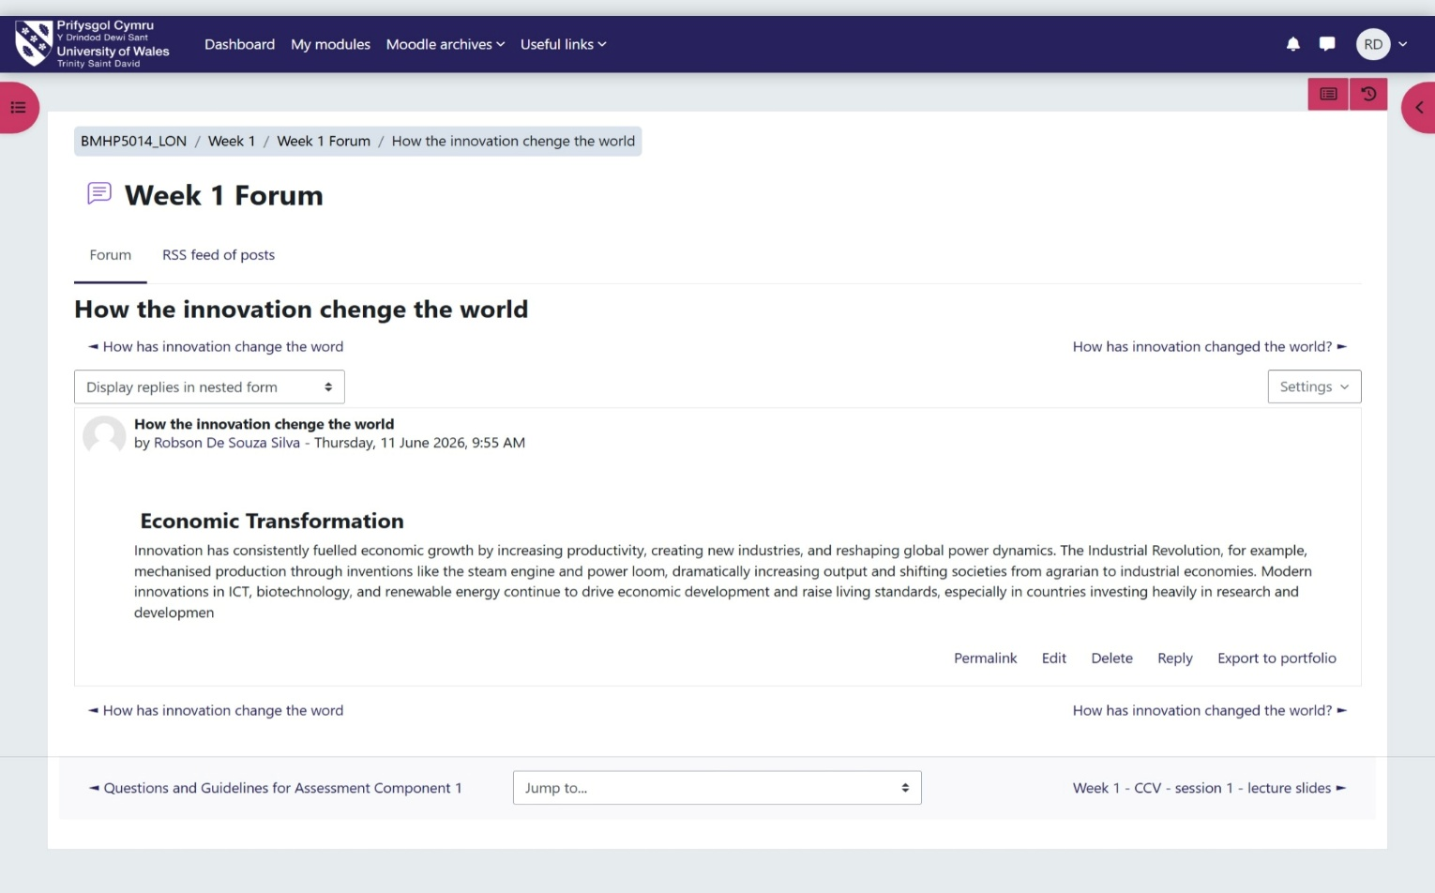

2 - Mind Map
Digital exclusion is a growing problem in health and social care because many services now rely on online booking, remote monitoring, and digital communication. People without digital skills or access face delays, missed appointments, and reduced ability to manage long-term conditions. Using a systems thinking approach, this problem can be understood as the result of interconnected factors such as poverty, limited digital literacy, language barriers, and inaccessible technology (Meadows, 2008). My mind map shows how these causes combine to create unequal access and increased pressure on face-to-face services. If digital exclusion is not addressed, health inequalities will widen and vulnerable groups—such as older adults, migrants, and people with disabilities—will experience poorer outcomes. Solutions such as digital training, community hubs, and hybrid service models can help create more inclusive care.
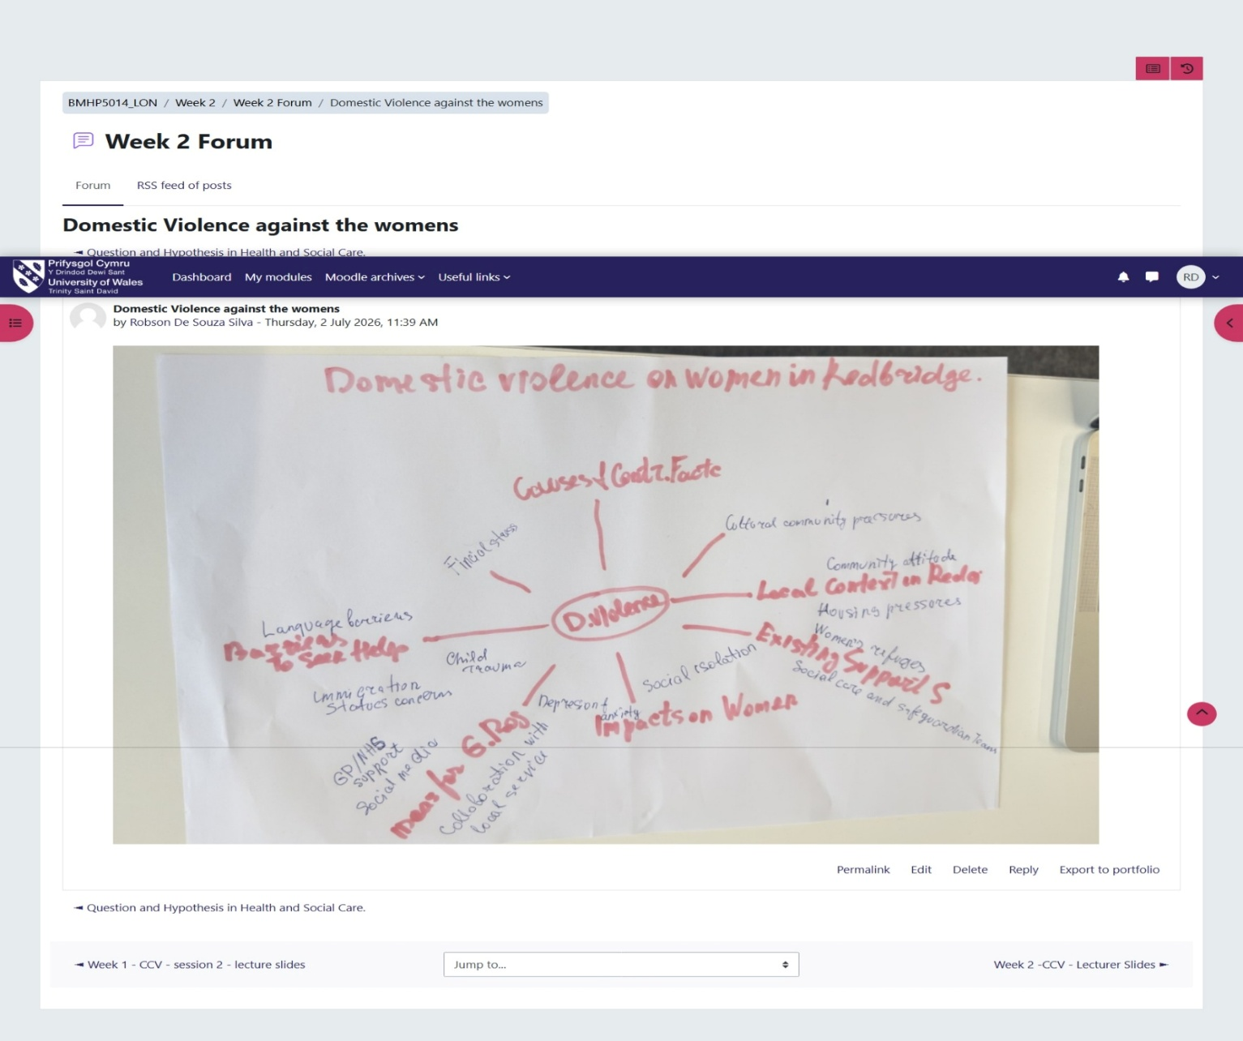

3 - Self-Reflection of Group Activity

Participating in the group activity helped me understand how divergent thinking supports effective collaboration in Health and Social Care. At the start, our group generated a wide range of ideas without judging or limiting them, which allowed everyone to contribute freely. Using this open, exploratory approach made me more aware of the importance of listening actively and valuing different perspectives, especially when working with people who have varied experiences and confidence levels.
As we shared ideas, I contributed by helping to expand possible directions for the task and encouraging the group to consider multiple options before narrowing them down. This process highlighted how divergent thinking can reduce pressure, promote creativity, and ensure that decisions are more inclusive. It also showed me the value of distributing responsibilities according to individual strengths, which made our workflow more balanced and efficient.
I recognised that group work can present challenges, such as differing communication styles, but maintaining openness and respect helped us overcome these. Overall, the activity strengthened my confidence in group discussions and reinforced how shared problem-solving and creative thinking are essential skills in Health and Social Care practice.
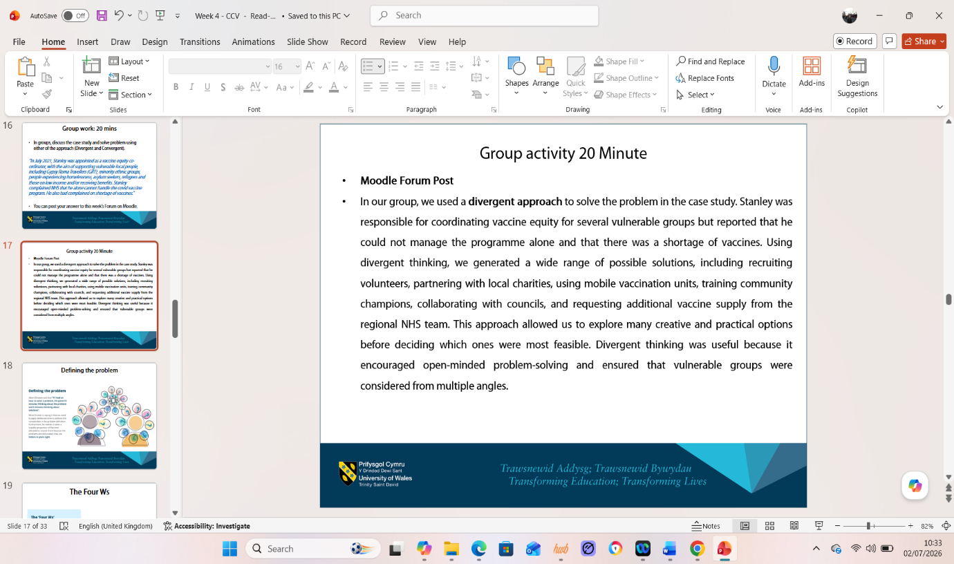

4 – Case Study Analysis of a UK Innovation
NHS virtual wards were developed to address rising hospital pressures, avoidable admissions, and long lengths of stay for people with long-term conditions such as COPD and heart failure (NHS England, 2023). The core problem was that many patients required monitoring but not an acute hospital bed, leading to overcrowding and delayed access to care (King’s Fund, 2023). Creativity was essential in designing a model that combined remote monitoring technology, multidisciplinary teamwork, and home-based clinical support. This creative re-design of traditional care pathways enabled clinicians to track symptoms, oxygen levels, and vital signs in real time, supporting early intervention (NHS England, 2023).
Rogers’ Diffusion of Innovation Theory helps explain why virtual wards spread quickly across the NHS: staff perceived them as useful, easy to use, and beneficial for patient outcomes (Rogers, 2003). Reported outcomes include reduced hospital admissions, shorter lengths of stay, improved patient experience, and increased independence for service users (King’s Fund, 2023; NHS England, 2023). Staff also benefit from reduced bed pressures and more efficient resource allocation. Virtual wards create value by improving outcomes while using resources more effectively, and evidence suggests the model can be scaled across regions and clinical pathways (NHS England, 2023).

5 - Research Task
Issue: Staff Stress and Burnout in Health and Social Care
Burnout is a major and persistent issue in UK health and social care, driven by chronic workload pressures, emotional labour, and organisational strain. West et al. (2020) argue that excessive demands, limited autonomy, and sustained emotional intensity are key contributors to staff exhaustion, drawing directly on Maslach’s Burnout Theory, which explains how emotional exhaustion and depersonalisation develop when resources are insufficient. Their findings help explain why frontline staff in overstretched wards often experience fatigue, reduced empathy, and difficulty maintaining compassionate care.
Kinman and Teoh (2018) similarly identify workload, poor leadership, and inadequate recovery time as central causes of burnout, emphasising that the problem is rooted in organisational systems rather than individual resilience. Their systems-level perspective aligns with wider systems theory, showing how structural pressures—such as staffing shortages and long shifts—interact to create stress. Both articles agree that burnout arises from interconnected organisational factors, though Kinman and Teoh (2018) place greater emphasis on leadership and workplace culture. Together, these studies deepen my understanding of how burnout manifests in real settings, contributing to sickness absence, turnover, and reduced patient safety (West et al., 2020; Kinman & Teoh, 2018).

6 - Exploring Digital Innovation in Health and Social Care

1. Benefit of Wearable Health Technologies
Wearable health technologies, such as smartwatches and fitness trackers, support the management of chronic conditions by enabling continuous, real-time monitoring of symptoms. For people with conditions like diabetes, hypertension, or heart failure, wearables provide data on heart rate, physical activity, sleep, and irregular rhythms, allowing earlier detection of deterioration (Wang et al., 2021). This supports self-management and timely clinical intervention. The Technology Acceptance Model (Davis, 1989) helps explain why wearables are increasingly adopted: users perceive them as useful and easy to integrate into daily routines. In practice, NHS remote monitoring programmes use wearables to track patients with heart failure at home, reducing hospital admissions and improving confidence in managing symptoms. Wearables create value by empowering patients, improving safety, and reducing pressure on acute services. Evidence shows improved adherence and better long-term outcomes when patients actively engage with their health data (Wang et al., 2021).

2. How Electronic Health Records Improve Communication
Electronic Health Records (EHRs) improve communication and collaboration by allowing healthcare professionals to access accurate, up-to-date information in one shared system. This reduces duplication, prevents medication errors, and supports coordinated decision-making across multidisciplinary teams (Kruse et al., 2018). For example, when a GP, district nurse, and hospital consultant can all view the same care plan, they can respond more quickly to changes in a patient’s condition. EHRs also support safer transitions between services, such as discharge from hospital to community care. The Technology Acceptance Model (Davis, 1989) explains that staff are more likely to use EHRs when they perceive them as efficient and easy to navigate. In real practice, NHS Summary Care Records allow clinicians to access essential information during emergencies, improving continuity and reducing delays. Overall, EHRs strengthen communication, reduce risk, and enhance patient-centred care (Kruse et al., 2018).

3. Digital Technology for Prevention and Health Promotion
Digital technology plays a key role in preventative care by helping people monitor risks, access information, and change behaviours before illness develops. Mobile health apps, online coaching, and digital screening tools support early intervention and promote healthier lifestyles. For example, the NHS Diabetes Prevention Programme uses digital platforms to deliver personalised coaching, activity tracking, and behaviour-change support, helping people at high risk of Type 2 diabetes reduce weight and improve physical activity (NHS England, 2022). The Technology Acceptance Model (Davis, 1989) helps explain why these tools are effective: people engage more when digital interventions are accessible, user-friendly, and clearly beneficial. Digital prevention tools also reduce inequalities by offering flexible, remote access for people who cannot attend in-person sessions. Evidence shows that digital programmes can significantly reduce progression to long-term conditions and support sustained lifestyles

7- Understanding the NHS Leadership Framework

1. Summary of the NHS Leadership Framework
The NHS Leadership Framework sets out the behaviours, values, and skills expected from everyone involved in delivering safe, high-quality care. It views leadership as a shared responsibility rather than something reserved for senior staff. The framework highlights behaviours such as inspiring shared purpose, leading with care, evaluating information, connecting services, sharing the vision, and engaging teams (NHS Leadership Academy, 2013). These behaviours support collaborative working, evidence-based decision making, and a compassionate, person-centred culture. The framework is essential in health and social care because effective leadership directly shapes patient safety, staff wellbeing, and continuous improvement. Strong leadership also enables innovation, helping teams respond to challenges such as increasing demand, digital change, and persistent health inequalities. Transformational leadership theory reinforces this by showing that leaders who motivate, encourage, and support their teams are more likely to create positive change and improve outcomes (Bass & Avolio, 1994).

2. Leadership Behaviour: Inspiring Shared Purpose
“Inspiring shared purpose” means helping teams understand the importance of their work and how it contributes to better outcomes. Leaders use this behaviour to promote creativity by building a safe, trusting environment where staff feel valued and confident to share new ideas. For example, a ward manager might involve staff in redesigning patient flow, encouraging them to identify problems and suggest creative improvements. By linking these ideas to a shared aim—such as improving patient experience—the leader strengthens motivation and ownership. Transformational leadership supports this behaviour by emphasising vision, encouragement, and collective commitment (Bass & Avolio, 1994).

3. Reflective Journal Entry
During this module, my understanding of creativity and value creation in health and social care has grown significantly. I initially viewed creativity as an individual talent, but I now see it as a structured process that enhances services, outcomes, and experiences. Ideas such as innovation, systems thinking, and value-based care helped me understand how creative thinking leads to meaningful change. Activities like analysing digital tools and exploring leadership behaviours increased my confidence in applying creativity in practice. This learning will influence my future career by encouraging me to approach challenges with curiosity, involve others in problem solving, and design solutions that genuinely benefit service users.

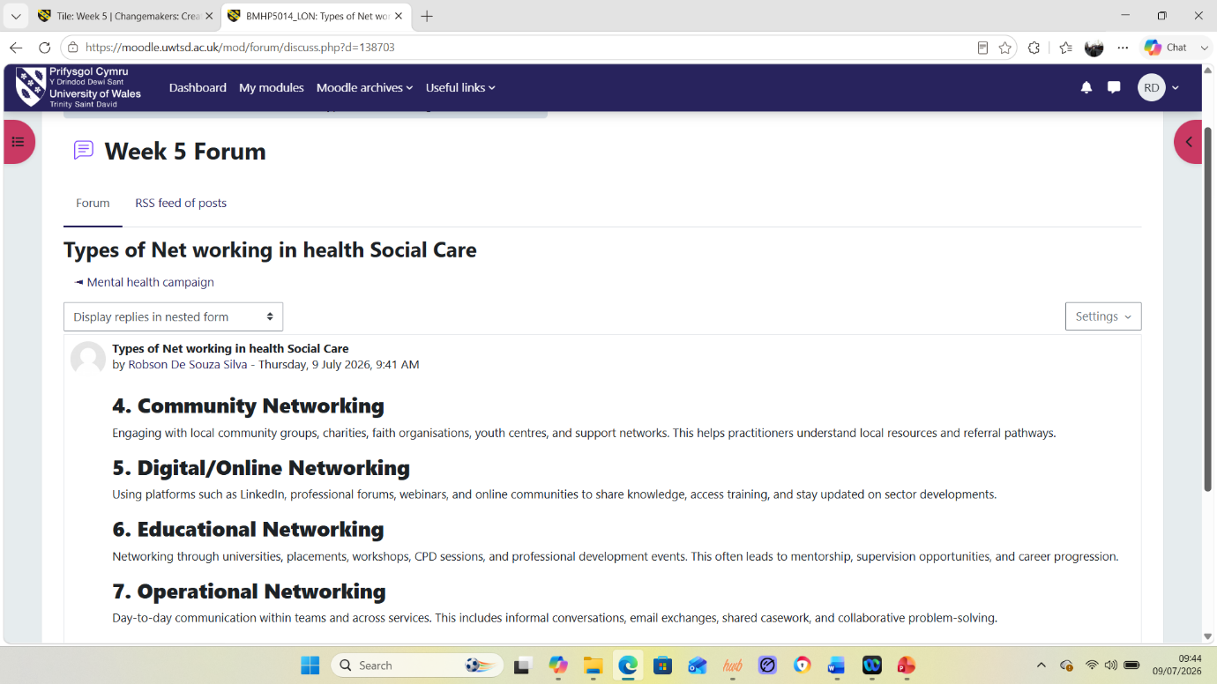

Self-Reflection Journal Entry

Conclusion:

This module helped me see creativity and innovation as more than generating new ideas. I learned that innovation in health and social care is a deliberate, coordinated effort to create sustained change that improves health outcomes, organisational efficiency, cost-effectiveness, and user experiences. I also learned that value creation depends on the “fit” between an innovation and the environment it enters especially organisational culture, governance, leadership, communication, and collaboration.
A key perspective shift came from the discussion of barriers and diffusion: even promising innovations can fail due to resistance to change, limited resources, communication barriers, weak stakeholder involvement, and risk-averse norms. I also reflected on how psychological safety and information sharing enable teams to experiment and learn.
In my future professional role, I will focus on building innovation-friendly cultures, aligning goals with governance, and sustaining momentum through endurance so that creativity translates into practical, lasting value.

References:

Amabile, T. (1996) Creativity in Context. Boulder, CO: Westview Press. Accessed 22 June
Burnes, B. (2017) Managing Change. 7th edn. Harlow: Pearson Education.
Care Quality Commission (CQC) (2023) What good leadership looks like. Available at: https://www.cqc.org.uk/ (Accessed: 2 July 2026).
Davis, F. (1989) ‘Perceived usefulness, perceived ease of use, and user acceptance of information technology’, MIS Quarterly, 13(3), pp. 319–340.
Health Foundation (2020) The digital divide: reducing inequalities in health and care. Available at: https://www.health.org.uk/publications/long-reads/the-digital-divide (Accessed: 2 July 2026).
King’s Fund (2023) Virtual wards: What are they and how do they work? Available at: https://www.kingsfund.org.uk (Accessed: 22 June 2026).
Kinman, G. and Teoh, K. (2018) ‘What could make a difference to the mental health of UK doctors? A review of the research evidence’, BMJ Open, 8(7), pp. 1–6.
Kruse, C. et al. (2018) ‘Impact of electronic health records on communication and care coordination’, JMIR Medical Informatics, 6(2), pp. 1–10.
NHS England (2023) Virtual Wards: Supporting Patients at Home. Available at: https://www.england.nhs.uk (Accessed: 22 June 2026).
NHS Leadership Academy (2013) The Healthcare Leadership Model. Available at: https://www.leadershipacademy.nhs.uk/resources/healthcare-leadership-model/ (Accessed: 2 July 2026).
Rogers, E.M. (2003) Diffusion of Innovations. 5th edn. New York: Free Press.
West, M., Bailey, S. and Williams, E. (2020) The Courage of Compassion: Supporting Nurses and Midwives to Deliver High Quality Care. London: The King’s Fund.
World Health Organization (WHO) (2020) Digital health and equity. Available at: https://www.who.int/health-topics/digital-health (Accessed: 2 July 2026).

