

University of Wales Trinity Saint David
School of Engineering
Designing a MTB fork
Stress Analysis and Dynamics
ACMA 5010
Daniel Grelak
1901993

Calculations of minimum outside diameter of fork.

- Calculations

Data: $y_{max}=10 mm=0.01m$
$$E=210GPa$$
$$Re=275Mpa-yield of steel$$
$$k=0.55Re=151.25Mpa$$

$W_{2}$
$$W_{1}$$

L
$y$
2mm

$x$
From Area Moment of Inertia:
$$I=\frac{π(D^{4}-d^{4})}{64}$$
Section Modulus:
$$Z=\frac{I}{y}$$

$d$
$D$

From Cantilever Beam with concentrated load at the end:

$$y=\frac{W_{1}L^{3}}{3EI}$$
$$W_{1}=\frac{y×3EI}{L^{3}}$$

For Fox 32 with L=510mm and D=32m:

$$I=\frac{π({0.032}^{4}-{0.028}^{4})}{64}=2.13×{10}^{-8}$$
$$W_{1}=\frac{0.01×3×210×{10}^{9}×2.13×{10}^{-8}}{{0.51}^{3}}$$
$W_{1}=337.2 N-\max{load for deflection ≤10mm}$
$$M=F×L=337.2 ×0.51=171.97 Nm-\max{moment}$$

From simple theory of elastic bending:

$$σ_{max}=\frac{M}{I}×y=\frac{171.97}{2.13×{10}^{-8}}×0.01=80708920.19=80.71 MPa-\max{stress}$$

$$σ_{max}≤k$$

$$80.71≤151.25-this fork will be able to withstand set stress$$

- Assumptions and limitations

Calculation for minimum outside diameter turned out to be difficult and I was not able to solve them with available data. I spend long them trying to assume what loads could be acting on the forks and I could not get the answer. Even after assumptions of rider weight and bike weight I did not know how to handle loads from riding over obstacles, braking etc. Having deadline coming shortly I decided to calculate loads for my fork which has 32 mm of diameter and 510 mm length to the crown. My fork is made from aluminium, but I used data for steel from the task description.
I assumed that fork is a Cantilever Beam with concentrated load at the end and I used appropriate formulas. Of course, there is more forces and loads acting on a fork, not only in calculated direction but these calculations also would be difficult with available data.
I have found formula for braking force, maybe that could be used in calculations with assumption of velocity and the stopping distance of the bike.

Types and history of MTB forks.

All currently produced mountain bikes consist of a front suspension that is necessary to overcome any obstacle that person riding a bike can potentially meet on a trail. Role of a suspension fork is to absorb and dampen forces resulting from hitting obstacles, so rider cannot feel full magnitude of such hits and remain in control of the bike. There is wide availability of types of forks from many producers that are competing for customers of all levels of experience.

- Travel
Every fork has its travel distance, that is amount that suspension can compress (Bodman, 2014). We can split forks in few categories (Table 1) by amount of their travel and therefore their application. These categories are set by mountain bikers and are widely used by community and producers.

Travel | Discipline | Description
80-100 mm | Cross Country | Designed to go uphill easily, modern XC bikes start with 100mm travel.
~130 mm | Trail | Designed to suit most of the riders, they climb easily and allow to descent comfortably on trails.
150-160 mm | All mountain | Designed to descent on difficult trails while still allowing to climb somewhat comfortably.
+180 mm | Downhill | Designed to descent on most difficult trails, not suitable for climbs as even pedalling on flat is hard.
Table 1 Travel of forks

- Types

Forks occurs in many types and can be split in categories, due to type of construction and manner of damping. In Table 2 few main categories are set out.

Type of construction | Suspension method
Single crown | Spring (coil)
Dual crown | Elastomer
Upside down | Elastomer + spring (coil)
One sided (Lefty) | Oil + Spring (coil)
Linkage | Oil + Air
HeadShok- In Steering tube | -
Table 2. Types of forks

Some of them are still in use and the older constructions are no longer implemented in mountain bikes as they are archaic, heavy and not as efficient.

Suspension Methods

- Coil – Coil + Oil
Coil is a simple method of suspension that uses spring made of steel or cro-moly or titanium in newer and more expensive models. In modern mtb forks we can observe spring in one leg and damping system with oil in the other that allows rebound control and smooths out the way fork works significantly. Such That solution is popular low to mid-range mountain bikes as it offers good properties in competitive price.

- Elastomer – Elastomer + Coil

This type of suspension uses rubber cushioning that absorbs shock during the ride (Outspokin,2018). Some models also had a coil to further increase damping and rebound properties. This suspension is archaic and currently not being used in mtb bikes.
In 1990 Doug Bradbury developed first Manitou elastomer spring suspension with 35 mm stanchions. Stiffness could be adjusted by turning of polymer polymer cylinders (J-Tech, 2019).

- Air + Oil

Forks with such suspension use the compression of air to absorb terrain obstacles. Air forks spring rate is compressive which means that it is harder to compress it further it travels through the range (Wherethroadforks, 2021). This method allows broad range of customization by changing pressure inside the leg, increasing the pressure makes suspension stiffer and lowering it makes it softer. Volume of air chamber can also be customized by adding additional spacers. Damping system with compression and rebound control is also implemented. This system is popular in higher end models in broad range of travel.

Type of construction

Mountain bike forks regardless of method of suspension occur in few different ways of construction based on different assumptions and ideas. Through the years some of the ideas were further developed and some of them are forgotten.

- Single Crown

First type of fork that has been developed, with most of variations and widest application range. Currently by far the most popular front suspension construction with spring system being either coil or air. Forks damping properties are enhanced by implementation of oil system. Schematic example of such suspension is presented in Figure 1.
This fork consists of few main parts as crown, stanchions attached to it and outer tubes called lowers. This model being air system also has an air valve for adjusting pressure inside of a fork. Compression and rebound adjustment knobs allow user to adapt suspension to terrain and personal preferences. Through axle connects two arms of the fork and holds wheel in place, modern axles are called Quick Release and can be dismounted easily.

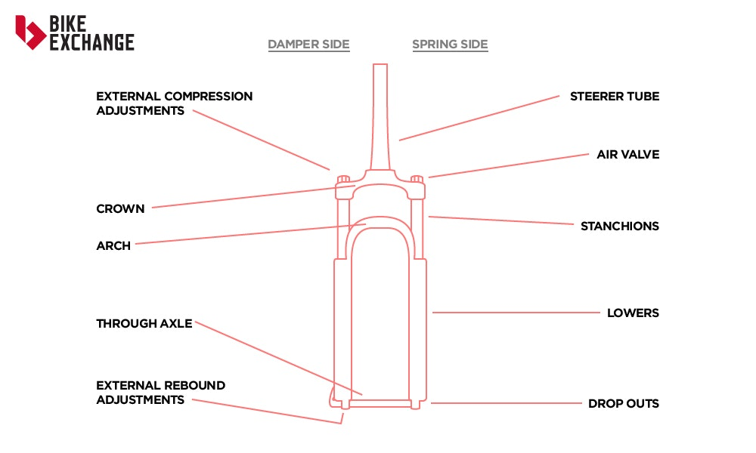

Figure 1 Single Crown fork.(Jones,2018)

Development of this type of forks started in 1989 when RockShox released their RS-1 model (Figure 2). Fork was around 1.5 kg and had 25.4 mm stanchions made of cro-moly. Rebound or compression control were not available.
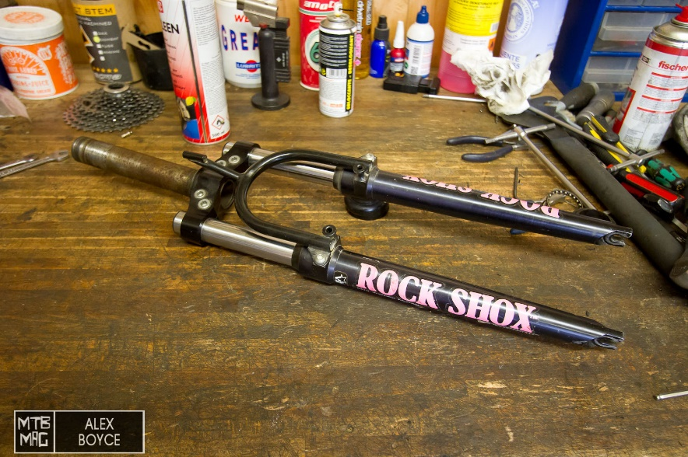

Figure 2 RockShox RS-1 (Boyce,2015)

- Dual Crown

This construction is similar in design to Single Crown but have additional crown that allows longer legs and higher travel range in a fork, it also makes fork stiffer and stronger. This solution is popular in downhill mountain bikes, which need to withstand extreme forces on most difficult trails.

- Upside down

In this type of fork stanchions are meeting outer tubes from the bottom instead of the top side (Figure 3). Idea behind this was to reduce unsprung mass and for better lubrication, however stiffness of construction in difficult terrain was an issue and this solution did not become popular (Haworth,2019).

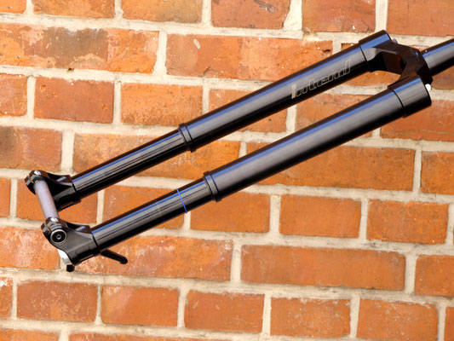

Figure 3 Upside down fork (Haworth,2019)

- Lefty

Lefty is a fork developed by Cannondale and idea behind it its very interesting. It is constructed with one single leg on the left side. It is also working in upside down orientation. To ensure the use of only single leg would be possible and to prevent twisting, top of the stanchions are square. This also allows to use of needle bearings that spin inside of the leg instead of bushings (B. Lin,2019). Lefty suspension is implemented with a success in cross country bicycles where high travel range is not that important.

- Linkage
Multi-link suspension system with dynamic wheel path, meaning wheel moves upwards and rearwards with compression of the suspension (A. Evans,2019). It is designed to reduce flex and allow more feeling and control of the front wheel.
One of first implemented linkage fork was Amp Link F3, designed for cross country races it used single spring and rebound cartridge (Boyce,2015).

- Development

Mountain bike forks history starts in late 1980’s when riders wanted to increase their speed and comfort of ride in difficult terrain. Through the years countless number of models were invented and brought to live to achieve current standard of affordable and reliable front suspension.
Few companies from around the world had the biggest part in development of mtb forks. On this honourable list we may include names such as
- RockShox with their first RS-1 model; MAG 20 and 30 with magnesium lower legs and adjustable compression; MAG 21SL with aluminium stanchions and titanium hardware; Judy released in 1995 with adjustable both travel and damper started a line of forks that is available in new versions in current mtbs; current models like Pike are full of new features like wireless adjustments and lockout or Pressure Relief system.
- Manitou with first elastomer fork Answer and few of its iterations with higher travel. Answer Manitou 4 its worth mentioning with its titanium bolts, CNC machined parts, 70 mm of travel and customization control; Manitou III with aluminium stanchions and adjustable travel.
- Cannondale with HeadShok with an air spring in head tube; HeadShok Moto with dual crown and 114 mm of travel; line of left sided forks Lefty.

There are other companies that had impact on mountain bike industry but its simply to many of them to list them all in this short text.
In the last 30 years we have seen rapid growth in fork development. Starting with simple constructions made from basic materials, with short travel and no adjustment availability through some of more advanced models that used expensive materials like titanium and carbon fibre we got to current standards of light and rigid suspension systems that are reliable and widely adjustable.
Currently developers emphasize wireless communication with all mtb systems and that is the way I believe manufactures will develop further in the near future. Another important aspect is lubrication, manufacturers not only in mtb industry find new solutions that allow for smoother operation by reducing friction, longer lifetime of seals and more reliability. This will develop rapidly in the future, for example having in mind how important for Red Bull F1 team is their cooperation with Mobil 1 in car development. Of course, like in other industries companies will also investigate lowering weight of the forks and increasing their mechanical properties by testing new materials, composites and manufacturing processes. Maybe we may see 3D printed parts in mtb forks soon?

Manufacturing process

Manufacturing of forks significantly evolved over last 30 years, like in other areas of industry developments in material sciences and machinery allowed producers to make considerable technological progress.
To withstand various forces acting on a fork and extreme working conditions they had to be manufactured from appropriate materials. Precursors of modern forks were made of steel, cro-moly (RS-1 stanchions), magnesium (MAG 20 legs) or even currently popular carbon fibre (Pace forks sliders). Parts of the first ones like RockShox RS-1 were often handmade in small workshops with simple machines and tools, Figure 4 show lower legs that has been machined to lower the weight. All of RS-1 assemble is completely removable, legs, brace and steering tube could be disassembled if required (Boyce,2015).
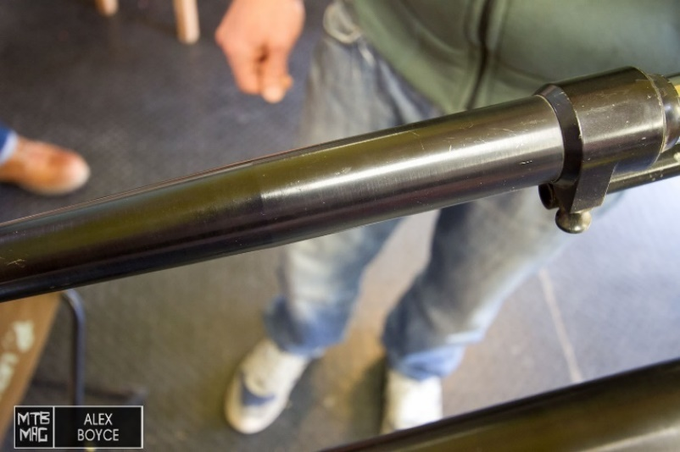

Figure 4 Machined RS-1 lowers (Boyce,2015)
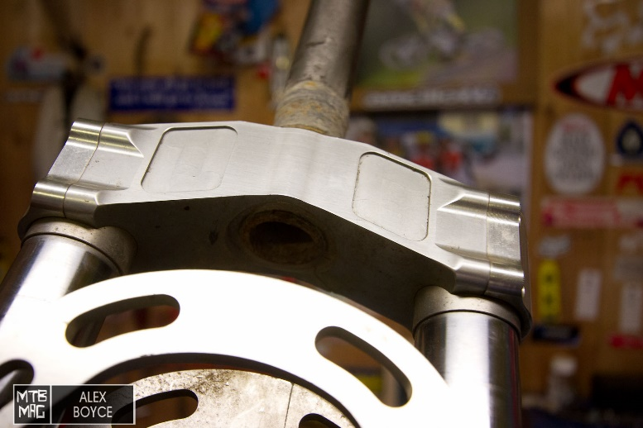

Figure 5 RC35 crown (Boyce,2015)

For many enthusiasts pinnacle of mountain biking engineering in the 90’s was Pace RC35 with its carbon Kevlar legs and machined from solid piece of metal crown (Figure 5). Crowns were often CNC machined but rarely from one piece. Other processes used to manufacture the parts were turning, drawing, bonding and forging. One of unusual manufacturing processes used in production was turning of steering tube instead of drawing it like today.

Currently manufacturing of forks is complicated process that requires access to newest machinery and tooling. It is no longer possible to make a competitive fork in small workshop. Most of the parts are made from CNC machined aluminium and composites.

Testing

To verify calculations for diameter of the fork appropriate machine could be developed. In such a device mounting of the fork should be possible in area of the crown so it will not be able to move on this side, acting like cantilever beam. Then through axle should be connected to pulling device with loading set to required value. We would be able then to measure the deflection of the fork under the set load. If deflection is lower than expectations fork is ready to be released. Devices of that kind but more advanced are currently used in development of RockShox forks and I have witnessed how such a device operates.

References

Bodman, N., 2014. Suspension 101: Concepts & Definitions | Blister. [online] BLISTER. Available at: <https://blisterreview.com/recommended/suspension-101-concepts-definitions> [Accessed 22 April 2022].
Outspokin, 2018. What Is Elastomer Suspension And How Does It Work? | Outspokin Cycles. [online] Outspokin Cycles. Available at: <https://outspokincycles.ca/elastometer-suspension-work/> [Accessed 22 April 2022].
wherethroadforks, 2021. Coil Fork Vs Air Fork: Pros and Cons. [online] Where The Road Forks. Available at: <https://wheretheroadforks.com/coil-fork-vs-air-fork-pros-and-cons/> [Accessed 22 April 2022].
J-Tech, 2019. History of Suspension. [online] J-TECH Suspension Ltd. Available at: <https://j-techsuspension.co.uk/pages/history-of-suspension> [Accessed 22 April 2022].
Boyce, A., 2015. A Brief History Of Suspension Forks Part 1. [online] MTB-MAG.COM. Available at: <https://www.mtb-mag.com/en/a-brief-history-of-suspension-forks-part-1/> [Accessed 22 April 2022].
Boyce, A., 2015. A Brief History Of Suspension Forks Part 2. [online] MTB-MAG.COM. Available at: <https://www.mtb-mag.com/en/a-brief-history-of-suspension-forks-part-2/> [Accessed 22 April 2022].
Haworth, B., 2019. 10 mountain bike products that refuse to die - MBR. [online] MBR. Available at: <https://www.mbr.co.uk/news/mountain-bike-products-refuse-to-die-373012> [Accessed 22 April 2022].
Lin, B., 2022. Cannondale Lefty Fork Review: Should You Buy It?. [online] The Pro's Closet. Available at: <https://www.theproscloset.com/blogs/news/should-you-ride-a-lefty-fork> [Accessed 22 April 2022].
Evans, A., 2019. Trust launches another bonkers linkage fork with longer travel. [online] BikeRadar. Available at: <https://www.bikeradar.com/news/trust-shout-linkage-fork-with-longer-travel/> [Accessed 22 April 2022].
Jones, T., 2018. Mountain Bike Suspension Basics: What to Know. [online] BikeExchange. Available at: <https://www.bikeexchange.com.au/blog/mountain-bike-suspension-basics-what-to-know-1> [Accessed 22 April 2022].

