
User Requirements and Prototype
Sahyra Khan (2237641)
Usability Engineering: Dr Osman Elgawi
3/5/26

Contents
Abstract 3
Introduction 3
1.0 Test Personas and Their User & Experience Requirements 4
2.0 How Information Was Gathered to Support the Design of the Personas 8
2.1 Questionnaire 8
Key Findings 9
2.2 Informal Semi-Structured Interviews 10
Key Findings 10
2.3 Focus Group 11
Key Findings 11
2.4 How Findings Informed the Personas 11
3.0 Designing for Usability 12
Heuristic Foundations 13
Accessibility Considerations 13
Cognitive Load and Information Architecture 13
Emotional Design 13
4.0 Wireframe Storyboards 14
Storyboards and Interface Design 18
Home Screen 18
Role Assignment Screen 18
Day Phase Screen 18
Night Phase and Banishment Vote Screens 18
5.0 Feedback Collection Process on Storyboard Design 19
References 20
Appendices 22

Abstract

This report presents the user-centred research and early interface design of UWTSD Campus Traitors, a mobile social deduction game adapted for a university context. Personas were developed using questionnaires, interviews, and a focus group to identify diverse user and accessibility requirements. Guided by usability theory and inclusive design principles, low-fidelity wireframes were created to illustrate a clear, accessible, and engaging gameplay experience.

Introduction

This report presents the user-centred research and early interface design for UWTSD Campus Traitors, a mobile social deduction game adapted to the University of Wales Trinity Saint David context. The aim is to design an inclusive and usable digital experience that supports a diverse academic community, including undergraduate and postgraduate students, remote learners, academic staff, neurodivergent users, and international students.

The project is grounded in established usability engineering principles, which emphasise deriving clear user requirements through structured research rather than assumption [1]. Usability is defined by the extent to which specified users can achieve specified goals effectively, efficiently, and with satisfaction in a particular context of use [2]. Given the varied needs of the UWTSD population, accessibility and cognitive simplicity are treated as core design constraints. Research highlights that minimising cognitive load improves clarity and reduces user error, particularly in interactive systems requiring rapid decision-making [3]. Accessibility guidance such as WCAG further reinforces the need for appropriate contrast, scalable text, and assistive technology compatibility from the outset of design [4].

The report proceeds by outlining six evidence-based personas and their prioritised requirements, describing the mixed-methods research used to develop them, explaining the usability theories informing the interface, and presenting low-fidelity wireframe storyboards that illustrate the full gameplay journey.

1.0 Test Personas and Their User & Experience Requirements

Below are six personas representing a diverse cross-section of UWTSD students and staff. They reflect different ages, abilities, campuses, and digital confidence levels to ensure inclusive design [5]. Personas are a widely used user-centred design technique that help teams maintain focus on real user needs and avoid designing for assumptions rather than evidence [1].
Persona 1: Andreea - First-Year Undergraduate Living on Campus
Profile
- Age: 18
- Location: Swansea campus halls
- Programme: BSc Cyber Security
- Technology Use: Regular mobile gamer
- Accessibility: No declared disabilities
User Requirements
- Quick and simple game setup
- Clear, mobile-friendly navigation
- Short game rounds suitable for breaks between lectures
- Reliable performance on campus Wi-Fi
Experience Requirements
- A fun, tense atmosphere without complex mechanics
- Strong visual indicators for Day/Night phases
- Smooth social play with friends in shared spaces
Persona 2: Irum – Part-Time Postgraduate Studying Remotely
Profile
- Age: 34
- Location: Carmarthen (studies mostly online)
- Programme: MA Education Studies
- Technology Use: Moderate; uses mobile for study and communication
- Accessibility: Limited time; prefers simple, low-cognitive-load interfaces
User Requirements
- Easy onboarding with minimal steps
- Ability to join games remotely with average broadband
- Clear explanations of rules and roles
- Reconnection support if the internet drops
Experience Requirements
- Calm, uncluttered interface
- Clear feedback during voting and phase transitions
- A sense of inclusion even when playing remotely

Persona 3: Hawraman – Academic Staff Member Using the Game in Class
Profile
- Age: 47
- Role: Lecturer in Business Management
- Technology Use: Comfortable with standard apps; not a gamer
- Accessibility: Uses reading glasses; prefers high-contrast visuals
User Requirements
- Simple facilitator setup mode
- Adjustable game length for teaching sessions
- High-contrast text and readable fonts
- Content appropriate for mixed student groups
Experience Requirements
- A professional tone suitable for academic use
- A clear end-of-game summary for class discussion
- Predictable navigation that is easy to explain

Persona 4: Sana – Neurodivergent Student with Visual Stress
Profile
- Age: 22
- Location: Private accommodation in Swansea
- Programme: BA Graphic Design
- Technology Use: Regular mobile user; enjoys casual games
- Accessibility: Visual stress and mild dyslexia
User Requirements
- Adjustable text size and colour themes
- Reduced-motion mode to avoid visual overload
- Icons paired with short, simple text
- Consistent layout across all screens
Experience Requirements
- A calm, predictable interface
- Information presented in small, manageable chunks
- Optional audio cues to support visual information

Persona 5: Sobia – Mature Student Balancing Study and Work
Profile
- Age: 41
- Programme: BA Business and Management (part-time)
- Location: Carmarthenshire
- Technology Use: Uses mobile mainly for practical tasks
- Accessibility: Often multitasking; prefers straightforward interactions

User Requirements
- Very simple controls
- Ability to pause or rejoin sessions
- Minimal reading required
- Clear instructions without jargon
Experience Requirements
- Low-pressure gameplay
- Clear progress indicators
- A sense of achievement without needing gaming experience
Persona 6: Rita – International Student New to the UK
Profile
- Age: 20
- Programme: BA International Tourism Management
- Location: Swansea
- Technology Use: Regular mobile user; English is a second language
- Accessibility: Language support needs
User Requirements
- Simple, easy-to-understand English
- Visual explanations of roles and actions
- Clear icons and symbols
- Minimal slang or culturally specific reference
Experience Requirements
- Welcoming, inclusive tone
- Confidence that she understands the rules
- A game that helps her socialise with new classmates

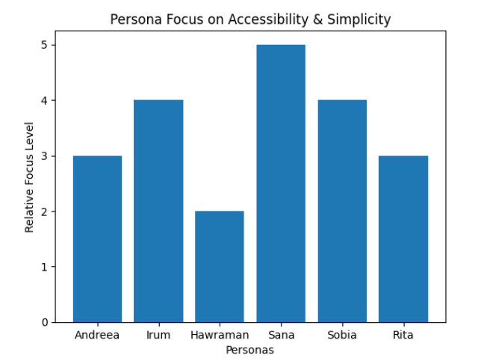
Figure 1 Prioritising easy accessibility and simplicity in the board game by the six personas.

2.0 How Information Was Gathered to Support the Design of the Personas

Generating personas that genuinely reflect the UWTSD community required structured, evidence-based research rather than assumption. A mixed-methods approach was adopted, combining a questionnaire, informal semi-structured interviews, and a focus group. This triangulation of methods is consistent with best practice in user-centred design, which recommends using multiple complementary data sources to build a richer and more reliable picture of user needs. Each method was selected for a specific purpose: the questionnaire provided quantitative breadth, the interviews offered qualitative depth, and the focus group surfaced collaborative insights that neither method could generate alone [6].

2.1 Questionnaire
A short, structured questionnaire (see Figure 2) was designed and distributed to students across a range of programmes and study modes at UWTSD. It comprised twelve questions organised into five sections: background information, technology and gaming habits, accessibility and usability preferences, game preferences, and educational use. A combination of closed multiple-choice items and one open-text field was used, allowing for efficient data collection whilst leaving space for unanticipated responses [7].
The questionnaire was shared digitally, making it accessible to both on-campus and remote learners. This design decision reflects the recognition that part-time and distance learners are a significant and often under-represented part of the UWTSD student body. Questionnaires are widely recognised as an effective tool for gathering data from a geographically dispersed population quickly and at low cost [6].
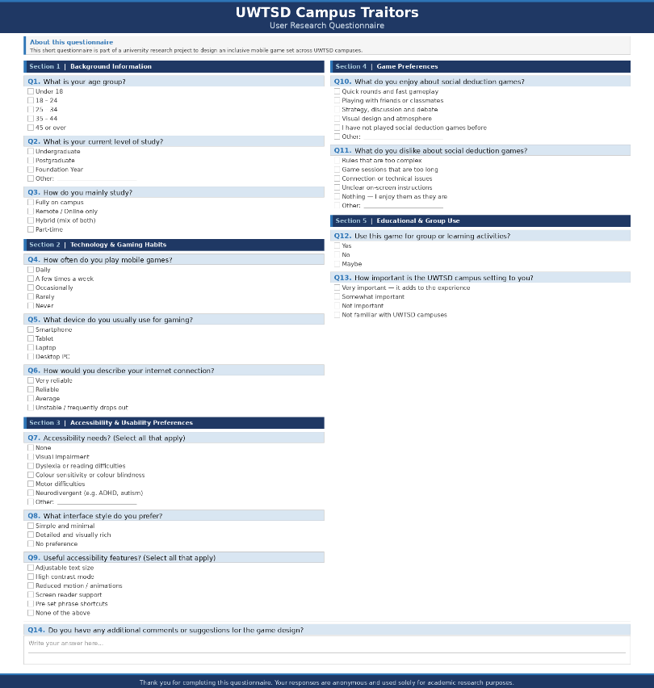
Figure 2 Questionnaire Form

Key Findings
Analysis of responses revealed several consistent patterns that directly informed persona development. Many students expressed a preference for short, easy-to-join games that could be played between lectures, highlighting the importance of a fast and intuitive onboarding process. Remote and part-time students emphasised the need for the game to function reliably on average internet connections, which influenced decisions around server architecture and offline-tolerant design [8]. A notable proportion of respondents indicated accessibility requirements including dyslexia, visual stress, and colour sensitivity, reinforcing the need for a highly customisable interface [9]. Staff members who completed the questionnaire suggested that the game could serve an educational function in group or seminar settings, provided it was straightforward to set up and explain. These findings are summarised in Figure 3.

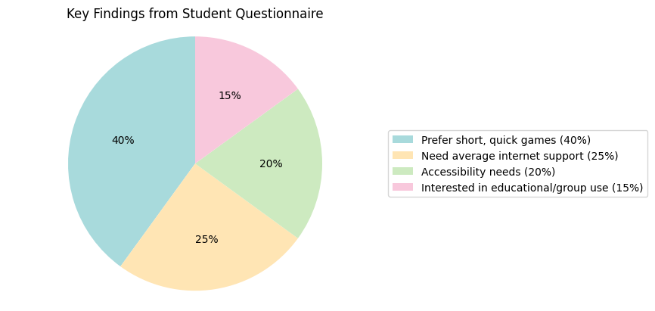
Figure 3 Key findings from student questionnaires

2.2 Informal Semi-Structured Interviews
Short semi-structured interviews were carried out with a small group of students and one member of academic staff. Semi-structured interviews were chosen because they offer flexibility: whilst a set of guiding topics ensures consistency across sessions, the open format allows participants to raise concerns or priorities that a pre-designed questionnaire might not anticipate [4]. This is particularly valuable in the early stages of design research, where the goal is discovery rather than confirmation [10].
Participants were asked about when and where they typically use mobile games, what makes a mobile interface easy or difficult to navigate, their reactions to themes of mystery and tension inherent in social deduction mechanics, and which accessibility features they currently rely on. Sessions were kept conversational and brief to encourage honest, unguarded responses rather than rehearsed answers.

Key Findings
Interview analysis revealed that students across all profiles prioritised clear instructions and predictable navigation, particularly when playing in a social group context where confusion disrupts the shared experience. Several participants mentioned a preference for calm, reduced-motion interfaces to avoid sensory overload, a finding particularly relevant to neurodivergent users. The academic staff participant emphasised the value of a summary or briefing screen that could be used to orient students at the start of a session, an insight that led to the inclusion of a How to Play screen in the interface design. These themes are visualised in Figure 4, which illustrates the relative importance of key themes identified across interview sessions.

2.3 Focus Group
A focus group of five students from different courses was held on the Swansea campus. Focus groups are particularly effective for exploring attitudes and preferences in a social context, as participants build on each other's responses and surface collective insights that individual interviews may not reveal [1]. This made the method especially appropriate for a game that is itself fundamentally social in nature.
Participants discussed their experiences with comparable games such as Among Us and the original Traitors format, what they found enjoyable or frustrating about those experiences, how they envisaged a UWTSD-themed version looking and feeling, and what features would help them feel genuinely included regardless of ability or location [11].

Key Findings
The focus group produced several design-critical insights. Participants agreed that while tension and mystery are central to the appeal of social deduction games, overly complicated interfaces undermine rather than enhance that experience. There was enthusiasm for the UWTSD setting, with participants suggesting that campus-specific imagery and location names would increase engagement and a sense of belonging. Critically, accessibility options were consistently framed as essential rather than supplementary, with participants noting that features such as adjustable text and high contrast modes benefit all players in varying environmental conditions, not only those with permanent disabilities. This aligns with the concept of the curb-cut effect, wherein features designed for accessibility frequently improve usability for the broader population [5]. The group also agreed that joining a game session should take under one minute, establishing a clear and measurable usability benchmark.

2.4 How Findings Informed the Personas
The combined data from all three methods were reviewed thematically and used to construct six personas representing distinct user types within the UWTSD community. Each persona maps directly to patterns identified in the research data rather than being constructed from assumption. The six persona types emerging from the research represent: students who require fast, simple gameplay; remote learners who need reliable low-bandwidth access; staff members who need an interface that is easy to explain in a teaching context; students with visual stress or neurodivergent needs requiring strong accessibility options; mature or part-time students with limited time and low gaming confidence; and international students who benefit from clear language and strong visual guidance.
MoSCoW Framework is a prioritisation technique used in project management to categorise requirements based on importance. It divides features into four groups [12].
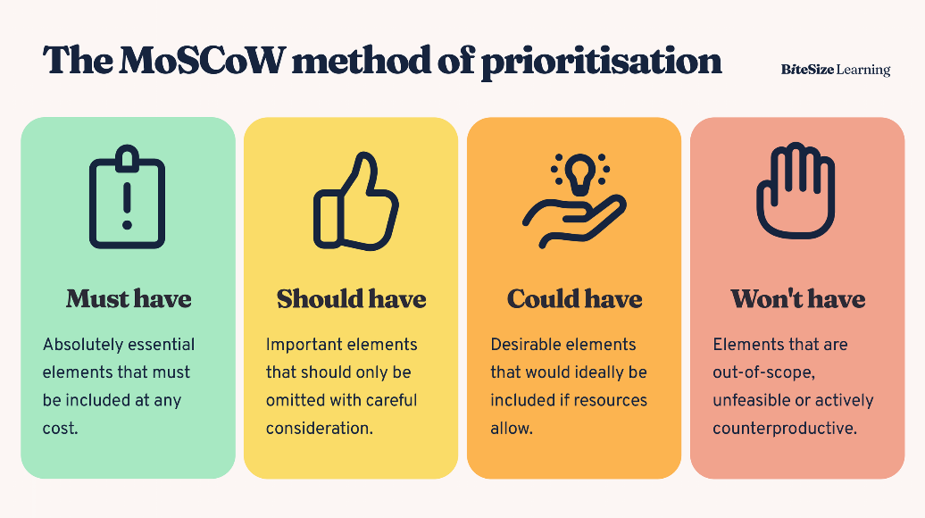
Figure 4 MoSCoW Prioritisation Model

Full user and experience requirements for each persona, categorised using the MoSCoW framework [13], are provided in Appendix A. The MoSCoW method - distinguishing between Must Have, Should Have, Could Have, and Won't Have requirements - was selected because it provides a structured and communicable basis for prioritisation that is widely used in agile and user-centred design processes [3].
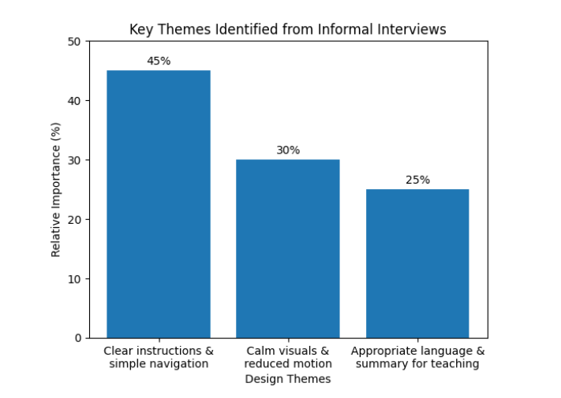
Figure 5 Relative importance of key themes identified from informal interviews, highlighting usability, accessibility, and teaching-focused requirements.

3.0 Designing for Usability

Usability is defined by ISO 9241-11 as the extent to which a product can be used by specified users to achieve specified goals with effectiveness, efficiency, and satisfaction in a specified context of use [14]. For UWTSD Campus Traitors, usability is not merely a quality attribute but an ethical imperative, given the diversity of the intended user base.

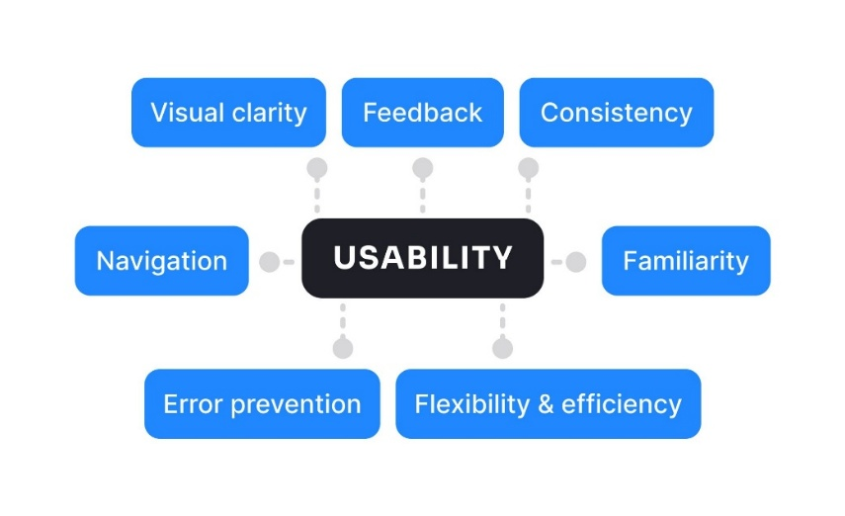

Figure 6 Core Usability Principles Applied in Interface Design

Heuristic Foundations
The interface design was guided primarily by Nielsen's ten usability heuristics [7]. Particularly relevant to this project are visibility of system status, so players always know whose turn it is and what phase of the game they are in; user control and freedom, allowing players to revisit instructions or exit a phase without penalty; and error prevention, through confirmation prompts before irreversible actions such as casting a vote. Norman's concept of affordance was also applied throughout, ensuring interactive elements clearly communicate their purpose through shape, size, and positioning, reducing cognitive loads for all users [15].
Eight Golden Rules
Complementing Nielsen's heuristics, Schneiderman’s Eight Golden Rules of Interface Design also informed key decisions throughout the wireframe development. Particularly relevant to this project are the rules of consistency, which ensures all screens follow a predictable layout; designing for error prevention, which supports users who may be less confident with technology; and reducing short-term memory load, which aligns directly with the cognitive load principles applied across the interface [16].

Accessibility Considerations
Accessibility was treated as a primary design constraint. The Web Content Accessibility Guidelines (WCAG 2.1) informed decisions around colour contrast, touch target sizing, and screen-reader compatibility [17] Colour alone were never used as the sole means of conveying information, critical for users with colour vision deficiencies. All graphical elements were specified with text alternatives in anticipation of screen-reader use [18].

Cognitive Load and Information Architecture
Sweller's Cognitive Load Theory informed the decision to layer information progressively throughout the interface [19]. Rather than presenting all game rules at once, the application uses contextual prompts and tooltips to deliver relevant information at the appropriate moment. The information architecture follows a simple hierarchical structure: Home Screen > Game Lobby > Role Assignment > Day Phase > Night Phase > Banishment Vote > Results. Clear navigation cues and a persistent status bar ensure players can always orient themselves within the game sequence.

Emotional Design
Drawing on Norman's three levels of emotional design -visceral, behavioural, and reflective [20] - the storyboards were developed to evoke suspense and collegiate community. The visceral layer is addressed through an atmospheric visual tone. The behavioural layer is supported through smooth, predictable interaction patterns. At the reflective level, the university setting encourages players to identify with the game world through familiar campus imagery.

4.0 Wireframe Storyboards

A wireframe is a low-fidelity visual representation of a digital interface that outlines the basic layout, structure, and functionality without detailed visual design. It focuses on content placement, navigation, and user interaction, enabling designers to plan how users will move through the interface before colours, graphics, or styling are applied [21].

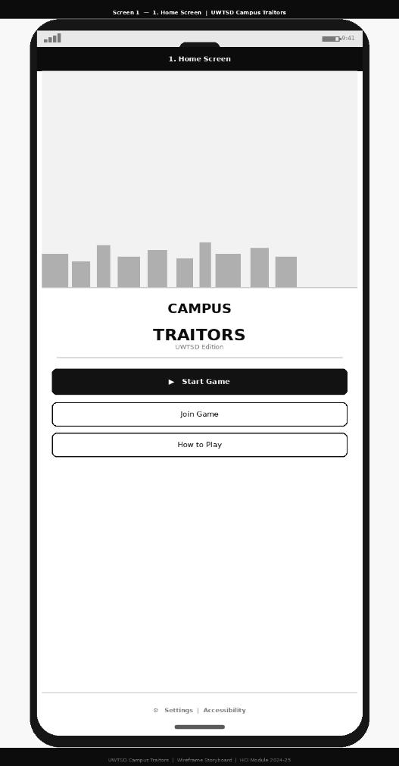
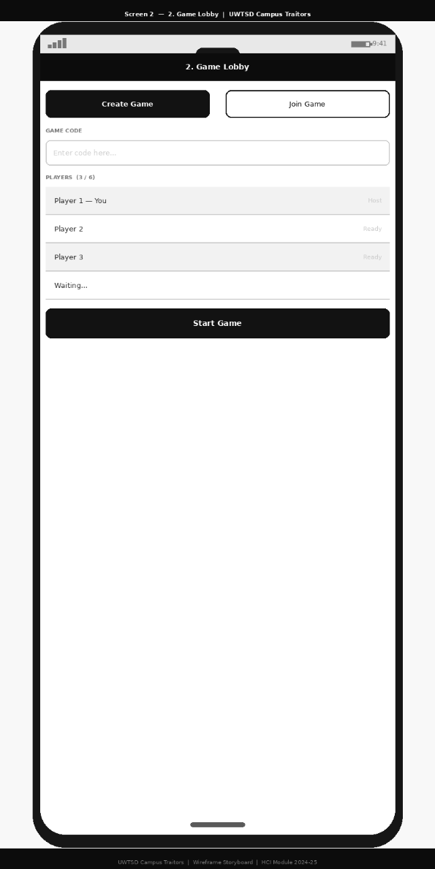

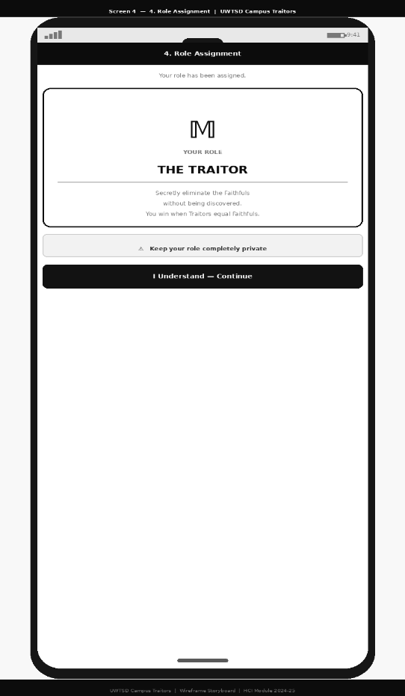
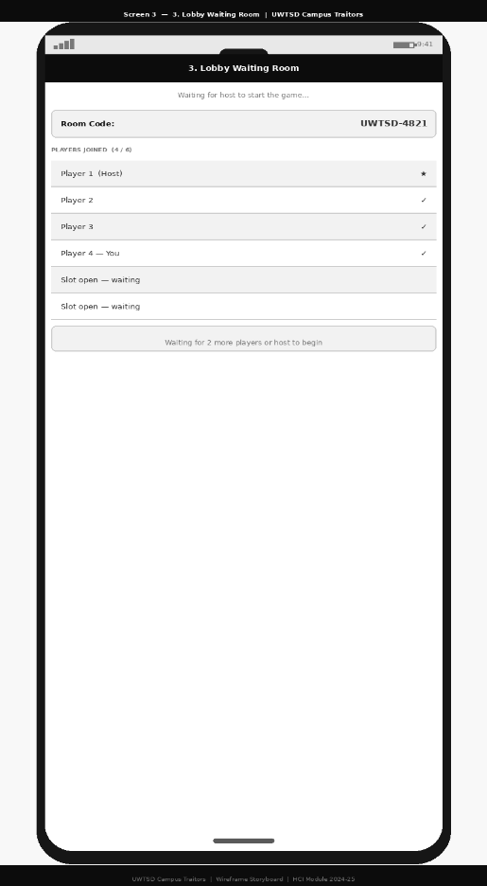
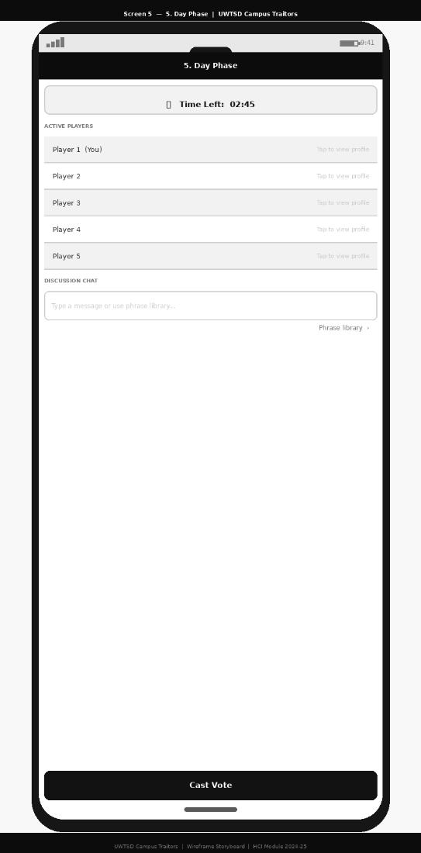
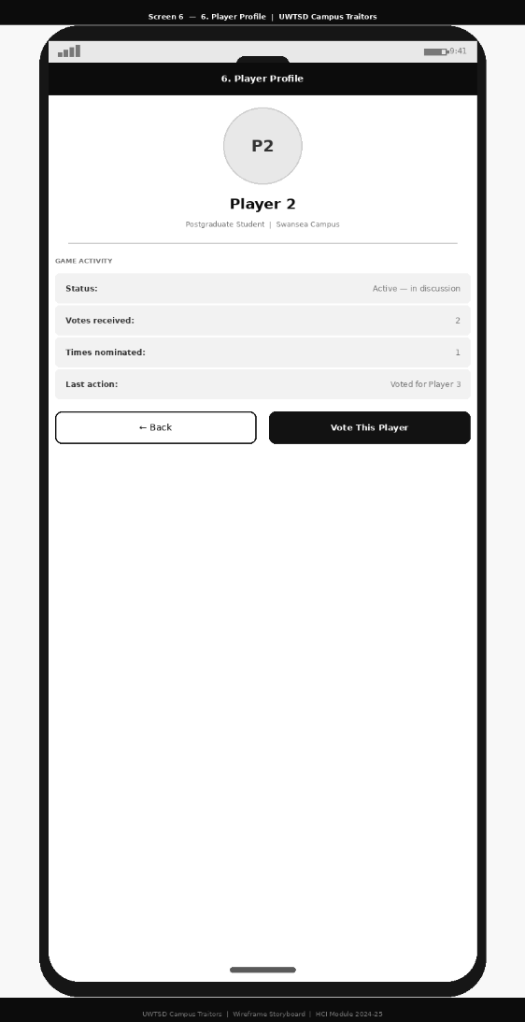
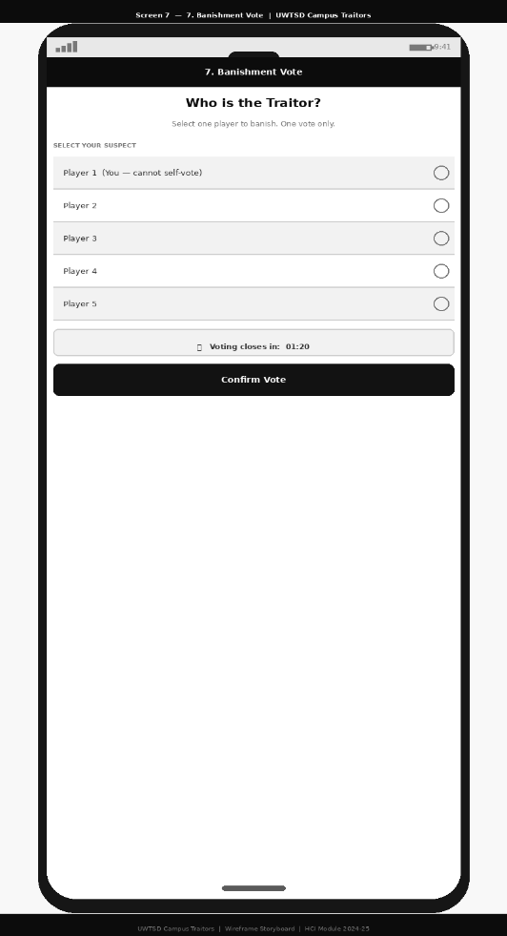
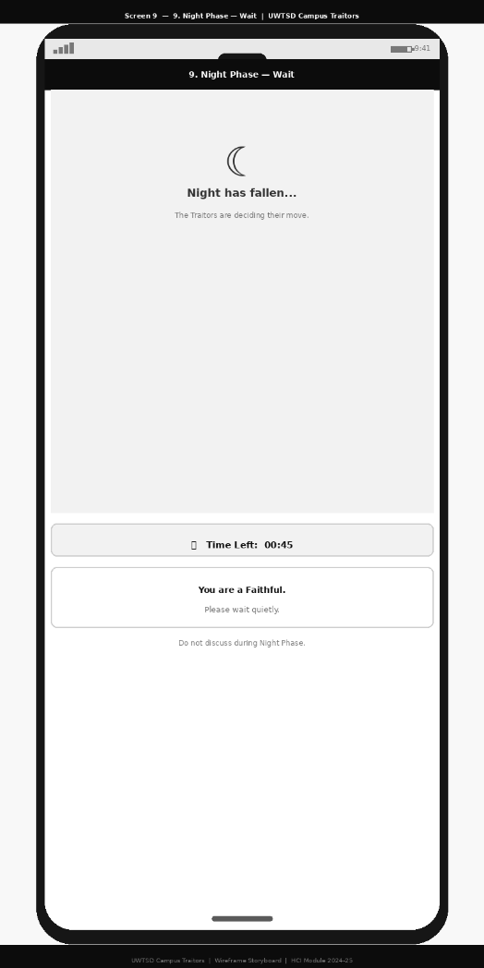
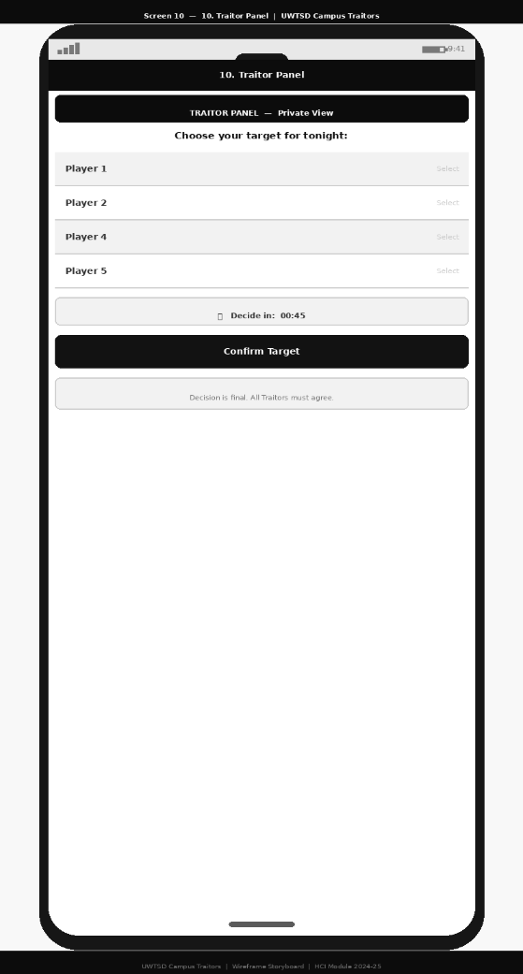
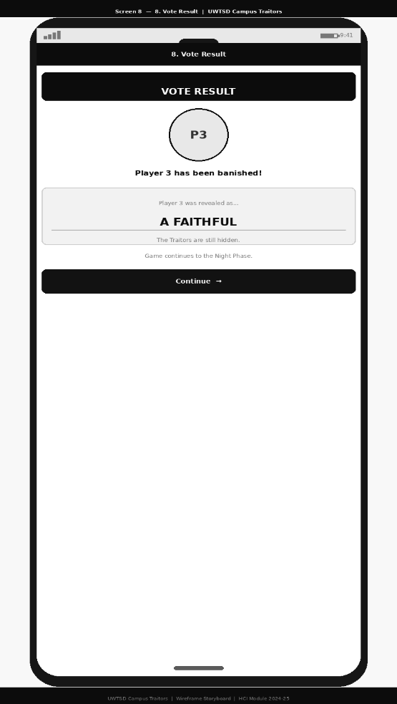
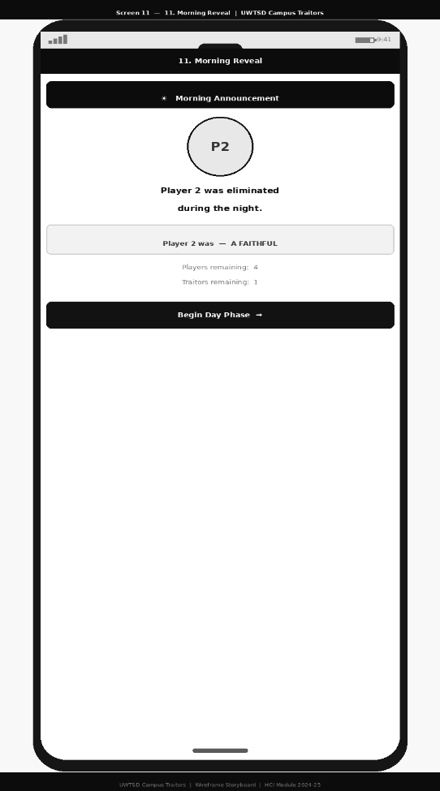
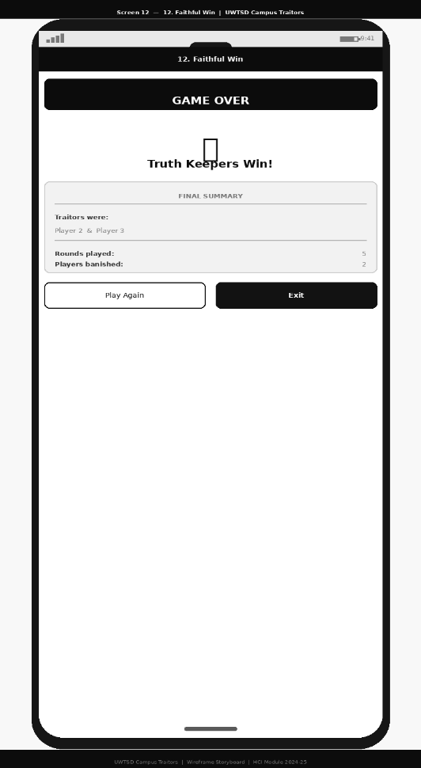
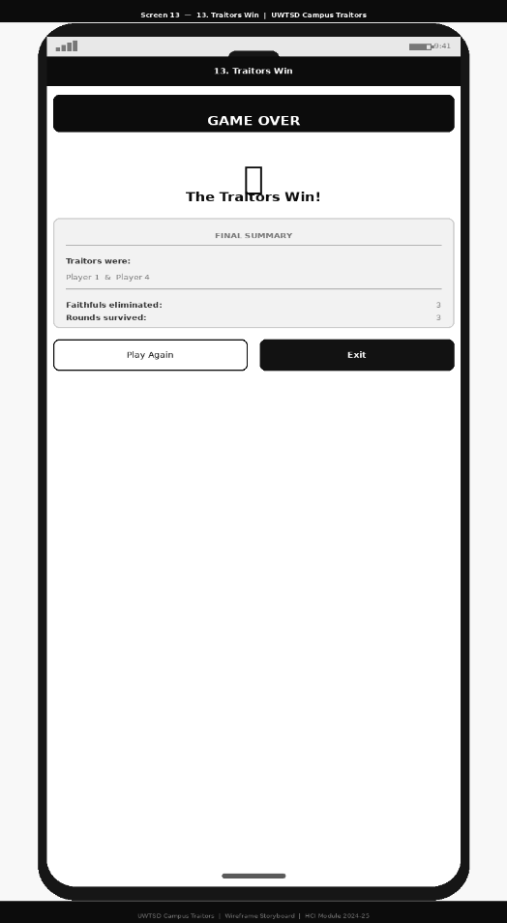
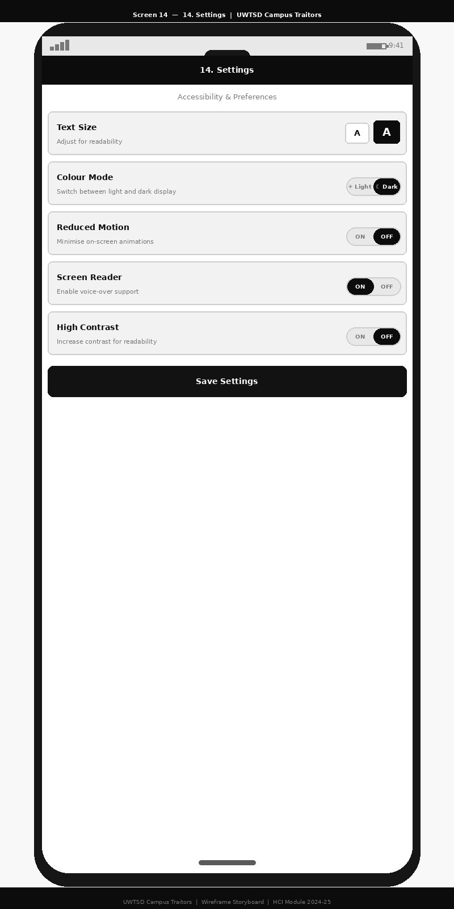

Storyboards and Interface Design

The complete storyboard set is provided in Appendix B. The following discussion highlights the key screens and the design rationale underpinning them.

Home Screen
The Home Screen presents the game title against a stylised silhouette of the UWTSD SA1 campus waterfront. Three primary actions are available: Start New Game, Join Existing Game, and How to Play. The layout follows a single-column structure to ensure clarity across a range of screen sizes. A settings icon in the top-right corner provides access to accessibility preferences including text size and contrast mode. The typographic hierarchy uses a large display font for the game title with body text sized at a minimum of 16sp to meet accessibility guidelines [22].

Role Assignment Screen
Following lobby creation, each player privately views their Role Assignment Screen. The design uses a large, centrally positioned role card - either Traitor or Faithful - with a brief one-sentence description of the role's objective. A confirmation tap is required before proceeding. The role card uses both colour and distinct iconography to ensure the distinction is accessible to users with colour vision deficiencies, consistent with dual coding theory [10].

Day Phase Screen
The Day Phase Screen forms the core social interaction hub. A central panel displays the list of active players, each represented by an avatar and name. A prominent countdown timer indicates time remaining in the discussion phase, with audible and haptic feedback at intervals. A scrollable chat panel allows players to type messages, supplemented by a pre-set phrase library for players with language or literacy barriers.

Night Phase and Banishment Vote Screens
During the Night Phase, Faithful players see a waiting screen whilst Traitor players access a private collaborative panel to select their target. The Banishment Vote Screen allows all players to cast a single vote with a confirmation prompt to prevent accidental selections. Large touch targets and clear visual separation between player entries ensure ease of use for players with motor difficulties. Screen transitions use simple directional slide animations consistent with established mobile navigation conventions.

5.0 Feedback Collection Process on Storyboard Design

Feedback used to inform the creation of the prototype was gathered through background research, questionnaires, informal interviews, and a small focus group, rather than direct testing of the wireframes. This research helped identify common user preferences, frustrations, and accessibility needs related to mobile social games. Participants of UWTSD consistently highlighted the importance of simple interfaces, short play sessions, and clear instructions, particularly for use between lectures or in group settings. Accessibility-related feedback, such as the need for calm visuals, reduced motion, and minimal text, strongly influenced early design decisions. Academic staff also emphasised the value of professional language and clear end-of-game summaries for teaching use. Overall, this early feedback shaped the structure, features, and priorities of the prototype before any visual design work began, ensuring that the wireframes were grounded in real user needs rather than assumptions.

References

[1] P. M. P. Curvo, “The Traitors: Deception and Trust in Multi-Agent Language Model Simulations,” 2025, doi: 10.48550/arxiv.2505.12923.
[2] W. Lidwell, K. Holden, and J. Butler, Universal principles of design : 200 ways to increase appeal, enhance usability, influence perception, and make better design decisions, Updated and Expanded third edition. Beverly: Rockport Publishers, 2023. [Online]. Available at: https://ezproxy.uwtsd.ac.uk/login?url=https://www.vlebooks.com/product/openreader?id=TrinityStD&accId=8886856&isbn=9780760375174&uid=^u
[3]X. Tao, P. Chen, M. Tsami, F. Khayati, and M. Eckert, “Design Process of a Self Adaptive Smart Serious Games Ecosystem,” 2025, doi: 10.48550/arxiv.2510.04615.
[4] J. del Sagrado and I. M. del Águila,“Assisted requirements selection by clustering,” Requirements engineering, vol. 26, no. 2, pp. 167–184, 2021, doi: 10.1007/s00766-020-00341-1.
[5] IEEE Standard Definitions for Use in Reporting Electric Generating Unit Reliability, Availability, and Productivity. New York, USA: IEEE, 2023.
[6] J. Nielsen, “Usability 101: Introduction to Usability,” Nielsen Norman Group, 2020. [Online]. Available: https://www.nngroup.com/articles/usability-101-introduction-to-usability
[7] R. G. Bias and J. Nielsen, “Minimizing cognitive load in user interface design,” Nielsen Norman Group, 2021. [Online]. Available: https://www.nngroup.com/articles/minimize-cognitive-load
[8] R. N. S. de Castro, R. M. de C. Andrade, T. de G. R. Darin, L. A. Carvalho, N. Carneiro, and M. Araújo, “Accessibility Strategies in a Mobile Card Game,” in Proceedings of the XX Brazilian Symposium on Software Quality, M. P. Barcellos, V. Garcia, M. Barcellos, T. Conte, U. Kulesza, N. Valentim, M. Paludo, A. B. Albuquerque, I. Machado, S. R. B. Oliveira, C. Lima, S. Reinehr, A. R. C. da Rocha, A. R. Rocha, G. Santos, R. Santos, S. Marczak, E. D. Canedo, D. Viana, I. de S. Santos, and A. Fontão, Eds., New York, NY, USA: ACM, 2021, pp. 1–8. doi: 10.1145/3493244.3493270.
[9] A. Jaramillo-Alcázar, J. Arias, I. Albornoz, A. Alvarado, and S. Luján-Mora, “Method for the Development of Accessible Mobile Serious Games for Children with Autism Spectrum Disorder,” International journal of environmental research and public health, vol. 19, no. 7, p. 3844, 2022, doi: 10.3390/ijerph19073844.
[10]. R. Longhurst and L. Johnston, “Semi-structured interviews and focus groups,” in Key Methods in Geography, 3rd ed., N. Clifford, M. Cope, T. Gillespie, and S. French, Eds. London, U.K.: SAGE Publications, 2023, pp. 168–178.
[11] A. E. Pezalla, A. Scott, L. Nappa, and T. “Diane” Hsieh, “Humanizing the Research Process: Collaborative Reflections on Prioritizing Research Participants’ Agency, Trust, and Connection,” Qualitative report, vol. 29, no. 6, pp. 1603–1620, 2024, doi: 10.46743/2160-3715/2024.6631.

[12] H. Alshammare, M. Alshayeb, and M. Baslyman, “A Domain-Independent Framework for Effective Prioritization and Evaluation of UX Aspects in Mobile Apps,” in IEEE/ACM International Conference on Automated Software Engineering workshops, IEEE, Nov. 2025, pp. 99–106. doi: 10.1109/ASEW67777.2025.00029.
[13] S. Vijayakumar, P. K. Krishna, and H. M. Raviraja, “Assessing the Effectiveness of MoSCoW Prioritization in Software Development: A Holistic Analysis across Methodologies,” EAI endorsed transactions on internet of things, vol. 10, 2024, doi: 10.4108/eetiot.6515.
[14] L. M. M. Castro, Ed., Updates on Software Usability. Place of publication not identified: IntechOpen, 2023.
[15] R. Hertwig, G. Gigerenzer, and T. Pachur, Heuristics: The Foundations of Adaptive Behavior. Oxford University Press, 2011. doi: 10.1093/acprof:oso/9780199744282.001.0001.
[16] I. Paryudi and S. Fenz, “Evaluation of User Interface Design of Semergy System,” in Proceedings of the 16th International Conference on Information Integration and Web-based Applications & Services, G. Anderst-Kotsis, I. Khalil, M. Indrawan-Santiago, H.-Q. Nguyen, A. M. Tjoa, and M. Steinbauer, Eds., New York, NY, USA: ACM, 2014, pp. 469–473. doi: 10.1145/2684200.2684349.
[17] World Wide Web Consortium (W3C), Web Content Accessibility Guidelines (WCAG) 2.2, W3C Recommendation, 2023.
[18] E. S. Piskun and U. A. Maksimchuk, “Digital Accessibility of Educational Information Content Taking into Account the Web Content Accessibility Guidelines,” Cifrovaâ transformaciâ (Online), vol. 31, no. 2, pp. 59–68, 2025, doi: 10.35596/1729-7648-2025-31-2-59-68.
[19] Z. Sohrabi, S. Nosrati, Z. Nouri Khaneghah, E. Ramezanpor, S. Ghanavati, and A. Zhianifard, “A Comparative Study of the Effect of Two Methods of Online Education Based on Sweller’S Cognitive Load Theory and Online Education in A Common Way on the Academic Engagement of Medical Students in Anatomy,” Medical journal of the Islamic Republic of Iran, vol. 37, p. 73, 2023, doi: 10.47176/mjiri.37.73.
[20] Ke QIAO, “Research on the Application of Emotional Design in Leather Home Furnishings,” Pige Kexue Yu Gongcheng, vol. 35, no. 5, pp. 121–127, 2025, doi: 10.12472/j.issn.1004-7964.202400200.
[21] J. Wang, C. Ranscombe, and B. Eisenbart, “Prototyping in Smart Product Design: Investigating Prototyping Tools to Support Communication of Interactive and Environmental Qualities,” Proceedings of the Design Society, vol. 2, pp. 2243–2252, 2022, doi: 10.1017/pds.2022.227.
[22] J. J. Saw and L. P. Gatzke, “Designing visual hierarchies for the communication of health data,” Journal of the American Medical Informatics Association : JAMIA, vol. 31, no. 11, pp. 2722–2729, 2024, doi: 10.1093/jamia/ocae175.

Appendices

Appendix A1: User Requirements (MoSCoW)
Priority | User Requirement
Must Have | Users must be able to start or join a game session quickly with minimal steps
Must Have | The game must function reliably on average mobile internet connections
Must Have | Navigation must be simple and intuitive with clear calls to action on every screen
Must Have | Clear instructions must be available before and during gameplay
Must Have | Users must be able to clearly always identify the current game phase
Must Have | Role information must be communicated privately and unambiguously to each player
Must Have | All interactive elements must meet a minimum touch target size of 44x44 pixels
Must Have | The interface must be compatible with screen readers and assistive technologies
Should Have | Users should be able to adjust text size, colour mode, and motion settings
Should Have | The game should be straightforward to set up for group or classroom use
Should Have | A pre-set phrase library should be available to support players with language barriers
Should Have | Haptic and audible feedback should be provided at key phase transitions
Could Have | Users could customise visual themes or avatar appearance
Could Have | Users could pause and rejoin a session if interrupted
Could Have | A multilingual interface could be provided supporting Welsh and English
Won't Have | Advanced player statistics or competitive ranking systems are not included in this version
Won't Have | Real-time voice or video chat integration is not included in this version

Appendix A2: Experience Requirements (MoSCoW)
Priority | Experience Requirement
Must Have | The game experience must feel clear, calm, and easy to understand throughout
Must Have | Gameplay must minimise cognitive load and avoid unnecessary complexity
Must Have | Players must feel confident knowing what to do at each stage of the game
Must Have | The interface must create a sense of suspense and engagement appropriate to the game theme
Must Have | Players must feel that the game is fair and that rules are consistently applied
Should Have | The visual design should be calm and uncluttered to reduce sensory overload
Should Have | Reduced motion options should be available for users with visual or neurological sensitivity
Should Have | Language used throughout must be inclusive, plain, and appropriate for an academic context
Should Have | The UWTSD campus setting should feel recognisable and add to the sense of immersion
Could Have | Subtle audio cues could enhance atmosphere during phase transitions
Could Have | Light university-themed visual elements could strengthen the sense of place
Could Have | Players could feel a sense of community and shared experience through the game design
Won't Have | Highly animated or visually intense effects are excluded from this version to support accessibility

Wireframe Storyboards
Appendix B: Wireframe Storyboards
The following descriptions accompany the 14 wireframe screens presented in the storyboard. All screens are designed at a 390x844px viewport equivalent, consistent with a standard mid-range smartphone display. Navigation flows between screens are indicated by directional arrows in the storyboard overview.
Appendix B1: Home Screen (Screen 1)
The Home Screen provides the primary entry point into the game. A stylised silhouette of the UWTSD SA1 waterfront provides contextual identity whilst maintaining a wireframe aesthetic. Three clearly labelled actions - Start Game, Join Game, and How to Play - are arranged in a single-column hierarchy with the most important action given greatest visual prominence, consistent with Nielsen's principle of recognition over recall [7]. A persistent settings and accessibility shortcut sits at the base of the screen.
Appendix B2: Game Lobby (Screen 2)
The Game Lobby allows the host to create a session or players to join using a code. The player list updates in real time as participants join, providing clear visibility of system status [7]. A prominent Start Game button is reserved for the host to prevent confusion over who initiates the game. This screen directly addresses the user requirement for quick and simple session setup identified in the focus group findings.

Appendix B3: Lobby Waiting Room (Screen 3)
The Waiting Room screen displays the session code and lists confirmed players as they join, with vacant slots clearly indicated. A status message informs players of progress towards the required number, reducing uncertainty during the wait. This screen addresses the experience requirement for players to feel confident about what is happening at each stage.
Appendix B4: Role Assignment Screen (Screen 4)
Each player is privately shown their assigned role - Traitor or Faithful - via a large, centred role card. The card uses both colour and iconography simultaneously to communicate role identity, ensuring the distinction is accessible to users with colour vision deficiencies in line with WCAG 2.1 [11]. Minimal text reduces cognitive load. A mandatory confirmation tap prevents accidental progression before the player has registered their role.
Appendix B5: Day Phase - Discussion (Screen 5)
The Day Phase screen is the central interaction hub of the game. It displays the active player list, a countdown timer with haptic and audible feedback, and a discussion chat panel with a pre-set phrase library. The persistent timer addresses Nielsen's visibility of system status heuristic [7]. The phrase library supports players with language barriers, directly responding to the needs identified in the Aisha persona.
Appendix B6: Player Profile View (Screen 6)
Tapping any player in the Day Phase opens their profile, displaying game activity data such as votes received and last action. This screen supports strategic discussion and decision-making, adding depth to the social deduction experience. A Vote button is available directly from this view to streamline the interaction flow.
Appendix B7: Banishment Vote Screen (Screen 7)
Players cast a single vote to nominate a player for banishment. Each entry uses large, well-spaced touch targets of at least 44x44 pixels to support players with motor difficulties, consistent with the Kofi persona requirements. A confirmation prompt prevents irreversible accidental selections, addressing Nielsen's error prevention heuristic [7]. The vote outcome is revealed only once all players have voted.
Appendix B8: Vote Result Card (Screen 8)
Following the vote, all players see a result card revealing which player was banished and whether they were a Traitor or Faithful. This moment of revelation is central to the game's emotional experience. The screen is designed to be clear and readable at a glance, with the key information - the player's identity and role - given maximum visual prominence.
Appendix B9: Night Phase - Faithful Waiting Screen (Screen 9)
Faithful players see an atmospheric waiting screen during the Night Phase, featuring a moon motif and a brief message asking them to wait quietly. Visual complexity is reduced to minimise sensory stimulation during this passive phase, addressing the experience requirement for calm, uncluttered design. Reduced motion mode replaces any animation with a static display.
Appendix B10: Night Phase - Traitor Panel (Screen 10)
Traitor players are directed to a private collaborative panel where they select their elimination target. The panel is clearly labelled as private to reinforce confidentiality. Target selection uses large tappable rows with a confirmation step, and a timer maintains pace. This role-conditional screen is a key interaction design feature of the application.
Appendix B11: Morning Announcement (Screen 11)
The Morning Announcement screen reveals which player was eliminated during the Night Phase, along with their role. It provides a summary of remaining players and Traitors before prompting all players back into the Day Phase. This screen anchors the game loop and supports the experience requirement for players to always understand the current game state.
Appendix B12: Game Over - Faithful Win (Screen 12)
The Faithful Win screen presents the outcome when all Traitors have been successfully banished. A final summary displays the Traitors' identities, rounds played, and outcome. Play Again and Exit options are clearly provided. This screen supports the reflective dimension of Norman's emotional design model [9], allowing players to process and discuss the outcome.
Appendix B13: Game Over -Traitors Win (Screen 13)
The Traitors Win screen mirrors the structure of Screen 12, presenting the outcome when Traitors have eliminated enough Faithful players to equal them in number. The consistent layout across both outcome screens reduces cognitive effort when interpreting results and reinforces interface predictability.

Appendix B14: Settings and Accessibility Menu (Screen 14)
The Settings screen is accessible at any point via a persistent icon in the navigation bar. It provides five independently adjustable options: text size, colour mode, reduced motion, screen reader support, and high contrast mode. Each option includes a plain-language description of its purpose. This screen directly addresses the accessibility requirements of the Rhian and Kofi personas and reflects the principle that accessibility features should be prominently available rather than hidden [5].

