Preapring for research
Ahmad Habib
2317248

Preapring for research

Contents
Task 1: Mind Map of Ideas 4
Task 2: Research Proposal 5
Task 3: Ethics Form 12
Task 4: Justification of the Chosen Research Method 41
Task 5: Draft Research Questions 43
Task 6: Evaluation of the Chosen Data Analysis Method 45
References 45

Task 1: Mind Map of Ideas

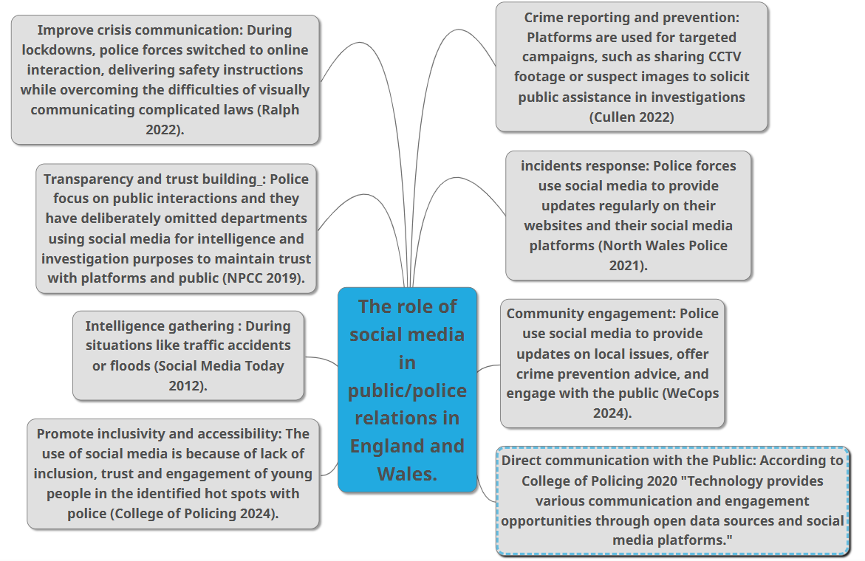

Task 2: Research Proposal
Task 2: Proposal form (1500 words)
For this task you are required to complete the proposal form as shown in Appendix 1 below.


UNDERGRADUATE DISSERTATION
RESEARCH PROPOSAL FORM

NAME:  Ahmad Habib | ID No.: 2317248
DRAFT RESEARCH TITLE QUESTION:
Title: How can the use of social media improve the relationship between the police and the public in England and Wales?
Social media is a way to communicate by using different websites which allows people to talk with each other, post information and share photos and videos. Social media is used by organisations and people keen to establish a connection with millions of others. However, social media allows the police to communicate with people giving them an opportunity to feel that they are accessible as an organisation (The Police Foundation 2014).

SUMMARY OF RESEARCH AIM & OBJECTIVES:
Aim: To analyse the role of social media in public/police relations in England and Wales.
Objectives:
1: Explore existing challenges of maintaining public trust and confidence in the police.
2: Examine how the police currently utilise social media outlets to facilitate community engagement.
3: Assess public perception regarding police use of social media as an effective means of communication between the police and the public in England and Wales.

THEORETICAL CONTEXT:
This section will examine the role of social media in term of improving the relationship between the public and the police.
Police forces in England and Wales use the social media to communicate with the public and to give them the chance to engage with the police and feel that they are a part of the society (The Police Foundation 2014). This is to say that transparency grows when police forces use social media to share details regarding current enquiries and operations. Because the public may see and comprehend police operations, transparency fosters trust. The Police Foundation (2014) believes that police forces may efficiently show accountability using social media, which is crucial for fostering more public trust. People's trust in the police increases when they believe that law enforcement is honest, which enhances relationships with the community. Moreover, police forces can communicate with the public directly using social media in a natural and engaging manner. The Metropolitan Police (2020) highlights how social media sites like Facebook, Instagram, and Twitter give the chance to engage with local communities, offering guidance, responding to enquiries, and supporting neighbourhood projects. Engaging content, such community outreach initiatives, crime prevention advice, or missing person alerts, promotes a sense of shared responsibility for public safety. Moreover. It is critical that the police and social media have a productive working relationship. Cooperating with the media to inform the public can aid in the investigation of crimes and provide the public with information about the actions and motivations of the police. It is a significant method that the police uphold the values of transparency and accountability. (South Yorkshire Police 2025). Additionally, A good working relationship between the police and the media is crucial. Working with the media to communicate with the public would be helpful to solve crimes and keep communities safe. It can also give the people ideas of what is police are doing and why (College of Policing 2022).
The social media plays a crucial role in developing the public engagement with the police. However, South Wales Police (2025) have set rules for the use of social media posts for the Public and they called it “Social media house rules”. They said that they use social media to engage with communities. And that they want to keep people informed of what is happening and provide people with crime prevention advice which means that they want their social media accounts to be safe spaces for all who use them, so they ask that all followers adhere to their house rules. They reserve the right to hide or delete comments or block users who break these house rules. In addition, South Wales Police have warned/advice people that everything they say on police social media accounts is public and that people are legally responsible for what they say and post on police’s pages, as the police do have the ability to disable comments, but they prefer to do this as a last resort or when they judge there is a need to do so, for instance, in order to protect the integrity of investigations. Moreover, they have mentioned and reminded people, advised them to not posts like abusive, hateful, sexually or racially offensive, threatening and spam.
By highlighting these guidelines, South Wales Police aim to provide an environment that increase respectful between the public and the police in addition to encouraging public safety and awareness in a digital world. Additionally educating the public by providing advice on crime prevention. These rules establish limits to make sure that, even if social media is a useful tool for communication and connection, it never turns into a place for harm or illegal conduct.

SUMMARY OF RESEARCH –SURVEY METHOD:
A mix of quantitative and qualitative writing methods would be conducted as qualitative would be about the quality and exploring what is behind decisions, and the quantitative would consider some statistics. Both open-ended qualitative and closed-ended quantitative questions would be utilised to gather comprehensive data, ensuring a well-rounded understanding of the research topic
As this would be mixed, then statistics would meet narratives and that is to give an idea of the research question
The survey will be through Microsoft forms to gather information from people by asking questions which could help to understand how they feel about this topic and to gather direct feedback from the audience, audience must be over the age of 18 and the survey must be easy to access for audience, designed well by Microsoft, and anonymous, so details of audience cannot be shared
The survey can collect data by including demographic questions like age, gender, race, ethnicity, employment status, level of education, marital status, and more.
SUMMARY OF SAMPLING FRAMEWORK:
Provide details of target sample. For example, who are you intending to ask to participate in your research, will you be seeking perspectives from experts who work in a given field, or will you be using a general questionnaire to gauge perspectives from members of the public?

This research will target the public in England and Wales, people aged 18 and above, using online survey methods as the primary data collection technique (Evans and Mathur, 2018). The surveys will be shared on social media platforms like, Facebook, Twitter, Instagram, and LinkedIn. This aligns with the nature of the research study since it examines social media in police-public relations (Williams, Burnap and Sloan, 2016). Therefore, the selection strategy will incorporate social media for several methodological reasons. First, it is easy to reach out to a large and diverse population using digital communication technology – that is, the population where the beliefs, attitudes, and practices regarding the research question are most likely to be found (Gelinas et al., 2017). Every participant will have a brief text about the purpose of the survey, ethical issues that may arise, and the participation requirements to ensure that all participants do not participate blindly.
The distribution will involve posting to community groups, forums, and pages focusing on law enforcement, as well as pages where the general public can weigh in. This will enable reach of participants in the entire region of England and Wales at minimal cost while being prudent in the utilisation of available resources (Topolovec-Vranic and Natarajan, 2016). In order to achieve wider representation, the participants will be encouraged to pass the survey along to others who could possibly be of interest, will seek to ensure the capture of a wide cross-section of the population (Evans and Mathur, 2018). In order to minimise methodological problems likely to result from the survey, the survey will incorporate demographic questions regarding the areas of the population's age, gender, ethnic group, geographical area, education level and use of social media (Daikeler, Silber and Bošnjak, 2021). These data points will enable contextualisation of findings in terms of national population density as well as demographic and thereby establish the sampling bias upon analysis (British Society of Criminology, 2021). In addition, the demography, procedural and data quality aspects of the survey will include attention checks.
The targeted number of respondents is 100, which is enough to obtain statistically valid results while not being overly large for the analysis. It will also be possible to withdraw from the group, and the information provided will be anonymous. Regarding the most effective way of screening the participants, their ages will be determined by screening questions to ensure they meet the required legal age for participation in research and that they live and work in England or Wales (Siva, Nayak and Narayan, 2019). By using this survey-based approach, the study will effectively collect information on public attitudes to police use of social media and do so with scientific, ethical rigor. This framework presents a middle-ground view of the methods that enable access to participants, sufficient sample representation, and a correct ethical research process (Mannix, Wilkes and Daly, 2014).

INITIAL REFERENCE LIST:

Task 3: Ethics Form

APPLICATION FOR ETHICAL APPROVAL
RESEARCH STUDENTS
This form is to be completed by the student within SIX months for full-time students and TWELVE months for part time students, after the commencement of the research degree or following progression to Part Two of your course.

Once complete, submit this form via the MyTSD Doctoral College Portal at (https://mytsd.uwtsd.ac.uk).

This document is also available in Welsh.

RESEARCH STAFF ONLY
All communications relating to this application during its processing must be in writing and emailed to pgresearch@uwtsd.ac.uk , with the title ‘Ethical Approval’ followed by your name.

STUDENTS ON UNDERGRADUATE OR TAUGHT MASTERS PROGRAMMES should submit this form (and receive the outcome) via systems explained to you by the supervisor/module leader.

In order for research to result in benefit and minimise risk of harm, it must be conducted ethically. A researcher may not be covered by the University’s insurance if ethical approval has not been obtained prior to commencement.

The University follows the OECD Frascati manual definition of research activity: “creative work undertaken on a systematic basis in order to increase the stock of knowledge, including knowledge of man, culture and society, and the use of this stock of knowledge to devise new applications”. As such this covers activities undertaken by members of staff, postgraduate research students, and both taught postgraduate and undergraduate students working on dissertations/projects.

The individual undertaking the research activity is known as the “principal researcher”.

Ethical approval is not required for routine audits, performance reviews, quality assurance studies, testing within normal educational requirements, and literary or artistic criticism.

Please read the notes for guidance before completing ALL sections of the form.

This form must be completed and approved prior to undertaking any research activity. Please see Checklist for details of process for different categories of application.

SECTION A: About You (Principal Researcher)
1 | Full Name: |  | Ahmad Habib
2 | Tick all boxes that apply: |  | Member of staff: | ☐ | Honorary research fellow: | ☐
 | Undergraduate Student | ☒ | Taught Postgraduate Student | ☐ | Postgraduate Research Student | ☐

3 | Institute/Academic Discipline/Centre: | Blue light Academy
4 | Campus: | Swansea business Campus
5 | E-mail address: | 2317248@student.uwtsdc.uk
6 | Contact Telephone Number: | 07796871663
 | For students:
7 | Student Number: | 2317248
8 | Programme of Study: | Criminology and Policing
9 | Director of Studies/Supervisor: | Laura Knight

SECTION B: Approval for Research Activity
1 | Has the research activity received approval in principle?  (please check the Guidance Notes as to the appropriate approval process for different levels of research by different categories of individual) |  | YES | ☒ | NO | ☐
 |  |  |  |  | Date
2 | If Yes, please indicate source of approval (and date where known): Approval in principle must be obtained from the relevant source prior to seeking ethical approval | Research Degrees Committee |  | ☒ | 18/02/2025
2 |  | Institute Research Committee |  | ☒ | 18/02/2025
2 |  | Other (write in) |  | ☐

SECTION C: Internal and External Ethical Guidance Materials
 | Please list the core ethical guidance documents that have been referred to during the completion of this form (including any discipline-specific codes of research ethics, location-specific codes of research ethics, and also any specific ethical guidance relating to the proposed methodology). Please tick to confirm that your research proposal adheres to these codes and guidelines. You may add rows to this table if needed.
1 | UWTSD Research Ethics & Integrity Code of Practice | ☒
2 | UWTSD Research Data Management Policy | ☒
3 | [List any other relevant documents here] | ☐

SECTION D: External Collaborative Research Activity
If there are external collaborators then you should gain consent from the contact persons to share their personal data with the university. If there are no external collaborators then leave this section blank and continue to section E.
1 | Institution
2 | Contact person name
3 | Contact person e-mail address
4 | Is your research externally funded? |  | YES | ☐ | NO |  | ☐
5 | Are you in receipt of a KESS scholarship? |  | YES | ☐ | NO |  | ☐
6 | Are you specifically employed to undertake this research in either a paid or voluntary capacity? | Voluntary | YES | ☐ | NO | ☐
7 |  | Employed | YES | ☐ | NO | ☐
8 | Is the research being undertaken within an existing UWTSD Athrofa Professional Learning Partnership (APLP)? | If YES then the permission question below does not need to be answered. | YES | ☐ | NO |  | ☐
9 | Has permission to undertake the research has been provided by the partner organisation? | (If YES attach copy)  If NO the application cannot continue | YES | ☐ | NO |  | ☐

Where research activity is carried out in collaboration with an external organisation
10 | Does this organisation have its own ethics approval system? | YES | ☐ | NO | ☐
 | If Yes, please attach a copy of any final approval (or interim approval) from the organisation (this may be a copy of an email if appropriate).

SECTION E: Details of Research Activity
1 | Indicative title: | How can the use of social media improve the relationship between the police and the public in England and Wales.
2 | Proposed start date: | October 2025 | Proposed end date: | May 2026
Introduction to the Research (maximum 300 words per section)
Ensure that you write for a Non-Specialist Audience when outlining your response to the points below:
- Purpose of Research Activity
- Proposed Research Question
- Aims of Research Activity
- Objectives of Research Activity
Demonstrate, briefly, how Existing Research has informed the proposed activity and explain
- What the research activity will add to the body of knowledge
- How it addresses an area of importance.
3 | Purpose of Research Activity  The Purpose of this research is to examine the role of social media in terms of improving the relationship between the public and the police, as social media is a way to communicate by using different websites which allow people to talk with each other, post information and share photos and videos. Social media is used by organisations and people keen to establish a connection with millions of others. However, social media allows the police to communicate with people giving them an opportunity to feel that they are accessible as an organisation (The Police Foundation 2014).  (this box should expand as you type)
4 | Research Question  How can the use of social media improve the relationship between the police and the public in England and Wales.
5 | Aims of Research Activity  To analyse the role of social media in public/police relations in England and Wales.  (this box should expand as you type)
6 | Objectives of Research Activity  1: Explore existing challenges of maintaining public trust and confidence in the police.  2: Examine how the police currently utilise social media outlets to facilitate community engagement.  3: Assess public perception regarding police use of social media as an effective means of communication between the police and the public in England and Wales.  (this box should expand as you type)
7 | Proposed methods (maximum 600 words)  Provide a brief summary of all the methods that may be used in the research activity, making it clear what specific techniques may be used. If methods other than those listed in this section are deemed appropriate later, additional ethical approval for those methods will be needed. You do not need to justify the methods here but should instead describe how you intend to collect the data necessary for you to complete your project.
This research uses both quantitative and qualitative research paradigms to offer an all-inclusive insight into the ways by which social media can enhance police-public relations in England and Wales (Creswell and Creswell, 2018). This integration method shows both the probability and important knowledge trends of people’s perceptions.
Mixed Methods Design
The explanatory sequential mixed methods design will be adopted that integrates quantitative data collection and analysis and then followed by qualitative evidence-based data collection techniques to expound the numerical results (Ivankova, Creswell and Stick, 2006). This makes the findings more valid as it eliminates the shortcomings of other single-method research by gaining confirmations from multiple sources (Skamagki et al., 2022). In criminological studies, applying mixed methods is also helpful for studying other cultural realities, such as police and community relations (Cullen, 2020).
Online Survey
The primary data-gathering tool will be an online survey created using Microsoft Forms (Braun et al., 2021, p 187-188). As an online platform, it has the right technical characteristics, such as data safety, convenience for participating from any device, and the possibility to set up anonymous responses to avoid ethical concerns (Stantcheva, 2023). To achieve the research objectives, the survey questions will be closed-ended and open-ended questions that will fall under three broad areas.
1. Public trust and confidence in police (addressing Objective 1)
2. Awareness and usage of police social media channels (addressing Objective 2)
3. Perceptions of police social media effectiveness (addressing Objective 3)
Question types will consist of Likert-scale elements, aiming to capture attitudinal variables, multiple choice to capture demographic and behavioural aspects of the recipients, and open text boxes to allow the respondents to proffer rich and qualitative data (Edwards et al., 2013). To ensure that the survey does not pose issues about clarity of questions, technical functionality, or time, the survey will be pretested among 8-10 individuals before it is entirely administered (Andrews, Nonnecke and Preece, 2003).
Online surveys have been chosen as the key data-gathering tool for research because of their relevance to the objectives and practical reasons (Olimpo and Day, 2024).

To ensure a quality response, the survey will take 15 to 20 minutes to complete and capture as many aspects as possible without burdening participants. The data will be collected for 6 weeks to allow enough time to disseminate it across different networks and enhance the response rate (Naderifar, Goli and Ghaljaie, 2017).
Content Analysis
Surveys completed by the police force and control organisations will be complemented by a systematic content analysis of the listed official social media accounts of 10 police forces across England and Wales. Analysis of the content scholarships, engagement rates, and communication approaches for three months (Edwards et al., 2013). Posts will be coded according to content, number of followers, and the reactions of the target population to the posts.

Thematic Analysis
Qualitative data which will be collected through an online survey comprising of open-ended questions will be analysed by the method described by Braun et al. (2021) of thematic analysis which consists of steps such as; data familiarization, coding, theme development, theme reviewing, theme definition and reporting. This approach makes it possible in analysing patterns of the participant narratives on their perspective towards police in engaging in social media communication (Naderifar, Goli and Ghaljaie, 2017).
Ethical Considerations
All the research processes will be guided by a code of ethics, including informed consent, data security, as well as safety of the participants' identity. The survey will be preceded by an informed consent form that will outline the aims of the study and participants' rights and will ensure their agreement to be involved (British Society of Criminology, 2015). Through this approach to methodology, the study wishes to present reliable empirical evidence on the role of social media in police-public relationships with consideration of the merits as well as demerits of chosen methods

(this box should expand as you type)
Location of research activity
Identify all locations where research activity will take place.
8 | Online  (this box should expand as you type)
Research activity outside of the UK
If research activity will take place overseas, you are responsible for ensuring that local ethical considerations are complied with and that the relevant permissions are sought. Specify any local guidelines (e.g. from local professional associations/learned societies/universities) that exist and whether these involve any ethical stipulations beyond those usual in the UK (provide details of any licenses or permissions required). Also specify whether there are any specific ethical issues raised by the local context in which the research activity is taking place, for example, particular cultural and/or legal sensitivities or vulnerabilities of participants. If you live in the country where you will do the research then please state this.
9 | (this box should expand as you type)

10 | Use of documentation not in the public domain: Are any documents NOT publicly available? | NO | ☒
10 |  | YES | ☐
11 | If Yes, please provide details here of how you will gain access to specific documentation that is not in the public domain and that this is in accordance with the current data protection law of the country in question and that of England and Wales.  (this box should expand as you type)

 | Does your research relate to one or more of the seven aims of the Well-being of Future Generations (Wales) Act 2015? | YES | NO
12 | A prosperous Wales | ☒ | ☐
13 | A resilient Wales | ☐ | ☒
14 | A healthier Wales | ☒ | ☐
15 | A more equal Wales | ☒ | ☐
16 | A Wales of cohesive communities | ☒ | ☐
17 | A Wales of vibrant culture and thriving Welsh language | ☐ | ☒
18 | A globally responsible Wales | ☐ | ☒
19 | If YES to any of the above, please give details:
This is because my research is about how social media builds the relationship between police the public, so it applies to all boxes I have ticked, as using social media in the right way can make Wales prosperous, healthier and equal.

(this box should expand as you type)

SECTION F: Scope of Research Activity
 | Will the research activity include: | YES | NO
1 | Use of a questionnaire or similar research instrument? | ☐ | ☐
2 | Use of interviews? | ☐ | ☒
3 | Use of focus groups? | ☐ | ☐
4 | Use of participant diaries? | ☐ | ☒
5 | Use of video or audio recording? | ☐ | ☒
6 | Use of computer-generated log files? | ☐ | ☐
7 | Participant observation with their knowledge? | ☐ | ☒
8 | Participant observation without their knowledge? | ☐ | ☒
9 | Access to personal or confidential information without the participants’ specific consent? | ☐ | ☒
10 | Administration of any questions, test stimuli, presentation that may be experienced as physically, mentally or emotionally harmful / offensive? | ☐ | ☒
11 | Performance of any acts which may cause embarrassment or affect self-esteem? | ☐ | ☒
12 | Investigation of participants involved in illegal activities? | ☐ | ☒
13 | Use of procedures that involve deception? | ☐ | ☒
14 | Administration of any substance, agent or placebo? | ☐ | ☒
15 | Working with live vertebrate animals? | ☐ | ☒
16 | Procedures that may have a negative impact on the environment? | ☐ | ☒
17 | Other primary data collection methods. Please indicate the type of data collection method(s) below. | ☐ | ☐
 | Details of any other primary data collection method:  (this box should expand as you type) | ☐ | ☐
If NO to every question, then the research activity is (ethically) low risk and may be exempt from some of the following sections (please refer to Guidance Notes).

If YES to any question, then no research activity should be undertaken until full ethical approval has been obtained.

SECTION G: Intended Participants
If there are no participants then do not complete this section, but go directly to section H.

 | Who are the intended participants: | YES | NO
1 | Students or staff at the University? | ☒ | ☐
2 | Adults (over the age of 18 and competent to give consent)? | ☒ | ☐
3 | Vulnerable adults? | ☐ | ☒
4 | Children and Young People under the age of 18? (Consent from Parent, Carer or Guardian will be required) | ☐ | ☒
5 | Prisoners? | ☐ | ☒
6 | Young offenders? | ☐ | ☒
7 | Those who could be considered to have a particularly dependent relationship with the investigator or a gatekeeper? | ☐ | ☒
8 | People engaged in illegal activities? | ☐ | ☒
9 | Others. Please indicate the participants below, and specifically any group who may be unable to give consent. | ☐ | ☒
 | Details of any other participant groups:  (this box should expand as you type) | ☐ | ☒

Participant numbers and source
Provide an estimate of the expected number of participants. How will you identify participants and how will they be recruited?
10 | How many participants are expected? | Aim around 100  (this box should expand as you type)
11 | Who will the participants be? | Adults and students over 18  (this box should expand as you type)
12 | How will you identify the participants? | Survey, then email will be social media accounts with the link  (this box should expand as you type)

 | Information for participants: | YES | NO | N/A
13 | Will you describe the main research procedures to participants in advance, so that they are informed about what to expect? | ☒ | ☐ | ☐
14 | Will you tell participants that their participation is voluntary? | ☒ | ☐ | ☐
15 | Will you obtain written consent for participation? | ☒ | ☐ | ☐
16 | Will you explain to participants that refusal to participate in the research will not affect their treatment or education (if relevant)? | ☐ | ☐ | ☒
17 | If the research is observational, will you ask participants for their consent to being observed? | ☐ | ☐ | ☒
18 | Will you tell participants that they may withdraw from the research at any time and for any reason? | ☒ | ☐ | ☐
19 | With questionnaires, will you give participants the option of omitting questions they do not want to answer? | ☒ | ☐ | ☐
20 | Will you tell participants that their data will be treated with full confidentiality and that, if published, it will not be identifiable as theirs? | ☒ | ☐ | ☐
21 | Will you debrief participants at the end of their participation, in a way appropriate to the type of research undertaken? | ☒ | ☐ | ☐
22 | If NO to any of above questions, please give an explanation
 | (this box should expand as you type)

 | Information for participants: | YES | NO | N/A
24 | Will participants be paid? | ☐ | ☒ | ☐
25 | Is specialist electrical or other equipment to be used with participants? | ☐ | ☒ | ☐
26 | Are there any financial or other interests to the investigator or University arising from this study? | ☐ | ☒ | ☐
27 | Will the research activity involve deliberately misleading participants in any way, or the partial or full concealment of the specific study aims? | ☐ | ☒ | ☐
28 | If YES to any question, please provide full details
 | (this box should expand as you type)

SECTION H: Anticipated Risks

Outline any anticipated risks that may adversely affect any of the participants, the researchers and/or the University, and the steps that will be taken to address them.

If you have completed a full risk assessment (for example as required by a laboratory, or external research collaborator) you may append that to this form.
1 | Full risk assessment completed and appended? |  | Yes | ☐
1 |  |  | No | ☒
2 | Risks to participants  For example: sector-specific health & safety, emotional distress, financial disclosure, physical harm, transfer of personal data, sensitive organisational information
 | Risk to participants:  Privacy and confidentiality  (this box should expand as you type) | How you will mitigate the risk to participants:  Make sure all data and information are secured and make sure it is anonymous  (this box should expand as you type)
3 | If research activity may include sensitive, embarrassing or upsetting topics (e.g. sexual activity, drug use) or issues likely to disclose information requiring further action (e.g. criminal activity), give details of the procedures to deal with these issues, including any support/advice (e.g. helpline numbers) to be offered to participants. Note that where applicable, consent procedures should make it clear that if something potentially or actually illegal is discovered in the course of a project, it may need to be disclosed to the proper authorities
 | (this box should expand as you type)
4 | Risks to the investigator  For example: personal health & safety, physical harm, emotional distress, risk of accusation of harm/impropriety, conflict of interest
 | Risk to the investigator:  (this box should expand as you type) | How you will mitigate the risk to the investigator:  (this box should expand as you type)
5 | University/institutional risks  For example: adverse publicity, financial loss, data protection
 | Risk to the University:  Data Breach  Data protection  (this box should expand as you type) | How you will mitigate the risk to the University:  Make the survey anonymous  (this box should expand as you type)
6 | Environmental risks  For example: accidental spillage of pollutants, damage to local ecosystems
 | Risk to the environment:  (this box should expand as you type) | How you will mitigate the risk to environment:  (this box should expand as you type)

 | Disclosure and Barring Service
 | If the research activity involves children or vulnerable adults, a Disclosure and Barring Service (DBS) certificate must be obtained before any contact with such participants. | YES | NO | N/A
7 | Does your research require you to hold a current DBS Certificate? | ☐ | ☐ | ☐
8 | If YES, please give the certificate number. If the certificate number is not available please write “Pending”; in this case any ethical approval will be subject to providing the appropriate certificate number.

SECTION I: Feedback, Consent and Confidentiality

1 | Feedback  What de-briefing and feedback will be provided to participants, how will this be done and when?
I will provide support helpline

(this box should expand as you type)
2 | Informed consent  Describe the arrangements to inform potential participants, before providing consent, of what is involved in participating. Describe the arrangements for participants to provide full consent before data collection begins. If gaining consent in this way is inappropriate, explain how consent will be obtained and recorded in accordance with prevailing data protection legislation.
The survey will ask them about their consent to participate, ensuring that they understand the purpose of the survey

(this box should expand as you type)
3 | Confidentiality / Anonymity  Set out how anonymity of participants and confidentiality will be ensured in any outputs. If anonymity is not being offered, explain why this is the case.
I would not include personal questions and make the survey anonymous
And ensure that survey collects anonymous responses

(this box should expand as you type)

SECTION J: Data Protection and Storage

 | Does the research activity involve personal data (as defined by the General Data Protection Regulation 2016 “GDPR” and the Data Protection Act 2018 “DPA”)? | YES | NO
1 | “Personal data” means any information relating to an identified or identifiable natural person (‘data subject’). An identifiable natural person is one who can be identified, directly or indirectly, in particular by reference to an identifier such as a name, an identification number, location data, an online identifier or to one or more factors specific to the physical, physiological, genetic, mental, economic, cultural or social identity of that natural person. Any video or audio recordings of participants is considered to be personal data. | ☐ | X
 | If YES, provide a description of the data and explain why this data needs to be collected:
2 | (this box should expand as you type)
 | Does it involve special category data (as defined by the GDPR)? | YES | NO
3 | “Special category data” means sensitive personal data consisting of information as to the data subjects’ –  (a) racial or ethnic origin,  (b) political opinions,  (c ) religious beliefs or other beliefs of a similar nature,  (d) membership of a trade union (within the meaning of the Trade Union and Labour Relations (Consolidation) Act 1992),  (e) physical or mental health or condition,  (f) sexual life,  (g) genetics,  (h) biometric data (as used for ID purposes), | X | ☐
 | If YES, provide a description of the special category data and explain why this data needs to be collected:
4 | In the Survey, some questions will be asked about how people find social media in terms of improving the relationship between the police and the public members, and there would be questions and feedback/ personal experience about it.  (this box should expand as you type)

 | Will data from the research activity (collected data, drafts of the thesis, or materials for publication) be stored in any of the following ways? | YES | NO
5 | Manual files (i.e. in paper form)? | ☐ | ☒
6 | University computers? | ☐ | ☒
7 | Private company computers? | ☐ | ☒
8 | Home or other personal computers? | ☐ | ☒
9 | Laptop computers/ CDs/ Portable disk-drives/ memory sticks? | ☐ | ☒
10 | “Cloud” storage or websites? | ☐ | ☒
11 | Other – specify: | ☐ | ☒
12 | For all stored data, explain the measures in place to ensure the security of the data collected, data confidentiality, including details of backup procedures, password protection, encryption, anonymisation and pseudonymisation:
All stored data will be secured ensuring only authorised personnel can access information

(this box should expand as you type)

 | Data Protection
 | Will the research activity involve any of the following activities: | YES | NO
13 | Electronic transfer of data in any form? | ☒ | ☐
14 | Sharing of data with others at the University outside of the immediate research team? | ☐ | ☒
15 | Sharing of data with other organisations? | ☐ | ☒
16 | Export of data outside the UK or importing of data from outside the UK? | ☐ | ☒
17 | Use of personal addresses, postcodes, faxes, emails or telephone numbers? | ☐ | ☒
18 | Publication of data that might allow identification of individuals? | ☐ | ☒
19 | Use of data management system? | ☐ | ☒
20 | Data archiving? | ☐ | ☒
21 | If YES to any question, please provide full details, explaining how this will be conducted in accordance with the GDPR and Data Protection Act (2018) (and any international equivalents, where appropriate):
This is going to be in OneDrive

(this box should expand as you type)
22 | List all who will have access to the data generated by the research activity:
The supervisor and I

(this box should expand as you type)
23 | List who will have control of, and act as custodian(s) for, data generated by the research activity:
Myself

(this box should expand as you type)
24 | Give details of data storage arrangements, including security measures in place to protect the data, where data will be stored, how long for, and in what form. Will data be archived – if so how and if not why not.
I will store the data in a secure system such as Microsoft OneDrive which offers encrypted storage and compliance with security protocols

(this box should expand as you type)
25 | Please indicate if your data will be stored in the UWTSD Research Data Repository (see https://researchdata.uwtsd.ac.uk/. If so please explain. (Most relevant to academic staff)
 | (this box should expand as you type)
26 | Confirm that you have read the UWTSD guidance on data management (see https://www.uwtsd.ac.uk/library/research-data-management/) | YES | ☒
27 | Confirm that you are aware that you need to keep all data until after your research has completed or the end of your funding | YES | ☒

SECTION K: Declaration
The information which I have provided is correct and complete to the best of my knowledge. I have attempted to identify any risks and issues related to the research activity and acknowledge my obligations and the rights of the participants.

In submitting this application I hereby confirm that I undertake to ensure that the above named research activity will meet the University’s Research Ethics and Integrity Code of Practice which is published on the website: https://www.uwtsd.ac.uk/research/research-ethics/
1 | Signature of applicant: | AhmadHabib | Date:  30/04/2025

For STUDENT Submissions:
2 | Director of Studies/Supervisor: |  | Date:
3 | Signature: |  | Date:

For STAFF Submissions:
4 | Academic Director/ Assistant Dean: |  | Date:
5 | Signature: |  | Date:

Checklist: Please complete the checklist below to ensure that you have completed the form according to the guidelines and attached any required documentation:
☒ | I have read the guidance notes supplied before completing the form.
☒ | I have completed ALL RELEVANT sections of the form in full.
☒ | I confirm that the research activity has received approval in principle
☐ | I have attached a copy of final/interim approval from external organisation (where appropriate)
☐ | I have attached a full risk assessment (where appropriate) ONLY TICK IF YOU HAVE ATTACHED A FULL RISK ASSESSMENT
☒ | I understand that it is my responsibility to ensure that the above named research activity will meet the University’s Research Ethics and Integrity Code of Practice.
☒ | I understand that before commencing data collection all documents aimed at respondents (including information sheets, consent forms, questionnaires, interview schedules etc.) must be confirmed by the DoS/Supervisor, module tutor or Academic Director.

STUDENTS ON UNDERGRADUATE OR TAUGHT MASTERS PROGRAMMES should submit this form (and receive the outcome) via systems explained to you by the supervisor/module leader.

Task 4: Justification of the Chosen Research Method

The recognition of the role of social media in police-public relations acknowledges that this is a multifaceted area of study. It also permits the identification of the quantitative and qualitative trends that define these relations in the context of digital media (O’Cathain, Murphy and Nicholl, 2010). This way, the research will avoid the shortcomings of single-method research and use both paradigms to gain deep insights into this aspect of contemporary society (Fielding, 2012). This is particularly useful for this research because police-community relations entail both quantitative elements, such as engagement rates, as well as qualitative aspects, such as trust and perception. According to Low (2024), “this statement implies that it is easier for individuals and communities to share and engage with the police.” The approach enables examination of the extent and nature of social media’s impact on police-public relations. “The practice of mixed methods research has leaned toward a more positivist methodological orientation, one that employs qualitative data as “handmaiden” or “second best” to the quantitative data; the qualitative data’s job is to illustrate quantitative results or to assist with the building of more robust quantitative measures, such as survey research questions” (Hesse-Biber, 2010).
Online surveys have been chosen as the key data-gathering tool for research because of their relevance to the objectives and practical reasons (Olimpo and Day, 2024). Examining social media using digital research methods ensures correspondence between the subject matter and the technique being used (Procter, Vis and Voss, 2013). One advantage of online surveys is that they allow participants to express themselves freely on concerns that could otherwise be influenced by social desirability features such as trust in police institutions. Online distribution facilitates broader geographical representation across England and Wales, including diverse communities across police jurisdictions (Jones and Lister, 2019). It is essential for generating information that considers the different policing environments in different environments. Using digital methods, the research study addresses resource limits while not compromising on methodological precision, thus, the efficiency of online surveys in individual research studies (Bryda and Costa, 2023).
The combination of both the closed and the open-ended questions ensures that the survey, which focuses on objective data, is complemented by the collected qualitative information. This integration establishes an explanatory context for quantitative dimensions, producing broad data from one research instrument (Gummer and Robmann, 2014). This is not well-suited for digitally engaged populations in sampling but is compatible with the research interest in social media engagement (O’Halloran et al., 2016). In this way, the research reveals possibilities of enhancing the police-public relations utilising social media and pointing to the advantages and shortcomings of the chosen methods.

Task 5: Draft Research Questions

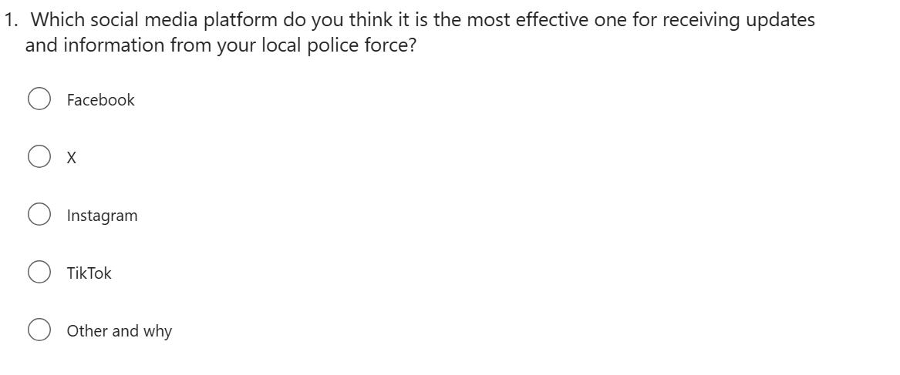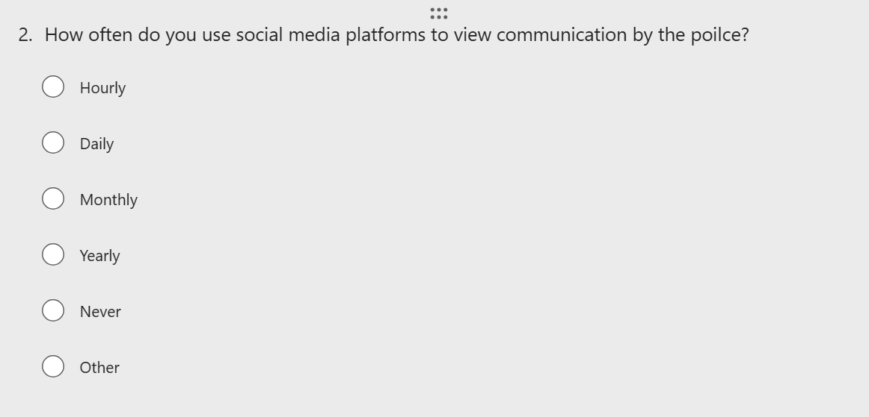

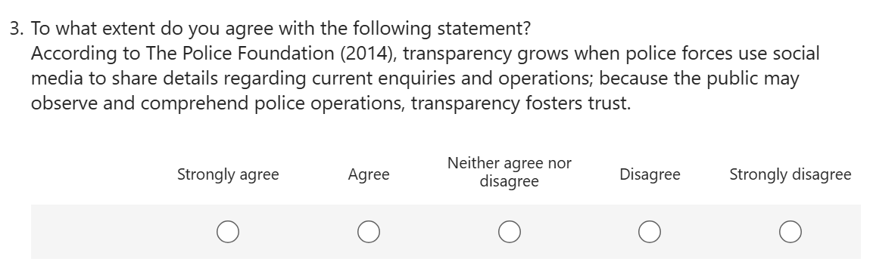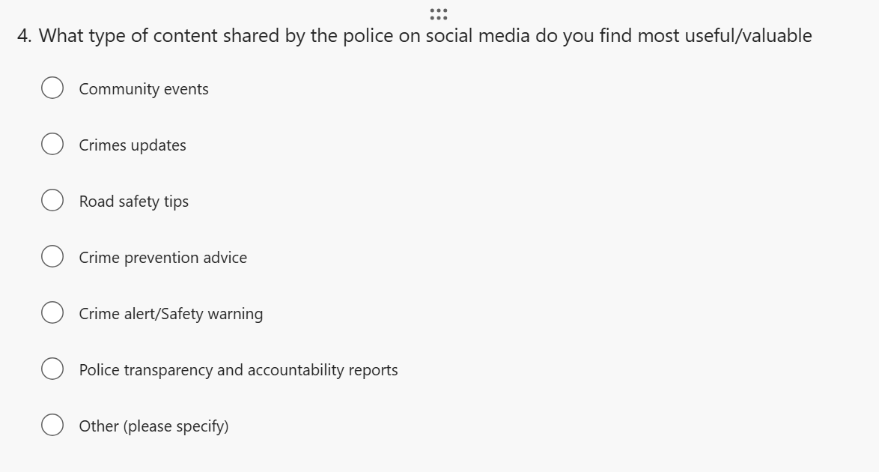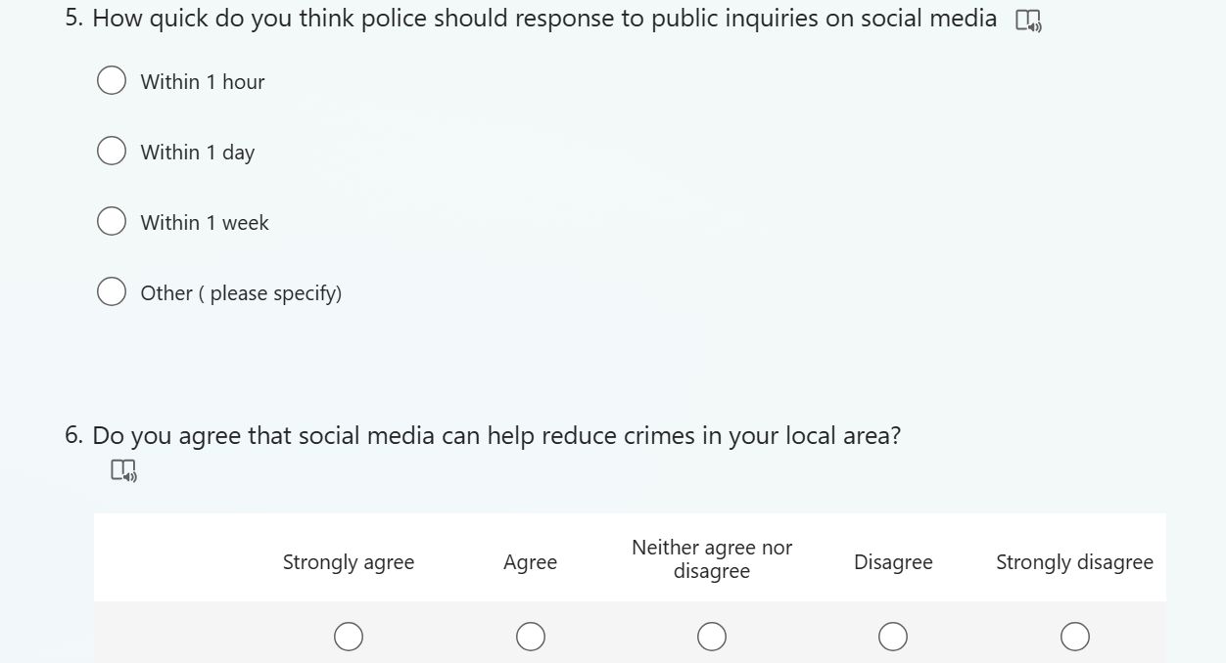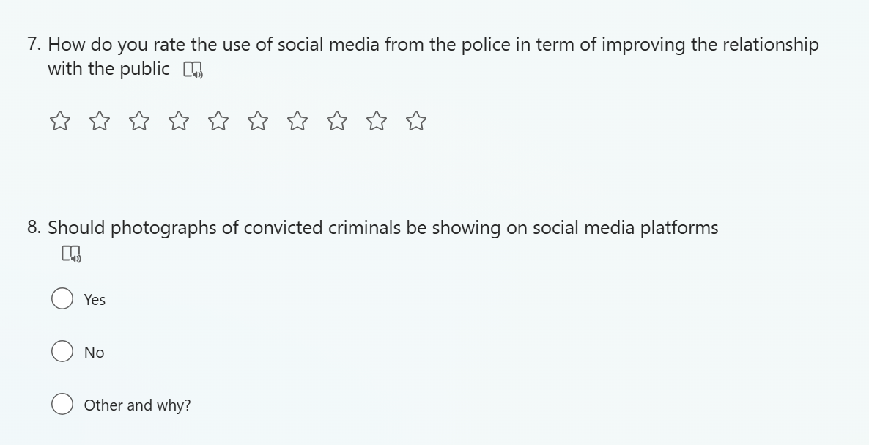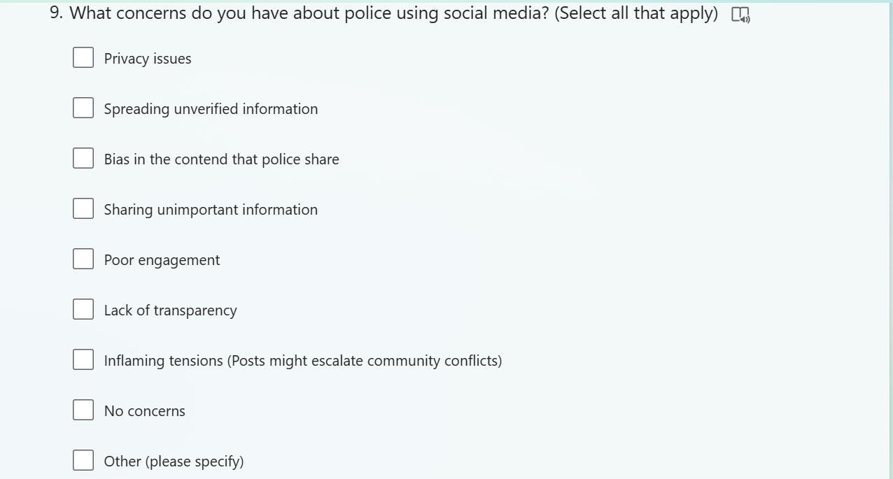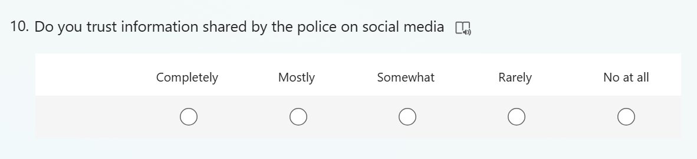

Task 6: Evaluation of the Chosen Data Analysis Method

This study uses quantitative data analysis employing statistical methods and qualitative results that run through thematic analysis, matching the mixed-method design. This integration helps in having a better understanding of how social media affects the relationship between police and the public in England and Wales (Braun and Clarke, 2022).
Qualitative data from the survey will be analysed using the content analysis method, while quantitative data will be analysed using descriptive and inferential statistical analyses in SPSS (Statistical Package for the Social Sciences). “Frequency distributions, measures of central tendency and dispersion, and cross-tabulations” give a clear picture of response patterns (van Elst, 2013). This approach means that the demographic differences in the use of social media by the police are brought out clearly while highlighting general trends through statistical analysis. Pallant (2020) points out that descriptive statistics works well at helping the researcher to give a summary of large data sets while still being intellectually fair.
Inferential statistics will encompass chi-square tests to check associations between two or more qualitative variables and t-tests to compare the mean of different demographic subsets (Mweshi and Muhyila, 2024). These will include establishing whether aspects like age, geographical location, or prior police contact affect the perception of police social media effectiveness. Hierarchical multiple regression analysis will also determine which variables are the best predictors of public trust and confidence in police social media communications.
Regarding the open-ended questions of the questionnaire, thematic analysis is deemed appropriate for this study. Exploratory analysis will be most suitable for this method because it offers substantial structure yet is malleable, especially when using the six-phase procedure outlined by Braun and Clarke (2006). Nowell et al., (2017: p2), define thematic analysis as ‘a rigorous, accessible and theoretically flexible method designed for data analysis’ which is appropriate for capturing the interpersonal processes of police-public operational social media engagement.
The process of coding will involve utilising the NVivo program to assist in structuring and analysing text. The coding process will be organised through an inductive method so that themes will not be imposed by the research but will be derived from responses by participants (Lungu, 2022). This works well with the exploratory research design because the information gathered is from the participant’s viewpoint. When analysing samples, codes will be compiled into broader categories focusing on public perception of police use of social media.
Information processing is an essential aspect of the analytical process, and data integration is pivotal. In alignment with Fetters and Freshwater’s (2015) suggestions, the quantitative and qualitative data will be merged using two forms of integration: narrative synthesis and convergent analysis. This integration allows for “expansion” whereby qualitative data offers depth to the quantitative put forth by the statistical discoveries made (Dawadi, Shrestha and Giri, 2021). The combination of these analytical lenses affirms the conclusions due to methodological triangulation (Morse, 2016). By using an analytical, quantitative approach within this study, the research will identify and quantify the extent to which the use of social media enhances police-public relations in England and Wales.

References

- Andrews, D., Nonnecke, B. and Preece, J. (2003) ‘Electronic Survey Methodology: A Case Study in Reaching Hard-to-Involve Internet Users’, International Journal of Human-Computer Interaction, 16(2), pp. 185–210. Available at: https://doi.org/10.1207/s15327590ijhc1602_04 (Accessed: 04/04/2025).
- Braun, V. and Clarke, V (2006). ‘Using Thematic Analysis in Psychology’, Qualitative Research in Psychology, 3(2), pp. 77–101. Available at: https://doi.org/10.1191/1478088706qp063oa (Accessed: 04/04/2025).
- Braun, V. and Clarke, V. (2022) ‘Conceptual and design thinking for thematic analysis.’, Qualitative Psychology, 9(1), pp. 3–26. Available at: https://doi.org/10.1037/qup0000196 (Accessed: 04/04/2025).
- Braun, V. et al. (2021) ‘The online survey as a qualitative research tool’, International Journal of Social Research Methodology, 24(6), pp. 641–654. Available at: https://doi.org/10.1080/13645579.2020.1805550 (Accessed: 04/04/2025).
- British Society of Criminology (2015) Statement of Ethics, British Society of Criminology. Available at: https://www.britsoccrim.org/ethics/ (Accessed:4/04/2025).
- British Society of Criminology (2021) Statement of ethics. Available at: https://www.britsoccrim.org/ethics/ (Accessed: 4/04/2025).
- Bryda, G. and Costa, A.P. (2023) ‘Qualitative Research in Digital Era: Innovations, Methodologies and Collaborations’, Social Sciences, 12(10), pp. 1–17. Available at: https://doi.org/10.3390/socsci12100570 (Accessed: 04/04/2025).

- Cullen, A (2022). POLICE AND SOCIAL MEDIA IN ENGLAND AND WALES: EXPLORING POLICE COMMUNICATIONS AND IMAGE WORK IN THE DIGITAL SOCIETY. Available at: https://orca.cardiff.ac.uk/id/eprint/156197/1/Police%20and%20Social%20Media%20in%20England%20and%20Wales%20-%20Arron%20Cullen.pdf (Accessed: 04/04/2025).
- College of policing (2022). Media relations. Available at: https://www.college.police.uk/app/engagement-and-communication/media-relations (Accessed: 15/02/2025).
- College of Policing (2024). Targeted social media to reduce serious crime. Available at: https://www.college.police.uk/support-forces/practices/targeted-social-media-reduce-serious-crime (Accessed: 3/04/2025).
- College of Policing (2020). Communication. Available at: https://www.college.police.uk/app/engagement-and-communication/communication (Accessed: 04/04/2025).
- Creswell, J.W. and Creswell, J.D. (2018) Research design: Qualitative, quantitative, and Mixed Methods Approaches. 5th edn. London: SAGE Publications. Available at: https://spada.uns.ac.id/pluginfile.php/510378/mod_resource/content/1/creswell.pdf (Accessed: 4/04/2025).
- Cullen, A. (2022) Police and Social Media in England and Wales: Exploring Police Communications and Image Work in the Digital Society. Available at: https://orca.cardiff.ac.uk/id/eprint/156197/1/Police%20and%20Social%20Media%20in%20England%20and%20Wales%20-%20Arron%20Cullen.pdf (Accessed: 4/04/2025).
- Daikeler, J., Silber, H. and Bošnjak, M. (2021) ‘A Meta-Analysis of How Country-Level Factors Affect Web Survey Response Rates’, International Journal of Market Research, 64(3), p. 147078532110509. Available at: https://doi.org/10.1177/14707853211050916 (Accessed: 04/04/2025).
- Dawadi, S., Shrestha, S. and Giri, R.A. (2021) ‘Mixed-Methods Research: a Discussion on Its Types, Challenges, and Criticisms’, Journal of Practical Studies in Education, 2(2), pp. 25–36. Available at: https://doi.org/10.46809/jpse.v2i2.20 (Accessed: 04/04/2025).
- Evans, J.R. and Mathur, A. (2018) ‘The Value of Online Surveys: a Look Back and a Look Ahead’, Internet Research, 28(4), pp. 854–887. Available at: https://doi.org/10.1108/intr-03-2018-0089 (Accessed: 04/04/2025).
- Edwards, A. et al. (2013) ‘Digital social research, social media and the sociological imagination: surrogacy, augmentation and re-orientation’, International Journal of Social Research Methodology, 16(3), pp. 245–260. Available at: https://doi.org/10.1080/13645579.2013.774185 (Accessed: 04/04/2025).
- Fetters, M.D. and Freshwater, D. (2015) ‘The 1 + 1 = 3 Integration Challenge’, Journal of Mixed Methods Research, 9(2), pp. 115–117. Available at: https://doi.org/10.1177/1558689815581222 (Accessed: 04/04/2025).
- FOUNDATIONS OF DESCRIPTIVE AND INFERENTIAL STATISTICS Lecture notes for a quantitative-methodological module at the Bachelor degree (B.Sc.) level HENK VAN ELST (2019). Available at: https://arxiv.org/pdf/1302.2525 (Accessed: 4/04/2025).
- Fielding, N.G. (2012) ‘Triangulation and Mixed Methods Designs’, Journal of Mixed Methods Research, 6(2), pp. 124–136. Available at: https://doi.org/10.1177/1558689812437101 (Accessed: 04/04/2025).
- Gelinas, L. et al. (2017) ‘Using Social Media as a Research Recruitment Tool: Ethical Issues and Recommendations’, The American Journal of Bioethics, 17(3), pp. 3–14. Available at: https://www.ncbi.nlm.nih.gov/pmc/articles/PMC5324729/ (Accessed: 4/04/2025).
- Gummer, T. and Roßmann, J. (2014) ‘Explaining Interview Duration in Web Surveys’, Social Science Computer Review, 33(2), pp. 217–234. Available at: https://doi.org/10.1177/0894439314533479 (Accessed: 04/04/2025).
- Hesse-Biber, S. (2010) ‘Qualitative Approaches to Mixed Methods Practice’, Qualitative Inquiry, 16(6), pp. 455–468. Available at: https://journals.sagepub.com/doi/pdf/10.1177/1077800410364611 (Accessed: 04/04/2025).
- Ivankova, N.V., Creswell, J.W. and Stick, S.L. (2006) ‘Using Mixed-Methods Sequential Explanatory Design: from Theory to Practice’, Field Methods, 18(1), pp. 3–20. Available at: https://doi.org/10.1177/1525822X05282260 (Accessed: 04/04/2025).
- Jones, T. and Lister, S. (2019) ‘Localism and police governance in England & Wales: Exploring continuity and change’, European Journal of Criminology, 16(5), pp. 552–572. Available at: https://doi.org/10.1177/1477370819860689 (Accessed: 04/04/2025).
- London assembly (2020). Met police social media accounts. Available at: https://www.london.gov.uk/who-we-are/what-london-assembly-does/questions-mayor/find-an-answer/met-police-social-media-accounts (Access: 10th/02/2025).
- Low, N. (2024) Use of digital, scientific and other technologies by the police and wider criminal justice system, POST. Available at: https://post.parliament.uk/use-of-digital-scientific-and-other-technologies-by-the-police-and-wider-criminal-justice-system/ (Accessed: 04/04/2025).
- Lungu, M. (2022) ‘The Coding Manual for Qualitative Researchers’, American Journal of Qualitative Research, 6(1), pp. 232–237. Available at: https://doi.org/10.29333/ajqr/12085 (Accessed: 04/04/2025).
- Mannix, J., Wilkes, L. and Daly, J. (2014) ‘Pragmatism, persistence and patience: A user perspective on strategies for data collection using popular online social networks’, Collegian, 21(2), pp. 127–133. Available at: https://doi.org/10.1016/j.colegn.2014.03.001 (Accessed: 04/04/2025).
- Morse, J.M. (2016) Mixed Method Design. Routledge. Available at: https://doi.org/10.4324/9781315424538 (Accessed: 04/04/2025).
- Mweshi, G. and Muhyila, M. (2024) ‘Determining a Statistical Analysis for the Quantitative Study’, ResearchGate, 07,(04,), pp. 187–231. Available at: https://doi.org/10.14738/assrj.117.17018 (Accessed: 04/04/2025).
- North Wales Police (2021). North Wales Police Corporate Communications – Media Engagement Policy. Available at: https://www.northwales.police.uk/SysSiteAssets/media/downloads/north-wales/north-wales/news/north-wales-police-media-engagement-policy.pdf (Accessed: 04/04/2025).
- Naderifar, M., Goli, H. and Ghaljaie, F. (2017) ‘Snowball Sampling: a Purposeful Method of Sampling in Qualitative Research’, Strides in Development of Medical Education, 14(3). Available at: https://doi.org/10.5812/sdme.67670 (Accessed: 04/04/2025).
- NPCC (2019). Social Media Project: Target operating model. Available at: https://www.npcc.police.uk/SysSiteAssets/media/downloads/publications/publications-log/2019/npcc-police-social-media-target-operating-model.pdf (Accessed: 04/04/2025).
- Nowell, L.S. et al. (2017) ‘Thematic analysis: Striving to Meet the Trustworthiness Criteria’, International Journal of Qualitative Methods, 16(1), pp. 1–13. Available at: https://doi.org/10.1177/1609406917733847 (Accessed: 04/04/2025).
- O’Halloran, K.L. et al. (2016) ‘A Digital Mixed Methods Research Design: Integrating Multimodal Analysis With Data Mining and Information Visualization for Big Data Analytics’, Journal of Mixed Methods Research, 12(1), pp. 11–30. Available at: https://doi.org/10.1177/1558689816651015 (Accessed: 04/04/2025).
- O’Cathain, A., Murphy, E. and Nicholl, J. (2010) ‘Three techniques for integrating data in mixed methods studies’, BMJ, 341(sep17 1), pp. c4587–c4587. Available at: https://doi.org/10.1136/bmj.c4587 (Accessed: 04/04/2025).
- Olimpo, J.T. and Day, E.L. (2024) ‘Getting Started with Mixed Methods Research: A Primer’, Scholarship and Practice of Undergraduate Research, 7(3), pp. 6–11. Available at: https://doi.org/10.18833/spur/7/3/3 (Accessed: 04/04/2025).
- Pallant, J. (2020) SPSS Survival Manual. 7th edn. London: Routledge. Available at: https://doi.org/10.4324/9781003117452 (Accessed: 04/04/2025).
- Procter, R., Vis, F. and Voss, A. (2013) ‘Reading the riots on Twitter: methodological innovation for the analysis of big data’, International Journal of Social Research Methodology, 16(3), pp. 197–214. Available at: https://doi.org/10.1080/13645579.2013.774172 (Accessed: 04/04/2025).
- Ralph, L. et al. (2022) ‘Maintaining police-citizen relations on social media during the COVID-19 pandemic’, Policing and Society, 32(6), pp. 764–777. Doi.org/10.1080/10439463.2022.2091565 (Accessed: 04/04/2025).

- South Yorkshire Police (2025). Policy P6 - Engagement and Communication. Available at: https://www.southyorkshire.police.uk/foi-ai/south-yorkshire-police/policy/policy-p6---engagement-and-communication/ (Accessed: 11th/02/2025).
- South Wales Police (2025). Social media house rules. Available at: https://www.south-wales.police.uk/police-forces/south-wales-police/areas/about-us/about-us/social-media/social-media-house-rules/ (Accessed: 15/02/2025).
- Social Media Today (2012). The UK Police and Social Media. Partners in Crime?. Available at: https://www.socialmediatoday.com/content/uk-police-and-social-media-partners-crime (Accessed: 04/04/2025).
- Siva, M., Nayak, D. and Narayan, K. (2019) ‘Strengths and weakness of online surveys’, IOSR Journal Of Humanities And Social Science (IOSR-JHSS, 24(5), pp. 31–38. Available at: https://www.iosrjournals.org/iosr-jhss/papers/Vol.%2024%20Issue5/Series-5/E2405053138.pdf (Accessed: 04/04/2025).
- Skamagki, G. et al. (2022) ‘The concept of integration in mixed methods research: A step-by-step guide using an example study in physiotherapy’, Physiotherapy Theory and Practice, 40(2), pp. 1–8. Available at: https://doi.org/10.1080/09593985.2022.2120375 (Accessed: 04/04/2025).
- Stantcheva, S. (2023) ‘How to Run Surveys: A Guide to Creating Your Own Identifying Variation and Revealing the Invisible’, Annual Review of Economics, 15(1), pp. 205–234. Available at: https://doi.org/10.1146/annurev-economics-091622-010157 (Accessed: 04/04/2025).
- The Police Foundation (2014). Police use of social media. Available at: https://www.police-foundation.org.uk/wp-content/uploads/2017/08/Social_media_briefing_FINAL.pdf (accessed: 4th/02/2025).
- Topolovec-Vranic, J. and Natarajan, K. (2016) ‘The Use of Social Media in Recruitment for Medical Research Studies: a Scoping Review’, Journal of Medical Internet Research, 18(11), p. 286. Available at: https://www.jmir.org/2016/11/e286/ (Accessed: 04/04/2025).
- WeCops (2024). Policing and Social Media: The Role of Personal Police Accounts in Community Engagement. Available at: https://www.wecops.uk/events/2024/10/policing-and-social-media-role-personal-police-accounts-community-engagement#:~:text=Police%20forces%20across%20the%20UK,to%20crises%2C%20and%20build%20relationships (Accessed: 04/04/2025).
- Williams, M.L., Burnap, P. and Sloan, L. (2016) ‘Crime Sensing with Big Data: The Affordances and Limitations of using Open Source Communications to Estimate Crime Patterns’, British Journal of Criminology, 57(2). Available at: https://doi.org/10.1093/bjc/azw031 (Accessed: 04/04/2025).

